**WEB TECHNOLOGIES**

**P. Manoj Kumar**

**221810309047**

**CSE-B9**

**1Q. check weather given number is +ve or -ve or zero**

**Program:-**

<html>

<body>

<h1>check weather given number is +ve or -ve or zero </h1>

<script type="text/javascript">

var a;

a=5;

if(a>0)

document.write(a+ "is positive");

else

if(a<0)

document.write(a+ "is negative");

else

if(a==0)

document.write(a+ "is zero");

</script>

</body>

</html>

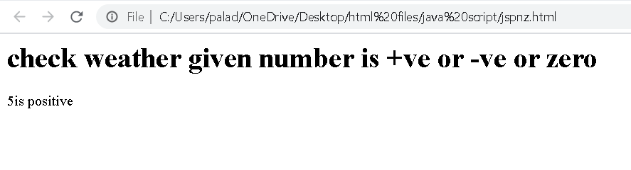

**2Q. check the largest among 3 numbers**

**Program:-**

<html>

<body>

<h1>check the largest among 3 numbers </h1>

<script type="text/javascript">

var a,b,c;

a=5;

b=10;

c=30;

if(a>b && a>c)

document.write(a+ "is largest");

else

if(b>a && b>c)

document.write(b+ "is largest");

else

if(c>a && c>b)

document.write(c+ "is largest");

</script>

</body>

</html>

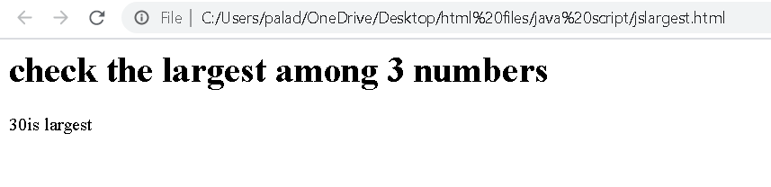

**3Q. multiplication table**

**Program:-**

<html>

<body>

<h1>multiplication table</h1>

<script type="text/javascript">

var table;

table=2;

for(i=1;i<=10;i++)

{

document.write("2*"+i+"="+i*table+"<br/>");

}

</script>

</body>

</html>

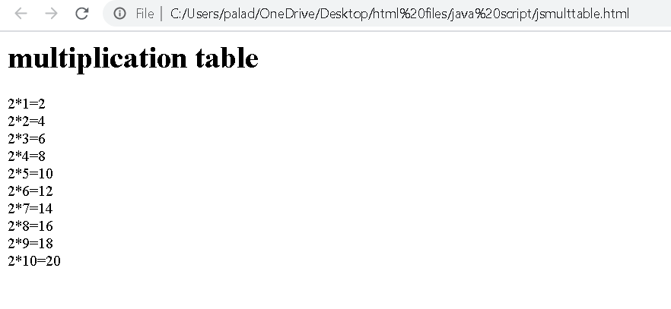

**4Q.find factorial of a number.**

**Program:-**

<html>

<body>

<p>the given number x is 4</p>

<script>

var x=4;

var fact=1;

for(var i=1;i<=x;i++)

{

fact=fact*i;

}

document.write("factorial of the given number is : "+fact,"<br/>");

</script>

</body>

</html>

