**TITLE : SMART WATER MANAGEMENT SYSTEM**

**PHASE 4 : DEVELOPMENT PART-2**

[In this part you will continue building your project.

* Continue building the project by developing the data-sharing platform.
* Use web development technologies (e.g., HTML, CSS, JavaScript) to create a platform that displays real-time water consumption data.
* Design the platform to receive and display water consumption data from IoT sensors and promote water conservation efforts. ]

**Water Consumption platform (Website design)**

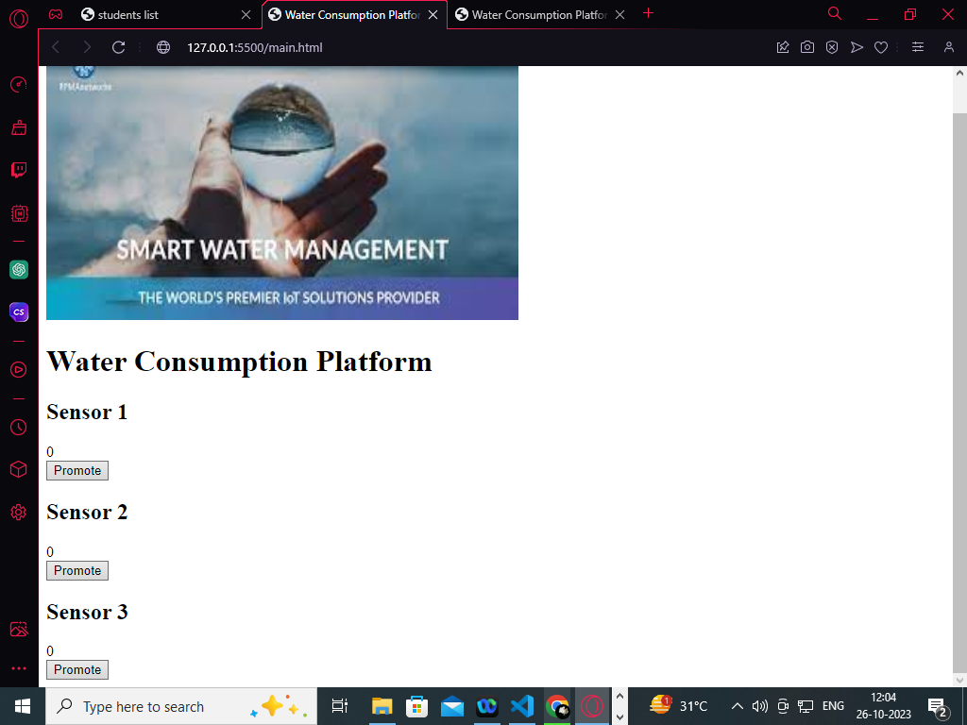

**Pattern:**

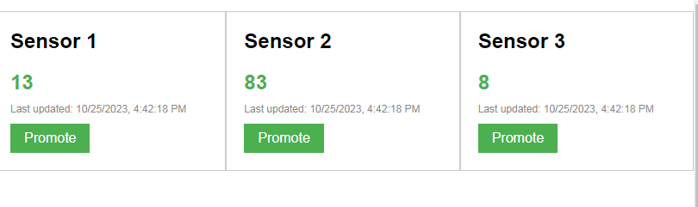

**CODE:**

**//html code**

<!DOCTYPE html>  
<html>  
<head>  
    <title>Water Consumption Platform</title>  
     
</head>  
<body>  
    <h1>Water Consumption Platform</h1>  
    <div id="dataContainer">  
        <div class="sensorCard">  
            <h2>Sensor 1</h2>  
            <div class="sensorValue" id="sensor1Value">0</div>  
            <div class="lastUpdated" id="sensor1LastUpdated"></div>  
            <button class="promoteButton" onclick="promoteWaterConservation(1)">Promote</button>  
        </div>  
        <div class="sensorCard">  
            <h2>Sensor 2</h2>  
            <div class="sensorValue" id="sensor2Value">0</div>  
            <div class="lastUpdated" id="sensor2LastUpdated"></div>  
            <button class="promoteButton" onclick="promoteWaterConservation(2)">Promote</button>  
        </div>  
        <div class="sensorCard">  
            <h2>Sensor 3</h2>  
            <div class="sensorValue" id="sensor3Value">0</div>  
            <div class="lastUpdated" id="sensor3LastUpdated"></div>  
            <button class="promoteButton" onclick="promoteWaterConservation(3)">Promote</button>  
        </div>  
    </div>  
  
     
</body>  
</html>

**//css code:**

  body {  
            font-family: Arial, sans-serif;  
        }  
  
        h1 {  
            text-align: center;  
            margin-top: 40px;  
        }  
  
        #dataContainer {  
            display: flex;  
            justify-content: space-between;  
        }  
  
        .sensorCard {  
            width: 300px;  
            border: 1px solid #ccc;  
            padding: 20px;  
            margin-bottom: 20px;  
        }  
  
        h2 {  
            margin-top: 0;  
        }  
  
        .sensorValue {  
            font-size: 24px;  
            font-weight: bold;  
            color: #4CAF50;  
            margin-bottom: 10px;  
        }  
  
        .lastUpdated {  
            font-size: 12px;  
            color: #888;  
        }  
  
        .promoteButton {  
            background-color: #4CAF50;  
            color: white;  
            border: none;  
            padding: 8px 16px;  
            text-align: center;  
            text-decoration: none;  
            display: inline-block;  
            font-size: 16px;  
            margin-top: 10px;  
            cursor: pointer;  
        }

**//javascript code:**

  function updateSensorValue(sensorId) {  
            var sensorValue = Math.floor(Math.random() * 100); // Replace with actual sensor data  
  
            var valueElement = document.getElementById("sensor" + sensorId + "Value");  
            var lastUpdatedElement = document.getElementById("sensor" + sensorId + "LastUpdated");  
  
            valueElement.textContent = sensorValue;  
            lastUpdatedElement.textContent = "Last updated: " + new Date().toLocaleString();  
        }  
  
        function promoteWaterConservation(sensorId) {  
            // Code to promote water conservation efforts  
            alert("Promote water conservation for sensor " + sensorId);  
        }  
  
        setInterval(function() {  
            // Update sensor values every 5 seconds  
            updateSensorValue(1);  
            updateSensorValue(2);  
            updateSensorValue(3);  
        }, 5000);