Testing, Linux and Server Assessment

Question 1: Create a complete project directory from scratch, apply correct permissions, and set ownership.

Step 1 — Create Directory Structure
Use a single mkdir -p command to create the webapp/ directory with all three subdirectories at once:
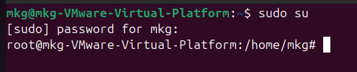
mkdir -p /home/ec2-user/webapp/scripts \
/home/ec2-user/webapp/logs \
/home/ec2-user/webapp/config

Step 2 — Create config/app.conf
Use nano to write two configuration lines into app.conf, then press Ctrl+D to save:
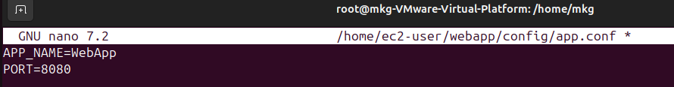
cat /home/ec2-user/webapp/config/app.conf
APP_NAME=WebApp
PORT=8080

Step 3 — Create Empty Log File
Create an empty log file and verify it is 0 bytes:

touch /home/ec2-user/webapp/logs/app.log
ls -l /home/ec2-user/webapp/logs/app.log

Step 4 — Set Permissions

chmod 755 /home/ec2-user/webapp/scripts
chmod 644 /home/ec2-user/webapp/config/app.conf

Permission Breakdown:
755 (scripts/) | rwx (read, write, execute) | r-x (read, execute) | r-x (read, execute)
644 (app.conf) | rw- (read, write) | r-- (read only) | r-- (read only)

- 755 means the owner (root) can read, write, and enter the directory. Group members and all others can only read and enter — they cannot modify contents.
- 644 means the owner can read and edit the file. Everyone else (group and others) can only read it — no writing allowed.

Step 5 — Change Ownership Recursively
Transfer ownership of the entire webapp/ directory tree to root:

sudo chown -R root:root /home/ec2-user/webapp/
ls -lR /home/ec2-user/webapp/
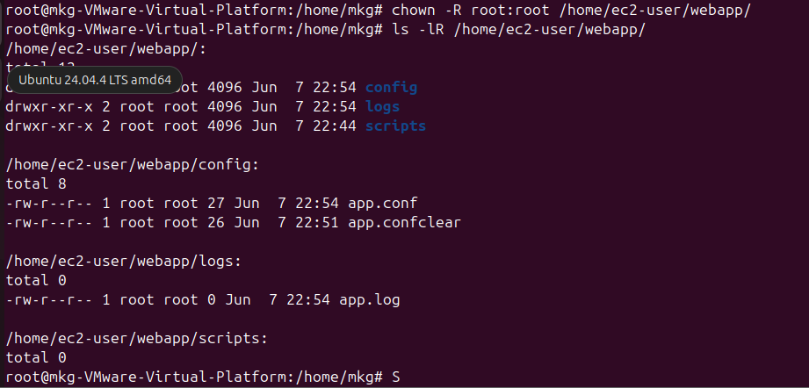

Expected Final Directory Structure

Question 2: Write an Interactive Log Script

Objective | Write a bash script that takes user input, reads a config file, and writes timestamped log entries to logs/app.log.

Step 1 — Create the Script File
Navigate to the scripts directory and open vim to create the script:

cd /home/ec2-user/webapp/scripts/
nano log_user.sh

Step 2 — Script Contents
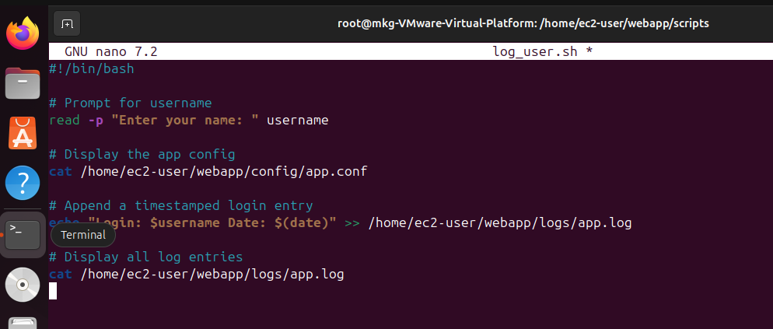
Save and Exit:

Step 3 — Make Script Executable

chmod +x log_user.sh

Step 4 — Run the Script Three Times
Execute the script with three different names to populate the log file:

./log_user.sh # Enter: Chirag
./log_user.sh # Enter: Priya
./log_user.sh # Enter: Ravi
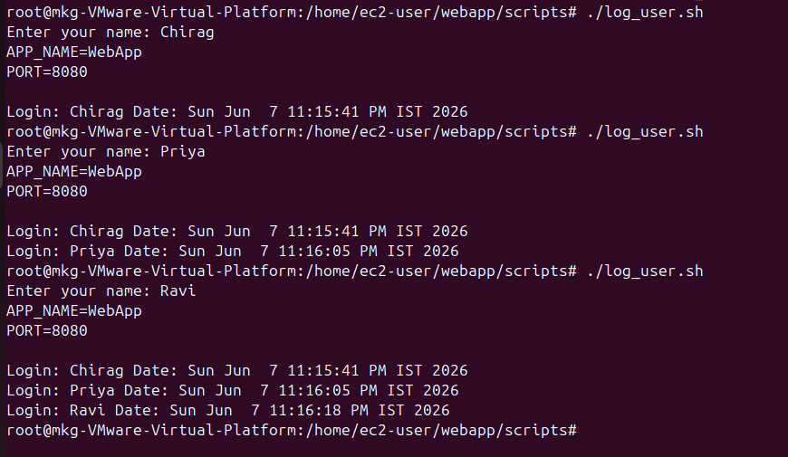

Step 5 — Verify the Log File

cat /home/ec2-user/webapp/logs/app.log

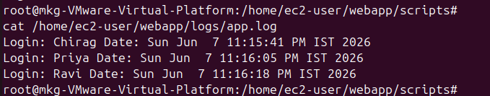

Question 3: User Management and File Permission Control

Objective | Create 4 Linux users, assign two write access and two read-only access to log_user.sh using Linux groups and chmod.

Step 1 — Create the 'writers' Group

sudo groupadd writers

Step 2 — Create Four Users
Create all four users with home directories using the -m flag:

sudo useradd -m devuser1
sudo useradd -m devuser2
sudo useradd -m devuser3
sudo useradd -m devuser4
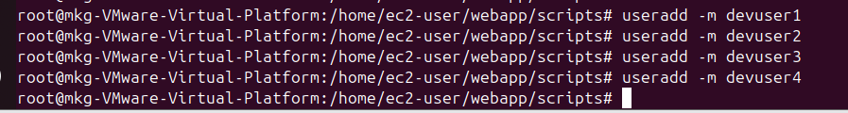

Step 3 — Add Write-Access Users to 'writers' Group
devuser1 and devuser2 get write access; devuser3 and devuser4 remain outside the group:

sudo usermod -aG writers devuser1
sudo usermod -aG writers devuser2
Verify Group Membership:
groups devuser1
groups devuser2

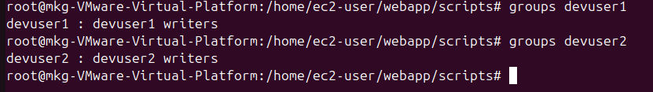

Step 4 — Change Group Ownership of the Script

sudo chown root:writers /home/ec2-user/webapp/scripts/log_user.sh
Verify:
ls -l /home/ec2-user/webapp/scripts/log_user.sh

Step 5 — Set chmod 664 Permissions

sudo chmod 664 /home/ec2-user/webapp/scripts/log_user.sh
Permission Breakdown — chmod 664:

Permission | Owner | Group | Others
664 | rw- (read, write) | rw- (read, write) | r-- (read only)
Who | root (owner) | writers group (devuser1, devuser2) | devuser3, devuser4

Step 6 — Verify Permissions

ls -l /home/ec2-user/webapp/scripts/log_user.sh

Step 7 — Test Access as Each User
devuser1 / devuser2 — Write Access Test:

su - devuser1
echo 'test write' >> /home/ec2-user/webapp/scripts/log_user.sh
# Should succeed (no permission denied)
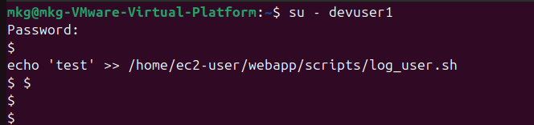
devuser3 / devuser4 — Read-Only Access Test:

su - devuser3
cat /home/ec2-user/webapp/scripts/log_user.sh

echo 'test' >> /home/ec2-user/webapp/scripts/log_user.sh
# Should FAIL: bash: permission denied

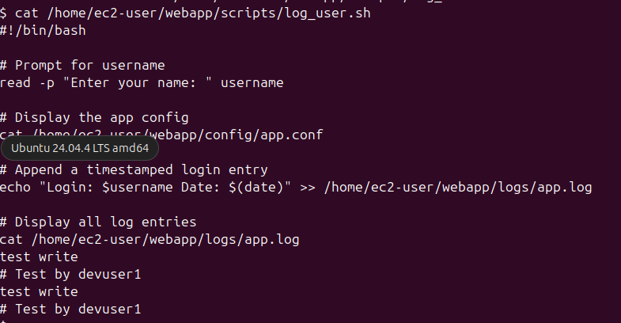

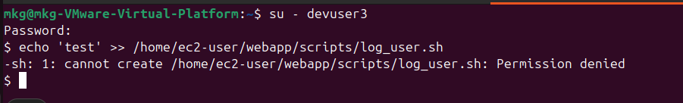

Summary — Access Control Table

User | Group | Permission | Access Level
devuser1 | writers | rw- (6) | Read + Write
devuser2 | writers | rw- (6) | Read + Write
devuser3 | others | r-- (4) | Read Only
devuser4 | others | r-- (4) | Read Only

