  - PRODUCT BLUEPRINT

HomeBop product blueprint
A family planner that can grow into a useful social network and a local home-meal marketplace.
01 PLAN 02 SHARE 03 SERVE
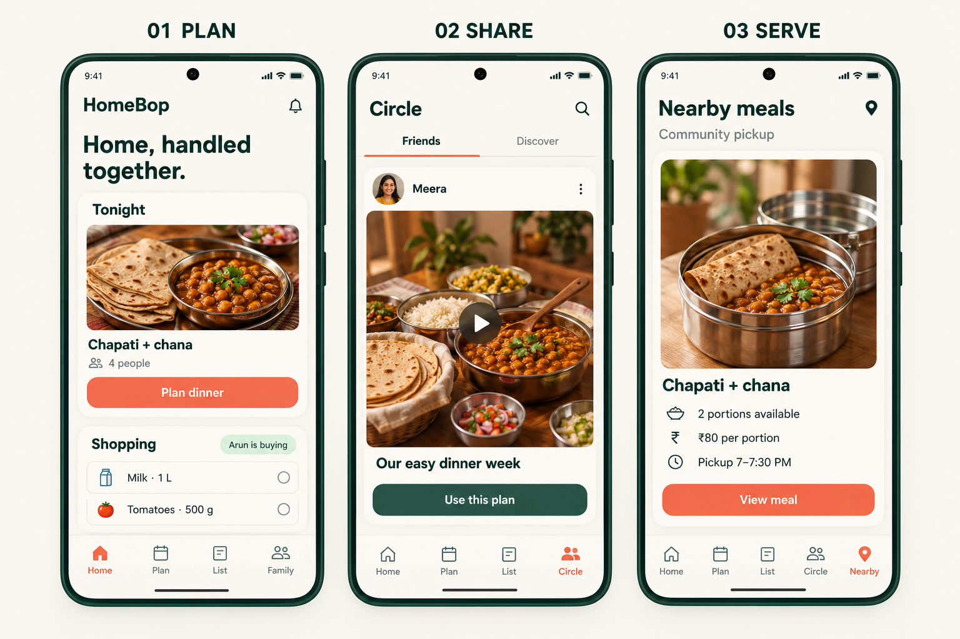
Vision concept for three future releases

Build the daily habit first
The first build is the private family planner. Social sharing and food sales are later decisions, each with its own evidence and launch requirements.
Concept for mentor review
22 October 2026

  - PRODUCT OVERVIEW

The idea in one minute
One product direction, with three clearly separated releases.
Problem: Meal decisions and shopping requests are scattered across conversations. One adult may end up remembering, reminding and checking everything.
First solution: A private shared view of tonight’s meal, what is missing, who has accepted the work and what is finished.
Release | Problem addressed | What we build
1 Plan MVP | What are we cooking, what do we need, and who will handle it? | Meal planning, shared groceries, accepted responsibilities and purchase history.
2 Share | A useful family post is hard to turn into our own routine. | Photos, short videos and audience controls. Attach a recipe or menu that another household can copy.
3 Serve | A cook has fresh extra portions; a nearby household wants a meal. | Approved sellers, local meal listings, orders, payment, pickup and support.

A familiar example
Meera chooses dinner and adds milk. Arun taps I’ll buy. Everyone sees his name beside the item. After he taps Bought, it leaves the active list and stays in history. No one needs to send another “Did you buy it?” message.
Initial audience: Working households in one Kerala community that cook regularly and buy from both local shops and online services. Any adult can coordinate the home.
Name: Keep HomeBop as the working brand: short, friendly and broad enough for all three releases. Pronunciation: “home-bop”. Trademark, domain and app-store clearance remain open.

  - EVIDENCE AND JUDGMENT

Commercial potential
Yes, it is technically feasible. Commercial success is still unproven.
Recommendation: validate Version 1 before funding all three.
More features do not remove the risks of weak demand, low retention or expensive customer acquisition.
Verified public offering | Implication for HomeBop
PlanNEat [1] Indian meal planning and grocery lists; advertised as free when checked. | Regional meals and a generated list are already available. A clearer daily benefit must justify switching or paying.
FamilyWall [2] Family lists, meal planning, tasks and private photo/video sharing. | An organiser plus family media is already an established combination.
HomeFoodi [3] Discovery and direct contact with home chefs and tiffin suppliers. | Home-cook discovery and earning from home cooking are existing propositions. Food commerce is a competitive, operational business.

The distinction to test
A useful post becomes a household action. Copy a dinner plan, confirm ingredients, let someone accept the shopping, and complete the meal. Later, a household could choose a nearby meal when cooking plans change.
This is a positioning hypothesis, not a verified unique invention. Public websites show advertised features; they do not establish competitors’ active users, profitability or unmet demand in Kerala. A plain interface is not evidence that an app has few users.
What would change the recommendation: households returning without reminders, adults sharing responsibility, actual subscription renewals, and later repeat food orders with positive contribution after variable costs.

  - SECTION 1 PLAN

The MVP home screen
Problem: the family cannot see the plan, missing purchases and responsibilities together.

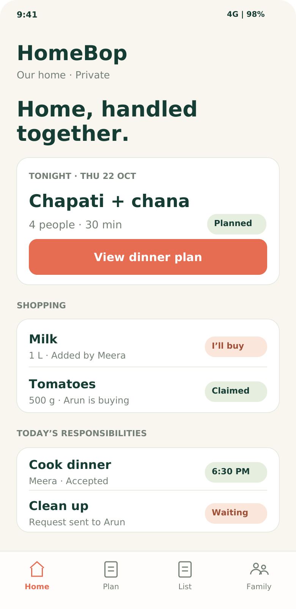

One useful daily view
Tonight’s meal, urgent groceries and accepted tasks are visible immediately.

Build now
- Individual accounts in a private household.
- Saved meal favourites and a simple week view.
- Shared groceries, including non-food essentials.
- Claim, assign, accept and complete tasks.
- Bought history, Undo and focused reminders.

Keep the first release focused
The social feed, food listings, checkout, delivery, receipt scanning and automatic pantry tracking belong to later work.

Four tabs
Home · Plan · List · Family

UI CONCEPT · Fictional data; no live accounts, synchronisation or notifications are implemented by this blueprint.
Success for the user: open the app and know what to do next. It should remain useful when only one adult is active, while making shared participation easy.

  - SECTION 1 PLAN WORKFLOW

Set up the home and plan a meal
Solution: start from familiar meals and a short private household setup.
1. Create a home, set usual portions and choose favourites. 2. Invite another adult through a private link. 3. Select tonight’s meal or copy a previous week.
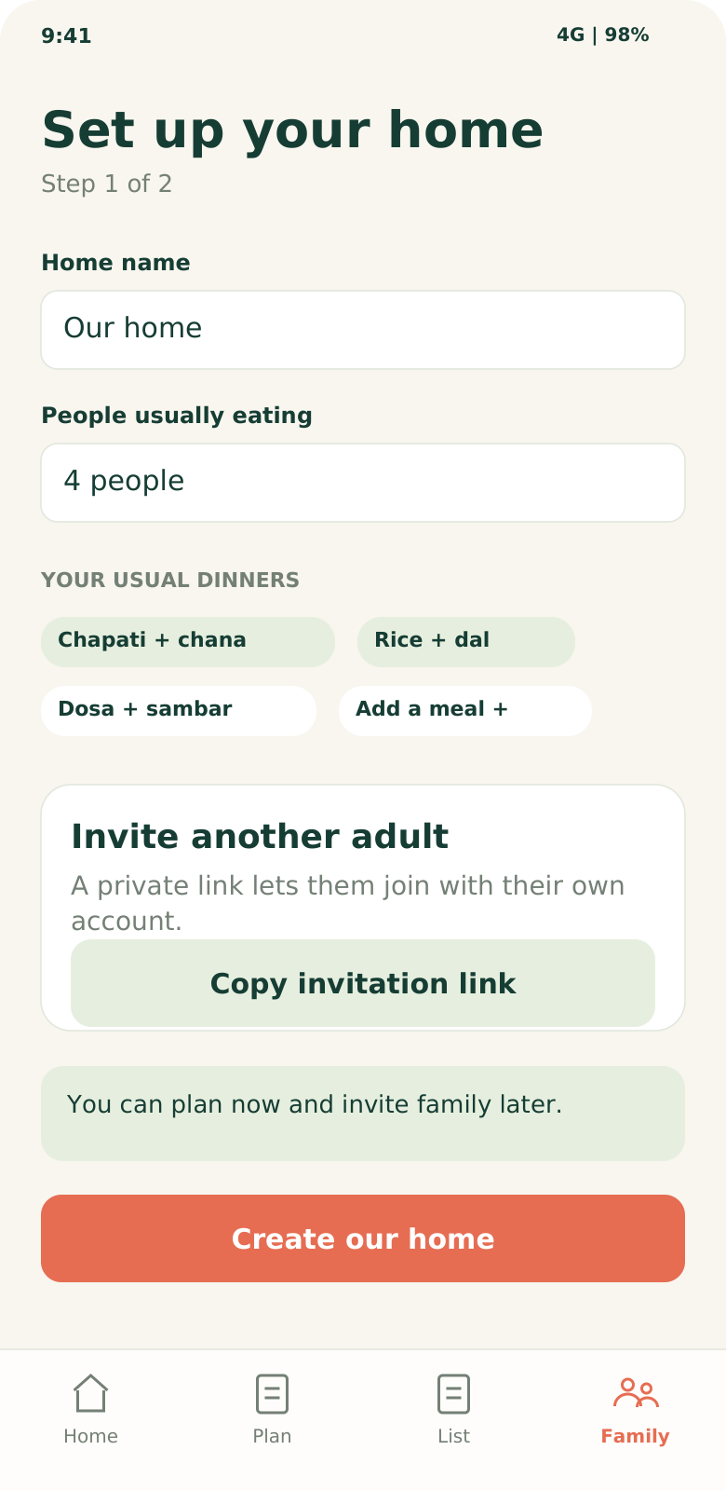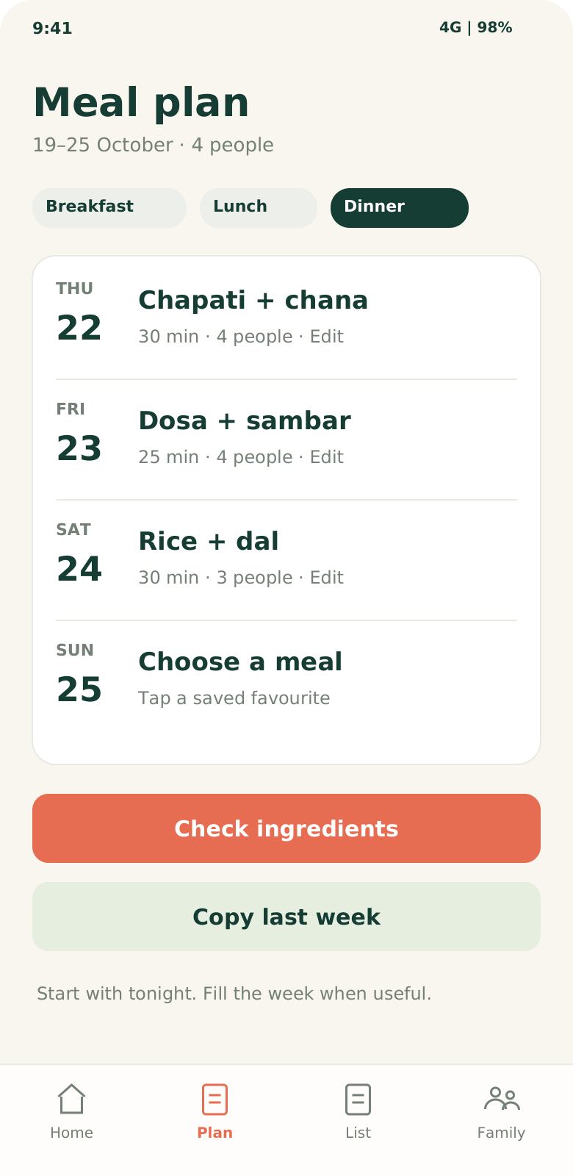
Setup: invitations require acceptance; each adult uses their own account. The household can start planning before anyone joins.
Meal plan: dinner is the starting view. Breakfast and lunch are optional. Household recipes and quantities remain editable.
Proposed interface screenshots · All names and meal plans are illustrative.

  - SECTION 1 PLAN WORKFLOW

Turn a meal into a shared list
Only confirmed shortages become shopping requests.
4. Check the editable ingredient estimates: Have / Need / Check. 5. Add shortages to the list, or add any everyday item by name. 6. A member taps I’ll buy.
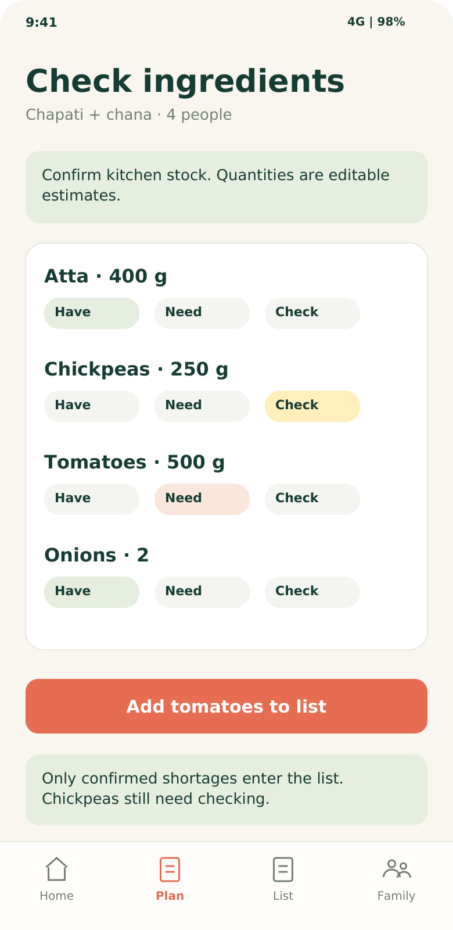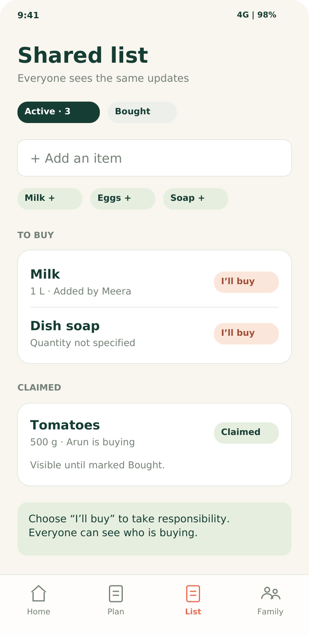
Have / Need / Check: the app does not assume stock. “Check” stays unresolved. An ingredient list requires a saved recipe with ingredients.
Shared list: an item name is enough. Quantity and brand are optional. Show an existing active match before adding a duplicate.
Proposed interface screenshots · A claimed item remains visible with the buyer’s name.

  - SECTION 1 PLAN WORKFLOW

Complete the purchase
Claiming a purchase and completing it are different actions.
7. A confirmed claim displays the buyer to everyone. 8. Record the amount bought. 9. Complete items move to history; a partial purchase leaves the remainder active.
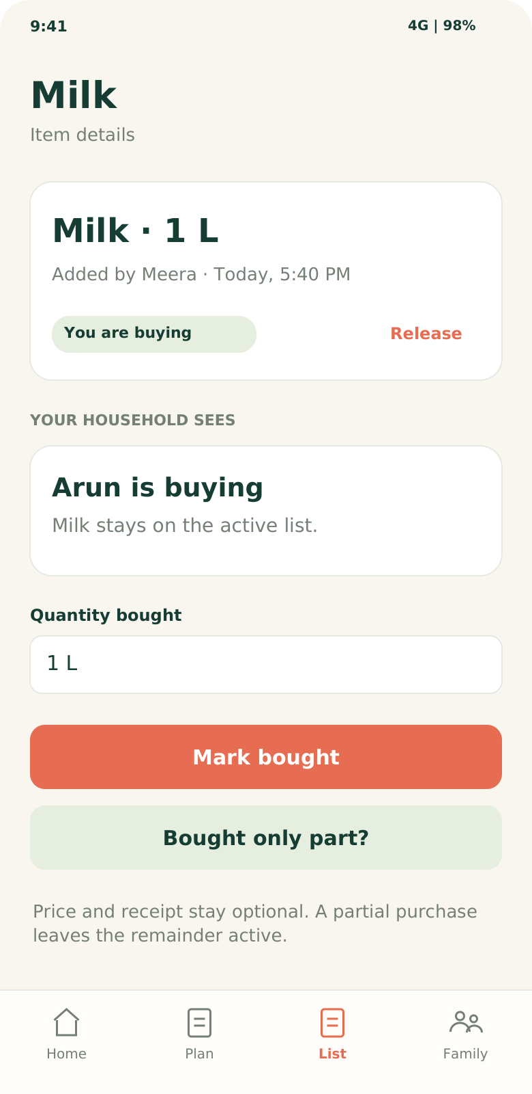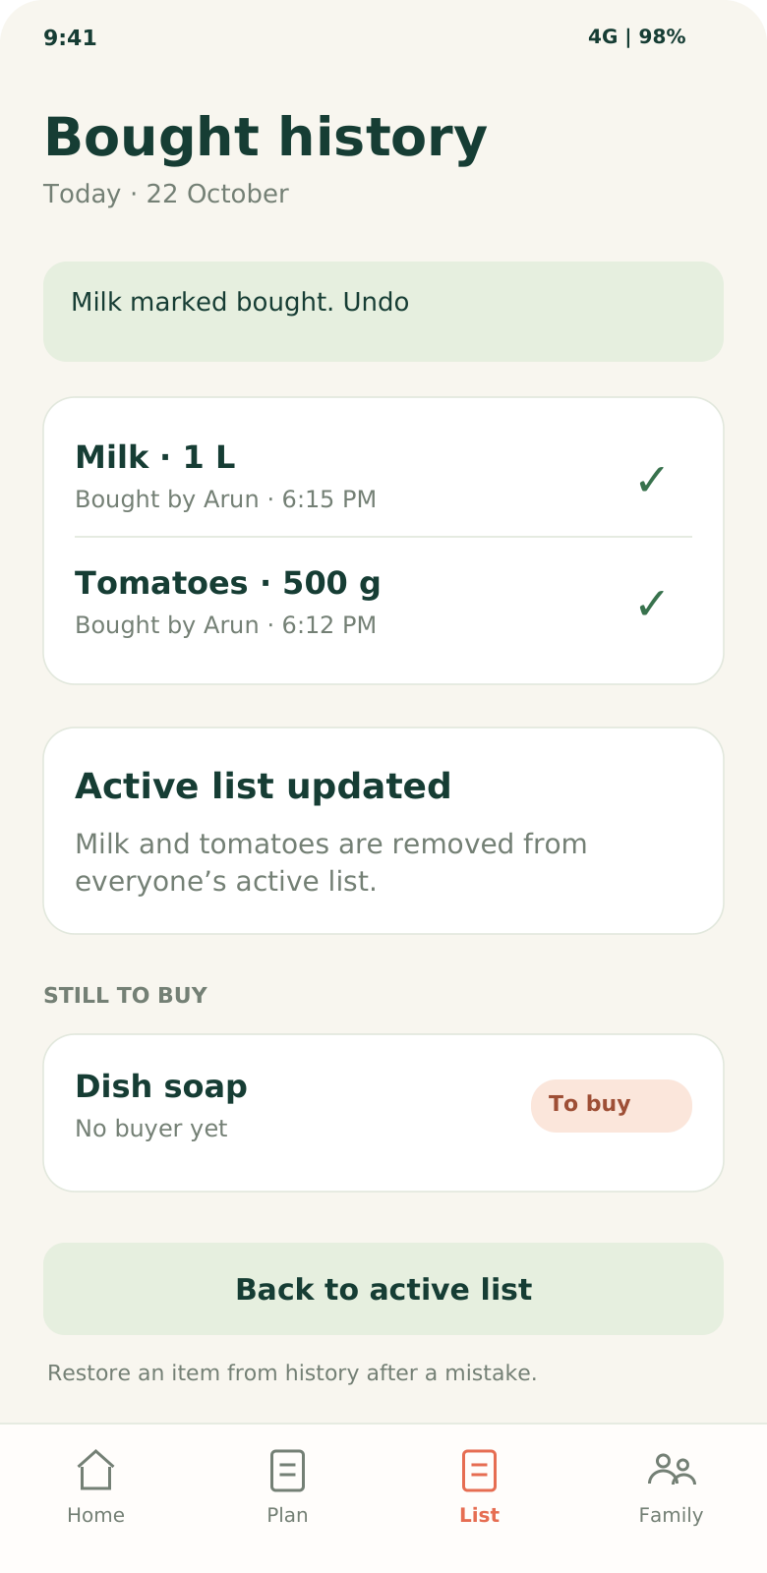
Claim: Arun takes responsibility. He can release the item. Another member can record a purchase with a clear confirmation.
Bought: history retains who bought what and when. Undo restores the prior state. Price and receipt never block completion.
Proposed interface screenshots · Two simultaneous claims must produce one confirmed buyer.

  - SECTION 1 BUILD CONTRACT

Make the MVP dependable
This page gives the mentor and developer a concrete definition of “working”.
Current state | Action | Next state and visible result
Needed | A member taps I’ll buy | Claimed, after server confirmation; everyone sees the buyer.
Needed | A member assigns it | Awaiting acceptance. The named adult can accept or decline.
Awaiting acceptance | Accept / decline | Accept → Claimed. Decline → Needed. Assigning alone never means accepted.
Claimed | Bought / partial / release | Bought → history. Partial → remainder stays active. Release → Needed.
Bought | Undo or restore | Restore the relevant prior state and remaining quantity; preserve the activity record.

Acceptance checks before a family pilot
1 Two accounts, one confirmed buyer. Test simultaneous claims on two phones. The server confirms one buyer. Offline edits show Pending sync until confirmed.
2 Changes do not lose work. Prevent accidental duplicate items. Changing dinner never silently deletes purchases already made. Conflicting edits require review.
3 Responsibilities require acceptance. Cook, shop and clean-up requests allow Accept / Can’t today. Send focused notifications to the responsible adult.
4 Private household access is enforced. Invites expire or can be revoked. Removed members lose access. Support account deletion and recovery.
Suggested build: an installable mobile web app, shared database, server-side household access rules and a small reviewed recipe set. Rules and templates are enough to start; AI is optional.

  - SECTION 2 SHARE

Share ideas families can use
Problem: an interesting family video rarely becomes an organised meal or routine.
Solution: publish a photo or short video and optionally attach a saved recipe, weekly menu or checklist. Another household can preview and use a private copy.
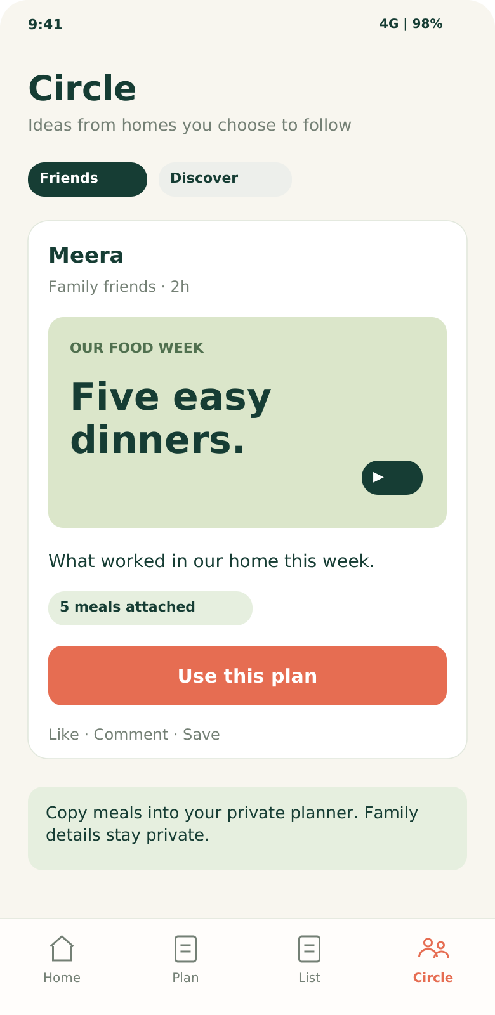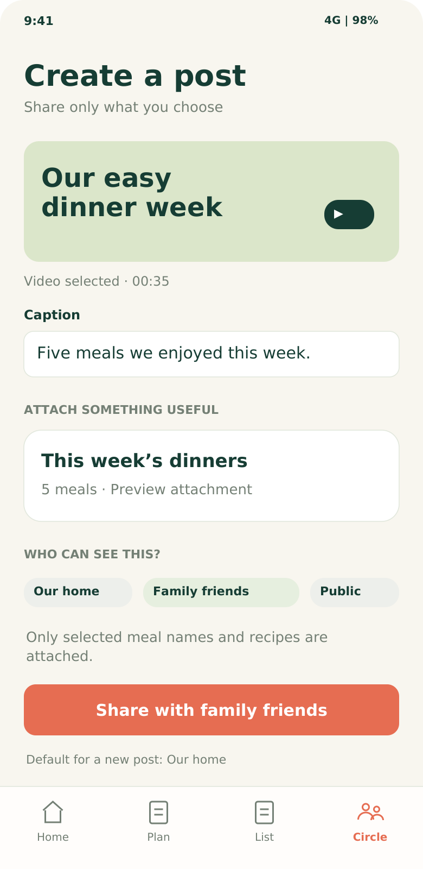
Circle: friends’ posts and public discovery are separate. A “Use this plan” action connects the post to a practical household benefit.
Create: choose Our home, Family friends or Public. Existing plans can be attached without retyping. Ordinary family moments need no attachment.
Proposed interface screenshots · Family settings move to the profile; Circle becomes the fourth tab.

  - SECTION 2 WORKFLOW AND BOUNDARIES

From watching to doing
The social feature must improve the household routine to earn its place.
1 Share an idea. Meera selects a dinner video, attaches five saved meals, previews exactly what will be shared and chooses the audience.
2 Make a private copy. A friend taps Use this plan, checks the meals, adjusts servings and swaps unsuitable dishes. The original contributor keeps credit.
3 Confirm ingredients. The copied recipe supplies editable estimates. The household checks stock before adding shortages to its own shopping list.
4 Share the work. Members accept shopping, preparation and clean-up. Later changes to the original post do not overwrite the household’s copy.
5 Share the result if desired. The family can post its version or keep the whole activity private. Public posting is always optional.
Audience | Meaning
Our home Default | Only current members of the private household.
Family friends | Only accepted people in the selected friend circles.
Public | Deliberately published content available beyond the household.

Private by design: attachments share chosen meals or recipes, never attendance, shopping activity, home addresses or assignments. Adult-managed sharing for children; obtain permission from people featured.
Launch essentials: report, block, remove and appeal controls; upload and storage limits; a moderation owner. Watch whether posts lead to copied plans and repeat household use, not just views.

  - SECTION 3 SERVE

Fresh meals from nearby homes
Problem: a cook has fresh extra portions while someone nearby needs a meal.
Solution: approved home cooks list portions, price, ingredients and a pickup window. Start in one small community. Pre-orders can make supply more predictable than relying only on surplus.
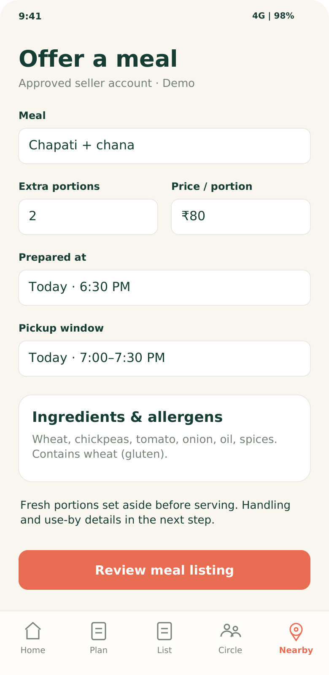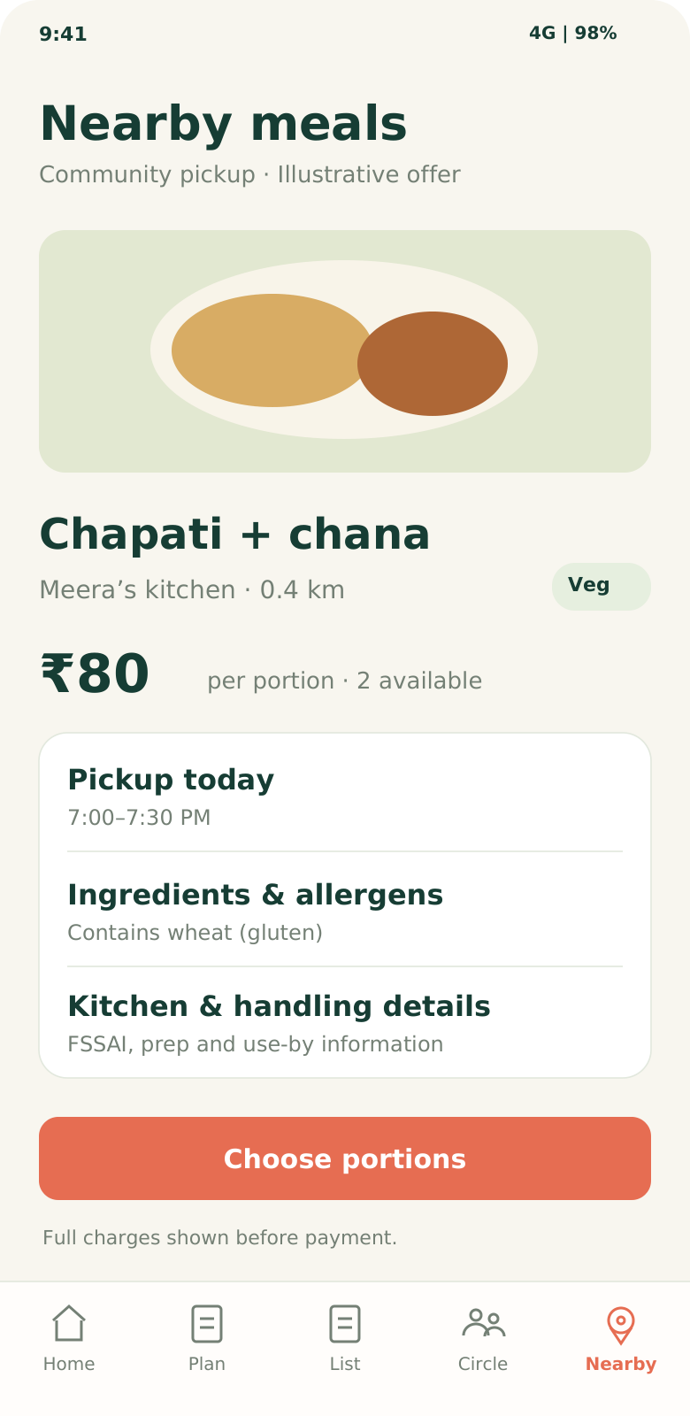
Seller: a separate approved selling role. Only eligible fresh, unserved portions are listed; an existing household account alone does not qualify.
Buyer: review the seller, ingredients, allergens, preparation/handling details, portions and total charges before placing an order.
Proposed interface screenshots · ₹80 and the food offer are illustrative. No sale or income is promised.

  - SECTION 3 ORDERS AND OPERATIONS

Orders need reliable operations
Start with community pickup and a limited group of approved sellers.

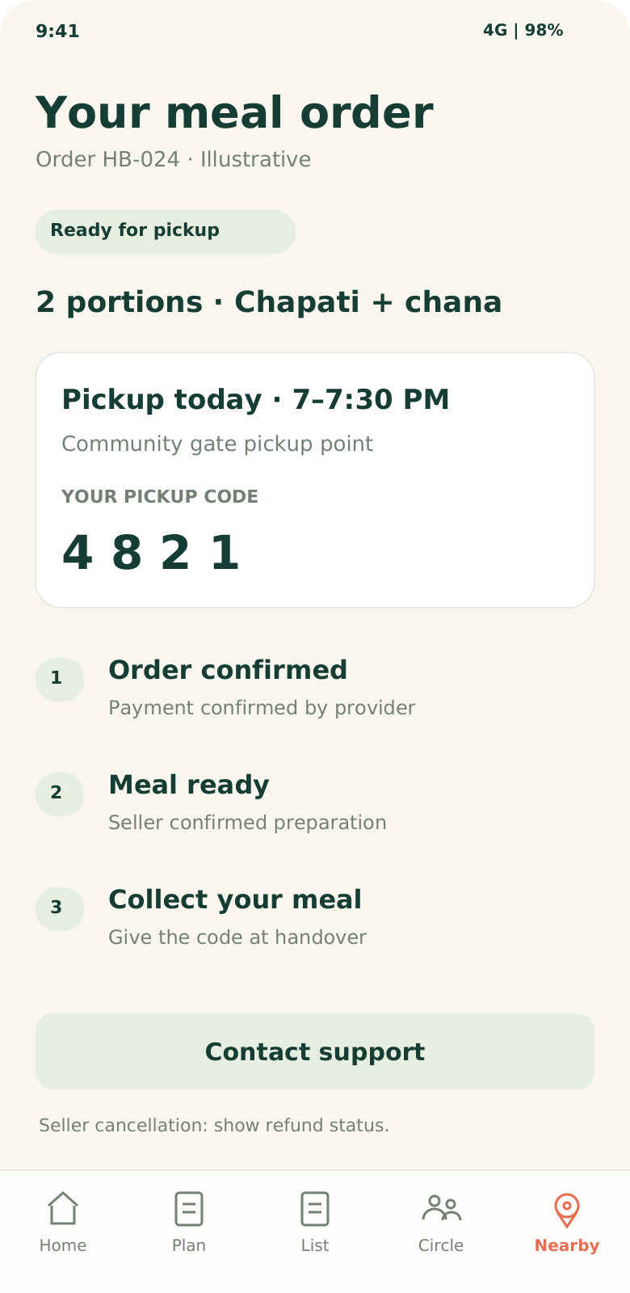

Order workflow
Approved seller → published meal → buyer reserves portions → payment confirmation → order confirmed → ready → pickup code → completed.

Handle failure visibly
Reserve stock atomically. Release expired unpaid reservations. Prevent overselling. Seller cancellation or failed fulfilment triggers the agreed refund process. A late payment needs reconciliation.

Operate the service
Record preparation, handling and use-by information. Hide listings at the safe cutoff. Keep order traceability, a food-complaint route and a named support owner. Show payout status to sellers.

Separate selling from sharing
A public recipe does not become a food listing automatically. Exact pickup details are shared at the appropriate confirmed-order stage.

Required before enabling paid food orders
Obtain the applicable FSSAI registration/licence for each seller. FSSAI’s March 2026 order states that platforms listing food businesses and facilitating orders/transactions require a central FSSAI licence. [4, 5]
The 2019 surplus-food rules cover free distribution and define surplus as safe, unused food not served to customers. They are not permission for commercial leftover sales. Confirm the exact model, local permissions, tax, payment and consumer obligations before launch. [6]

  - BUSINESS MODEL

Who pays and for what
Treat prices and economics as experiments. These figures are not forecasts.
Stage | Proposed revenue | What must first be proved
1 Planner | Free shared list and basic planning. Test ₹149 / household / month for reusable guided weekly plans and advanced household routines. | Families experience enough recurring value to pay and renew; core use stays simple.
2 Social | Basic posting and copying remain free. The household subscription remains the first revenue test. Creator packs may follow. | Shared ideas lead to completed plans and retained users. Media and moderation costs remain affordable.
3 Meals | Test a clearly disclosed seller commission, illustrated at 10% of meal value. | Sellers accept the fee and buyers reorder. Order contribution covers variable payment, support and fulfilment costs.

Illustrative economics with costs visible
Planner example: 100 paying households × ₹149 = ₹14,900 in gross monthly receipts at the illustrated consumer price. Tax treatment, payment fees, hosting, content, support and marketing reduce the amount available to the business.
Meal example: 2 portions × ₹80 = ₹160 meal value. A 10% commission is ₹16; ₹144 remains for the seller before ingredients, fuel, labour, packaging and applicable deductions. Platform contribution is the ₹16 fee less its variable costs. No profit is implied.
Acquisition: recruit through one apartment or workplace community and a small number of local cooks. Measure the cost per household that remains active or paying. National downloads without repeat use are not the target.
Do not rely on future marketplace income to justify an unused MVP.
If the planner attracts users but not payers, revise the offer before expanding paid development.

  - BUILD AND EXPANSION DECISIONS

Criteria for the next release
Suggested pilot gates, not industry benchmarks or proof of a national market.
Stage | Small real world test | Proceed only when
Before build | Interview 10 households. Watch how they plan and shop today; test the screens against one recent real problem. | A repeated problem remains after trying existing alternatives. Participants agree to test the working MVP.
Version 1 | 30 homes for 6 weeks of usage, followed by a two-month paid test. Active week = a meal planned plus a shopping or task action completed. | Illustrative target: 18 active in weeks 5–6; 12 homes with two participating adults; then 8 paid households renewing for a second month.
Version 2 | An opt-in group of existing households with a few contributors. Track post → copied plan → meal used. | Illustrative target: 10 distinct homes use a copied plan on two separate weeks; core retention holds; moderation and media costs fit the budget.
Version 3 | One community, 5 approved sellers and about 30 buyers. Check demand before enabling paid orders. | Compliance and support are ready; repeated paid orders show positive contribution after measured variable costs and support can handle incidents.

Build in reviewable steps
A. Agree scope and screens. B. Build two-account household setup, recipes and shopping states. C. Test sync, privacy, duplicates and undo. D. Run the family pilot. E. Decide whether to add sharing. F. Validate food demand and operations before commerce.

Start in one neighbourhood
Begin with Malayalam and English, familiar local meals, large controls and low data use. Expand to another community, then another language and cuisine only after the same core experience retains users. Food sales require sufficient cooks and buyers in each local area.
Decision rule: if families do not return, improve the core or stop that approach. A social feed should not be used to conceal weak planner use. Facebook- or Google Pay-level adoption is an ambition, not an evidence-backed outcome.

  - MENTOR HANDOFF

What to approve now
Approve the Version 1 scope and the household pilot; review later stages separately.

A short explanation for your mentor
“HomeBop first helps a family decide meals, prepare a shared grocery list and divide the work. Once families use it regularly, we add social posts that others can turn into their own plans. Later, approved home cooks can offer fresh meals to neighbours. Each release solves a separate problem and has a test before we expand.”

Research sources checked 22 October 2026
[1] PlanNEat · official product page
Advertised Indian meal planning, recipe ingredients, grocery lists and current free access.
[2] FamilyWall · official product page
Advertised meal planning, shopping lists, tasks and private family photos/videos.
[3] HomeFoodi · official product page
Home-chef and tiffin discovery with direct supplier contact; advertised capabilities only.
[4] FSSAI · e-commerce compliance order, 18 March 2026
Page 5, opening paragraph: central licence requirement for platforms facilitating orders/transactions.
[5] FSSAI · licensing and registration FAQs, 27 March 2026
2026 changes to licensing/registration. Use current FoSCoS eligibility and confirm the relevant business category.
[6] FSSAI · surplus-food regulations, 2019
Definitions and scope on page 5: safe unused food, free distribution and no profit.

Status and limitations
All screens are proposed UI concepts with fictional data; this deliverable is a product blueprint, not a functioning app. Pricing, pilot targets and positioning are proposals. Public product pages do not verify adoption, revenue or profitability. The name is provisional. National success cannot be guaranteed.

