Extraction of Main Urban Roads from High Resolution Satellite Images by Machine Learning

In this paper author is using AdaBoost machine learning algorithm to extract road from satellite images. To train AdaBoost author is using QuickBird satellite images dataset and then applying various features extraction technique such Canny Edge Detection, Hough Line and LBP to extract features from images and then this extracted features will be input to AdaBoost for learning or training a model. This AdaBoost trained model can be applied on any test satellite image to extract road as AdaBoost trained on straight lines features so it can predict straight line road from any test images.

To implement this project we have apply following techniques

1. Input images: using this module we will input satellite images
2. Canny Edge Detection: using this method we will extract edges from images
3. Hough Transformation: if extracted edges contains straight line then we got road in input images and then extract features
4. LBP: Extracted features will be input to LBP algorithm to extract out road lines from images
5. AdaBoost Learning: extracted LBP features will be input to AdaBoost algorithm to train a model.
6. Road Extraction: AdaBoost trained model will be applied on test image to get road

To implement this project we have designed following Modules

1. Upload Satellite Images Dataset: using this module we will upload satellite images dataset to application
2. Run Canny, Hough & LBP Features Extraction Algorithms: using this module we will read all images and then extract features using Canny, Hough and LBP
3. Train AdaBoost Algorithm: using this module we will input extracted features to AdaBoost algorithm to train a model
4. Road Extraction from Test Images: using this module we will input test image and then AdaBoost will learn and extract road from given satellite images

In below screen we are showing code for above method implementations

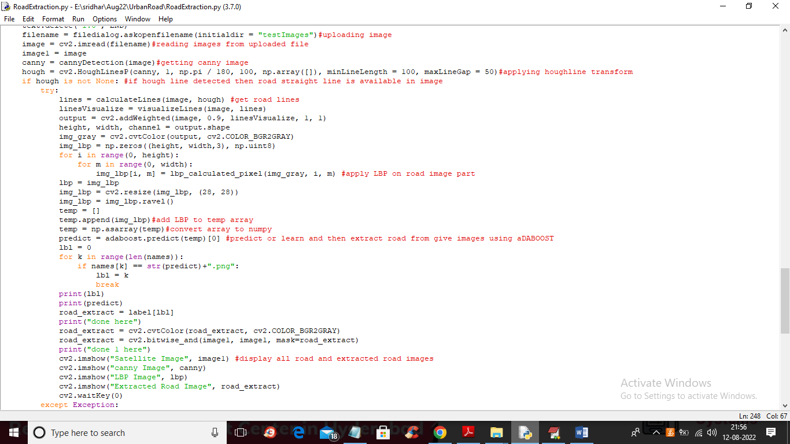

In above screen read red colour comments to know about all algorithms used in the paper.

To implement this project we have used below dataset images available inside ‘Dataset’ folder

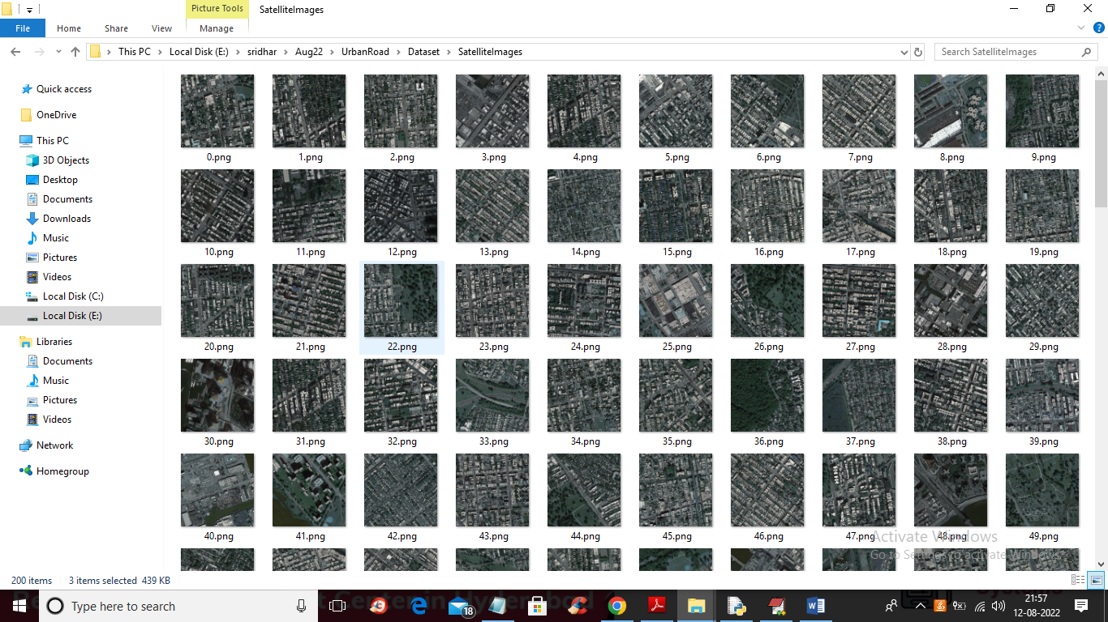

We are using above images to implement this project

SCREEN SHOTS

To run project double click on ‘run.bat’ file to get below screen

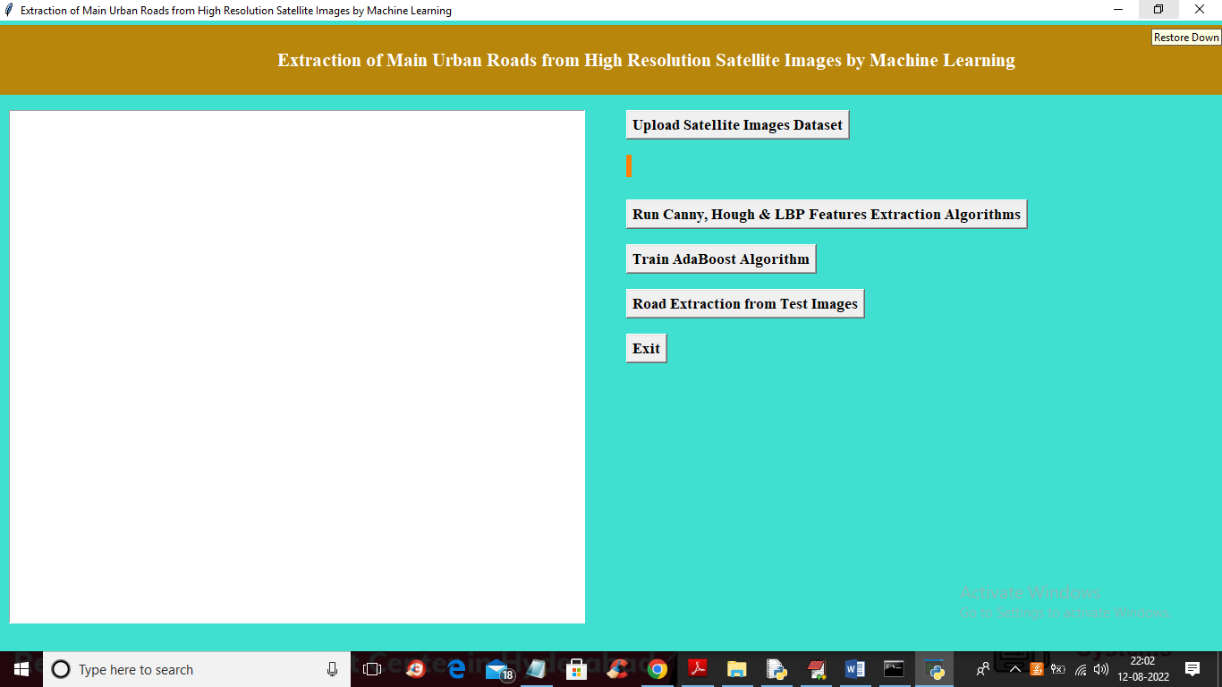

In above screen click on ‘Upload Satellite Images Dataset’ button to upload dataset and get below output

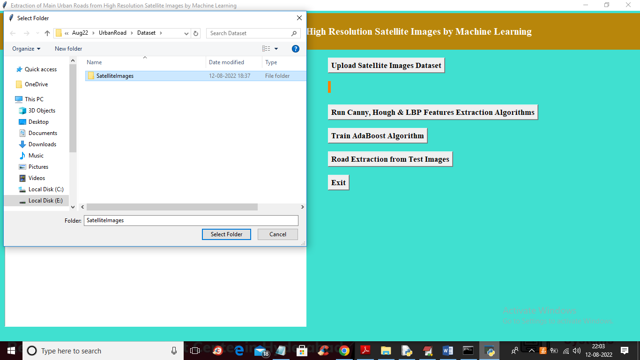

In above screen selecting and uploading ‘Satellite Images’ folder and then click on ‘Select Folder’ button to load dataset and get below output

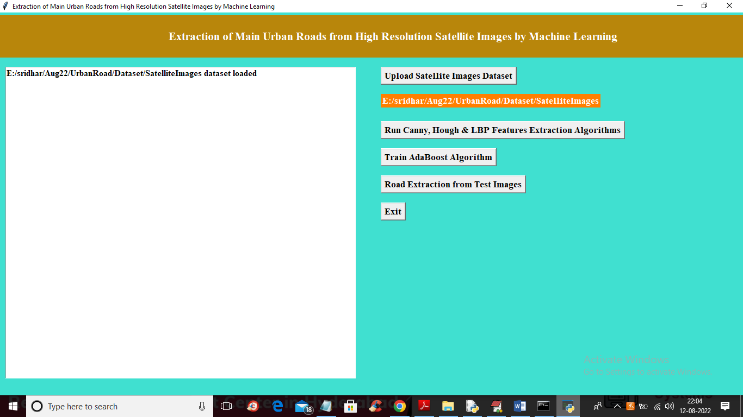

In above screen dataset loaded and now click on ‘Run Canny, Hough & LBP Features Extraction Algorithms’ button to extract features from all dataset images and get below output

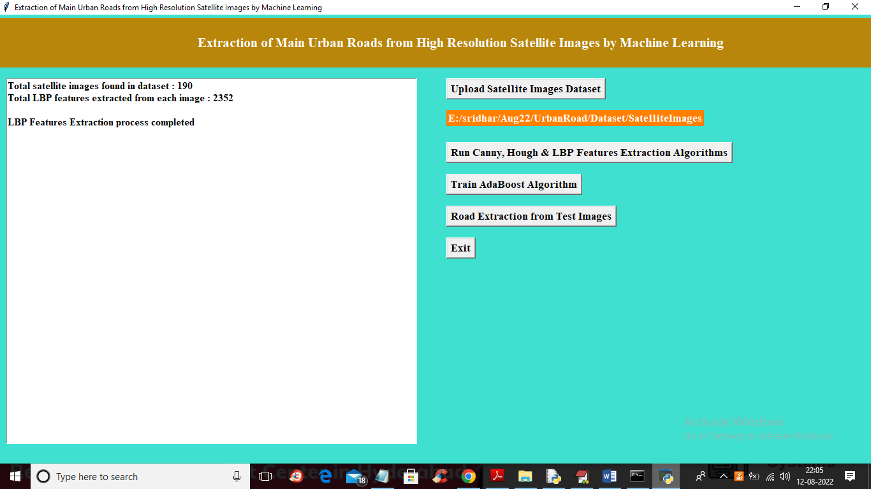

In above screen we can see application found 190 images in dataset and then extract 2352 features from each images and then generate features extracted training array and now click on ‘Train AdaBoost Algorithm’ button to train AdaBoost and get below output

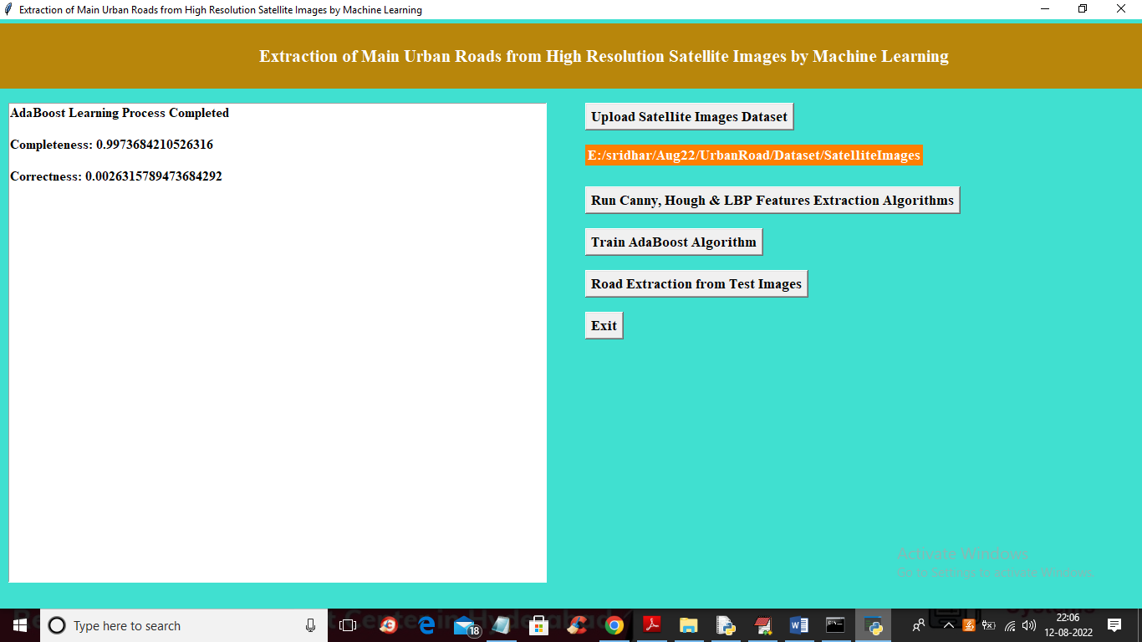

In above screen AdaBoost training completed and we got Completeness (refers to correct prediction %) value as 0.99% and we got Correctness (wrong prediction %) as 0.0026 and now click on ‘Road Extraction from Test Images’ button to upload Satellite image and then AdaBoost will extract road from it

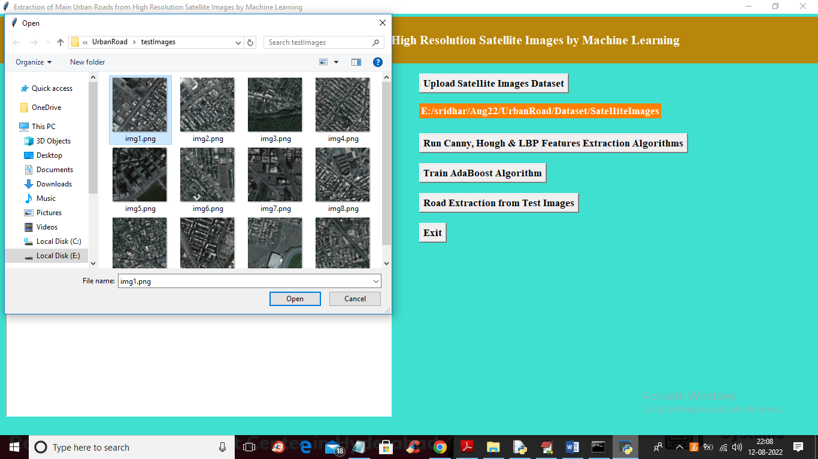

In above screen selecting and uploading ‘img1.png’ file and then click on ‘Open’ button to get below output

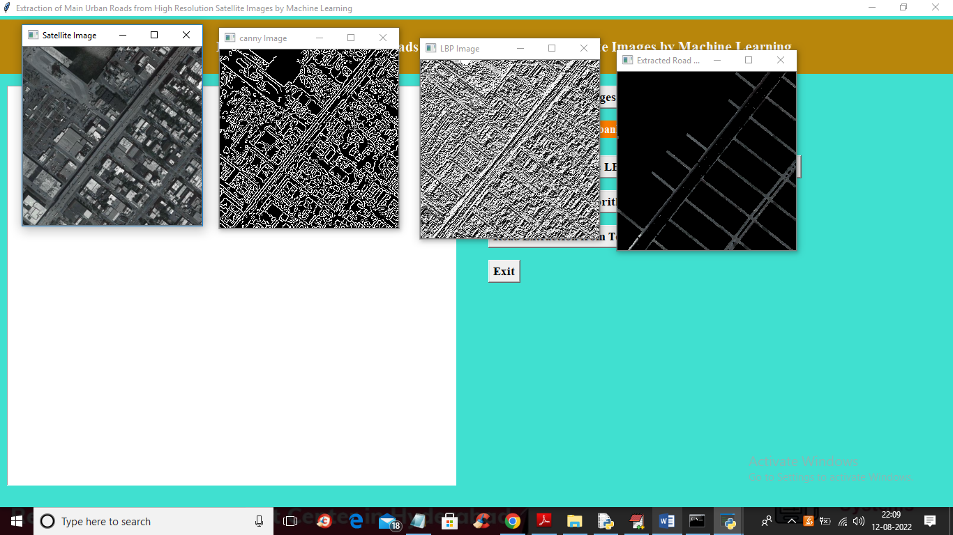

In above screen first image is the uploaded Satellite image and second image is Canny Edge detected image and 3rd image is the LBP image and in LBP image we can see straight ROAD line clearly and this line will extract by AdaBoost and give output as 4th image and in 4th image we can see extracted road clearly and in 4th image we can see small white colour dots as vehicles. Similarly you can upload and test other images

Below is the extracted road from other satellite images

