**44-599: Introduction to Data Visualization**

**Worksheet for drawing Network Analysis Chart using Alteryx Designer**

1. In this worksheet we are going to draw a Network Analysis chart using the transaction data from a grocery store.
2. Download Alteryx software from the link provided. <http://www.alteryx.com/>
3. Select Try Alteryx for free and fill all the required information to sign up for Alteryx.
4. Select the Desktop version and install the software.
5. The data set for the network analysis chart can be found below.



1. Drag and drop the Input Data icon from the tool bar to the workflow window.

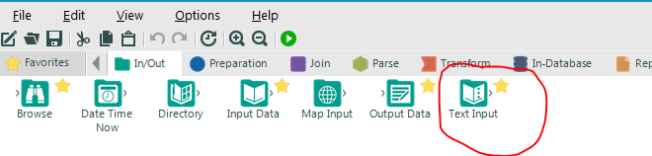

1. Drag and drop MB rule tool that is present in the predictive grouping to the workflow and place it next to the Input Data. It will automatically connects to the input data.

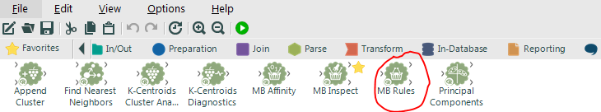

1. In the configuration window, select the transaction key field as Transaction ID and Select the field that contains the item identifier as Item description.
2. In the method to use select apriori algorithm and in the drop down list select association rules.
3. In the configuration window set the allowable minimum number of items in a rule to 1 and the level of support as 0.02 and the level of confidence as 0.05. Here, we can take default configuration values as shown below.

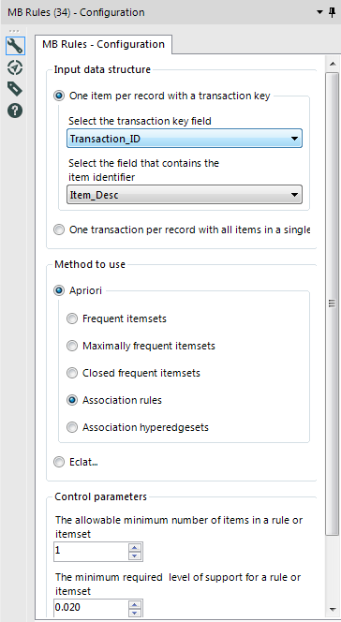

1. Now drag and drop MB inspect tool and place it next to the MB rules tool. Here, we can take default configuration values.

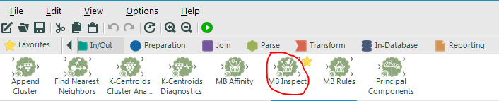

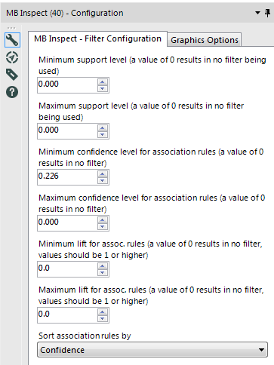

1. Next drag and drop formula tool and connect it to the output of the MB inspect tool.

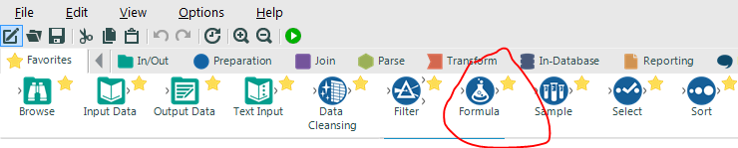

1. Now drag and drop a select tool. In the configuration window select the field LHS and rename it to Nodes.

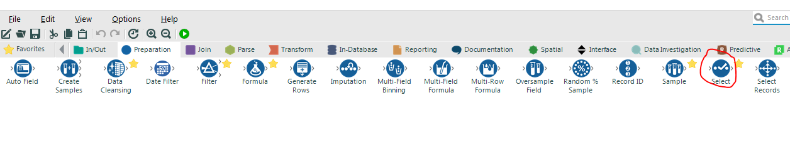

1. Drag and drop another select tool into the workflow and connect it to the output of the formula tool and select the field RHS in the configuration window.
2. Drag and drop a union tool which is under join tools. Now connect the outputs of two select tools to the Union tool. Here, we can take default configuration values.

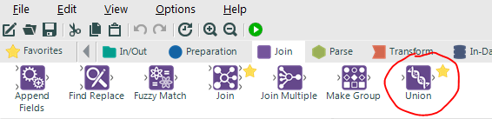

1. Then add the above output to a Filter tool and check the Basic Filter radio button and select the expression “Is Not Empty”.
2. Now drag and drop unique tool and place it next to the filter tool. In the configuration window check the box next to the nodes. This will allow only the unique nodes in a network diagram.
3. Then connect the output of this formula tool to another select tool and rename the LHS and RHS fields to from, to respectively.
4. Now connect the output of this select tool to a new Filter tool and select the Custom filter and type the expression !IsEmpty([from]) and !IsEmpty([to]) in the expression window.
5. Now drag and drop Network Analysis tool from the Predictive toolset and connect the output of unique tool to the Node(N) input of Network Analysis tool. Similarly connect the output of custom filter tool to Edge(E) input of Network analysis tool.
6. Then view the Data output(D) and Interactive output(I) of Network analysis tool by connecting them to two separate Browse tools from the IN/Out tool set.
7. The workflow looks as shown below.

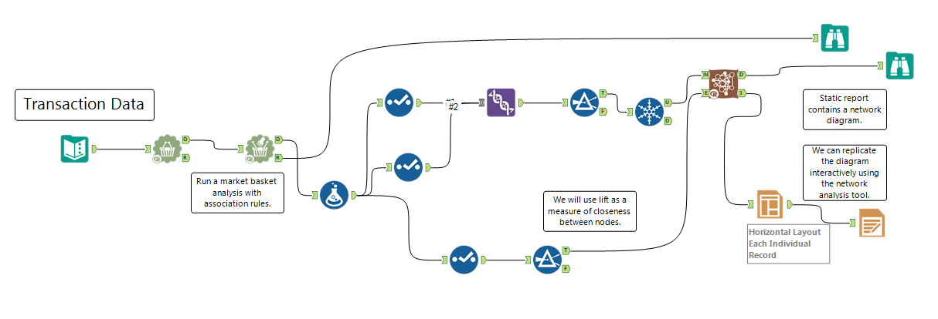

1. Similarly the data at various points of the workflow can be viewed by connecting browse tools at their respective points in the workflow.
2. The output chart would be as shown in below figure.

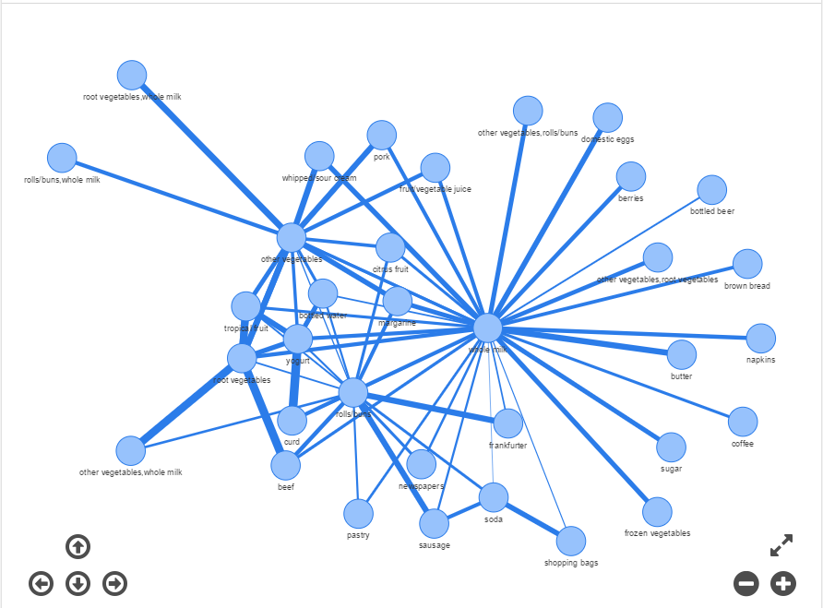

1. In the Network analysis diagram click on various Nodes to highlight it along with its respective edges.
2. Similarly select various categories of distribution of centrality measures to view them in the form of bar charts.