AIC-2101 · SPEC-DRIVEN DEVELOPMENT WITH OPENSPEC · PARTICIPANT EDITION
BeanBotics Receipts, Spec First
All six AIC-2101 labs in one 45-minute run in VS Code with Claude Code and OpenSpec: initialise, explore, write a spec by hand, let the AI review it, build with review gates, verify, archive, fix without SDD, and record the decision

Ticket | BEAN-204 · Receipt for completed orders, with tax
Who it is for | Software engineers, data engineers, tech leads, architects and project managers. No OpenSpec experience needed.
Time | 45 minutes in ten timed parts
You need | VS Code with the Claude Code extension, Node.js 20.19 or later, uv (Python 3.10 or later), Git, and beanbotics-lab.zip
Tools | OpenSpec 1.17.0 · Claude Code with Opus 5.5, effort Medium
Screenshots | All screenshots come from a real run of this exact lab on a freshly unzipped project on 11 November 2026. Personal details are blurred.
Version | 1.0 · November 2026

INFO
How to read this guide. Every step says exactly what to click or type. Prompts are in black boxes: paste them word for word as one message.
MUST MATCH boxes list what you will see on any fresh run: files, commands, counts, money values and verdicts.
MAY DIFFER boxes list what can change between runs: Claude’s wording and layout, the order of its steps, the dates in archive folder names, and commit hashes after the first two.

Contents
If page numbers are missing, right-click the table and choose Update Field.

1. Jira Ticket
Key | BEAN-204
Summary | Itemised receipt for completed orders, with 8.5% tax
Type · Priority | Story · High
Component | beanbotics · orders API and order queue
Labels | openspec, spec-driven, ai-assisted
Story points | 3
Assignee | You (lab participant)
Description | Context. BeanBotics customers can choose a drink size and follow an order from pending to completed, but nobody gets a receipt. There is no tax anywhere in the system. Finance cannot reconcile what a completed order cost.  Ask. Use OpenSpec with Claude Code to specify the receipt before coding, have the spec reviewed, build it with review gates between artifacts, verify it, and archive it into the main specs. Record the money-handling decision as an ADR.  Acceptance tests. tests/test_receipt_acceptance.py holds the product owner’s acceptance criteria. Do not edit it.  Out of scope. Printing or emailing receipts, receipt history, customizations, discounts, dynamic pricing and tax configuration.
Definition of Done | • All acceptance criteria in Section 4 are met and recorded in the Results Sheet (Section 10).  • uv run pytest: 7 passed. openspec validate --all --strict: 4 passed.  • Every task in tasks.md is ticked and /opsx:verify reports no critical issues.  • The change is archived, and the ADR is committed.

2. User Story
WHY THIS MATTERS
As a BeanBotics customer whose order is complete,
I want an itemised receipt showing the drink, the subtotal, the 8.5% tax and the total,
so that I know exactly what I paid, and the finance team can reconcile every order to the cent.

2.1 The same lab by role
Role | What you practise
Software engineer | Write a delta spec by hand, let the AI find its gaps, then implement against acceptance tests that start red and finish green.
Data engineer | See why money needs exact decimal arithmetic and a stated rounding rule: $5.00 × 8.5% is exactly half a cent.
Tech lead | Run the full OpenSpec loop, switch from the core to the expanded workflow, and use review gates and verify before archiving.
Architect | Keep behaviour in the spec and decisions in design.md, then record the money decision as an ADR.
Project manager | See where a vague phrase (“total includes tax”) would have stalled the work, and read the git history as an audit trail.

3. Problem Statement
BeanBotics is a small coffee-ordering web app: a FastAPI backend with a service layer, and a vanilla HTML and JavaScript front end. Orders are kept in memory. Two features are already built and specified in OpenSpec: drink size selection, and the order status lifecycle (pending → preparing → ready → completed).
BEAN-204 asks for a receipt. The first draft of the spec says only that “the total includes tax”. That sentence hides three decisions: the tax rate, whether tax is applied per line or once to the subtotal, and how to round. An AI agent will happily guess all three, and a guess that is right once is luck, not engineering.
In this lab you write the spec yourself, let Claude review it, fix the gap before any code exists, and then build against acceptance tests that pin the exact values.

3.1 What makes this hard
- Half cents. $5.00 × 8.5% = $0.425. Half-up rounding gives $0.43; other methods give $0.42.
- Floats. Binary floating point cannot hold 0.425 exactly, so the same sum can round differently on different code paths.
- Dependencies. The receipt depends on two existing specs: the price of the chosen size, and the completed status.

3.2 Rules for this lab
- Spec before code. No application code changes until the spec is reviewed and validates.
- Do not edit tests/. The acceptance tests are the product owner’s criteria.
- Approve only what you expect. Approve file edits, openspec, uv run and read-only commands such as cat, grep and git diff. Decline anything that starts a server or a browser.

4. Acceptance Criteria
ID | Criterion | Proven in
AC1 | Tooling. openspec --version prints 1.17.0. | Step 1.2
AC2 | Red baseline. uv run pytest: 3 failed, 4 passed. The three receipt acceptance tests fail; the four others pass. | Step 1.3
AC3 | OpenSpec initialised (core). 6 skills and 6 commands in .claude/. openspec list --specs: drink-size-selection, order-status-lifecycle and order-status-ui, 4 requirements each. | Step 2.1
AC4 | Explore. Claude reports no tax, subtotal or receipt anywhere in backend/, frontend/ or the config. No files change. | Step 3.1
AC5 | Expanded workflow. .claude/commands/opsx/ lists continue, ff, new and verify alongside the core commands. | Step 4.1
AC6 | Hand-written spec. Change add-order-receipt has your proposal and spec. openspec status: 2/4 artifacts (proposal, specs). | Steps 4.2–4.3
AC7 | Spec gap caught before code. The AI review lists the missing tax rule first. You add the Tax calculation requirement (8.5%, half-up, $5.00 → $0.43) by hand. validate --strict: valid. | Steps 5.1–5.2
AC8 | Review gates. /opsx:continue writes design.md and stops; a second /opsx:continue writes tasks.md (backend before frontend, pytest last) and stops. | Steps 6.1–6.2
AC9 | Implemented. All tasks ticked. uv run pytest: 7 passed. The receipt for a Large Neural Network Latte shows $6.50, Tax (8.5%) $0.55, Total $7.05. | Steps 7.1–7.3
AC10 | Verified and archived. /opsx:verify: no critical issues. After archive, openspec list --specs shows 4 specs including order-receipt, and validate --all --strict: 4 passed. | Steps 8.1–8.3
AC11 | Fix without SDD. The header typo “Coffe” is fixed by a plain prompt, with no OpenSpec change. | Step 9.1
AC12 | ADR committed. docs/decisions/0001-decimal-money-half-up-tax.md is committed. git log --oneline -3 ends with ef0ec7d and 754d3ec. | Step 10.1

5. Before You Start

5.1 Check your machine
Check | How | Expected
VS Code and Claude Code | Open VS Code. The Claude Code icon (orange spark) is in the activity bar. | Signed in. Opus 5.5 is in the model menu.
Node.js | node --version | v20.19 or later
uv | uv --version | Any recent version. Install from docs.astral.sh/uv if missing.
Git identity | git config --global user.name | Prints your name. If empty, set user.name and user.email: you commit once.
Lab project | beanbotics-lab.zip from your instructor | One zip, about 135 KB
Port 8000 | Nothing else running on it | Stop any earlier BeanBotics server

5.2 Rules that make your run match this guide
- Fresh copy. Delete any older beanbotics folder and unzip again.
- Personal add-ons off. Turn off personal plugins, hooks and automatic memory. They change answers and add cards you will not see here.
- Model. Opus 5.5 with effort Medium, as in the screenshots.
- Paste prompts exactly, as one message. They name files and forbid side commands, which keeps every run on the same path.
- Run terminal commands one at a time. OpenSpec’s progress spinner can overwrite output when several commands are pasted together.
- Keep VS Code in a normal window. Not full screen.

6. OpenSpec in One Page
OpenSpec keeps two kinds of specification in the repository. Claude Code reads and writes them through /opsx commands that openspec init installs.
Folder | What it is | Who changes it
openspec/specs/ | Current system specifications. What the system does today, as requirements with scenarios. | Only archive, when a change ships
openspec/changes/<name>/ | A proposed change. proposal.md (why and what), specs/ (deltas: ADDED, MODIFIED or REMOVED requirements), design.md (how and why), tasks.md (checklist). | You and Claude
openspec/changes/archive/ | Finished changes, dated, kept for history | archive

Command | Profile | Use it to
/opsx:explore | core | Think and investigate. Never writes code.
/opsx:propose <name> | core | Create a change and all four artifacts in one go.
/opsx:apply <name> | core | Implement tasks and tick them off.
/opsx:archive <name> | core | Merge the deltas into openspec/specs and move the change to the archive.
/opsx:new <name> | expanded | Create an empty change folder.
/opsx:continue <name> | expanded | Write the next artifact only, then stop for review.
/opsx:ff <name> | expanded | Write all remaining artifacts at once.
/opsx:verify <name> | expanded | Check the code against the specs: completeness, correctness, coherence.

WHY THIS MATTERS
Specs say what the system does. design.md says how and why. An ADR records a decision that outlives the change. In this lab you write one of each.

7. Lab Overview
Part | What you do | Course lab | Min | Criteria
1 | Install OpenSpec, set up the project, red baseline | Lab 1 | 6 | AC1–AC2
2 | Initialise OpenSpec (core), reload, run the app | Lab 1 | 5 | AC3
3 | Explore before changing anything, then clear context | Lab 2 | 4 | AC4
4 | Switch to the expanded workflow, scaffold, write the spec by hand | Labs 4, 5 | 6 | AC5–AC6
5 | AI reviews your spec; fix the tax gap by hand | Labs 3, 5 | 5 | AC7
6 | Design and tasks, one artifact at a time | Lab 4 | 5 | AC8
7 | Apply, run the tests, check the receipt | Labs 1–3 | 7 | AC9
8 | Verify and archive | Labs 4, 5 | 4 | AC10
9 | Fix a cosmetic bug without SDD | Lab 5 | 1 | AC11
10 | Write and commit an ADR | Lab 6 | 2 | AC12
 | Total |  | 45

8. Lab Steps

Part 1 · Install and baseline (6 minutes)
STEP 1.1 Open the project · 1 min
- Unzip beanbotics-lab.zip into a working folder, for example Documents/projects. You get a folder called beanbotics.
- File › Open Folder, choose beanbotics, click Open. If VS Code asks whether you trust the authors, click Yes. Close the Welcome tab.
- Terminal › New Terminal. It opens in the beanbotics folder.
STEP 1.2 Install the pinned OpenSpec version · 2 min
TYPE IN THE VS CODE TERMINAL, ONE LINE AT A TIME
npm install -g @fission-ai/openspec@1.17.0
openspec --version
MUST MATCH YOUR SCREEN
openspec --version prints exactly 1.17.0.
STEP 1.3 Install dependencies and run the acceptance tests · 3 min
TYPE IN THE VS CODE TERMINAL, ONE LINE AT A TIME
uv venv && uv pip install -r requirements.txt
uv run pytest
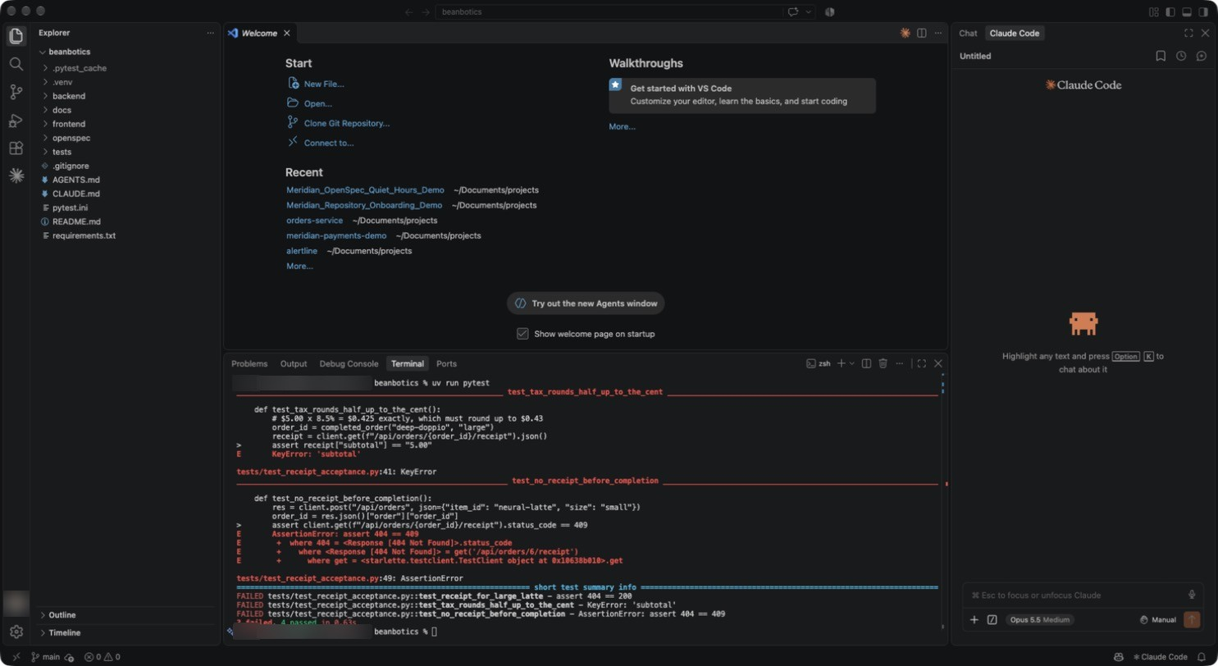
Figure 1: Red baseline: the receipt does not exist yet
1 test_tax_rounds_half_up_to_the_cent fails: the receipt endpoint returns 404, so there is no subtotal.
2 Summary: three receipt tests FAILED.
3 3 failed, 4 passed. The four passing tests cover existing behaviour, plus the 404 for an unknown order.
MUST MATCH YOUR SCREEN
3 failed, 4 passed, with the same three FAILED test names.
WHY THIS MATTERS
Starting red proves the tests can fail. When they turn green in Part 7, you know it was the change that fixed them.

Part 2 · Initialise OpenSpec and run the app (5 minutes)
STEP 2.1 Initialise OpenSpec with the core profile · 2 min
Type clear, then run each line on its own:
TYPE IN THE VS CODE TERMINAL, ONE LINE AT A TIME
openspec init --tools claude --profile core --no-animation
openspec list --specs
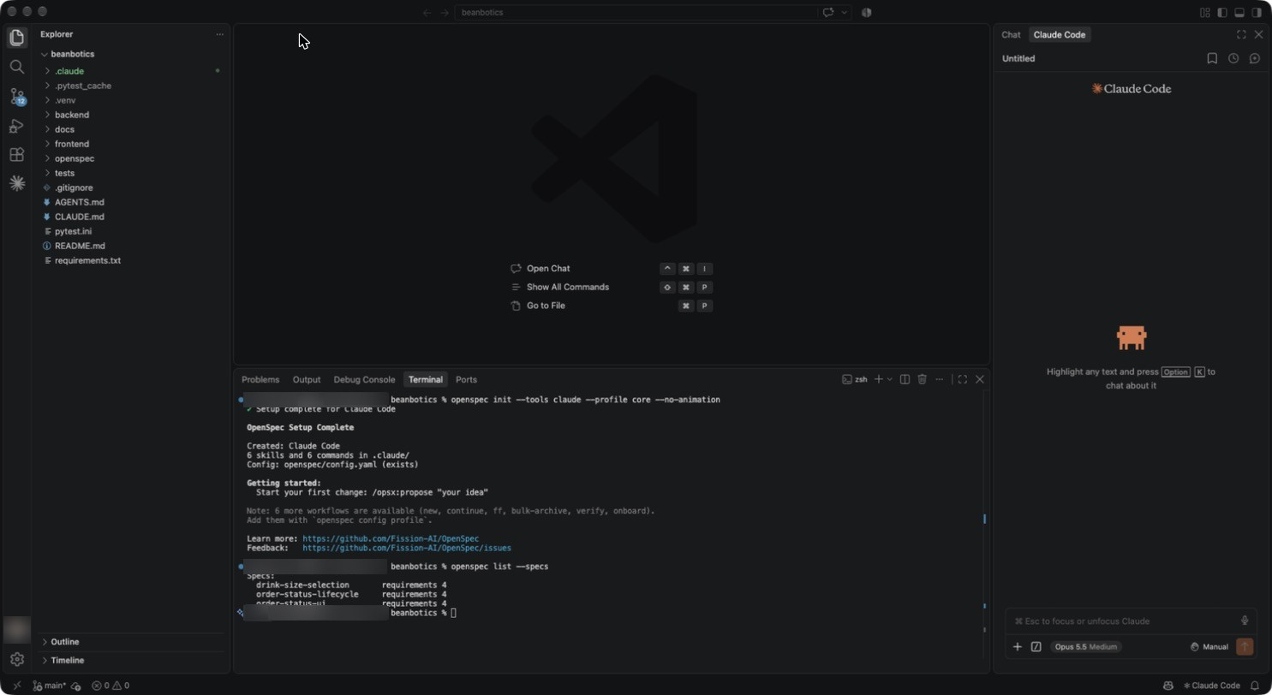
Figure 2: OpenSpec initialised for Claude Code
1 Setup complete for Claude Code: 6 skills and 6 commands in .claude/. Config: openspec/config.yaml (exists), because the project context was already written.
2 Note: 6 more workflows are available. You add some of them in Part 4.
3 Three existing specs with 4 requirements each: what the system already does.
MUST MATCH YOUR SCREEN
6 skills and 6 commands in .claude/. Specs drink-size-selection, order-status-lifecycle, order-status-ui, requirements 4 each.
STEP 2.2 Reload VS Code and start the app · 3 min
- Cmd+Shift+P (Ctrl+Shift+P on Windows), type Developer: Reload Window, press Enter. Claude Code now sees the new /opsx commands.
- Open the terminal again (Ctrl+` ) and start the app. Leave it running for the rest of the lab:
TYPE IN THE VS CODE TERMINAL, ONE LINE AT A TIME
uv run uvicorn backend.app:app --reload --port 8000
Open http://localhost:8000 in your browser.
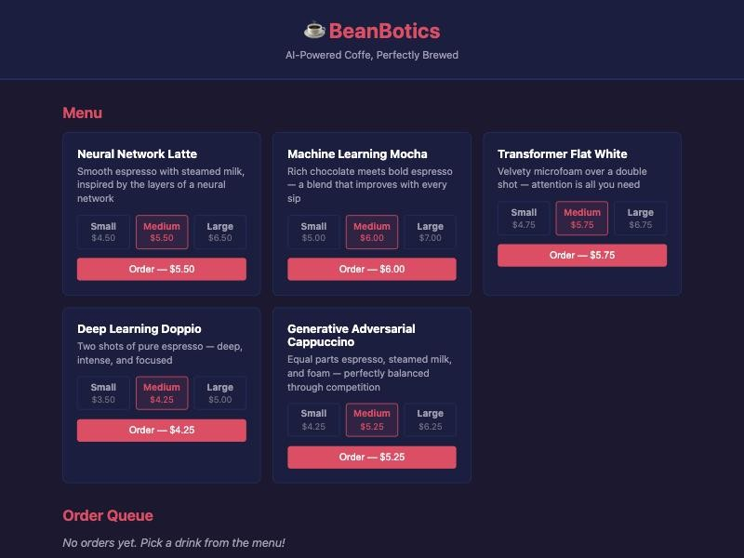
Figure 3: BeanBotics before the change
1 The tagline says “Coffe”. Leave it: you fix it in Part 9.
2 Each card has size options and an Order button with the price of the selected size.
3 The order queue is empty.
Open the Claude Code panel. Under the prompt box, click the model chip and check the model and effort.
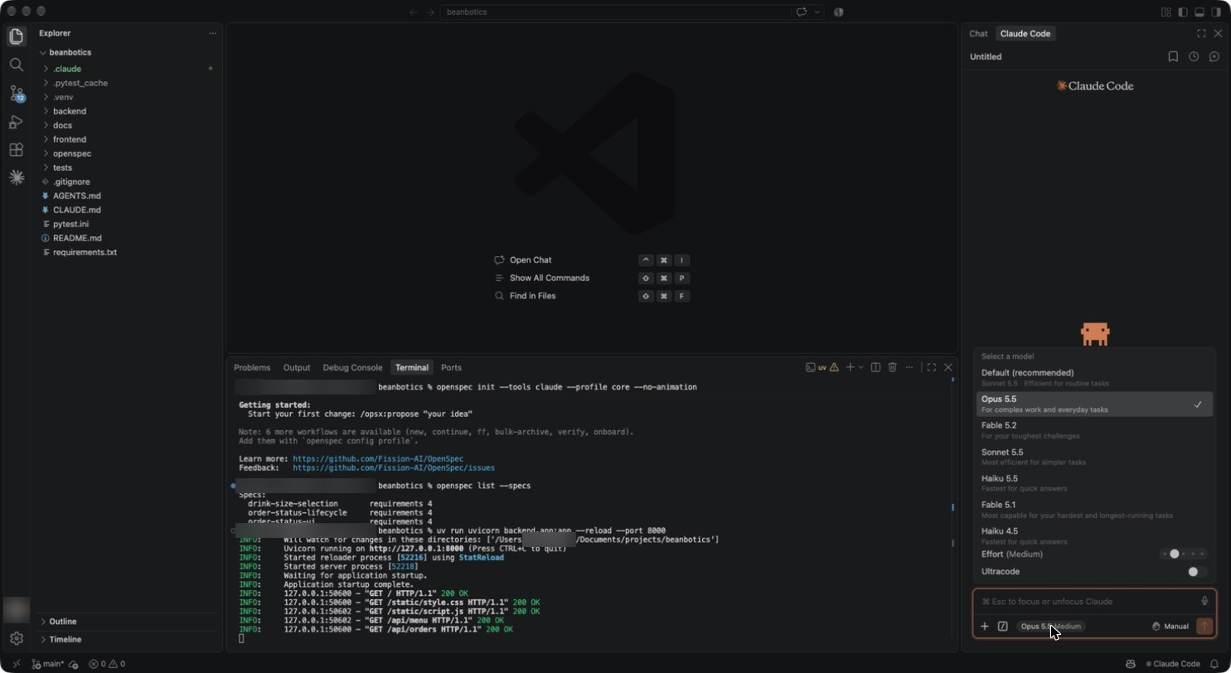
Figure 4: Model menu
1 Opus 5.5 is ticked. The screenshots in this guide use Opus 5.5.
2 Effort is set to Medium.

Part 3 · Explore before changing anything (4 minutes)
STEP 3.1 Investigate how prices work today · 3 min
Paste as one message:
TYPE IN THE CLAUDE CODE PROMPT BOX
/opsx:explore How are order prices calculated today, from backend/data/menu.json through to the order queue? Is there any tax, subtotal or receipt anywhere in backend/, frontend/ or openspec/specs/? Do not create or change any files and do not run any commands.
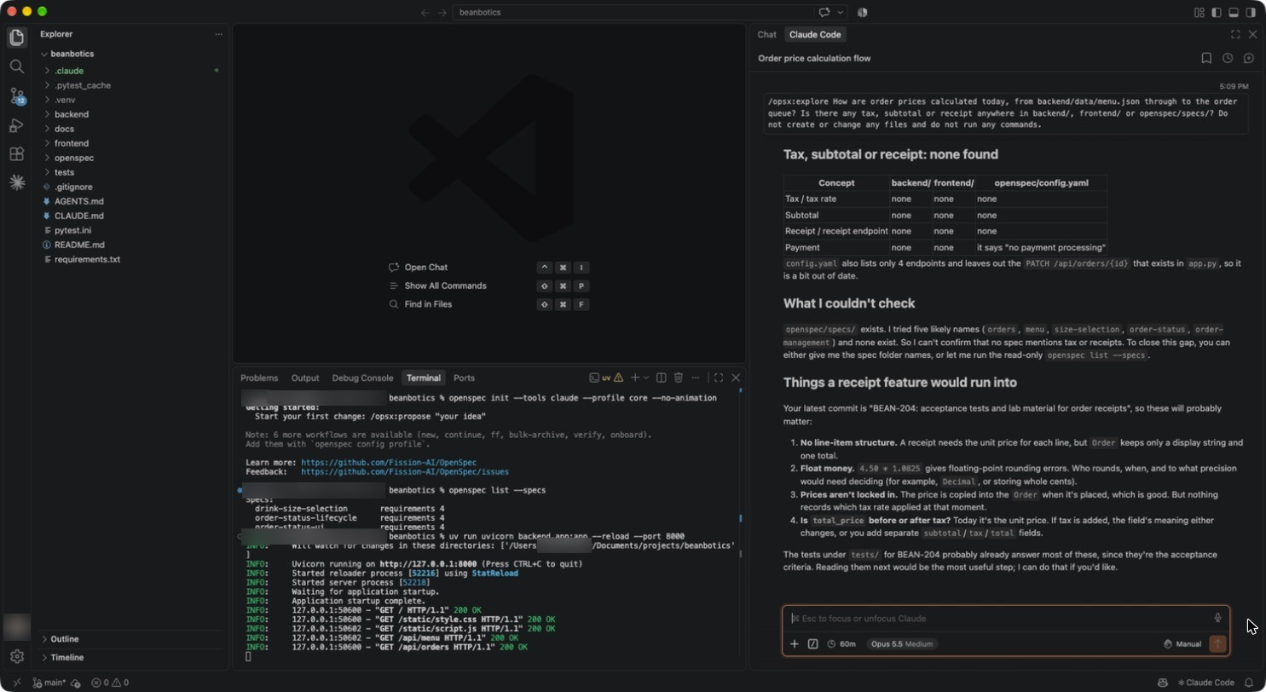
Figure 5: Explore result: nothing about tax or receipts exists
1 A table: tax, subtotal, receipt and payment are “none” in backend/, frontend/ and config.yaml.
2 Claude also notes that config.yaml leaves out the PATCH endpoint: a small drift between the context and the code.
3 It names the risks a receipt will run into: floats, rounding, and whether total_price is before or after tax. These are the questions your spec must answer.
MUST MATCH YOUR SCREEN
No files change. The answer says there is no tax, subtotal or receipt anywhere.
MAY DIFFER (THIS IS NORMAL)
Claude may not open openspec/specs/ because it was told not to run commands. Wording and layout vary.
STEP 3.2 Clear the context · 1 min
In the Claude prompt box, type /clear and press Enter. Your understanding stays in your head and in the files; the exploration noise leaves the context window.

Part 4 · Expanded workflow and a hand-written spec (6 minutes)
STEP 4.1 Switch to the expanded workflow · 2 min
Click + in the terminal panel to open a second terminal, so the app keeps running in the first. Run each line on its own:
TYPE IN THE VS CODE TERMINAL, ONE LINE AT A TIME
openspec config set profile custom
openspec config set workflows '["propose","explore","new","continue","ff","apply","verify","update","sync","archive"]'
openspec update
ls .claude/commands/opsx/
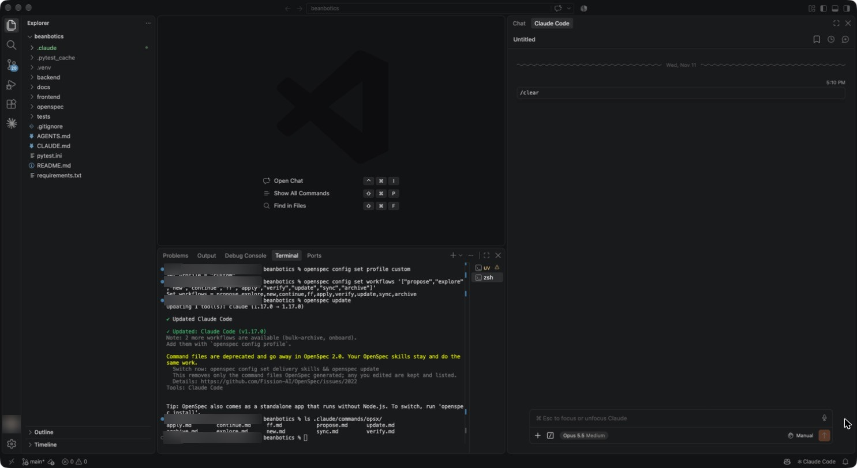
Figure 6: Expanded workflow commands installed
1 The profile is custom and the workflows list includes new, continue, ff and verify.
2 openspec update: Updated Claude Code (v1.17.0). The yellow note about command files is information only.
3 The command folder now has 10 files, including continue.md, ff.md, new.md and verify.md.
MUST MATCH YOUR SCREEN
ls lists apply, archive, continue, explore, ff, new, propose, sync, update and verify.
WATCH OUT
These two config commands change OpenSpec’s settings for your user account, not just this project. Section 8, Step 10.2 shows how to switch back.
STEP 4.2 Scaffold the change · 1 min
TYPE IN THE CLAUDE CODE PROMPT BOX
/opsx:new add-order-receipt Only create the change folder. Do not write any artifacts; I will write the proposal and specs by hand.
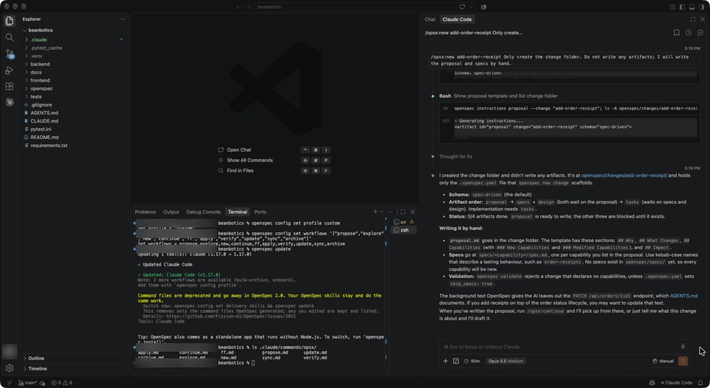
Figure 7: An empty change folder
1 Claude runs openspec new change and stops. The folder holds only .openspec.yaml.
2 It explains the artifact order: proposal, then specs and design, then tasks.
MAY DIFFER (THIS IS NORMAL)
Claude may approve its own openspec commands without a card, or show a card. If a card asks to run openspec, click 1 Yes.
STEP 4.3 Put your hand-written proposal and spec in place · 3 min
The proposal and first spec draft are in docs/lab/. Open both and read them: they are what you would have typed. In the second terminal, type clear, then run each line on its own:
TYPE IN THE VS CODE TERMINAL, ONE LINE AT A TIME
cp docs/lab/proposal.md openspec/changes/add-order-receipt/proposal.md
mkdir -p openspec/changes/add-order-receipt/specs/order-receipt
cp docs/lab/order-receipt-spec.md openspec/changes/add-order-receipt/specs/order-receipt/spec.md
openspec status --change add-order-receipt
Open openspec/changes/add-order-receipt/specs/order-receipt/spec.md in the editor.
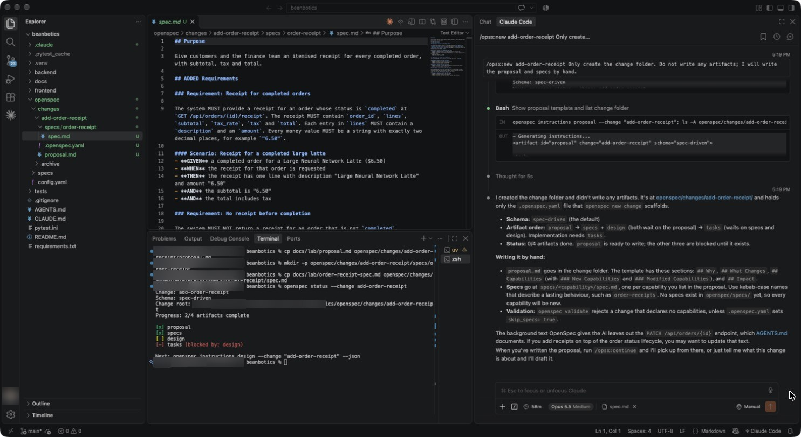
Figure 8: Your spec, and the change status
1 ## Purpose is written by you, so the archived spec has a real purpose, not a placeholder.
2 Requirement “Receipt for completed orders” fixes the endpoint, the fields and two-decimal money strings.
3 The scenario only says “the total includes tax”. Notice what it does not say.
4 Progress: 2/4 artifacts complete. Proposal and specs are ticked; design is next.
MUST MATCH YOUR SCREEN
2/4 artifacts complete: [x] proposal, [x] specs, [ ] design, [-] tasks (blocked by: design).

Part 5 · Let the AI review your spec, then fix it (5 minutes)
STEP 5.1 Ask for a review · 2 min
TYPE IN THE CLAUDE CODE PROMPT BOX
Review the proposal and delta spec I wrote in openspec/changes/add-order-receipt/ against openspec/specs/ and the acceptance tests in tests/test_receipt_acceptance.py. List the gaps, ambiguities and conflicts, most important first, in under 200 words. Do not change any files and do not run any commands.
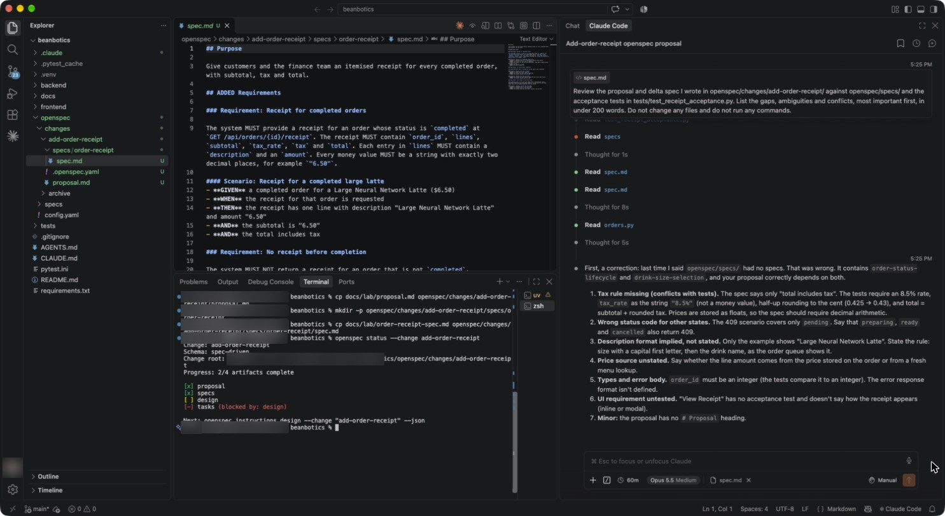
Figure 9: The review: the tax rule is missing
1 #1 Tax rule missing (conflicts with tests): the tests require 8.5%, the string "8.5%", half-up rounding (0.425 → 0.43), and total = subtotal + rounded tax. Prices are floats, so the spec should require decimal arithmetic.
2 Other findings: the 409 scenario covers only pending; the description format is implied; the UI requirement has no test.
MUST MATCH YOUR SCREEN
The first finding is the missing tax rule: rate, rounding and decimal arithmetic.
MAY DIFFER (THIS IS NORMAL)
The number and order of the minor findings. You only need to act on #1 for this lab.
WHY THIS MATTERS
This is the AIC-2101 Lab 3 debugging lesson, moved earlier. The bug would have been in the spec, not the code. Catching it at review costs one paragraph; catching it after apply costs a re-apply.
STEP 5.2 Add the tax requirement by hand · 3 min
- Open docs/lab/tax-requirement.md, click inside the text, press Cmd+A, then Cmd+C.
- Switch to the spec.md tab. Click at the very start of the line “### Requirement: No receipt before completion”, press Cmd+V, then Cmd+S.
- Check the file now has about 54 lines and a “### Requirement: Tax calculation” block.
- In the second terminal, run:
TYPE IN THE VS CODE TERMINAL, ONE LINE AT A TIME
openspec validate add-order-receipt --strict
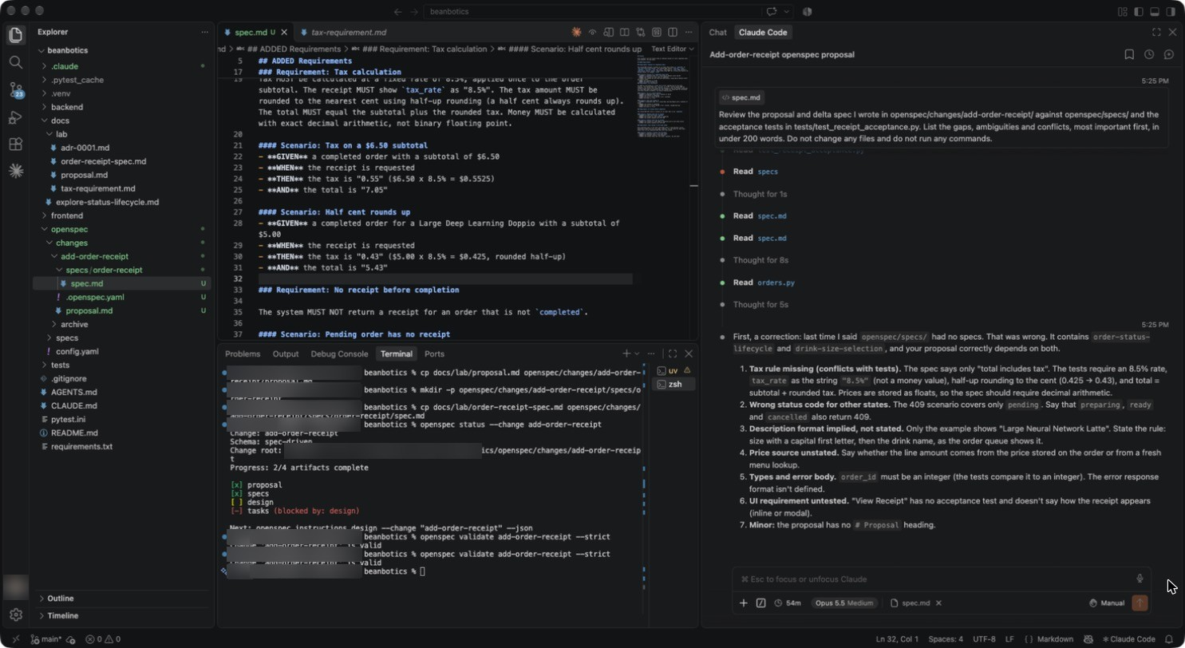
Figure 10: The tax rule is now part of the contract
1 Scenario “Tax on a $6.50 subtotal”: tax "0.55", total "7.05".
2 Scenario “Half cent rounds up”: Large Deep Learning Doppio $5.00 → tax "0.43", total "5.43".
3 Change 'add-order-receipt' is valid.
WATCH OUT
If the file still has 39 lines, the paste did not land. Copy again from tax-requirement.md and repeat.

Part 6 · Design and tasks with review gates (5 minutes)
STEP 6.1 Generate the design only · 3 min
Type /clear in the Claude prompt box, then paste:
TYPE IN THE CLAUDE CODE PROMPT BOX
/opsx:continue add-order-receipt Generate design.md only, then stop so I can review it. Keep it at decision level (why, not code): no variable names or function signatures.
When the Allow write to design.md card appears, read the diff on the left and click 1 Yes.
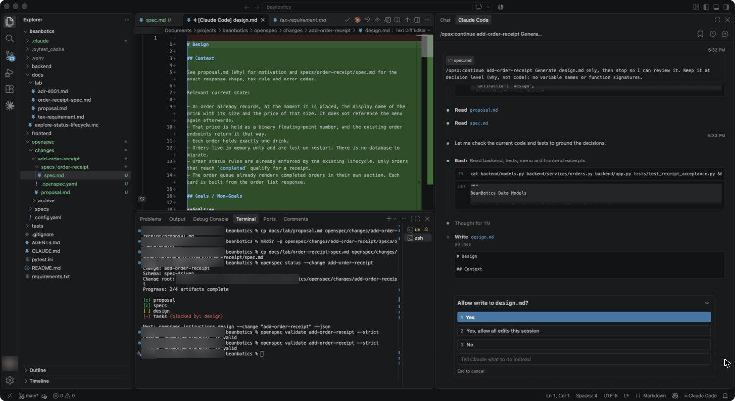
Figure 11: Approving the design
1 design.md opens as a diff. Context describes today’s system in plain words.
2 Click 1 Yes. You can choose 2 to allow all edits for this session, but in this part one card is enough.
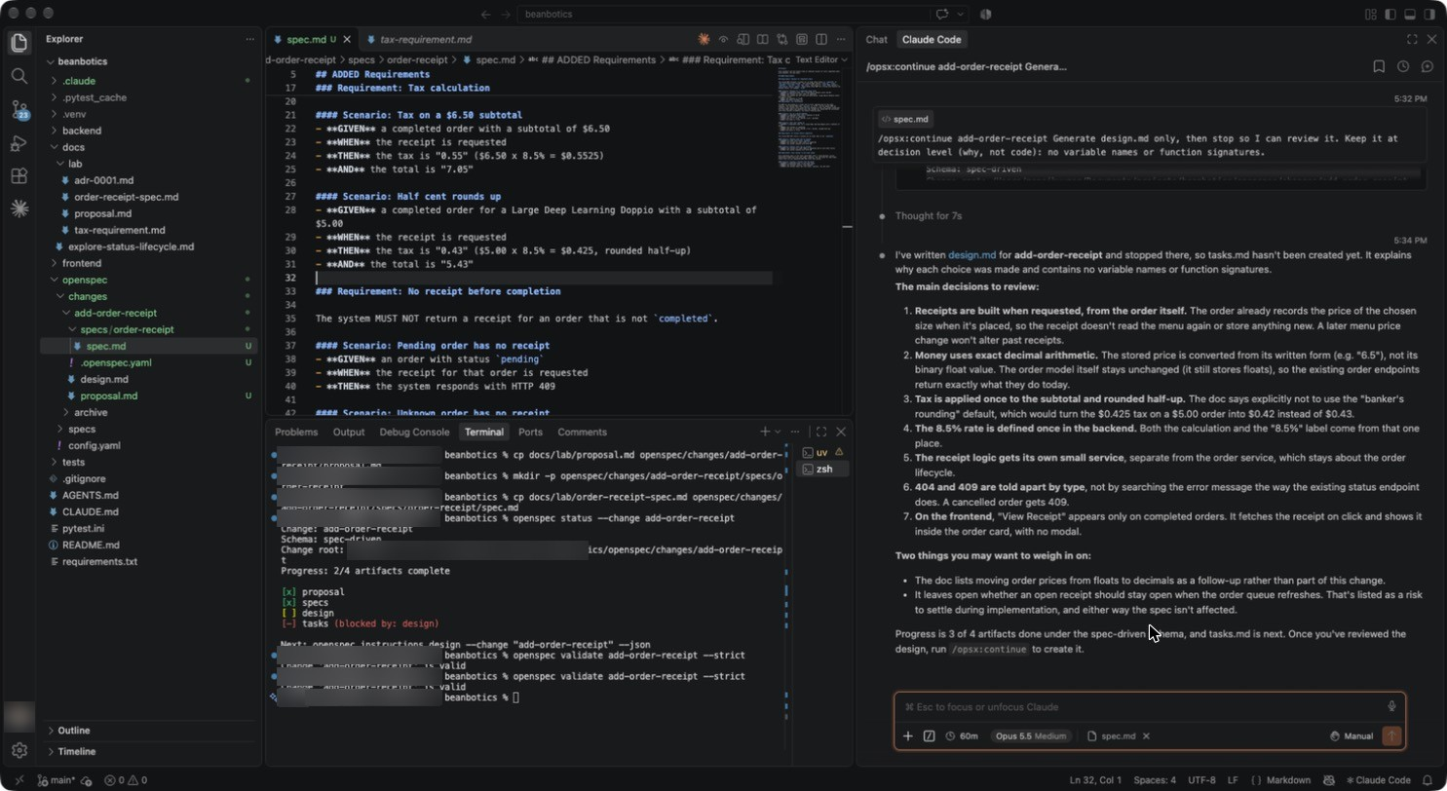
Figure 12: Design decisions to review
1 Receipts are built from the order itself, so a later menu price change does not alter past receipts.
2 Money uses exact decimal arithmetic; tax is applied once to the subtotal and rounded half-up; 8.5% is defined once.
3 404 and 409 are told apart by error type. “View Receipt” appears only on completed orders.
4 Progress: 3 of 4 artifacts. Claude stopped before tasks.md, as asked.
MUST MATCH YOUR SCREEN
design.md only; no tasks.md yet. Decimal arithmetic, half-up, tax once on the subtotal.
STEP 6.2 Generate the tasks only · 2 min
TYPE IN THE CLAUDE CODE PROMPT BOX
/opsx:continue add-order-receipt Generate tasks.md only, then stop. Put backend tasks before frontend tasks and finish with a task to run uv run pytest.
Read the diff and click 1 Yes on the Allow write to tasks.md card.
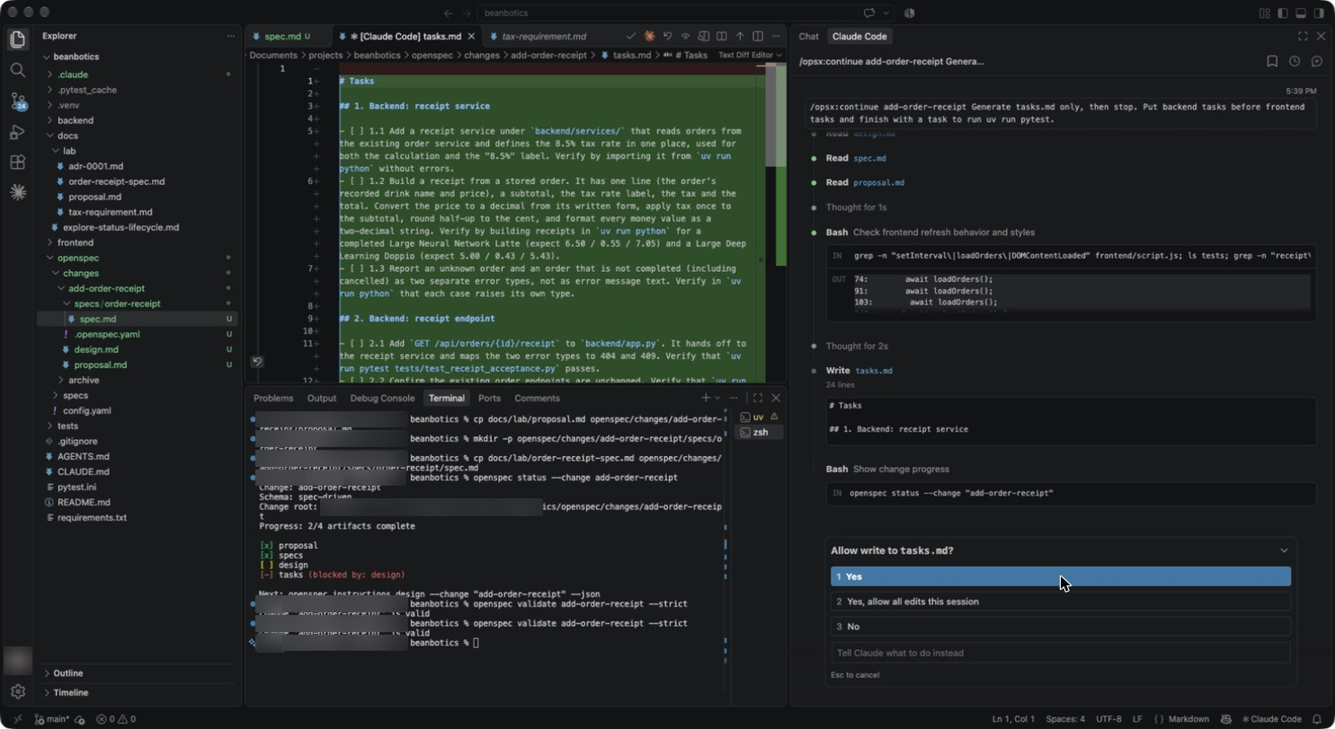
Figure 13: Approving the task list
1 Each task names how to check it, for example the expected values 6.50 / 0.55 / 7.05 and 5.00 / 0.43 / 5.43.
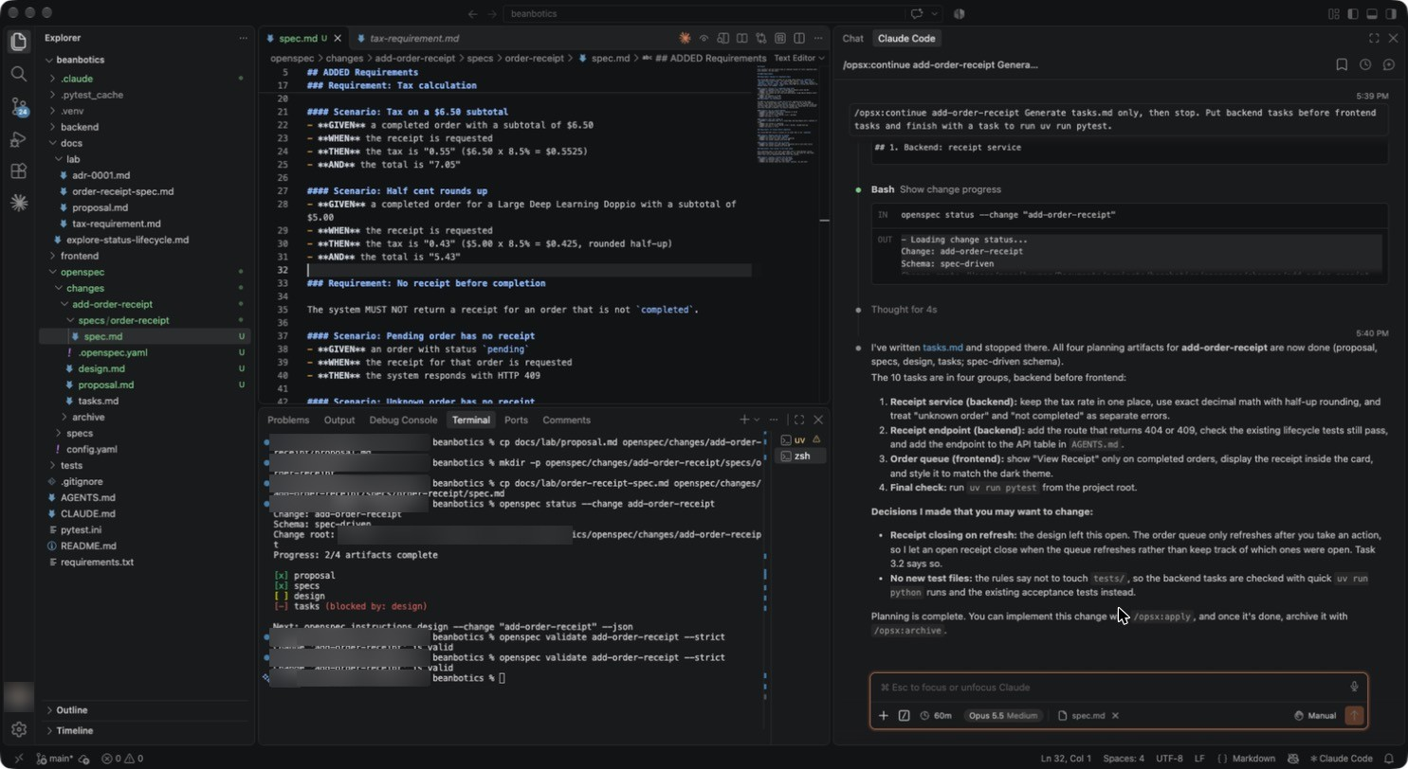
Figure 14: Planning complete
1 Four groups, backend first: receipt service, receipt endpoint, order queue, final check (uv run pytest).
2 All four planning artifacts are done. Next: /opsx:apply.
MUST MATCH YOUR SCREEN
Tasks are ordered backend → endpoint → frontend → uv run pytest.
MAY DIFFER (THIS IS NORMAL)
The exact number of tasks (10 here) and their wording.

Part 7 · Apply, test and look (7 minutes)
STEP 7.1 Implement · 5 min
Type /clear, then paste:
TYPE IN THE CLAUDE CODE PROMPT BOX
/opsx:apply add-order-receipt Do not edit anything under tests/. Use your edit tool for file changes, not shell redirection. Do not start any servers or browsers; I will check the UI myself in the running app on port 8000. Run uv run pytest as the final task.
TIP
Many cards appear: one per file edit and one per tick in tasks.md. To save time, choose 2 Yes, allow all edits this session on the first edit card. Command cards still ask each time: approve uv run, cat, grep and openspec. Click 3 No on anything that starts a server or a browser.
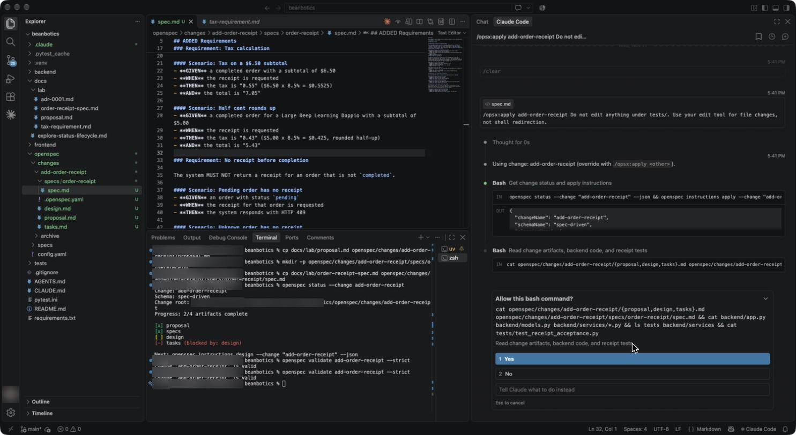
Figure 15: Apply starts by reading the change
1 Claude reads proposal, design, tasks, spec, backend code and the acceptance tests before writing anything. Approve this read-only command.
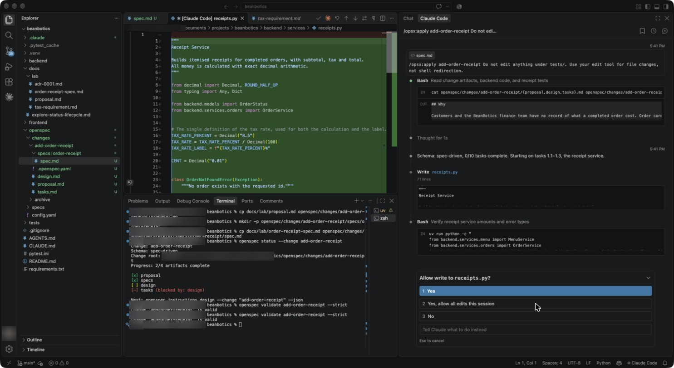
Figure 16: The first file: a receipt service
1 backend/services/receipts.py: the 8.5% rate is defined once, with Decimal and ROUND_HALF_UP.
2 Click 1 Yes, or 2 to allow all edits for the session.
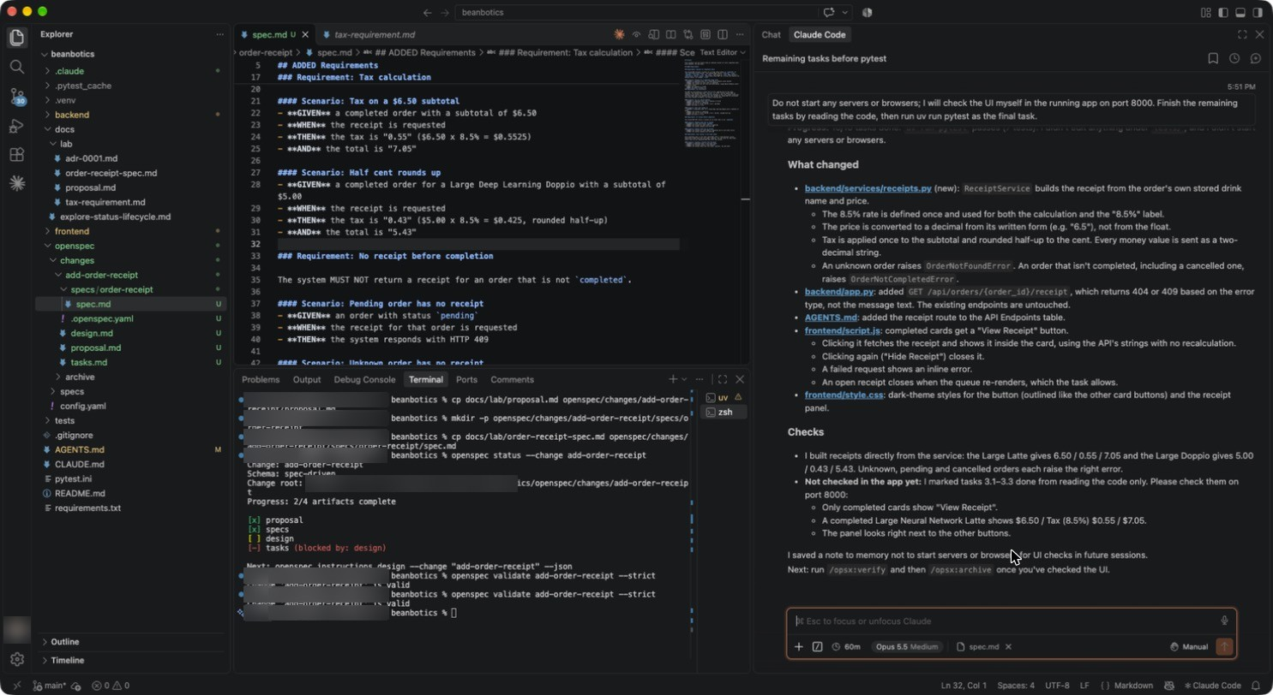
Figure 17: Apply finished
1 What changed: receipts.py (new), app.py (GET /api/orders/{order_id}/receipt), AGENTS.md, script.js and style.css.
2 Checks: 6.50 / 0.55 / 7.05 and 5.00 / 0.43 / 5.43; unknown, pending and cancelled orders raise the right error.
3 Claude asks you to check the UI on port 8000 yourself.
MAY DIFFER (THIS IS NORMAL)
The screenshots in this part were taken with a shorter first prompt; the sentence about servers and browsers was sent as a follow-up after Claude tried to start a second server. With the prompt above you will not see that detour.
Class names, CSS, and the order of the edits.
STEP 7.2 Run the acceptance tests yourself · 1 min
TYPE IN THE VS CODE TERMINAL, ONE LINE AT A TIME
clear
uv run pytest
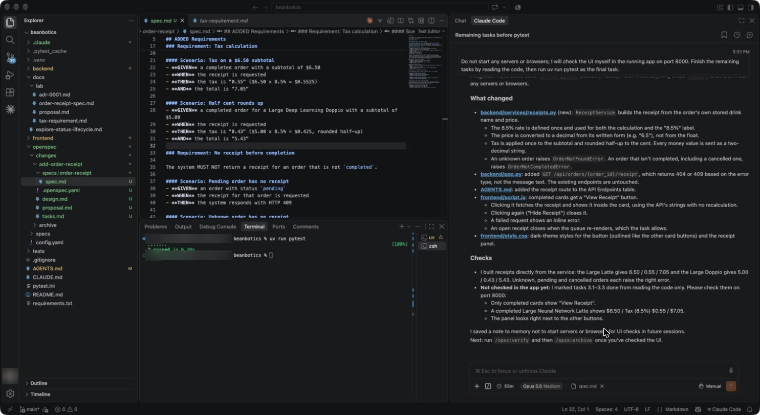
Figure 18: Green: 7 passed
1 The same seven tests that started 3 failed, 4 passed.
MUST MATCH YOUR SCREEN
7 passed.
STEP 7.3 Check the receipt in the browser · 1 min
- Refresh http://localhost:8000 with Cmd+Shift+R.
- On Neural Network Latte, choose Large, then click Order — $6.50.
- In the Order Queue, click Start Preparing, then Mark Ready, then Complete.
- Click View Receipt on the completed order.
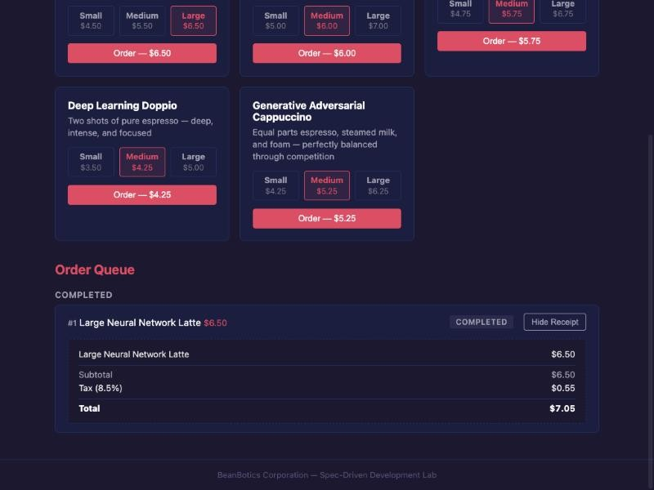
Figure 19: The receipt matches the spec to the cent
1 Completed order #1, Large Neural Network Latte, with a Hide Receipt button.
2 Line item $6.50, Subtotal $6.50, Tax (8.5%) $0.55, Total $7.05.
MUST MATCH YOUR SCREEN
$6.50 · $6.50 · Tax (8.5%) $0.55 · Total $7.05.
MAY DIFFER (THIS IS NORMAL)
Colours, spacing and the exact layout of the receipt panel.

Part 8 · Verify and archive (4 minutes)
STEP 8.1 Verify against the spec · 2 min
Type /clear, then paste. Approve the read-only commands it asks for.
TYPE IN THE CLAUDE CODE PROMPT BOX
/opsx:verify add-order-receipt Do not start any servers or browsers and do not change any files. Report completeness, correctness and coherence in under 150 words.
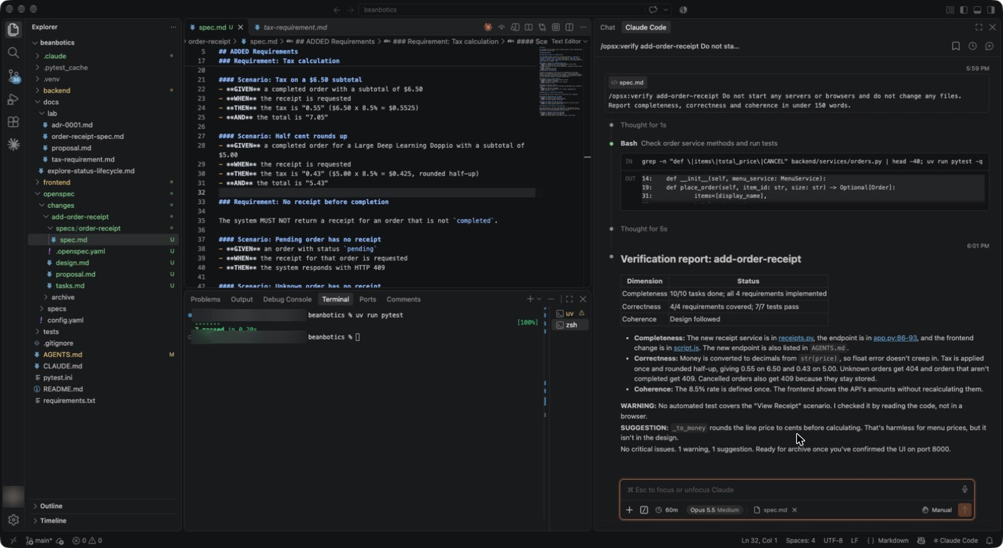
Figure 20: Verification report
1 Completeness: 10/10 tasks, all 4 requirements. Correctness: 4/4 requirements covered, 7/7 tests pass. Coherence: design followed.
2 One warning (no automated test for the View Receipt scenario) and one suggestion. No critical issues.
MUST MATCH YOUR SCREEN
No critical issues. All tasks and requirements complete. 7/7 tests pass.
STEP 8.2 Archive · 1 min
TYPE IN THE CLAUDE CODE PROMPT BOX
/opsx:archive add-order-receipt Do not run any commands other than openspec.
Claude asks whether to sync the specs. Choose Sync now (Recommended), then click Submit answers.
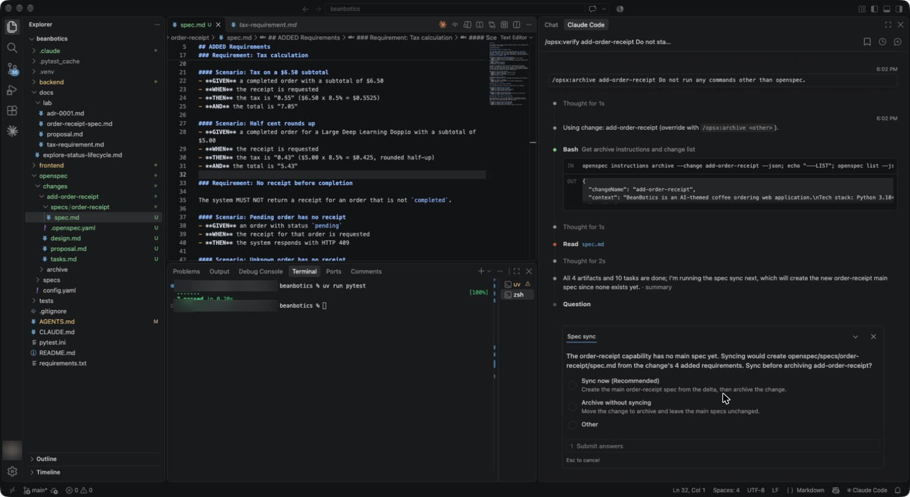
Figure 21: Sync before archiving
1 order-receipt has no main spec yet. Sync now creates openspec/specs/order-receipt/spec.md from your four requirements.
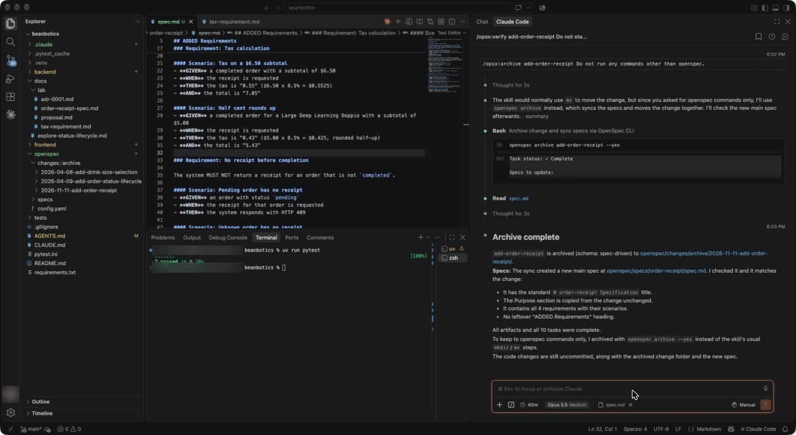
Figure 22: Archive complete
1 The change moves to openspec/changes/archive/<date>-add-order-receipt.
2 The new main spec has a title, your Purpose and all four requirements.
STEP 8.3 Read the updated spec suite · 1 min
TYPE IN THE VS CODE TERMINAL, ONE LINE AT A TIME
clear
openspec list --specs
openspec validate --all --strict
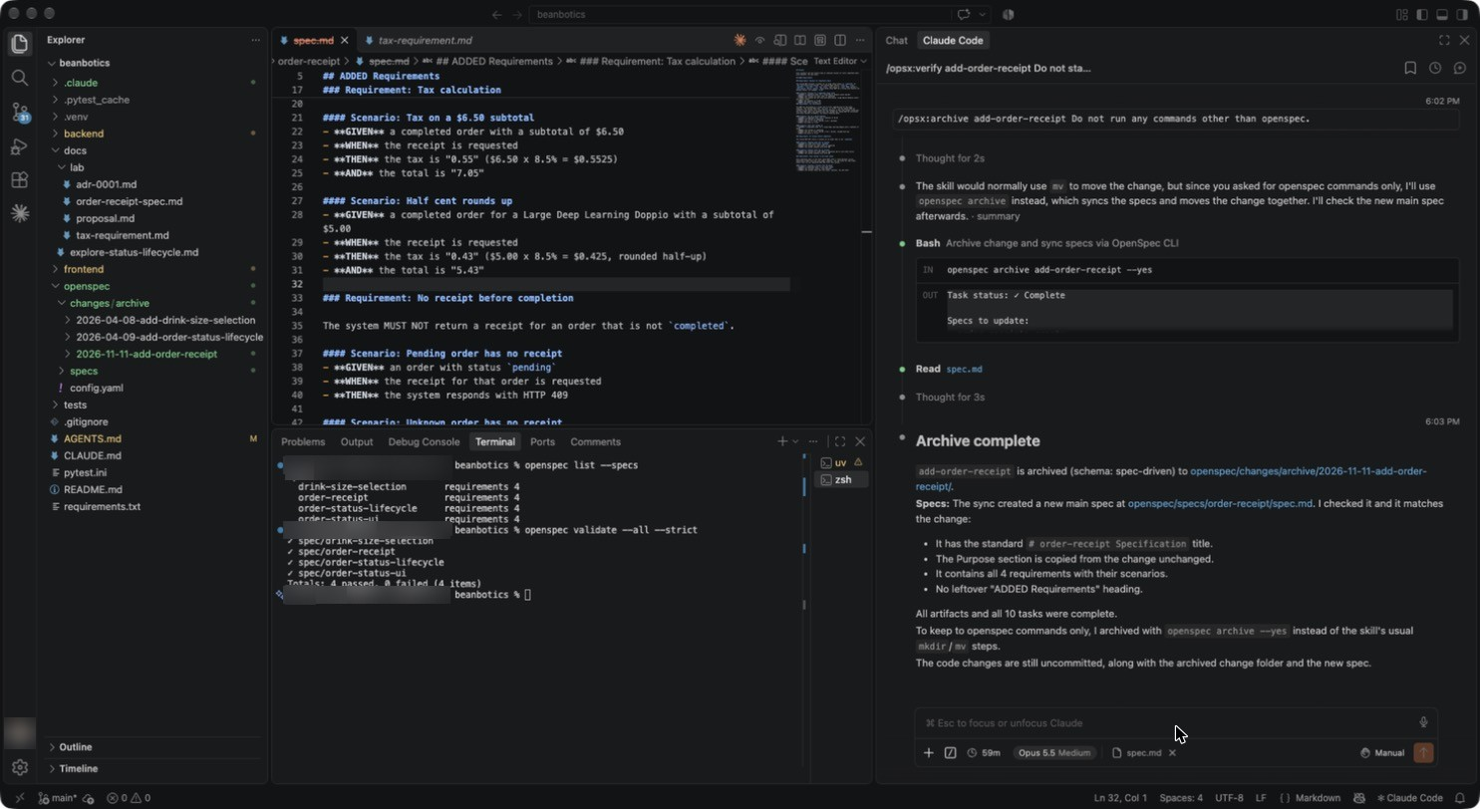
Figure 23: Four specs, all valid
1 order-receipt now sits beside the three original specs, 4 requirements each.
2 Totals: 4 passed, 0 failed (4 items).
MUST MATCH YOUR SCREEN
4 specs including order-receipt; validate: 4 passed, 0 failed.
MAY DIFFER (THIS IS NORMAL)
The archive folder name starts with the date you archive (2026-11-11 here).

Part 9 · Fix without SDD (1 minute)
STEP 9.1 A cosmetic fix needs no spec · 1 min
Type /clear, then paste. Click 1 Yes on the edit card.
TYPE IN THE CLAUDE CODE PROMPT BOX
The header tagline in frontend/index.html says "Coffe" instead of "Coffee". Fix that typo only. This is a cosmetic fix, so do not use OpenSpec.
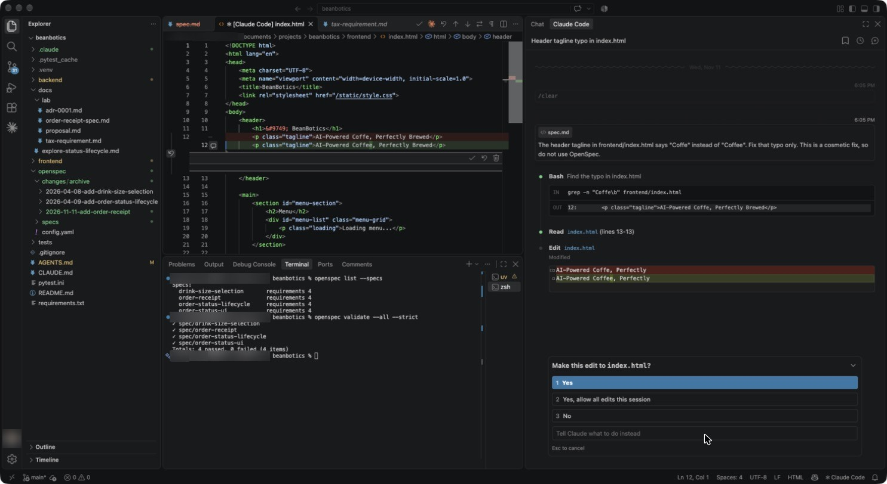
Figure 24: One-word fix, no OpenSpec
1 Claude finds line 12 with grep and changes Coffe to Coffee. No change folder, no spec.
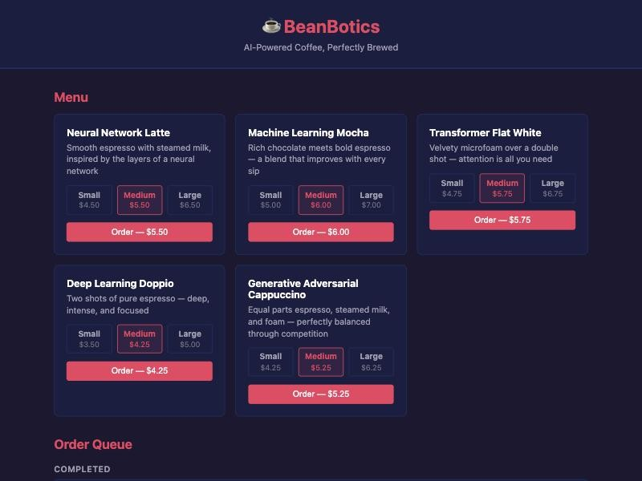
Figure 25: Fixed in the browser
1 Refresh with Cmd+Shift+R: “AI-Powered Coffee, Perfectly Brewed”.
WHY THIS MATTERS
No behaviour changed and no spec mentions the tagline, so the spec workflow would add cost and nothing else. Use SDD when openspec/specs would change.

Part 10 · Record the decision as an ADR (2 minutes)
STEP 10.1 Commit the ADR with the change · 2 min
The ADR text is in docs/lab/adr-0001.md. In the second terminal, type clear, then run each line on its own:
TYPE IN THE VS CODE TERMINAL, ONE LINE AT A TIME
mkdir -p docs/decisions
cp docs/lab/adr-0001.md docs/decisions/0001-decimal-money-half-up-tax.md
git add -A
git commit -q -m "BEAN-204: order receipts with 8.5% half-up tax, ADR 0001"
git log --oneline -3
Open docs/decisions/0001-decimal-money-half-up-tax.md and read it.
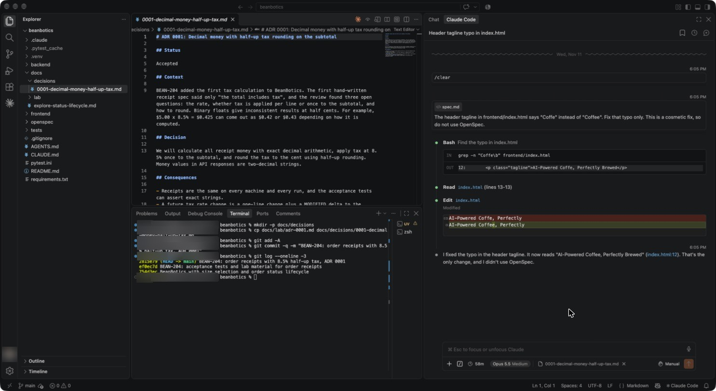
Figure 26: The decision, recorded and committed
1 Nygard format: Status Accepted; Context explains the three open questions and the half-cent problem.
2 Decision: decimal arithmetic, 8.5% once on the subtotal, half-up; money as two-decimal strings.
3 git log: your commit on top of ef0ec7d and 754d3ec, the two commits every participant starts from.
MUST MATCH YOUR SCREEN
The last two lines of git log --oneline -3 are ef0ec7d BEAN-204: acceptance tests… and 754d3ec BeanBotics with size selection…
MAY DIFFER (THIS IS NORMAL)
The hash of your own commit, because it includes your name and the time.
STEP 10.2 Clean up after the lab · —
Stop the app with Ctrl+C in the first terminal. To return OpenSpec to its default commands for other projects, run:
TYPE IN THE VS CODE TERMINAL, ONE LINE AT A TIME
openspec config profile core

9. Where Work Stalls, and What You Saw
Stall | Where it appeared in this lab | What fixed it
Vague requirement | “The total includes tax” left rate, base and rounding open | AI review, then a hand-written requirement with exact scenarios
Rediscovery after context loss | Exploration findings are needed later | /clear between phases; the spec files carry the knowledge
Plan drift | All artifacts generated at once can carry a mistake through to tasks | /opsx:continue with a review after each artifact
Agent detours | Claude tried to start a second server and a headless browser | Declined the card; the prompt now forbids it
Missing evidence | Prevented: red tests first, green after, verify report, receipt checked by hand | Acceptance tests and /opsx:verify
Lost reasoning | Why decimals and half-up? The code alone does not say | ADR 0001

9.1 Take-aways by role
Role | Take-away
Software engineer | Write the scenario with the exact numbers before the code. Name files and forbid side commands in prompts.
Data engineer | Money is decimal, rounding is a rule, and a half cent is the test case that proves it.
Tech lead | Core profile for small changes; expanded with continue and verify when review gates pay off.
Architect | Spec = what, design = how and why for this change, ADR = why for the long term.
Project manager | The git log and the archive folder tell the story of the change without reading any code.

10. Results Sheet
ID | Evidence on my screen | Done
AC1 | openspec --version: ________ | ☐
AC2 | Baseline: ____ failed, ____ passed | ☐
AC3 | Skills/commands: ____ Specs: ____ | ☐
AC4 | Explore found tax anywhere: yes / no | ☐
AC5 | New commands listed: ____________ | ☐
AC6 | openspec status: ____/4 | ☐
AC7 | Review finding #1: ____________ Valid: yes / no | ☐
AC8 | continue stopped after design: yes / no after tasks: yes / no | ☐
AC9 | pytest: ____ passed Receipt total: $______ | ☐
AC10 | Critical issues: ____ Specs after archive: ____ | ☐
AC11 | Tagline now reads: ____________ | ☐
AC12 | Last two commits: ________ ________ | ☐

