SUPERMARKET DATABASE
E-R DIAGRAM:
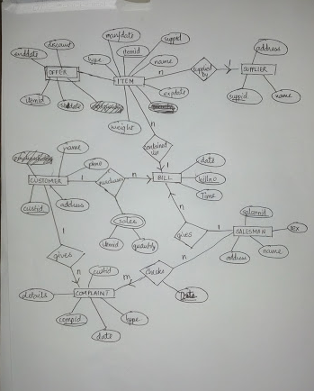
http://prntscr.com/4nwmjo

Description:
Each Item in the supermarket is specified by a unique itemid and it also has the following information associated with it ,Item also has a unique name.Item also has a weight and type associated with it.The expiry date (expdate) and manufacture date(manfdate) are also stored.It is supplied by a particular supplier who has his own unique spplier id and name.The Data base also has his address.
The supermarket also provides discount on items ,an offer specifies these details and is associated with only one item.Offer is subjected to enddate,the offer starts on a particular date(stdate).
For every customer the supermarket has a unique custid and name, the name address and phone number(phno) are stored for reference.
Customer purchases a bill .The bill contains items in it.The bill also has its own Unique billno ,the date and time when the bill is issued is also stored for reference.The is given by the salesman.
Salesman has a unique salsmnid and name,the phno,sex and address of a salesman are stored for reference.
Customer gives complaints which are checked by the salesman ,The complaint has details and the type of complaint(on how impotant it is), a complaint is given by a unique compid,the id of the customer giving the compaint is also specified and has date associated with it.
Whenever a salesman checks a complaint the date is stored so that we can check back when a complaint was checked
From the purchases made the sales is kept track of by the no of items sold for each item.

Functional Specifications

1)The supermarket starts with an initial quatity of items .
2)Form the datebase at any point we can get the quatities of each item and the quatity of items sold of aparticular item.
3)We can buy items
4)Items can be sold
5)Items can be supplied to the supermarket
6)From the database expired items can be removed
7)New customers can start purchasing bills
8)Salesmen can join and leave
9)Bills can be issued or given
10)Complaints can be processed(checked)
11)We can give a comaplaint to the database
12)Offers can be started and expired offers can be removed
SCHEMA DIAGRAM
Item:
ItemId | Name | ManfDate | ExpDate | Weight | Type | Suppld | Billno

Supplier:

SupplierId | Name | Address

Customer:

CustId | Name | PhNO | Address

Bill:

BillNo | CustId | SalsmnId | Date | Time

Salesman:

SalsmnId | Name | Sex | Address

Compliant:

CompId | Date | Type | Details | CustId

Check:

CompId | Date | SalsmnId

Offer:

ItemId | Stdate | enddate | Discount

