**GLOG**

I have created glog using glogster. Topic is Switerland

The glog contains top places in switerland, famous food, and some interesting videos..etc

**Here are some screenshots:**

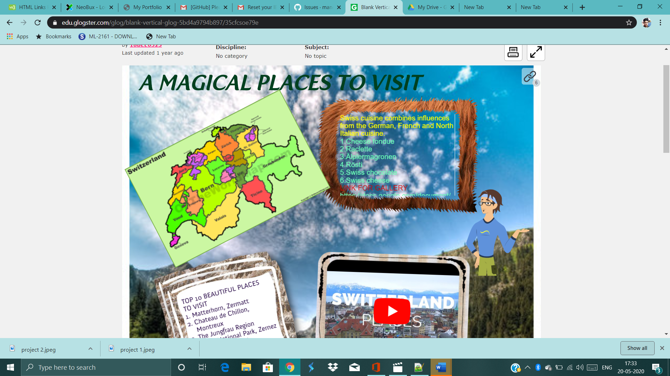

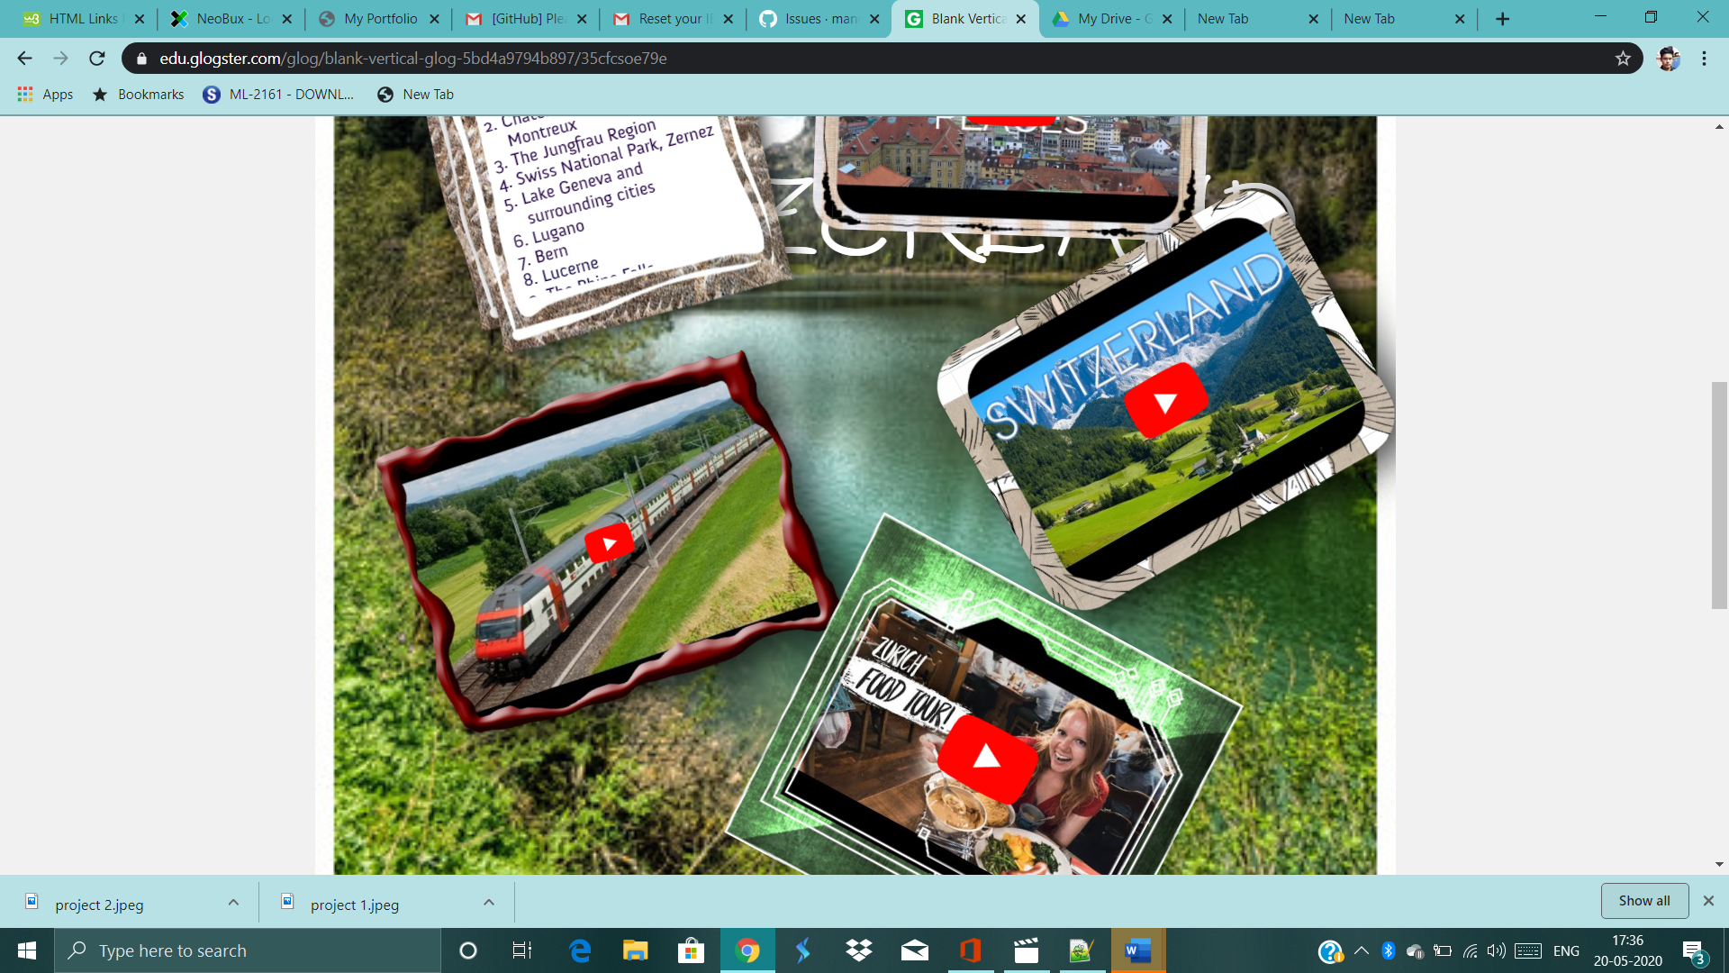

**Link:**

https://edu.glogster.com/glog/blank-vertical-glog-5bd4a9794b897/35cfcsoe79e