**SAMPLE CHAT BOT**

I have created simple chat bot on facebook which replies back. I have done this with the help of Node-red Application and used IBM-Watson services.

This chat bot replies text and play audio as well.

For text I have used ok Watson API for this

**Here is the screenshots:**

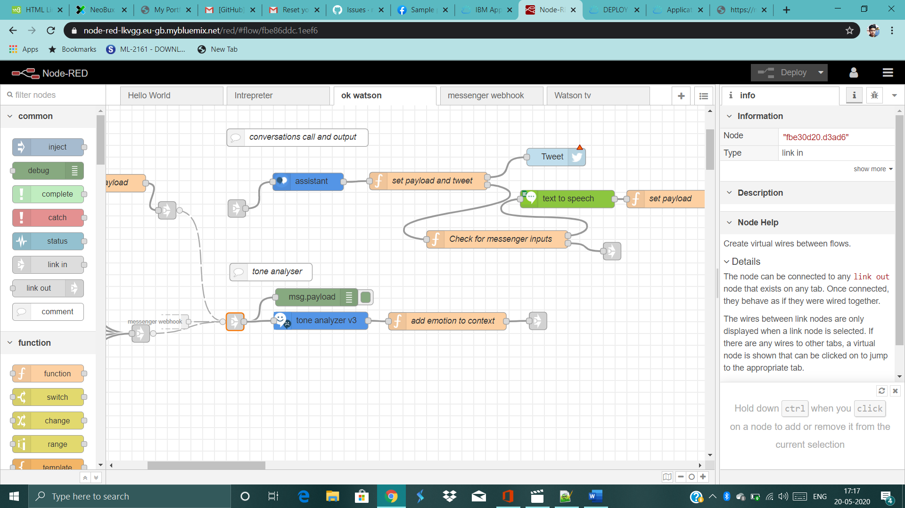

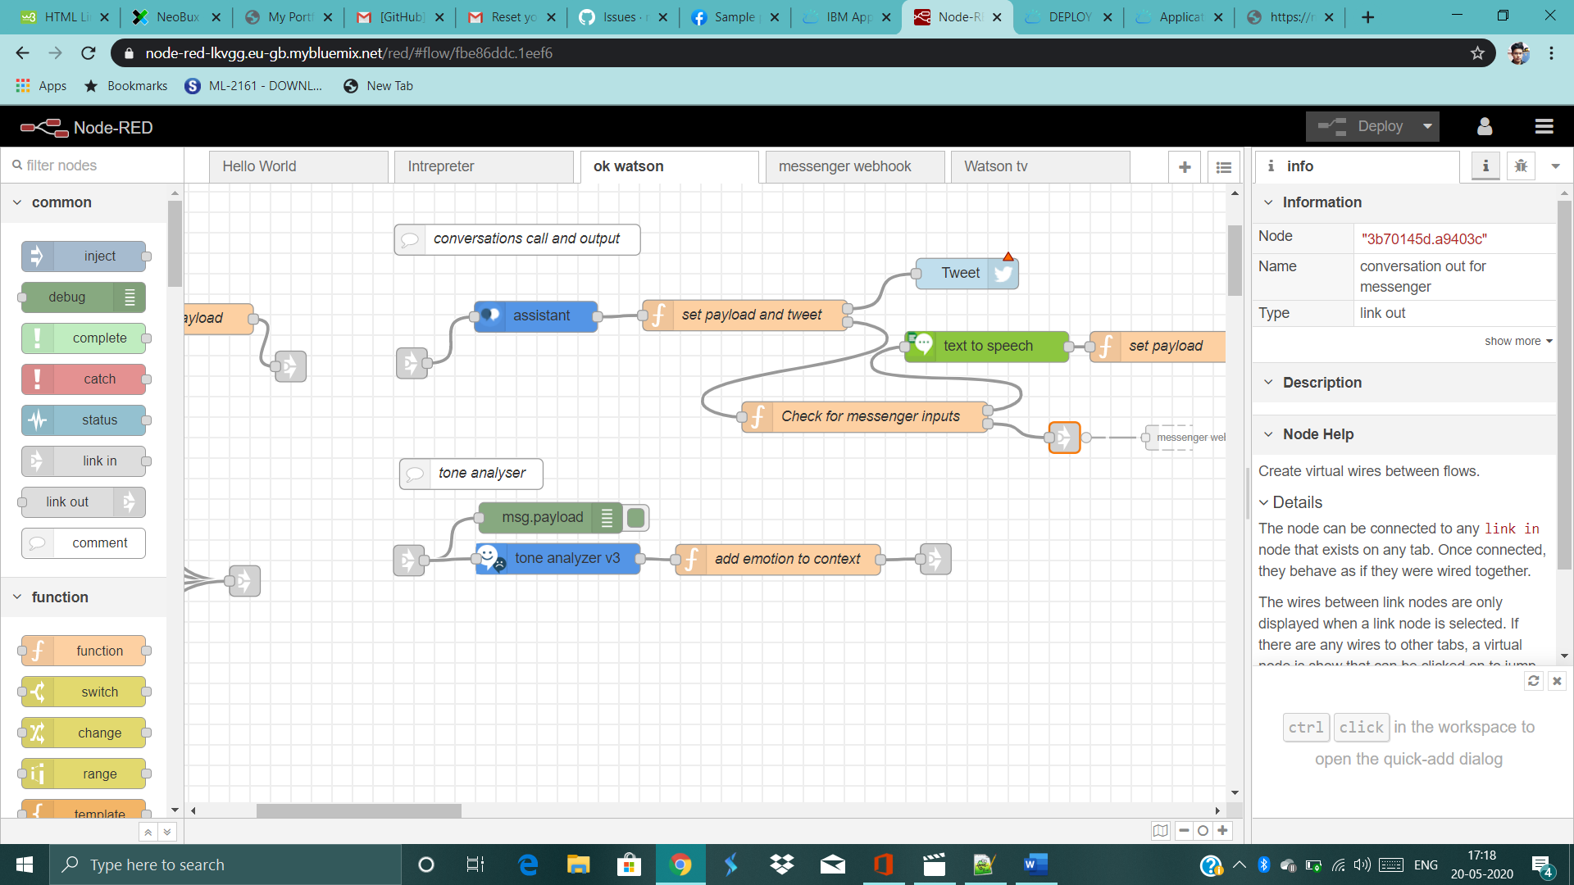

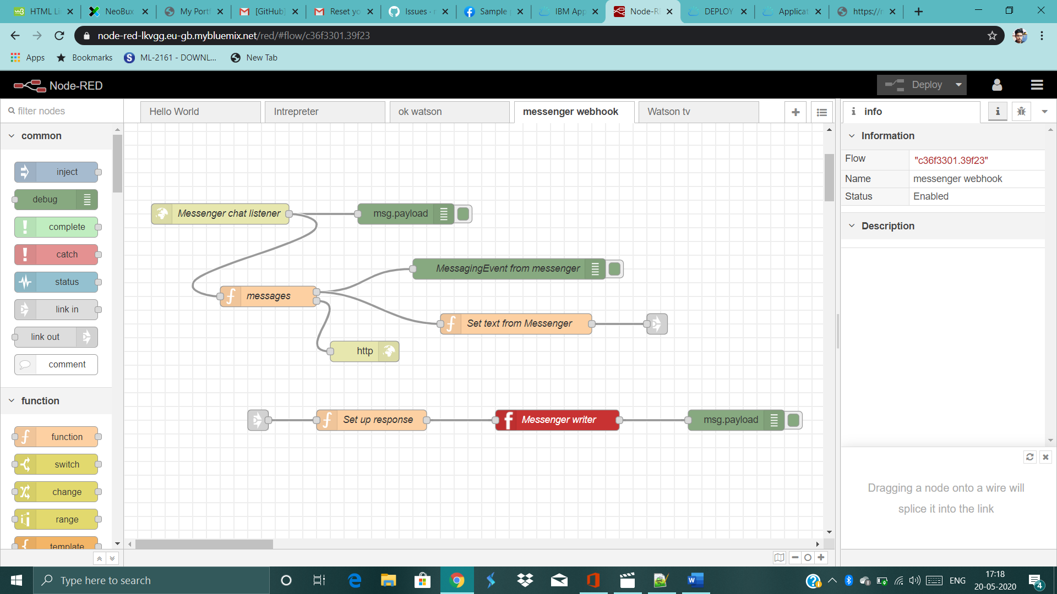

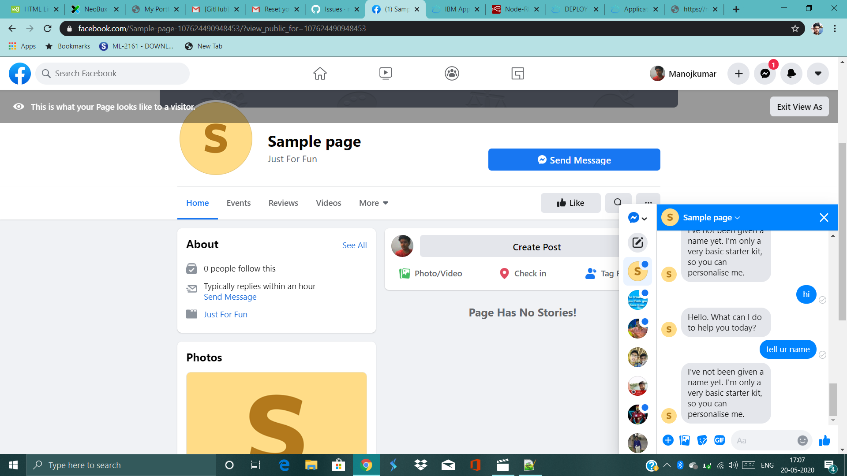

**Facebook-link:**

<https://www.facebook.com/Sample-page-107624490948453/?view_public_for=107624490948453>