**Current Data calls made from UI side :**

We make below 3 data calls in sequence, which are dependent on each other

**1. Notify that we are exporting to PowerBI**  
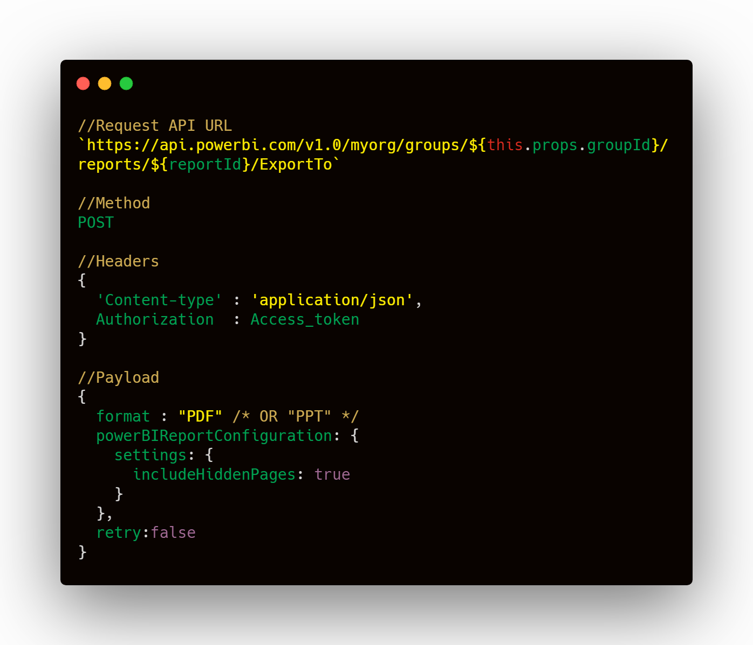  
 **Response received :**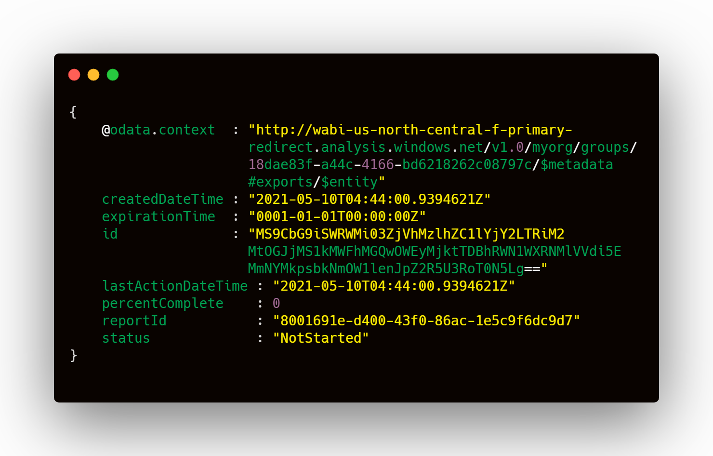 ***Use the "id" value in above response as "exportId" in below data call***

**2. To get download percentage or download tracker**

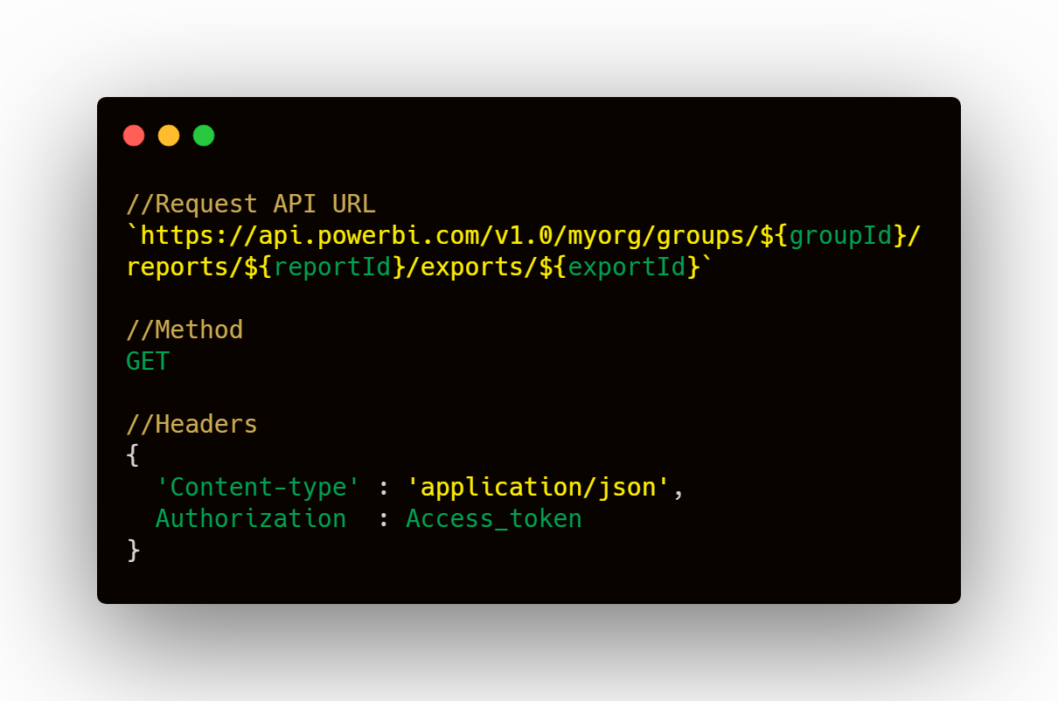

**Response received** :

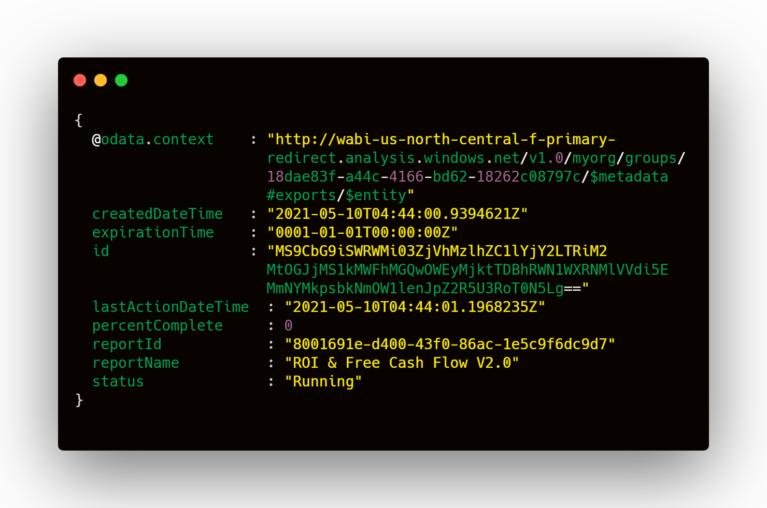

* ***The above call is made recursively for every 30 seconds until ,the status in above response changes to "Succeeded" and “percentageComplete” is 100.***
* ***Use the “reportName” from above data call for 3rd data call mentioned below***
* ***Also Use the "id" value from the response of export data call(1st data call) as "exportId" in below data call***

**3. Fetch the PowerBi report**

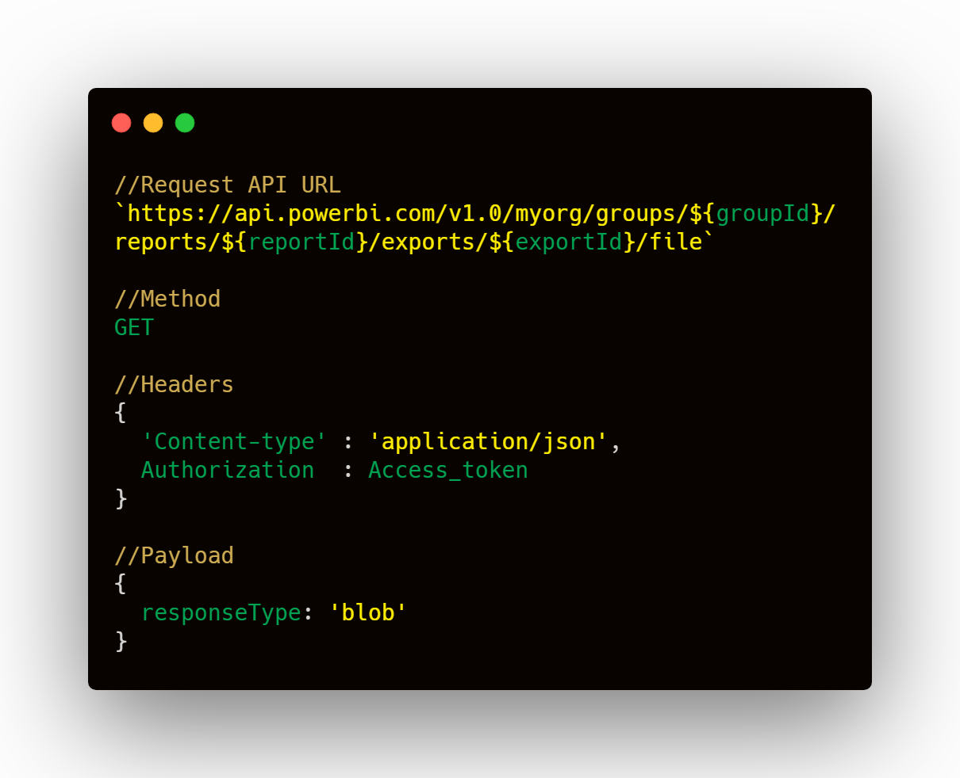

**Response received :  
*Information will be in blob type, which will be converted to file format (either PDF or PPT) at client side.***

**DESIGN :**

Use Scheduler Service to update cache periodically with all reports and Expose API endpoint to get the reports from cache

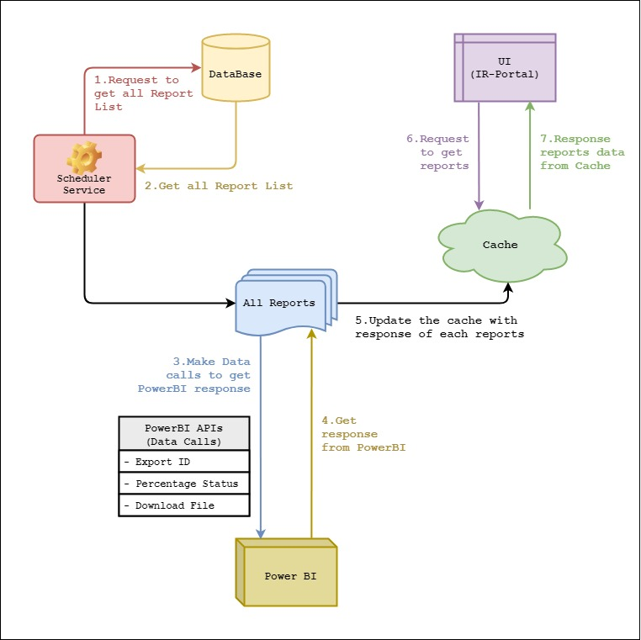

**1.** Run a scheduler service periodically which will do below set of actions

* Get all reports from DB (from view irpc.vw_report_details)
* From each report, get the reportId , groupId . Using this 2 data information, fire the 3 powerBI  
  sequential requests .
* Copy the PowerBI report response from above PowerBI data call, and update the cache for the corresponding report.
* Now Reports response can be directly downloaded from the prefetched cache instead of firing 3 PowerBI data calls everytime from UI

**2.** Expose an Rest Endpoint , when fired from UI or PostMan, will directly fetch the PowerBI response for the corresponding report and copy the response into requested format file (PDF/PPT) and download the same.

**Cache Structure**

|  |  |  |
| --- | --- | --- |
| **ReportId** | **PDF_Response** | **PPT_Response** |
| *Unique ReportId of the each report acting as primary key* | *PDF response for the report* | *PPT response for the report* |

**Constraints/Limitations on PowerBI**

1. After downloading 3 or 4 reports , then I am getting error from PowerBI like

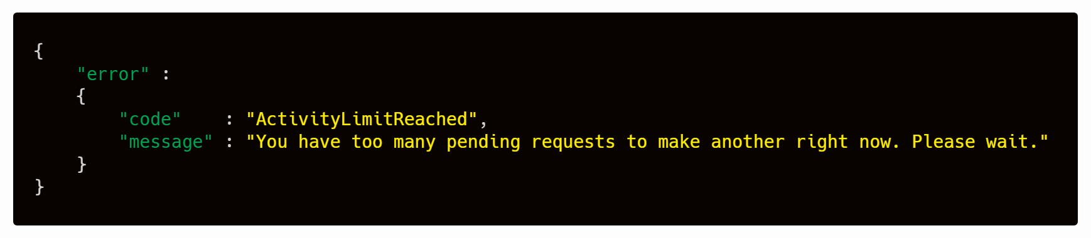

We are also getting other errors from PowerBi sometimes like, mentioned below

1. InvalidRequest, Report requested for export is not on dedicated capacity
2. Unknown Error : {"Message" : "An error has occurred."}
3. Resolvable Error :

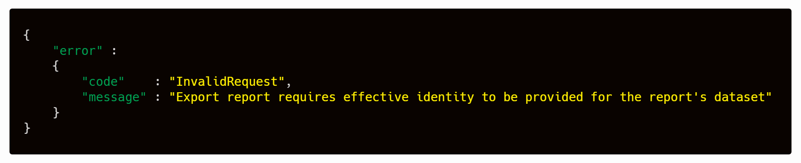

**Questions**

1. How often reports gets refreshed ?

**Challenges**

1. We need to do some R&D on choosing right cache mechanism
2. Integration of cache with our application
3. Limitations from PowerBI (like mentioned above in errors)