BaudRateGeneratorI2C_tb.v

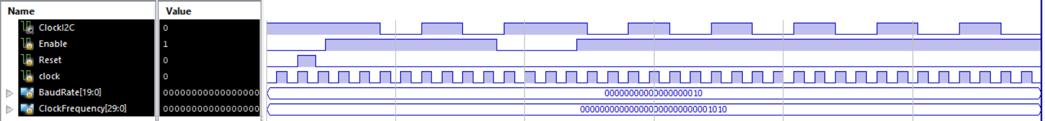

I2C_Controller!2C_tb.v

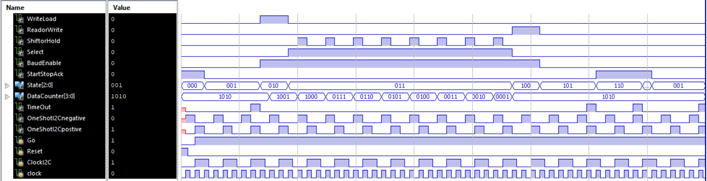

I2C_DataUnit_tb.v

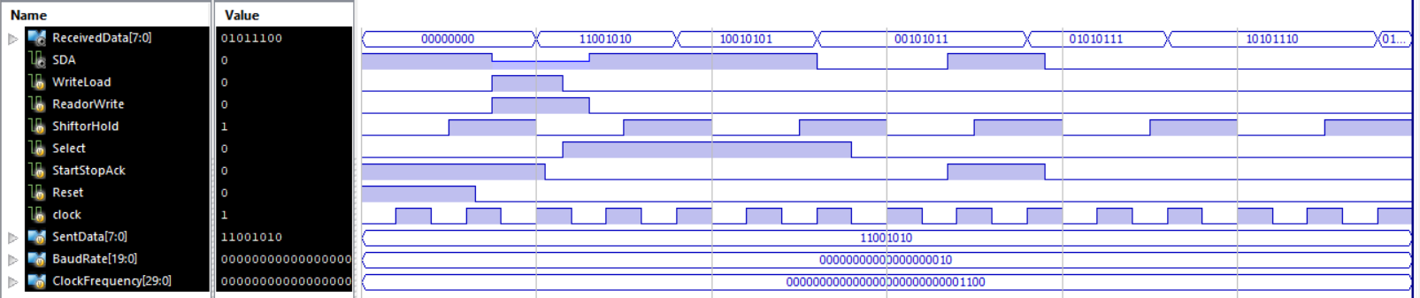

I2C_SDAmodule_tb.v

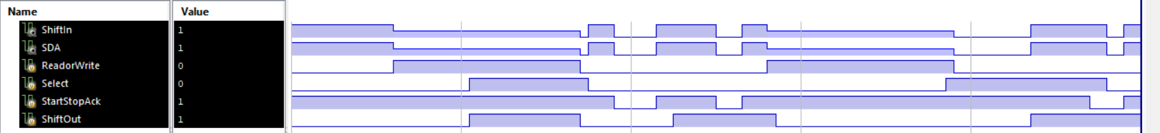

I2C_ShiftRegister_tb.v

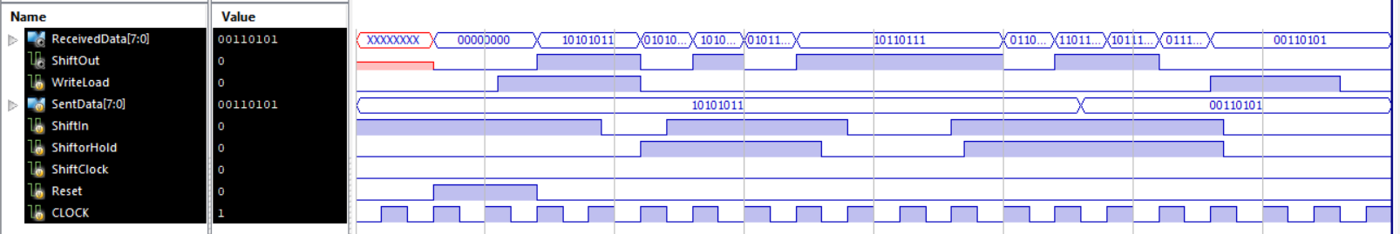

SquareWaveGenerator_tb.v

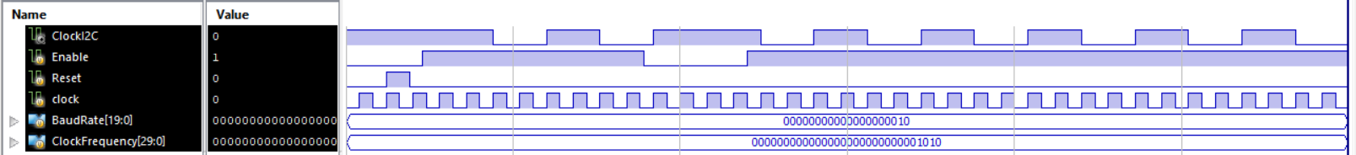

lab7phase1overall2018fall_tb.v

