Hive -Introduction

**Objectives**:

* Hive
* Application Areas of Hive
* Hive Architecture
* Identify the situations when to use and when not to use Hive

**Hive -Data Warehouse:**

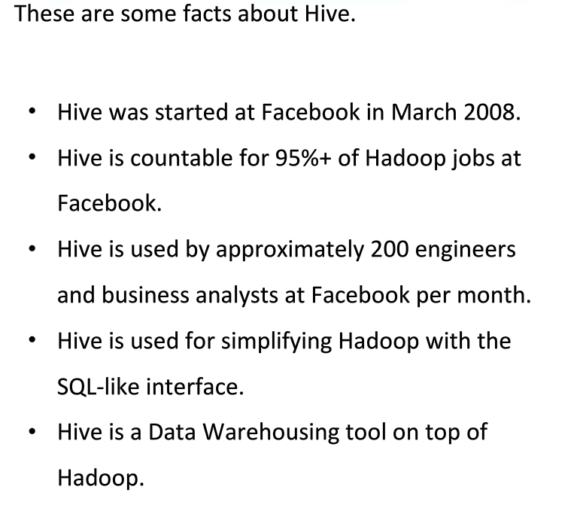

**What is Hive?**

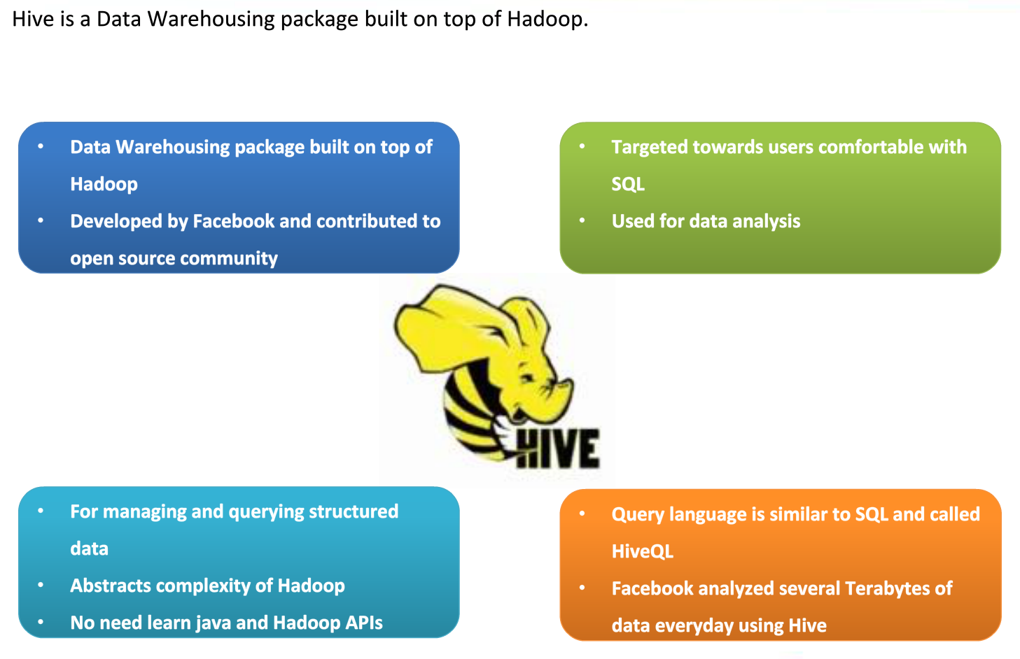

**Hive-Use Cases:**

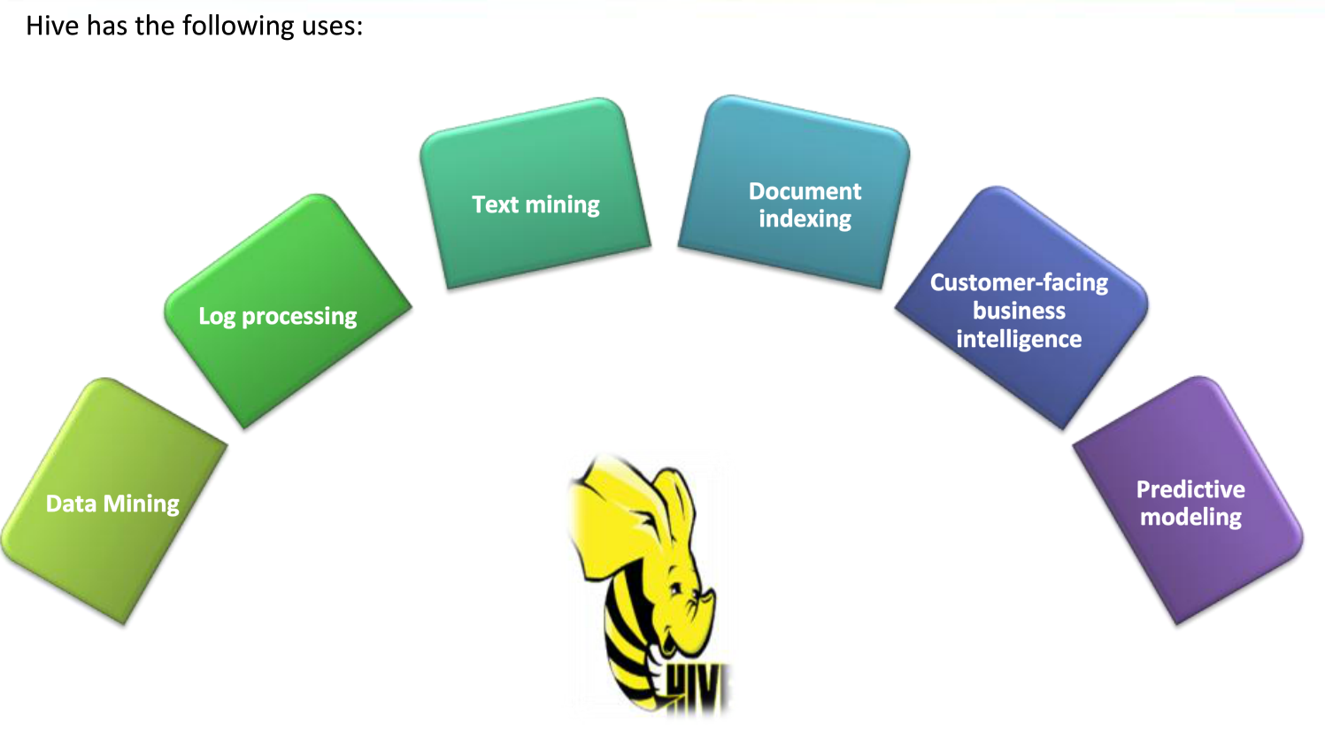

* Data Mining:
* Log Processing:
* Text Mining:
* Document Indexing:
* Customer-facing BI:
* Predictive Modeling:

**Hive-Architecture:**

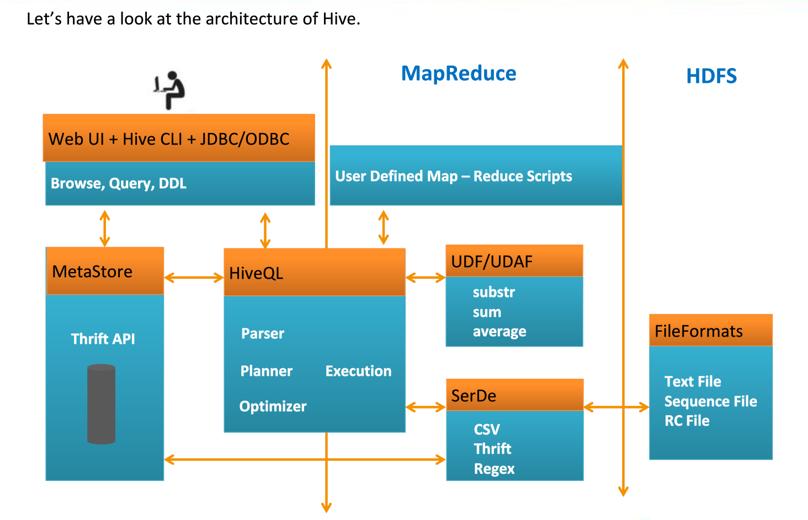

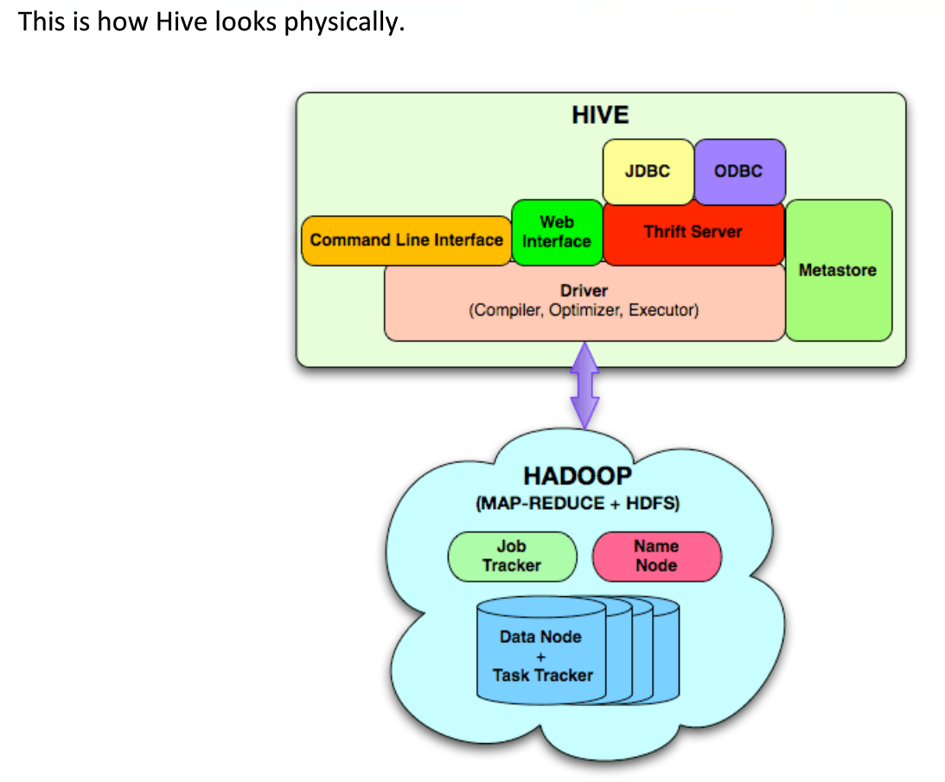

**When to Use and When not to use Hive:**

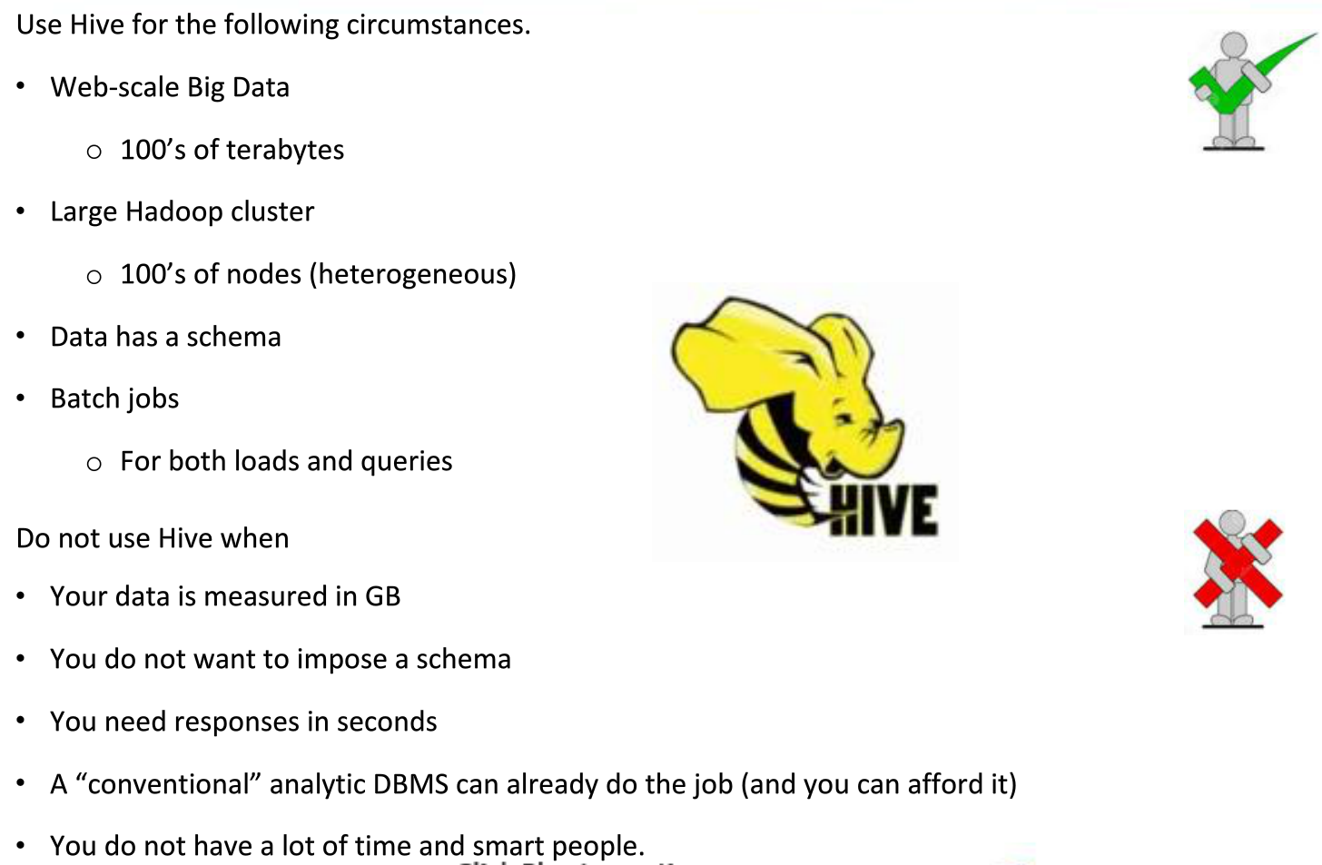

**Summary:**

