Punit: Cloud FinOps data project PID 254247

Feedback

* Punit is highly aspirant, has worked on Dev, Testing, PM, SM roles thus far.
* He is confident to take up Agile coach role also
* Have done Agile/SM certifications other than SAFe PO/PMP certification
* Handled team size ranging from 7-30
* Exposure across Agile/Project management activities, good hold on Jira, confluence, MS project, Office 365, ALM, Panaya, Clarity etc.
* Familiar with sprint planning, PI planning, Scrum of Scrums, daily stand up, sprint grooming, metrics and measurements, both offline/Jira tracking
* Punit is based out of Gujarat now, considering his father's health issue he would need to continue WFH for some time, post which he can join Bangalore office.

===============================================================================================

May 2021 joined

both engagements in proper Agile

US bank eng. - much bigger one thatn canadian. CLosed to 2 years handling. Used by operational user to track financial transactions. Anybody interacting with payment transaction to be reported in operational console. Retry the transactions on glitches.

Team from TCS, wipro - UI, US banck, PS - backend operations - microservices - sigma design

~ 50 to 30 folks

Ensuring delivery

Anti patterns

All team wanted to prove their mettle

Create a close net group

Challenge:

===========

- 4 DMs from US bank, but one DM would create an impression that he is driving, he wil not allow anyone to pitch in, he left the company

- alignnig to one person, he left

- DS - 30 mins to 1 hr

- agile concepts he tried to imbibe, slowly team got aligned

- based on new leads there were fluctuaions, but he wsa able to align driving the eng. being a servant leader.

Handling certain team members, PS/other grp

- client buy in = was able to get

PO - he was not giving details for the story to be created

- create epics but not at story level

- what kind of stories he was not giving details

included product leadership to handle, getting epics/features ready. He highligted on pro agile approach from US bank side, agile coaches from us bank helped to get alignment.

In TCS - entire account handled for agile operation. LATAM, US, Asia, Europe,

Canadian eng. - 6 months - Proof of acceptance - Sandeep was overlooking. He was handling the entire account of ~ 20 folks.

- Whether

DS - who involved

- 7 mins to 15 mins

- developers n SM

- recommend delivery leads on need basis

- team of 4-5 testers, regression test cases,

- team size of 9-10 from PS, testers also included. Altogeher 30 memebers

What other ceremonies -

- sprint planning

daily stand up

sprint grooming

backlog grooming

po review - closed grp - prod manager, po, sm, team

po demoing to end users - train the trainer -

monthly release, mostly every month stakeholder demo

sprint duration - 2 weeks - 10 days , but once a month demo

PI planning, dependencies -

- EMM - entreprise manage ??? -

- scrum of scrums, PI planning involved

- product groups involved

- PO, prod mngr, teach leads from each team, ux leads

-----------------------------------------------------------------------------------------------------------------

Roles and Responsibilities:Schedule Management, Project Management and Controlling, Project Status Reporting, Run Scrum ceremonies, Track team progress and velocity, Help resolve impediments for team and Customer management

Skills/Domain:Agile Project Management, Scrum Master, Agile Consulting and Agile Coach

-----------------------------------------------------------------------------------------------------------------

Challenges faced:

Metrics:

Certificatoin:

- PO also done,

ulitmately want to have agile coach

payment domain per se, cpg domain, - wanted to try with PO also, if open

Career:

web develper, @ honeywell, aerospace

TCS - calcutta - legacy app - cobol

testing later with kpmg through tcs

performance/automation testing engr

Moved to Agile roles later on

iot data center management - manufacturing sites - 2 or 3 members - did assessment, purchased sensors, governance - us

proctor n gamble - prod implementation - stibo 3rd vendor

sapient - may 2021,

Tools used:

----------

Jira

MS project - office 365

alm

ms visio

panaya

clarity - pm tool

Raja - involved - operational excellency

- moring is on this

-

Jira based reports + offline reports

**Jan 1st only release, can pull out if need be, Sandeep can work on this.**

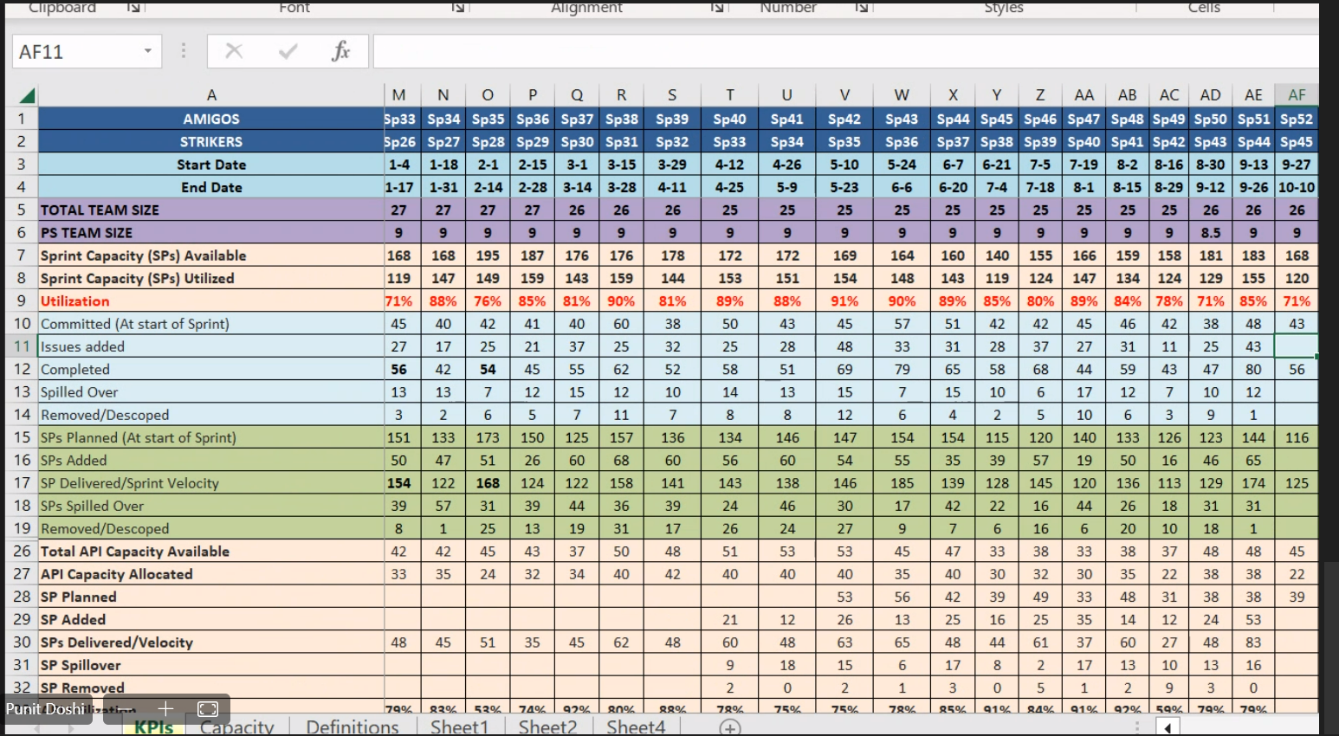

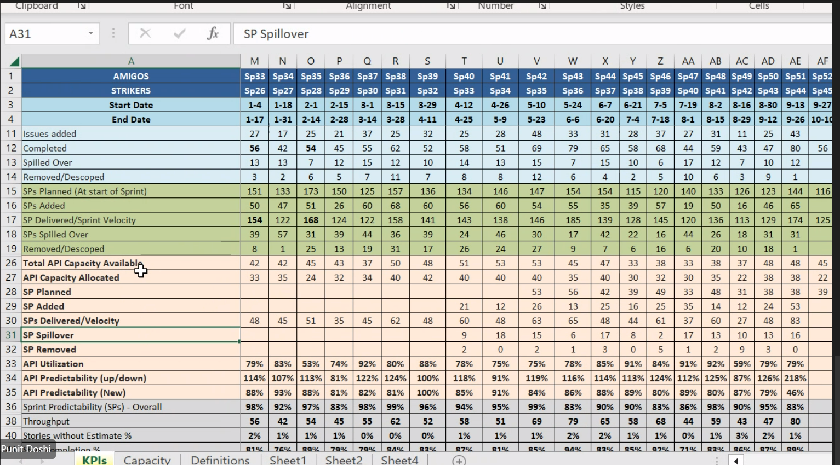

Velocity was the major one tracked

Estimated vs ccommited

Predictability

Story point completion %

Father diagnosed with chronic TB

* He might have to WFH for some time
* Blr base location
* Kids school – Gujarat