| Name | Manoj Mani |
| --- | --- |
| Date | 02/01/2024 |
| Type | Daily Assignment |
| Topic | Creating Delta Lake Table |

Delta lake table in Azure Databricks:

* Delta Lake tables in Azure Databricks refer to tables that leverage the Delta Lake storage layer for managing big data workloads in a scalable, reliable, and transactional manner.
* Delta Lake is an open-source storage layer that brings ACID transactions to Apache Spark and big data processing.
* That provides ACID transactions, data reliability, query performance, data caching and indexing, and many other benefits.
* Delta Lake tables in Azure Databricks are well-suited for handling large-scale data processing tasks in a reliable and scalable manner.
* Making them a preferred choice for big data workloads in the Azure cloud environment.

Created a Databricks **(manoj_workspace)** resource:

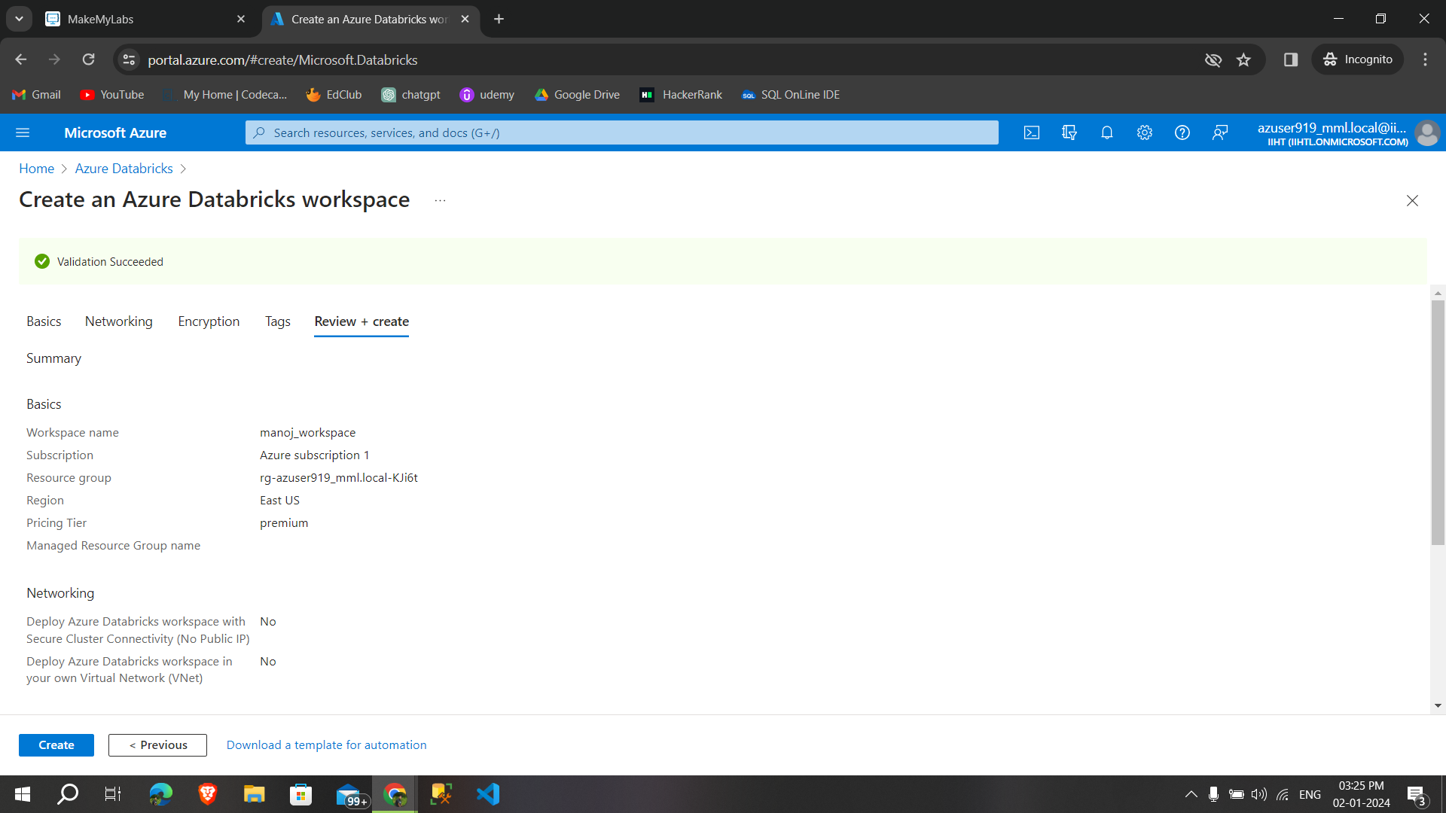

After creating a workspace **created a cluster:**

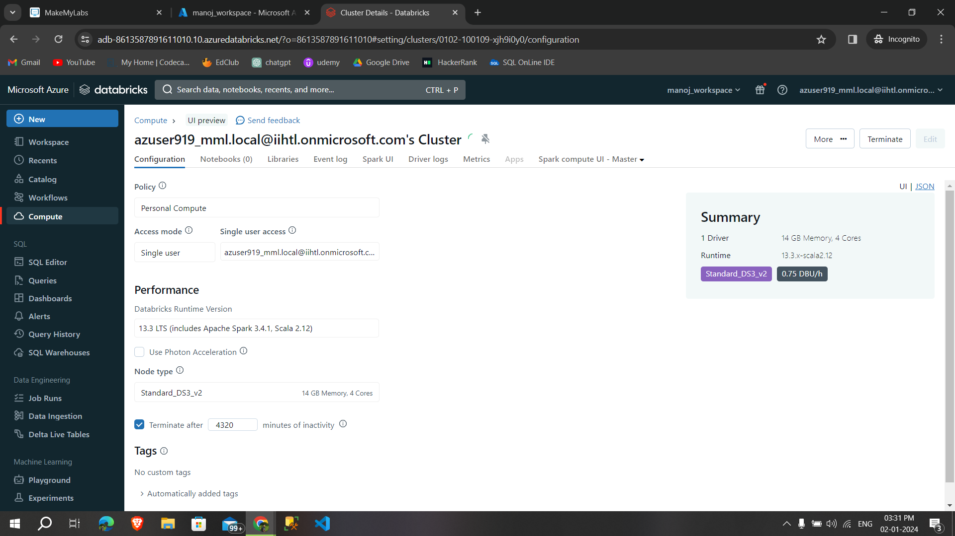

After that creating a notebook and ran some sample codes, then uploading local files into Databricks:

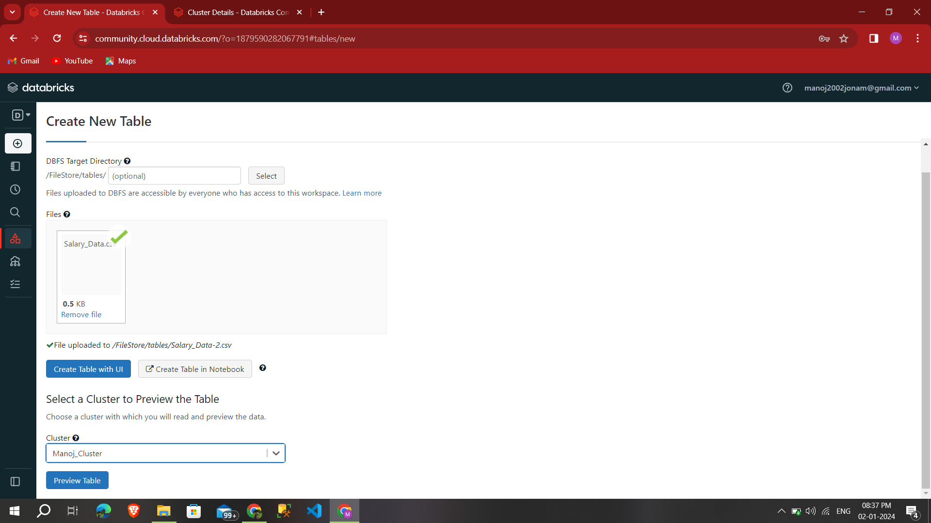

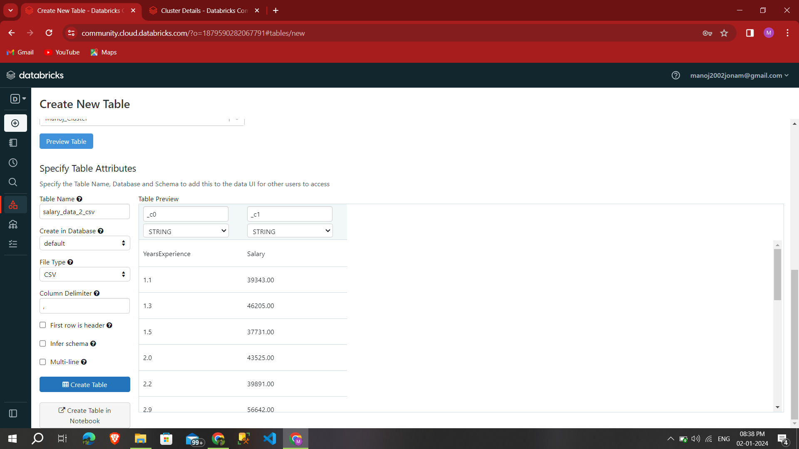

Successfully uploaded **csv files into databricks as table** in that cluster:

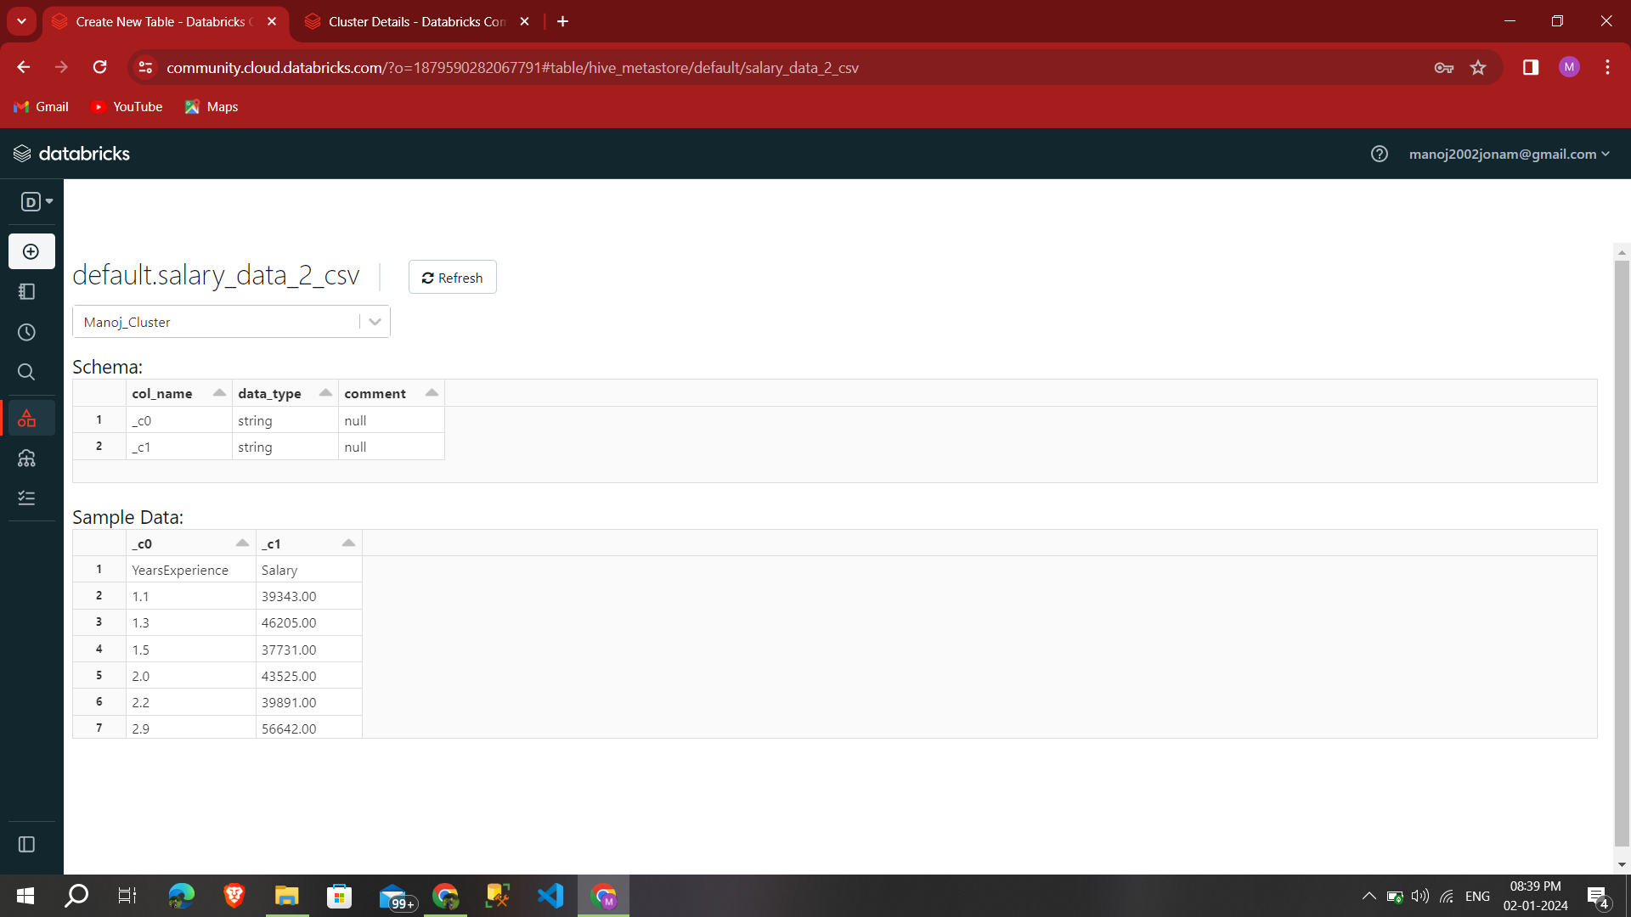

Then **performing some codes** by using the csv files,

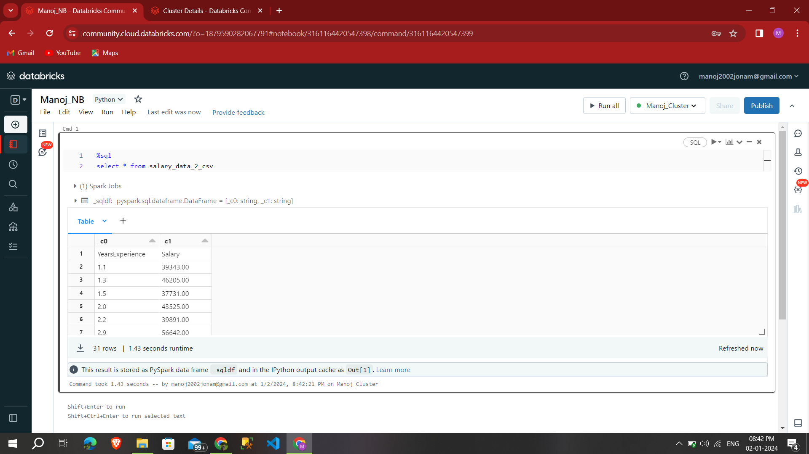

Then displaying the table in **dataframe,**

