Creating **cluster and notebook** in azure databricks:

After successfully logged in the azure portal and selecting the azure databricks service,inside that selecting the **azddatabiba_Hexaware**.

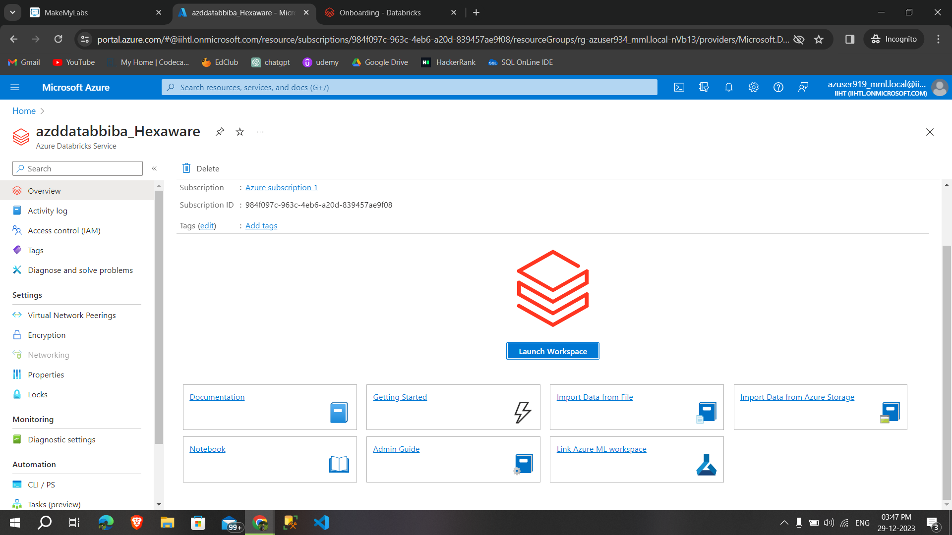

Then **launch the workspace** of azure databricks,after clicking on that redirected to the below page,

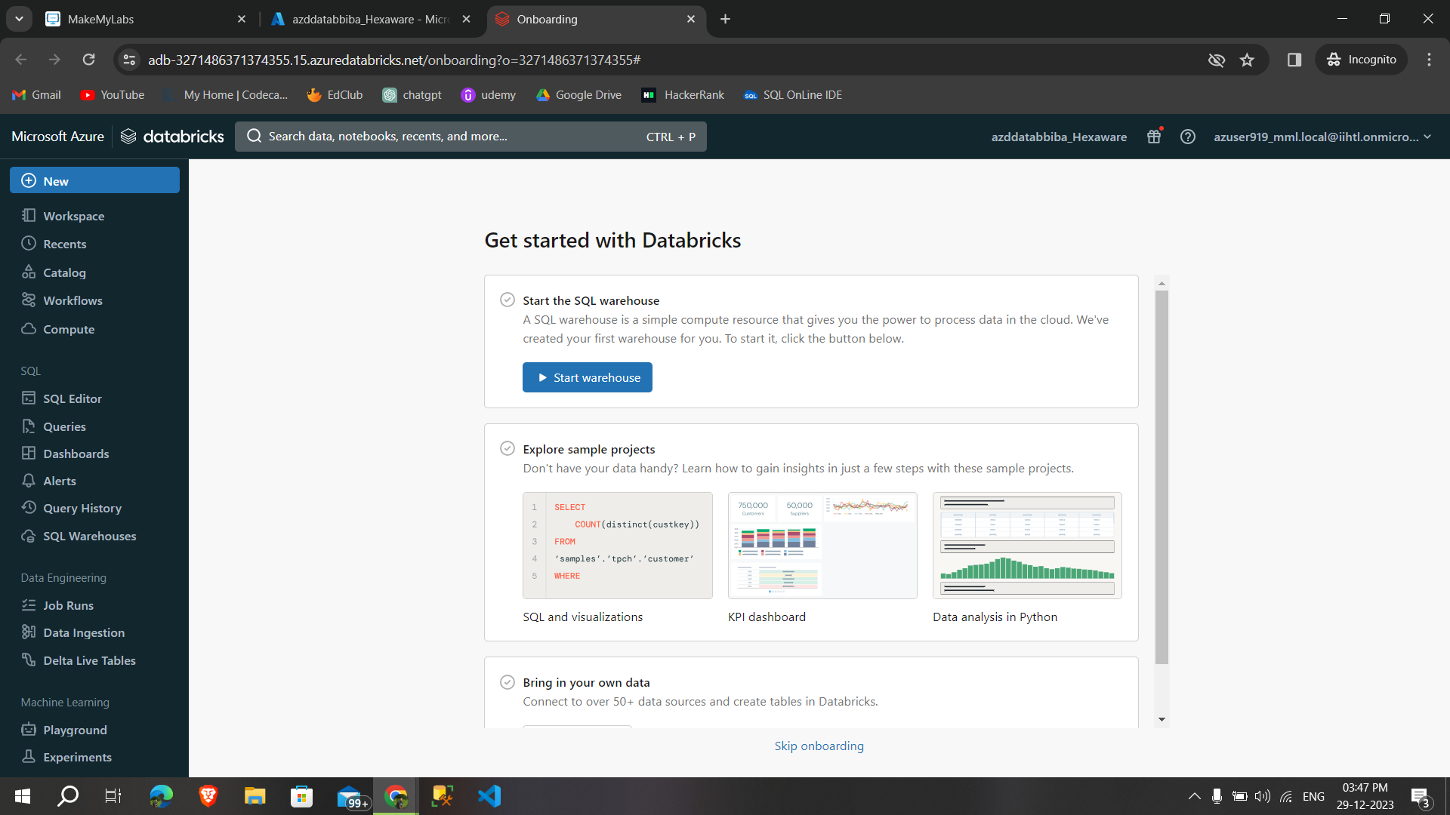

Then click on **new to create a new cluster,**

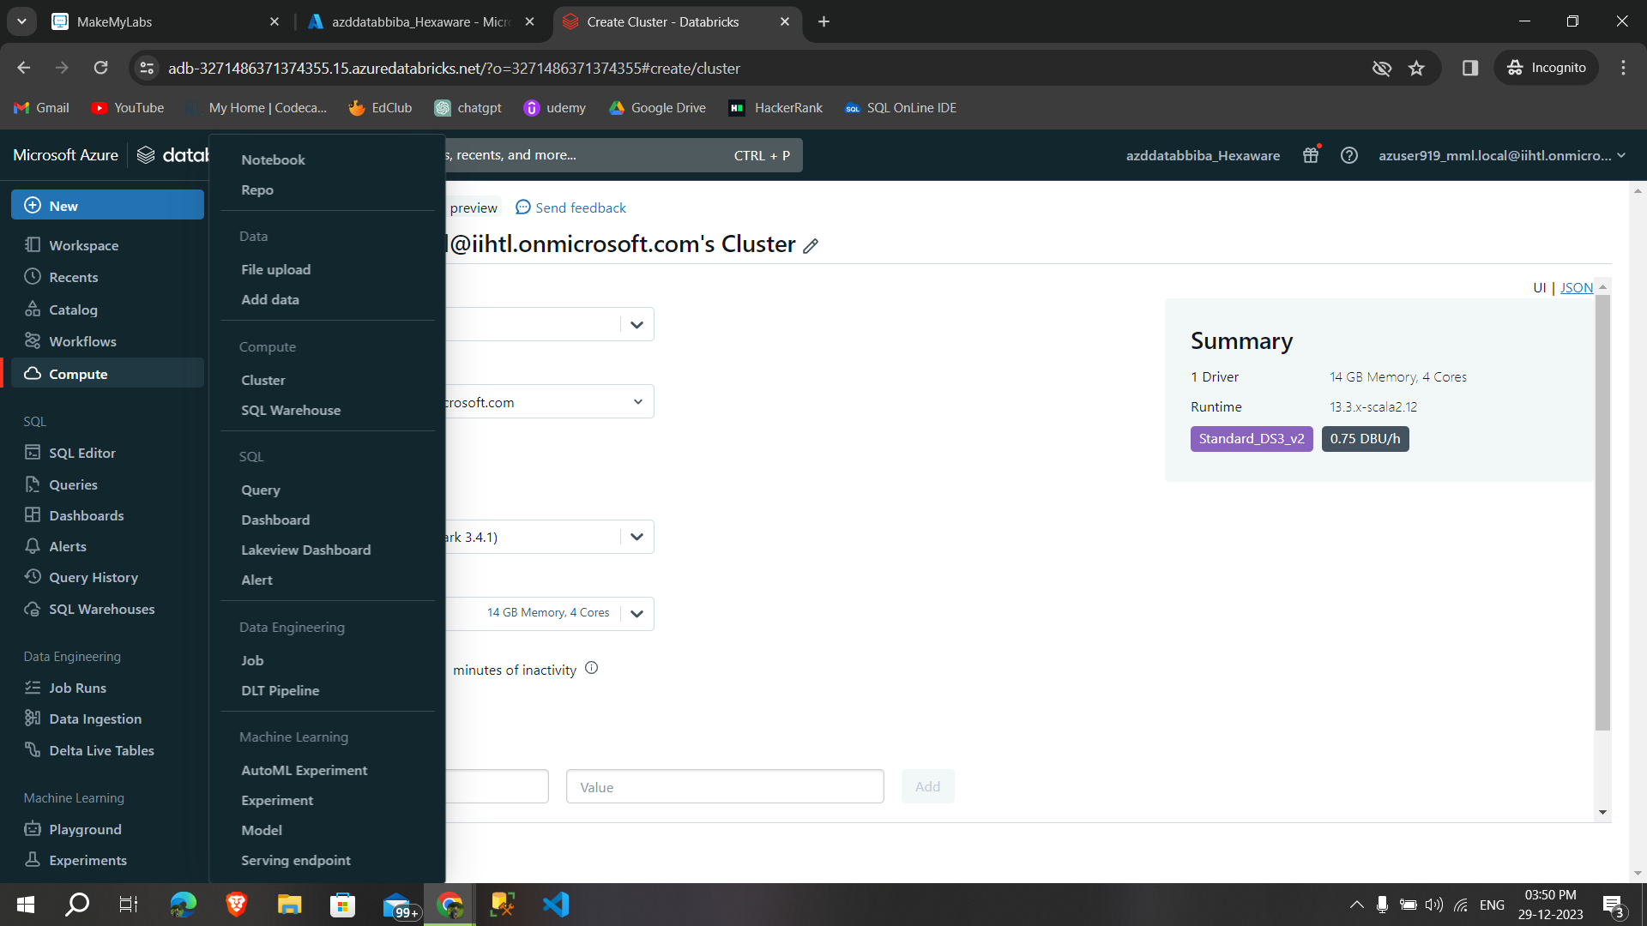

After selecting the cluster, we need to configure the specifications we want. After that, click **"Create Compute" to initiate the process** of creating the cluster.

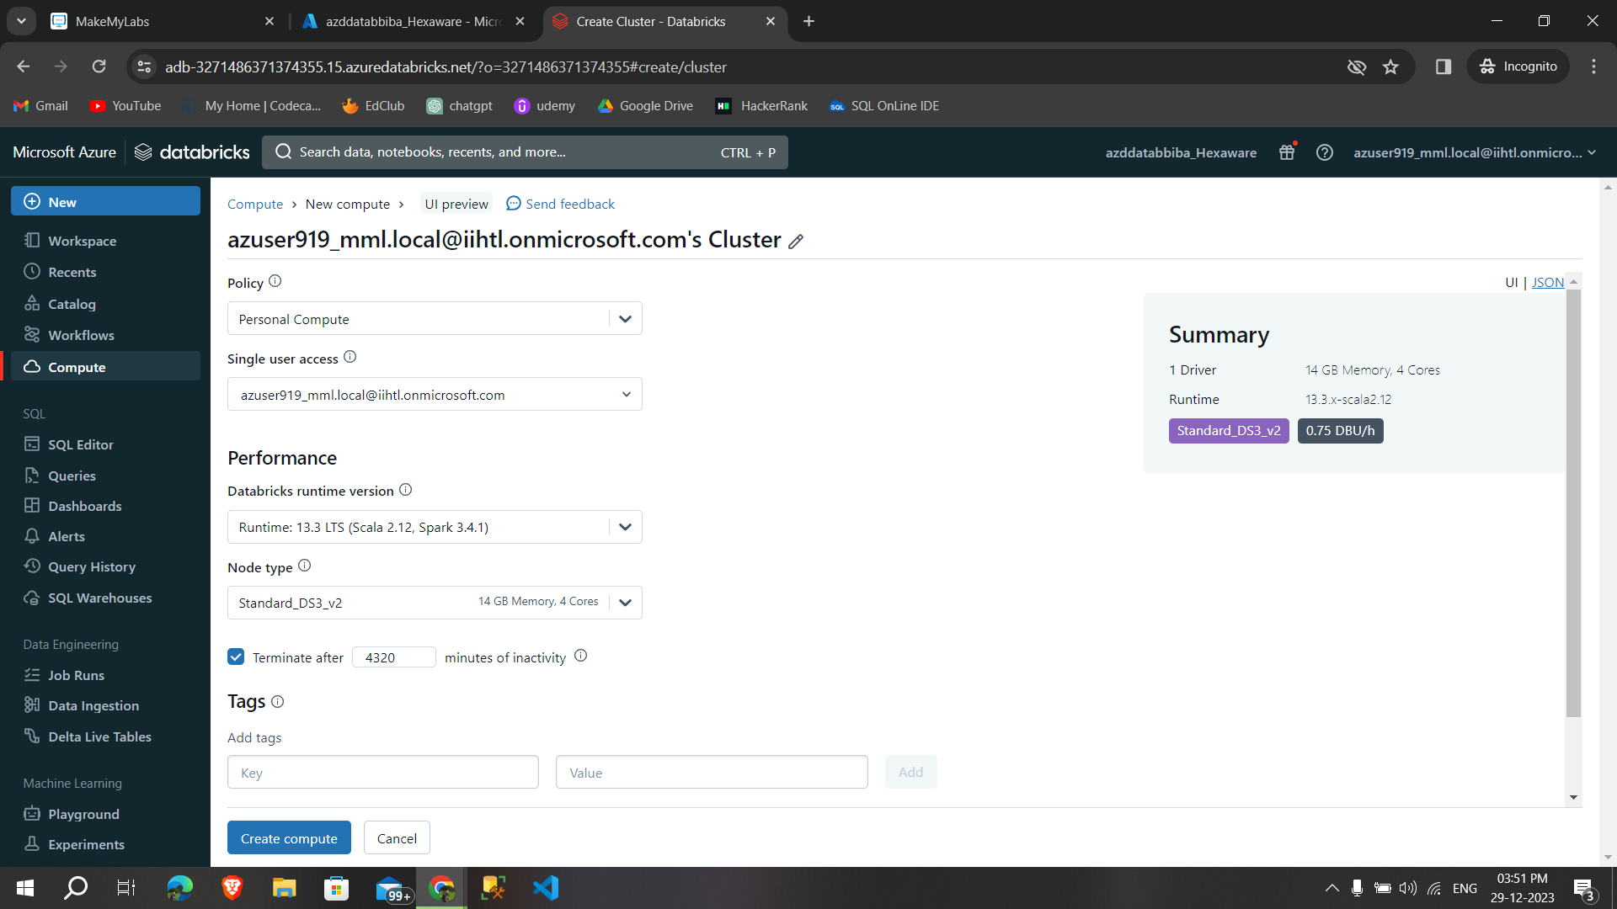

Successfully **created the cluster,**

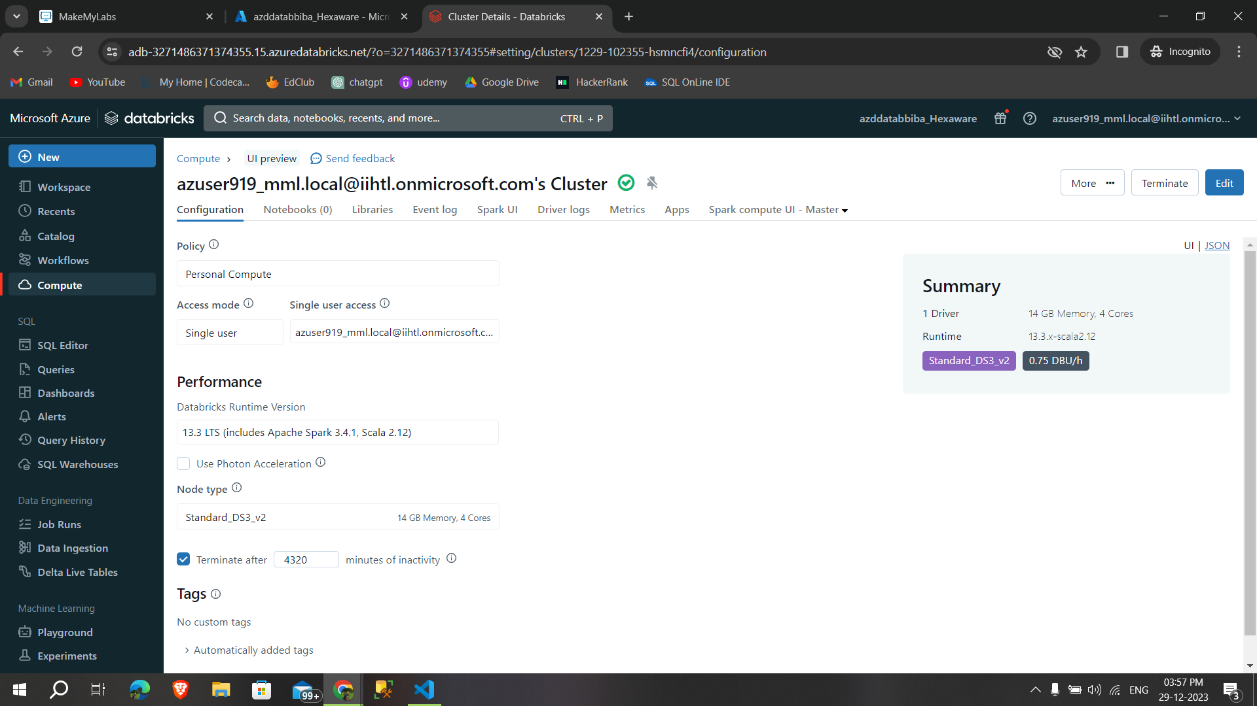

After that click on new to **open a new notebook** in that we can see which cluster we are connecting to the notebook,

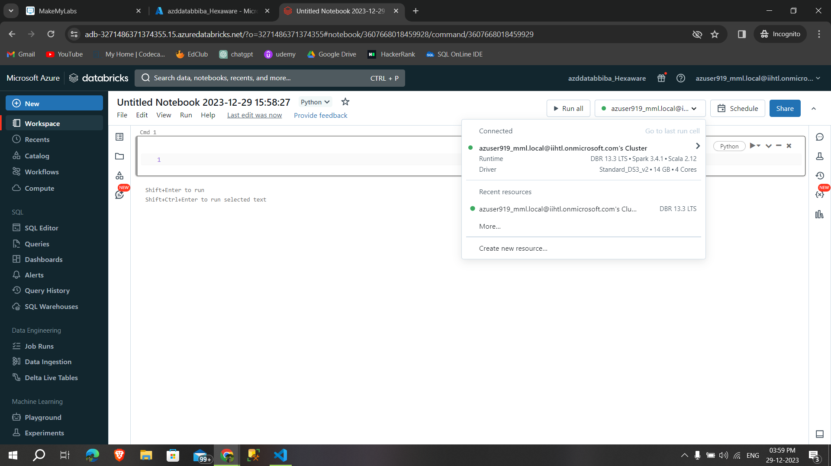

Then type some pyspark commands in that **notebook and run it**

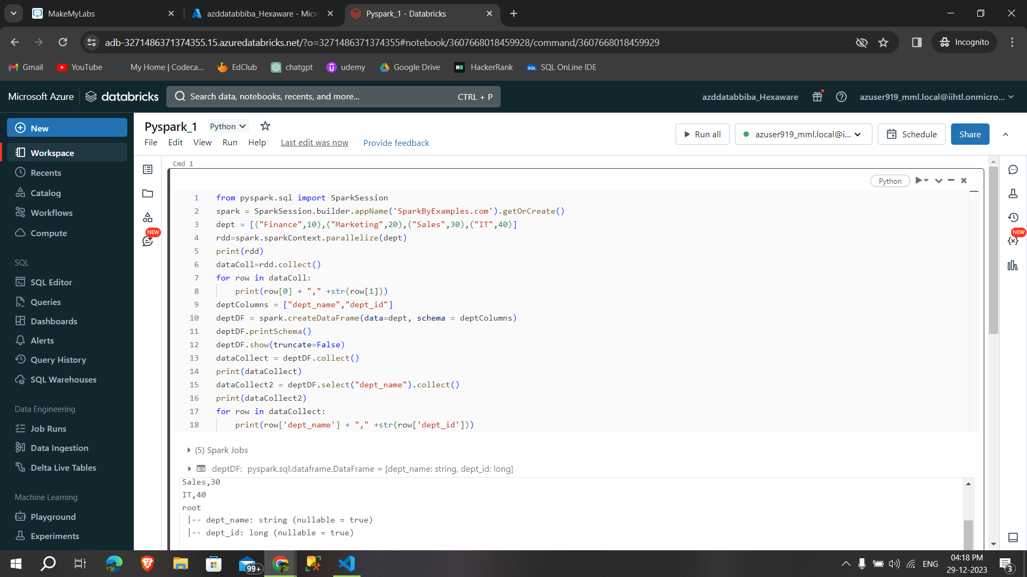

**Continuation**

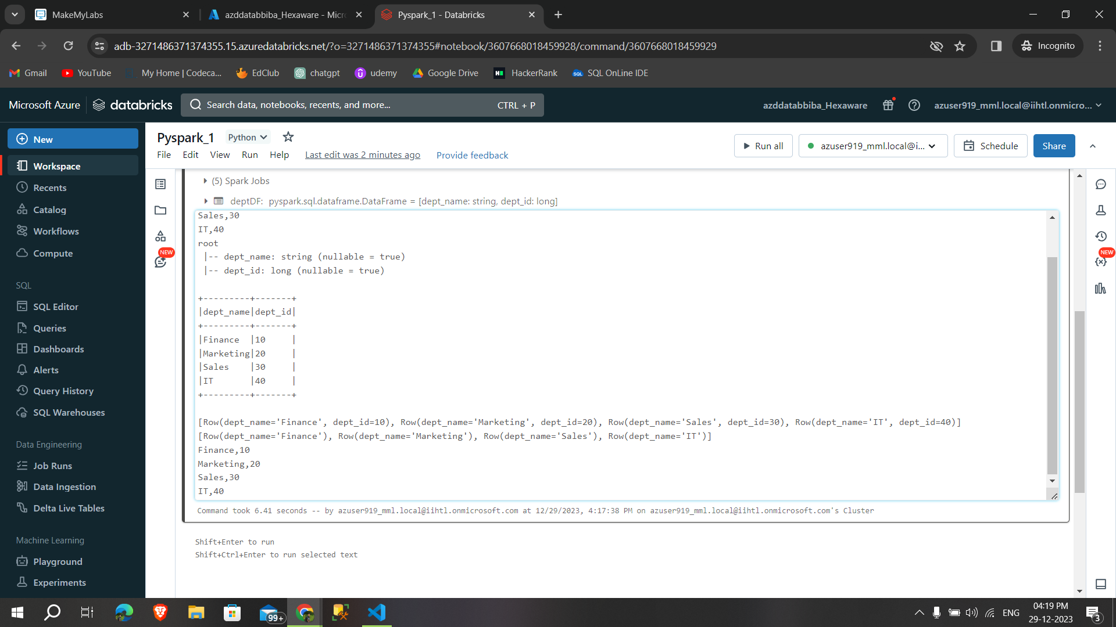

Then in the workspace we can able to see **our recent works,**

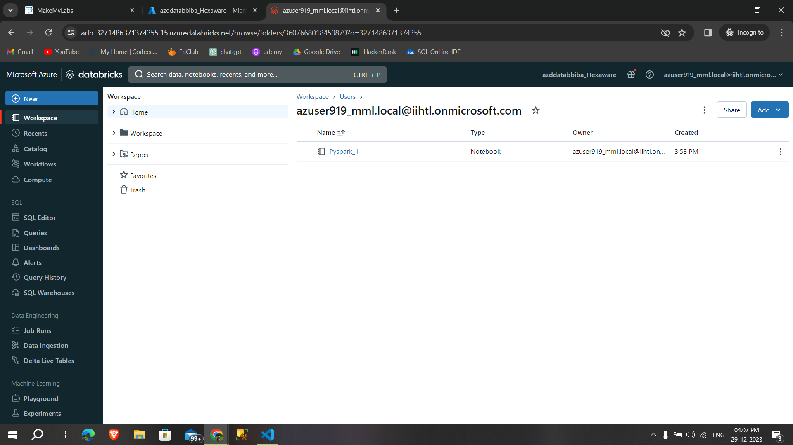

Created a another notebook to **run another pyspark commands**

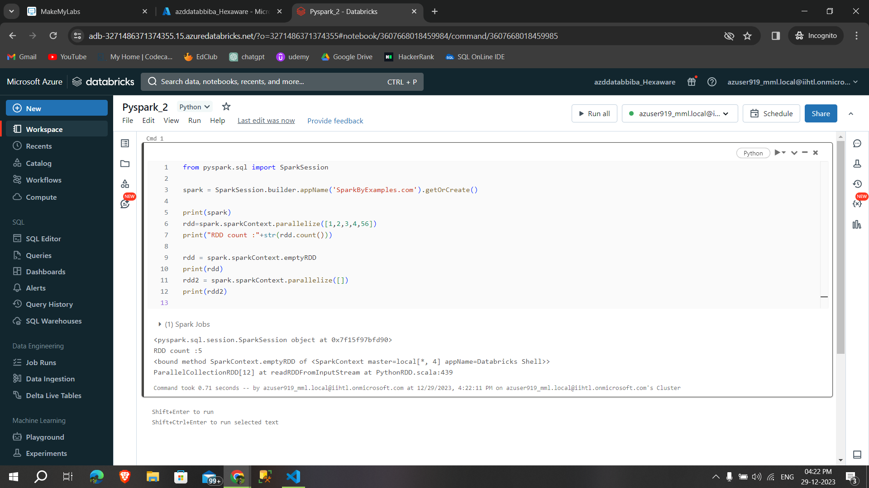

we can able to see **our recent works,**

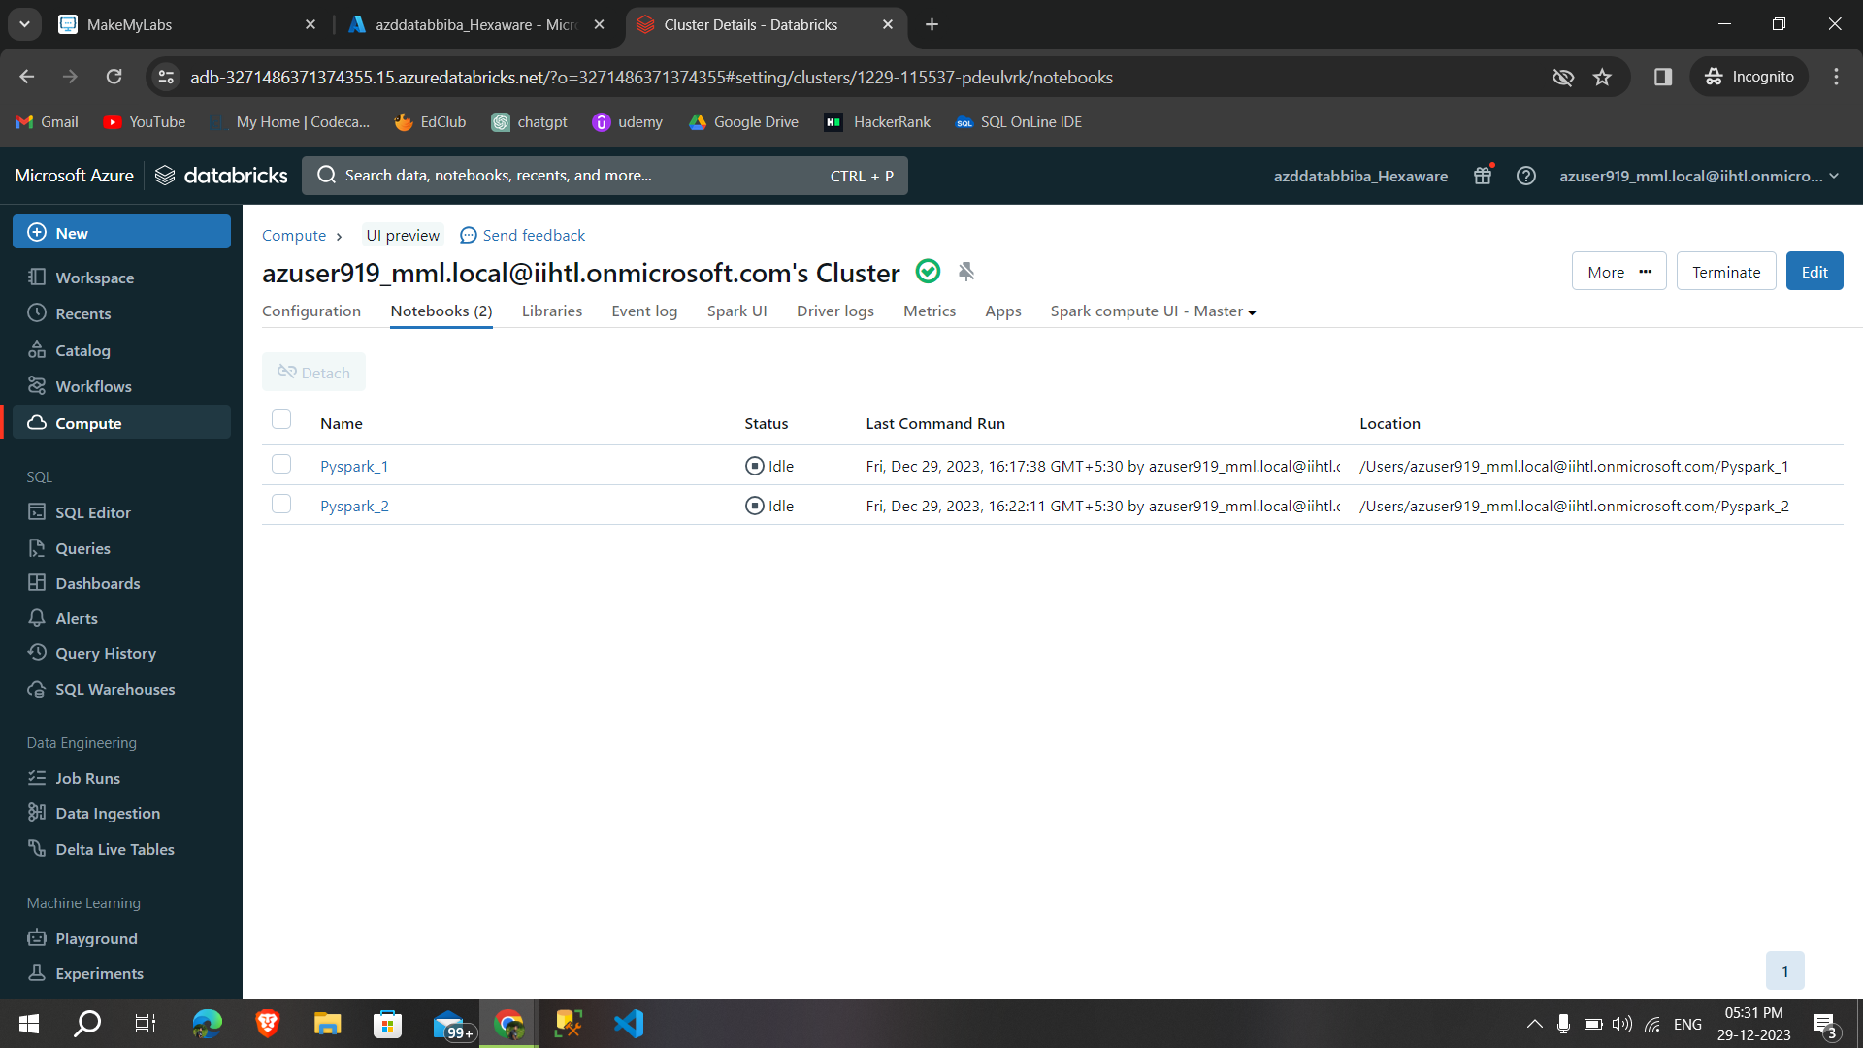

In this tab we can able to **event log,**

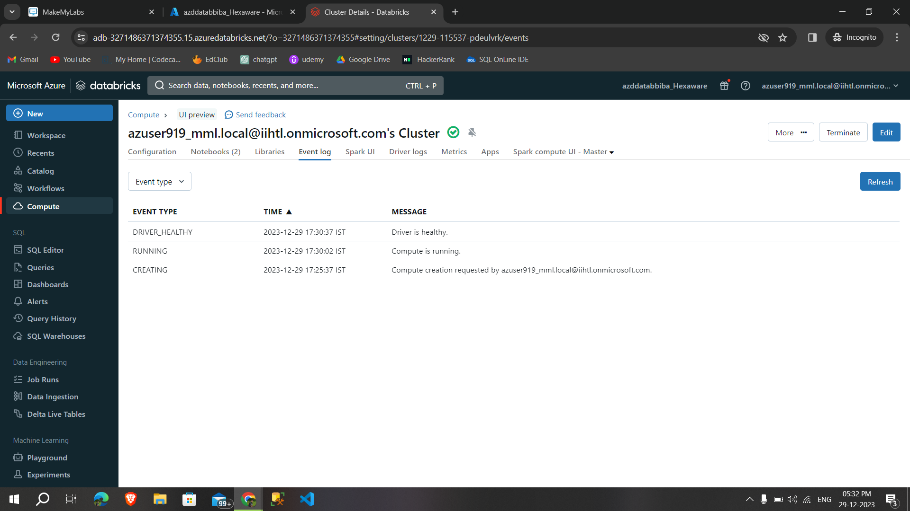

This is the **Spark UI,**

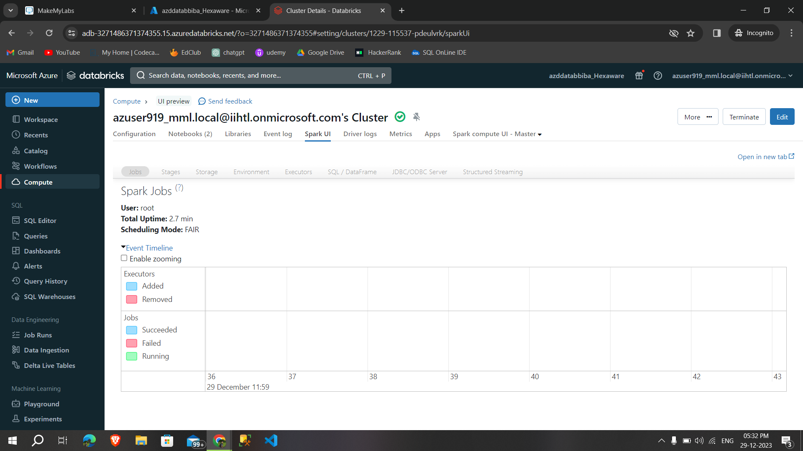

After practicing the commands, I **terminated the cluster** in the Compute tab.

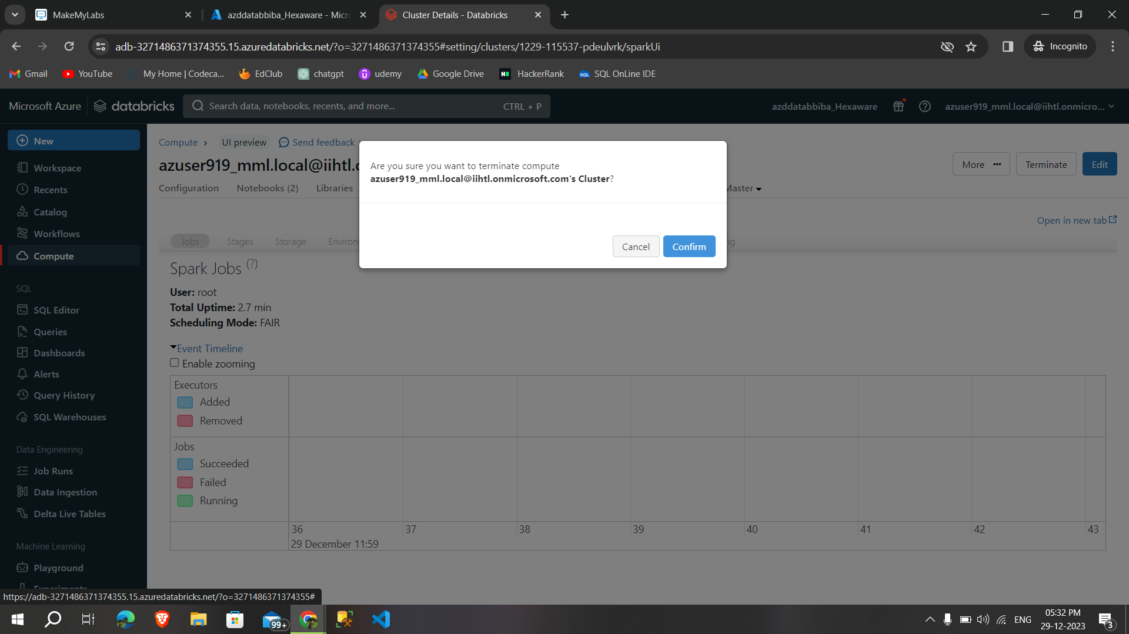

Then **deleted it**,

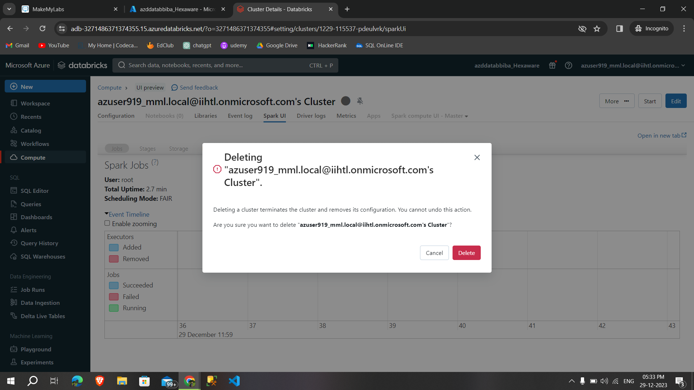

These are the process of creating and deleting the cluster