Create a new visualization

Creating a **databricks workspace,**

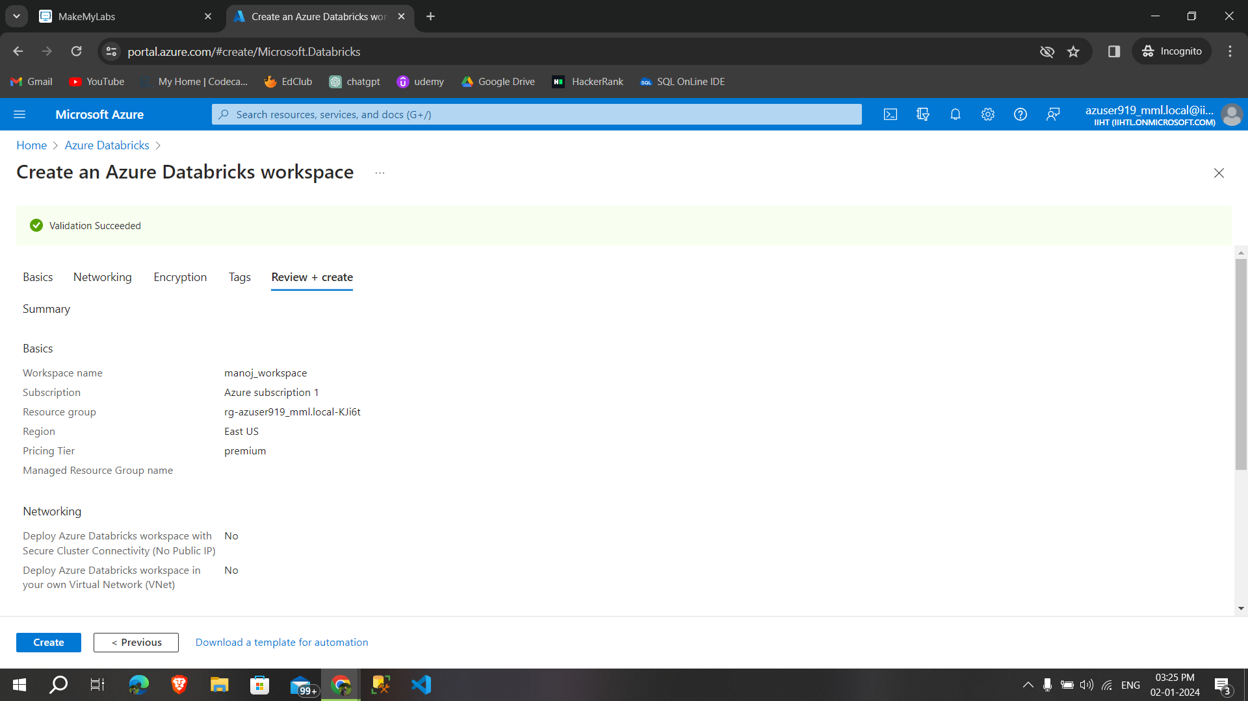

After creating the databricks workspace and **created a cluster**, creating a notebook and running the commands

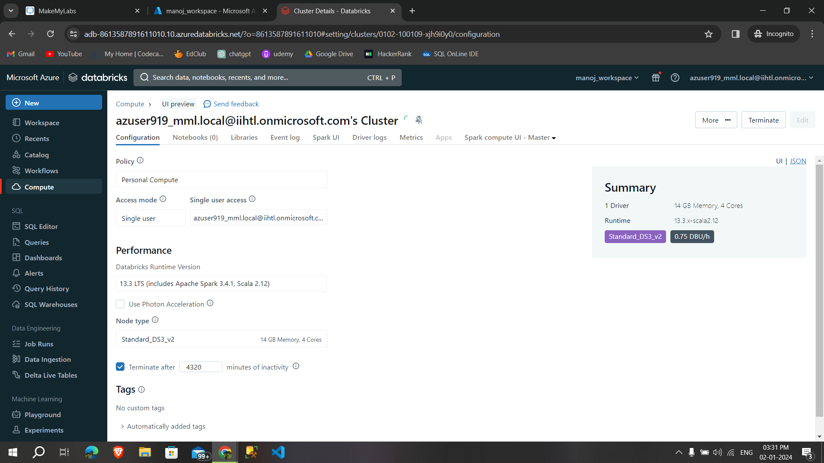

With the help of using some csv files**,displaying the content**

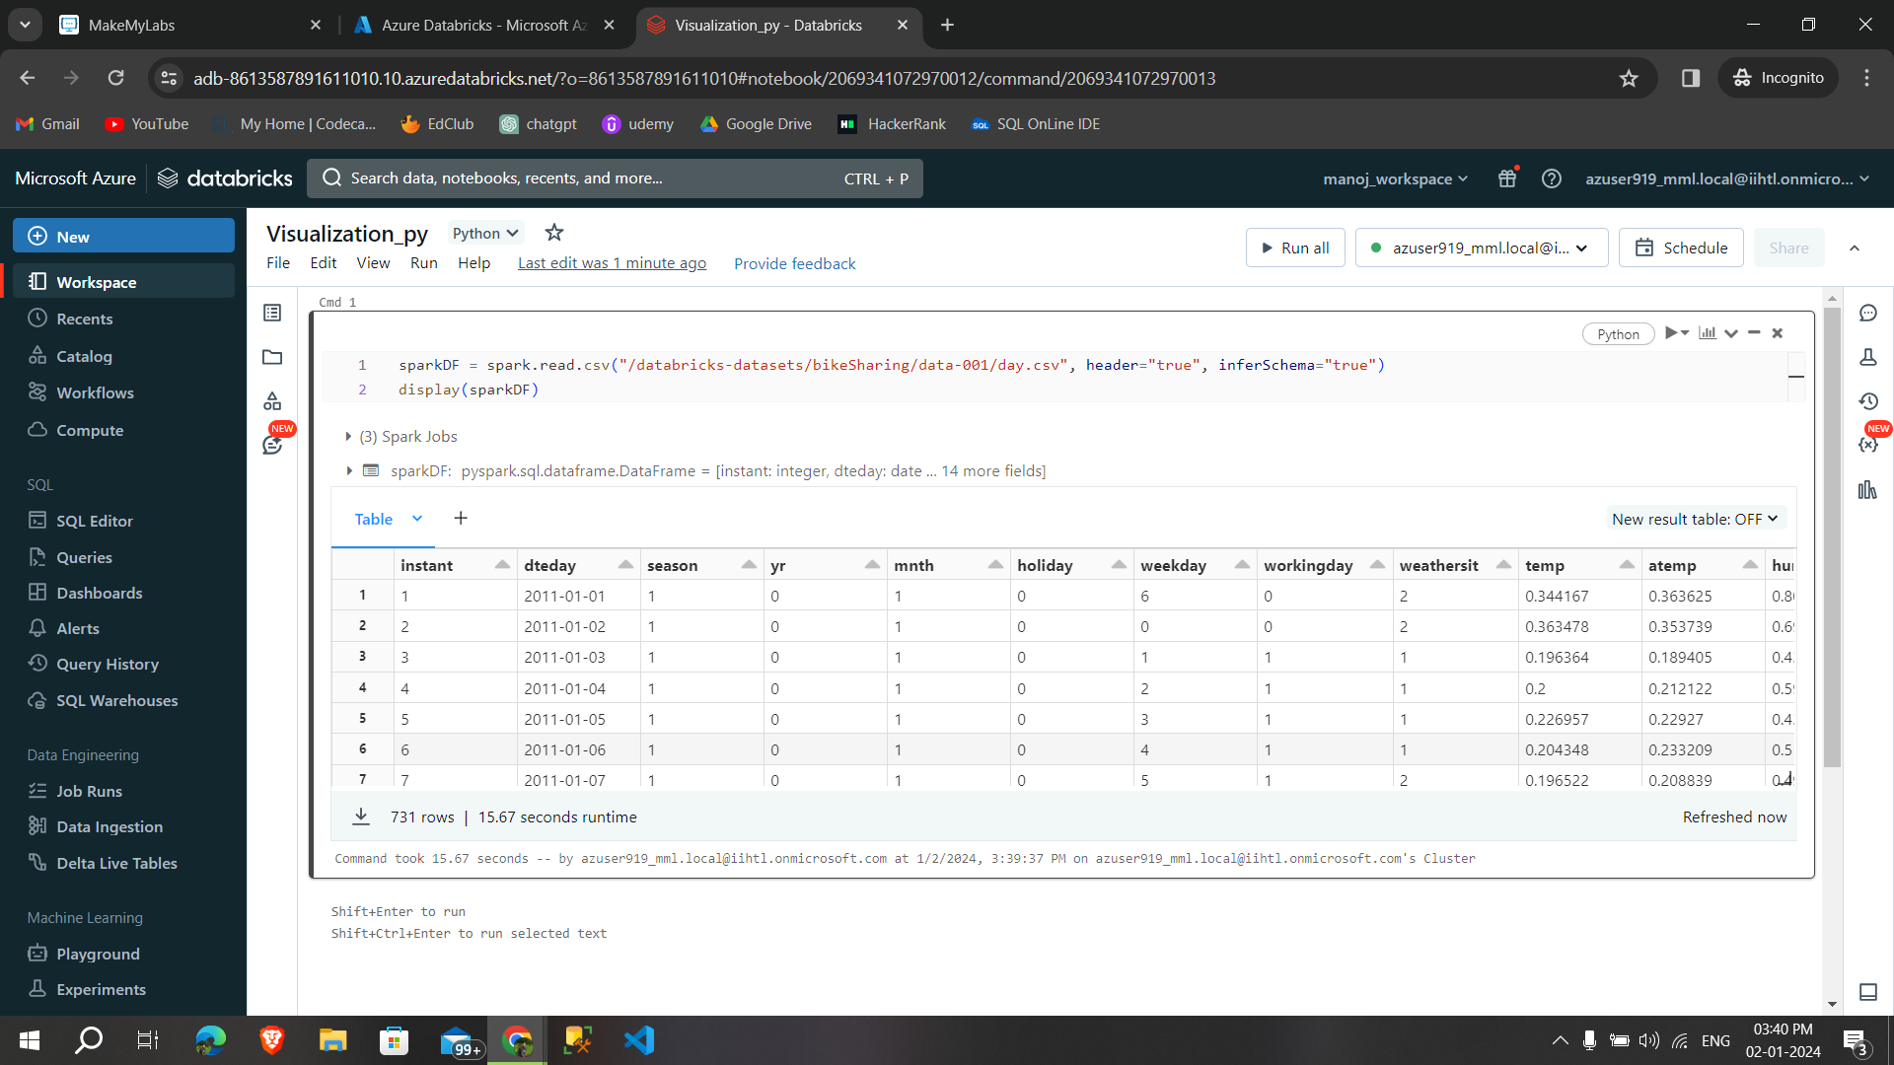

To create a **visualization**, click + above a result and **select Visualization**. The visualization editor appears.

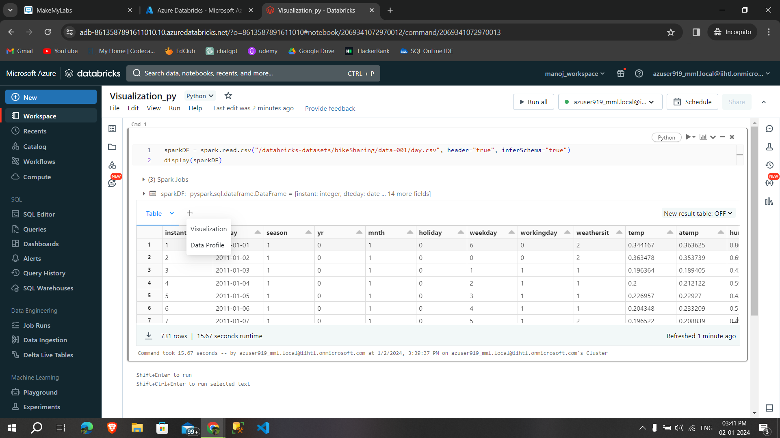

In the **Visualization Type** drop-down, choose a type.Select the data to appear in the visualization. Click **Save.**

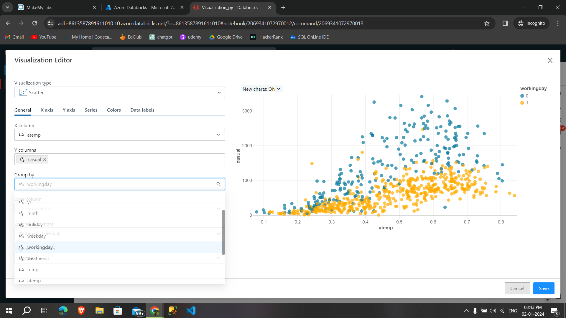

After **saving the visualization** ,it shows in the output

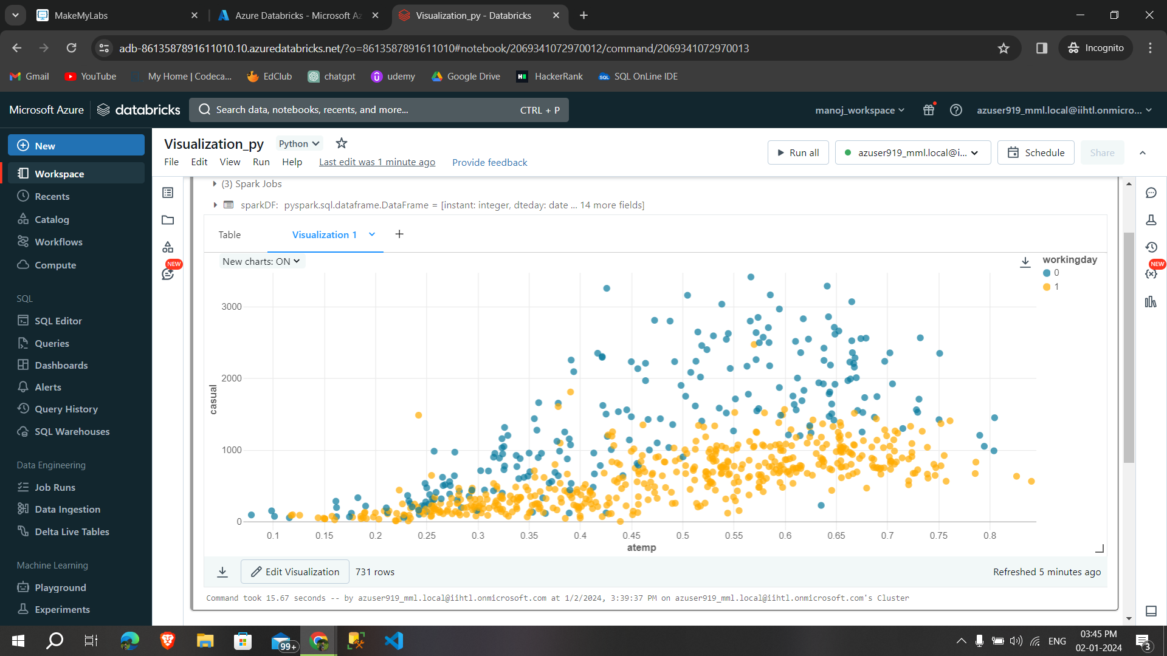

Create a **new data profile**

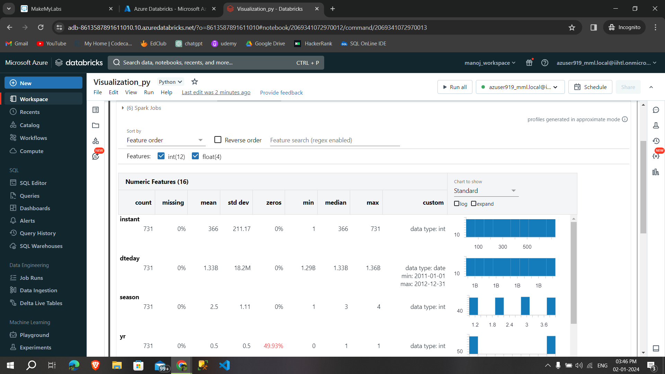

Work with visualizations and data profiles, we can **remove,duplicate and rename the data profile**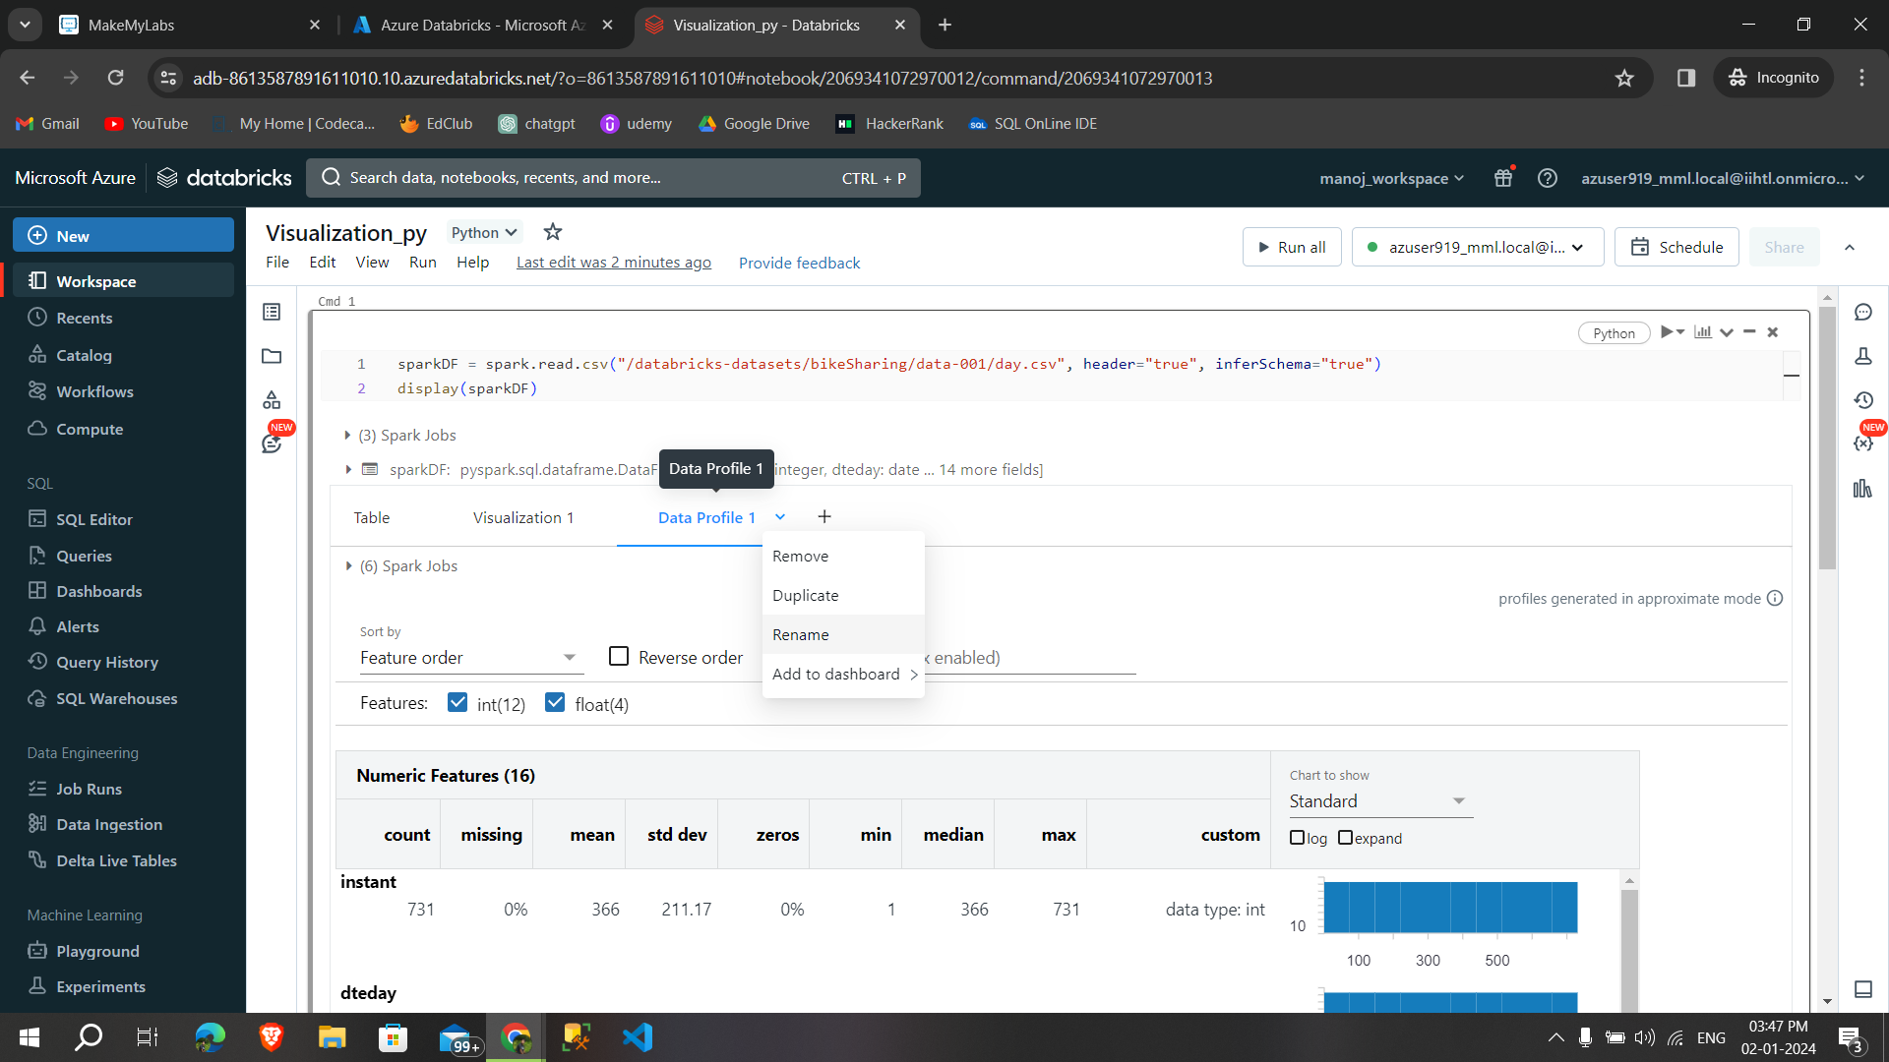

We can also change the **colors in the color tab,**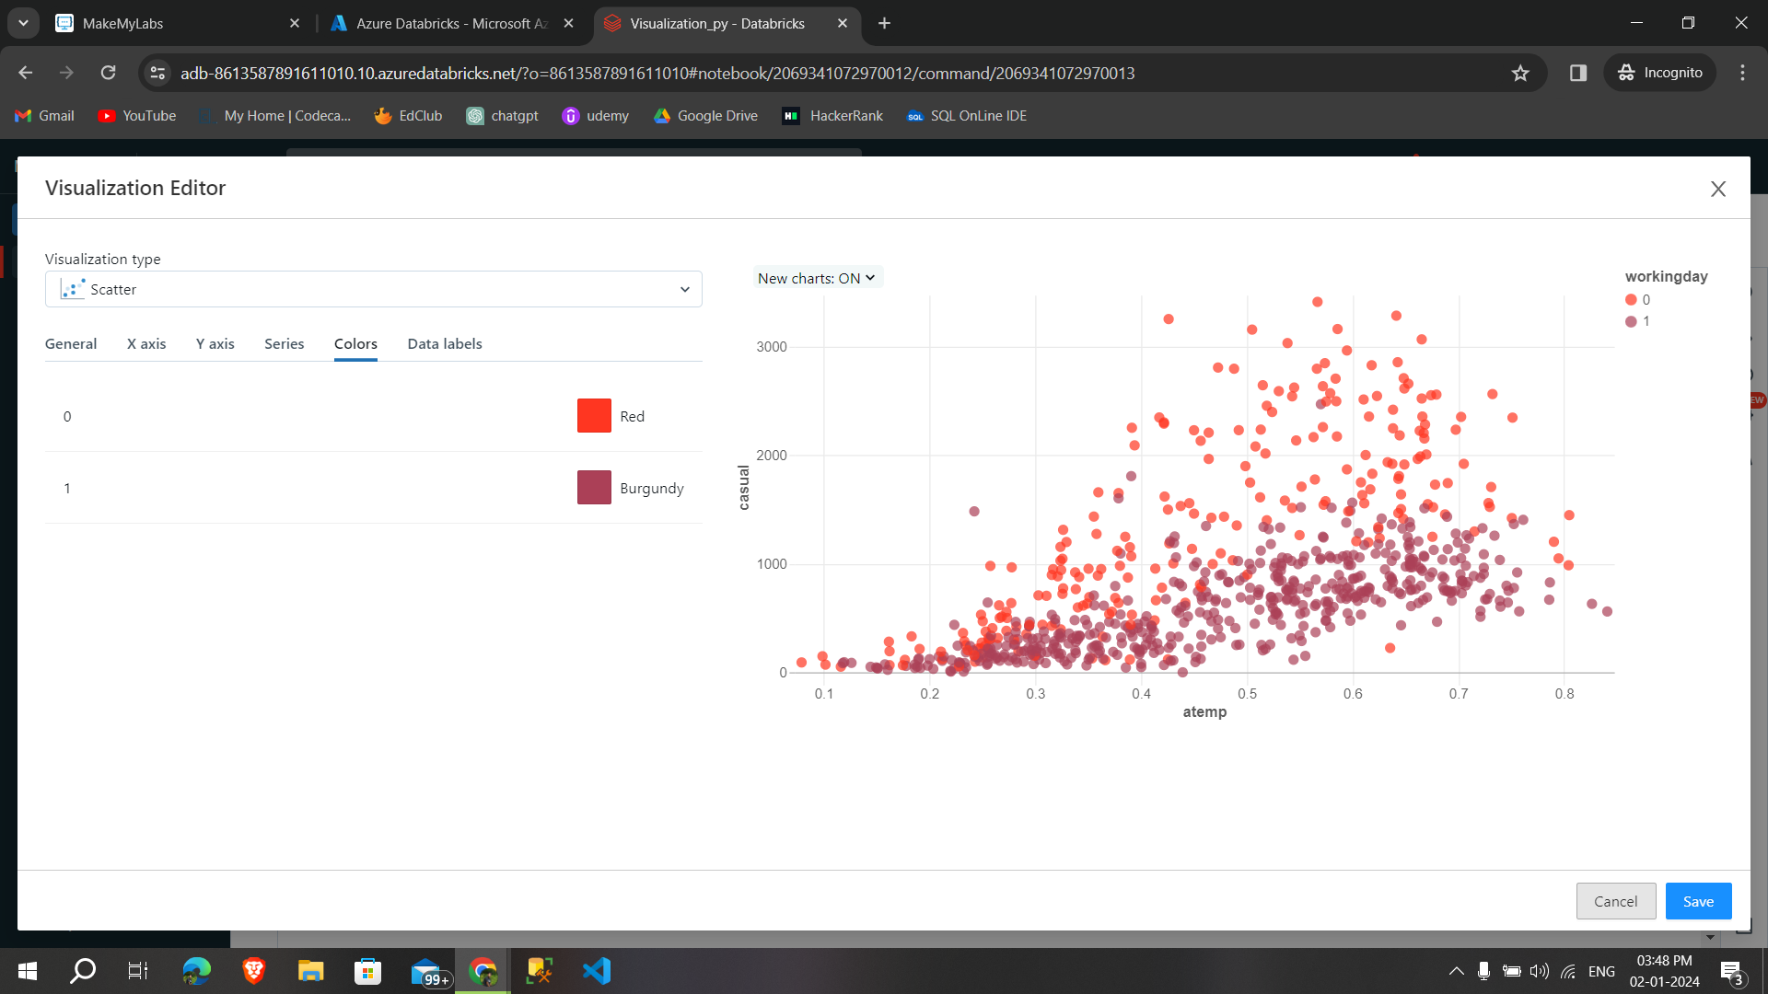

Visualization tools

If you hover over the top right of a chart in the visualization editor, a Plotly toolbar appears where you can perform operations such as select, zoom, and pan.



These are the process of creating a visualization and functions.