**Login process:**

**Make my lab Login page** 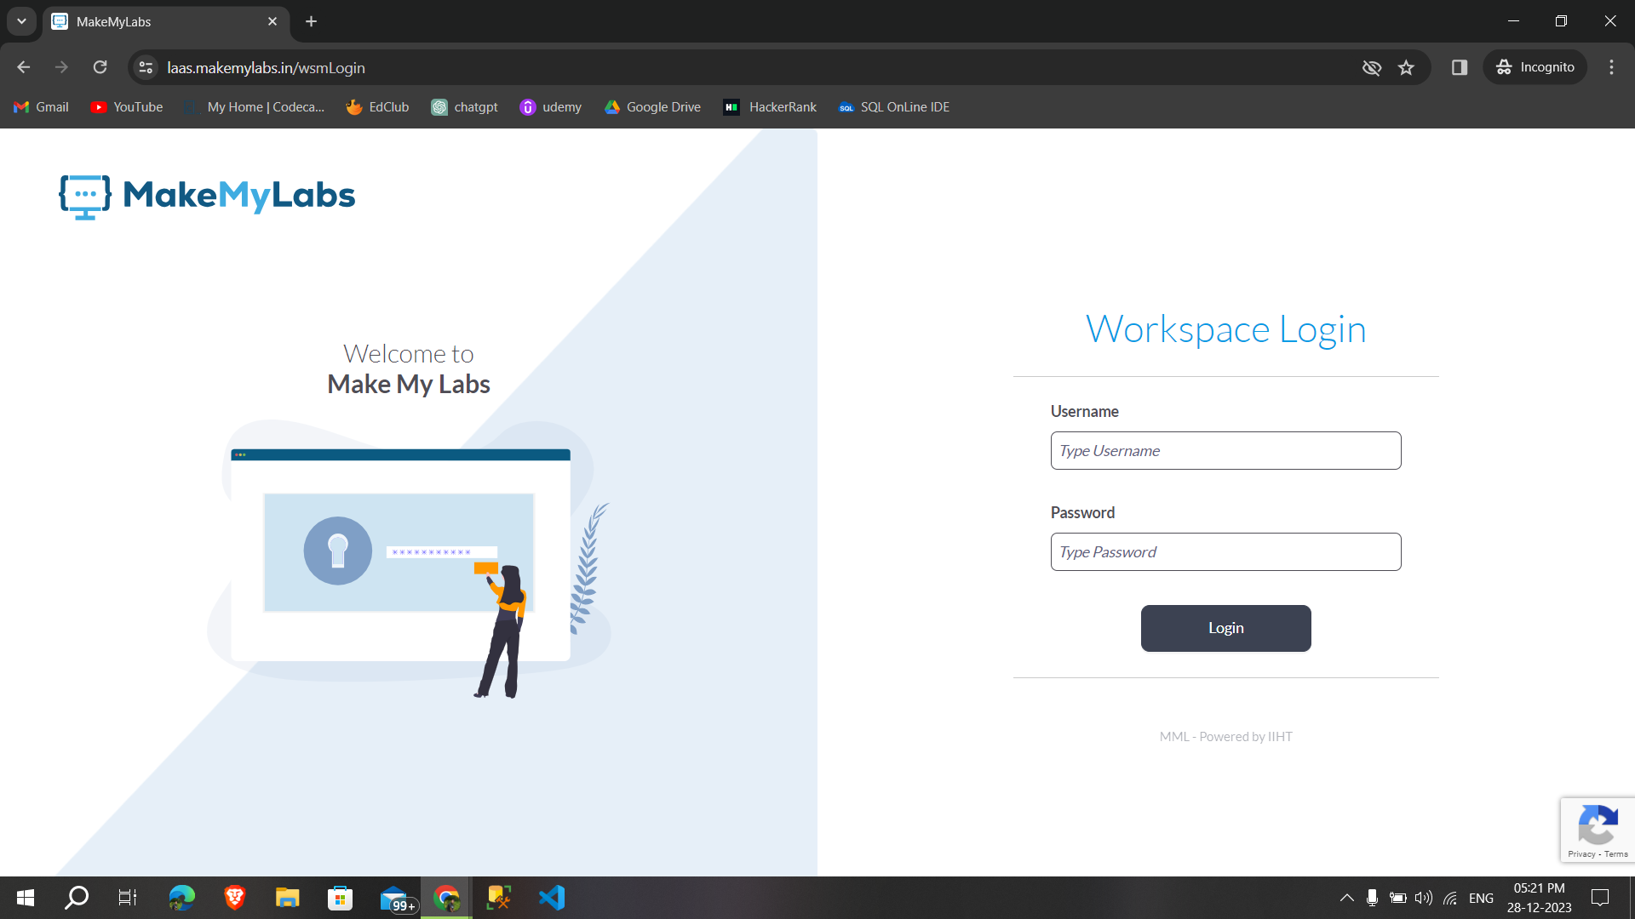

**By using the credentials that are in the mail logged in successfully:**

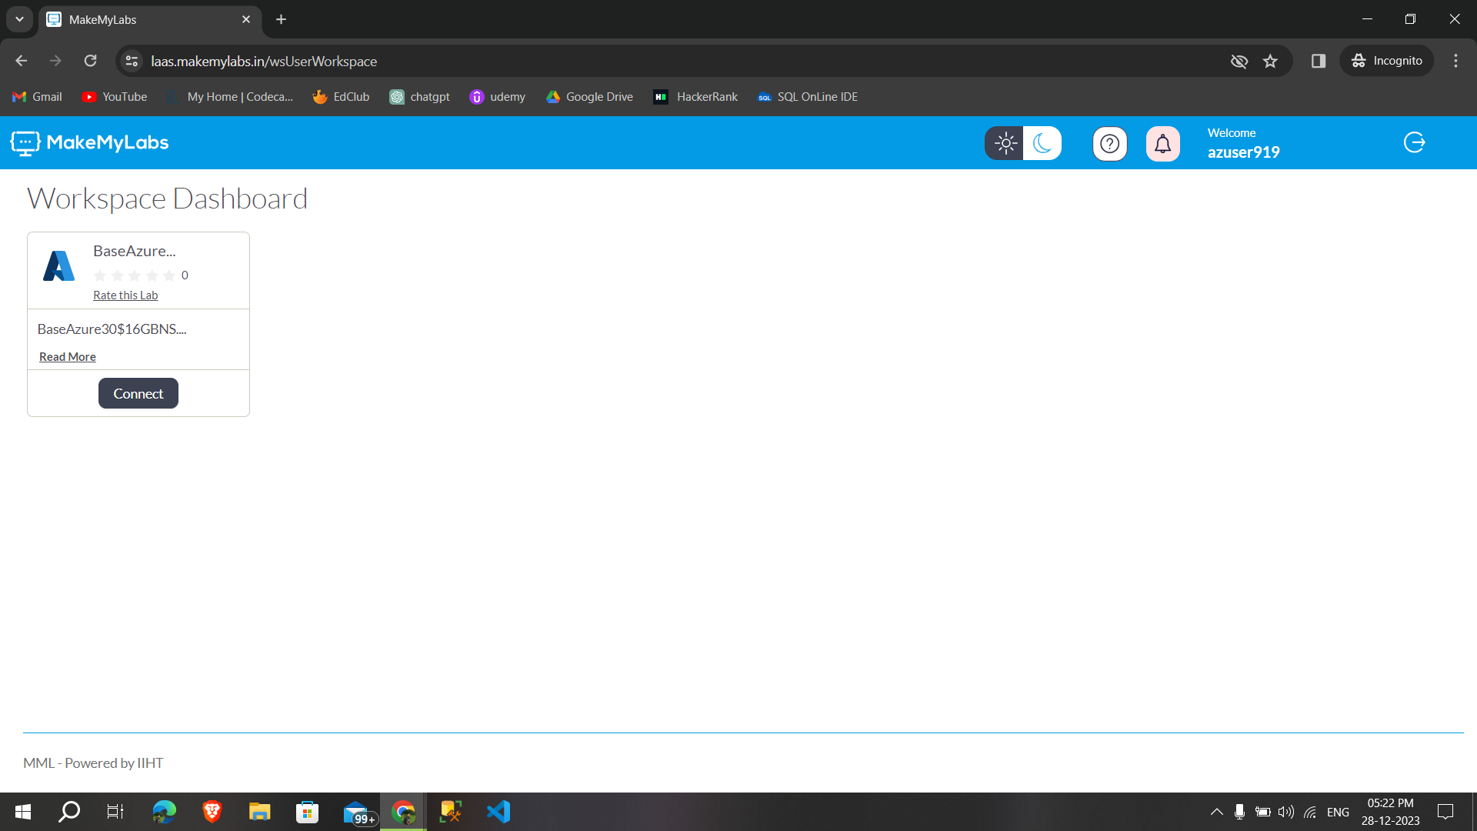

**After clicking on the connect goes to the another page that provides temporary password and username:**

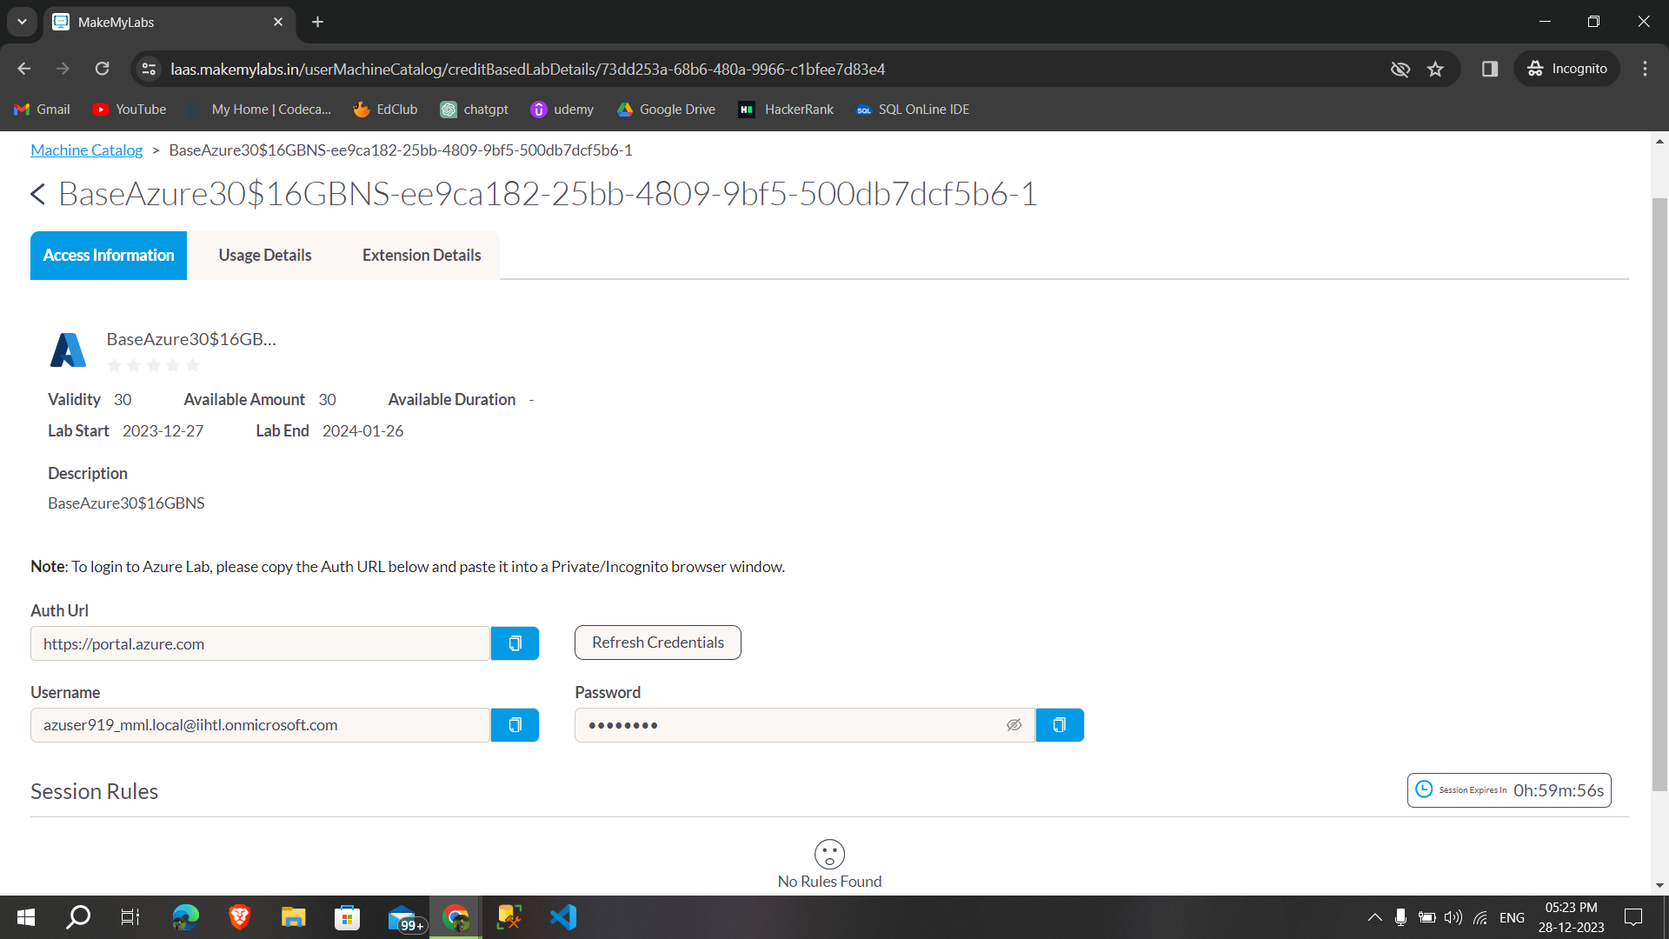

**By using those temporary password and username successfully opened the azure account:**

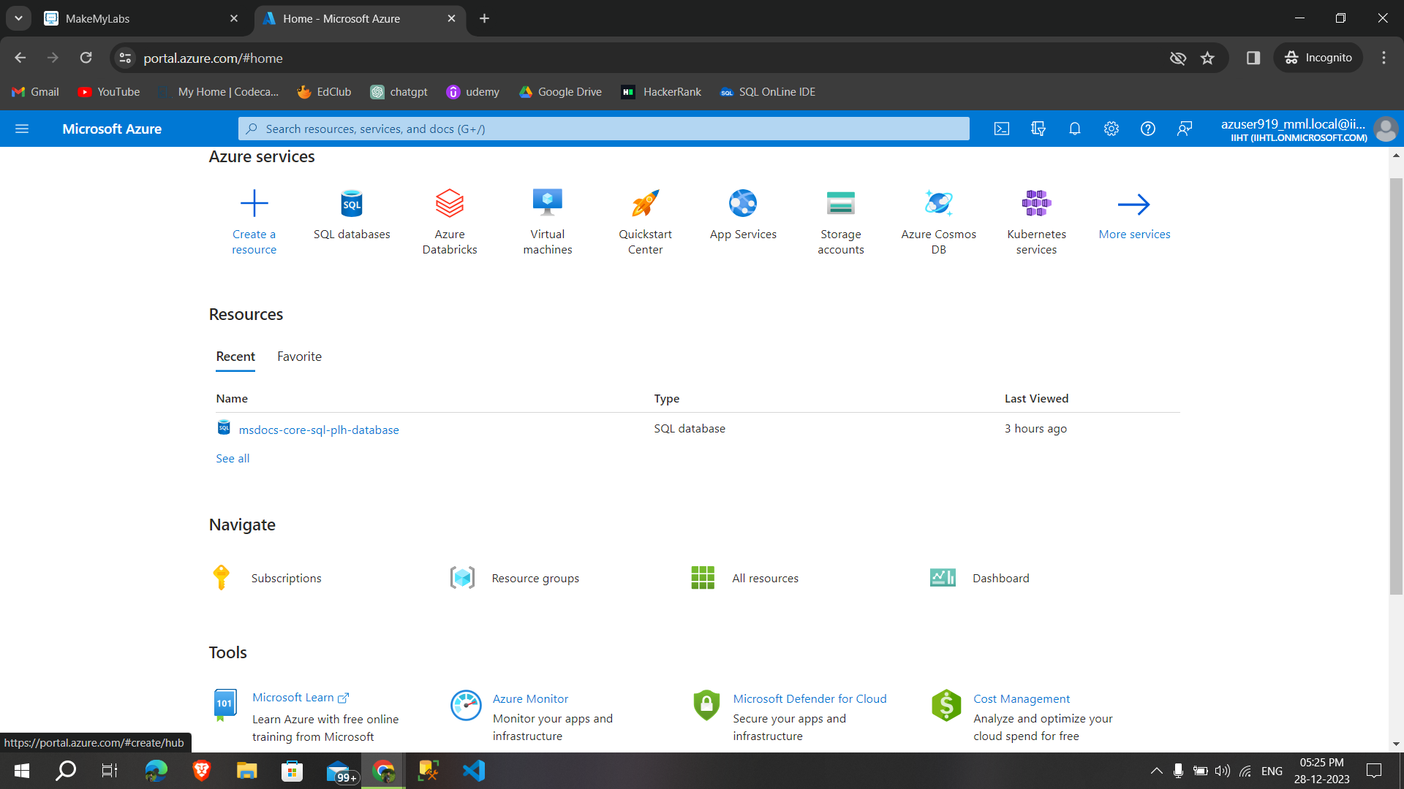

**Introduction to Azure Databricks:**

* Azure Databricks is a cloud-based big data analytics platform provided by Microsoft Azure in collaboration with Databricks.

**Apache Spark:**

* It is an open-source, distributed computing system that provides fast and general-purpose cluster-computing frameworks for big data processing.

**Databricks:**

* A unified analytics platform that integrates various components to facilitate collaborative and efficient big data and machine learning workflows.Those are
  + - **Clusters**
    - **Workspace/Notebook**
    - **MLFlow**
    - **SQL Analytics**
    - **Administration Controls**
    - **Delta Lake**
    - **Optimized Spark** (5x faster)
    - **Databases/Tables**

Some **key aspects** of Azure Databricks:

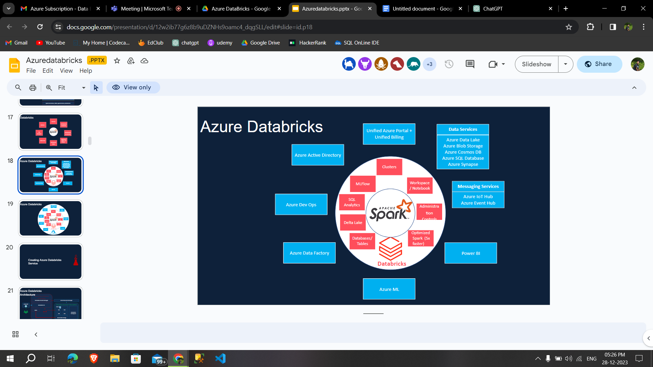

It combines Apache Spark, a powerful open-source analytics engine, with Azure cloud services to provide a collaborative and scalable environment for big data and machine learning workloads.

