**Basic Functions of Spark**

With some random csv files using these pyspark commands,

**Reading a file and show:**

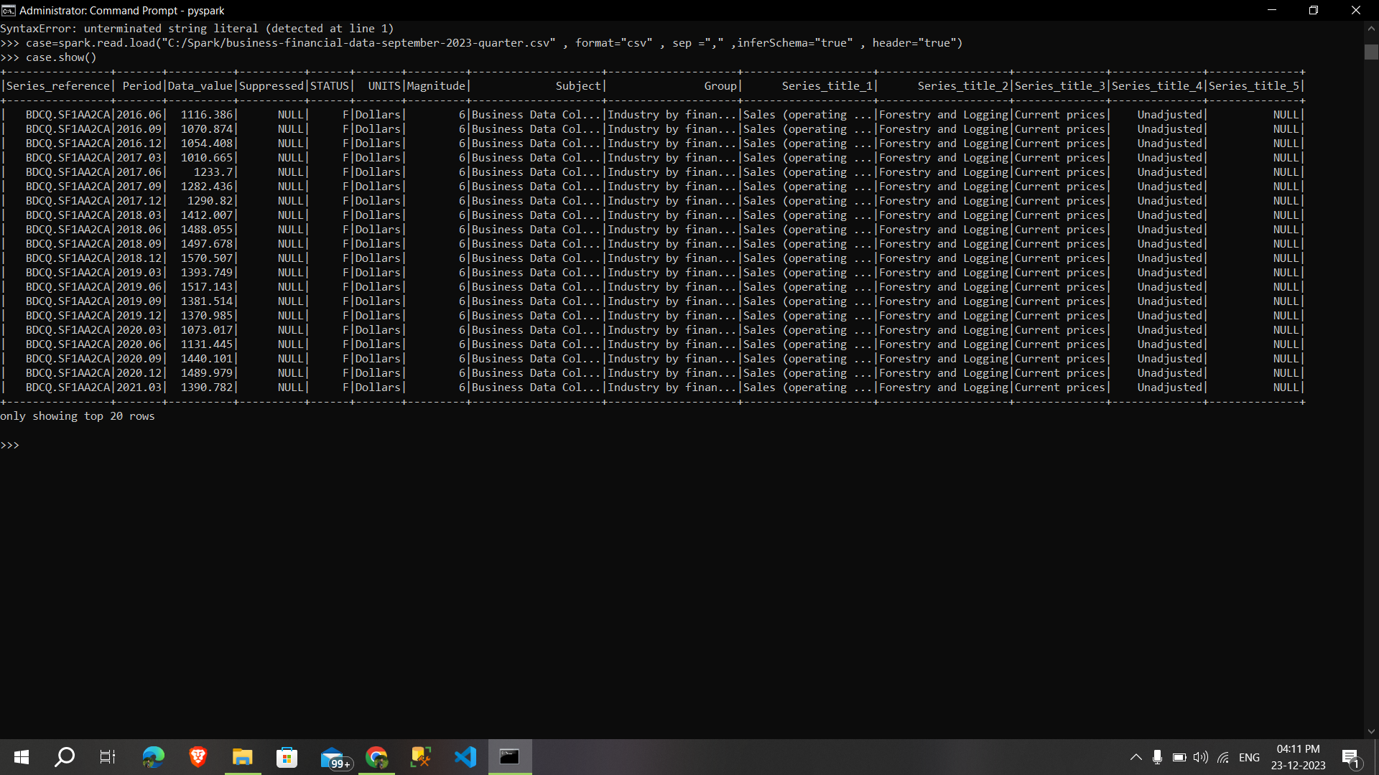

**Changing the column name:**

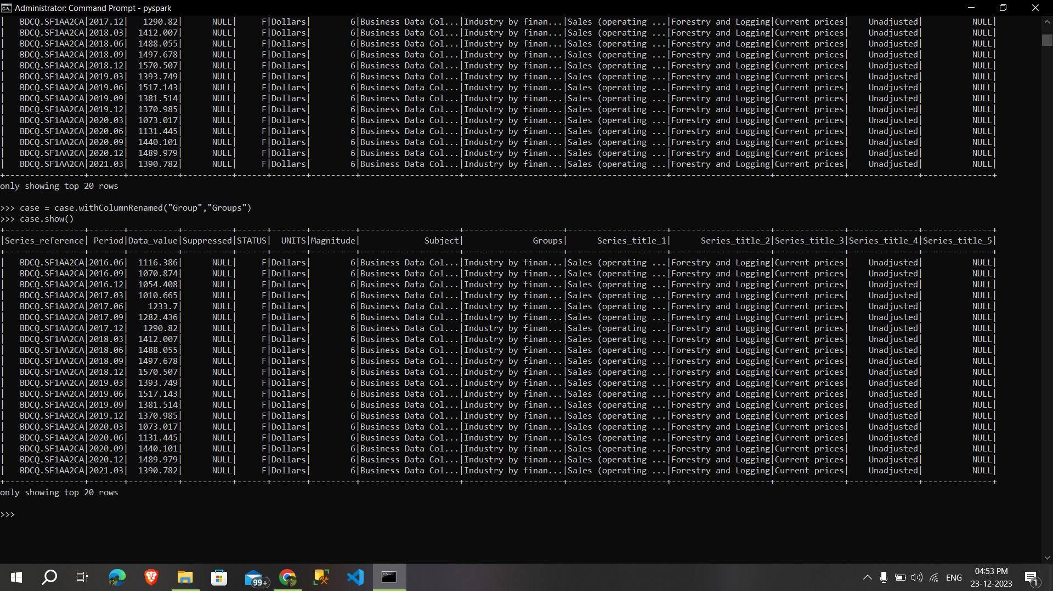

**Selecting particular column:**

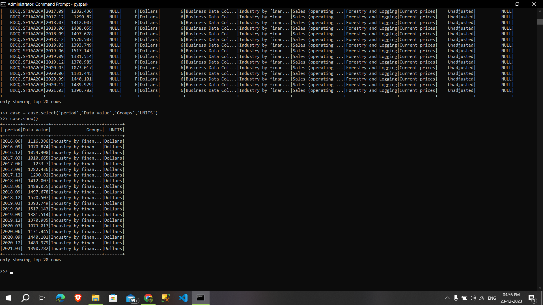

**Sorting the particular column:**

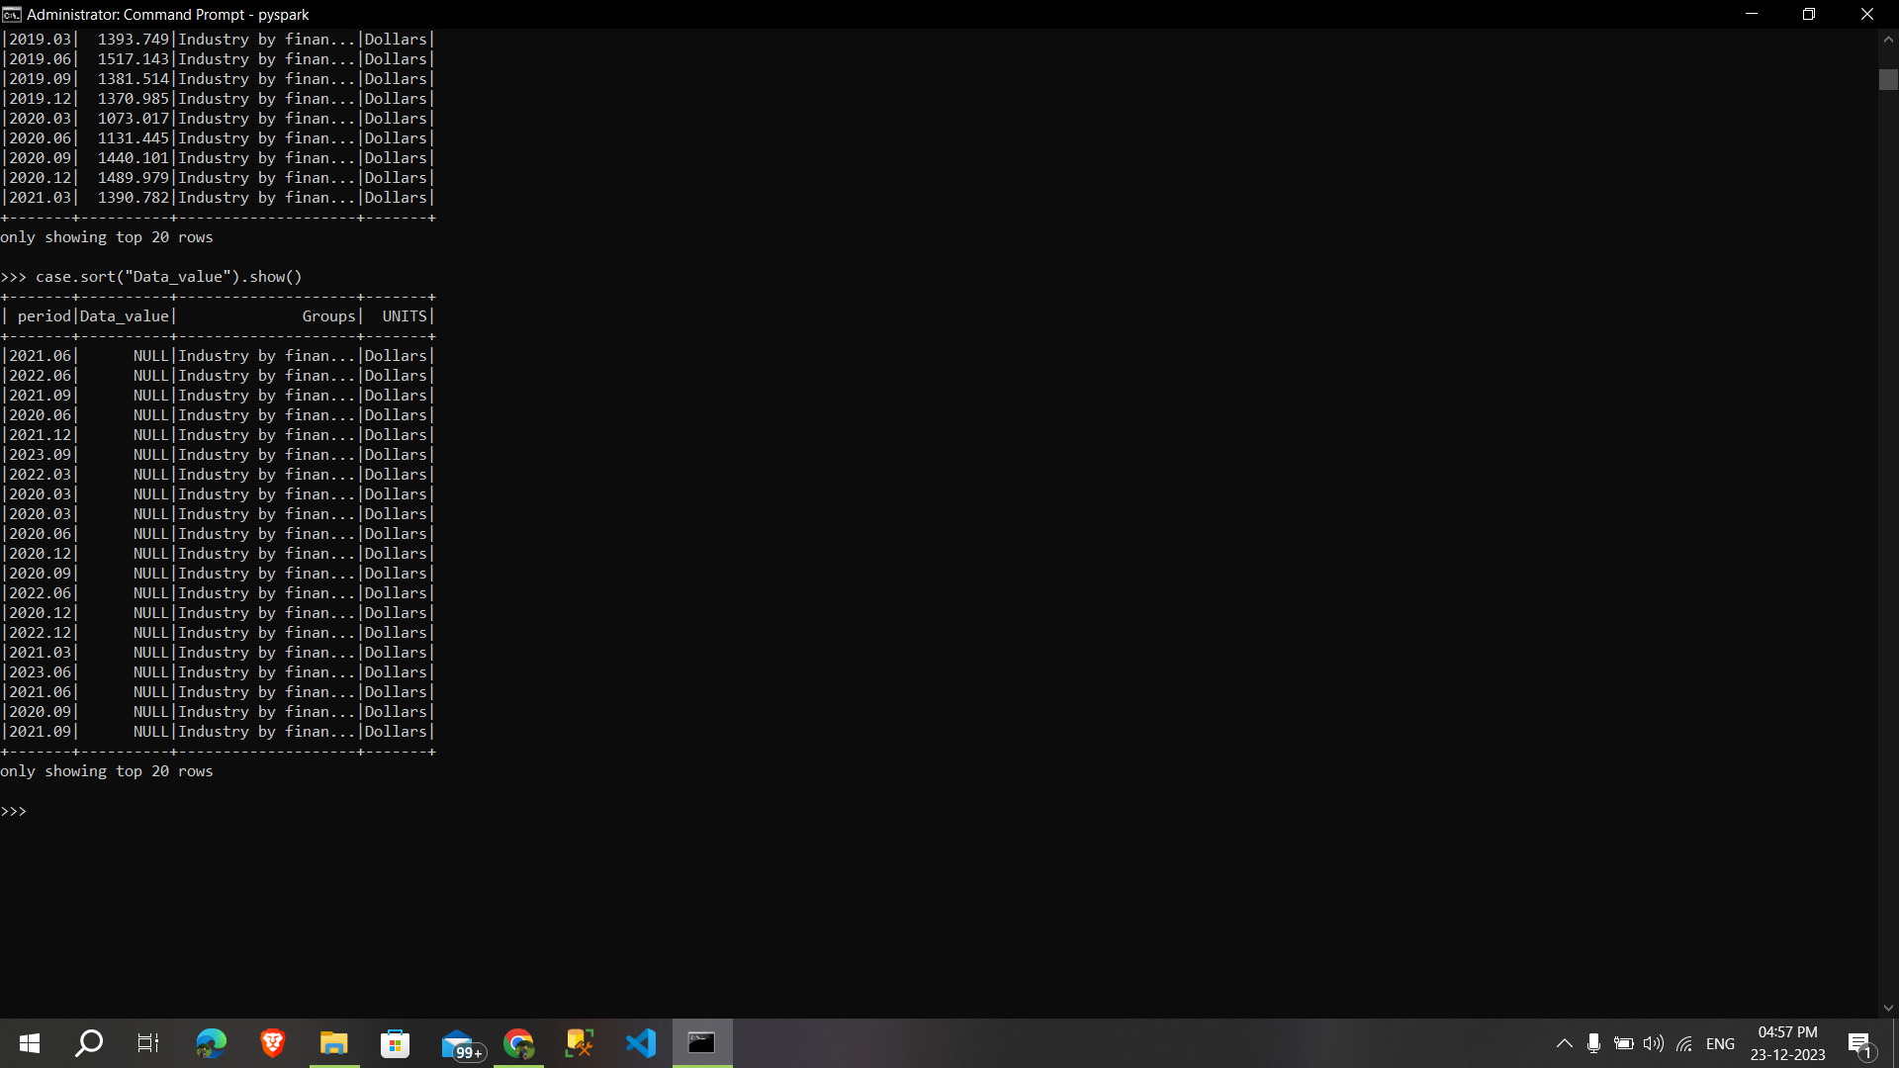

**Group by :**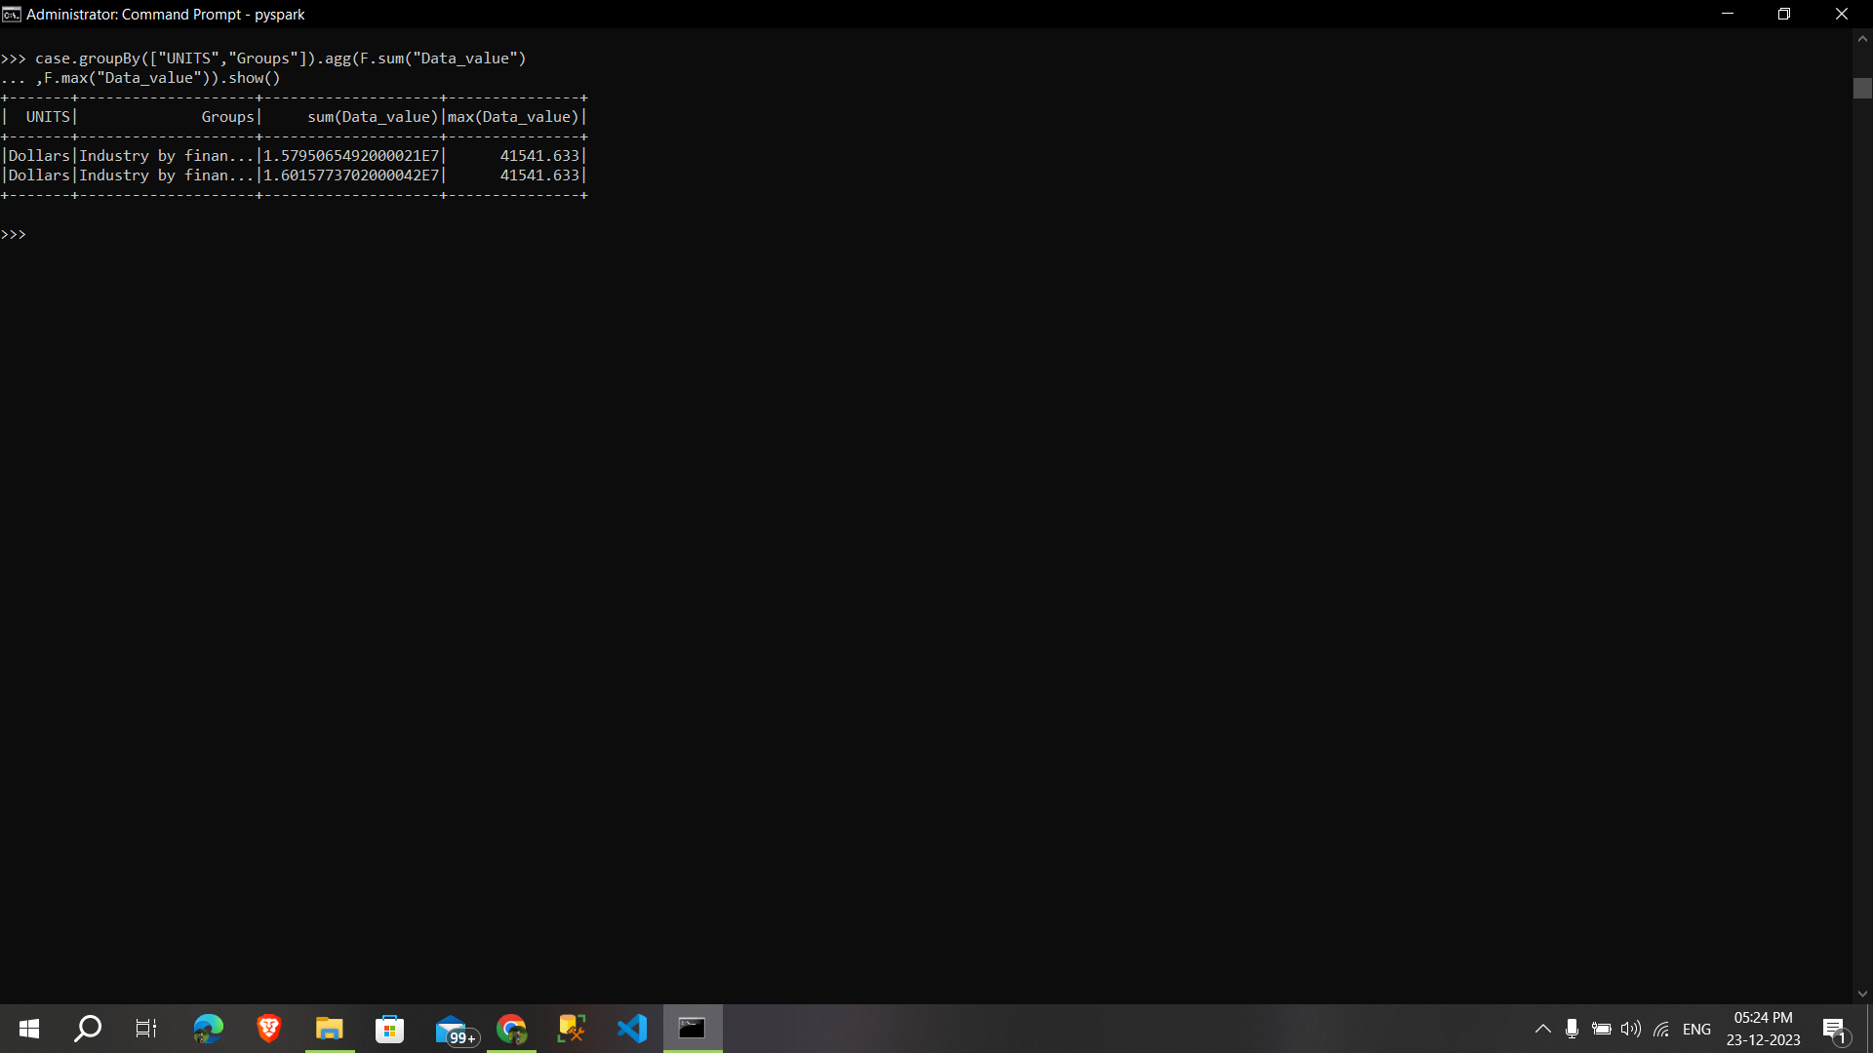

**By using Filter:**

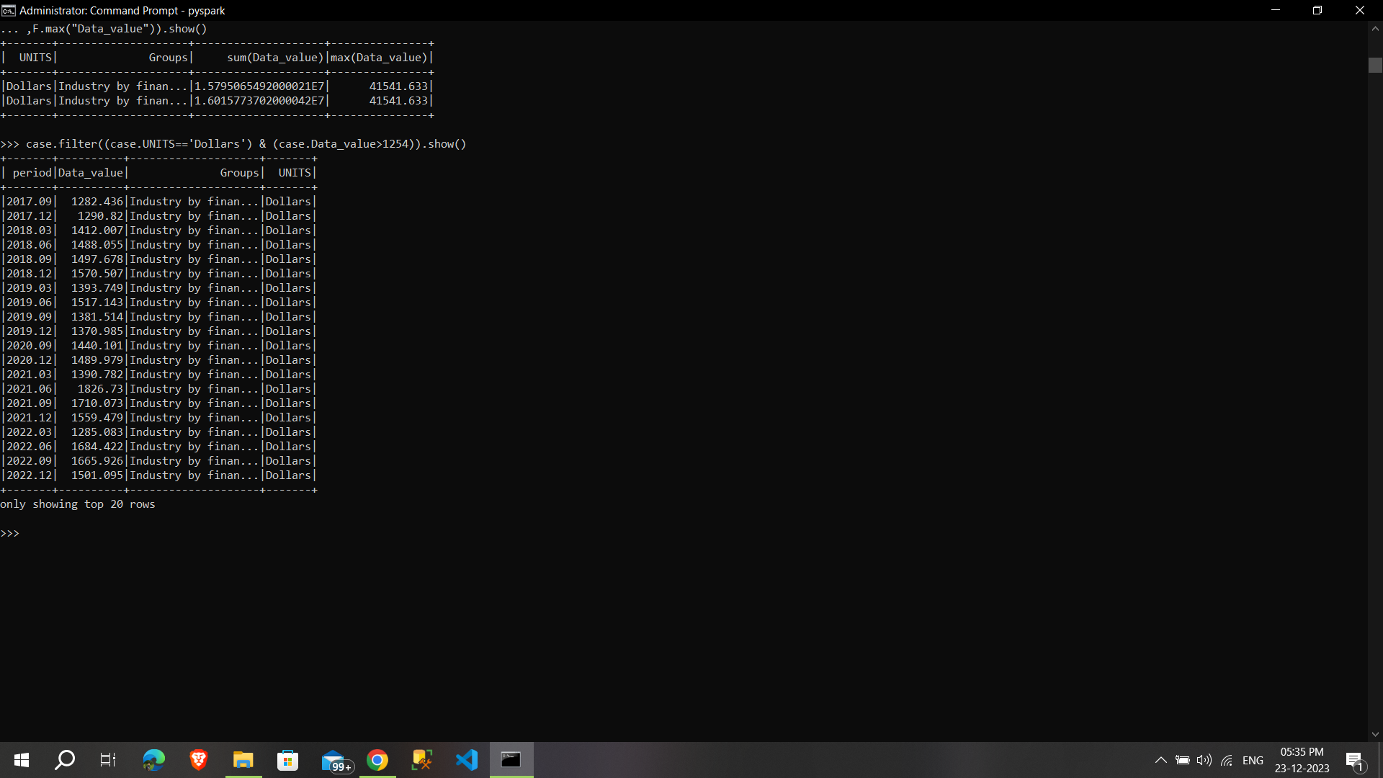

**Pyspark Commands**

To start the **spark shell** open the command prompt type - **spark-shell**

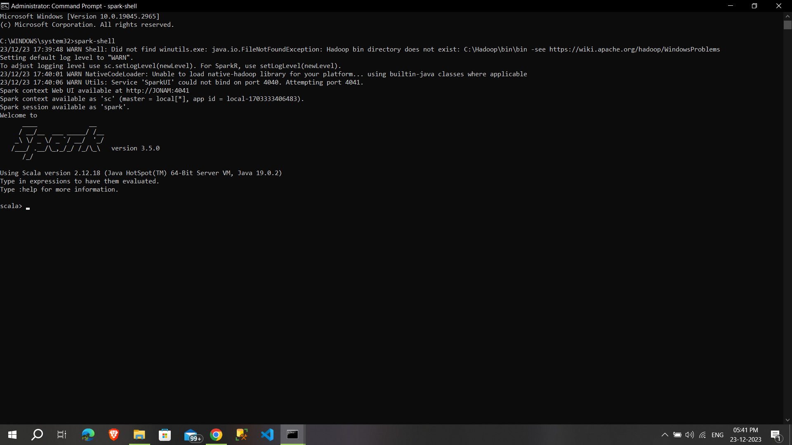

* To **Read a file** from the local system - **scala> val name = sc.textFile(“name.txt”)**

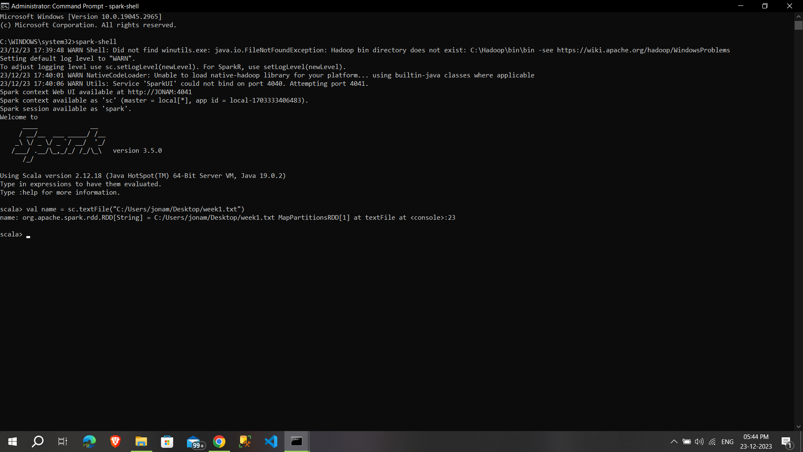

* To **count items** in RDD - **scala> newdata.count()**

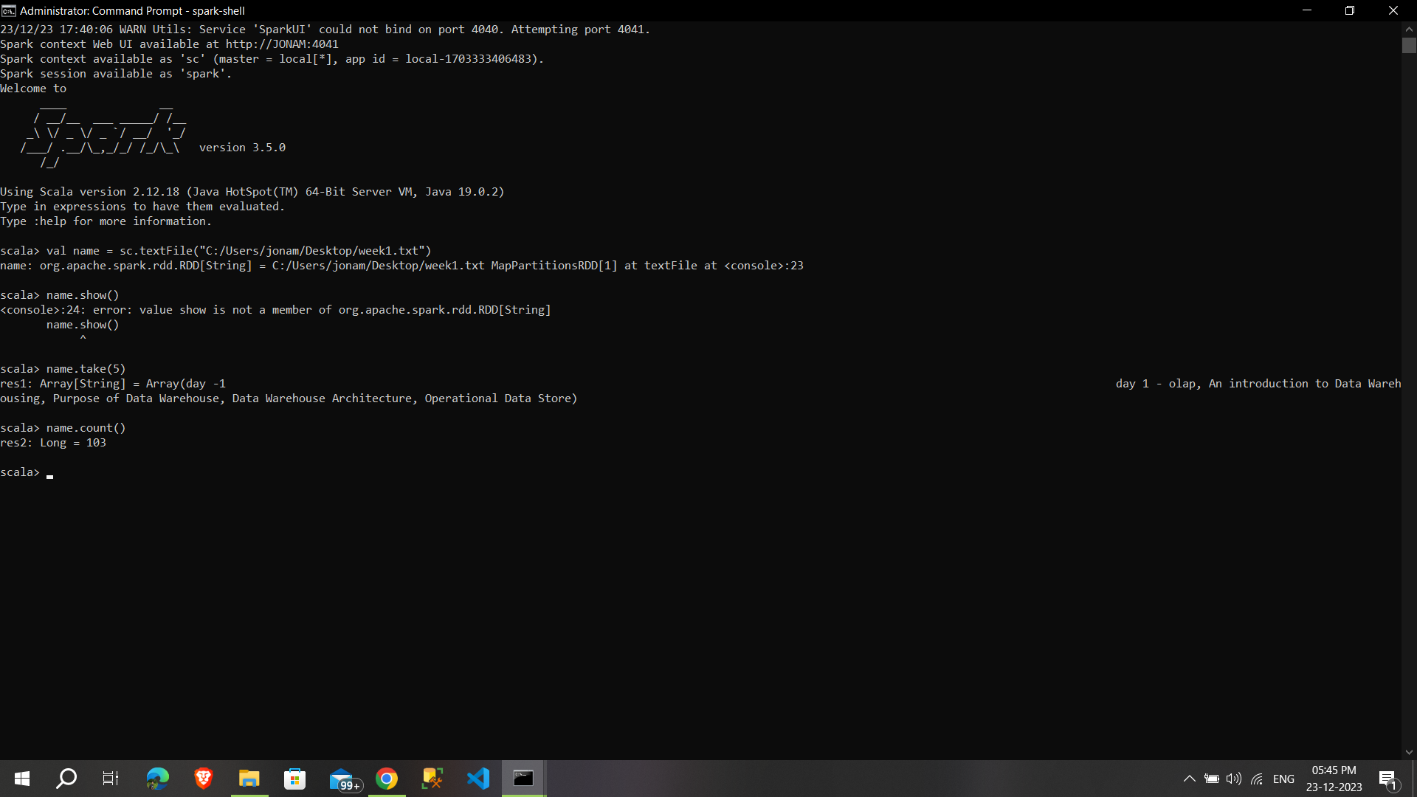

* To **read the first 3** items from RDD - **name.take(3)**

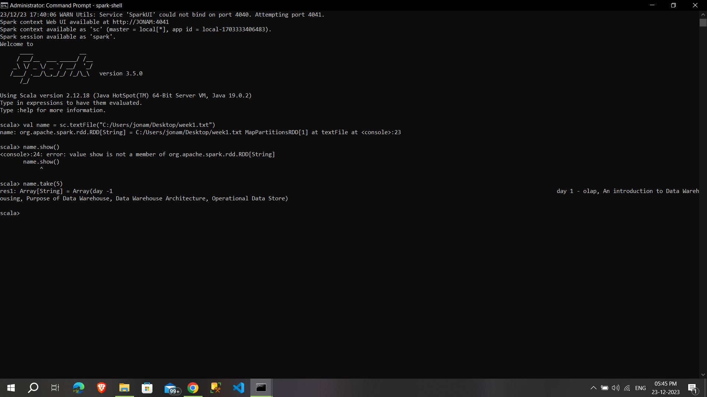

**Using collect() to show** 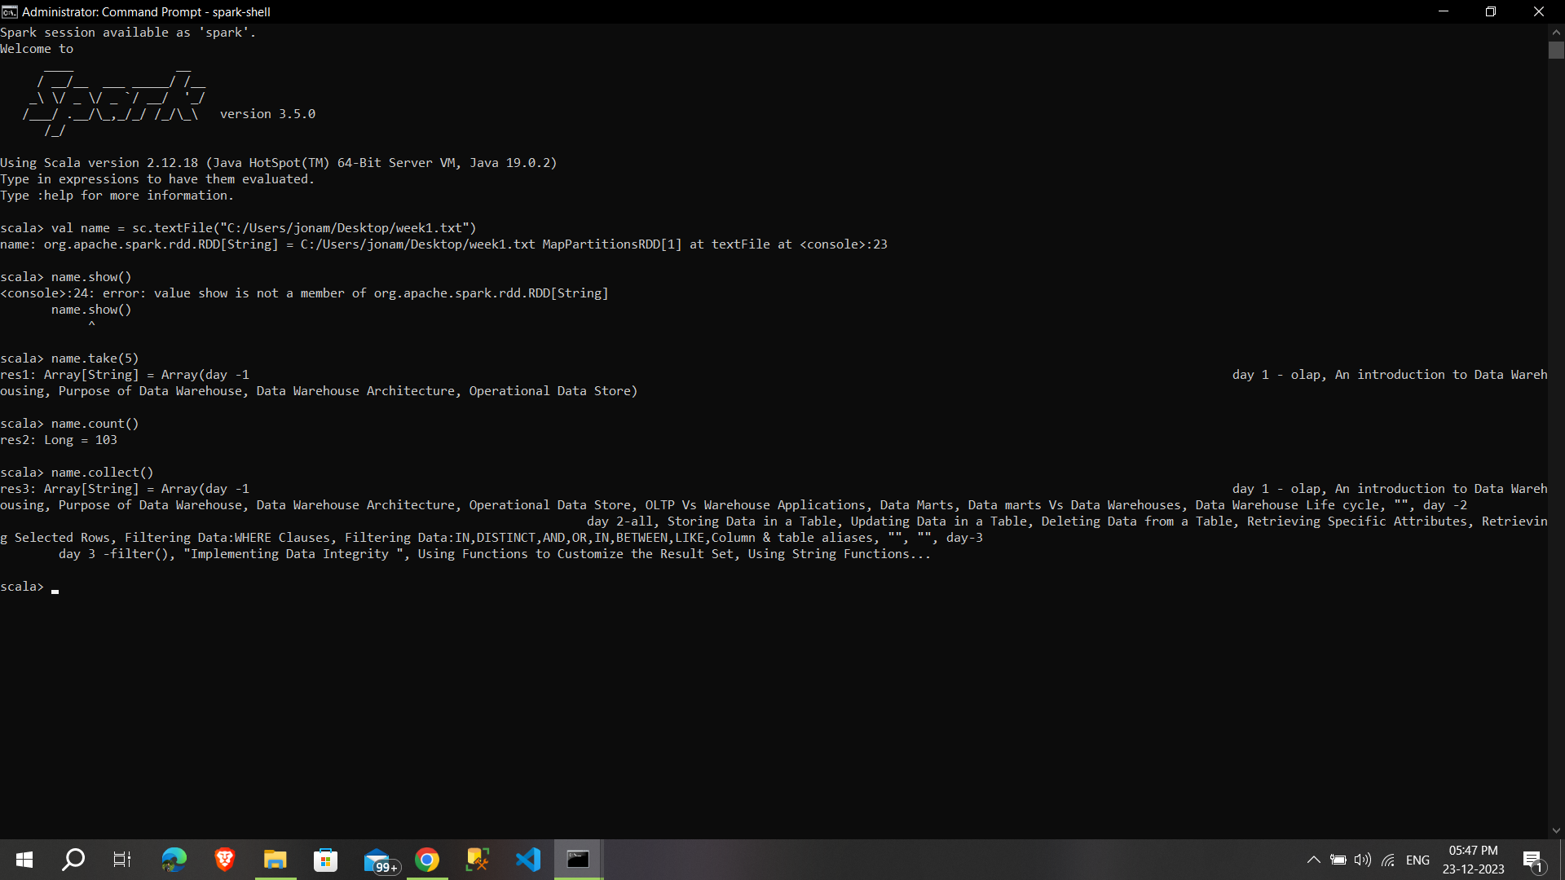

**Using :quit**

