**if Statement**

* If the simple code of block is to be performed if the condition holds true then the if statement is used.

**if..else Statement**

* In the conditional if Statement the additional block of code is merged as else statement which is performed when if condition is false.

**if-elif Statement**

* The if-elif statement is a shortcut of if..else chain. While using if-elif statement at the end else block is added.

**while loop**

* It  is used to execute a block of statements repeatedly until a given condition is satisfied.

**For Loop**

* For loops are used for sequential traversal.

**IF-statement:**

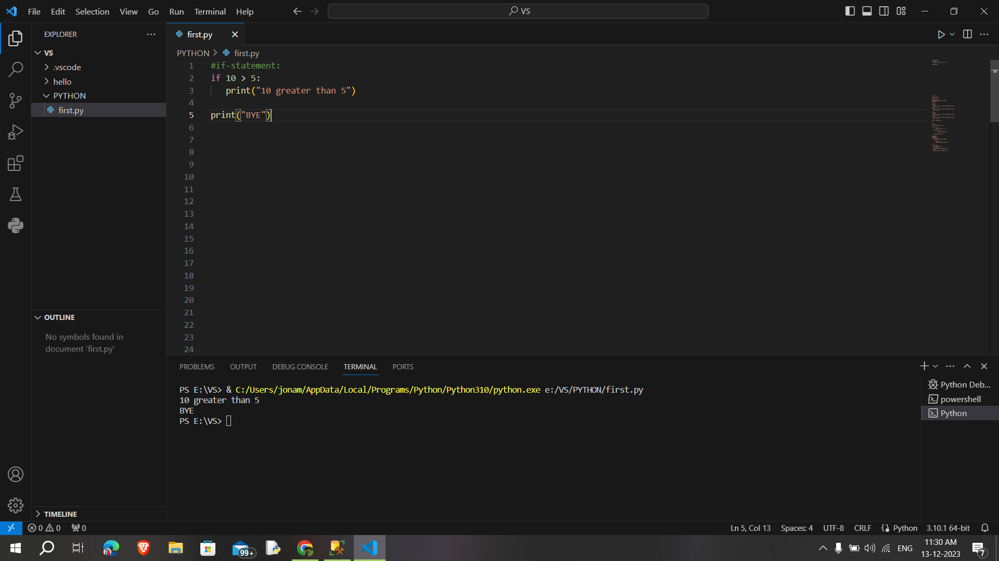

**IF-else statement:**

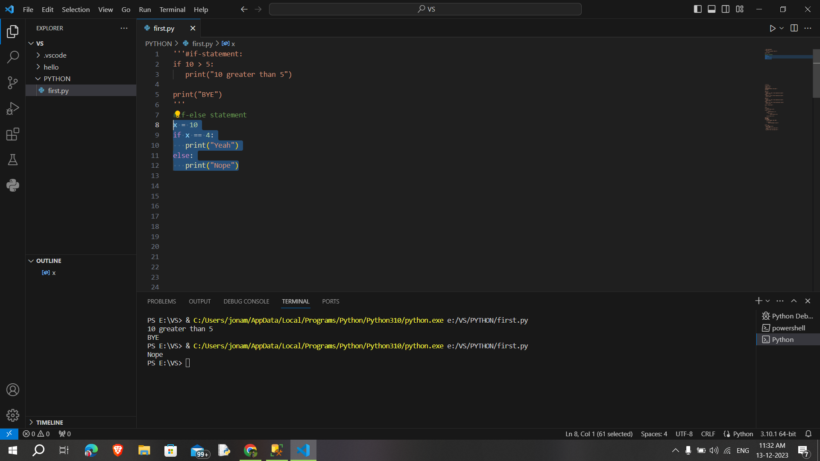

**If-else chain condition:**

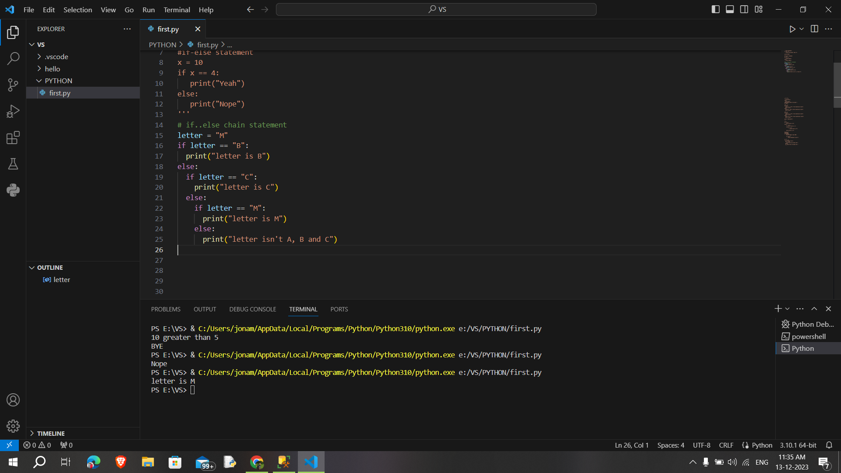

**Nested if statement:**

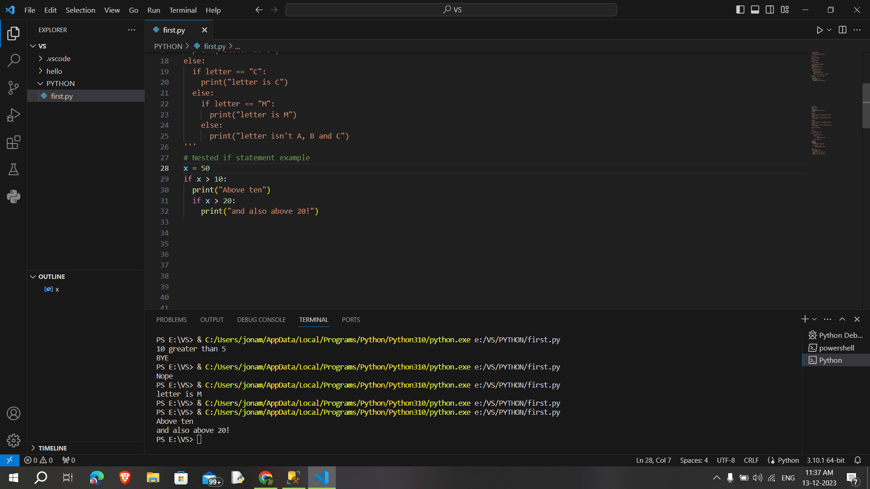

**If-elif statement:**

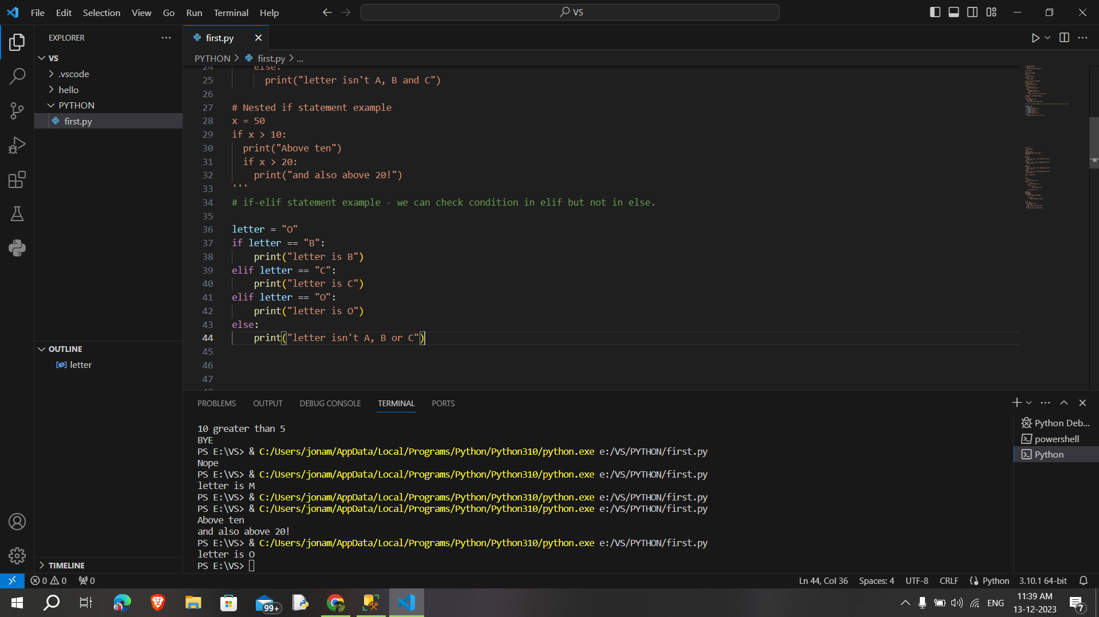

**While loop:**

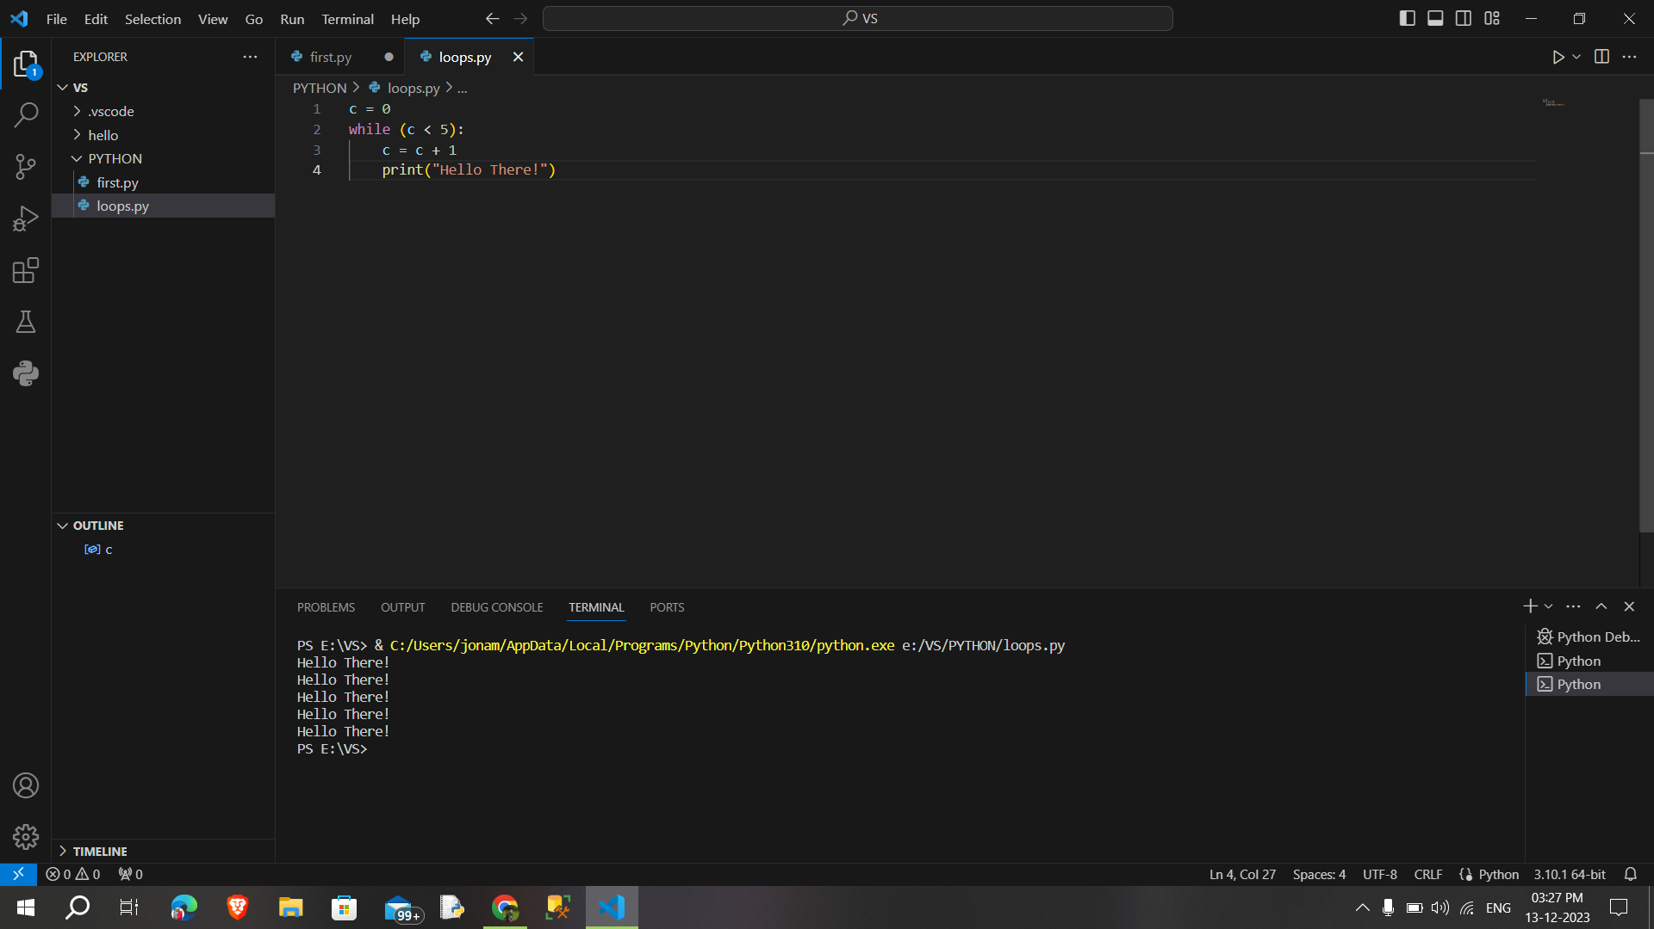

**While-else loop**

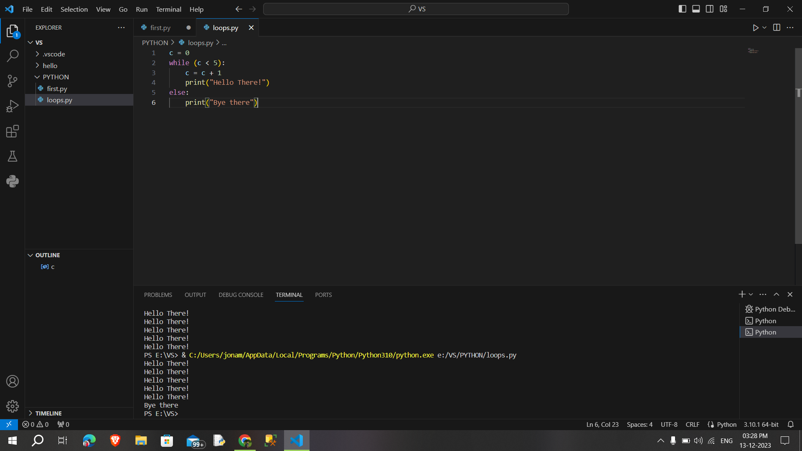

**For loop:**

