**Arrays in Numpy:**

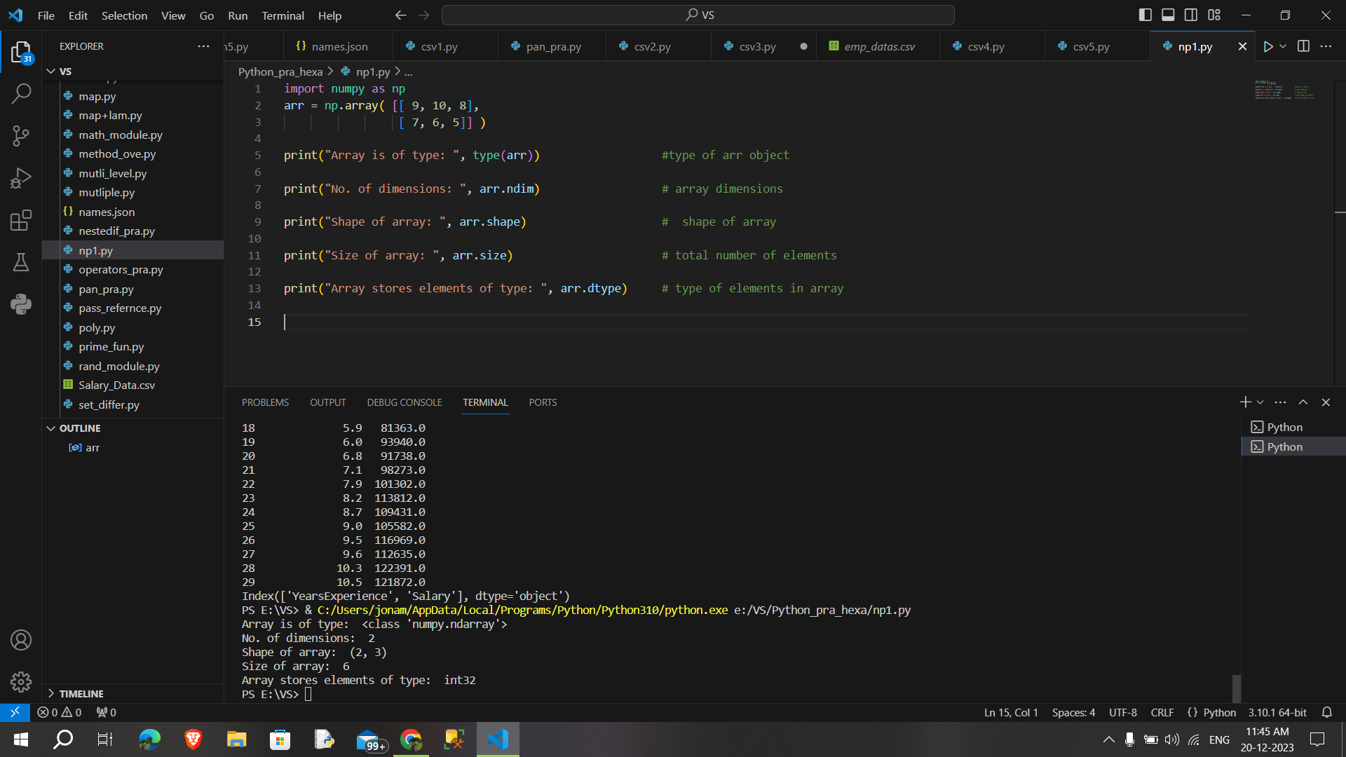

**NumPy Array Creation:**

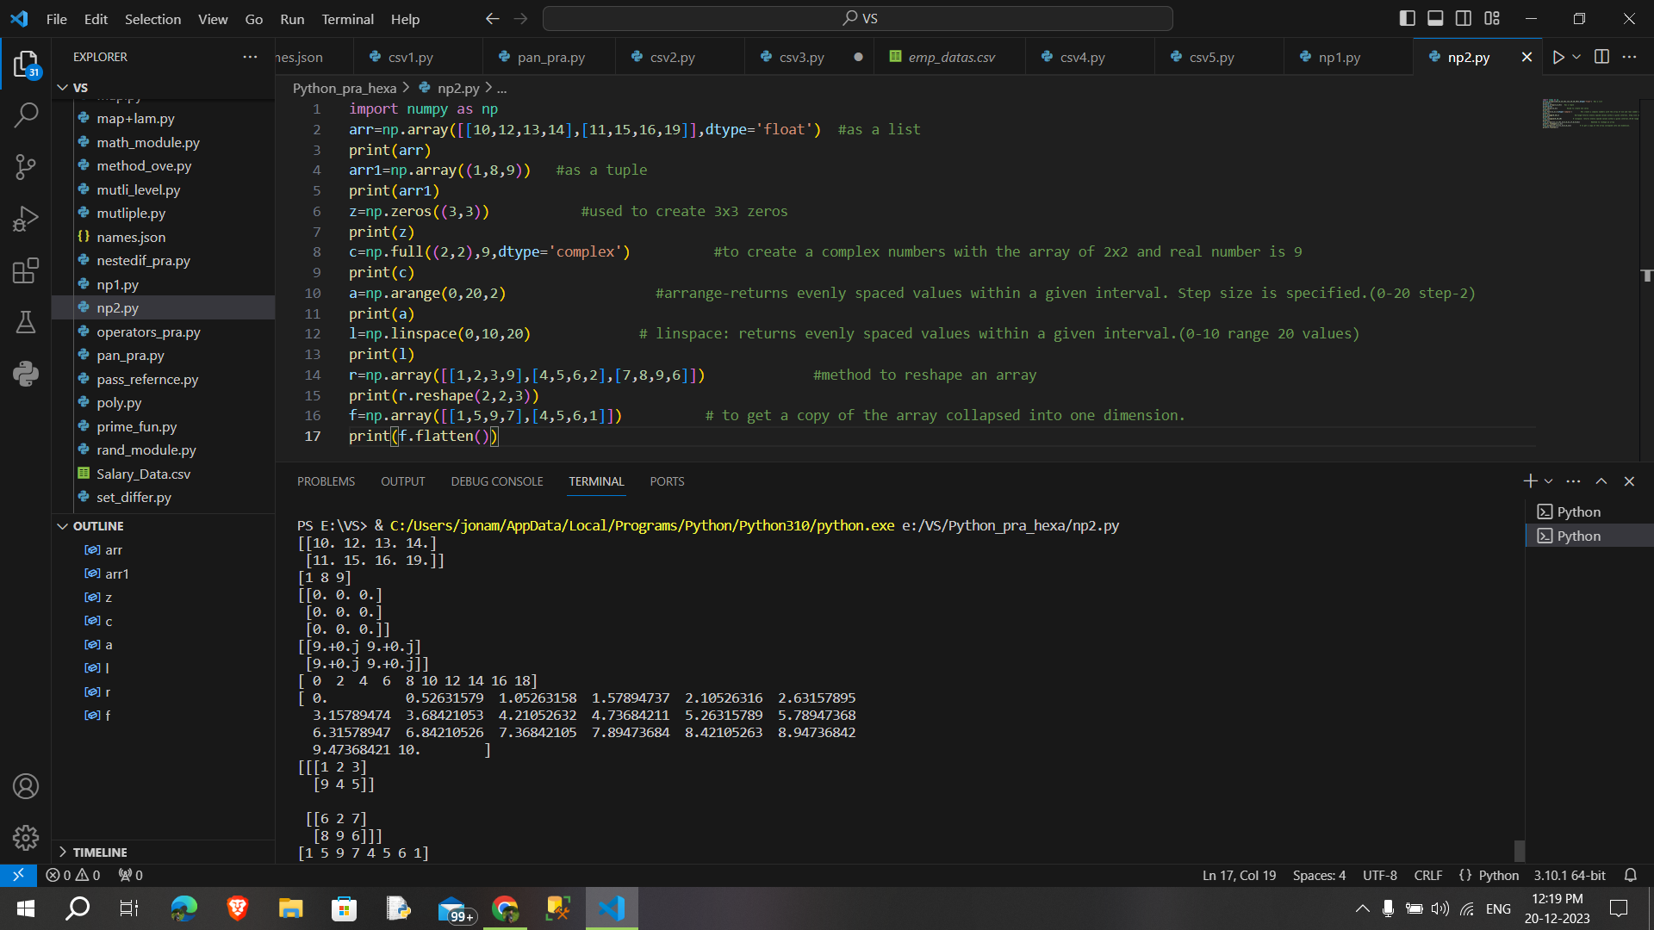

**NumPy Array Indexing:**

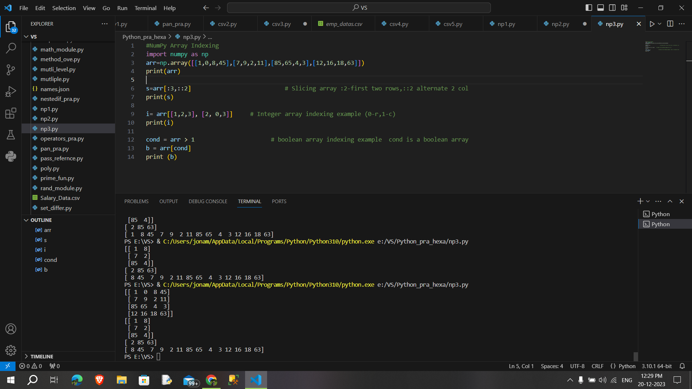

**NumPy Basic Operations:**

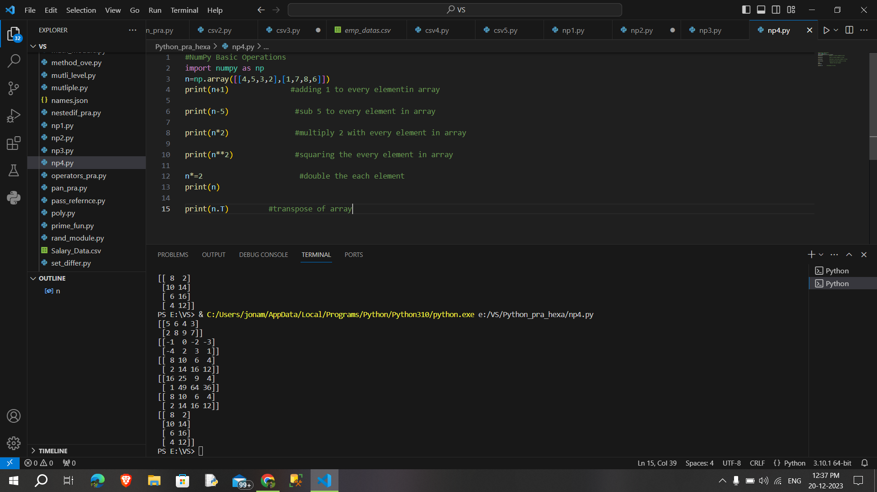

**NumPy – Unary Operators:**

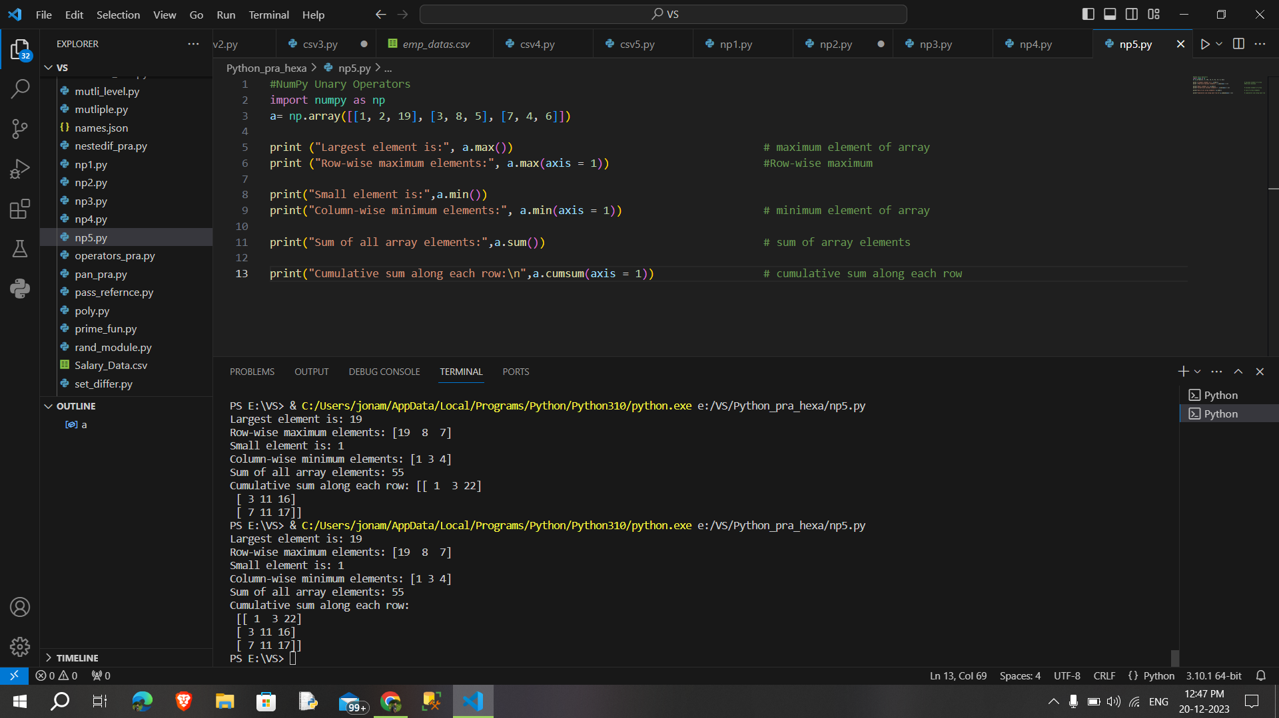

**NumPy – Binary Operators:**

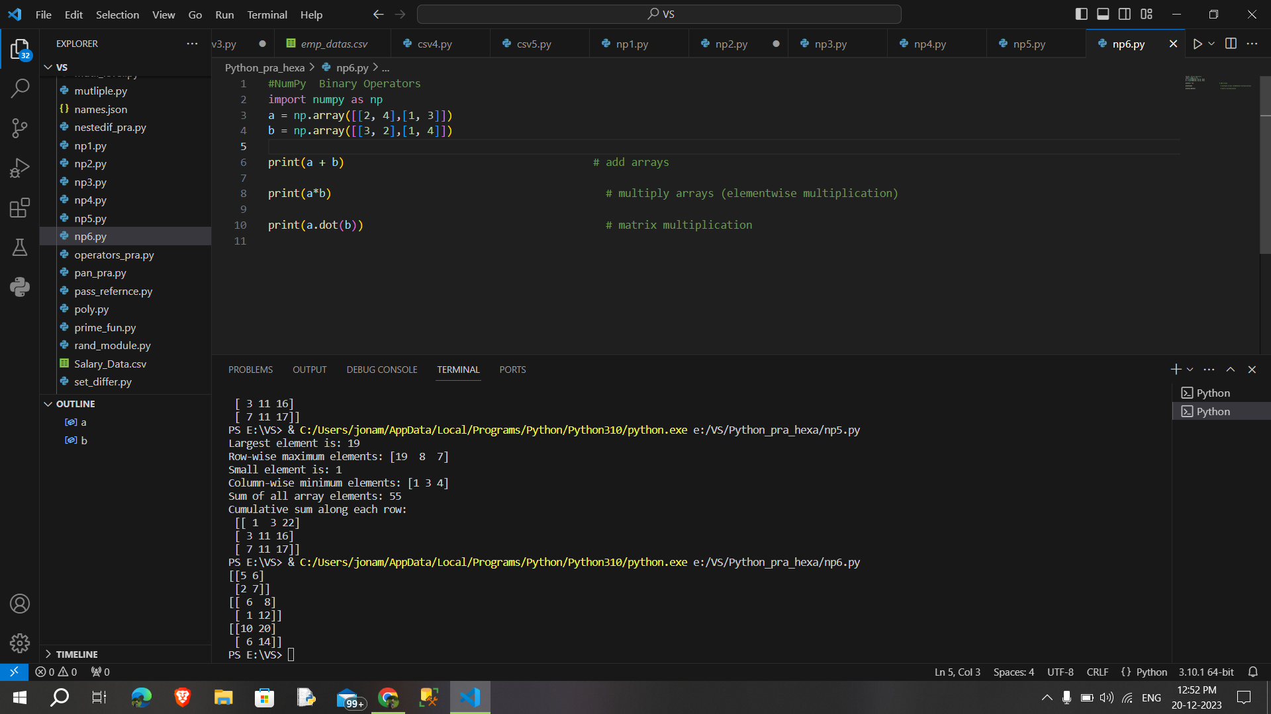

**NymPy ufuncs:**

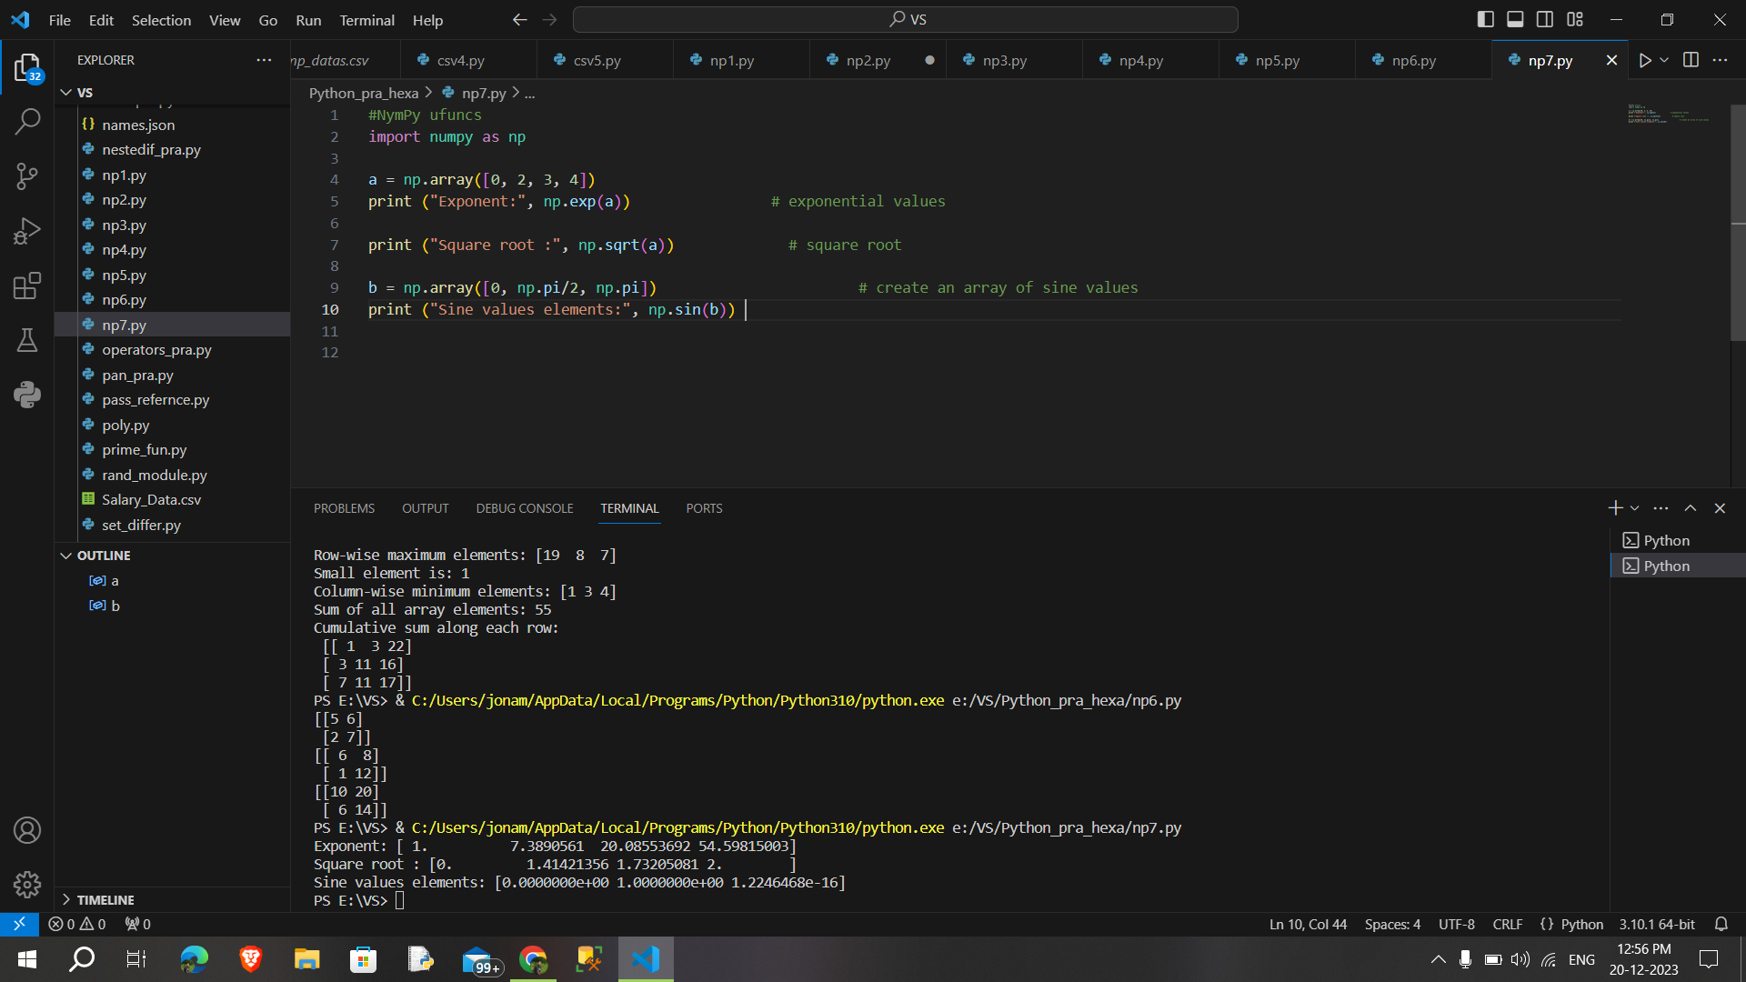

**NumPy Sorting Arrays:**

