**Using storage procedure**

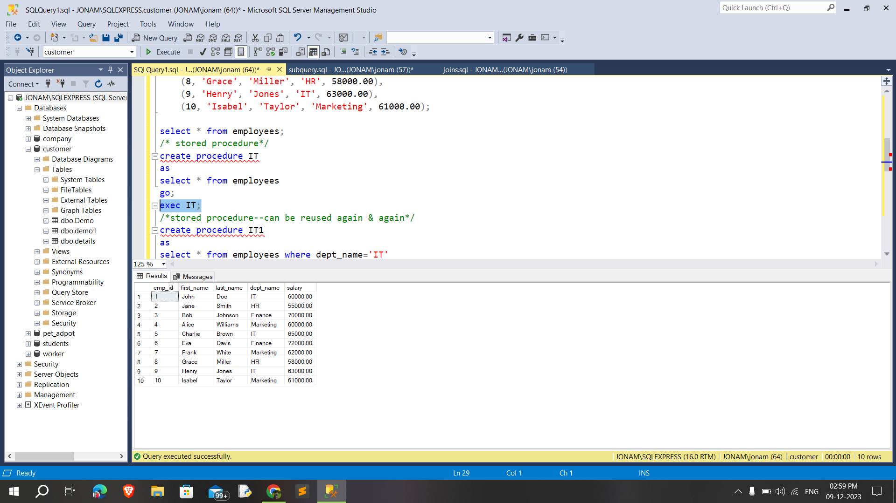

**Single and multiple parameter**

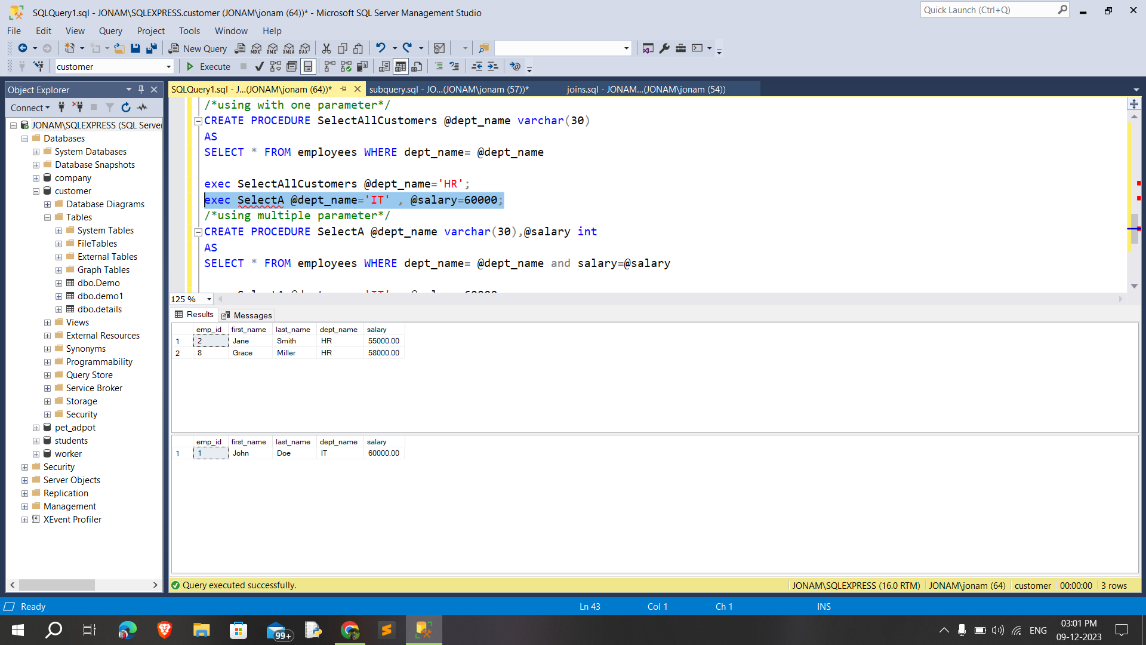

**Group by & Rollup**

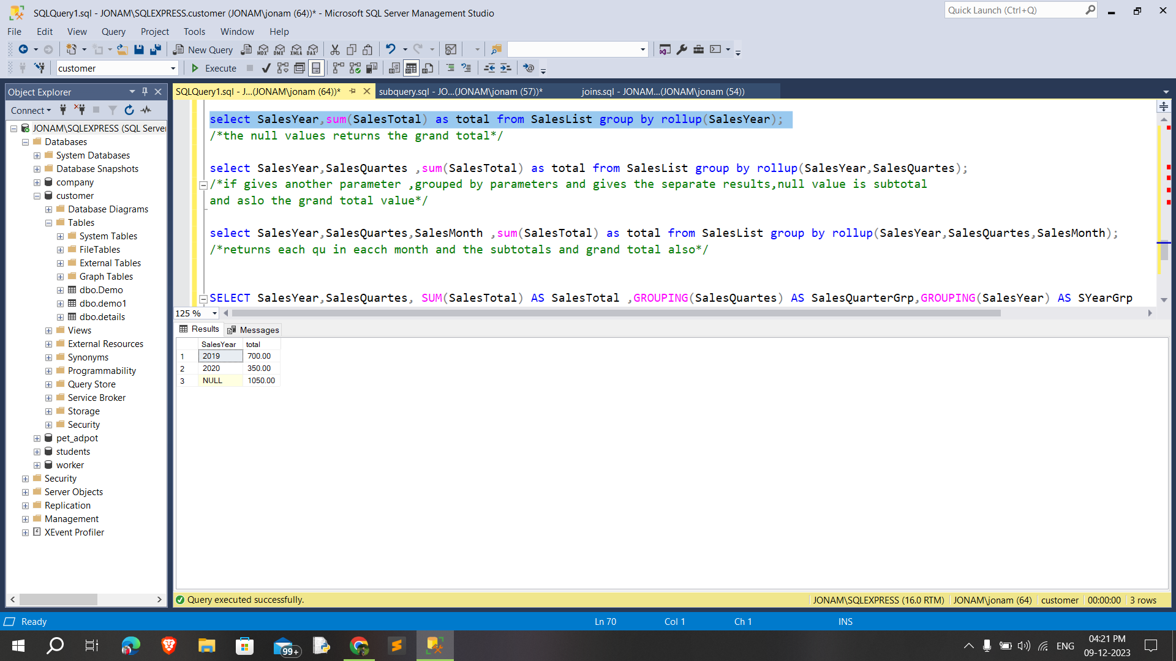

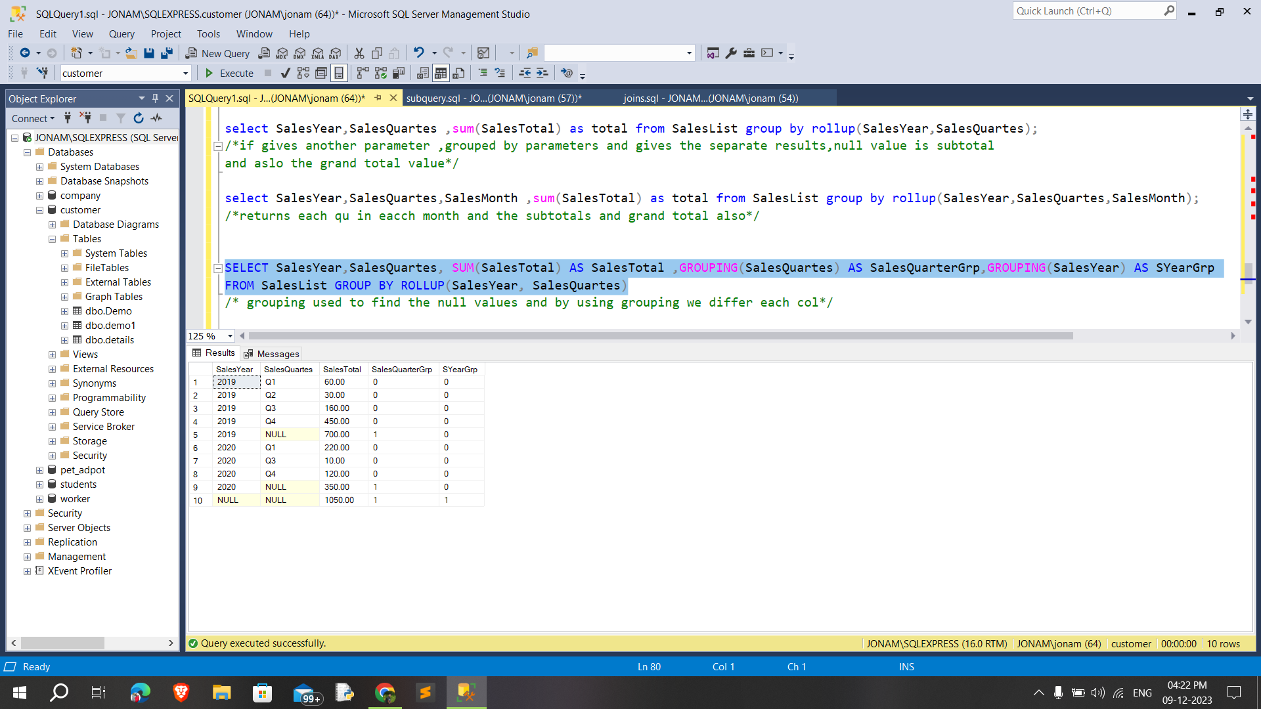

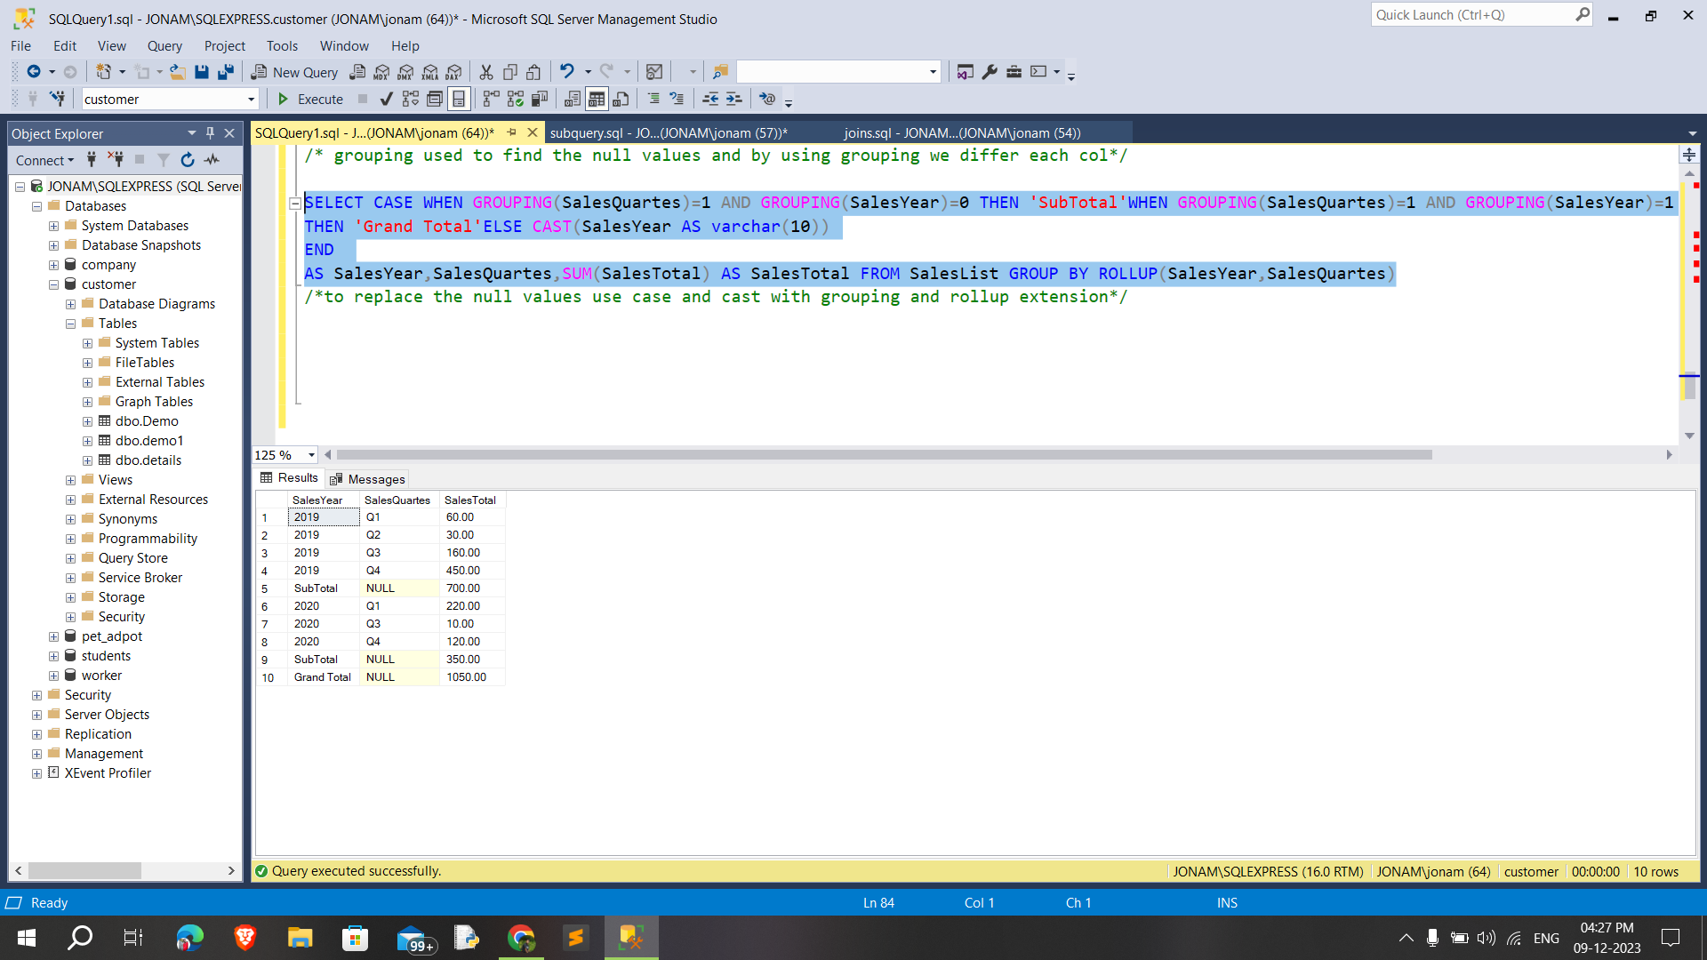

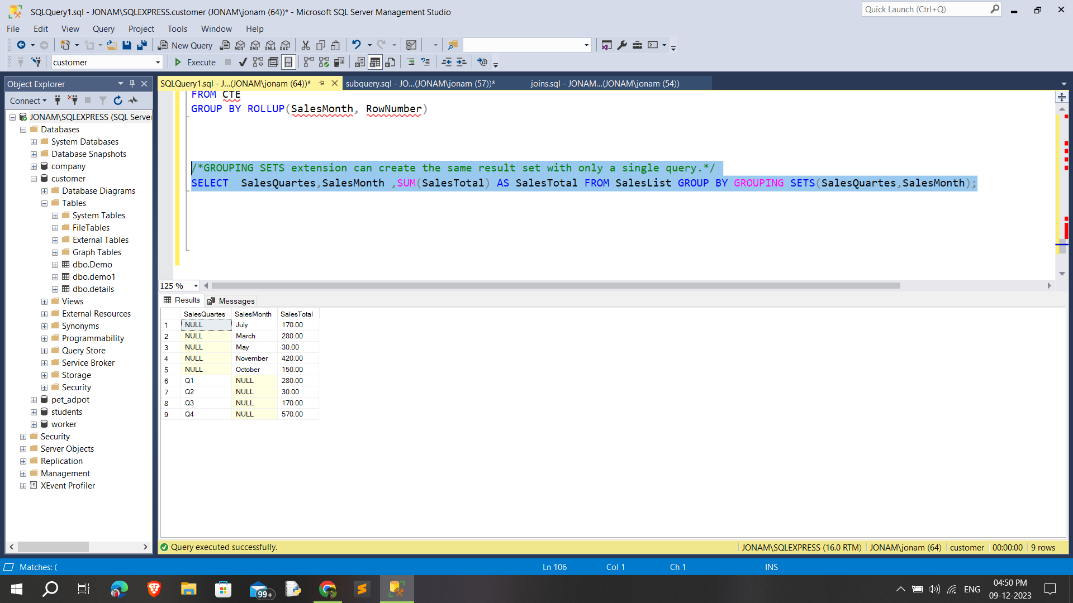

**Database schema:**

A database schema is the logical representation of a database, which shows how the data is stored logically in the entire database.

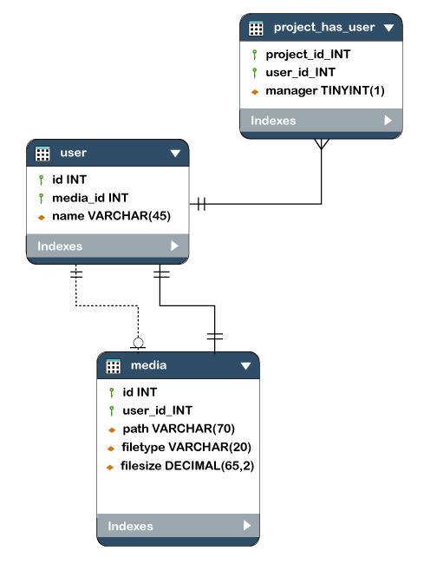

**Types of schemas:**

* Logical Schema
* Physical Schema
* View Schema

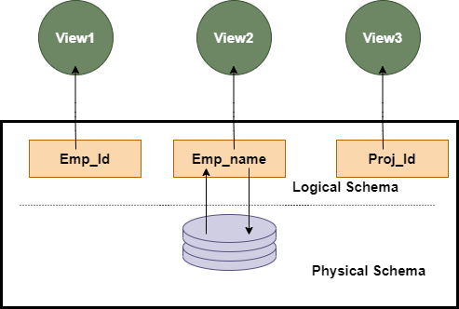

**Database schema design:**

* Flat Model
* Hierarchical Model
* Network Model
* Relational Model
* Star Schema
* Snowflake Schema