**Data cleaning:**

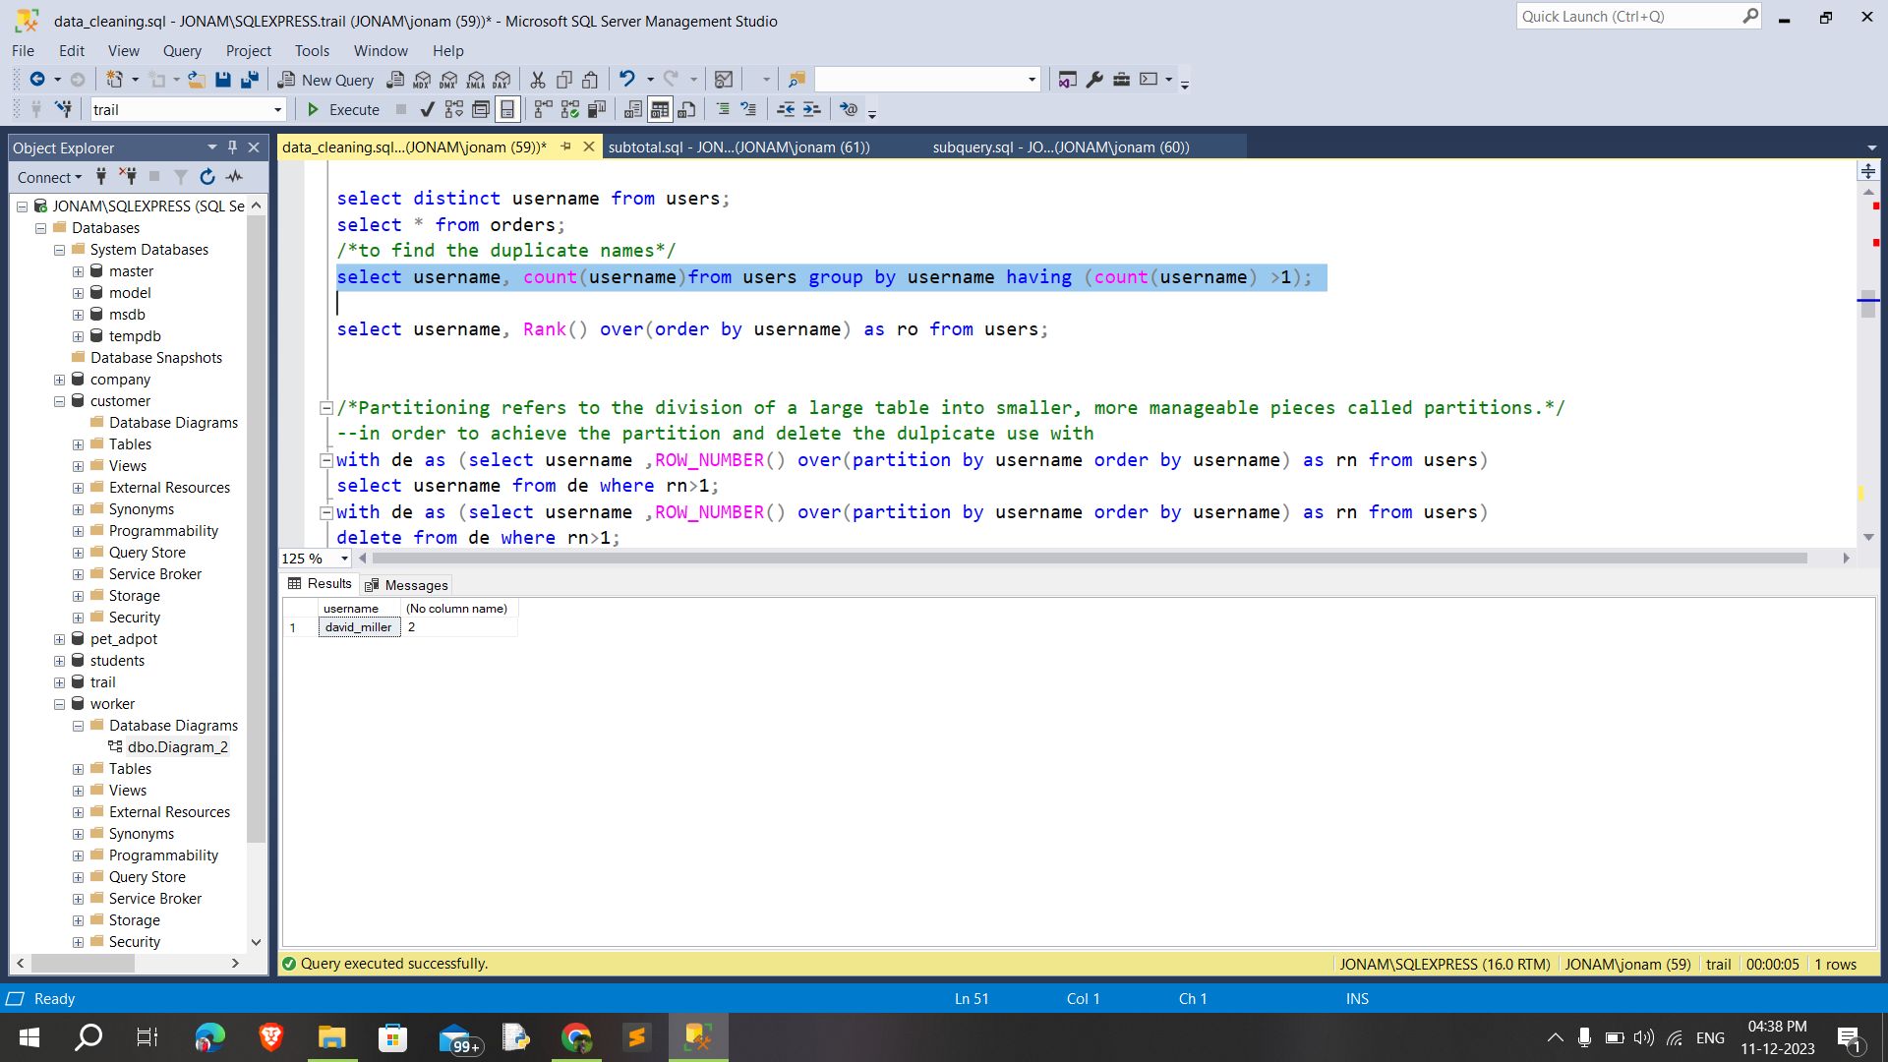

**Checking for missing values,**

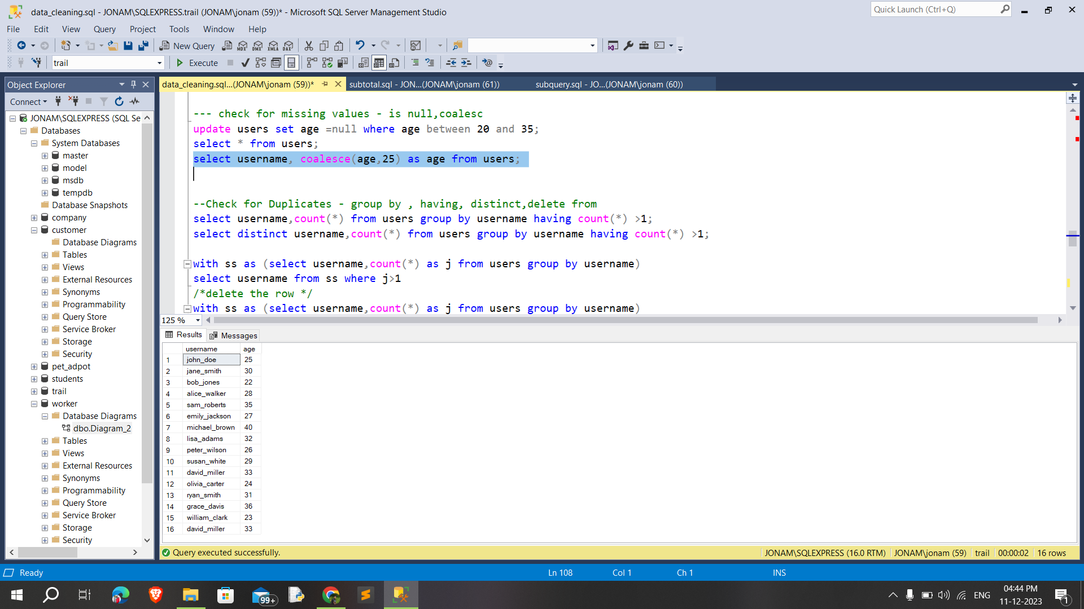

**Check for Duplicates,**

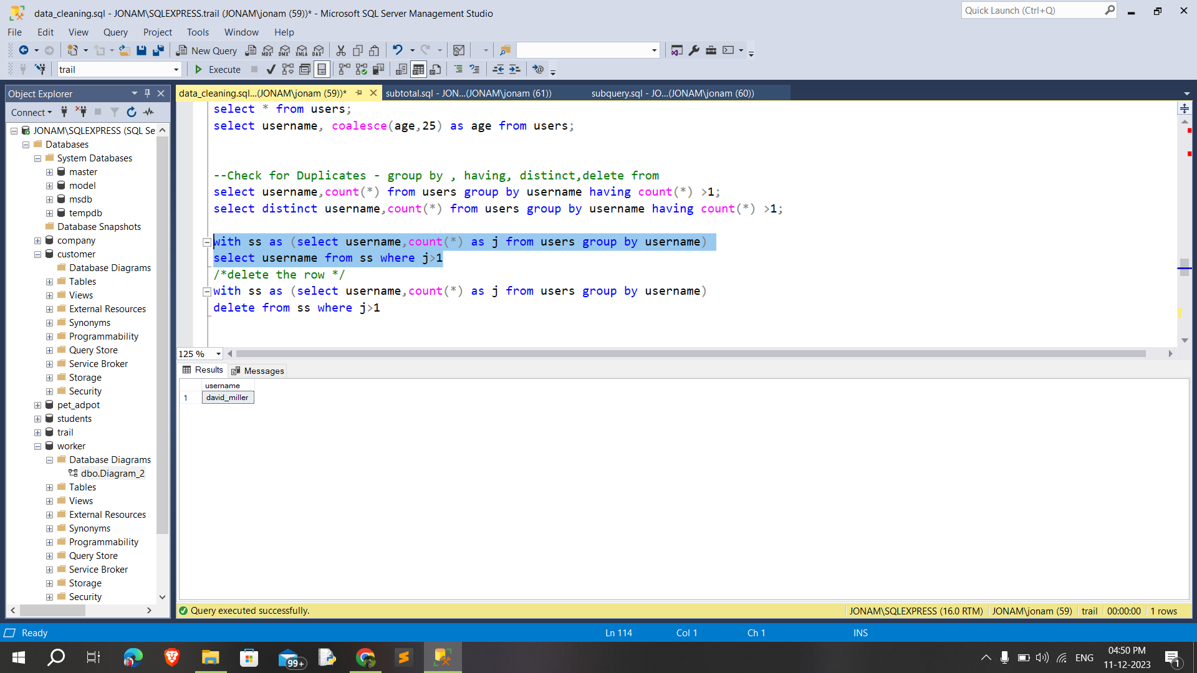

**Standardizing and Transforming Data** :

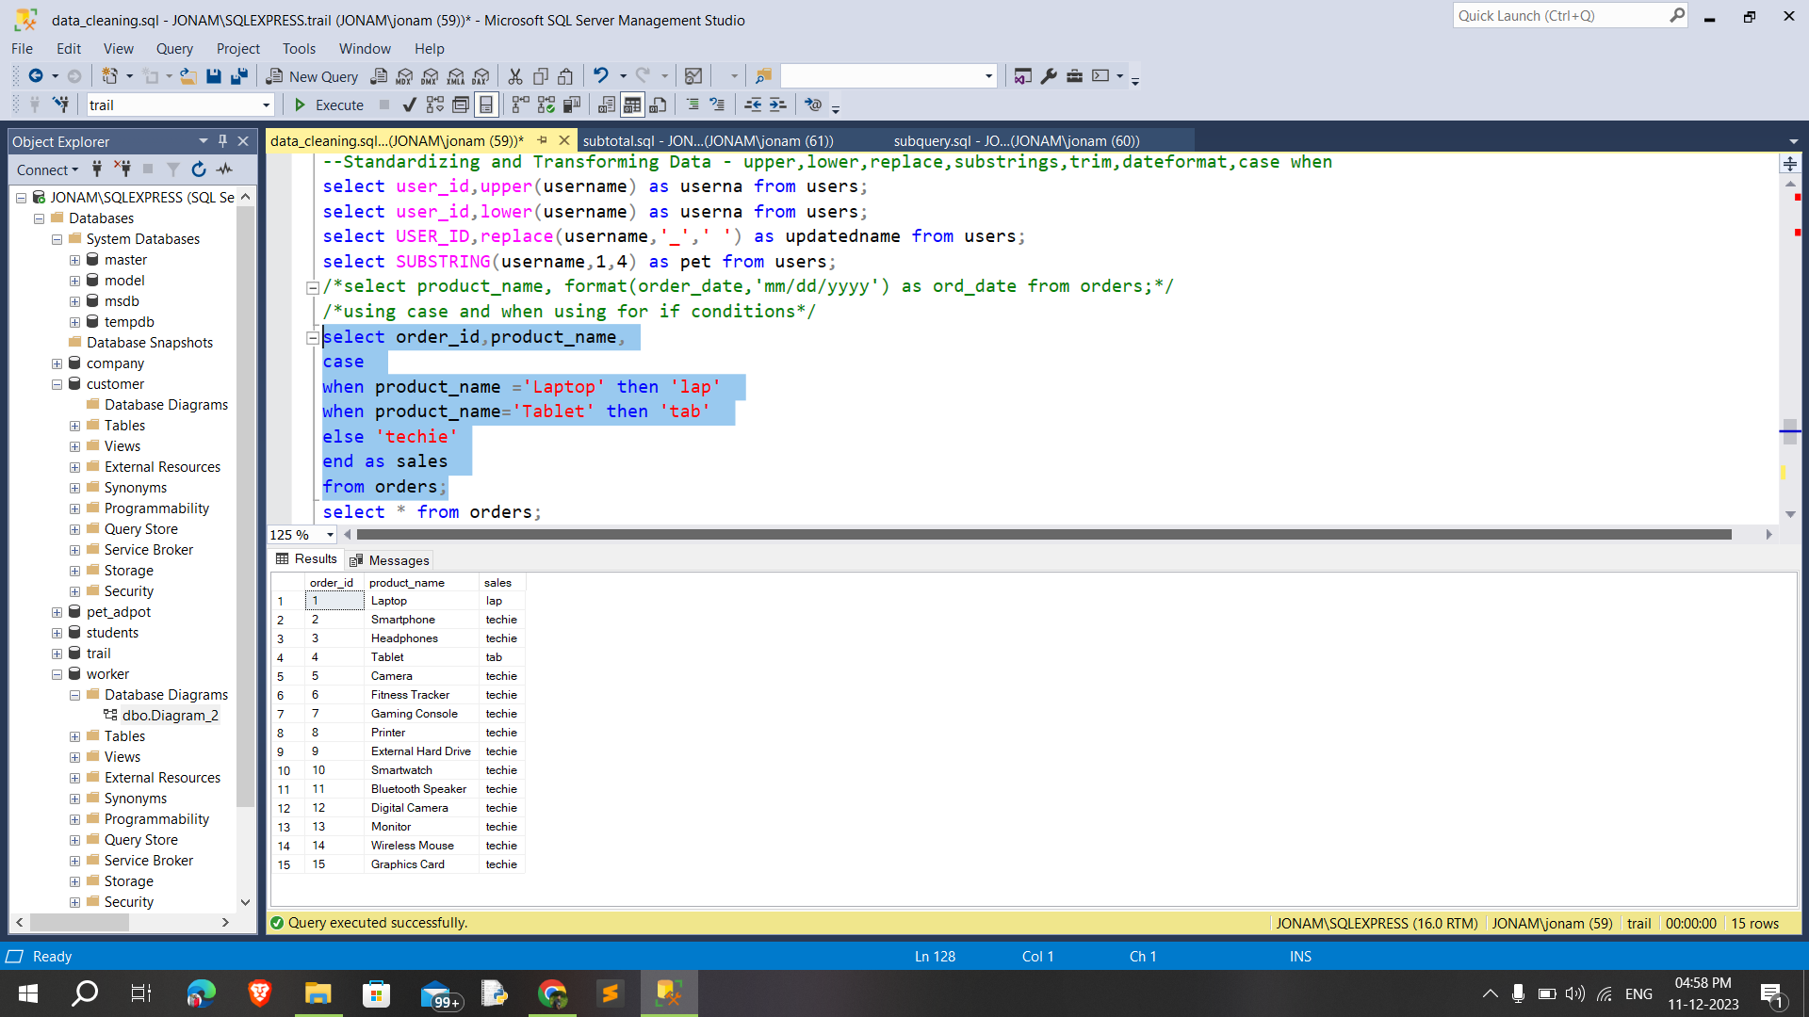

**Updating Data / Column Data Types**

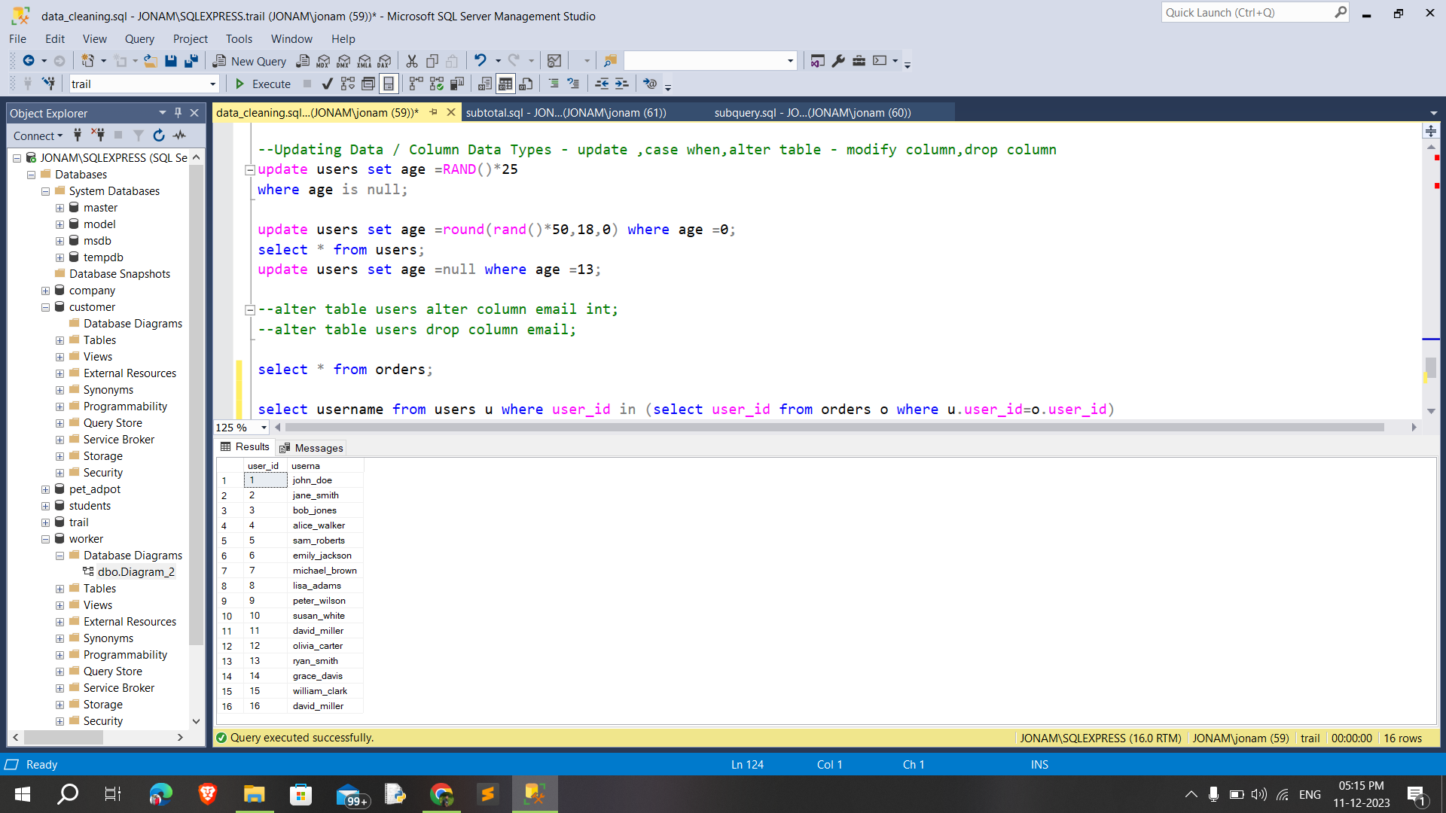

**partitions**

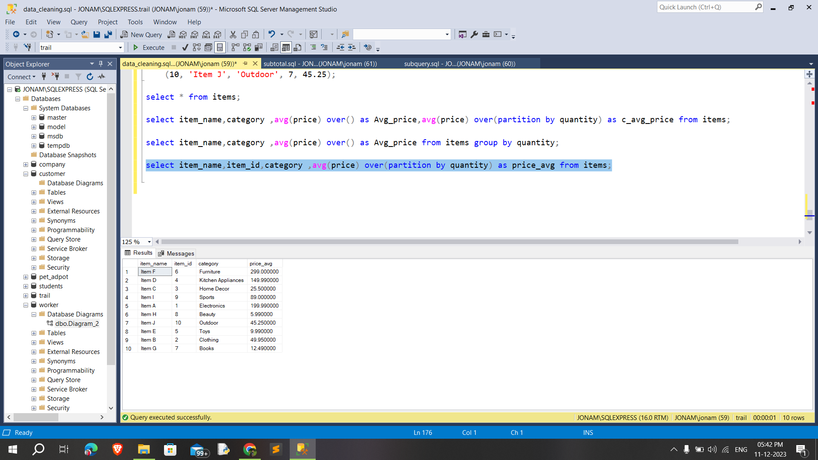

**Effective data cleaning process**

**1. Check for Missing Values** - is null,COALESCE

**2. Check for Duplicates** - group by , having, distinct,delete from

**3. Standardizing and Transforming Data** - upper,lower,replace,substrings,trim,dateformat,case when

**4. Updating Data / Column Data Types** - update ,case when,alter table - modify column,drop column

**Daigram of the database:**

