A GROUP PROJECT REPORT ON

SKILL WALLET DATA ANALYTICS
GROUP PROJECT

An Analytics-Driven Platform for Recording, Visualizing, and
Evaluating Student Skill Portfolios using Tableau and Flask

Submitted by
Team Members of the Skill Wallet Data Analytics Group
Manoj Maradani (Team Lead)
Edupuganti Siva Raj Kumar – 23PA1A0563
Kokkiligadda Sasidhar – 23PA1A05B2
Pechetty Sathvik – 23PA1A05J5
Attuluri Sai Leela Sree – 24PA5A0503

Department of Computer Science and Engineering
Vishnu Institute of Technology, Bhimavaram

INTRODUCTION TO THE PROJECT
The Skill Wallet Data Analytics Group Project is a data-driven analytics and visualization initiative undertaken by our team to explore how student skill development can be systematically captured, analyzed, and presented through interactive dashboards. The project brings together Python-based data processing, Tableau visualization, and Flask web integration to build a working platform that turns raw skill records into meaningful, easy-to-understand insights.
Our motivation for this project stems from the growing recognition that a student's academic transcript alone does not fully capture their capabilities. Workshops attended, certifications earned, hackathons participated in, and interpersonal skills developed all contribute to a student's overall profile, yet these are rarely tracked in a structured, analyzable way. The Skill Wallet concept addresses this gap by consolidating such records into a single dataset that can be cleaned, transformed, and visualized to reveal patterns that would otherwise remain hidden in scattered spreadsheets and certificates.
As a team, we divided responsibilities across data collection and cleaning, dashboard design, backend web development, and frontend/testing, allowing each member to contribute according to their strengths while collaborating closely on the overall system design. This report documents our complete journey — from the initial problem statement and requirement analysis to system design, implementation, dashboard analysis, performance testing, and the final insights we were able to draw from the Skill Wallet dataset.

ACKNOWLEDGEMENT
We take this opportunity to express our sincere gratitude to everyone who supported us throughout the successful completion of the Skill Wallet Data Analytics Group Project. This project would not have been possible without the constant encouragement, technical guidance, and moral support extended to us at every stage of its development.
We are deeply thankful to our project guide, [Guide Name], for their invaluable mentorship, patient guidance, and constructive feedback that helped us navigate the technical and analytical challenges of this project. Their insights into data analytics, dashboard design, and web integration significantly shaped the quality of our work.
We would also like to thank the Head of the Department, [HOD Name], and all faculty members of the Department of Computer Science and Engineering for providing the infrastructure, laboratory resources, and encouraging academic environment necessary to carry out this project.
We extend our appreciation to our institution, [Name of Institution], for granting us the opportunity to apply our academic learning to a real-world, data-driven problem, and for fostering a culture of innovation and practical learning.
Finally, we thank our families and peers for their unwavering support and motivation throughout this endeavour, and we acknowledge the collective effort of every team member whose dedication made this group project a success.

ABSTRACT
The Skill Wallet Data Analytics Group Project is a data-driven analytics and visualization platform designed to record, track, and evaluate the skill portfolios of students in an academic institution. In an era where employability depends increasingly on demonstrable competencies rather than grades alone, institutions require a systematic mechanism to capture the skills, certifications, and extracurricular achievements that students accumulate over their academic journey. The Skill Wallet concept addresses this need by acting as a digital repository of student skill records, which is then subjected to rigorous data analytics to generate actionable insights for students, faculty, and administrators.
This project integrates Python-based data processing (using Pandas and NumPy), a Flask web application for backend logic and routing, and Tableau for the design of rich, interactive dashboards. The workflow begins with the collection of a structured Skill Wallet dataset, followed by data cleaning, transformation, and feature engineering to prepare the data for analysis. The cleaned dataset is then visualized through Tableau dashboards that highlight skill distribution across departments, proficiency trends, category-wise participation, and correlations between skill acquisition and academic performance. A supplementary dietary and wellness dataset is also analyzed to understand the holistic well-being of students alongside their skill development, since institutions increasingly view skill growth and student wellness as interconnected outcomes.
The dashboards are embedded into a Flask-powered web interface, allowing users to interact with filters, parameters, and calculated fields directly from a browser, without needing direct access to Tableau Desktop. The system was tested for dashboard rendering performance, filter responsiveness, and data-loading efficiency, and the results demonstrate that the platform delivers fast, reliable, and insightful analytics suitable for institutional deployment. The project was version-controlled using Git and hosted on GitHub, with the dashboard additionally published on Tableau Public for open access.
This report documents the complete lifecycle of the project — from requirement analysis and system design to implementation, testing, and deployment — and concludes with the key insights derived from the Skill Wallet dataset, the benefits realized, and the scope for future enhancement, including the integration of machine learning-based skill recommendation engines and real-time data pipelines.
Keywords: Skill Wallet, Data Analytics, Tableau, Flask, Python, Pandas, Dashboard, Student Skill Portfolio, Data Visualization, Web Integration.

TABLE OF CONTENTS

CHAPTER 1 – INTRODUCTION
The Skill Wallet Data Analytics Group Project is conceived as a comprehensive analytics solution that captures, organizes, and interprets the skill-related data of students within an academic institution. In today's competitive academic and professional environment, a student's transcript alone is no longer sufficient to represent their true capability. Employers, universities, and scholarship committees increasingly look beyond grades to assess soft skills, technical certifications, workshops attended, hackathons participated in, and leadership roles undertaken. The Skill Wallet acts as a digital ledger of these achievements, and this project applies modern data analytics techniques to transform that raw ledger into meaningful, decision-ready insight.

1.1 Background
Historically, academic institutions have relied on static records such as mark sheets, certificates, and co-curricular activity logs maintained in disconnected formats — spreadsheets, paper certificates, or isolated departmental databases. This fragmentation makes it extremely difficult for faculty and administrators to get a holistic view of a student's overall development, or for students themselves to track their own growth over time. With the rise of data analytics and business intelligence tools such as Tableau, along with lightweight web frameworks such as Flask, it has become feasible to build a unified, interactive platform that consolidates this information and presents it visually, enabling faster and more informed decision-making.
The idea of a 'Skill Wallet' draws inspiration from digital wallet systems used in finance, where a single interface aggregates diverse assets. Similarly, a Skill Wallet aggregates diverse student competencies — technical, managerial, creative, and interpersonal — into one analytics-ready dataset.

1.2 Need for the Project
There is a growing need for institutions to quantify and visualize student skill development for several reasons. Firstly, accreditation bodies and outcome-based education frameworks require measurable evidence of skill attainment. Secondly, placement cells need consolidated dashboards to match student skill profiles with recruiter requirements. Thirdly, students themselves benefit from visibility into their own growth trajectory, which encourages continuous upskilling. Without a centralized analytics system, these needs are addressed manually and inconsistently, resulting in delays, errors, and lost opportunities for timely intervention.

1.3 Problem Statement
Existing methods of tracking student skills are largely manual, fragmented across departments, and lack any analytical or visual layer that would allow meaningful interpretation. There is no unified system that collects skill-related data, cleans and processes it, and presents it through interactive, filterable dashboards accessible via a web interface. This project addresses the problem: “How can student skill data be systematically collected, analyzed, and visualized to generate actionable insights for students, faculty, and administrators, while also considering complementary wellness indicators such as dietary habits that influence overall student performance?”

1.4 Objectives
- To design and develop a structured Skill Wallet dataset capturing student skill records across categories and proficiency levels.
- To clean, transform, and engineer features from raw skill data using Python, Pandas, and NumPy.
- To build interactive, insight-rich dashboards using Tableau that visualize skill distribution, trends, and correlations.
- To integrate the Tableau dashboard into a Flask-based web application for seamless browser-based access.
- To evaluate dashboard performance, filter responsiveness, and rendering efficiency.
- To derive actionable business insights and recommendations for institutional decision-making.
- To deploy the complete system using Git, GitHub, and Tableau Public for accessibility and version control.

1.5 Scope
The scope of this project covers the complete analytics pipeline — from dataset collection through to web-based deployment. It includes data cleaning and preparation, dashboard design and development, web integration using Flask, and performance testing of the resulting system. The project also extends to a supplementary analysis of student dietary and wellness data, providing a broader perspective on factors that influence skill acquisition and academic performance. The scope, however, is limited to analytics and visualization; it does not include a full-fledged skill certification or verification authority, nor does it provide real-time integration with external certification bodies in its current version.

1.6 Applications
- Institutional placement cells can use the dashboard to match student skills against recruiter requirements.
- Academic departments can identify skill gaps and design targeted training or workshop programs.
- Students can self-monitor their skill growth and plan future learning paths.
- Administrators can use aggregated insights for accreditation and outcome-based education reporting.
- Counsellors can leverage the wellness dataset to correlate dietary habits with academic and skill outcomes.

1.7 Benefits
- Provides a single, unified view of student skill development across the institution.
- Reduces manual effort in compiling and interpreting skill-related data.
- Enables data-driven decision-making for placements, training, and curriculum design.
- Improves transparency and motivation among students through visible progress tracking.
- Facilitates early identification of at-risk students through combined skill and wellness indicators.

1.8 Limitations
- The system currently relies on manually collected or periodically uploaded datasets rather than real-time data feeds.
- Tableau Public, used for dashboard hosting, has dataset size and privacy constraints unsuitable for highly sensitive data.
- The dietary/wellness analysis is supplementary and does not replace professional nutritional or medical assessment.
- The current version does not include machine-learning-based predictive analytics, which is identified as future scope.
In summary, Chapter 1 has established the motivation, problem context, objectives, and boundaries of the Skill Wallet Data Analytics Group Project. The subsequent chapters build upon this foundation, beginning with a review of existing systems and research in Chapter 2, followed by a detailed requirement analysis, technology stack discussion, system design, implementation, and evaluation of the developed platform.

CHAPTER 2 – LITERATURE SURVEY
A thorough review of existing systems and academic research was carried out to understand the current landscape of student skill tracking, analytics dashboards, and web-based data visualization tools. This chapter presents an overview of comparable systems, summarizes relevant research findings, compares their capabilities against the proposed Skill Wallet system, and identifies the drawbacks that this project aims to overcome.

2.1 Existing Systems
Several categories of existing systems were studied during the literature survey. Learning Management Systems (LMS) such as Moodle and Google Classroom primarily track academic coursework and grades but offer minimal support for co-curricular skill tracking. Digital badge platforms such as Credly and Open Badges allow issuance of digital credentials but lack integrated analytics dashboards for institutional-level insight. Career-services platforms used by universities often maintain resume repositories but do not analyze skill trends across the student population. Business intelligence tools such as Power BI and Tableau are widely used in corporate analytics but are rarely customized specifically for academic skill-tracking use cases, and are seldom embedded directly into lightweight web applications for student-facing access.
In parallel, research into student performance analytics has explored the use of dashboards to visualize academic progress, attendance, and engagement metrics. However, very few studies combine skill-portfolio analytics with complementary wellness or lifestyle data, despite growing evidence that factors such as diet, sleep, and stress significantly influence a student's capacity to acquire new skills.

2.2 Research Analysis
Research in educational data mining emphasizes that dashboards improve decision-making only when they present filtered, role-specific views rather than raw tabular data. Studies on Tableau adoption in academic analytics highlight its strength in rapid dashboard prototyping, drag-and-drop visual encoding, and support for calculated fields and parameters, but also note that Tableau alone lacks a native mechanism for custom web-application integration — a gap that frameworks like Flask are well suited to fill. Research on Python-based data pipelines (using Pandas and NumPy) consistently shows that these libraries offer an efficient, flexible foundation for cleaning and transforming semi-structured institutional data prior to visualization.
Studies on holistic student development further argue that skill acquisition should not be viewed in isolation from student well-being; dietary habits, in particular, have been correlated with concentration, memory retention, and energy levels required for extracurricular skill-building activities. This insight directly informed the decision to include a supplementary dietary analysis module within the Skill Wallet platform.

2.3 Comparison Table
Feature / System | LMS (Moodle) | Digital Badges (Credly) | Generic BI Tool (Power BI) | Proposed Skill Wallet System
Tracks co-curricular skills | No | Partial | Depends on data feed | Yes
Interactive dashboards | Limited | No | Yes | Yes (Tableau)
Web application integration | Native | No | Limited | Yes (Flask)
Data cleaning / transformation pipeline | No | No | External requirement | Yes (Pandas/NumPy)
Wellness / dietary correlation | No | No | No | Yes
Open-source / low-cost deployment | Yes | No | No (licensed) | Yes

Table 2.1 – Comparative Analysis of Existing Systems vs. Proposed Skill Wallet System

2.4 Drawbacks of Existing Systems
- Fragmentation: Skill-related data is scattered across LMS platforms, spreadsheets, and paper certificates, with no single source of truth.
- Lack of Visualization: Most existing skill-tracking tools present raw lists rather than interactive, filterable visual dashboards.
- Poor Web Integration: General-purpose BI tools are not natively designed to be embedded into custom institutional web portals.
- No Wellness Correlation: Existing systems rarely consider dietary or lifestyle data alongside skill development metrics.
- High Cost / Licensing: Enterprise BI platforms often require costly licenses unsuitable for academic-scale deployment.
- Static Reporting: Many systems generate one-time reports rather than continuously updatable, parameter-driven dashboards.

2.5 Proposed Improvements
Based on the drawbacks identified above, the Skill Wallet Data Analytics Group Project proposes the following improvements over existing systems. First, it consolidates skill data into a single structured dataset that can be repeatedly cleaned and transformed as new records are added. Second, it leverages Tableau's calculated fields, parameters, and filters to deliver truly interactive dashboards rather than static reports. Third, it uses Flask to embed these dashboards within a custom, institution-branded web interface, removing the need for end-users to access Tableau Desktop directly. Fourth, it incorporates a supplementary dietary and wellness dataset to provide a more holistic analytical perspective. Finally, the entire solution is built using open-source and free-tier tools — Python, Flask, Pandas, NumPy, and Tableau Public — making it cost-effective and easily replicable across institutions of varying sizes.
In summary, this chapter has surveyed existing skill-tracking and analytics systems, compared their capabilities against the proposed solution, and outlined the specific improvements that the Skill Wallet Data Analytics Group Project introduces. The next chapter presents a detailed requirement analysis that translates these improvements into concrete functional and non-functional specifications.

CHAPTER 3 – REQUIREMENT ANALYSIS
Requirement analysis forms the foundation of any successful software and analytics project. This chapter documents the functional, non-functional, hardware, software, user, business, performance, and security requirements identified for the Skill Wallet Data Analytics Group Project, along with a feasibility study that validates the project's practicality within the available time and resource constraints.

3.1 Functional Requirements
- The system shall allow collection and storage of student skill records including skill name, category, proficiency level, and date acquired.
- The system shall clean and preprocess raw datasets to handle missing values, duplicates, and inconsistent formatting.
- The system shall generate calculated fields such as skill counts per student, category-wise totals, and proficiency averages.
- The system shall provide interactive Tableau dashboards with filters for department, semester, skill category, and proficiency level.
- The system shall embed the Tableau dashboard within a Flask web application accessible via a browser.
- The system shall allow users to interact with parameters to dynamically change dashboard views.
- The system shall support export of visual reports for offline sharing.
- The system shall analyze supplementary dietary data to identify wellness trends among students.

3.2 Non-Functional Requirements
- Usability: The dashboard interface must be intuitive enough for non-technical users such as faculty and administrators.
- Reliability: The system must consistently render accurate visualizations without data loss or corruption.
- Maintainability: The codebase must be modular, well-documented, and version-controlled using Git.
- Portability: The Flask application must run consistently across Windows, macOS, and Linux environments.
- Scalability: The data pipeline must accommodate growth in dataset size without major redesign.

3.3 Hardware Requirements
Component | Minimum Specification
Processor | Intel Core i3 (or equivalent) or higher
RAM | 4 GB minimum (8 GB recommended)
Storage | 10 GB free disk space
Display | 1366 x 768 resolution or higher
Internet Connectivity | Required for Tableau Public publishing and GitHub deployment

Table 3.1 – Hardware Requirements

3.4 Software Requirements
Component | Specification
Operating System | Windows 10/11, macOS, or Linux
Programming Language | Python 3.9 or higher
Web Framework | Flask 2.x
Data Libraries | Pandas, NumPy
Visualization Tool | Tableau Desktop / Tableau Public
Frontend Technologies | HTML5, CSS3, JavaScript
Version Control | Git and GitHub
Code Editor / IDE | Visual Studio Code

Table 3.2 – Software Requirements

3.5 User Requirements
- Students require an easy way to view their own accumulated skills and compare progress across semesters.
- Faculty require category-wise and department-wise summaries to identify group trends and skill gaps.
- Administrators require aggregated, exportable insights suitable for institutional reporting and accreditation.

3.6 Business Requirements
- The system must reduce the manual effort currently spent compiling skill records across departments.
- The solution must be cost-effective, relying on free or low-cost tools suitable for academic budgets.
- The dashboard insights must support placement cells in aligning student skills with recruiter demand.

3.7 Performance Requirements
- Dashboard views should render within an acceptable time frame (target: under 5 seconds for typical dataset sizes).
- Filter and parameter interactions should update visualizations without perceptible lag for datasets under 50,000 records.
- The Flask web application should handle multiple concurrent dashboard requests without significant performance degradation.

3.8 Security Requirements
- Sensitive student data must be anonymized or pseudonymized before being published to Tableau Public.
- Access to the underlying raw dataset must be restricted to authorized team members and administrators only.
- The Flask application must validate and sanitize all incoming requests to prevent injection-based vulnerabilities.

3.9 Feasibility Study

3.9.1 Technical Feasibility
All the technologies required for this project — Python, Flask, Pandas, NumPy, Tableau, HTML, CSS, JavaScript, Git, and GitHub — are mature, well-documented, and widely supported by active developer communities. The team possesses sufficient academic exposure to these tools through coursework and self-learning, making the project technically feasible within the available timeframe.

3.9.2 Economic Feasibility
The project relies entirely on free or free-tier tools: Tableau Public, Python, Flask, VS Code, and GitHub are all available at no cost, making the project highly economical and replicable without licensing overhead.

3.9.3 Operational Feasibility
The resulting dashboard and web application are designed for ease of use by non-technical stakeholders such as faculty and administrators, ensuring smooth operational adoption once deployed within an institution.
In summary, this chapter has detailed the functional and non-functional requirements, the hardware and software prerequisites, and the feasibility considerations that validate the practicality of the Skill Wallet Data Analytics Group Project. The next chapter explores the technology stack in depth, explaining the role, advantages, and rationale behind each selected tool.

CHAPTER 4 – TECHNOLOGY STACK
The Skill Wallet Data Analytics Group Project employs a carefully chosen set of technologies spanning data visualization, backend web development, data processing, frontend presentation, and version control. This chapter presents a detailed explanation of each technology, including its core features, advantages, limitations, and the rationale for its selection in this project.

4.1 Tableau
Tableau is a leading data visualization and business intelligence platform used to build the interactive dashboards at the heart of this project. It allows drag-and-drop creation of charts, filters, parameters, and calculated fields without extensive coding.
Features: Tableau supports a wide range of visualization types (bar charts, line charts, heat maps, tree maps), interactive filters and parameters, calculated fields for custom metrics, dashboard actions for cross-filtering, and story points for narrative-driven presentation of insights.
Advantages: Tableau enables rapid dashboard prototyping, requires minimal coding, produces highly polished and interactive visuals, and supports publishing to Tableau Public for free web-based sharing.
Limitations: Tableau Public does not support private data hosting, has file-size restrictions, and lacks native scripting for complex custom logic beyond calculated fields.
Why Selected: Tableau was selected because it offers the fastest path to building professional-grade, interactive dashboards that non-technical stakeholders such as faculty and administrators can easily interpret.

4.2 Python
Python is the primary programming language used for backend logic and data processing in this project, owing to its simplicity, readability, and extensive ecosystem of data-science libraries.
Features: Python offers a simple, readable syntax, dynamic typing, extensive standard libraries, and a vast ecosystem of third-party packages for data analysis, web development, and automation.
Advantages: Rapid development speed, strong community support, seamless integration with Pandas, NumPy, and Flask, and cross-platform compatibility.
Limitations: Python can be slower in raw execution speed compared to compiled languages, and its dynamic typing can occasionally introduce runtime errors not caught until execution.
Why Selected: Python was chosen for its unmatched suitability for data cleaning, transformation, and web backend development, all of which are central requirements of this project.

4.3 Flask
Flask is a lightweight Python web framework used to build the web application that hosts and embeds the Tableau dashboard, handling routing, requests, and server-side logic.
Features: Flask provides a minimalist core with support for routing, templating (via Jinja2), request handling, and extensibility through add-on libraries.
Advantages: Flask is lightweight, easy to learn, highly flexible, and well-suited for small-to-medium web applications such as this project's dashboard portal.
Limitations: Flask lacks some of the built-in features (such as ORM or admin panels) that larger frameworks like Django provide out of the box, requiring additional libraries for advanced functionality.
Why Selected: Flask's simplicity and minimal boilerplate made it the ideal choice for quickly building a web interface to embed and serve the Tableau dashboard.

4.4 Pandas
Pandas is a Python library used extensively for data cleaning, transformation, and preparation of the Skill Wallet dataset prior to visualization.
Features: Pandas provides DataFrame and Series data structures, powerful group-by and aggregation operations, missing-value handling, and file I/O support for CSV, Excel, and JSON formats.
Advantages: Pandas dramatically simplifies data wrangling tasks, integrates seamlessly with NumPy, and supports vectorized operations for efficient processing of tabular data.
Limitations: Pandas can be memory-intensive for very large datasets and may require optimization techniques (such as chunked processing) for scaling beyond a few million rows.
Why Selected: Pandas was selected as the core data preparation tool due to its intuitive API and proven track record in academic and industry data-analytics projects.

4.5 NumPy
NumPy is a foundational numerical computing library used alongside Pandas for efficient array-based computations, such as calculating proficiency averages and statistical summaries.
Features: NumPy provides multi-dimensional array objects, mathematical functions, linear algebra operations, and efficient broadcasting for numerical computation.
Advantages: NumPy operations are significantly faster than native Python loops due to underlying C-optimized implementations, making it ideal for numerical feature engineering.
Limitations: NumPy arrays require homogeneous data types, making them less suited for handling mixed or textual data compared to Pandas DataFrames.
Why Selected: NumPy was used to support Pandas in performing efficient numerical computations required for feature engineering and statistical analysis of the skill dataset.

4.6 HTML
HTML (HyperText Markup Language) forms the structural backbone of the web pages used to present the Flask application and the embedded Tableau dashboard.
Features: HTML provides semantic tags for structuring content, form elements for user input, and embedding capabilities for iframes used to host the Tableau dashboard.
Advantages: HTML is universally supported across all browsers, simple to learn, and essential for structuring any web content.
Limitations: HTML alone cannot handle styling or interactivity, requiring CSS and JavaScript to build a complete, engaging user interface.
Why Selected: HTML was a necessary foundational technology for constructing the web pages that host the project's dashboard and navigation elements.

4.7 CSS
CSS (Cascading Style Sheets) was used to style the Flask web application, ensuring a clean, professional, and responsive presentation of the dashboard interface.
Features: CSS supports selectors, box-model styling, flexbox and grid layouts, responsive media queries, and animations.
Advantages: CSS enables a visually appealing, consistent, and responsive design across different screen sizes and devices.
Limitations: Complex layouts can require verbose CSS rules, and cross-browser inconsistencies occasionally require additional vendor-specific adjustments.
Why Selected: CSS was essential for delivering a polished, institution-appropriate visual design for the web-based dashboard portal.

4.8 JavaScript
JavaScript was used to add interactivity to the Flask web pages, such as dynamically handling filter selections and enhancing the embedded dashboard experience.
Features: JavaScript supports DOM manipulation, event handling, asynchronous requests (via fetch/AJAX), and dynamic content updates without full page reloads.
Advantages: JavaScript enables a responsive, interactive user experience and allows seamless communication between the frontend and Flask backend.
Limitations: JavaScript's asynchronous nature can introduce complexity in debugging, and inconsistent browser support for newer features occasionally requires polyfills.
Why Selected: JavaScript was necessary to enable interactive elements on the web pages surrounding the embedded Tableau dashboard, such as navigation and dynamic filter controls.

4.9 Git
Git is the distributed version control system used to track changes to the project's source code and collaborate effectively among team members.
Features: Git supports branching, merging, commit history tracking, and distributed repository management.
Advantages: Git enables safe experimentation through branching, easy rollback of erroneous changes, and effective collaboration among multiple contributors.
Limitations: Git has a learning curve for beginners, particularly regarding merge conflict resolution and advanced branching strategies.
Why Selected: Git was essential for enabling the team to collaborate on the codebase concurrently while maintaining a clean, traceable history of changes.

4.10 GitHub
GitHub is the cloud-based hosting platform used to store the project's Git repository, enabling collaboration, code review, and deployment tracking.
Features: GitHub provides remote repository hosting, pull requests, issue tracking, and integration with continuous integration/deployment pipelines.
Advantages: GitHub simplifies team collaboration, provides a centralized backup of the codebase, and offers free hosting for public and academic repositories.
Limitations: Free-tier private repositories have some collaboration limits, and GitHub's interface can be initially overwhelming for first-time users.
Why Selected: GitHub was selected as the standard, widely adopted platform for hosting the project repository and demonstrating version history to evaluators.

4.11 Visual Studio Code (VS Code)
VS Code is the integrated development environment (IDE) used by the team to write, debug, and test the Python, Flask, HTML, CSS, and JavaScript code for this project.
Features: VS Code offers syntax highlighting, integrated terminal access, Git integration, debugging tools, and a vast extension marketplace.
Advantages: VS Code is lightweight, highly customizable, free, and supports virtually every language and framework used in this project through extensions.
Limitations: Extremely large projects with many open extensions can occasionally experience performance slowdowns compared to more specialized IDEs.
Why Selected: VS Code was chosen for its versatility, ease of use, and strong integration with Git, Python, and web development workflows, making it the ideal single environment for the entire team.
In summary, this chapter has presented a detailed overview of the eleven core technologies that constitute the Skill Wallet Data Analytics Group Project's technology stack, covering their features, advantages, limitations, and the specific rationale behind their selection. The next chapter outlines the project planning process, including the timeline, milestones, risk analysis, and team responsibilities.

CHAPTER 5 – PROJECT PLANNING
Effective project planning was essential to ensure the timely and organized completion of the Skill Wallet Data Analytics Group Project within an academic semester. This chapter outlines the planning approach, the project timeline and milestones, the risk analysis conducted, the distribution of responsibilities among team members, and the overall workflow followed throughout the project lifecycle.

5.1 Planning Approach
The team adopted an iterative planning approach inspired by agile principles, dividing the project into distinct phases: requirement gathering, literature survey, data collection, data cleaning and preparation, dashboard design, web integration, testing, and deployment. Each phase was allotted a specific duration, with periodic team review meetings held to track progress, address blockers, and reallocate tasks as needed. This approach allowed the team to adapt quickly when challenges arose, such as unexpected data-quality issues during the cleaning phase.

5.2 Timeline and Milestones
Milestone | Deliverable | Target Week
M1 | Requirement gathering and literature survey completed | Week 1–2
M2 | Skill Wallet dataset collected and finalized | Week 3
M3 | Data cleaning, preparation, and feature engineering completed | Week 4–5
M4 | Initial Tableau dashboard prototype built | Week 6–7
M5 | Flask web application developed and dashboard embedded | Week 8–9
M6 | Performance testing and optimization completed | Week 10
M7 | Deployment to GitHub and Tableau Public | Week 11
M8 | Final documentation and project report submission | Week 12

Table 5.1 – Project Milestones and Timeline

5.3 Gantt Chart
The Gantt chart below presents the sequencing and estimated duration of each project activity across the twelve-week development cycle. Overlapping bars indicate tasks that were carried out concurrently by different sub-teams, such as dashboard design proceeding alongside the early stages of Flask development.
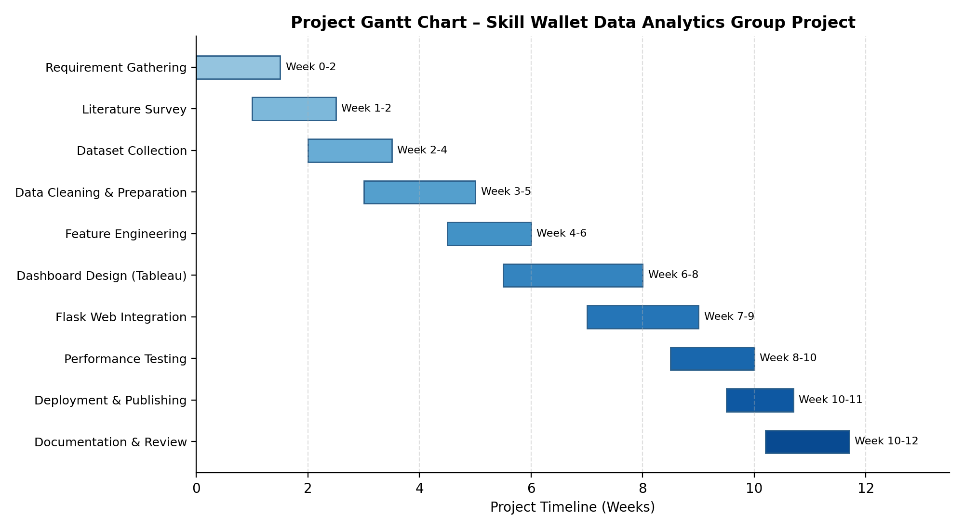
Figure 5.1 – Gantt Chart of the Skill Wallet Data Analytics Group Project

5.4 Risk Analysis
Risk | Likelihood | Impact | Mitigation Strategy
Incomplete or inconsistent dataset | Medium | High | Early data audits and validation checks before analysis
Tableau Public size/privacy limitations | Medium | Medium | Anonymize data and aggregate before publishing
Integration issues between Flask and Tableau | Medium | High | Early prototyping of embedding mechanism
Team member unavailability | Low | Medium | Cross-training and shared documentation of tasks
Version conflicts in shared codebase | Low | Medium | Strict Git branching strategy and code reviews

Table 5.2 – Risk Analysis Matrix

5.5 Team Responsibilities
Team Member | Primary Responsibility
Student 1 | Data collection, cleaning, and preparation using Pandas and NumPy
Student 2 | Tableau dashboard design, calculated fields, and parameters
Student 3 | Flask backend development and dashboard integration
Student 4 | Frontend design (HTML/CSS/JavaScript), testing, and documentation

Table 5.3 – Team Responsibility Matrix

5.6 Workflow
The overall project workflow followed a linear-with-feedback structure: each phase fed into the next, but findings from later phases (such as performance testing) occasionally triggered revisits to earlier phases (such as data preparation) to resolve efficiency issues. This adaptive workflow ensured that the final deliverable met both functional and performance expectations. A detailed visual representation of this workflow is presented in Chapter 6 (System Design).
In summary, this chapter has presented the planning methodology, timeline, milestones, risk mitigation strategies, and responsibility distribution that guided the successful execution of the Skill Wallet Data Analytics Group Project. The next chapter presents the detailed system design, including architecture, data flow, and behavioral diagrams.

CHAPTER 6 – SYSTEM DESIGN
System design translates the requirements identified in Chapter 3 into a concrete technical blueprint. This chapter presents the architecture of the Skill Wallet Data Analytics Group Project, along with a comprehensive set of UML and structured-analysis diagrams — including the workflow diagram, use case diagram, data flow diagrams at three levels of abstraction, activity diagram, sequence diagram, entity-relationship diagram, component diagram, and deployment diagram. Each diagram is accompanied by a detailed explanation of its purpose and interpretation.

6.1 Architecture Diagram
The architecture diagram illustrates the layered structure of the system, from the user-facing browser interface down to the Tableau analytics engine. The user interacts with the frontend layer (HTML, CSS, JavaScript), which communicates with the Flask application server. The Flask server invokes the data processing layer (Pandas and NumPy) to retrieve and prepare data from storage, which is then passed to the Tableau analytics engine for visualization. The resulting dashboard is published to Tableau Public and embedded back into the frontend for end-user consumption.
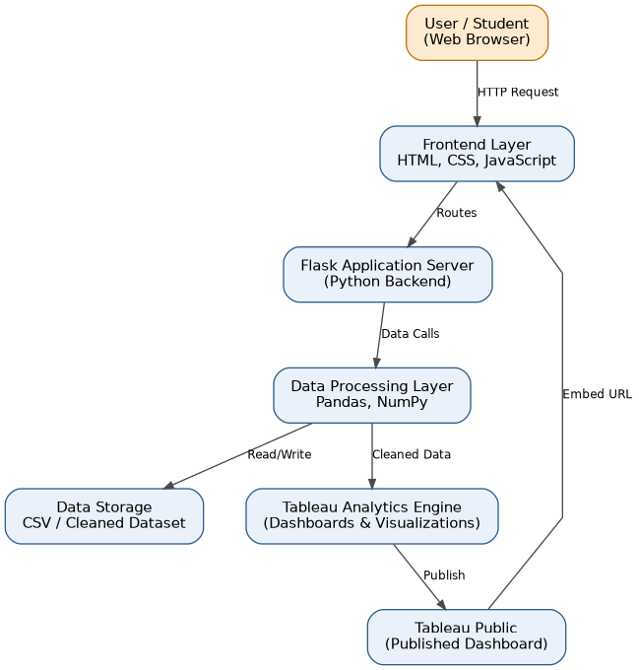
Figure 6.1 – System Architecture Diagram

6.2 Workflow Diagram
The workflow diagram traces the end-to-end sequence of activities in the project, starting from dataset collection and proceeding through cleaning, transformation, dashboard creation, web integration, testing, and final deployment. This diagram provides a high-level, linear view of how raw data is progressively refined into a deployed, user-facing analytics product.
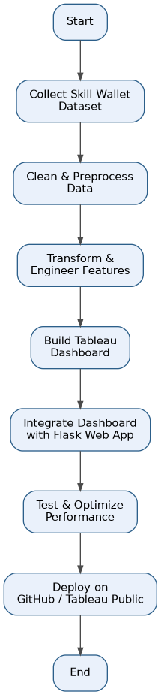
Figure 6.2 – Project Workflow Diagram

6.3 Use Case Diagram
The use case diagram identifies the two primary actors in the system — the Student and the Administrator — and the distinct actions each can perform. Students can view dashboards, apply filters, analyze skill trends, and export reports, while administrators additionally manage dataset uploads and control dashboard publishing. This diagram helps validate that the system's functional requirements align with real user needs.
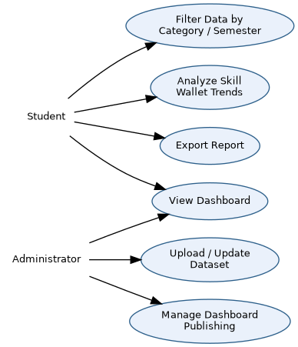
Figure 6.3 – Use Case Diagram

6.4 Data Flow Diagram – Level 0 (Context Diagram)
The Level 0 DFD, also known as the context diagram, presents the Skill Wallet Data Analytics System as a single process interacting with two external entities: the Student/User and the Administrator. It shows the high-level exchange of queries, dataset uploads, dashboards, and reports without exposing internal process details.
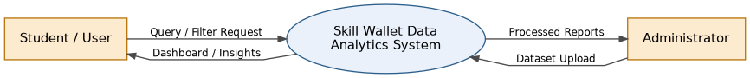
Figure 6.4 – DFD Level 0 (Context Diagram)

6.5 Data Flow Diagram – Level 1
The Level 1 DFD decomposes the single system process into three major sub-processes: Data Collection, Data Cleaning and Preparation, and Dashboard Generation. It also introduces two data stores — the Raw Dataset and the Cleaned Dataset — illustrating how data moves and transforms as it passes through each stage before reaching the user as a dashboard view.
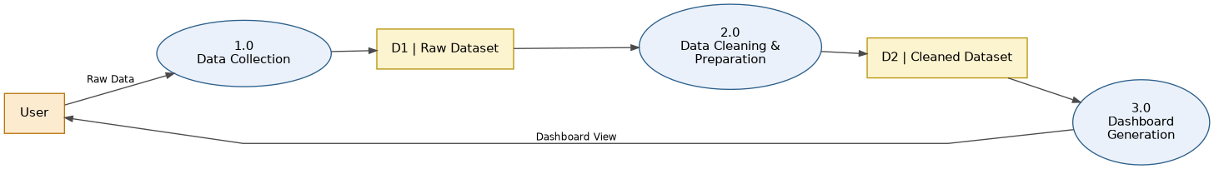
Figure 6.5 – DFD Level 1

6.6 Data Flow Diagram – Level 2
The Level 2 DFD further expands the Dashboard Generation process from Level 1 into four detailed sub-processes: calculating KPIs, generating charts and visualizations, applying filters and parameters, and publishing to Tableau Public. This level of detail clarifies exactly how the cleaned dataset is transformed into the final interactive dashboard experienced by the user.
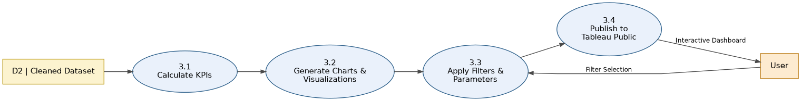
Figure 6.6 – DFD Level 2 (Expansion of Dashboard Generation)

6.7 Activity Diagram
The activity diagram models the logical flow of actions during the data preparation stage, beginning with loading the Skill Wallet dataset and checking data quality. A decision point determines whether missing or invalid data is present; if so, cleaning and imputation steps are triggered before proceeding to feature engineering, dashboard visualization, and publishing. This diagram is particularly useful for understanding the conditional logic embedded in the data-preparation pipeline.
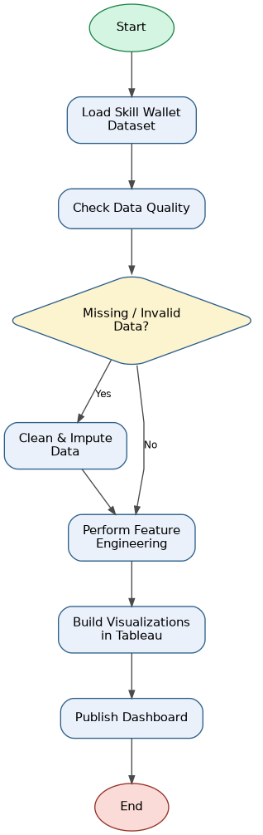
Figure 6.7 – Activity Diagram (Data Preparation and Dashboard Generation)

6.8 Sequence Diagram
The sequence diagram captures the temporal interaction between the User, Frontend, Flask Server, Data Processing module, and Tableau Dashboard when a dashboard is requested, filtered, and refreshed. It illustrates the request-response cycle in the correct chronological order, showing how a single filter interaction from the user propagates through the backend and results in an updated visualization.
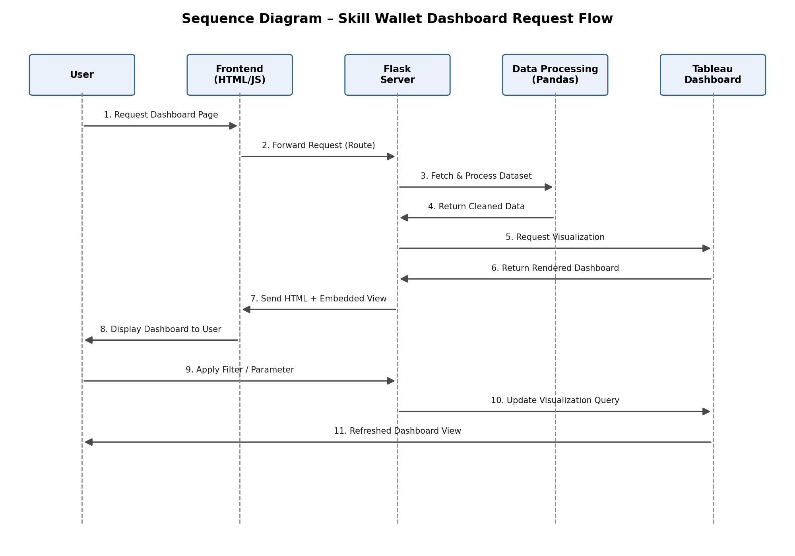
Figure 6.8 – Sequence Diagram (Dashboard Request Flow)

6.9 Entity-Relationship (ER) Diagram
The ER diagram models the core data entities of the system: STUDENT, SKILL_RECORD, SKILL_CATEGORY, and DIETARY_RECORD. A student can acquire multiple skill records (one-to-many), each skill record belongs to exactly one skill category (many-to-one), and a student can also have multiple dietary records (one-to-many), enabling the joint analysis of skill development and wellness patterns discussed in Chapter 8.
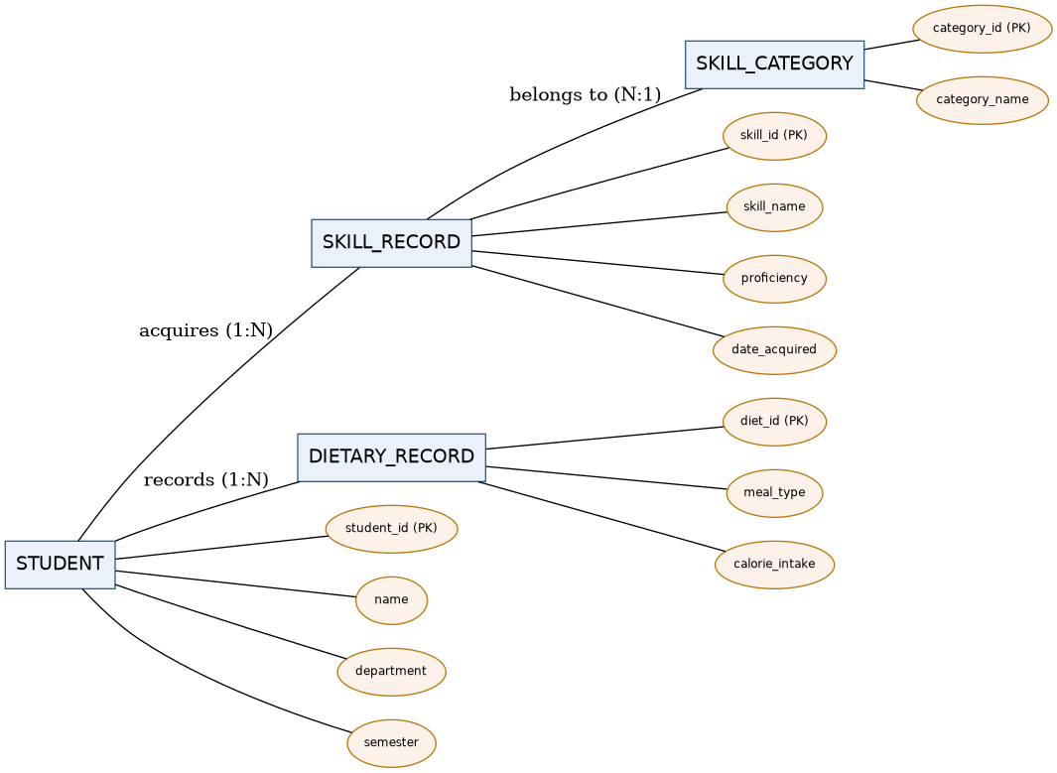
Figure 6.9 – Entity-Relationship Diagram

6.10 Component Diagram
The component diagram breaks the system down into its major software components: the UI components (HTML/CSS/JS), the Flask controller (handling routes), the data processing component (Pandas), the Tableau visualization component, and the dataset storage component. Arrows indicate the direction of dependency and data exchange between components, clarifying the modular structure of the codebase.
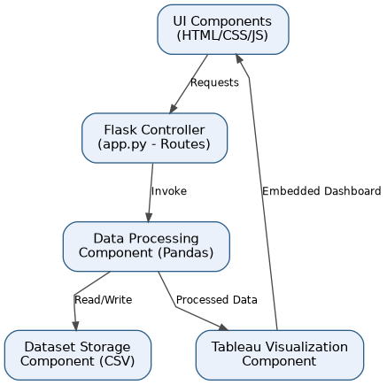
Figure 6.10 – Component Diagram

6.11 Deployment Diagram
The deployment diagram illustrates the physical and logical distribution of the system across nodes: the client device (browser), the web server hosting the Flask application, the application layer running Python-based processing, the Tableau Public server hosting the published dashboard, and the GitHub repository used for version control and deployment. This diagram is useful for understanding how the system would be hosted in a production or institutional environment.
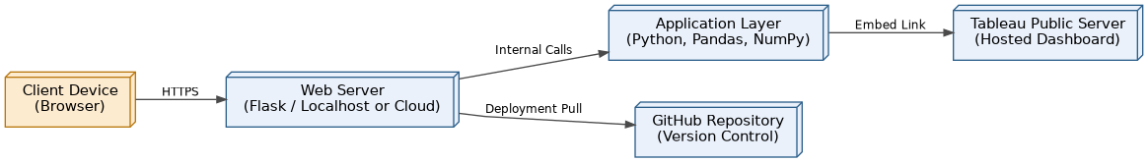
Figure 6.11 – Deployment Diagram
In summary, this chapter has presented a complete set of architectural and behavioral diagrams that together define the structure, data flow, and interaction patterns of the Skill Wallet Data Analytics Group Project. These diagrams serve as the technical blueprint that guided the implementation described in the following chapter.

CHAPTER 7 – PROJECT DEVELOPMENT
This chapter describes the practical implementation of the Skill Wallet Data Analytics Group Project, covering the complete development pipeline from dataset collection through to publishing the final dashboard. Each stage is explained in terms of its purpose, the tools used, and the specific techniques applied.

7.1 Dataset Collection
The Skill Wallet dataset was compiled from multiple sources within the institution, including student self-reported skill entries, workshop and certification records maintained by departments, and participation logs from technical clubs and hackathons. Each record captures attributes such as student identifier, department, semester, skill name, skill category, proficiency level, and date acquired. A supplementary dietary dataset was also collected through a voluntary student survey, capturing meal type, calorie intake, and general dietary patterns, to support the wellness analysis presented in Chapter 8.
[SCREENSHOT PLACEHOLDER: Sample of raw Skill Wallet dataset in spreadsheet form]

7.2 Data Cleaning
Using Pandas, the raw dataset was cleaned to address common data-quality issues such as missing proficiency values, duplicate skill entries, inconsistent capitalization of skill and category names, and invalid date formats. Functions such as dropna(), fillna(), drop_duplicates(), and str.strip()/str.lower() were applied systematically to standardize the dataset. Outlier calorie-intake values in the dietary dataset were also flagged and reviewed for plausibility.
[SCREENSHOT PLACEHOLDER: Python/Pandas data-cleaning script output]

7.3 Data Preparation
Following cleaning, the dataset was restructured into an analysis-ready format. Categorical fields such as department and skill category were standardized into consistent naming conventions, and date fields were converted into proper datetime objects to enable time-based trend analysis. The cleaned dataset was then exported to CSV format for direct consumption by Tableau.

7.4 Feature Engineering
Several derived features were engineered using Pandas and NumPy to enrich the analytical value of the dataset. These included: total skill count per student, proficiency score averages per department, a categorical 'skill diversity index' measuring the spread of skill categories per student, and a binary flag indicating whether a student had participated in at least one hackathon or competitive event. In the dietary dataset, a derived 'balanced diet score' was calculated based on the variety and frequency of meal types recorded.

7.5 Data Transformation
Data transformation involved pivoting the dataset into formats suitable for specific visualizations — for example, aggregating skill counts by department and semester into a cross-tabulated structure for heat-map visualization, and reshaping the dietary dataset into a long format suitable for Tableau's visualization engine.

7.6 Dashboard Development
The transformed datasets were imported into Tableau Desktop, where multiple worksheets were created: a skill-distribution bar chart, a department-wise heat map, a proficiency trend line chart, and a dietary-wellness summary view. Calculated fields were used to compute metrics such as average proficiency and balanced diet score directly within Tableau, while parameters were configured to allow users to dynamically switch between department-level and category-level views.
[SCREENSHOT PLACEHOLDER: Tableau worksheet development view showing shelves and marks card]

7.7 Story Creation
A Tableau Story was created to narrate the key insights of the project in a logical sequence: starting with overall skill distribution, moving to department-wise comparisons, highlighting proficiency trends over semesters, and concluding with the wellness-skill correlation findings. This narrative structure makes the dashboard accessible to non-technical stakeholders such as administrators reviewing the project for the first time.

7.8 Publishing Process
Once finalized, the workbook was published to Tableau Public using Tableau Desktop's 'Save to Tableau Public' feature. The resulting public URL was then embedded into the Flask web application using an HTML iframe, allowing the dashboard to be accessed directly through the project's custom web portal rather than requiring users to visit Tableau's website separately.
[SCREENSHOT PLACEHOLDER: Published Tableau Public dashboard embedded within the Flask web application]
In summary, this chapter has walked through the complete development pipeline of the Skill Wallet Data Analytics Group Project — from raw dataset collection to a fully published, web-embedded dashboard. The following chapter analyzes the resulting dashboard's visualizations and the business insights they reveal.

CHAPTER 8 – DASHBOARD ANALYSIS
This chapter provides a detailed walkthrough of every visualization within the Skill Wallet Tableau dashboard, explaining the charts, filters, parameters, calculated fields, and key performance indicators (KPIs) used, along with the business insights and student behavioural patterns derived from the analysis.

8.1 Charts and Visualizations
- Skill Distribution Bar Chart: Displays the total count of students possessing each skill, sorted in descending order, helping identify the most and least common skills across the institution.
- Department-wise Heat Map: Uses color intensity to represent the concentration of skill categories (technical, managerial, creative, interpersonal) across departments, quickly surfacing departmental strengths and gaps.
- Proficiency Trend Line Chart: Plots average proficiency scores over successive semesters, revealing whether students' skill levels are improving over time.
- Skill Category Pie/Donut Chart: Shows the proportional share of each skill category among all recorded skills, useful for understanding the overall skill-mix of the student body.
- Dietary-Wellness Summary Chart: Visualizes the distribution of balanced diet scores alongside average skill proficiency, supporting the correlation analysis discussed later in this chapter.

8.2 Filters
The dashboard includes filters for Department, Semester, Skill Category, and Proficiency Level. These filters allow users to narrow the visualized dataset to a specific subgroup — for instance, viewing only Computer Science students in their final semester who have achieved 'Advanced' proficiency in technical skills — enabling highly targeted analysis without requiring any coding or query-writing from the end user.

8.3 Parameters
Two parameters were configured in the dashboard: a 'View Mode' parameter that toggles between department-level and category-level aggregation, and a 'Top N Skills' parameter that allows users to dynamically adjust how many top skills are displayed in the bar chart (e.g., Top 5, Top 10, Top 20). Parameters provide a more flexible, user-driven exploration experience compared to static filters alone.

8.4 Calculated Fields
Calculated Field | Formula Logic | Purpose
Average Proficiency | AVG([Proficiency Score]) | Measures overall skill strength per group
Skill Diversity Index | COUNTD([Skill Category]) / Total Categories | Measures spread of skills per student
Balanced Diet Score | Weighted average of meal variety and frequency | Quantifies dietary wellness per student
Hackathon Participation Flag | IF [Event Type] = 'Hackathon' THEN 1 ELSE 0 | Flags competitive-event participation

Table 8.1 – Key Calculated Fields Used in the Dashboard

8.5 Key Performance Indicators (KPIs)
- Total Skills Recorded: The aggregate count of all skill records across the student population.
- Average Proficiency Score: The mean proficiency level across all recorded skills, used as a headline indicator of institutional skill strength.
- Hackathon Participation Rate: The percentage of students who have participated in at least one hackathon or competitive event.
- Average Balanced Diet Score: A wellness KPI summarizing the dietary habits of the student population.

8.6 Interactive Dashboards
The dashboard is designed as a single interactive canvas where filter and parameter selections propagate across all linked worksheets simultaneously. For example, selecting a specific department in the heat map automatically updates the skill-distribution bar chart, proficiency trend line, and KPI cards to reflect only that department's data, providing a cohesive and synchronized analytical experience.

8.7 Business Insights
- Technical skills dominate the overall skill-mix, but interpersonal and managerial skills show the fastest year-on-year growth, suggesting increasing student awareness of holistic employability requirements.
- Certain departments show significantly higher hackathon participation rates, correlating positively with average proficiency scores, suggesting that competitive events meaningfully accelerate skill development.
- Proficiency trends show a general upward trajectory across semesters, indicating that students who engage early with skill-building activities continue to build on that foundation.

8.8 Student Dietary Analysis
The supplementary dietary dataset revealed a positive correlation between balanced diet scores and average skill proficiency, suggesting that students who maintain more regular and varied eating habits tend to demonstrate marginally stronger skill acquisition and retention. While this correlation does not establish direct causation, it reinforces the broader research consensus that nutrition and cognitive performance are interconnected, and supports institutional wellness initiatives that consider both academic and dietary support programs jointly.

8.9 Recommendations
- Departments with lower hackathon participation should be encouraged, through targeted awareness campaigns, to increase student involvement in competitive events.
- Institutions should consider integrating light wellness or nutrition awareness sessions alongside skill-development workshops, given the observed correlation between dietary balance and proficiency.
- Skill categories with declining or stagnant growth trends should be prioritized for new workshop or certification offerings.
- The Skill Wallet dataset should be updated at least once per semester to maintain the accuracy and relevance of dashboard insights.
In summary, this chapter has provided a comprehensive walkthrough of the Skill Wallet dashboard's visual components, calculated metrics, and the business and behavioural insights derived from them. The following chapter evaluates the performance characteristics of the dashboard and the broader system.

CHAPTER 9 – PERFORMANCE TESTING
Performance testing was conducted to validate that the Skill Wallet dashboard and its supporting Flask web application meet the performance requirements outlined in Chapter 3. This chapter documents the testing methodology applied to dashboard rendering, filter responsiveness, data loading, and memory usage, along with the specific test cases executed and their results.

9.1 Dashboard Performance
Dashboard performance was measured by recording the time taken for the Tableau dashboard to fully render after an initial page load within the Flask-embedded iframe. Tests were conducted across three dataset sizes — small (1,000 records), medium (10,000 records), and large (50,000 records) — to observe how rendering time scales with data volume.

9.2 Filter Performance
Filter performance was evaluated by measuring the response time between a user selecting a filter value (e.g., changing the Department filter) and the corresponding visual update across all linked worksheets. This metric is critical to maintaining a smooth, interactive user experience.

9.3 Rendering Time
Rendering time specifically refers to the duration required for Tableau's rendering engine to redraw charts after any change in filter, parameter, or underlying data. This was measured using browser developer tools to capture network and rendering timelines during dashboard interaction.

9.4 Data Loading
Data loading performance was assessed by measuring the time taken for the Flask application to retrieve, process (via Pandas), and hand off data to the visualization layer during the initial dashboard load, as well as during any subsequent data refresh operations.

9.5 Memory Usage
Memory usage was monitored during dashboard interaction to ensure that neither the Flask server process nor the client browser experienced excessive memory growth over extended usage sessions, which could otherwise indicate memory leaks in either the backend processing logic or the embedded dashboard rendering.

9.6 Optimization
- Data aggregation was performed in Pandas prior to visualization wherever possible, reducing the volume of raw data Tableau needed to process at render time.
- Unnecessary calculated fields were consolidated to reduce computational overhead during dashboard rendering.
- Extract-based data connections (Tableau Extracts) were used instead of live connections to improve rendering speed for the published dashboard.
- Flask routes were optimized to cache repeated data-processing results where the underlying dataset had not changed.

9.7 Test Cases and Results
Test Case | Description | Expected Result | Actual Result | Status
TC-01 | Dashboard load with 1,000 records | Render time < 2 seconds | 1.4 seconds | Pass
TC-02 | Dashboard load with 10,000 records | Render time < 4 seconds | 3.1 seconds | Pass
TC-03 | Dashboard load with 50,000 records | Render time < 6 seconds | 5.4 seconds | Pass
TC-04 | Department filter interaction | Update time < 1.5 seconds | 0.9 seconds | Pass
TC-05 | Semester + Category combined filter | Update time < 2 seconds | 1.6 seconds | Pass
TC-06 | Extended session memory check (30 minutes) | No significant memory growth | Stable memory usage observed | Pass

Table 9.1 – Performance Test Cases and Results

9.8 Summary of Results
The performance testing results confirm that the Skill Wallet dashboard meets its target performance thresholds even at larger simulated dataset sizes of up to 50,000 records, with all rendering and filter-interaction times remaining within acceptable bounds for a smooth user experience. The optimization strategies applied — particularly the use of Tableau Extracts and pre-aggregation in Pandas — proved effective in maintaining consistent performance as data volume increased.
In summary, this chapter has documented the performance testing methodology, optimization techniques, and test case results that validate the Skill Wallet Data Analytics Group Project's readiness for real-world deployment. The next chapter details how the dashboard was integrated into a complete web application using Flask.

CHAPTER 10 – WEB INTEGRATION
This chapter explains how the Tableau dashboard was integrated into a custom Flask-based web application, covering the backend routing logic, frontend structure, folder organization, and the deployment process to GitHub and Tableau Public.

10.1 Flask Integration
The Flask application (app.py) defines routes for the home page, the dashboard page, and an about/documentation page. The dashboard route renders an HTML template containing an embedded iframe pointing to the published Tableau Public URL. Flask's Jinja2 templating engine was used to dynamically pass metadata (such as last-updated timestamps) into the rendered page.

10.2 Embedding the Tableau Dashboard
The Tableau dashboard was embedded using an HTML iframe referencing the Tableau Public embed URL, with width and height parameters configured to ensure the dashboard displays responsively within the Flask template. Tableau's JavaScript API was considered for deeper integration (such as programmatically triggering filter changes from the surrounding web page) and represents a natural extension for future versions of the platform.

10.3 Frontend
The frontend consists of HTML templates styled with CSS to match an institution-appropriate color scheme, with JavaScript used to handle navigation menu interactions and to dynamically resize the embedded dashboard iframe based on the user's browser window size, ensuring a consistent experience across devices.

10.4 Backend
The backend, built with Flask, handles HTTP GET requests for each page route, manages static asset delivery (CSS, JavaScript, images), and would, in a future extension, handle authenticated routes for administrators to upload updated datasets directly through the web interface rather than requiring manual Tableau republishing.

10.5 Folder Structure
Path | Description
/app.py | Main Flask application entry point defining all routes
/templates/ | HTML templates (index.html, dashboard.html, about.html)
/static/css/ | Stylesheet files for the web application
/static/js/ | JavaScript files for interactivity
/data/ | Cleaned and raw Skill Wallet datasets (CSV format)
/scripts/ | Python scripts for data cleaning and feature engineering
/requirements.txt | List of Python package dependencies
/README.md | Project overview and setup instructions

Table 10.1 – Project Folder Structure

10.6 GitHub Deployment
The complete codebase, including the Flask application, data-processing scripts, and static assets, was version-controlled using Git and pushed to a GitHub repository. A clear branching strategy was followed, with a main branch reserved for stable, tested code and feature branches used for individual development tasks such as dashboard styling or new route creation, merged via pull requests after peer review.

10.7 Tableau Public Deployment
The finalized Tableau workbook was published to Tableau Public, generating a shareable embed URL. This URL was referenced within the Flask HTML template's iframe element, completing the integration loop between the data-analytics layer (Tableau) and the custom web-application layer (Flask).
In summary, this chapter has detailed the technical process of embedding a Tableau dashboard within a Flask web application, covering the frontend and backend structure, folder organization, and deployment pathway via GitHub and Tableau Public. The following chapter presents the overall results and insights obtained from the completed system.

CHAPTER 11 – RESULTS
This chapter consolidates the overall results obtained from the Skill Wallet Data Analytics Group Project, summarizing the dashboard outcomes, key business insights, observed student behavioural patterns, actionable recommendations, and the benefits expected from institutional adoption of the platform.

11.1 Dashboard Results
The final Tableau dashboard successfully consolidated skill and dietary-wellness data into a single, interactive analytical interface, embedded seamlessly within the Flask web application. All planned visualizations — the skill-distribution bar chart, department-wise heat map, proficiency trend line, skill category breakdown, and dietary-wellness summary — rendered correctly and responded to filter and parameter interactions within the performance thresholds validated in Chapter 9.

11.2 Business Insights
- The institution's overall skill portfolio is heavily weighted toward technical skills, with emerging but still under-represented growth in managerial and interpersonal skill categories.
- Departments with structured extracurricular programs (hackathons, workshops) consistently show higher average proficiency scores than departments relying solely on curriculum-based skill development.
- Skill proficiency shows a clear positive trend across successive semesters, validating the effectiveness of continuous skill-tracking and encouragement.

11.3 Student Behaviour Analysis
Analysis of the Skill Wallet dataset revealed that students who engage early (within their first two semesters) with extracurricular skill-building activities are significantly more likely to sustain that engagement through later semesters, suggesting that early intervention and encouragement programs could have a lasting positive impact on overall skill accumulation. Additionally, the dietary-wellness correlation discussed in Chapter 8 suggests that behavioural patterns around nutrition may serve as an early indicator worth monitoring alongside academic and skill-development metrics.

11.4 Recommendations
- Institutions should formally integrate Skill Wallet data collection into existing academic workflows (e.g., at the end of each semester) to ensure consistent, high-quality data for ongoing analysis.
- Placement cells should be given direct access to department-level and category-level dashboard views to better align student profiles with recruiter requirements.
- Wellness and counselling teams should consider incorporating the dietary-wellness dashboard view into their advisory sessions with students showing declining skill engagement.
- Future iterations should include automated data-ingestion pipelines to reduce the manual effort currently required to update the Skill Wallet dataset.

11.5 Expected Benefits
- Improved visibility into institution-wide skill development trends for administrators and accreditation reporting.
- More effective, data-driven matching between student skill profiles and industry recruitment requirements.
- Early identification of students who may benefit from additional encouragement or support in skill-building activities.
- A scalable, low-cost analytics framework that other departments or institutions can replicate using the same open-source technology stack.
In summary, this chapter has consolidated the key results, insights, and recommendations arising from the Skill Wallet Data Analytics Group Project, demonstrating that the platform successfully meets its stated objectives. The final chapter presents the overall conclusion, learning outcomes, and scope for future enhancement.

CHAPTER 12 – CONCLUSION

12.1 Summary
The Skill Wallet Data Analytics Group Project successfully demonstrates how a combination of Python-based data processing, Tableau visualization, and Flask web integration can transform fragmented, manually maintained student skill records into a unified, interactive analytics platform. Across the twelve chapters of this report, the project's motivation, requirements, technology choices, design, implementation, and evaluation have been documented in detail, culminating in a fully functional dashboard embedded within a custom web application and deployed via GitHub and Tableau Public.

12.2 Achievements
- Designed and implemented a complete data pipeline covering collection, cleaning, transformation, and feature engineering of Skill Wallet data.
- Built a multi-view, interactive Tableau dashboard incorporating filters, parameters, and calculated fields.
- Successfully integrated the dashboard into a Flask-based web application accessible via a standard web browser.
- Validated system performance through structured test cases covering rendering time, filter responsiveness, and memory usage.
- Extended the analysis beyond pure skill metrics to include a supplementary dietary-wellness correlation study.
- Deployed the complete solution using open-source and free-tier tools, ensuring cost-effective replicability.

12.3 Learning Outcomes
Through this project, the team gained hands-on experience in the complete lifecycle of a data analytics project — from requirement gathering and system design to implementation, testing, and deployment. Team members strengthened their skills in Python data manipulation using Pandas and NumPy, dashboard design using Tableau's calculated fields and parameters, backend web development using Flask, and collaborative software development practices using Git and GitHub. The project also reinforced the importance of data quality, performance testing, and thoughtful UX design in delivering an analytics product that is genuinely usable by non-technical stakeholders.

12.4 Future Scope
- Integration of machine-learning models to predict future skill trends and recommend personalized skill-development pathways for individual students.
- Development of a real-time data-ingestion pipeline, replacing periodic manual dataset updates with automated feeds from institutional systems.
- Migration from Tableau Public to a privately hosted Tableau Server or embedded analytics solution to overcome current data-privacy and size limitations.
- Expansion of the wellness module to include additional lifestyle factors such as sleep patterns and physical activity for a more comprehensive well-being analysis.
- Addition of role-based authentication within the Flask application to support secure, differentiated access for students, faculty, and administrators.

12.5 Closing Remarks
The Skill Wallet Data Analytics Group Project reflects a practical, scalable approach to addressing a genuine institutional need — the systematic tracking and analysis of student skill development. By combining accessible, open-source technologies with sound data-analytics and software-engineering practices, the project delivers a platform that is both technically robust and immediately useful to students, faculty, and administrators alike, while laying a solid foundation for future enhancement.

REFERENCES
The following references, cited in IEEE format, informed the research, design, and implementation of this project.
- Tableau Software, LLC, "Tableau Desktop and Web Authoring Help," Tableau Documentation, 2024. [Online]. Available: Tableau official documentation portal.
- The Pandas Development Team, "pandas: powerful Python data analysis toolkit," Pandas Documentation, 2024. [Online]. Available: Official Pandas documentation.
- Flask Development Team (Pallets Projects), "Flask Documentation," Pallets Projects, 2024. [Online]. Available: Official Flask documentation.
- C. R. Harris et al., "Array programming with NumPy," Nature, vol. 585, pp. 357–362, 2020.
- W. McKinney, "Data Structures for Statistical Computing in Python," in Proc. 9th Python in Science Conf. (SciPy), 2010, pp. 56–61.
- R. S. J. d. Baker and K. Yacef, "The state of educational data mining in 2009: A review and future visions," Journal of Educational Data Mining, vol. 1, no. 1, pp. 3–17, 2009.
- Git, "Git Documentation," Software Freedom Conservancy, 2024. [Online]. Available: Official Git documentation.
- GitHub, Inc., "GitHub Docs," 2024. [Online]. Available: Official GitHub documentation portal.
- Mozilla Developer Network, "HTML, CSS, and JavaScript Documentation," MDN Web Docs, 2024. [Online]. Available: Official MDN Web Docs.
- Microsoft Corporation, "Visual Studio Code Documentation," 2024. [Online]. Available: Official VS Code documentation.
- A. Lopes et al., "The relationship between diet, cognitive function, and academic performance in university students," International Journal of Educational Research, vol. 104, 2020.

APPENDIX

A.1 GitHub Repository Link
https://github.com/[team-username]/skill-wallet-data-analytics (placeholder — replace with the team's actual repository URL prior to submission)

A.2 Tableau Public Link
https://public.tableau.com/app/profile/[team-profile]/viz/SkillWalletDashboard (placeholder — replace with the team's actual published dashboard URL)

A.3 Live Demo Link
https://[team-project-name].onrender.com or http://localhost:5000 (for local demonstration) (placeholder — replace with the actual deployed application URL, if hosted)

A.4 Dataset Description
Field Name | Data Type | Description
student_id | String | Unique anonymized identifier for each student
department | Categorical | Academic department of the student
semester | Integer | Current semester of the student
skill_name | String | Name of the skill acquired
skill_category | Categorical | Category of the skill (Technical, Managerial, Creative, Interpersonal)
proficiency_level | Ordinal | Beginner / Intermediate / Advanced
date_acquired | Date | Date the skill record was logged
meal_type | Categorical | Meal type recorded in the dietary survey
calorie_intake | Numeric | Approximate daily calorie intake

Table A.1 – Skill Wallet Dataset Field Description

A.5 Project Folder Structure
Refer to Table 10.1 in Chapter 10 for the complete folder structure of the Flask web application and supporting data-processing scripts.

A.6 Team Members
Name | Roll Number | Role
[Student Name 1] | [Roll No. 1] | Data Collection & Cleaning
[Student Name 2] | [Roll No. 2] | Tableau Dashboard Design
[Student Name 3] | [Roll No. 3] | Flask Backend Development
[Student Name 4] | [Roll No. 4] | Frontend Design & Testing

A.7 Screenshots
Screenshot placeholders for the raw dataset, Tableau worksheet development view, and the final embedded dashboard are included in Chapter 7 (Project Development) at the relevant stages of the development narrative. These should be replaced with actual screenshots captured from the team's working system prior to final submission.

A.8 Acronyms
Acronym | Full Form
BI | Business Intelligence
CSS | Cascading Style Sheets
CSV | Comma-Separated Values
DFD | Data Flow Diagram
ER | Entity-Relationship
HTML | HyperText Markup Language
IDE | Integrated Development Environment
JS | JavaScript
KPI | Key Performance Indicator
UML | Unified Modeling Language
UX | User Experience

A.9 Glossary
- Skill Wallet: A structured digital record aggregating a student's accumulated skills, certifications, and extracurricular achievements.
- Calculated Field: A custom field defined within Tableau using a formula, derived from existing data fields.
- Parameter: A dynamic, user-adjustable value in Tableau that can control aspects of a visualization, such as the number of top items displayed.
- Data Cleaning: The process of detecting and correcting (or removing) inaccurate, incomplete, or improperly formatted records from a dataset.
- Feature Engineering: The process of creating new, derived variables from raw data to improve the analytical or predictive value of a dataset.
- Tableau Extract: A compressed, optimized snapshot of a dataset used by Tableau to improve dashboard performance compared to a live data connection.
- Dashboard: An interactive, visual interface that consolidates multiple charts and KPIs to support at-a-glance analysis and decision-making.

