Session 8

# Assignment -2

**Sample dataset (student-details.txt file attached separately as well):**

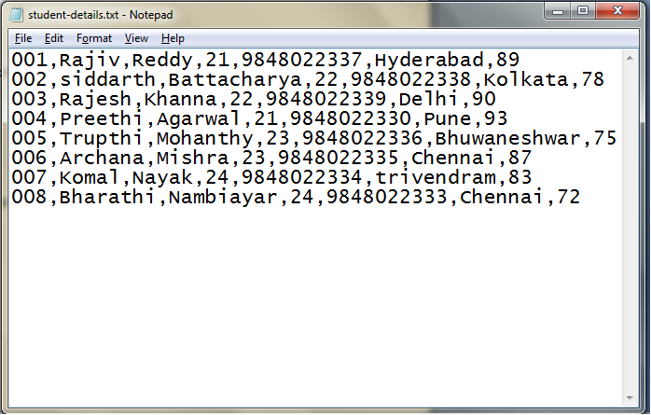

**Commands:**

1. Concat Function:

grunt> student_details = LOAD '/pig_data/student-details.txt' USING PigStorage(',') as (id:int, firstname:chararray, lastname:chararray, age:int, phone:chararray, city:chararray, gpa:int);

grunt> student_name_concat = foreach student_details Generate CONCAT (firstname, lastname);

grunt> Dump student_name_concat;

1. LIMIT Function:

Grunt> Dump student_details LIMIT 4;

1. SUM Function:

Here I am doing SUM of all gpa of each student.

Grunt> student_group = GROUP student_details ALL;

Grunt> student_sum_gpa = FOREACH student_group GENERATE group, SUM(student_details.gpa);

Grunt> Dump student_sum_gpa;

1. MIN Function:

Here I am retrieving who got minimum gpa among all student.

Grunt> student_min = FOREACH student_group GENERATE MIN(student_details.gpa);

Grunt> Dump student_min;

1. MAX Function:

Here I am retrieving who got maximum gpa among all student.

Grunt> student_max = FOREACH student_group GENERATE MAX(student_details.gpa);

Grunt> Dump stundent_max;