**INDEX PAGE**

|  |  |  |
| --- | --- | --- |
| **S.NO** | **CONTENT** | **DATE** |
| 1 | INTRODUCTION |  |
| 2 | COLLECTION OF SEALS |  |
| **3** | PROCESS |  |
| **4** | REFINARY |  |
| **5** | WENGER’S |  |
| **6** | QC & MICROLAB |  |
| **7** | PATCHIN |  |

***INTRODUCTION***

**Ruchi Soya** is the largest [manufacturer](https://en.wikipedia.org/wiki/Manufacturer) of [edible oil](https://en.wikipedia.org/wiki/Edible_oil) in [India](https://en.wikipedia.org/wiki/India). It was acquired by [Patanjali Ayurved](https://en.wikipedia.org/wiki/Patanjali_Ayurved) in 2019. Ruchi Soya has been ranked at 175 in the top 250 [consumer products](https://en.wikipedia.org/wiki/Consumer_products) companies, in the "Global Powers of the Consumer Products Industry 2012", according to a report published by [Deloitte](https://en.wikipedia.org/wiki/Deloitte) Touche Tohmatsu.

Ruchi Soya Industries Limited, through its [subsidiaries](https://en.wikipedia.org/wiki/Subsidiaries), engages in the manufacture and sale of edible oils, [vanaspati](https://en.wikipedia.org/wiki/Vanaspati), bakery fats, and [soya](https://en.wikipedia.org/wiki/Soya_bean) food primarily in India. It also offers soya chunks, granules, and soya flour products. The company is a part of the Ruchi Group. The company exports Agri-Commodities, including raw cotton. It procures material from its close business associates (directly ginners) based at various locations across India. It is exporting to various buying houses, textile mills, and trading companies worldwide. The company extracts various types of seed. It offers food products, such as textured [soy protein](https://en.wikipedia.org/wiki/Soy_protein), soya flour, fruit juice, and soya milk. The company also offers gram, wheat, rice, maize, shorgum, seeds, coffee, marine products, tuar, peas, barley, soap, fresh fruit bunch, seedling, and plant & machinery (equipment).

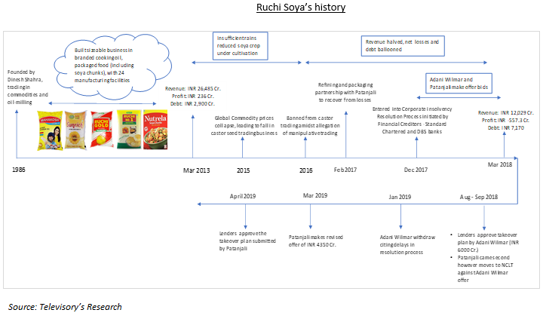

***COLLECTION OF SEALS***

A **seal** is a device for making an impression in [wax](https://en.wikipedia.org/wiki/Sealing_wax), clay, paper, or some other medium, including an embossment on paper, and is also the impression thus made. The original purpose was to authenticate a document, or to prevent interference with a package or envelope by applying a seal which had to be broken to open the container (hence the modern English verb "to seal", which implies secure closing without an actual wax seal).

The seal is part of the brand-building and consumption exercise for qualitative value-added products of soybean which include tofu (soy paneer), soy nuggets, soy milk, breakfast cereals, et al.

Speaking to *FE*, Suresh Itapu, general secretary of Soy Food Association of India and technical director of ASA, a non-profit organisation promoting soybeans and other soy products, explained that these organisations are working with the industry to launch value-added products to increase the rate of consumption even in the rural areas.

The soybean oil extraction in the country has flourished to a great extent but only about 18% of the soybean bulk as oil is used in consumption and most of the remaining, which is still de-fatted protein, is exported to the western countries for cattle feed, he pointed out.

***PROCESS***

* Shares of Ruchi Soya Industries have skyrocketed 36% in the last two trading days after the company announced a follow-on public offer.
* A follow-on public offer is a way of issuing funds for a stock exchange-listed company from its existing shareholders and investors.
* Here is a simple read on what FPO is and how to apply for it.

The process of issuing the FPO is similar to IPO as the company has to submit a red herring prospectus (RHP) to SEBI for its approval.  
  
The issue will open on March 24 and will be available for bidding till March 28, 2022.  
  
Ruchi Soya plans to utilise net proceeds from the FPO for repayment of certain borrowings, incremental working capital requirements, and general corporate purposes.

***REFINERY***

Soyabean oilseeds are crushed into flakes and crude soya oil is extracted through the extraction machine system. The resulting product is crude soybean oil. This crude oil requires degumming to remove the gums from the Soyabean oil. The caustic material removes free fatty acids from the oil. The oil is bleached and deodorized subsequently. Bleaching the Soyabean oil removes the yellow-orange carotenoid pigments and the green chlorophyll from the oil. Deodorization removes the odorous substances in which the oil is subjected to high temperatures under a vacuum for a period of time.

Benefits of Tinytech Soya Oil Refining

* Less oil loss
* Product having high stability
* Suitable for oil with high acid value and low gum impurity
* More FFA is distilled out

 solvent extracted SOYBEAN oil undergoes refining process in SOYBEAN oil refining plant. The process of SOYBEAN oil refining is conducted in four steps which are listed as well as explained below -

Degumming

Gums conditioning and Neutralization

Bleaching Deodorization

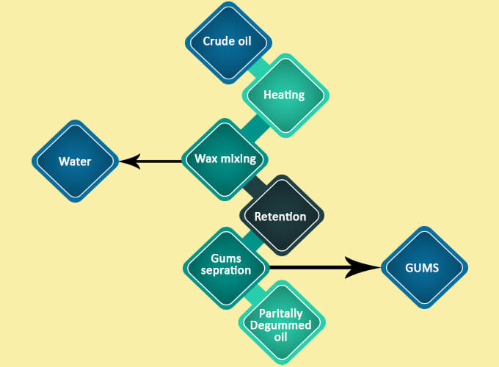

***WENGER’S***

Wengers was established in the year 1924 as a catering outfit for the British troops stationed in Delhi. In 1926 the tea room and Confectionery were inaugurated in Exchange stores in Kashmere gate. Sometime in the late 20’s early ’30s, Wengers shifted base from Kashmere Gate to Connaught Place and has been on this prominent location. Having successfully run a Bakery and Confectionery, both in Delhi and Simla, three restaurants in CP, pioneering Ice Cream Manufacture in Delhi, a Café in the Delhi University, Catering for all the Embassies, the High court, the Supreme Courts, and the Govt of India.

Over the years Wengers has attained legendary status amongst the food outlets in Delhi with people coming from far and wide to sample the food on offer. It is now the oldest surviving establishment in Connaught Place.

***QC & MICROLAB***

***OBJECT***:-- To identify the total plate const yeast ,coliform,Eeati&entrabactoria in plout.

Material requires is PCA Agar,,VABA,VRBGA cemical flash,weight machine ,destill water etc.

PROCESS:- we are using diluent method 10­-1 for the sampling and pavring method for the media.

1] Inoculate the b peptone water agar plate count agar,Rose bangal chloramhinical agar ,violet red bike agar and violet red glucor agar inculte at 121*c for 15 mint.

2] When its temp rise doyan at 40* to 47*c then prepare a 10-1 dilution in a test tube using BPW[buffer pepton water]

3] we are doing povring of PCA agar in a sin petri plate[10-1/1,10-1/2,10 -2/1 ….10-3/2] this are our dilutent.

4] first we take 1 gm of soya flour dissolve in 10-1 dilution and this seriol dilution again pipatte out in 10-2 and again in ml 10-3.

***5]*** pipatt out 1 ml sample and spreat in petri plate and paor RBCA mix well put for settle down.

6] 1 ml sample for VRBA & VRBGA and pour media in VRBA petrdisk and second sample spread in VRBGA plate and pour media in petri dish.

7] After solidify the media put in a inclutor in the inverte form.

8] RBCA include at 25*c for 5 days and not in invert form.

9] PCA include at 30* for 3 days in invorte form.

10] VRBA & VRBGA include at 37*c for 24 hours.

11] After completing inculpation time we monitor the growth of bacteria, geast & mould then accordingly to the result we give our report backterial growth should be less than 300 ck.

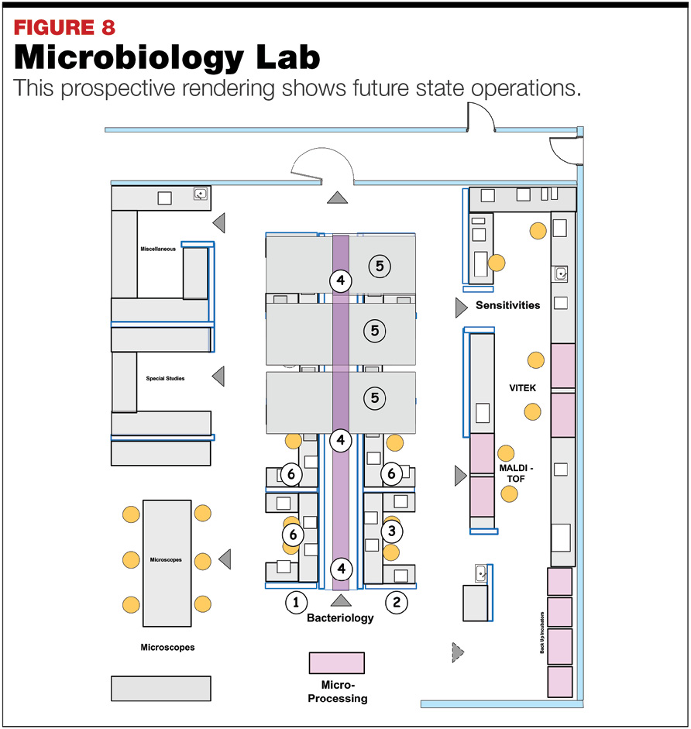

***PACHING***

paching There are many ways of isolating mutants. Patching is the technique of using a sterile toothpick to lift off a whole bacterial colony (or a part of it) and transferring it to the surface of a fresh agar plate. Patching can do 3 things for us: separate mutants from non-mutants, verify the genotype and/or phenotype of mutants and give us enough cells to work with (e.g. direct use in plasmid mini-preps)

Using a toothpick or tip (both sterile), pick your colony and patch onto a plate. Use the same tip to 'seed' a PCR tube. There will be enough remaining cells to lyse in the PCR tube in the initial denaturing step to release DNA for PCR.