**UNIT @1**

**1). What is WWW . write concept of www.**

World Wide Web, which is also known as a Web, is a collection of websites or web pages stored in web servers and connected to local computers through the internet. These websites contain text pages, digital images, audios, videos, etc. Users can access the content of these sites from any part of the world over the internet using their devices such as computers, laptops, cell phones, etc. The WWW, along with internet, enables the retrieval and display of text and media to your device.

A web page is given an online address called a Uniform Resource Locator (URL).

The World Wide Web -- also known as the web, WWW or W3 -- refers to all the public websites or pages that users can access on their local computers and other devices through the [internet](https://www.techtarget.com/whatis/definition/Internet). These pages and documents are interconnected by means of [hyperlinks](https://www.merriam-webster.com/dictionary/hyperlink) that users click on for information.

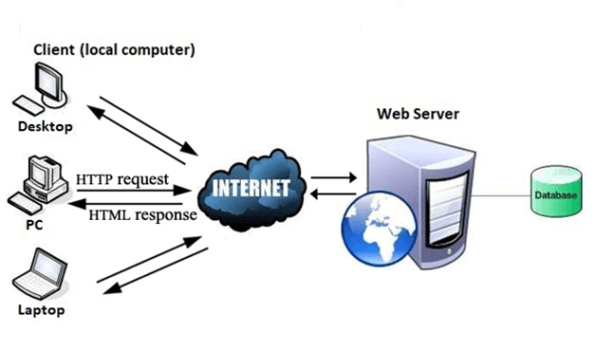

**2). Difference between WWW and Internet.**

|  |  |  |
| --- | --- | --- |
| S.No. | INTERNET | WWW |
| 1 | Internet is a global network of networks. | WWW stands for World wide Web. |
| 2 | Internet is a means of connecting a computer to any other computer anywhere in the world. | World Wide Web which is a collection of information which is accessed via the Internet. |
| 3 | Internet is infrastructure. | WWW is service on top of that infrastructure. |
| 4 | Internet can be viewed as a big book-store. | Web can be viewed as collection of books on that store. |
| 5 | At some advanced level, to understand we can think of the Internet as hardware. | At some advanced level, to understand we can think of the WWW as software. |
| 6 | Internet is primarily hardware-based. | WWW is more software-oriented as compared to the Internet. |
| 7 | It is originated sometimes in late 1960s. | English scientist Tim Berners-Lee invented the World Wide Web in 1989. |
| 8 | Internet is superset of WWW. | WWW is a subset of the Internet. |
| 9 | The first version of the Internet was known as ARPANET. | In the beginning WWW was known as NSFNET. |
| 10 | Internet uses IP address. | WWW uses HTTP. |

**(M.IMP)3). Difference between internet and intranet.**

**Internet:**   
Internet is used to connect the different networks of computers simultaneously. It is a public network therefore anyone can access the internet. On the internet, there are multiple users and it provides an unlimited of information to the users.

**Intranet:**   
Intranet is the type of internet that is used privately. It is a private network therefore anyone can’t access the intranet. On the intranet, there is a limited number of users and it provides a piece of limited information to its users.

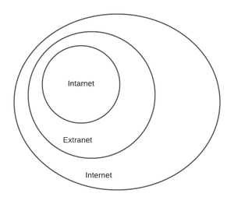

|  |  |  |
| --- | --- | --- |
| S.NO | Internet | Intranet |
| 1. | Internet is used to connect different networks of computers simultaneously. | Intranet is owned by private firms. |
| 2. | On the internet, there are multiple users. | On an intranet, there are limited users. |
| 3. | Internet is unsafe. | Intranet is safe. |
| 4. | On the internet, there is more number of visitors. | In the intranet, there is less number of visitors. |
| 5. | Internet is a public network. | Intranet is a private network. |
| 6. | Anyone can access the Internet. | In this, anyone can’t access the Intranet. |
| 7. | The Internet provides unlimited information. | Intranet provides limited information. |
| 8. | Using Social media on your phone or researching resources via Google. | A company used to communicate internally with its employees and share information |

**4).Http Protocol request and response explain.**

The operation of [**Hypertext Transfer Protocol (HTTP)**](https://www.omnisecu.com/tcpip/http-hypertext-transfer-protocol-what-is-http.php) involves the communication between a Hypertext Transfer Protocol (HTTP) client application (Usually web browser) and a Hypertext Transfer Protocol (HTTP) server application (Web servers like IIS). Hypertext Transfer Protocol (HTTP) uses [**Transmission Control Protocol (TCP)**](https://www.omnisecu.com/tcpip/transmission-control-protocol-tcp.php) as the Transport Layer Protocol at [**Well Known port number**](https://www.omnisecu.com/tcpip/tcp-port-numbers.php) 80. Once the [**TCP**](https://www.omnisecu.com/tcpip/transmission-control-protocol-tcp.php) connection is established, the two steps in Hypertext Transfer Protocol (HTTP) communication are

1) HTTP Client Request: Hypertext Transfer Protocol (HTTP) client sends an Hypertext Transfer Protocol (HTTP) Request to the Hypertext Transfer Protocol (HTTP) Server according to the HTTP standard, specifying the information the client like to retrieve from the Hypertext Transfer Protocol (HTTP) Server.

2) HTTP Server Response: Once the Hypertext Transfer Protocol (HTTP) Request arrived at the Hypertext Transfer Protocol (HTTP) server, it will process the request and creates an Hypertext Transfer Protocol (HTTP) Response message. The Hypertext Transfer Protocol (HTTP) response message may contain the resource the Hypertext Transfer Protocol (HTTP) Client requested or information why the Hypertext Transfer Protocol (HTTP) request failed.

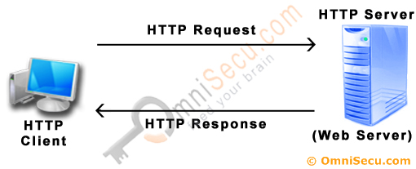

**5.) Explain Web browser and web server.**

For International Network communication, we require a web browser and web servers. Web browsers and servers play an important role in establishing the connection. The client sends requests for web documents or services. The message that goes from the web browser to the web server is known as an HTTP request. When the web server receives the request, it searches its stores to find the appropriate page. If the web server can locate the page, it parcels up to the HTML contained within (using some transport layer protocol), addresses these parcels to the browser (using HTTP), and transmits them back across the network. If the web server is unable to find the requested page, it sends a page containing an error message (i.e. Error 404 – page not found) and it parcels up to the dispatches that page to the browser. This message received by the web browser by the server is called the HTTP response. The main differences between the Web browser and web servers are:

| S. No. | Parameters | Web Browser | Web Server |
| --- | --- | --- | --- |
| 1. | Basics | Web Browser is an Application program that displays a World wide web document. It usually uses the internet service to access the document. | A web server is a program or the computer that provide services to other programs called client. |
| 2. | Function | The Web browser requests the server for the web documents and services. | The Web server accepts, approves, and responds to the request made by the web browser for a web document or service. |
| 3. | Responsibility | A web browser is a programme that uses websites to search the internet for information. | The web server is responsible for connecting websites and web browsers. |
| 4. | Interface | The web browser acts as an interface between the server and the client and displays a web document to the client. | The web server is a software or a system which maintain the web applications, generate response and accept clients data. |
| 5. | Components of architecture | Components of web browser architecture- a controller, client program, and interpreters. | Components of web server architecture- hardware, operating system software, and Web server software. |
| 6. | HTTP request and response | The web browser sends an HTTP request and gets an HTTP response. | The web server gets HTTP requests and sends HTTP responses. |
| 7. | Processing Model | Doesn’t exist any processing model for the web browser. | There exist three types of processing models for web servers i.e Process-based, Thread based, and Hybrid. |
| 8. | Storing data | Web browser stores the cookies for different websites. | Web servers provide an area to store and organize the pages of the website. |
| 9. | Installation | The web browser is installed on the client’s computer. | The web server can be a remote machine placed on the other side of your network or even on the other end of the globe, or it is your very own personal computer at home. |
| 10. | Examples | Examples of Web browsers are Mozilla Firefox, Google Chrome, and Internet Explorer. | An example of a Web Server is Apache Server. |

**6) Features of 2.0.**

***“Web 2.0 is the business revolution in the computer industry caused by the move to the internet as a platform, and any attempt to understand the rules for success on that new platform.”–*** Tim O’ Reilly.

It’s a simply improved version of the first worldwide web, characterized specifically by the change from static to dynamic or user-generated content and also the growth of social media.

The concept behind Web 2.0 refers to rich web applications, web-oriented architecture, and social web. It refer to changes in the ways web pages are designed and used by the users, without any change in any technical specifications.

**Advantages of Web 2.0:**

* Available at any time, any place.
* Variety of media.
* Ease of usage.
* Learners can actively be involved in knowledge building.
* Can create dynamic learning communities.
* Everybody is the author and the editor, every edit that has been made can be tracked.
* User-friendly.
* Updates in the wiki are immediate and it offers more sources for researchers.
* It provides real-time discussion.

**Web 2.0 tools and their features:**

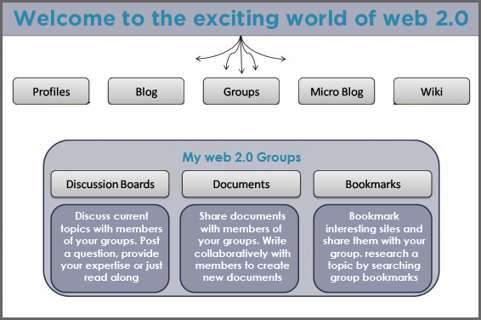

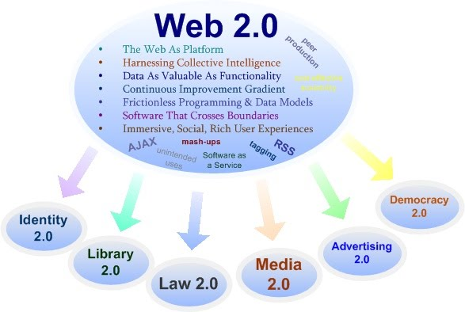

**# Bandwidth and cache explain.**

## Definition

**The maximum amount of data transmitted over an internet connection in a given amount of time.**

Bandwidth is often mistaken for internet speed when it's actually the volume of information that can be sent over a connection in a measured amount of time – calculated in megabits per second (Mbps).

If you love to stream HD videos, download large files and enjoy multiplayer gaming, you may want to consider speed plans of 100 Mbps and above. For all other activities like streaming music, surfing and video conferencing - anything above 25 Mbps should be enough. It all depends on how patient you are with potential buffering and slightly slower speeds when others at home are competing for bandwidth at the same time for their own activities.

Use our speed test tool to see how your current provider compares to Fios.

Cache🡪Web caching is the activity of storing data for reuse, such as a copy of a web page served by a web server.

It is cached or stored the first time a user visits the page and the next time a user requests the same page, a cache will serve the copy, which helps keep the origin server from getting overloaded.

Web caching solutions and strategies enhance page delivery speed significantly and reduce the work needed to be done by the backend server.

Caching servers can be set to refresh at specific intervals or in response to certain events to ensure that the freshest content is cached (useful for rapidly changing information, such as breaking news or rapidly changing pricing).

Caching can also protect against total outages, delivering already cached content when servers are down.

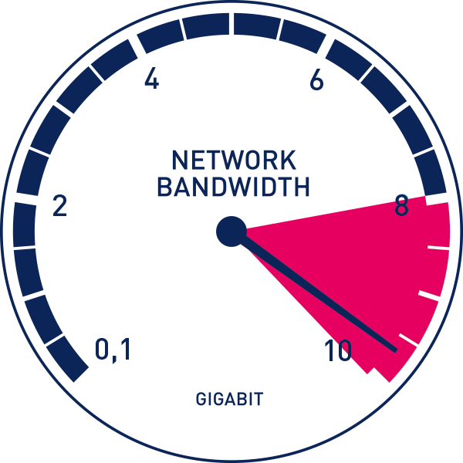Bandwith

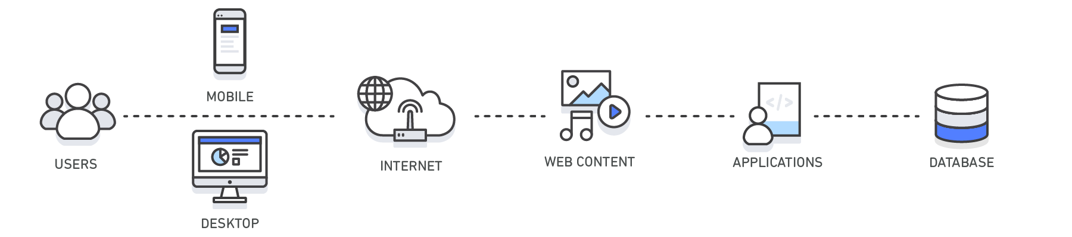Cacheing

# explain display resolutions.

The **display resolution** or display modes of a [digital television](https://en.wikipedia.org/wiki/Digital_television), [computer monitor](https://en.wikipedia.org/wiki/Computer_monitor) or [display device](https://en.wikipedia.org/wiki/Display_device) is the number of distinct [pixels](https://en.wikipedia.org/wiki/Pixel) in each dimension that can be displayed. It can be an ambiguous term especially as the displayed resolution is controlled by different factors in [cathode ray tube](https://en.wikipedia.org/wiki/Cathode_ray_tube) (CRT) displays, [flat-panel displays](https://en.wikipedia.org/wiki/Flat-panel_display) (including [liquid-crystal displays](https://en.wikipedia.org/wiki/Liquid-crystal_display)) and projection displays using fixed picture-element (pixel) arrays.

| **Common display resolutions (**[**N/A**](https://en.wikipedia.org/wiki/N/A)**= not applicable)** | | | | | | |
| --- | --- | --- | --- | --- | --- | --- |
| **Standard** | [**Aspect ratio**](https://en.wikipedia.org/wiki/Aspect_ratio) | **Width ([px](https://en.wikipedia.org/wiki/Pixel" \o "Pixel))** | **Height (px)** | [**Megapixels**](https://en.wikipedia.org/wiki/Megapixels) | [**Steam**](https://en.wikipedia.org/wiki/Steam_(service))[[6]](https://en.wikipedia.org/wiki/Display_resolution#cite_note-6)**(%)** | [**StatCounter**](https://en.wikipedia.org/wiki/StatCounter)[[7]](https://en.wikipedia.org/wiki/Display_resolution#cite_note-7)**(%)** |
| [nHD](https://en.wikipedia.org/wiki/Graphics_display_resolution#nHD) | 16:9 | 640 | 360 | 0.230 | N/A | 0.47 |
| [SVGA](https://en.wikipedia.org/wiki/Graphics_display_resolution#SVGA) | 4:3 | 800 | 600 | 0.480 | N/A | 0.76 |
| [XGA](https://en.wikipedia.org/wiki/XGA-2) | 4:3 | 1024 | 768 | 0.786 | 0.38 | 2.78 |
| [WXGA](https://en.wikipedia.org/wiki/Graphics_display_resolution#WXGA_HD) | 16:9 | 1280 | 720 | 0.922 | 0.36 | 4.82 |
| [WXGA](https://en.wikipedia.org/wiki/Graphics_display_resolution#1280x800) | 16:10 | 1280 | 800 | 1.024 | 0.61 | 3.08 |
| [SXGA](https://en.wikipedia.org/wiki/Graphics_display_resolution#SXGA) | 5:4 | 1280 | 1024 | 1.311 | 1.24 | 2.47 |
| [HD](https://en.wikipedia.org/wiki/Graphics_display_resolution#1360x768) | ≈16:9 | 1360 | 768 | 1.044 | 1.55 | 1.38 |
| [HD](https://en.wikipedia.org/wiki/Graphics_display_resolution#1366x768) | ≈16:9 | 1366 | 768 | 1.049 | 10.22 | 23.26 |
| [WXGA+](https://en.wikipedia.org/wiki/Graphics_display_resolution#WXGAplus) | 16:10 | 1440 | 900 | 1.296 | 3.12 | 6.98 |
| N/A | 16:9 | 1536 | 864 | 1.327 | N/A | 8.53 |
| [HD+](https://en.wikipedia.org/wiki/Graphics_display_resolution#1600x900) | 16:9 | 1600 | 900 | 1.440 | 2.59 | 4.14 |
| [WSXGA+](https://en.wikipedia.org/wiki/Graphics_display_resolution#WSXGAplus) | 16:10 | 1680 | 1050 | 1.764 | 1.97 | 2.23 |

**# explain Page layout and linking..**

Page layout refers to the arrangement of text, images, and other objects on a page. The term was initially used in [desktop publishing](https://techterms.com/definition/desktoppublishing) (DTP), but is now commonly used to describe the layout of [webpages](https://techterms.com/definition/webpage) as well. Page layout techniques are used to customize the appearance of magazines, newspapers, books, websites, and other types of publications.

The page layout of a printed or electronic document encompasses all elements of the page. This includes the page margins, text blocks, images, object padding, and any grids or [templates](https://techterms.com/definition/template) used to define positions of objects on the page. Page layout [applications](https://techterms.com/definition/application), such as Adobe InDesign and QuarkXpress, allow page designers to modify all of these elements for a printed publication. Web development programs, such as Adobe Dreamweaver and Microsoft Expression Studio allow Web developers to create similar page layouts designed specifically for the Web.

Since there are many applications that create customized page layouts, there is also a specific file format category for page layout file types. These files are similar to [word processing](https://techterms.com/definition/wordprocessor) documents, but may contain additional page formatting information and other types of visual content.

Web designing has direct link to visual aspect of a web site. Effective web design is necessary to communicate ideas effectively.

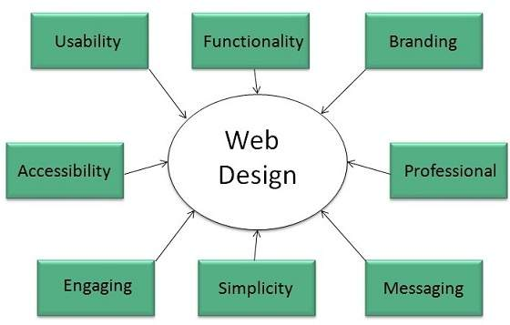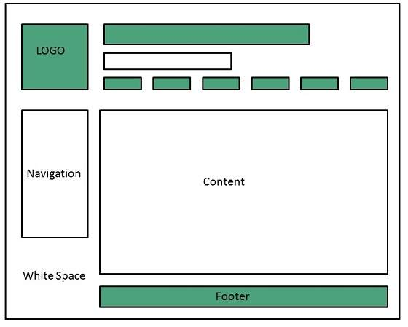

**# Expain user centric design.**

User-centered design (UCD) is an iterative design process in which designers focus on the users and their needs in each phase of the design process. In UCD, design teams involve users throughout the design process via a variety of research and design techniques, to create highly usable and accessible products for them.

## UCD is an Iterative Process

In user-centered design, designers use a mixture of investigative methods and tools (e.g., surveys and interviews) and generative ones (e.g., [brainstorming](https://www.interaction-design.org/literature/topics/brainstorming)) to develop an understanding of user needs. The term was coined in the 1970s. Later, cognitive science and usability engineering expert Don Norman adopted the term in his extensive work on improving what people experience in their use of items. And the term rose in prominence thanks to works such as User Centered System Design: New Perspectives on Human-Computer Interaction (which Norman co-authored with Stephen W. Draper) and Norman’s The Design of Everyday Things (originally titled The Psychology of Everyday Things).

Generally, each iteration of the UCD approach involves four distinct phases. First, as designers working in teams, we try to understand the *context* in which users may use a system. Then, we identify and specify the users’ *requirements*. A *design* phase follows, in which the design team develops solutions. The team then proceeds to an *evaluation* phase. Here, you assess the outcomes of the evaluation against the users’ context and requirements, to check how well a design is performing. More specifically, you see how close it is to a level that matches the users’ specific context and satisfies all of their relevant needs. From here, your team makes further iterations of these four phases, and you continue until the evaluation results are satisfactory.

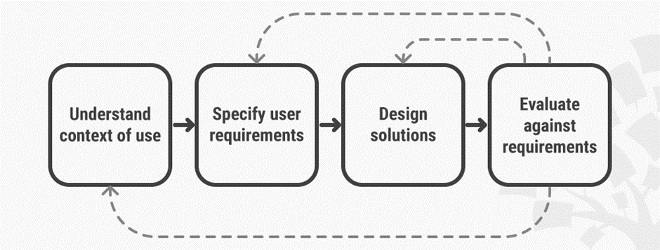

*User-centered design is an iterative process that focuses on an understanding of the users and their context in all stages of design and development.*

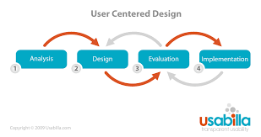

**#Expain Sitemap.**

A *sitemap* is a file where you provide information about the pages, videos, and other files on your site, and the relationships between them. Search engines like Google read this file to crawl your site more efficiently. A sitemap tells Google which pages and files you think are important in your site, and also provides valuable information about these files. For example, when the page was last updated and any alternate language versions of the page.

You can use a sitemap to provide information about specific types of content on your pages, including [video](https://developers.google.com/search/docs/crawling-indexing/sitemaps/video-sitemaps), [image](https://developers.google.com/search/docs/crawling-indexing/sitemaps/image-sitemaps), and [news](https://developers.google.com/search/docs/crawling-indexing/sitemaps/news-sitemap) content. For example:

* A sitemap *video entry* can specify the video running time, rating, and age-appropriateness rating.
* A sitemap *image entry* can include the location of the images included in a page.
* A sitemap *news entry* can include the article title and publication date.

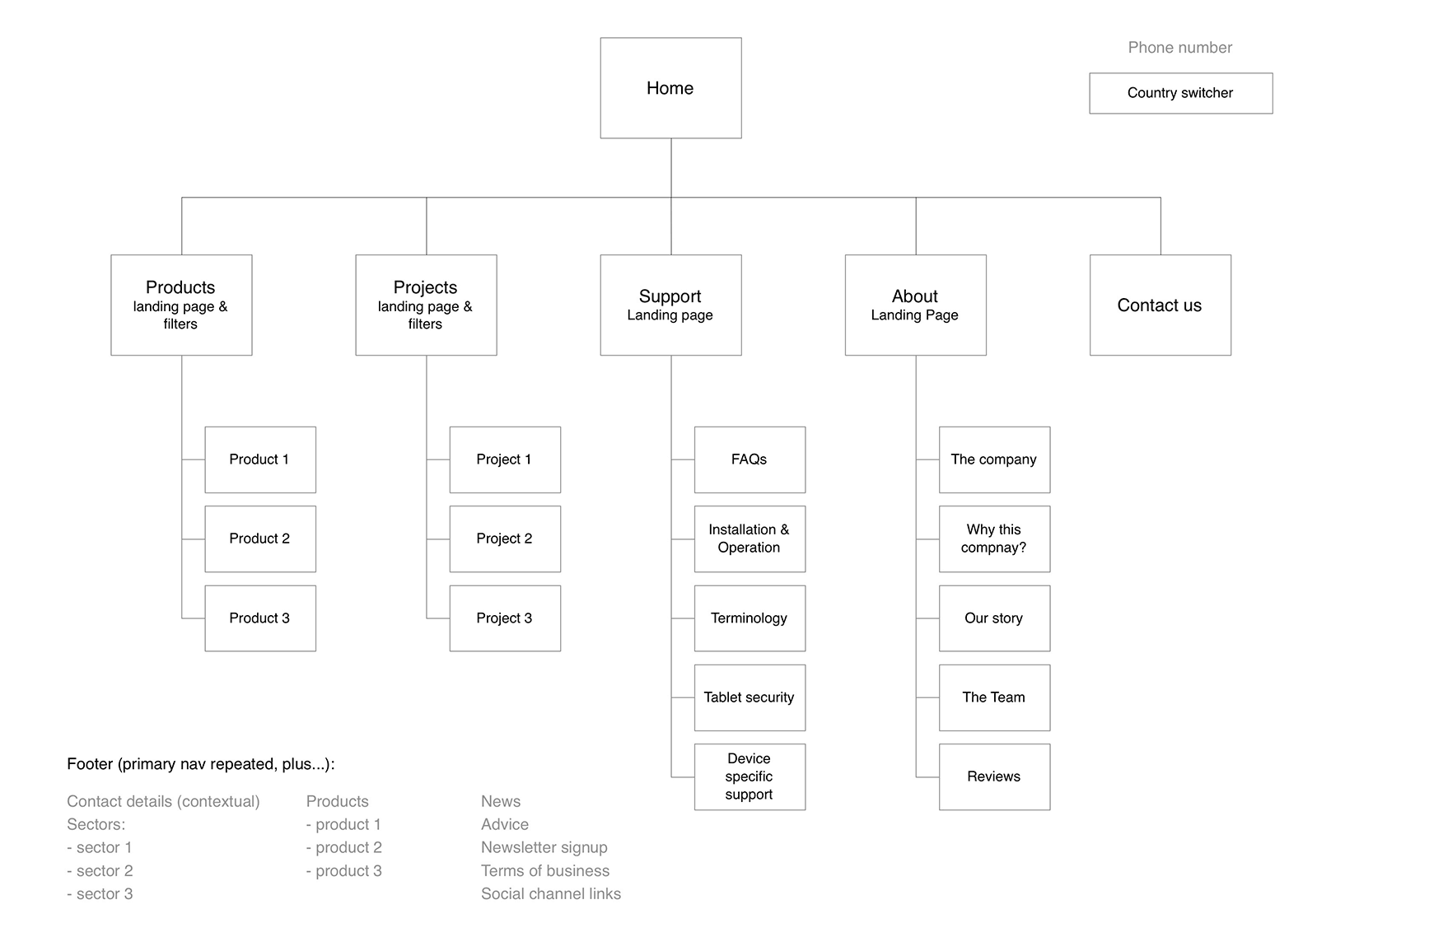

**# explain plaining and publishing websites.**

**Web Hosting:**Web Hosting, as the name suggests, is a type of internet hosting that allows one to make their website available to users through WWW using the internet. It simply provides space to the website on a web server so that files or data of the website can be stored. It is the best way to increase the growth of business and user experience.

**Note:** There are few popular free Web Hosting Platforms are [Hostinger](https://www.hostg.xyz/aff_c?offer_id=545&aff_id=115172&aff_sub=whvswp1" \t "_blank), Bluehost, etc.

**Web Publishing:** Web Publishing, as the name suggests, is the process of creating a website and placing it on the web server, and published content may include text, images, videos, and other types of media. Its main aim is to facilitate communication simply by adding context through style, emotion, and space. It is also known as online publishing.

**Web Hosting vs Web Publishing**

| **Web Hosting** | **Web Publishing** |
| --- | --- |
| It is a process of using server to host website. | It is a process of publishing or uploading original content on Internet. |
| Its process includes proving space in server to store web pages, make it available for viewing online, etc. | Its process includes uploading files, updating web pages, posting blogs, posting content to web pages, etc. |
| It allows for advanced level of customization. | It allows customization from beginner to advanced levels depending on platform. |
| It provides space in internet for website. | It makes website available to view on your domain. |
| It does not come with premade website. | It provides ready-made themes to develop website. |
| It allows for one-click installs and endless customization of self-hosted WordPress, Scalar, and Omeka. | It is limited to WordPress and NYU-approved theme and plugins. |
| Its main aim is to provide storage space for website or application on server on internet so that it can be accessed by other computers connected to internet. | Its main aim is to communicate ideas and concepts between people. |
| Its component includes Web Browser, FTP Client, Database Server, FTP Server, etc. | Its component includes domain name planning and registration, web hosting, web design and development, etc. |
| It allows one to store website online, provide technical support, data management, more security, etc. | It allows one to include colorful designs, photographs, and text in webpage for less cost. |

**# Designing effective navigation.**

1. Don’t Make your Users Guess!

It is sometimes necessary to spoon feed your visitors with information. Make careful decisions as to where your navigation is placed, and make it stand out. Then your users won’t sit there aimlessly clicking the mouse as they search in vain for some kind of direction.

2. Keep it high

Broadsheet newspaper editors place their most important information — latest headlines, significant content, etc — ‘above the fold’, meaning in the top half of the newspaper itself. Consider your pages from the same perspective, and keep the significant information, including the navigation, as high up as possible. Not only will this mean the navigation will load first in the user’s browser, but it also ‘hits’ the user faster. However, read Tip 3 for a word of warning on this point!

3. Below the Banners

Heard of snow blindness? Well, there’s a ‘condition’ known among Web users as ‘banner blindness’. Often, users naturally ignore content placed above any banner ads on your site — they simply consider this space for further advertisement. Although it might be tempting, don’t place any navigation elements above your banner ads.

4. Consistency is Key

I cannot stress this enough. On each and every page of your site, whether it’s your forums, your links page, or anywhere else, locate your navigation in the same place, with the same styles, and don’t change anything! This way, your users know exactly where to look for it.

5. Don’t be Adventurous

It’s always good to see your site stand out from the crowd, but please, when it comes to navigation, try and blend in with the rest of the flock. This way, regular Internet users will be used to your method of navigation to some degree — as they will have experienced, and learned on similar systems on other sites — and won’t need to be taught anything new. Using your navigation system will be easy!

6. Add a ‘Home’ Button

Your home page is the most important page on your site, so make sure your users always know how to get back to it. Not only will the ‘home’ button let people who clicked links on your site get back to where they began, but it also allows people who land on sub-pages within your Website to find your home page — potentially resulting in a new repeat visitor for your site.

***UNIT @2***

## HTML🡪What is HTML?

* HTML stands for Hyper Text Markup Language
* HTML is the standard markup language for creating Web pages
* HTML describes the structure of a Web page
* HTML consists of a series of elements
* HTML elements tell the browser how to display the content
* HTML elements label pieces of content such as "this is a heading", "this is a paragraph", "this is a link", etc.
* The <!DOCTYPE html> declaration defines that this document is an HTML5 document
* The <html> element is the root element of an HTML page
* The <head> element contains meta information about the HTML page
* The <title> element specifies a title for the HTML page (which is shown in the browser's title bar or in the page's tab)
* The <body> element defines the document's body, and is a container for all the visible contents, such as headings, paragraphs, images, hyperlinks, tables, lists, etc.
* The <h1> element defines a large heading
* The <p> element defines a paragraph

Basic example:-

<!DOCTYPE html>

<html>

<head>

<title>Page Title</title>

</head>

<body>

<h1>My First Heading</h1>

<p>My first paragraph.</p>

</body>

</html>

**2).expain html formatting and fonts.**

# **HTML Formatting**

**HTML Formatting** is a process of formatting text for better look and feel. HTML provides us ability to format text without using CSS. There are many formatting tags in HTML. These tags are used to make text bold, italicized, or underlined. There are almost 14 options available that how text appears in HTML and XHTML.

In HTML the formatting tags are divided into two categories:

* Physical tag: These tags are used to provide the visual appearance to the text.
* Logical tag: These tags are used to add some logical or semantic value to the text.

## HTML Formatting Elements

Formatting elements were designed to display special types of text:

* <b> - Bold text
* <strong> - Important text
* <i> - Italic text
* <em> - Emphasized text
* <mark> - Marked text
* <small> - Smaller text
* <del> - Deleted text
* <ins> - Inserted text
* <sub> - Subscript text
* <sup> - Superscript text

FONT🡪<p style="font-family:verdana">This is a paragraph.</p>  
<p style="font-family:'Courier New'">This is another paragraph.</p>

3). Expain Commenting code,color,hyperlink,lists,table,image,forms,XHTML,Meta tags.

**Commenting code🡪**

<!DOCTYPE html>

<html>

<body>

<p>This <!-- great text --> is a paragraph.</p>

</body>

</html>

Color🡪

<h1 style="background-color:DodgerBlue;">DodgerBlue</h1>

<h1 style="color:Tomato;">Hello World</h1>

Hyperlink🡪

<a href="*url*">*link text*</a>

Lists🡪

HTML List Tags

|  |  |
| --- | --- |
| **Tag** | **Description** |
| [<ul>](https://www.w3schools.com/tags/tag_ul.asp) | Defines an unordered list |
| [<ol>](https://www.w3schools.com/tags/tag_ol.asp) | Defines an ordered list |
| [<li>](https://www.w3schools.com/tags/tag_li.asp) | Defines a list item |
| [<dl>](https://www.w3schools.com/tags/tag_dl.asp) | Defines a description list |
| [<dt>](https://www.w3schools.com/tags/tag_dt.asp) | Defines a term in a description list |
| [<dd>](https://www.w3schools.com/tags/tag_dd.asp) | Describes the term in a description list |

<!DOCTYPE html>

<html>

<body>

<ul>

<li>Coffee</li>

<li>Tea</li>

<li>Milk</li>

</ul>

<ol>

<li>Coffee</li>

<li>Tea</li>

<li>Milk</li>

</ol>

<dl>

<dt>Coffee</dt>

<dd>- black hot drink</dd>

<dt>Milk</dt>

<dd>- white cold drink</dd>

</dl>

</body>

</html>

Table🡪The <table> tag defines an HTML table.

An HTML table consists of one <table> element and one or more <tr>, <th>, and <td> elements.

The <tr> element defines a table row, the <th> element defines a table header, and the <td> element defines a table cell.

An HTML table may also include <caption>, <colgroup>, <thead>, <tfoot>, and <tbody> elements.

<!DOCTYPE html>

<html>

<head>

<style>

table, th, td {

border: 1px solid black;

}

</style>

</head>

<body>

<h1>The table element</h1>

<table> <tr>

<th>Month</th>

<th>Savings</th>

</tr>

<tr>

<td>January</td>

<td>$100</td>

</tr>

<tr>

<td>February</td>

<td>$80</td>

</tr>

</table>

</body>

</html>

Images🡪

The HTML <img> tag is used to embed an image in a web page.

Images are not technically inserted into a web page; images are linked to web pages. The <img> tag creates a holding space for the referenced image.

The <img> tag is empty, it contains attributes only, and does not have a closing tag.

The <img> tag has two required attributes:

* src - Specifies the path to the image
* alt - Specifies an alternate text for the image

syntax:- <img src="*url*" alt="alternatetext">

Forms:-

The <form> element is a container for different types of input elements, such as: text fields, checkboxes, radio buttons, submit buttons, etc.

<!DOCTYPE html>

<html>

<body>

<h2>HTML Forms</h2>

<form action="/action\_page.php">

<label for="fname">First name:</label><br>

<input type="text" id="fname" name="fname" value="John"><br>

<label for="lname">Last name:</label><br>

<input type="text" id="lname" name="lname" value="Doe"><br><br>

<input type="submit" value="Submit">

</form>

</body>

</html>

XHTML🡪What is XHTML with example?

Extensible HyperText Markup Language (XHTML) is part of the family of XML markup languages. It mirrors or extends versions of the widely used HyperText Markup Language (HTML), the language in which Web pages are formulated.  
...  
XHTML.

|  |  |
| --- | --- |
| **Filename extension** | **.xhtml, .xht, .xml, .html, .htm** |
| Open format? | Yes |

Meta tag:🡪 The <meta> tag defines metadata about an HTML document. Metadata is data (information) about data.

<meta> tags always go inside the <head> element, and are typically used to specify character set, page description, keywords, author of the document, and viewport settings.

Metadata will not be displayed on the page, but is machine parsable.

Metadata is used by browsers (how to display content or reload page), search engines (keywords), and other web services.

<head> <meta charset="UTF-8">

<meta name="description" content="Free Web tutorials">

<meta name="keywords" content="HTML, CSS, JavaScript">

<meta name="author" content="John Doe">

<meta name="viewport" content="width=device-width, initial-scale=1.0">

</head>

5)Character entities .

Some characters are reserved in HTML.

If you use the less than (<) or greater than (>) signs in your text, the browser might mix them with tags.

Character entities are used to display reserved characters in HTML.

A character entity looks like this:

&*entity\_name*;

OR

&#*entity\_number*;

To display a less than sign (<) we must write: **&lt;** or **&#60;**

**# expain frames and frame sets.**

Frames and framesets are a technique that allows you to divide a page into static and dynamic elements. If a user refreshes the page, the browser reloads only the dynamic parts.

## Framesets

A frameset is the layout of a web page and is stored in its own HTML file. It contains the number of individual sections as well as the number and size of rows and columns. The corresponding HTML element is called "frameset" and can contain the attributes "cols" and "rows". “cols" defines the number of columns and "rows" the number of rows. The individual columns are separated by a comma. It is possible to format one or more columns or rows "dynamically", i.e. one or more rows adapt to the size of the fixed columns or rows. With col="400,\*" you create a frameset with two columns, where the first column is 400 pixels wide and the second column takes up the rest of the frame. The number and size of the rows are defined analogously to the columns. The resulting fields are then filled using HTML.

## Frames

A frame is the core of a frameset page. The "frame" element may not be closed by a closing element, but only "inline", i.e. by "/>" at the end of the opening element. In addition, the frame element may only be used within a frameset.

The two main attributes of a frame are "src" and "name". src" defines the content page to be loaded into the frame. This works the same as with other tags, such as "img". The "name" attribute serves as a destination for links and is therefore essential for navigation. Apart from these two HTML attributes, the following are allowed in a frame element: id, class, style, title, longdesc, frameborder, marginwidth, marginheight, noresize and scrolling. The HTML attributes frameborder, noresize, and scrolling are specific to the frame element.

<!DOCTYPE html>

<html>

<head>

<title>Example of HTML Frames using row attribute</title>

</head>

<frameset rows = "20%, 60%, 20%">

<frame name = "top" src ="C:/Users/dharam/Desktop/attr1.png" />

<frame name = "bottom" src ="C:/Users/dharam/Desktop/col\_last.png" />

</frameset>

</html>

**6). Create browser architecture and web site structure.**

### **Architecture of Web Browser**

The architecture of a web browser has certain components. They are Controller/Dispatcher, Interpreter, and Client Programs. The control unit in a CPU is a **controller**that takes in the input, interprets it, and then instructs the device to work in a certain way.

The **interpreter**receives this info from the controller to get ahead in the given task step by step. Lastly, the **client program** has sets of protocols to complete a particular service. Some common names are – HTTP, SMTP, FTP, etc.

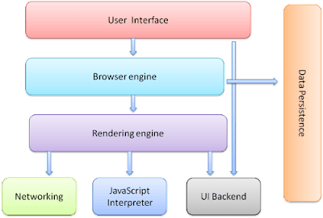

WEB SITE STRUCTURE

Structuring your website is crucial for both its usability and findability. Many sites lack a sound structure to guide visitors to the information they’re looking for. Having a clear site structure also leads to a better understanding of your site by Google, so it’s incredibly important for your SEO. Let’s take a closer look at how this works .Ideal site structure Let’s start by looking at an ideal situation: if you’re starting from scratch, how should you organize your site? We think a well-organized website looks like a pyramid with a number oflevels:1. Homepage2. Categories (or sections)3. Subcategories (only for larger sites)4. Individual pages and posts

The homepage should be all the way at the top. Then, you have some sections or category pages beneath it. You should be able to file all of your content under one of these categories. If your site is larger, you can divide these sections or categories into subcategories as well. Beneath your categories or subcategories are your individual page sand posts

