Openstack : All in one(Single Node) installation

Note : There are multiple ways to start-off with openstack depending on your requirement and available hardware.
- For having a tour of openstack and do nothing more in terms of dev/test, you can use the live Ubuntu-openstack image available at https://cloud-images.ubuntu.com/releases/precise/release/
- For a fast and simple way of installing all in one openstack, you can go for
1. devstack(Ubuntu : http://devstack.org/) or
2. packstack(Centos).
- Or the following way , manually install all in one openstack services one by one.

A quick overview of openstack components and there relationships

﻿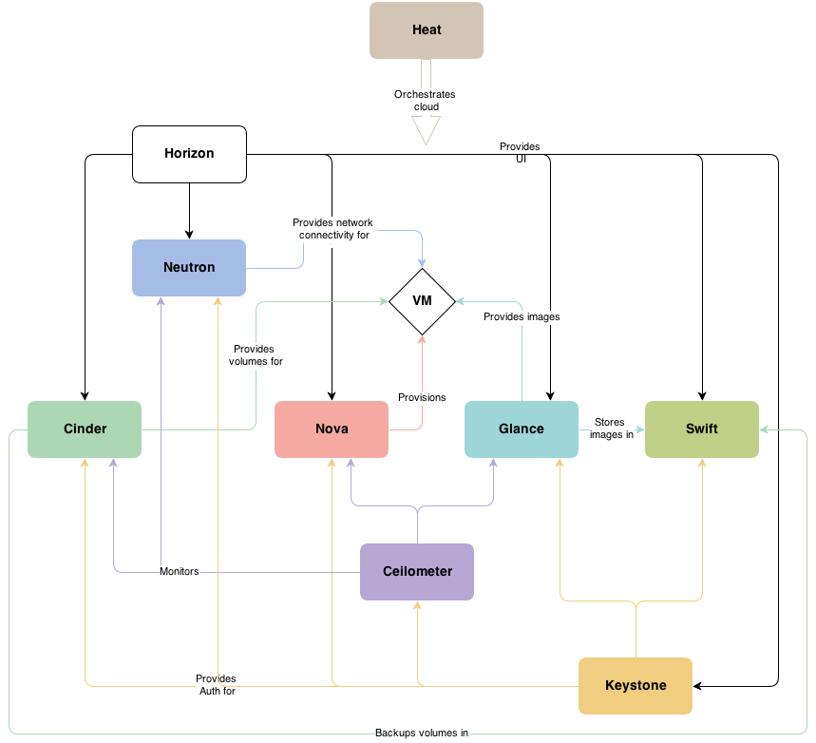

Requirements
- Hardware
x86_64, Dual core or higher, 4GB or more RAM, 250 GB or more HDD
- System software: OS
Ubuntu 12.04/14.04 LTS server with qemu-KVM
- Openstack components as part of the Ubuntu distro.

Steps to get openstack all in one node setup
Follow the below wiki till the beginning of Neutron section.
https://github.com/Ch00k/openstack-install-aio/blob/master/openstack-all-in-one.rst#operating-system
Note :
- For proper working of the openstack storage layer(cinder/swift/glance) it is advised to have the same partitioning on the host as mentioned in the link.
- Make sure you modify all the conf files to put the right IPs accordingly. Map your settings to the assumptions made in the wiki.

Continue to Neutron section but be aware that once you follow the Neutron installation you might end up doing some additional changes which might be mentioned as assumptions in the wiki.

- Since the adapter which connects to internet is put under the br-ex bridge, we need to replicate the configurations of that adapter on to the bridge so that we remain connected to internet and make internet available to Vms as well.
- /etc/network/interfaces is an important file for the same. In case DNS is not working you have to put the dns server ip in the /etc/resolv.conf file. The DNS server ip you can obtain from your administrator or by running dig on another machine in the same network as of yours.

Networking Concepts
Important Note: To understand the network infrastructure, please analyse and relate the next few points covering the network aspects.

a. /etc/network/Interfaces file from my host machine.
auto lo
iface lo inet loopback

auto eth0
iface eth0 inet manual
up ifconfig $IFACE 0.0.0.0 up
up ip link set $IFACE promisc on
down ip link set $IFACE promisc off
down ifconfig $IFACE down

auto br-ex
iface br-ex inet static
address 10.2.56.118
netmask 255.255.255.0
up route add default gw 10.2.56.1

auto eth1
iface eth1 inet static
address 192.168.8.70
netmask 255.255.255.0
up route add -net 192.168.0.0 netmask 255.255.0.0 gw 192.168.8.254

eth0 is connected to the external bridge br-ex which we need to assign the same IP that eth0 acquired from dhcp during initial boot. eth1 ideally should not connect to internet and its for openstack internal management calls.

b. Network Topology

A typical network topology of a simple cloud platform with two VMs would be as below. The VMs are in a private network 10.0.0.0/24 and also are connected to the external world using the router in between.

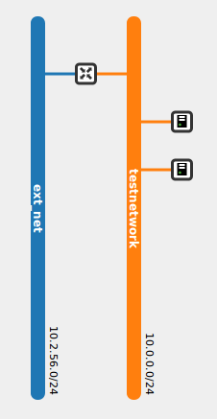

c. Data Flow : VM to internet (multinode)
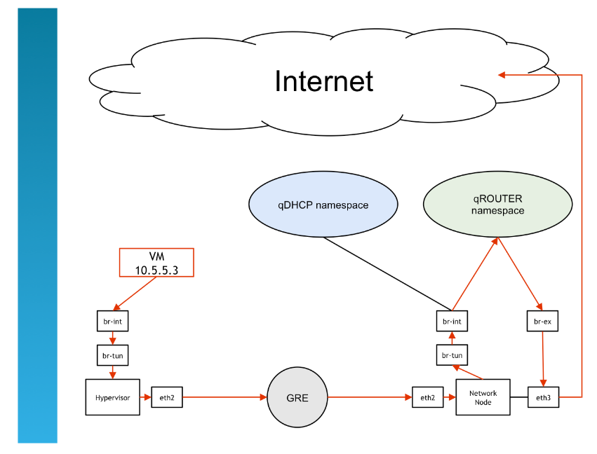

d. Network Structure when multi node(GRE-Tunnel)

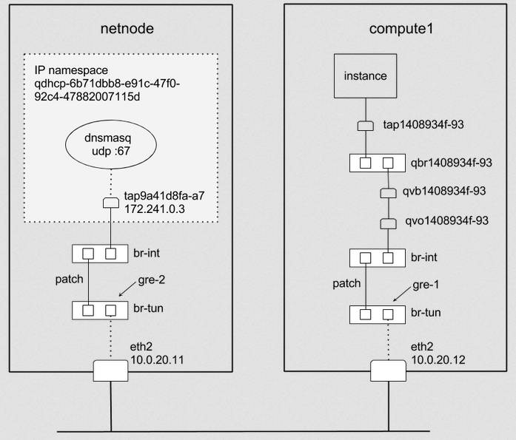

Note
The difference in a single node infra would be the absence of br-tun(which acts as a bridge/tunnel between different nodes to make it appear as if they run on a single node).

My First Run

For cross verification, below is the history of actions/commands during my first run.
Reference Wiki :
https://github.com/Ch00k/openstack-install-aio/blob/master/openstack-all-in-one.rst#operating-system

BEGIN
sudo -i
apt-get -y install Ubuntu-cloud-keyring python-software-properties software-properties-common python-keyring
echo deb http://Ubuntu-cloud.archive.canonical.com/Ubuntu precise-proposed/havana main >> /etc/apt/sources.list.d/havana.list
apt-get -y update && apt-get -y upgrade && apt-get -y dist-upgrade

MySql & messaging frameworks
apt-get install -y mysql-server python-mysqldb rabbitmq-server ntp
Modify conf, restart and populate db
sed -i 's/127.0.0.1/0.0.0.0/g' /etc/mysql/my.cnf
service mysql restart
cd /opt/openstack/
mkdir install_scripts
cd install_scripts/
wget https://raw2.github.com/Ch00k/openstack-install-aio/master/populate_database.sh
chmod +x populate_database.sh
sed -i 's/openstacktest/openstackcs/g' populate_database.sh
./populate_database.sh

IP forwarding
sed -i 's/#net.ipv4.ip_forward=1/net.ipv4.ip_forward=1/' /etc/sysctl.conf
sysctl net.ipv4.ip_forward=1

Keystone
apt-get install -y keystone
Modify conf, restart and populate db
vi /etc/keystone/keystone.conf
rm /var/lib/keystone/keystone.db
service keystone restart
keystone-manage db_sync
wget https://raw2.github.com/Ch00k/openstack-install-aio/master/populate_keystone.sh
chmod +x populate_keystone.sh
Modify script to update all required info
vi populate_keystone.sh
sed -i 's/openstacktest/openstackcs/g' populate_keystone.sh
./populate_keystone.sh
echo -e 'export OS_TENANT_NAME=admin\nexport OS_USERNAME=admin\nexport OS_PASSWORD=openstackcs \nexport OS_AUTH_URL="http://10.2.56.118:5000/v2.0/"' > ~/.keystonerc
source ~/.keystonerc
Treat keystonerc as mentioned in the wiki

Glance
apt-get -y install glance
Modify conf, restart and populate db
vi /etc/glance/glance-api.conf --- to modify as per link
vi /etc/glance/glance-api.conf --- to modify as per link
vi /etc/glance/glance-api-paste.ini --- to modify as per link
vi /etc/glance/glance-registry.conf --- to modify as per link
rm /var/lib/glance/glance.sqlite --- to modify as per link
service glance-api restart; service glance-registry restart
glance-manage db_sync
service glance-registry restart; service glance-api restart

Neutron: OVS
apt-get install -y openvswitch-controller openvswitch-switch openvswitch-datapath-dkms
ovs-vsctl add-br br-int
ovs-vsctl add-br br-ex
vi /etc/network/interfaces --- to modify as per link
ovs-vsctl add-port br-ex eth0
/etc/init.d/networking restart

Modify routes & resolve configurations as required.
route -n
vi /etc/resolv.conf -- Mention your nameserver explicitly.
Neutron: server& pluggins
apt-get install -y neutron-server neutron-plugin-openvswitch neutron-plugin-openvswitch-agent dnsmasq neutron-dhcp-agent neutron-l3-agent neutron-metadata-agent
service neutron-server stop
vi /etc/neutron/neutron.conf --- to modify as per link
vi /etc/neutron/api-paste.ini --- to modify as per link
vi /etc/neutron/metadata_agent.ini --- to modify as per link
vi /etc/neutron/l3_agent.ini --- to modify as per link
vi /etc/neutron/dhcp_agent.ini --- to modify as per link
vi /etc/neutron/plugins/openvswitch/ovs_neutron_plugin.ini --- to modify as per link
rm /var/lib/neutron/neutron.sqlite
for i in $( ls /etc/init.d/neutron-* ); do service `basename $i` restart; done

Nova
apt-get install -y nova-api nova-cert novnc nova-consoleauth nova-scheduler nova-novncproxy nova-doc nova-conductor nova-compute-kvm
vi /etc/nova/nova-compute.conf --- to modify as per link
cp /etc/nova/nova-compute.conf /etc/nova/nova-compute.conf.lfc
vi /etc/nova/nova-compute.conf --- to modify as per link
vi /etc/nova/api-paste.ini --- to modify as per link
cp /etc/nova/nova.conf /etc/nova/nova.conf.lfv
cp /etc/nova/nova.conf.lfv /etc/nova/nova.conf.lfc
vi /etc/nova/nova.conf --- to modify as per link
for i in $( ls /etc/init.d/nova-* ); do service `basename $i` restart; done
rm /var/lib/nova/nova.sqlite
nova-manage db sync
nova-manage service list

Cinder
apt-get install -y cinder-api cinder-scheduler cinder-volume
df -kh

Swift
apt-get -y install swift swift-account swift-container swift-object swift-proxy openssh-server memcached python-pip python-netifaces python-xattr python-memcache xfsprogs python-keystoneclient python-swiftclient python-webob git
apt-get install -f --fix-missing
apt-key update
apt-get -y install swift swift-account swift-container swift-object swift-proxy openssh-server memcached python-pip python-netifaces python-xattr python-memcache xfsprogs python-keystoneclient python-swiftclient python-webob git
apt-get update
apt-get -y install swift swift-account swift-container swift-object swift-proxy openssh-server memcached python-pip python-netifaces python-xattr python-memcache xfsprogs python-keystoneclient python-swiftclient python-webob git
mkdir -p /etc/swift && chown -R swift:swift /etc/swift/
mkdir -p /srv/node
vi /etc/swift/swift.conf --- to modify as per link
chown -R swift:swift /srv/node
openssl req -new -x509 -nodes -out /etc/swift/cert.crt -keyout /etc/swift/cert.key
cd /opt/openstack/install_scripts/
git clone https://github.com/openstack/swift.git && cd swift && python setup.py install
vi /etc/swift/proxy-se --- to modify as per link
vi /etc/swift/proxy-server.conf --- to modify as per link
mkdir -p /home/swift/keystone-signing && chown -R swift:swift /home/swift/keystone-signing
cd /etc/swift/
swift-ring-builder account.builder create 18 3 1
swift-ring-builder container.builder create 18 3 1
swift-ring-builder object.builder create 18 3 1
swift-ring-builder account.builder add z1-192.168.8.70:6002/sda4 100
swift-ring-builder container.builder add z1-192.168.8.70:6001/sda4 100
swift-ring-builder object.builder add z1-192.168.8.70:6000/sda4 100
swift-ring-builder account.builder rebalance
swift-ring-builder container.builder rebalance
swift-ring-builder object.builder rebalance

Network testing starts here : Reference : https://wiki.debian.org/OpenStackHowto/Quantum
neutron net-create testnetwork
neutron subnet-create testnetwork 10.0.0.0/24
subnet-update 126b75ac-4bb7-475d-ba2e-b8b85a710d4b --dns_nameservers list=true 8.8.8.8
neutron subnet-update 126b75ac-4bb7-475d-ba2e-b8b85a710d4b --dns_nameservers list=true 8.8.8.8
neutron router-create testrouter
neutron router-interface-add 1e69f5c4-2e2c-4399-97d0-64c822eb4e7a 126b75ac-4bb7-475d-ba2e-b8b85a710d4b
neutron net-create ext_net --router:external=True
neutron subnet-create --allocation-pool start=10.2.56.240,end=10.2.56.250 ext_net 10.2.56.0/24 --enable_dhcp=False
neutron net list
neutron subnet-list
neutron router-list
neutron router-gateway-set 1e69f5c4-2e2c-4399-97d0-64c822eb4e7a 08180148-93ca-410f-a64c-00339862010c
nova secgroup-add-rule default icmp -1 -1 0.0.0.0/0
nova secgroup-add-rule default tcp 1 65535 0.0.0.0/0
nova secgroup-add-rule default udp 1 65535 0.0.0.0/0
Try to launch an instance from horizon or CLI : "nova boot --flavor m1_512_20 --image "CirrOS 0.3.1" --nic net-id=9fdb051a-0f50-4972-8305-3bc2569a3241 cirros"

END

References summary

Single node setup
https://github.com/Ch00k/openstack-install-aio/blob/master/openstack-all-in-one.rst#operating-system
Multinode setup
https://github.com/fornyx/OpenStack-Havana-Install-Guide/blob/master/OpenStack-Havana-Install-Guide.rst
For testing the setup
https://wiki.debian.org/OpenStackHowto/Quantum

