HepatoTwin: Exploratory Data Analysis
Datasets used by the final pipeline · 18 October 2026
All figures and numbers are produced by src/eda_report.py (python -m src.eda_report) in https://github.com/manojna0012/HepatoTwin.

1. Datasets
Table 1. Datasets and their role in the pipeline.
Dataset | Role | Size after preparation
NHANES 2017–March 2020 and August 2021–August 2023, liver elastography (LUX) with demographics, examination, laboratory and questionnaire files | Training and evaluation of the liver state model (Layer 2) | 15,300 participants with a complete FibroScan examination
NHANES day-1 24-hour dietary recall (DR1TOT, DR1IFF) with USDA FPED | Each patient's own intake (Layer 3) | 9,391 reliable recalls
RecipeDB (lab API) | Candidate recipes (Layer 4) | 20,000 recipes; 10,108 main meals
Curated evidence table | Graded intervention effects (Layer 3) | 23 rows

2. NHANES FibroScan Cohort
Inclusion. Participants aged 12 and over with a complete elastography examination (LUAXSTAT = 1) and a recorded median CAP. The two cycles use the same examination and variable names; 2021–2023 is the last NHANES cycle with liver elastography. Values are kept in raw NHANES coding, and “refused” or “don't know” answers are converted to missing values in the model's feature step.
Table 2. Cohort characteristics.
Characteristic | Value
Participants (2017–2020 / 2021–2023) | 15,300 (9,021 / 6,279)
Age, median (IQR), years | 47 (27–63); range 12–80
Female | 51%
BMI, median; obesity (BMI ≥ 30) | 27.6 kg/m²; 36%
CAP, mean (SD); median | 256 (63) dB/m; 251 dB/m
CAP ≥ 248 / ≥ 280 / ≥ 302 dB/m | 52% / 34% / 24%
Reliable examinations (CAP IQR < 40 dB/m) | 62%
CAP at the device maximum (400 dB/m) | 1.5%

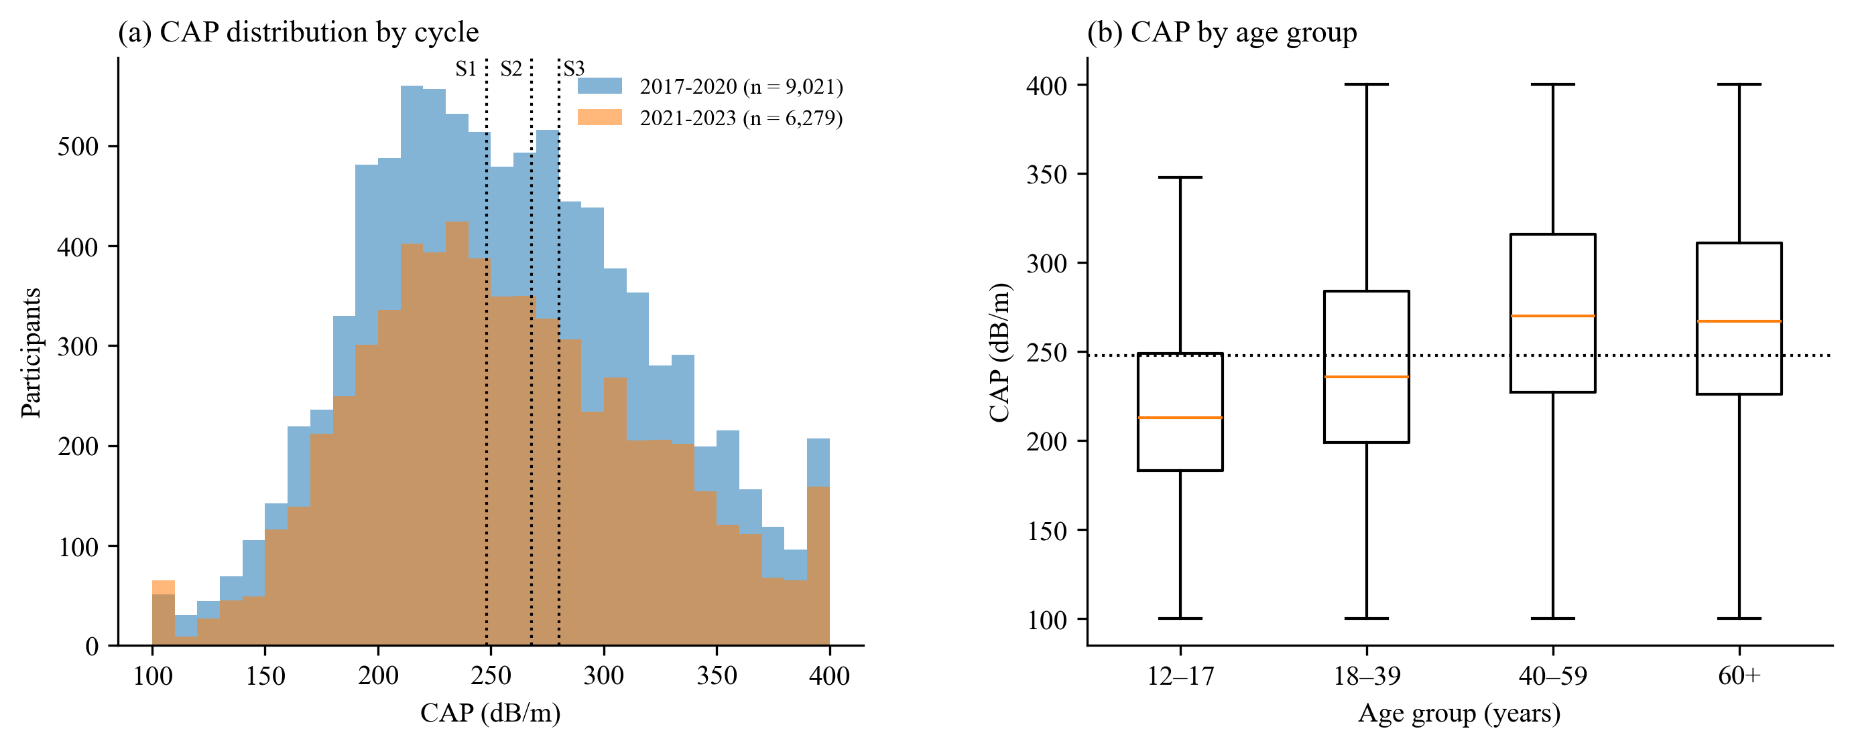
Figure 1. CAP by cycle with the steatosis grade cut-offs of Karlas et al. (2017), and by age group. The peak at 400 dB/m is the device maximum.
CAP is roughly bell-shaped around 251 dB/m, so about half the cohort lies above the main cut-off of 248 dB/m (53% in 2017–2020, 51% in 2021–2023). The cut-offs for grades S1, S2 and S3 lie only 20 and 12 dB/m apart, narrower than the model's typical error, which is why the model classifies steatosis at two cut-offs rather than predicting four grades.
Table 3. CAP and steatosis prevalence by group.
Factor | Group | n | Mean CAP | CAP ≥ 248
Sex | Female | 7,862 | 251 | 49%
 | Male | 7,438 | 261 | 55%
Age | 12–17 | 2,008 | 219 | 26%
 | 18–39 | 4,267 | 244 | 43%
 | 40–59 | 4,020 | 272 | 62%
 | 60+ | 5,005 | 269 | 62%
Race and ethnicity | Mexican American | 1,649 | 269 | 61%
 | Non-Hispanic Asian | 1,438 | 252 | 50%
 | Non-Hispanic Black | 3,121 | 246 | 46%
 | Non-Hispanic White | 6,545 | 259 | 53%
 | Other Hispanic | 1,609 | 257 | 55%
 | Other or multiracial | 938 | 253 | 49%
Prevalence rises sharply after age 40 and is highest among Mexican American participants and lowest among non-Hispanic Black participants, consistent with published NHANES analyses.

2.1 Which measurements relate to CAP
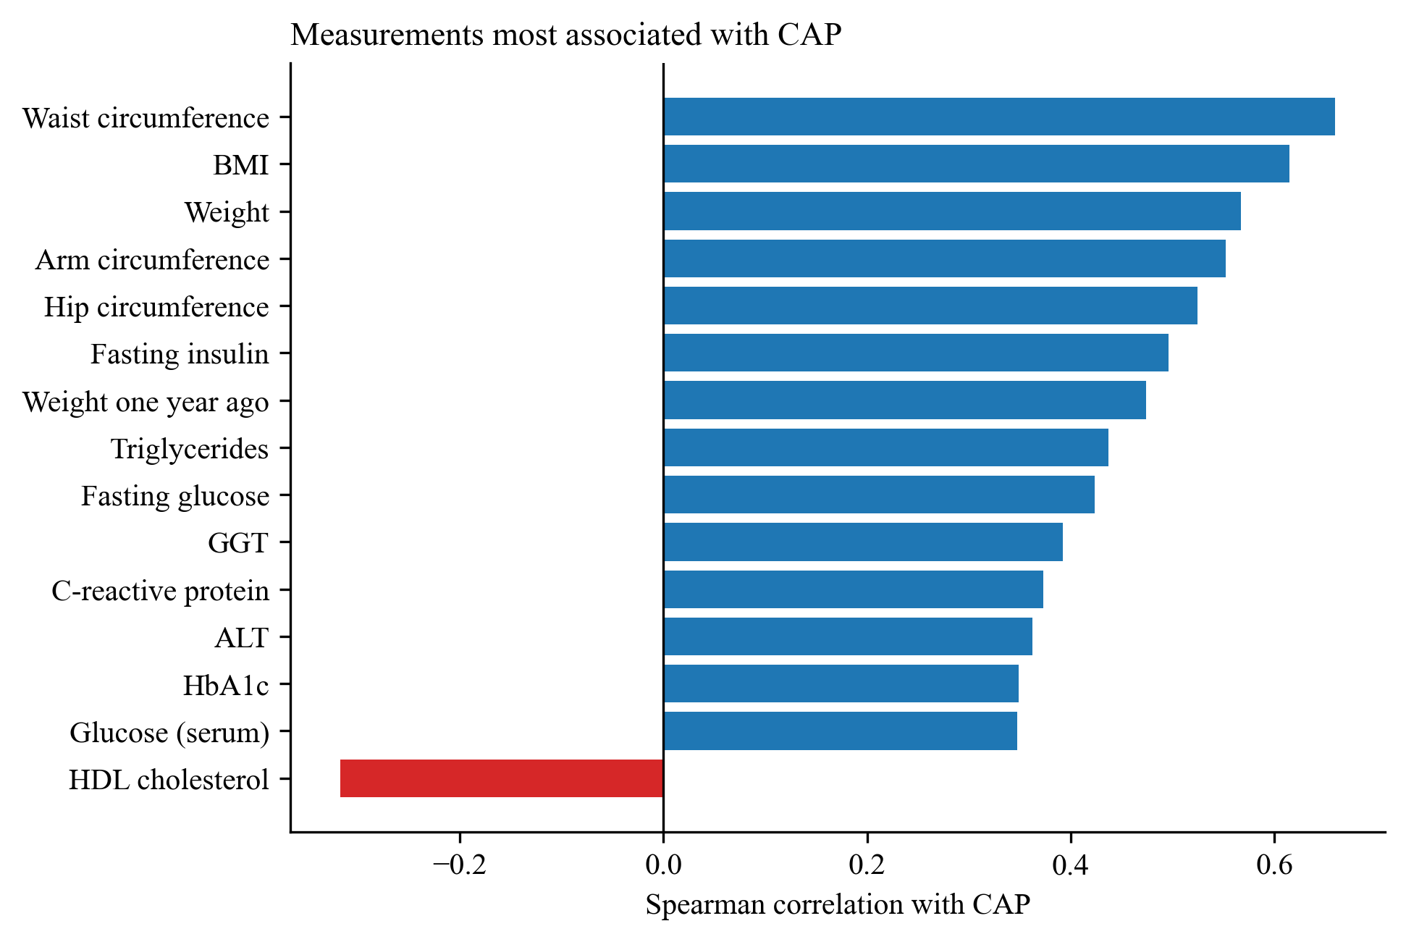
Figure 2. The 15 inputs with the strongest Spearman correlation with CAP.
Body size dominates: waist circumference (ρ = 0.66) and BMI (0.61) correlate most strongly, followed by other body measures, insulin resistance (fasting insulin, glucose, triglycerides) and liver enzymes (GGT, ALT). HDL cholesterol is the only strong negative correlate. Many top inputs measure the same thing (overall adiposity), which is why adding further body or laboratory variables improved the model only slightly.
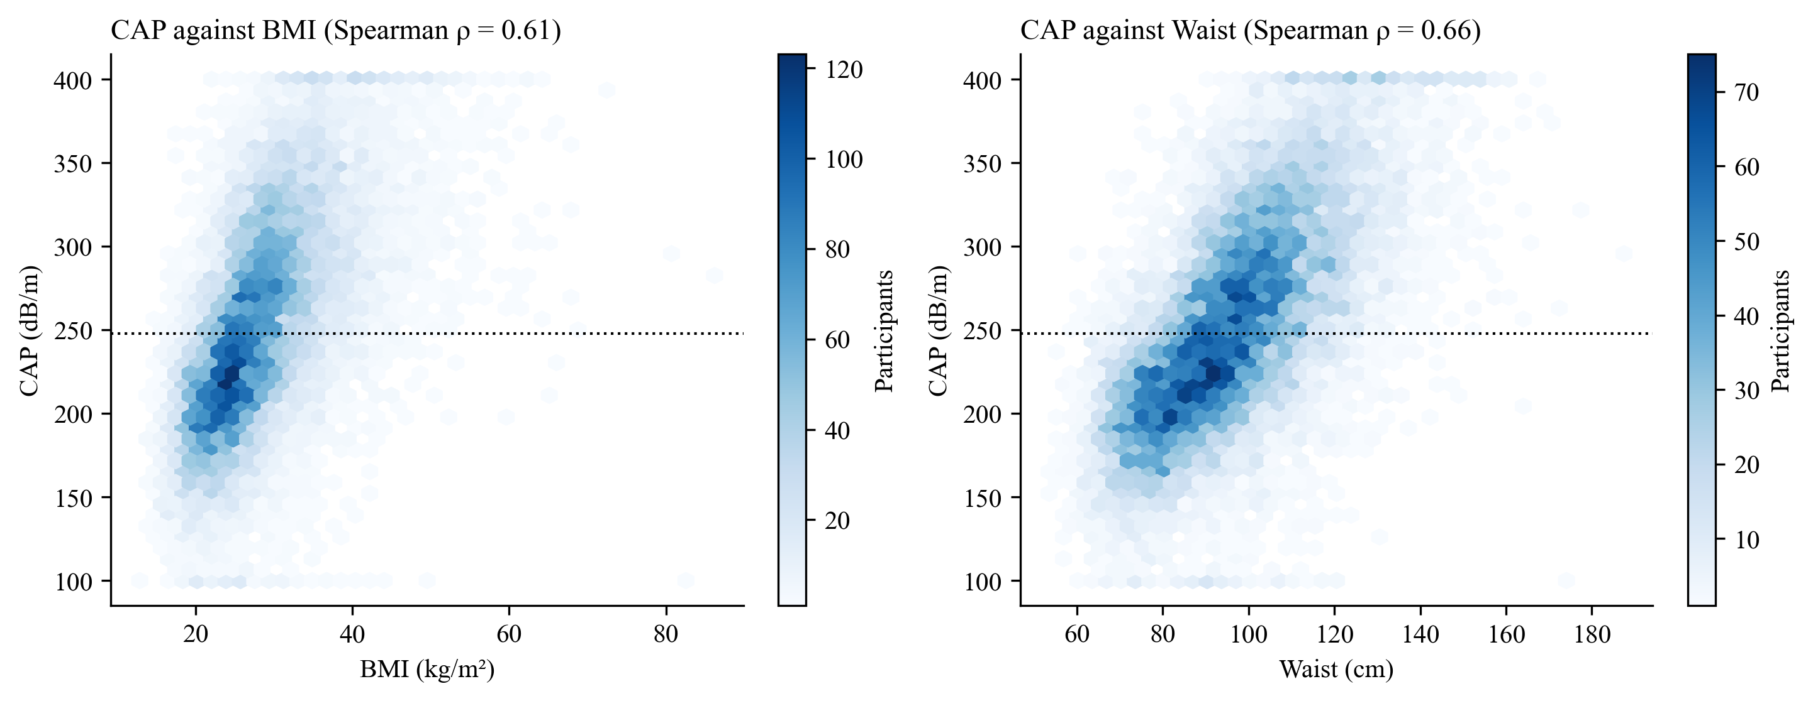
Figure 3. CAP against BMI and waist circumference. The vertical spread at any BMI shows how much liver fat varies between people of the same size.
The scatter shows the central limitation of the data: at a BMI of 30 kg/m², CAP ranges across almost the whole scale. Body size shifts the average, but much of the variation between individuals is not explained by routine measurements.

2.2 Missing values
Of the model's 81 inputs, 6 are complete and the median input is missing for 8.9% of participants. Most heavily missing inputs are missing by design: fasting insulin and glucose were measured only in the morning fasting subsample, and follow-up questions (for example, insulin use or drinks per drinking day) are asked only after a screening question. The final model (XGBoost) handles missing values natively, learning at each split which branch a missing value should follow, so no values are imputed.
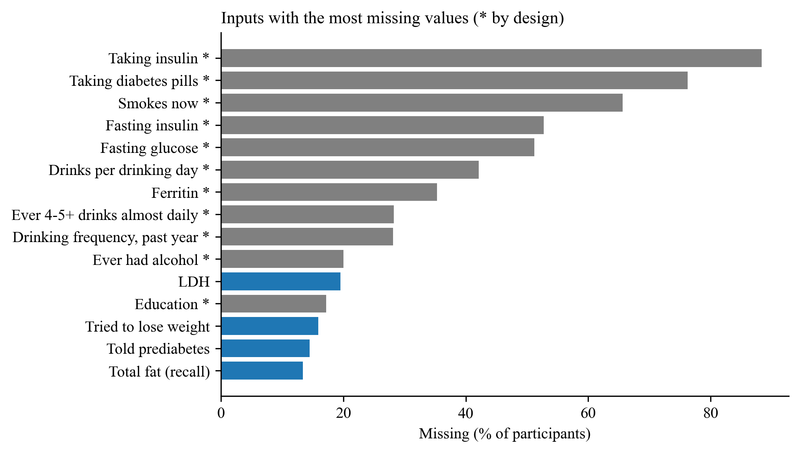
Figure 4. Inputs with the most missing values; grey bars (*) are missing by survey design.

3. 24-Hour Dietary Recall
Of 15,300 cohort participants, 13,250 have a day-1 recall. A recall is used only if complete and reliable, reported as a usual day, and of plausible energy (500–3,500 kcal for women, 800–4,000 for men): 2,050 have no usable recall, 3,218 reported eating much more or less than usual, and 641 have implausible energy, leaving 9,391. Added sugars and the HEI-2020 food groups come from USDA FPED: USDA's totals for 2017–2020 (9,021), and for 2021–2023 totals derived from the individual foods with USDA's method (4,789; 102 excluded for low food-code coverage), which reproduced USDA's 2017–2020 totals with r = 1.000.
Table 4. Median intake on the recall day (reliable recalls).
Measure | Reference | 2017–2020 | 2021–2023 | Missing the reference
Energy (kcal) | – | 1928 | 1865 | –
Saturated fat (% of energy) | ≤ 10 | 11.3 | 11.7 | 65%
Added sugars (% of energy) | ≤ 10 | 10.4 | 8.9 | 49%
Total sugars (% of energy) | – | 18.8 | 18.2 | –
Fibre (g per 1,000 kcal) | ≥ 14 | 7.1 | 7.8 | 89%
HEI-2020 (0–100) | – | 48.5 | 52.0 | –

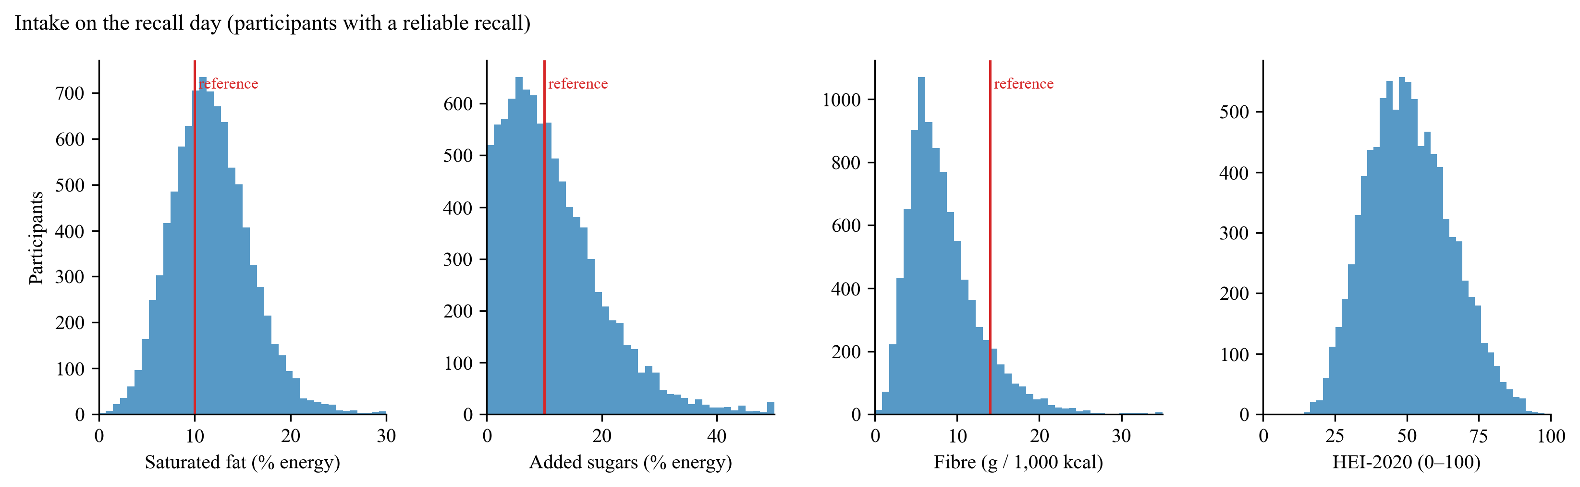
Figure 5. Intake on the recall day against the reference values used to score recipes.
Most participants miss the fibre reference and about two-thirds exceed the saturated-fat reference, while added sugars split close to half and half. These spreads are what allow the recall to raise some patients' priorities and lower others'. A single day is a noisy measure of usual intake, so it moves a priority by at most one level.

4. RecipeDB
The RecipeDB API available to the project holds 20,000 recipes. Screening keeps main meals (10,108): it removes desserts, drinks, sauces, condiments and non-food entries by category and title, and servings below 200 kcal. Of these, 264 have implausible nutrition (for example, energy inconsistent with macronutrients) and are held for review, leaving 9,844 scored meals; 565 meet all four reference values.
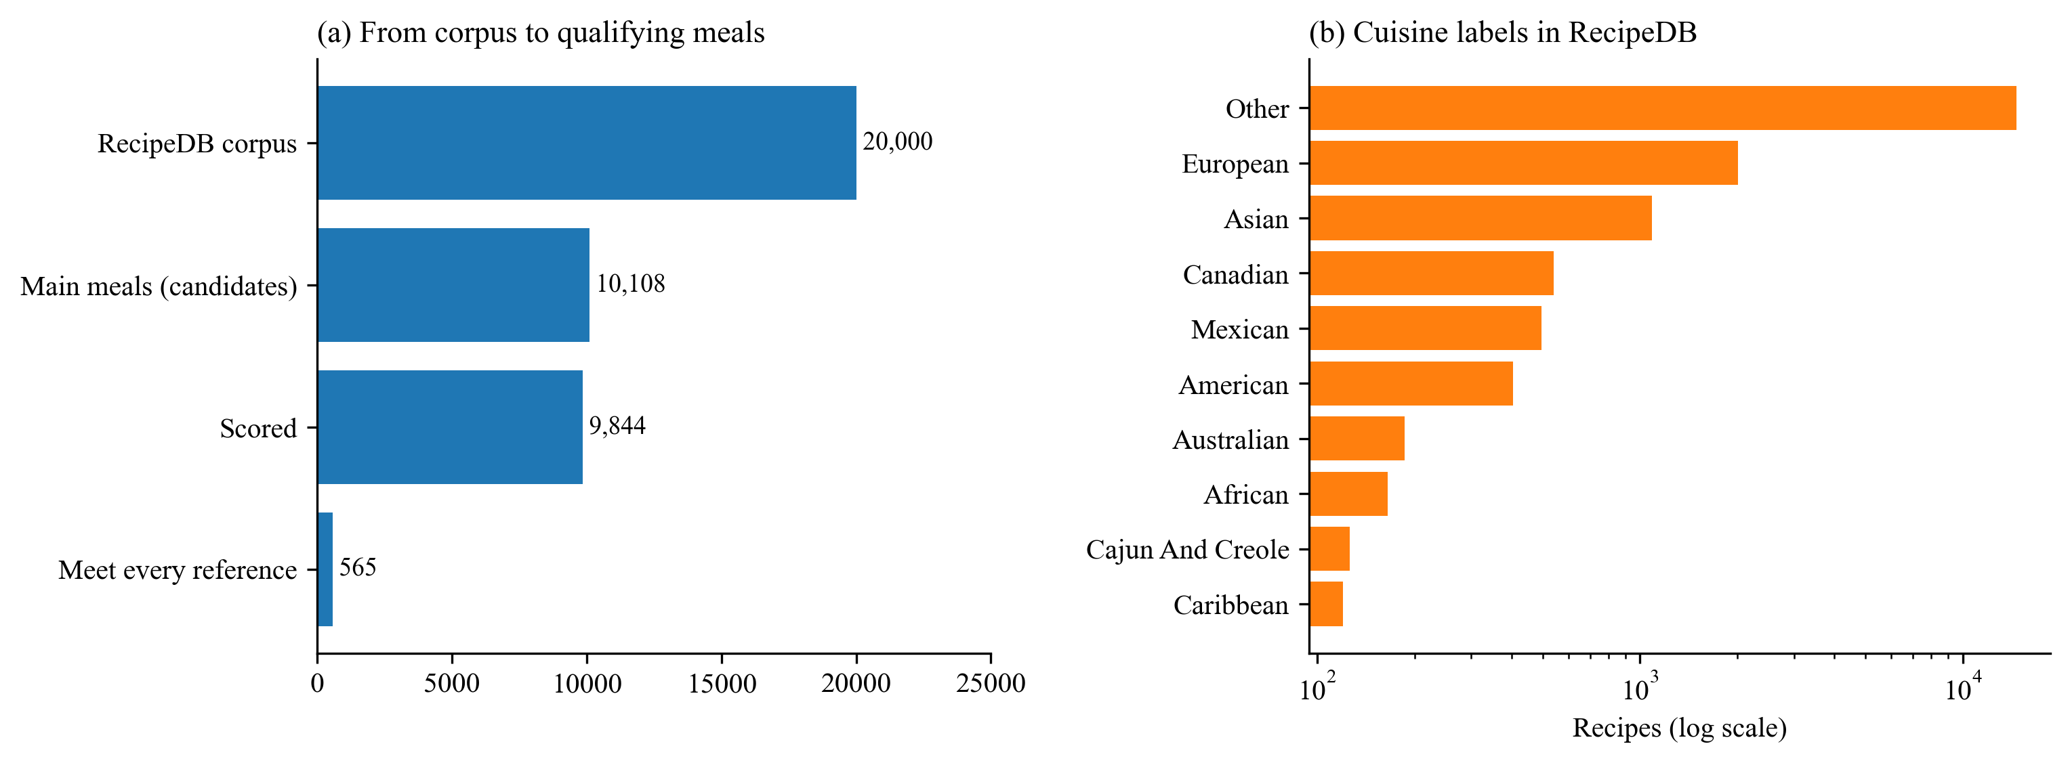
Figure 6. From the RecipeDB corpus to meals that meet every reference value, and the cuisine labels in the corpus.
Table 5. Share of the 10,108 candidate meals meeting each reference value.
Reference value | Share
Energy ≤ 600 kcal per serving | 75%
Saturated fat ≤ 10% of energy | 32%
Sugars ≤ 10% of energy | 73%
Fibre ≥ 14 g per 1,000 kcal | 18%
All four | 5.6%

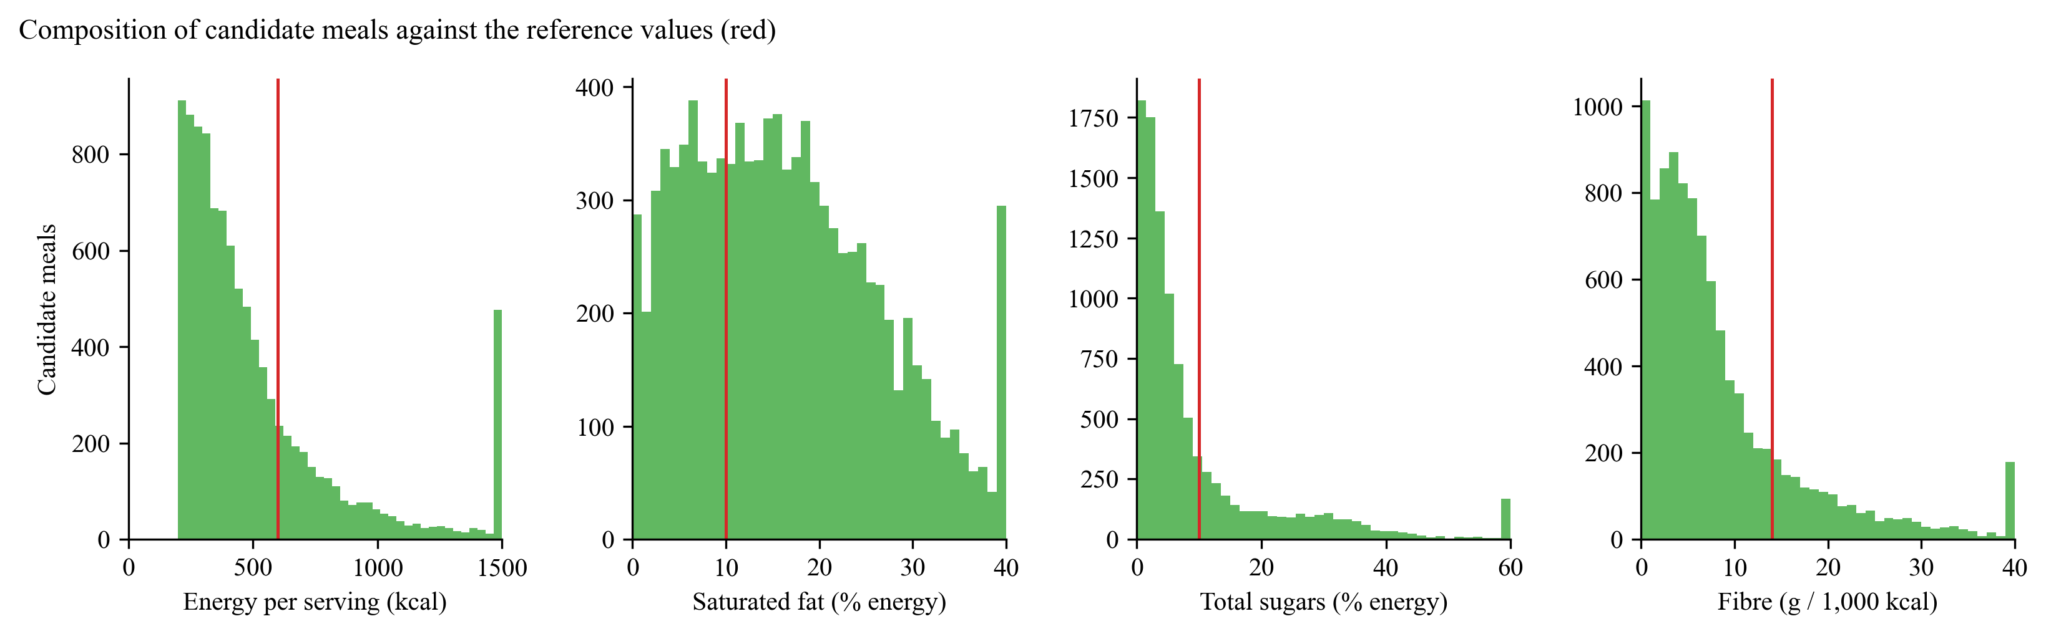
Figure 7. Composition of candidate meals; red lines are the reference values. Values beyond each axis range are shown at its right edge.
Fibre and saturated fat are the binding constraints: the median candidate meal has 5.9 g of fibre per 1,000 kcal and 15.3% of energy from saturated fat. 73% of recipes have no specific cuisine label (“Other”) and only 19 are Indian; among qualifying meals, Other 324, European 78, Asian 50, Mexican 33, American 26, African 19, Canadian 15, Cajun And Creole 6. Since the patient cohort is the US population, the ranking focuses on US cuisines, and cuisines with few qualifying meals (American, Canadian) are handled in the meal-plan step by repeating favourites or borrowing from the most similar cuisine.
Ratings. Ratings cluster at the top: the median and the 25th percentile are both 5.0, and only 1.9% are below 4.5. The number of ratings varies more (median 20, 90th percentile 66), so the acceptability score shrinks each rating towards the corpus mean according to how many people rated it.

5. Implications for the Pipeline
• About half of the cohort has steatosis, so the classification task is balanced and AUC, F1 and calibration are informative.
• Body size explains much of CAP, and many inputs measure the same thing, so further routine variables add little: the observed ceiling of R² ≈ 0.5 across all ages. Prediction is weakest at 60 and over, so the model is scoped to ages 12–59, where its test R² is 0.56.
• Grade cut-offs are closer together than the model's error, so steatosis is classified at two cut-offs, not as four grades.
• Missing values are largely structural and are handled natively by the tree model.
• Patients' recall intakes vary widely around the reference values, which makes diet-based personalisation of priorities meaningful.
• Only 5.6% of candidate meals meet every reference, and coverage differs by cuisine, which motivated the health gate in the ranking and the cuisine fallback in meal plans.

