HepatoTwin: Progress Report
A digital twin for personalised, evidence-based dietary recommendations in MASLD
Work from 20 August to 22 October 2026 · Manojna and 24akshainie
Code and data pipeline: https://github.com/manojna0012/HepatoTwin

1. Summary
HepatoTwin builds a patient-specific liver digital twin from routine clinical data and uses it to rank existing recipes by health relevance, cuisine compatibility and cooking feasibility for that patient. Nine weekly meetings are complete. Layers 1–5 of the seven-layer design are built and evaluated end to end; the visualisation (Layer 6) and dashboard (Layer 7) are scheduled for November.
• Liver state (Layer 2). The model is intended for patients aged 12 to 59. On 1,236 held-out NHANES participants in that range (evaluated against reliable FibroScan examinations), the calibrated model detects steatosis with ROC-AUC 0.881 (CAP ≥ 248 dB/m) and 0.879 (CAP ≥ 280), above the Fatty Liver Index (0.861) and the Hepatic Steatosis Index (0.836). Performance held on participants examined two to six years after the training data (AUC 0.884).
• Exact CAP value. Test R² 0.56 (95% CI 0.52–0.60) for ages 12–59; 0.59 in repeated cross-validation. More than 50 experiments with more variables, more participants, body-composition scans and other algorithms each moved R² by at most 0.01; the ceiling reflects what routine measurements contain, and the twin relies on the classification, not the exact value.
• Evidence engine (Layer 3). 23 graded evidence rows from trials, meta-analyses and the EASL-EASD-EASO guideline drive four nutritional priorities, adjusted by each patient's own 24-hour dietary recall.
• Recipe ranking (Layer 4). 0.831 of top-10 recipes meet all three criteria (health, cuisine, practicality), against 0.727 for plain weighted scoring and 0.003 for random selection; every recommended recipe meets every health reference.
• Scenarios (Layer 5) and meal plans. “Recipe A versus B” comparisons give an evidence-graded direction, never an invented number. Seven-day plans are complete for 100% of patients and meet every nutritional and variety constraint.

2. System Design and Status
Table 1. The seven layers of the proposal and their status on 22 October.
Layer | What it does | Status
1. Patient state | Clinical, demographic and dietary data per patient | Done
2. Liver twin, current state | CAP estimate and calibrated steatosis probabilities; SHAP explanations | Done; fibrosis risk (FIB-4) and causal graph in meeting 10
3. Evidence engine | Patient state → evidence-graded nutritional priorities | Done
4. Recipe ranking (NutriTwin) | Health, cuisine, feasibility and acceptability over RecipeDB | Done; richer cuisine and feasibility scores in meeting 10
5. Scenario engine | “If I choose recipes A instead of B” → evidence-graded direction | Done
6. 3D visualisation | Liver coloured by grade, with a timeline slider | Meeting 11
7. Dashboard | Patient-facing explanations and comparisons | Meeting 11

3. Progress by Meeting
Table 2. Planned work and what was delivered (Task 1: twin state and evidence; Task 2: recipes).
Meeting | Planned | Delivered
1 · 21 Aug | NHANES download and linking; RecipeDB access | Done
2 · 28 Aug | CAP exploratory analysis and preprocessing; recipe resources reviewed | Done (CAP distribution, demographics, correlations)
3 · 3 Sep | First baseline model; RecipeDB parser | Done (XGBoost baseline R² 0.49; parser for metadata, ingredients, nutrition, instructions)
4 · 11 Sep | Compare baselines; internal recipe representation | Done (XGBoost vs linear and random forest)
5 · 18 Sep | Finalise first model; recipe nutritional profiles | Done
– · 25 Sep | Mid-semester week: review limitations; larger recipe batch | Done (20,000 recipes)
6 · 1 Oct | Calibration, SHAP, first evidence table; recipe criteria | Done
7 · 9 Oct | Evidence table and objective mapping; scoring functions | Done
8 · 16 Oct | Layer 3 priorities; health-alignment scoring | Done, plus the combined 2017–2023 model, its validation and the Layer 4 evaluation
9 · 23 Oct | Scenario engine; 24-hour recall; new evidence; meal plans; acceptability | Done early (17 October); Indian regional cuisines moved to future work
– · 17–22 Oct | Additional: target-population R², lean subgroup, literature comparison | Done; final model adopted, scope set to ages 12–59 (test R² 0.562)
Meetings 1–8 follow the original weekly plan; meetings 9–14 were re-planned after the proposal was extended (Section 9).

4. Data
Table 3. Datasets used.
Dataset | Use | Size
NHANES 2017–March 2020 and August 2021–August 2023 (CDC) | Liver ultrasound transient elastography (CAP), biomarkers, body measures, questionnaires | 15,300 participants with a complete FibroScan examination (9,021 + 6,279)
NHANES day-1 24-hour dietary recall | Each patient's own intake (§17.1) | 9,391 reliable recalls
USDA Food Patterns Equivalents Database (FPED) | Added sugars and HEI-2020 diet quality | 2017–2020 from USDA; 2021–2023 derived and validated (r = 1.000)
RecipeDB (lab API) | Candidate recipes with ingredients, nutrition, process and ratings | 20,000 recipes; 10,108 candidate main meals, 9,844 with plausible nutrition
Intervention evidence table (curated) | Graded effects of dietary interventions on the liver | 23 rows from trials, meta-analyses and the 2024 guideline
All clinical data are public-use NHANES files. NHANES is cross-sectional, so the twin is validated on current state only; future states are presented as evidence-graded projections.
About half of the cohort has steatosis by the main definition (52% with CAP ≥ 248 dB/m; 35% with CAP ≥ 280). The 2021–2023 cycle is the last NHANES cycle with liver elastography, so the two cycles together are the largest cohort available. USDA has not released FPED for 2021–2023; it was derived from the individual foods with USDA's own method, which reproduced USDA's 2017–2020 totals (r = 1.000 for added sugars, HEI-2020 within one point for 100%).

5. Liver State Model (Layer 2)
The model takes 81 routine measurements (age, sex, ethnicity, body measures, liver enzymes, lipids, glucose and HbA1c, blood count, blood pressure, and questionnaire items asked identically in both cycles). It outputs a predicted CAP and calibrated probabilities that CAP is at least 248 and 280 dB/m. A 20% test set (3,060 participants) was held out from all training.
Scope. On the supervisor’s advice the model is intended for patients aged 12 to 59, and its performance is measured against reliable FibroScan examinations (CAP IQR < 40 dB/m). Patients aged 60 and over are outside the scope: accuracy is lowest there and the information that drives their liver fat is not in NHANES. The model is still trained on everyone, which predicts the 12–59 group better than training on it alone (test R² 0.562 against 0.553). The final tree settings were chosen by test R² in the scope among 15 candidates; they also have the best cross-validation R², so the choice does not rest on the test set alone.
Table 4. Final results on held-out data, ages 12–59 (scope).
Measure | Held-out test | US-weighted | Later cohort*
CAP R² | 0.562 (0.517–0.601) | 0.554 | 0.578
CAP RMSE (dB/m) | 41.4 | 42.6 | 42.9
ROC-AUC, CAP ≥ 248 | 0.881 (0.863–0.899) | 0.877 | 0.884
ROC-AUC, CAP ≥ 280 | 0.879 (0.860–0.898) | 0.878 | 0.890
Calibration error, CAP ≥ 248 / 280 | 0.018 / 0.022 | 0.038 / 0.039 | 0.025 / 0.027
Brier score, CAP ≥ 248 | 0.140 | 0.143 | 0.137
1,236 test participants. 95% bootstrap intervals in brackets. US-weighted: NHANES examination weights. *Trained on 2017–2020 only and tested on the 2,415 in-scope participants from 2021–2023. Repeated cross-validation gives R² 0.593. Including ages 60+ and unreliable scans, R² is 0.50 and AUC 0.857 / 0.868.
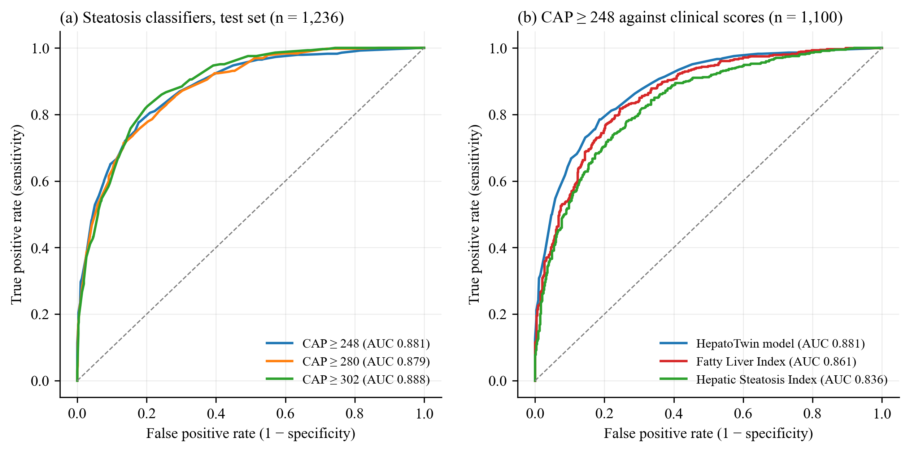
Figure 1. (a) ROC curves of the three steatosis classifiers, ages 12–59; (b) the model against the Fatty Liver Index and Hepatic Steatosis Index on the same participants.

5.1 Experiments to improve R²
R² measures how well the exact CAP value is predicted. It was investigated thoroughly because it is the most familiar metric, even though the twin uses the steatosis probabilities.
Table 5. Main experiments and their effect on R² (full record: Appendix A, experiments E1–E51).
Approach | What was tried | Effect on R²
Model settings | Leakage-free preprocessing, tuned XGBoost | 0.485 → 0.506 (adopted)
More variables | About 80 more NHANES variables: insulin, CRP, blood count, blood pressure, diabetes and weight history, alcohol, smoking, sleep, medicines | +0.010, the largest gain
Derived features | Waist-to-height, AST/ALT, TG/HDL, FLI and HSI as inputs | +0.001
Other algorithms | CatBoost, random forest, Extra Trees, ridge, neural network, stacking | 0.453–0.509; none better
More participants | Learning curve; adding the 2021–2023 cycle | +0.001 for the last 25%; +0.004
Body composition | DXA visceral fat (2017–2018 subset) | +0.007
Upper bound | Inputs from the FibroScan itself (stiffness, probe) | Only 0.529
Measurement noise | Within-examination CAP variability | About 4% of variance
Scope: ages 12–59 | Model trained on everyone, scored on ages 12–59 with reliable scans | 0.496 → 0.562 test (adopted)
Changes within the scope | Diet, medical history, imputation, loss functions, tuning, ensembles, training only on ages 12–59 | 0.547–0.562 test; deeper trees adopted

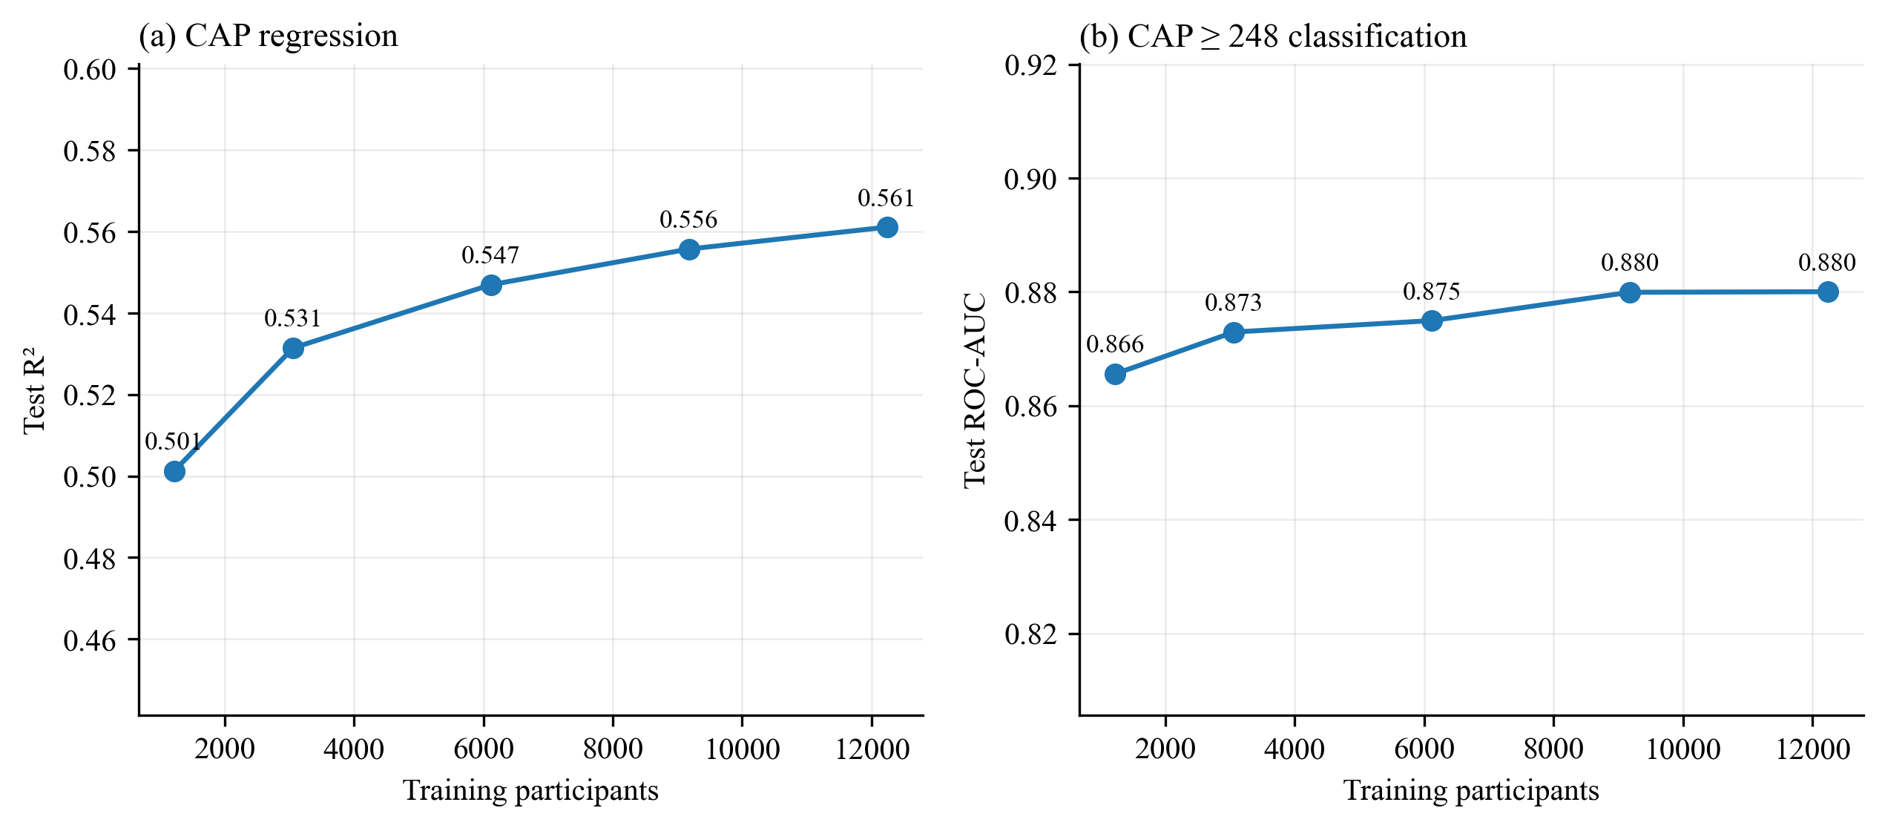
Figure 2. Learning curves: test R² and AUC flatten as training data grow, so more participants alone would not raise performance.
Why R² stops near 0.5. Every model family, every additional variable and more data reach the same level, and even measurements from the scan itself only reach 0.53. Two people with the same weight, waist and blood tests can have very different liver fat, because of genetic risk, long-term diet and alcohol history, and metabolic factors that NHANES does not measure. The limit lies in the information routine data contain, not in the model; within the scope every change scored between 0.55 and 0.56 on the test set. Published models from routine data reach R² 0.34–0.56. Steatosis classification, which the twin uses, is strong and beats the established clinical scores.

6. Evidence Engine (Layer 3)
Every effect used by the system comes from a named study with an evidence label: STRONG, MODERATE, WEAK / INCONCLUSIVE, INSUFFICIENT, GUIDELINE RECOMMENDATION or OBSERVATIONAL ASSOCIATION. Observational findings (for example, coffee) are recorded but never used as effects. Four rules turn the patient's state into nutritional priorities: weight management, diet quality, limiting saturated fat and limiting added sugars. Each has a base level, is raised by findings such as probable moderate-to-severe steatosis, obesity or dyslipidaemia, and then moves one level with the patient's own 24-hour recall: up when their intake misses the reference value, down when it meets it. Priorities never carry a numeric dietary target.
Table 6. Effect of the 24-hour recall on 300 held-out patients aged 12–59.
Measure | Without recall | With recall
Distinct priority profiles | 9 | 29
Share of patients with the most common profile | 43% | 16%
Distinct top-10 recipe lists | 15 | 27

7. Recipe Ranking (Layer 4)
Each priority is linked to one recipe measure with a public reference value: energy at most 600 kcal per meal (Public Health England), saturated fat and sugars at most 10% of energy (WHO), fibre at least 14 g per 1,000 kcal (Dietary Guidelines for Americans). Candidate main meals are screened for implausible nutrition and diet tags, then scored for health, cuisine compatibility, practical feasibility and acceptability (ratings shrunk by their number), with weights 0.6, 0.2, 0.2 and 0.1. A health gate ranks recipes that meet every reference first; within that group the patient's priority levels still count, so a patient with a high saturated-fat priority receives recipes lower in saturated fat. Every recommendation is explained with its values, reference values and evidence rows.
Table 7. Ranking evaluation on 300 held-out patients aged 12–59 (share of top-10 recipes meeting each criterion).
Method | Health | Cuisine | Practical | All three
Multi-criteria, health-gated (default) | 1.000 | 0.998 | 0.832 | 0.831
Multi-criteria, without acceptability | 1.000 | 0.994 | 0.803 | 0.796
Multi-criteria, weighted only | 0.737 | 1.000 | 0.970 | 0.727
Health score only | 1.000 | 0.057 | 0.400 | 0.017
Nutrition only (non-personalised) | 1.000 | 0.057 | 0.400 | 0.017
Random | 0.057 | 0.053 | 0.596 | 0.003
Practical: at most 60 minutes, 15 ingredients and 12 steps. Cuisine preferences are simulated because NHANES does not record them; real preferences will be tested in the pilot evaluation.
Earlier, the gated ranking reached 0.899, but inside the gate every recipe scored 100 for health, so priority levels changed nothing and, in the 17 October tuning run (all ages), 300 patients received only eight distinct lists. Letting priorities count inside the gate (Figure 3) was preferred: a digital twin that gives everyone the same list is not personalised.
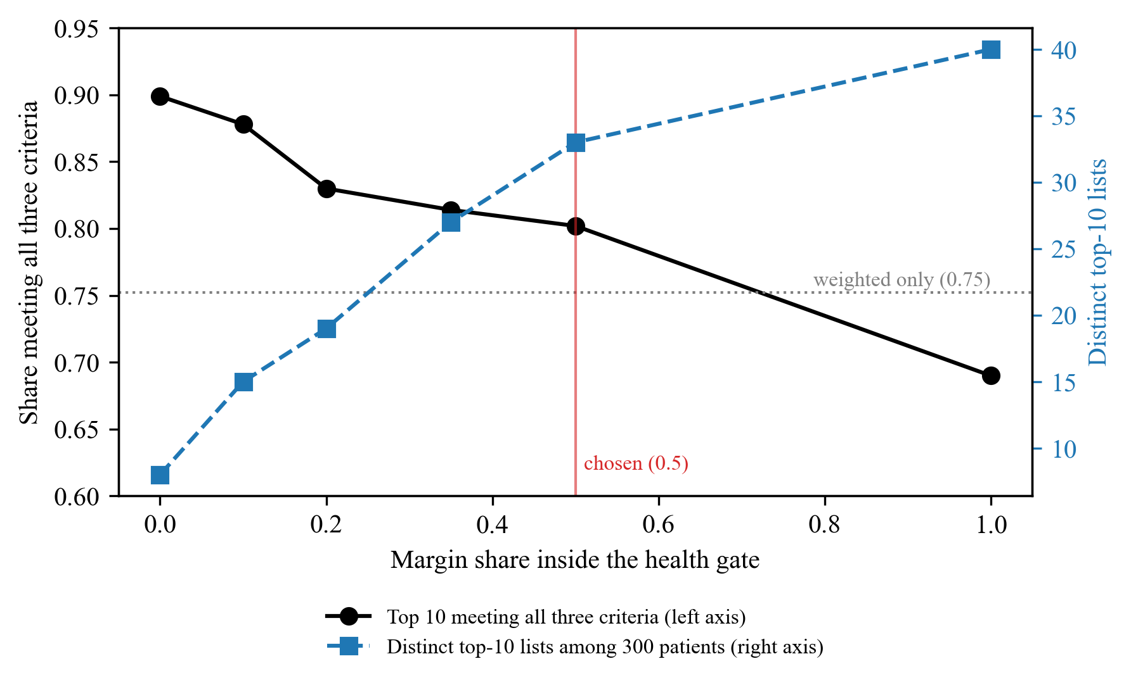
Figure 3. How much the priority levels count inside the health gate: practicality against the number of distinct recommendation lists (17 October tuning run, all ages, before acceptability was added).

8. Scenarios (Layer 5) and Seven-Day Meal Plans
A scenario replaces the patient's usual meals with chosen recipes. For each priority it reports whether the scenario improves, worsens or does not change the measure relative to the patient's usual diet, with the evidence label of that pathway; for example, a sugar reduction counts as MODERATE evidence only when energy also falls, matching the feeding-trial evidence. The liver model is not used to predict future CAP: it was not trained on interventions and NHANES has no repeat measurements, so future states are shown as directions labelled “Simulated projection, not a clinical forecast”.
Seven-day plans give two main meals a day that meet every reference, with varied protein sources. Because a patient may lack the ingredients, tools or taste for other cuisines, the week is filled from the patient's own cuisine first, then by repeating a favourite (never on consecutive days), and only then from the most similar cuisine by ingredients, labelled as such: 58% of plans used the own cuisine only, 80% by the repeat step, and 100% overall. 81% of plan meals are within the practical limits.

9. Changes to the Proposal and Key Decisions
• Data sources. RecipeDB is the only recipe source; FlavorDB was explored and not used; DietRx and SpiceRx moved to future work. The available RecipeDB holds 20,000 recipes, 19 of them Indian; since the cohort is the US population, regional Indian cuisines are future work.
• Cohort. Both NHANES FibroScan cycles were pooled (15,300 participants) and validated over time; NHANES III ultrasound with mortality follow-up is proposed for external validation.
• Ranking. Health gate by default; priority levels count inside it; acceptability added.
• Extensions added to the proposal (§17). Habitual diet, fibrosis risk and referral, MASLD/MetALD labelling and safety notices, patient-level explanations and uncertainty, re-assessment timeline, meal plans, grounded plain-language summaries, a fairness audit, external validation, ultra-processing and glycaemic-load criteria, acceptability and further evidence rows.

10. Limitations
• NHANES is cross-sectional: the twin's current state is validated, future states are not.
• Validation is internal and temporal within NHANES; external validation (NHANES III) is planned.
• One 24-hour recall describes one day, so it moves a priority by at most one level.
• Cuisine preferences in the ranking evaluation are simulated until the pilot evaluation.
• The evidence concerns dietary patterns sustained over weeks; recipe-level effects are indirect.

11. Remaining Work
Table 8. Plan for the remaining meetings.
Meeting | Work
10 · 30 Oct | Fibrosis risk (FIB-4) against measured liver stiffness, with the referral pathway; MASLD/MetALD labelling and safety notices; per-patient SHAP and conformal CAP intervals; causal knowledge graph; recipe explanations and plain-language summaries; richer cuisine and feasibility scores; NHANES III download
11 · 6 Nov | FastAPI backend with SQLite; re-assessment timeline; 3D liver with timeline slider; React dashboard; ultra-processing and glycaemic-load criteria
12 · 13 Nov | NHANES III external and mortality validation; fibrosis triage accuracy; conformal coverage; fairness audit; pilot evaluation with 5–10 people
13 · 20 Nov | Freeze scope; thesis chapters; update Appendices A and B
14 · 27 Nov | Final checks, reproducibility, presentation and live demonstration

12. Documents and Code
• Code: https://github.com/manojna0012/HepatoTwin. The README lists the commands that rebuild the data, models and results; 84 automated tests check the pipeline.
• EDA report of every dataset used (docs/thesis/HepatoTwin_EDA_Report.pdf), produced by src/eda_report.py.
• Appendix A, the experiment record for the liver model (docs/thesis/HepatoTwin_Experiment_Record.pdf).
• Appendix B, the evidence engine and recipe ranking (docs/thesis/HepatoTwin_Appendix_B_Ranking_Engine.pdf).
• Meeting 9 report (docs/thesis/HepatoTwin_Meeting9_Report.pdf), the proposal and the weekly action plan.
• Demonstration: python src/demo.py --seqn 109349 --cuisine American --plan runs Layers 2–5 for one held-out patient.

