Appendix A. Experiment Record for the Layer 2 Patient-State Model
This appendix records every experiment conducted between 5 September and 22 October 2026 to improve the HepatoTwin patient-state model, which predicts the controlled attenuation parameter (CAP; NHANES variable LUXCAPM, dB/m) measured by FibroScan transient elastography. For each experiment it states what was tested, the result, whether the change was adopted, and the reason. The cohort comprised participants with a complete elastography examination (LUAXSTAT = 1) and an observed CAP value, aged 12 to 80 years. The final model is intended for patients aged 12 to 59 and is evaluated where the reference CAP is reliable (Section A.9). All figures are taken from result files saved in the project repository.

A.1 Summary
Table A.1. Headline results.
Measure | Value | Context
Starting point | R² 0.491 | First XGBoost model, 14 inputs, fixed holdout (P1-test)
Best result on 2017–2020 data | R² 0.524 | 128 inputs, pooled five-fold out-of-fold (P2)
Selected model, held-out test | R² 0.562 (0.517–0.601) | Model scope: ages 12–59, reliable reference CAP; 1,236 test participants (Section A.9)
Selected model, cross-validation | R² 0.593 | Scope members, five-fold CV over all 15,300 participants, three seeds
Steatosis classification | ROC-AUC 0.881 / 0.879 | Calibrated classifiers for CAP ≥ 248 and ≥ 280 dB/m (scope, P3-test)
Temporal validation | R² 0.578; AUC 0.884 / 0.890 | Trained on 2017–2020, tested on 2021–2023 scope members, n = 2,415 (Section A.11)
Against clinical scores | AUC +0.020 vs FLI; +0.046 vs HSI | CAP ≥ 248, 1,100 in-scope test participants (Section A.12)
Outside the scope | R² 0.496 | All 3,060 test participants, including ages 60+ and unreliable examinations
Phase 6 variants | R² 0.584–0.597 (CV) | Changes to inputs, imputation, loss, tuning and ensembling; none reached 0.60 (Section A.8)

Fifty-one experiments varied the learning algorithm, the input features, the training weights, the treatment of the target, the training data and the evaluated population. Every change of algorithm or feature set produced an R² within approximately 0.01 of the same plateau near 0.51. Adding new information helped modestly: approximately 80 additional NHANES variables increased R² by 0.010, and the 2021–2023 FibroScan cycle increased it by 0.004 on the original cohort.
The selected model pools both NHANES FibroScan cycles, uses 81 routinely collectable inputs, down-weights less reliable examinations, and is accompanied by isotonic-calibrated steatosis classifiers. Its scope is ages 12 to 59, where it reaches test R² 0.562 against 0.553 for the original inputs trained on the same participants. Section A.10 sets out why R² plateaus; Phase 6 (Section A.8) shows that the same limit applies within the scope.

A.2 Evaluation Protocols
Three evaluation protocols were used. Because each scores a different set of participants, R² values from different protocols are not directly comparable. Every result in this appendix is labelled with its protocol.
Table A.2. Evaluation protocols.
Code | Design | Use
P1 | 9,021 participants (2017–March 2020) split once 80/20 with seed 42 into 7,216 development and 1,805 test participants. Model choice by five-fold CV on the development set (P1-CV); test results reported as P1-test. | September and early October experiments. The test set was examined repeatedly during development, so P1-test is an internal comparison rather than an independent validation.
P2 | All 9,021 participants, five-fold cross-validation with seed 42; R² computed on the pooled out-of-fold predictions. Baseline R² 0.5135. | October model-family and new-data experiments.
P3 | 15,300 participants from both FibroScan cycles. A 20% test set (3,060, stratified by cycle, seed 42) set aside first; model choice by five-fold CV on the remaining 12,240 (P3-CV); test set scored once (P3-test). | Combined model and final selection.

Outcome categories used in the tables: Adopted (carried forward into the model), Small gain (improvement under about 0.01 R², not or not fully adopted), No gain, Worse, and Diagnostic (an analysis that explains model behaviour rather than a candidate model).

A.3 Phase 1: Baselines (5–6 September)
The initial models used 14 inputs: age, sex, race and ethnicity, BMI, waist circumference, ALT, AST, HbA1c, total cholesterol, HDL cholesterol, and day-one dietary energy, protein, carbohydrate and fat.
Table A.3. Phase 1 experiments: baselines.
ID | Experiment | What was tested | Result | Outcome | Interpretation
E1 | Baseline XGBoost | 300 trees, depth 6, learning rate 0.05 on the 14 inputs. | P1-test R² 0.491; RMSE 44.52 dB/m | Adopted | Established the reference. The early workflow imputed missing values before splitting, which leaks test information; corrected in E3.
E2 | Algorithm comparison | XGBoost against linear regression and random forest. | P1-test R²: XGBoost 0.491; linear 0.488; random forest 0.486 | Small gain | XGBoost retained by a margin of 0.003. A linear model nearly matching a tree ensemble suggests the signal is largely additive and dominated by body-size variables. Selection here used test RMSE and was later replaced by CV-based selection.

A.4 Phase 2: Tuning, Additional Laboratory Inputs and the Supplied Model (to 18 September)
Table A.4. Phase 2 experiments: tuning and inputs.
ID | Experiment | What was tested | Result | Outcome | Interpretation
E3 | Leakage-free preprocessing and hyperparameter search | Imputation fitted within each fold; 40-configuration randomized search selected by CV RMSE. | P1-test R² 0.485 (corrected baseline) → 0.506; CV RMSE 45.89 → 45.03; paired bootstrap 95% CI for RMSE gain 0.52–1.38 dB/m | Adopted | First statistically clear improvement. Shallow trees (depth 4), a low learning rate and row subsampling limit overfitting on a noisy target. Became the 14-input reference model.
E4 | Second pass: 24 candidates, three input sets | 14, 19 and 28 inputs (adding height, weight, GGT, uric acid, triglycerides, albumin, ALP, creatinine, bilirubin, total protein, globulin, iron, BUN, LDH); XGBoost variants, missing-value indicators, histogram boosting, spline ridge, an equal blend. | P1-CV R²: 14 inputs 0.489; 19 inputs 0.496; 28 inputs 0.501; blend 0.502. P1-test 0.506 → 0.514; CI for RMSE gain −0.001 to 0.724 | Small gain | Additional laboratory values added about 0.01, but the interval includes zero. Liver-relevant markers add little beyond waist and BMI, which already capture most of the metabolic signal.
E5 | Reproduction of the supplied model (R² 0.535) | Supplied 36-input script refitted on its own CAP-stratified split and on the original split. | Stratified split: supplied 0.535, project model 0.541. Original split: supplied 0.511, project model 0.514 | Diagnostic | The reported 0.535 reflected an easier test split rather than a better model; on matched splits the project model scored higher. Single-split R² varies by roughly ±0.03 with test membership.
E6 | Engineered features | 36 raw inputs plus 10 derived features (waist-to-height, AST/ALT, TG/HDL, TC/HDL, partial HSI, FLI proxy, energy fractions, energy per kg) with missing-value indicators; 600 trees. | P1-CV R² 0.506 (best of six); P1-test 0.515; CI for RMSE gain over E4 −0.30 to 0.38 | Small gain | Became the 46-feature reference for October. Derived scores re-express inputs that the trees can already combine, so they contribute little new information.

A.5 Phase 3: Feature Ablations, Weighting and Regressor Choice (2 October)
All Phase 3 experiments used protocol P1, starting from the 36 raw inputs.
Table A.5. Phase 3 experiments: feature ablations and weighting.
ID | Experiment | What was tested | Result (P1-CV R²) | Outcome | Interpretation
E7 | Engineered-feature ablation | Raw only; plus four ratios; plus FLI and HSI; plus all ten engineered features. | 0.5035 / 0.5048 / 0.5032 / 0.5036 | Small gain | The four ratios added 0.001; the index scores added nothing. The ratios were kept.
E8 | Individual ratios | WHtR, AST/ALT, TG/HDL and TC/HDL each added alone. | 0.5022–0.5038 against 0.5035 (raw) | No gain | No single ratio carries information that the raw variables do not already provide.
E9 | LDL cholesterol | 46 features; plus LDL; plus LDL and a missing-value indicator. | 0.5036 → 0.5020 / 0.5030 | No gain | LDL is largely determined by total cholesterol, HDL and triglycerides, which are already inputs, and is missing for many participants.
E10 | Recursive feature elimination | Feature counts from 46 down to 10. | 46: 0.504; 25: 0.508; 15: 0.501; 12: 0.487; 10: 0.485 | No gain | About 20–25 features carry nearly all of the signal. Waist, the FLI proxy, waist-to-height and BMI rank highest.
E11 | Histogram gradient boosting | Same 40 features as XGBoost. | XGBoost 0.505; HistGradientBoosting 0.486 | Worse | Default regularization fits this noisy target less well than the tuned XGBoost.
E12 | Up-weighting extreme CAP values | Training weights increasing with distance from the mean, strength 0 to 0.75. | 0.505 → 0.500 / 0.494 / 0.488 | Worse | Prediction compression (E13) stems from missing information, not from the loss weighting. Weighting the extremes trades errors in the middle of the range for small gains at the tails.

A.6 Phase 4: Target Diagnostics and Model Families (13–16 October)
Diagnostics of the target variable were run first, as they explain why the subsequent model changes could not raise R² substantially.
Table A.6. Phase 4 diagnostics of the target and residuals.
ID | Experiment | What was tested | Result | Outcome | Interpretation
E13 | Residual analysis | Error and bias by CAP range on out-of-fold predictions (P2). | Slope of prediction on actual 0.51. Mean bias +44 dB/m for CAP < 200 and −67 dB/m for CAP > 390 | Diagnostic | Regression toward the mean: the inputs cannot separate very lean or very fatty livers from average ones, so predictions shrink toward approximately 255 dB/m.
E14 | CAP ceiling audit | Values at the device maximum and their examination quality. | 129 of 9,021 (1.4%) exactly 400 dB/m; median CAP IQR 5 dB/m against 35 dB/m for other examinations | Diagnostic | CAP is truncated at 400 dB/m, so higher true values are censored. Too few cases to limit R² materially.
E15 | Ceiling sensitivity | Model refitted and scored without CAP = 400 (P1-CV). | R² 0.506 → 0.488; RMSE 44.28 → 43.74 dB/m | No gain | Errors fall slightly, but R² falls because removing the highest values reduces the variance against which R² is measured.
E16 | Measurement quality by probe | Within-probe performance for M and XL probes (P1-CV). | Within-probe R²: M 0.419, XL 0.278; RMSE 42.0 and 50.8 dB/m | Diagnostic | The XL probe is used for larger body habitus and yields noisier CAP; probe choice itself tracks obesity.

Table A.7. Phase 4 experiments: model families and target treatments.
ID | Experiment | What was tested | Result | Outcome | Interpretation
E17 | Probe-aware regression | Probe type (M or XL) as an input (P1-CV). | 0.5062 → 0.5112 | Small gain | Not used in the final model: probe type is recorded during the FibroScan examination, and a patient with a FibroScan already has a measured CAP.
E18 | Probe weighting | XL examinations weighted 1.5× and 2×. | 0.5112 → 0.5080 / 0.5018 | Worse | XL examinations are noisier; giving them more weight increases the noise learned.
E19 | CatBoost | Same features and folds as XGBoost (P2). | XGBoost 0.5135; CatBoost 0.5093 | No gain | A different boosting implementation on the same information reaches the same plateau.
E20 | Classification-to-regression hybrid | Binary or four-class steatosis probabilities supplied to the regressor, nested CV (P2). | 0.5135 → 0.5116 / 0.5129 | No gain | Class probabilities are functions of the same inputs and add no new information.
E21 | Linear recalibration | Cross-fitted linear correction to stretch compressed predictions (P2). | 0.5135 → 0.5127 | No gain | Squared-error models are already calibrated in the mean; stretching predictions widens errors as much as it removes bias.
E22 | Quantile regression | Median (q50) model and an 80% interval from q10 and q90 (P1-CV). | q50 R² 0.503 against 0.506; interval coverage 74.7% (nominal 80%); mean width 98 dB/m | No gain | Useful for expressing uncertainty, not for accuracy. The interval width indicates that an individual CAP is uncertain by roughly ±50 dB/m.
E23 | Fold-local feature selection | Lasso and ExtraTrees RFE fitted within each fold (P1-CV). | 0.506 → Lasso 0.499; RFE 0.504 | No gain | Consistent with E10: weak features are not harming the model.
E24 | Alternative learners | Extra Trees, random forest and ridge regression on the 46 selected features (P1-CV). | XGBoost 0.506; Extra Trees 0.500; random forest 0.498; ridge 0.482 | No gain | Every model family reaches the same ceiling.
E25 | Neural network | Multilayer perceptron with layers (128, 64) (P1-CV). | 0.453 | Worse | Tabular data of this size with substantial missingness favours tree ensembles.
E26 | Stacking | XGBoost, Extra Trees and random forest with a ridge meta-learner (P1-CV). | 0.506 → 0.509 | Small gain | A gain of 0.003 for three times the training cost and complexity; not adopted.
E27 | Steatosis classification | Binary (S0 against S1–S3) and four-class; provisional cut-offs 248, 268 and 280 dB/m (P2). | Binary ROC-AUC 0.862, balanced accuracy 0.776. Four-class macro F1 0.439, one-vs-rest AUC 0.742 | Adopted | The binary task matches the evaluation specified in the proposal (AUC, F1, calibration) and performs well. The four-class task fails for S1 and S2, which span only 20 and 12 dB/m, narrower than the model error.
E28 | HbA1c ablation | Model with and without HbA1c on the same participants. | Not completed | — | The script stopped because an expected parameter file was never created; no results are available.

A.7 Phase 5: Additional Data (16 October)
Phase 4 indicated that the limit lay in the available information rather than in the model, so Phase 5 added NHANES components not previously used. Elastography fields and self-reported liver conditions were excluded as inputs throughout, because they would act as proxies for the target.
Table A.8. Phase 5 experiments: additional data.
ID | Experiment | What was tested | Result | Outcome | Interpretation
E29 | Extended NHANES variables | Added in cumulative groups (P2): body measures; fasting insulin and glucose (HOMA-IR, TyG); blood count, CRP and ferritin; blood pressure; questionnaires (diabetes, hypertension, weight history, alcohol, smoking, activity, sleep); prescriptions. | 0.5135 → body 0.5131 → fasting 0.5175 → blood count 0.5173 → blood pressure 0.5171 → questionnaire 0.5232 → prescriptions 0.5221; tuned, 128 inputs 0.5239 | Small gain | Largest single gain in the record (+0.010). Insulin resistance and diabetes or weight history add information not fully captured by body size. Prescriptions and several questions exist only in 2017–2020.
E30 | Learning curve | Training on 25%, 50%, 75% and 100% of each training fold (P2). | 0.488; 0.501; 0.511; 0.512 | Diagnostic | The curve flattens: the final 25% of data adds 0.002, so additional participants alone would help only slightly.
E31 | 2021–2023 FibroScan cycle | 6,279 additional participants with the same examination and variable names, added to training only (P2 folds). | 0.5135 → 0.5170 on the 2017–2020 participants | Small gain | Consistent with the learning curve. The 2021–2023 cycle is the final NHANES cycle with liver elastography.
E32 | DXA body composition | Visceral, subcutaneous, android and gynoid fat (2017–2018, ages 8–59; 3,307 linked participants). | 0.5094 → 0.5168 on the DXA subset | Small gain | Visceral fat is the strongest known correlate of liver fat, yet it adds only 0.007. Unsuitable for the final model: available for part of one cycle and not a routine test.
E33 | Measurement-noise estimate | Standard error of each examination’s median CAP from its IQR and number of valid measurements. | Within-examination noise ≈ 3.7% of CAP variance | Diagnostic | Noise within a single examination does not explain the ceiling; between-visit variation cannot be measured in NHANES.
E34 | Upper-bound check with examination-derived inputs | Liver stiffness and probe type from the same FibroScan examination (pooled cohort, five-fold CV). | 0.518 → with probe 0.524; with stiffness 0.529 | Diagnostic | These are not legitimate predictors, since they come from the measurement being predicted, and they still remain near 0.53.
E35 | Combined model | Both cycles (15,300 participants); 36 core inputs plus 45 variables collected identically in both cycles; training weighted by examination reliability (P3). | P3-test R²: 2017–2020-only reference 0.480; same inputs pooled 0.487; combined 0.493. Reliable examinations 0.517 → 0.533. P3-CV 0.520 | Adopted | Best full-population result. This test split is harder than average (the reference scores 0.480 on it against about 0.51 in CV), so the difference between models is the meaningful quantity.
E36 | Cohort filters | Each filter trained and scored within the filtered cohort; mean of three CV seeds. | All 0.518; CAP IQR < 40 0.548; ages 12–59 0.548; IQR < 40 and ages 12–59 0.584; adults only 0.498; without CAP 400 0.497; IQR < 40 and ages 60+ 0.414 | Diagnostic | The highest value in the record (0.584) is stable across seeds and age cut-offs of 50 to 65 years, but excludes 59% of participants, including everyone aged 60 or over. Not adopted.
E37 | Performance by age group | Error by age group on pooled out-of-fold predictions. | R²: 12–17 0.43; 18–39 0.54; 40–59 0.49; 60+ 0.41. RMSE 40.5, 42.2, 44.1, 46.0 dB/m | Diagnostic | Error in the 60+ group is only slightly larger; R² is low mainly because CAP varies less within that group (SD 59.6 against 63.0 dB/m overall).
E38 | Improving the 60+ group | 2017–2020 history and medication items; a 60+-only model; doubled weighting; deeper trees. | 60+ R² 0.405 → 0.406 / 0.394 / 0.406 / 0.408 | No gain | Determinants of liver fat in older adults, such as genetic risk, accurate alcohol history, muscle loss and other liver disease, are not measured in NHANES 2017–2023.
E39 | Calibrated steatosis classifiers | XGBoost classifiers for CAP ≥ 248 and ≥ 280 dB/m with isotonic calibration on training out-of-fold predictions and an F1-selected threshold (P3-test). | CAP ≥ 248: AUC 0.856, Brier 0.154, calibration error 0.025 → 0.018. CAP ≥ 280: AUC 0.868, calibration error 0.024 → 0.019 | Adopted | Additional inputs leave discrimination unchanged but reduce calibration error by about a quarter. Calibrated probabilities are required by the scenario engine.
E30, E33 and E34 were exploratory runs whose outputs were not saved to the repository. During Phase 5, questionnaire cleaning initially treated the codes 7 and 9 as missing for every item, which also removed valid answers such as 7 hours of sleep or 9 drinks. Missing-value codes were made item-specific and all affected experiments were rerun; R² changed by less than 0.001. The figures reported are from the corrected runs.

A.8 Phase 6: Target Population and Lean Participants (17–21 October)
Phase 6 started from the model selected on 16 October (the slow_wide settings: 1,500 trees, depth 4, learning rate 0.01) and asked two questions: how well it predicts CAP in a defined target population, and whether any change reaches R² 0.60 there; and why discrimination is lower in lean participants. It led to one change, deeper trees (E46), adopted in Section A.9; all figures in this section refer to the 16 October model unless stated.

Target population
The target population is participants with a reliable examination (CAP IQR < 40 dB/m, a standard quality criterion) aged 12 to 59, the filter that gave the highest stable R² in E36. Two further filters were examined: excluding excess alcohol, defined as average intake above 140 g a week for women or 210 g a week for men (the MetALD thresholds of Rinella et al., 2023) and estimated from drinking frequency (ALQ121) and drinks per drinking day (ALQ130); and stricter IQR cut-offs.
Table A.9. 16 October model (trained on all participants) scored on subsets of the held-out test set (P3-test).
Population | Share of test set | Test R² | RMSE (dB/m)
All participants | 100% | 0.493 | 43.6
No excess alcohol (MASLD cohort) | 94% | 0.501 | 43.2
Ages 12–59 | 67% | 0.511 | 43.4
Reliable examinations | 62% | 0.532 | 42.2
Reliable examinations, ages 12–59 (target) | 40% | 0.558 | 41.6
Target, no excess alcohol | 38% | 0.561 | 41.4
Target, IQR < 30, no excess alcohol | 24% | 0.567 | 41.8
Target, IQR < 20, no excess alcohol | 9% | 0.585 | 44.7
In the target population RMSE falls (43.6 → 41.6 dB/m) while the CAP standard deviation does not shrink (64.8 against 63.0 dB/m overall), so the higher R² reflects smaller errors rather than a narrower outcome. Stricter IQR cut-offs raise R² while RMSE rises and the subset becomes small; they were not adopted.
Because a single 20% split is noisy (E5) and the P3 test split is harder than average (E35), the target population was also evaluated by five-fold cross-validation over all 15,300 participants, repeated with three seeds, training on everyone and scoring the target members of each validation fold. Pooled R² was 0.591, 0.591 and 0.590 (RMSE 41.5 dB/m); single folds ranged from 0.546 to 0.617. With the final settings these become 0.593 (repeated cross-validation) and 0.562 (held-out test). On the supervisor’s advice, this population was adopted as the model’s scope (Section A.9).

Attempts to reach R² 0.60
Each variant was compared under five-fold cross-validation on the P3 training partition (seed 42), with R² computed on the target members of the validation folds (5,019 participants). The reference, the 16 October model, scored 0.5945. All 15 variants were afterwards also scored on the held-out test set (Section A.9).
Table A.10. Phase 6 experiments: target population (P3-CV, target R²).
ID | Experiment | What was tested | Result (target R²) | Outcome | Interpretation
E40 | Training population | Training only on the target population; target weighted ×3; training only on ages 12–59, all examinations (final settings, 22 October). | 0.5845; 0.5921; 0.5883 | Worse | Participants outside the target still carry information about the relationship between inputs and CAP. Test R²: target-only 0.547 against 0.558; ages 12–59 only 0.553 against 0.562.
E41 | Habitual diet | Day-1 recall measures: saturated fat, sugars and fibre per energy, HEI-2020, FPED food groups, sodium and fatty acids. | 0.5930 | No gain | One recall day is a weak measure of usual intake, consistent with the low importance of the existing dietary inputs.
E42 | Medical history | Questionnaire conditions (heart disease, stroke, thyroid, liver condition), urine albumin-to-creatinine ratio, number of prescriptions. | 0.5949 | No gain | Prescription names are not released for 2021–2023, so only a count was usable. A self-reported fatty-liver diagnosis (MCQ510A) was excluded as label leakage.
E43 | Fasting subsample | Target R² among participants with fasting insulin and glucose, as used by Liu et al. (2024) and Boullion et al. (2025). | 0.597 vs 0.592 without | No gain | The model already uses fasting values where measured. On the test set the subsample scored lower (0.550 against 0.560).
E44 | Missing-value handling | Median imputation with missing-value indicators (as in Du et al., 2026); MICE iterative imputation (as in Liu et al., 2024). | 0.5961; 0.5938 | No gain | XGBoost already handles missing values natively; imputation adds no information.
E45 | Loss function | Pseudo-Huber loss (slope 40 dB/m); absolute-error loss. | 0.5940; 0.5893 | No gain | Outliers in CAP are not what limits accuracy.
E46 | Hyperparameters | Five further settings: deeper trees with strong regularisation, shallow trees with more rounds, and three tuned combinations. | 0.5915–0.5960 | Adopted | Within 0.002 of the reference in CV, but the deepest setting had the highest test R² of all candidates (0.562 against 0.558) and was adopted (Section A.9).
E47 | Ensembling | Averages of 2–5 of the 15 valid variants. | Best 0.5969 | Small gain | Below 0.003; not adopted for the added complexity.
One further run, excluding hepatitis B from training, was invalid: the file used (HEPB_S) records surface antibody, which mostly reflects vaccination, so its result was discarded.

Lean participants
Zhu et al. (2026) reported an AUC of 0.892 for CAP ≥ 248 dB/m in NHANES non-Hispanic Asian participants with BMI < 28 kg/m², using a model developed in non-obese Chinese adults. On the same subgroup of the held-out test set (n = 209) the selected classifier reached 0.799, and 0.783 for all adults with BMI < 28 (n = 1,151). The cause was examined on the training partition by comparing the model with the Fatty Liver Index within BMI bands, and four lean-specific classifiers were tried.
Table A.11. CAP ≥ 248 dB/m discrimination by BMI band (P3-CV, out-of-fold).
BMI band | n | Prevalence | Model AUC | FLI AUC | Difference
All participants | 12,240 | 0.52 | 0.865 | 0.849 | +0.016
BMI < 28 | 6,354 | 0.30 | 0.809 | 0.788 | +0.021
BMI < 25 | 4,028 | 0.19 | 0.770 | 0.743 | +0.027
BMI ≥ 28 | 5,782 | 0.77 | 0.786 | 0.747 | +0.039

Table A.12. Phase 6 experiments: lean participants (P3-CV, AUC for CAP ≥ 248 dB/m in BMI < 28).
ID | Experiment | What was tested | Lean AUC (reference 0.809) | Outcome | Interpretation
E48 | Lean-only training | Classifier trained only on BMI < 28 (the approach of Zhu et al., 2026). | 0.804 (overall 0.852) | Worse | Less training data and no gain within the lean group.
E49 | Lean weighting | Lean participants weighted ×3. | 0.807 | No gain | —
E50 | Non-obese training | Classifier trained on BMI < 30. | 0.808 | No gain | —
E51 | Blend | Average of the selected and lean-only classifiers. | 0.808 | No gain | In lean non-Hispanic Asian participants every variant scored 0.823–0.826.

Discrimination falls in every BMI band, including participants with obesity (0.786), and the Fatty Liver Index falls by a similar amount: within a narrow BMI band the strongest predictor, body size, varies little. The model’s margin over FLI grows in every band, so the lean subgroup is not a specific failure of the model. The higher figure of Zhu et al. rests on a training set of about 150,000 Chinese adults, against roughly 700 lean Asian participants in our training data, and was obtained on complete cases only.

A.9 Final Model Selection

Scope
Following the supervisor’s guidance, the model’s intended use is restricted to patients aged 12 to 59, and its performance is evaluated where the reference CAP is reliable (CAP IQR < 40 dB/m). Patients aged 60 and over are outside the scope: R² is lowest in that group (E37), the extra experiments for it gained nothing (E38), and its determinants of liver fat are poorly measured in NHANES. The reliability condition concerns the reference measurement, not the patient; in use, the scope a clinician can apply is age. The model is still trained on every participant, because that predicts the scope better than training on ages 12–59 only (E40).

Model
The selected model is an XGBoost regressor (3,000 trees, depth 5, learning rate 0.005, minimum child weight 15, column subsampling 0.4) trained on 12,240 participants from both FibroScan cycles. It uses 81 raw inputs and six derived scores: waist-to-hip ratio, HOMA-IR, the triglyceride-glucose (TyG) index, mean systolic and diastolic blood pressure, and one-year weight change. Examinations with a CAP IQR of 40 dB/m or more are down-weighted (weight 40/IQR, minimum 0.25) rather than excluded. Two isotonic-calibrated classifiers estimate P(CAP ≥ 248) and P(CAP ≥ 280); they are unchanged from 16 October.
The examination weighting was chosen by training-set cross-validation. The tree settings were chosen on 21 October: each of the 15 Phase 6 candidates was trained on the full training partition and scored on the in-scope members of the held-out test set, and the candidate with the highest test R² was adopted. The same settings also have the highest full-population cross-validation R² of the 12 configurations compared (0.5205 against 0.5198 for the 16 October settings), and repeated cross-validation over all participants, which played no part in the choice, confirms the gain in the scope (0.593 against 0.590). Because the test set informed the choice, the test figures carry slight selection optimism.
Table A.13. Phase 6 candidates scored on the held-out test set within the scope (n = 1,236), highest first.
Candidate | CV R² | Test R² | Test RMSE (dB/m)
Deeper trees (E46, selected) | 0.5957 | 0.5622 | 41.42
Tuned-c (E46) | 0.5951 | 0.5617 | 41.44
Tuned-a (E46) | 0.5960 | 0.5603 | 41.51
Medical history (E42) | 0.5949 | 0.5600 | 41.53
16 October model (reference) | 0.5945 | 0.5582 | 41.61
Pseudo-Huber loss (E45) | 0.5940 | 0.5581 | 41.62
MICE imputation (E44) | 0.5938 | 0.5580 | 41.62
Habitual diet (E41) | 0.5930 | 0.5573 | 41.65
Target weighted ×3 (E40) | 0.5921 | 0.5570 | 41.67
Median imputation with indicators (E44) | 0.5961 | 0.5566 | 41.69
Diet and medical history (E41–E42) | 0.5927 | 0.5559 | 41.72
Shallow trees, more rounds (E46) | 0.5936 | 0.5547 | 41.78
Tuned-b (E46) | 0.5915 | 0.5521 | 41.90
Absolute-error loss (E45) | 0.5893 | 0.5497 | 42.01
Target-only training (E40) | 0.5845 | 0.5467 | 42.15
The best blend (deeper trees with tuned-c) scored 0.5626 and was not adopted, as it adds 0.0004 for two models. Source: data/results/combined/validation/target_population_test_scores.csv and target_population_repeated_cv.csv. Refitted by the training script, the selected model scores 0.562 (the same to three decimals).
Table A.14. Selected model, held-out test performance (P3-test). The reference uses the 36 core inputs with the same training participants and the base settings.
Test group | n | Selected R² | Reference R² | Selected RMSE (dB/m)
Scope: ages 12–59, reliable reference | 1,236 | 0.562 | 0.553 | 41.4
Ages 12–17 | 209 | 0.498 | 0.482 | 36.2
Ages 18–39 | 512 | 0.518 | 0.514 | 42.7
Ages 40–59 | 515 | 0.522 | 0.506 | 42.1
Outside the scope, for reference:
Ages 12–59, all examinations | 2,040 | 0.515 | 0.511 | –
All participants, including ages 60+ | 3,060 | 0.496 | 0.487 | 43.5
R² within an age band is lower than in the whole scope because CAP varies less within a band (SD 51.2 dB/m at 12–17 against 62.6 in the scope). 95% interval for the scope: 0.517–0.601.
Table A.15. Calibrated steatosis classifiers within the scope, held-out test performance (P3-test, n = 1,236). Cut-offs are provisional.
Target | ROC-AUC | Brier | Calibration error | F1
CAP ≥ 248 dB/m (any steatosis) | 0.881 (0.863–0.899) | 0.140 | 0.018 | 0.806
CAP ≥ 280 dB/m | 0.879 (0.860–0.898) | 0.132 | 0.022 | 0.713
All 3,060 test participants: AUC 0.857 and 0.868.

Reasons for the selection
1. Best result on every measure. Highest test R² in the scope among 15 candidates, highest full-population cross-validation R², and better than the same inputs trained on the same participants in the scope and in each of its age bands.
2. Defined scope. Intended for ages 12 to 59, where its accuracy is highest and validated; trained on every participant, which serves the scope better than training on it alone.
3. Routinely collectable inputs only. Body measurements, standard blood tests, blood pressure and a short questionnaire. No input comes from the FibroScan examination or from DXA.
4. Alignment with the proposal. The proposal’s evaluation plan (Section 12.1) specifies ROC-AUC, F1, Brier score and calibration; the calibrated classifiers report all four.
5. Tolerance of missing data. Fasting laboratory values are missing for about half of participants; the model accepts missing inputs.

Alternatives not selected
Table A.16. Alternatives considered and reasons for rejection.
Alternative | Result | Reason not selected
Model trained only on the scope population | R² 0.547–0.553 (test) | Training only on the target group, or only on ages 12–59, predicts the scope less well than training on everyone (E40).
128-input model | R² 0.524 (P2) | About 30 of its variables were not collected in 2021–2023; adding them to the pooled cohort raised CV R² by only 0.002 (0.518 to 0.519).
Probe type or liver stiffness as inputs | R² 0.524–0.529 | Both are produced by the FibroScan examination and are unavailable without a measured CAP.
Stacking, CatBoost, MLP, hybrid models, ensembles | R² 0.453–0.513 | No gain, or a gain too small to justify the added complexity (also E47).
DXA visceral fat | +0.007 R² | Available for one partial cycle only and not a routine test.

A.10 Why R² Plateaus
Nine independent lines of evidence indicate that the remaining variation in CAP is not explained by routine clinical measurements:
1. Every algorithm tested (linear regression, random forest, Extra Trees, histogram boosting, XGBoost, CatBoost, a neural network and stacking) reaches an R² between 0.45 and 0.52 on the same inputs (E2, E11, E19, E24–E26).
2. Feature engineering, selection and ablation change R² by at most 0.003 (E7–E10, E23).
3. The learning curve is flat; 6,279 additional participants add 0.004 (E30, E31; Figure A.1).
4. Direct DXA measurement of visceral fat adds 0.007 (E32).
5. Approximately 80 additional NHANES variables add 0.010 (E29).
6. Even inputs taken from the FibroScan examination itself reach only 0.53 (E34).
7. Within-examination measurement noise is about 4% of the variance, so the unexplained variance reflects biological differences between people with similar measured profiles, such as genetic risk, alcohol intake and dietary history (E33). Genetic risk alone is large: liver fat is about 52% heritable in twins (Loomba et al., 2015), and NHANES 2017–2023 contains no genotypes.
8. Within the scope, every change to inputs, imputation, loss, tuning, training population and ensembling all scored between 0.584 and 0.597, a spread smaller than the variation between cross-validation folds (E40–E47).
9. CAP is itself an imperfect measure of liver fat. Two operators agree with a concordance correlation of 0.82 (Ferraioli, 2021), and CAP correlates with MRI-PDFF at r = 0.66 (Ahn et al., 2018), so it shares about 44% of its variance with the reference measure. Part of every CAP reading is therefore measurement variation that no patient characteristic can predict.
Together these set a realistic ceiling. A model that knew each patient’s true liver state would still be compared with a single CAP reading, whose reproducibility limits R² to the order of 0.8; the heritable share of liver fat, which routine measurements do not capture, lowers the attainable value further. The in-scope test R² of 0.562 (0.593 in cross-validation) should be read against this ceiling rather than against 1.
The learning curve below refits the selected settings on random subsets of the training set and scores the in-scope test participants. Test R² rises from 0.501 with 1,224 participants to 0.556 with 9,180 and only to 0.561 with the full 12,240; AUC follows the same pattern (0.866 to 0.880).
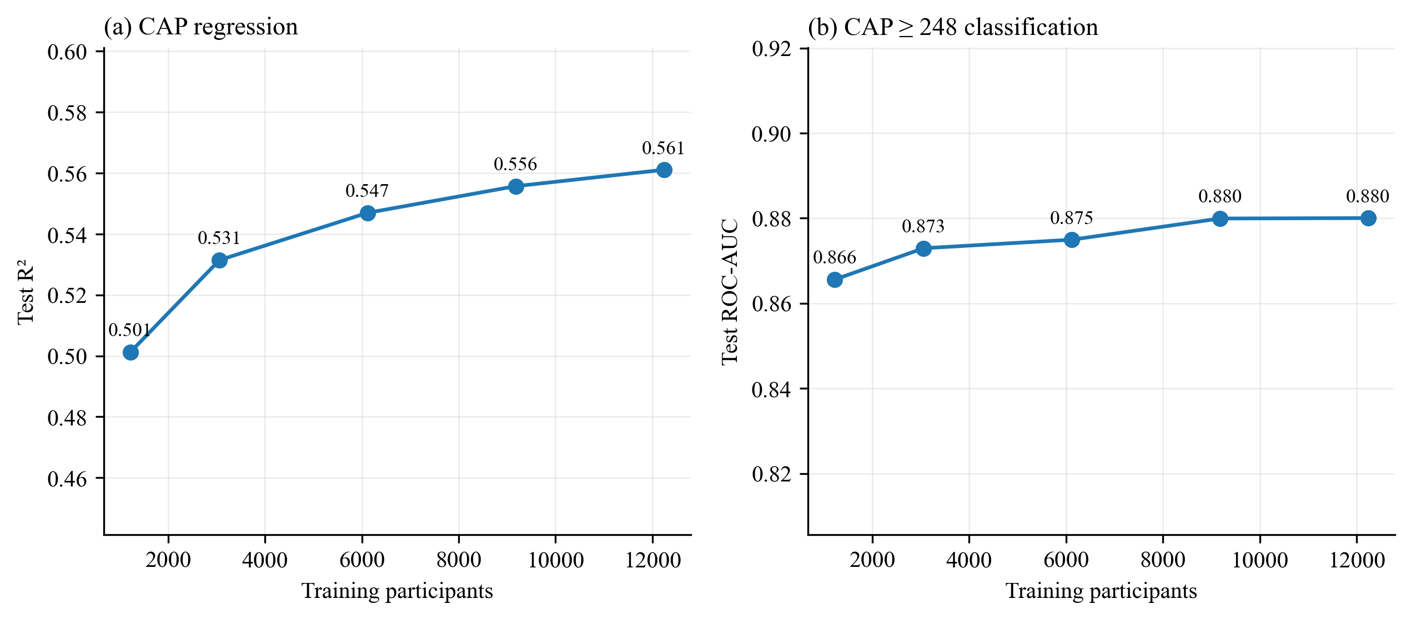
Figure A.1. Learning curves for the selected settings: held-out test performance within the scope (n = 1,236) against the number of training participants.
R² is therefore reported within the scope (0.562 on the held-out test set; 0.593 in repeated cross-validation) together with ROC-AUC and calibration, and the plateau is presented as a finding.

A.11 Additional Validation of the Selected Model
After selection, five further analyses (V1–V5) tested the selected model against the limitations identified during development. None of them changed the model or its settings, and the test set was not used to choose anything. All results are for the scope; intervals are 95% percentile bootstrap intervals from 1,000 participant resamples of the test set.
Table A.17. Additional validation analyses.
ID | Experiment | What was tested | Result | Outcome | Interpretation
V1 | Uncertainty | Bootstrap intervals for every test metric, in the scope and by age group. | R² 0.562 (0.517–0.601); AUC 0.881 (0.863–0.899) and 0.879 (0.860–0.898). | Reported | The classifiers are clearly in the 0.86–0.90 AUC range; the R² interval spans ±0.04.
V2 | Survey weighting | Test metrics weighted by NHANES examination weights (WTMECPRP, WTMEC2YR), pooled in proportion to cycle length. | R² 0.554; AUC 0.877 and 0.878; calibration error 0.038 and 0.039. | Reported | Performance holds for the weighted US population aged 12–59.
V3 | Age-specific calibration | Separate isotonic calibration for each age group, fitted on the same training out-of-fold predictions, compared with the single global calibration. | Scope calibration error 0.018→0.016 (CAP ≥ 248) and 0.022→0.021 (CAP ≥ 280). | Not adopted | Differences of 0.002 lie well within the intervals; the single calibration is kept.
V4 | Reference standard | Third classifier at the stricter cut-off CAP ≥ 302 dB/m, trained and calibrated in the same way. | AUC 0.888 (0.869–0.908); Brier 0.110; calibration error 0.031. | Reported | Discrimination is stable across three definitions of steatosis.
V5 | Temporal validation | Training on all 9,021 participants from 2017–March 2020 with the selected settings; testing on the 2,415 in-scope participants from 2021–2023. | R² 0.578 (0.549–0.603); AUC 0.884 and 0.890; calibration error 0.025 and 0.027. | Reported | No loss of performance on participants examined two to six years after the training data.

Table A.18. Selected model within the scope, with 95% bootstrap intervals: P3-test (n = 1,236) and temporal validation (trained on 2017–2020, tested on 2021–2023, n = 2,415).
Measure | P3-test, unweighted | P3-test, survey-weighted | Temporal test
CAP R² | 0.562 (0.517–0.601) | 0.554 (0.493–0.609) | 0.578 (0.549–0.603)
CAP RMSE (dB/m) | 41.4 (39.3–43.6) | 42.6 (39.5–45.7) | 42.9 (41.4–44.5)
AUC, CAP ≥ 248 | 0.881 (0.863–0.899) | 0.877 (0.851–0.901) | 0.884 (0.870–0.896)
AUC, CAP ≥ 280 | 0.879 (0.860–0.898) | 0.878 (0.849–0.905) | 0.890 (0.878–0.904)
AUC, CAP ≥ 302 | 0.888 (0.869–0.908) | 0.885 (0.850–0.916) | –
Brier, CAP ≥ 248 | 0.140 (0.129–0.150) | 0.143 (0.127–0.158) | 0.137 (0.130–0.145)
Brier, CAP ≥ 280 | 0.132 (0.121–0.144) | 0.134 (0.117–0.151) | 0.125 (0.117–0.133)
Calibration error, CAP ≥ 248 | 0.018 (0.016–0.046) | 0.038 (0.029–0.077) | 0.025 (0.019–0.041)
Calibration error, CAP ≥ 280 | 0.022 (0.019–0.049) | 0.039 (0.028–0.076) | 0.027 (0.019–0.044)
CAP R², all participants (outside scope) | 0.496 (0.465–0.524) | 0.510 (0.467–0.548) | 0.502 (0.482–0.520)
Source: data/results/combined/validation/ (rows labelled “scope (ages 12-59, reliable reference)”).
Calibration error is the expected calibration error over ten equal-sized bins. It is biased upward in small samples, which is why its intervals are asymmetric. Survey strata and primary sampling units were not used, so the intervals reflect participant sampling rather than the full survey design.
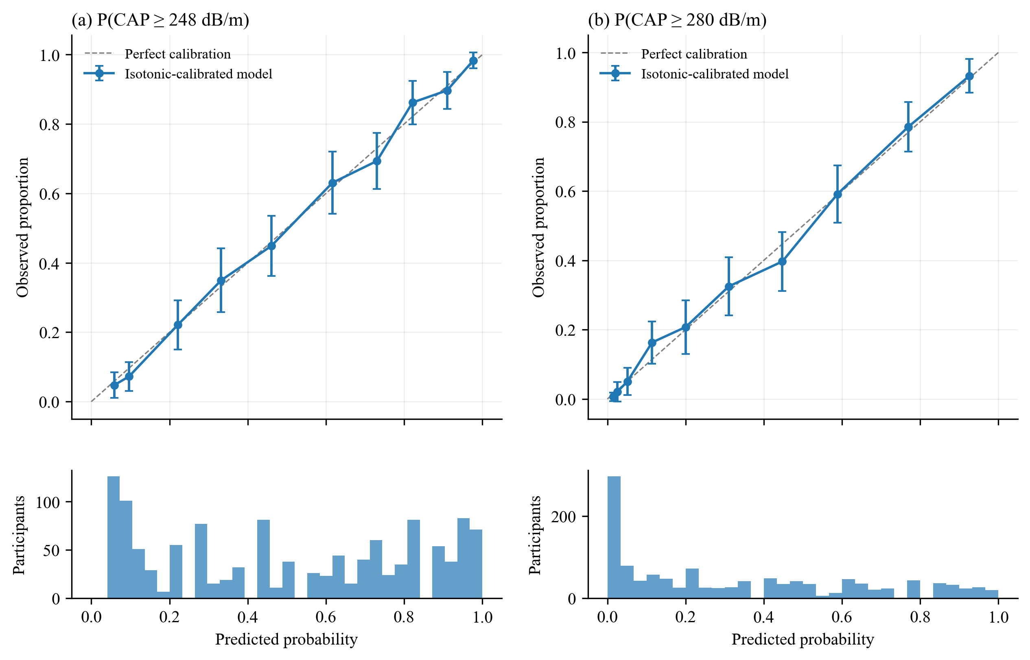
Figure A.2. Calibration of the isotonic-calibrated classifiers on the in-scope test participants (n = 1,236). Points are deciles of predicted probability with 95% binomial intervals; the histograms show the distribution of predicted probabilities.

A.12 Comparison with Clinical Scores
The selected classifiers were compared with two established non-invasive steatosis scores on the same held-out participants: the Fatty Liver Index (FLI; Bedogni et al., 2006), computed from BMI, waist circumference, triglycerides and GGT, and the Hepatic Steatosis Index (HSI; Lee et al., 2010), computed from the ALT/AST ratio, BMI, sex and diabetes. The comparison used the 1,100 in-scope test participants with every input to both scores. Differences in AUC are paired, with 95% intervals from 1,000 bootstrap resamples.
Table A.19. Discrimination of the selected classifiers and two clinical scores on the same in-scope test participants (n = 1,100). Δ AUC is the model minus the score.
Target | Model AUC | FLI AUC | Δ AUC vs FLI | HSI AUC | Δ AUC vs HSI
CAP ≥ 248 dB/m | 0.881 | 0.861 | +0.020 (0.011–0.029) | 0.836 | +0.046 (0.031–0.062)
CAP ≥ 280 dB/m | 0.879 | 0.849 | +0.030 (0.020–0.041) | 0.831 | +0.048 (0.032–0.064)
CAP ≥ 302 dB/m | 0.886 | 0.854 | +0.032 (0.019–0.044) | 0.837 | +0.049 (0.032–0.069)
On all 2,703 test participants with complete inputs the margins are similar: +0.018 to +0.033 over FLI and +0.047 to +0.062 over HSI.
The model discriminates better than both scores at every cut-off, and every interval excludes zero; the margin over FLI also holds within every BMI band (Section A.8). The margin is modest, which is expected: FLI is itself a strong predictor and a derived FLI value is one of the model inputs. FLI was computed with non-fasting serum triglycerides, because fasting values exist for only part of the cohort, which may slightly disadvantage it.
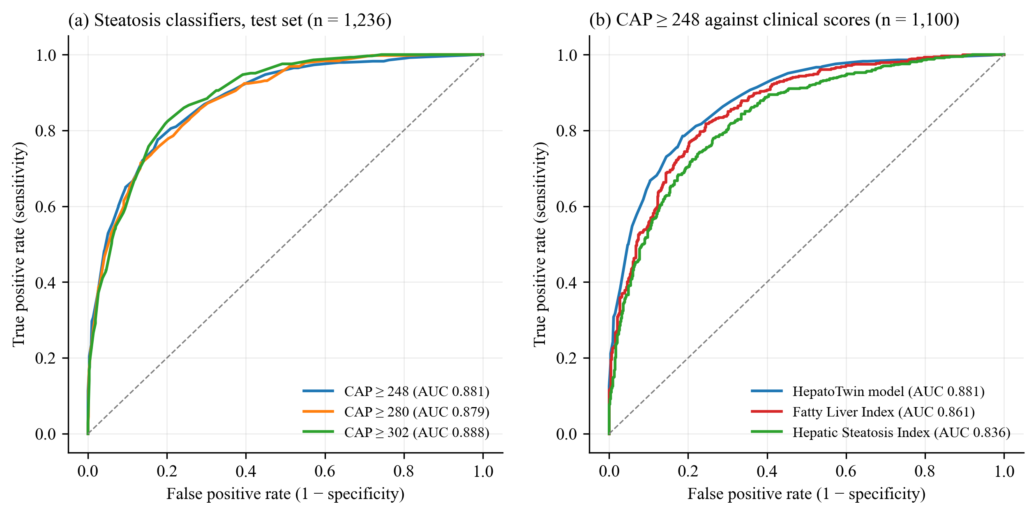
Figure A.3. Receiver operating characteristic curves on the in-scope test participants. (a) The three steatosis classifiers (n = 1,236). (b) The CAP ≥ 248 dB/m classifier against the Fatty Liver Index and the Hepatic Steatosis Index on the 1,100 participants with complete inputs.

A.13 Feature Importance
SHAP values for the CAP ≥ 248 dB/m classifier were computed with XGBoost’s exact TreeSHAP on the uncalibrated model; isotonic calibration is monotone, so the ranking of inputs is unchanged. SHAP describes how the model uses its inputs and does not establish causal effects. Overall, the classifier relies mainly on central adiposity (waist circumference and waist ratios), followed by body weight, age, BMI, the triglyceride-glucose index and HbA1c (Figure A.4, in-scope test participants).
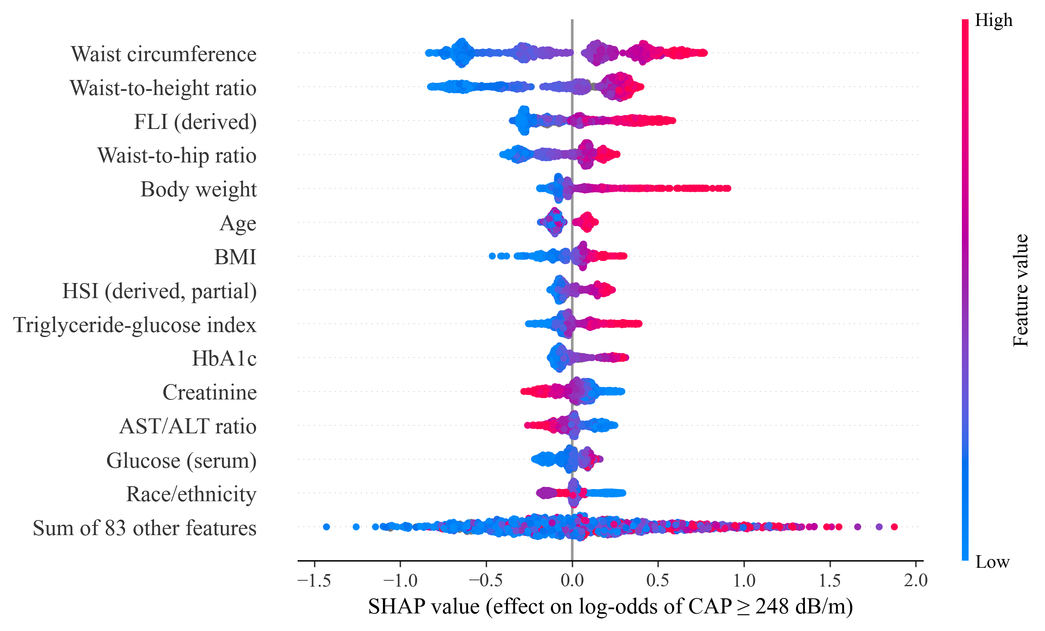
Figure A.4. SHAP summary for the CAP ≥ 248 dB/m classifier on the in-scope test participants. Each point is one participant; colour shows the input value and position its effect on the log-odds of steatosis.
Importance was also computed separately for each age group of the whole test set and expressed as each input’s share of the group’s total mean absolute SHAP value. The 60+ group, outside the scope, is shown for comparison.
Table A.20. Share of SHAP importance (%) by age group, held-out test set (CAP ≥ 248 dB/m classifier).
Input or group | All | 12–17 | 18–39 | 40–59 | 60+ (outside)
Waist circumference | 10.8 | 14.0 | 11.6 | 9.8 | 9.7
Waist-to-height ratio | 8.3 | 11.9 | 9.2 | 6.9 | 7.1
FLI (derived) | 6.5 | 6.3 | 6.4 | 6.8 | 6.4
HbA1c | 2.5 | 1.6 | 2.1 | 2.8 | 3.0
Triglyceride-glucose index | 2.3 | 1.8 | 2.2 | 2.7 | 2.4
Creatinine | 2.5 | 2.1 | 2.0 | 2.7 | 2.9
Body size (all measures, FLI, HSI) | – | 51.1 | 45.1 | 40.1 | 38.9
Blood sugar and insulin | – | 7.5 | 9.4 | 11.5 | 11.5
Lipids | – | 2.7 | 3.2 | 4.2 | 4.1
Test participants: 400 (12–17), 868 (18–39), 772 (40–59), 1,020 (60+). Full values: data/results/combined/figures/shap_importance_by_age.csv.
Waist circumference ranks first in every age group. Body size dominates in adolescents (51% of importance) and declines with age (39% at 60 and over), while blood-sugar and insulin markers rise from 7.5% to 11.5% after 40, consistent with the growing role of insulin resistance in adult steatosis. The higher weight on creatinine in older participants is consistent with muscle mass, which modifies the link between body size and liver fat. These patterns help explain the lower R² in older adults (E37–E38) and support limiting the scope to ages 12–59.

A.14 Comparison with Published Studies
Published models fall into two groups: models predicting a continuous liver-fat value (R²) and NHANES models classifying steatosis (AUC). No NHANES study reporting R² for CAP was found.
Table A.21. Continuous liver-fat prediction from routine data.
Study | Population | Outcome | Inputs | R²
UK Biobank preprint (insitro, 2024) | 40,533 UK adults | MRI-PDFF (log) | XGBoost, 37 body and blood measures | 0.37
UK Biobank preprint (insitro, 2024) | 9,723 UK adults | MRI-PDFF (log) | Plasma metabolomics | 0.34
UK Biobank preprint (insitro, 2024) | ~46,000 UK adults | MRI-PDFF (log) | DXA images (not routine) | 0.63–0.65
Asaturyan et al. (2022) | 28,796 UK Biobank adults | MRI-PDFF | Fatty Liver Index alone | 0.28–0.35
Asaturyan et al. (2022) | As above | MRI-PDFF | FLI+ (12 variables incl. liver diagnosis) | 0.56 (one fold)
Petäjä et al. (2016) | 378 Finnish adults | ¹H-MRS | Age, waist-to-hip, glucose, insulin, ALT, pIGFBP-1† | 0.44 / 0.49 (adj.)‡
Liu H. et al. (2022) | 272, obesity clinic, China | CAP | BMI, neck circumference, TG, C-peptide | 0.63–0.65‡
Chen et al. (2023), Shanghai Steatosis Index | 149 with overweight or obesity, China | MRI-PDFF | ALT, AST, fasting insulin, 1-h glucose | ρ 0.74§
Kotronen et al. (2009) | 470 Finnish adults | ¹H-MRS | Metabolic syndrome, diabetes, insulin, AST, AST/ALT | Not reported¶
Haas et al. (2021) | UK Biobank | MRI | Clinical factors such as BMI | Not reliable¶
Fatty Liver Index in this cohort | 13,502 / 5,548 | CAP | FLI (linear fit) | 0.44 / 0.50*
This study | 15,300 NHANES | CAP | 81 routine inputs | 0.56 test; 0.59 CV*
*Model scope (ages 12–59, reliable reference); all ages and examinations: 0.50. †Includes a specialist marker (phosphorylated IGFBP-1). ‡Discovery / validation for Petäjä et al.; validation for Liu et al. (0.70–0.76 in the derivation sample). The Chinese CAP study is small and selected (median CAP 320–335 dB/m against 251 in NHANES), which widens the outcome range and raises R². §Spearman correlation between predicted and measured liver fat, without a validation cohort. ¶Kotronen et al. report AUC 0.86–0.87 but no R² for their liver fat equation; Haas et al. state that liver fat could not be reliably estimated from clinical factors such as BMI.
Table A.22. Agreement of CAP with reference measures, and heritability of liver fat.
Measure | Value | Study
CAP against MRI-PDFF, adults with NAFLD (n = 65) | r = 0.66 | Ahn et al. (2018)
CAP, agreement between two operators | Concordance 0.82 | Ferraioli (2021), review
Heritability of hepatic steatosis (60 twin pairs, MRI-PDFF) | 0.52 (0.31–0.73) | Loomba et al. (2015)

Table A.23. NHANES steatosis classification models.
Study | Population | Outcome | Reported | This study
Du et al. (2026) | 6,814 adults, 2017–2020 | MASLD, CAP ≥ 280 | AUC 0.815–0.842 | AUC 0.879 (0.868)
Liu L. et al. (2024) | 4,177, fasting subsample | CAP ≥ 302 | AUC 0.859; FLI 0.838 | AUC 0.888 (0.872)
Zhang et al. (2025) | 2,460 complete cases | CAP ≥ 302 | AUC 0.874 (0.842–0.906) | AUC 0.888 (0.872)
Boullion et al. (2025) | 3,857 complete cases | CAP ≥ 238 | Accuracy 79.6% | AUC 0.881 (0.857), CAP ≥ 248
Zhu et al. (2026) | Asian, BMI < 28, complete cases | CAP ≥ 248 | AUC 0.892 | AUC 0.799 test; 0.823 CV†
This study: AUC within the scope, with all 3,060 test participants in brackets. The published studies cover adults of all ages, so the bracketed values are the closer comparison. †All ages.
Within its scope, the selected model’s held-out R² (0.56; 0.59 in cross-validation) is comparable to or above published routine-data models of liver fat (0.34–0.56, including 0.37 in UK Biobank and 0.49 in validation for a spectroscopy equation that needs a specialist marker). Across all ages its R² of 0.50 still exceeds the UK Biobank routine-data model. The studies differ in reference measure and population, so the values are indicative rather than directly comparable. Higher values come only from a small selected sample (0.65) or imaging inputs (0.63–0.65). No NHANES study reports R² for CAP, so this is the first such benchmark. In classification the selected model matches or exceeds every NHANES model, except Zhu et al. (2026) in lean Asian participants (Section A.8).

References
• Ahn SB, Jun DW, Kang BK, et al. Optimal cutoff value for assessing changes in intrahepatic fat amount by using the controlled attenuation parameter in a longitudinal setting. Medicine (Baltimore). 2018;97(50):e13636.
• Asaturyan HA, Basty N, Thanaj M, et al. Improving the accuracy of fatty liver index to reflect liver fat content with predictive regression modelling. PLoS One. 2022;17(9):e0273171.
• Boullion J, Husein A, Agrawal A, et al. Machine learning–based biomarker identification for early diagnosis of MASLD. J Clin Endocrinol Metab. 2025;110(11):e3866–e3877.
• Chen J, Yue J, Fu J, et al. A prediction model of liver fat fraction and presence of non-alcoholic fatty liver disease (NAFLD) among patients with overweight or obesity. Endocr J. 2023;70:977–985.
• Du S, Yu H, Du J, Xu Y. Machine learning models to predict MASLD with simple anthropometric and biochemical variables: a cross-sectional study in US population. Int J Hepatol. 2026;2026:8221645.
• Ferraioli G. Quantitative assessment of liver steatosis using ultrasound controlled attenuation parameter (Echosens). J Med Ultrason. 2021;48:489–495.
• Haas ME, Pirruccello JP, Friedman SN, et al. Machine learning enables new insights into genetic contributions to liver fat accumulation. Cell Genom. 2021;1(3):100066.
• Kotronen A, Peltonen M, Hakkarainen A, et al. Prediction of non-alcoholic fatty liver disease and liver fat using metabolic and genetic factors. Gastroenterology. 2009;137:865–872.
• Liu H, Li X, Han X, et al. Simple surrogate equations to predict controlled attenuation parameter values for screening NAFLD in a Chinese population. Front Med. 2022;9:894895.
• Liu L, Lin J, Liu L, et al. Automated machine learning models for NAFLD assessed by controlled attenuation parameter from the NHANES 2017–2020. Digit Health. 2024;10:20552076241272535.
• Loomba R, Schork N, Chen CH, et al. Heritability of hepatic fibrosis and steatosis based on a prospective twin study. Gastroenterology. 2015;149(7):1784–1793.
• Machine learning across multiple imaging and biomarker modalities in the UK Biobank improves genetic discovery for liver fat accumulation. medRxiv. 2024. doi:10.1101/2024.01.06.24300923.
• Petäjä EM, Zhou Y, Havana M, et al. Phosphorylated IGFBP-1 as a non-invasive predictor of liver fat in NAFLD. Sci Rep. 2016;6:24740.
• Rinella ME, Lazarus JV, Ratziu V, et al. A multisociety Delphi consensus statement on new fatty liver disease nomenclature. Hepatology. 2023;78:1966–1986.
• Zhang Y, Liu X, Zhang X, Fei Y, Li X. Machine learning-based prediction of MASLD using NHANES data. PLoS One. 2025;20(11):e0335656.
• Zhu Y, Wang Y, Zhang S, et al. Hepatic steatosis severity prediction in nonobese individuals: machine learning model development and validation. J Med Internet Res. 2026;28:e82529.

A.15 Limitations
• All validation is internal to NHANES. The temporal validation (V5) uses later participants from the same survey programme, not an external population. The P1 test set was reused during development, and every reported figure carries some selection optimism.
• Survey weights were applied in evaluation (V2) but not in training, and survey strata and clustering were not used for variance estimation.
• CAP is an imperfect measure of liver fat and is truncated at 400 dB/m. No biopsy reference is available in NHANES; results were therefore checked at three cut-offs (V4).
• The steatosis cut-offs (248, 280 and 302 dB/m) follow published CAP thresholds but have not been verified against histology in this cohort.
• The data are cross-sectional; the model describes current state and cannot predict response to dietary change.
• Single-split test R² varies by about ±0.03 with test membership (E5), so differences below 0.01 between models are within noise.
• The final tree settings were chosen using the held-out test set (Section A.9), so test R² is slightly optimistic; repeated cross-validation, which did not inform the choice, gives consistent results.
• The model is not validated for patients aged 60 or over, who are outside its scope (test R² 0.42 in that group). In-scope results are measured against reliable reference examinations; including unreliable ones, R² for ages 12–59 is 0.515.
• In lean non-Hispanic Asian participants the model is less discriminating than one trained on a large Asian cohort (Zhu et al., 2026); a population-specific model is future work.

