Error. Storages

**DEADLINE:** 24/06/2022, 18:00

## FOLDER STRUCTURE

|  |  |
| --- | --- |
| COE1_HW6/ *  ├─ task  ├─ homework/ *  ├─ index.html *  ├─ page_1.html *  ├─ page_2.html *  ├─ page_3.html *  ├─ css/ *  ├─ main.css *  ├─ js/ *  ├─ index.js * | *  - required |

TASKS

**Task.**

* You need to implement two functions in *index.js* – visitLink and viewResults.
* visitLink function should save to localStorage how many times each link was clicked (visited).
* viewResults should display a list how many times each link was visited (see example below) and afterwards clear the storage

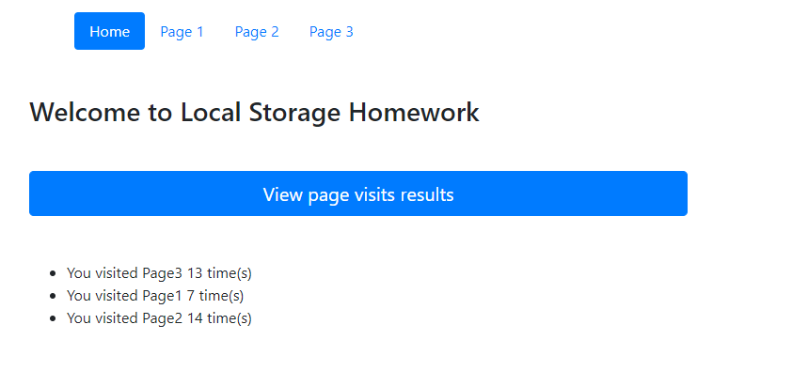

RESTRICTIONS

* Editing index.html is forbidden.
* Adding **task/** folder is forbidden. Do not push it to repository. (Only **homework/** should be pushed)

## BEFORE SUBMIT

* Code should be clean, without comments, readable, and tested
* Make sure your GitLab folder structure meets folder structure from this document (without **task** folder)

## SUBMIT

* The **COE1_HW6** folder without **task** folder should be uploaded to GitLab repository “**COE-1**” into **main** branch.

## USEFUL LINKS

* <https://developer.mozilla.org/ru/docs/Web/API/Storage>