1. Tables/Data files downloaded from the url ([Metro Transit](https://svc.metrotransit.org/)):

<https://svc.metrotransit.org/mtgtfs/next/gtfs.zip>

1. Created a relationship map between these tables and prepared a flow of data across all the gtfs_sql_tables to build a data pipeline flow model. Please see below relationship model for gtfs tables

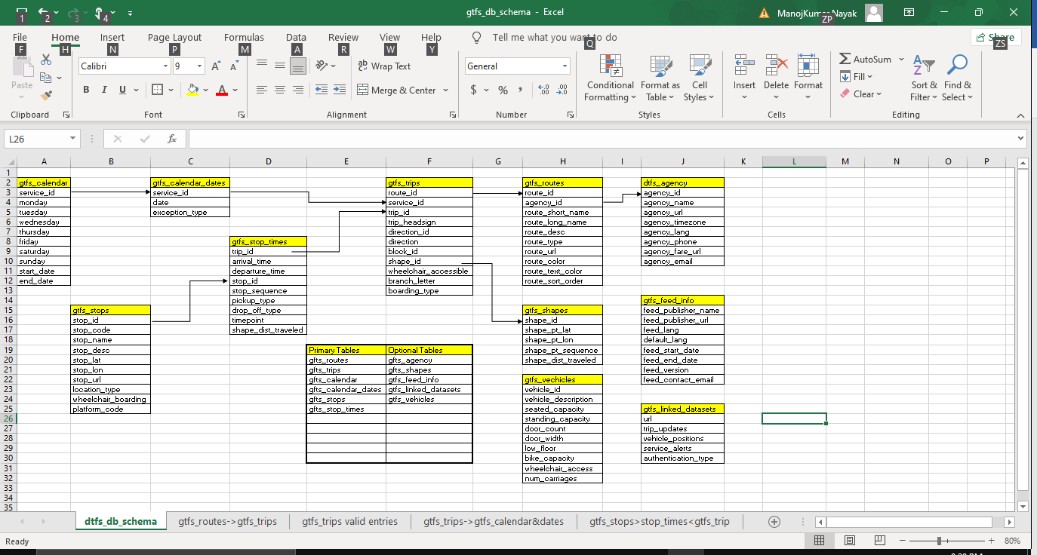

1. Build Relationship Model Using Input Date and Another Important Parameter CURRENT-DATE and CURRENT-TIME To fetch the details.