**Utilizing Machine Learning for Predicting Investment Trends in Startup Ventures**

# Brief Overview

## Overview

The startup ecosystem has witnessed unprecedented growth in recent years, with numerous innovative ventures emerging across various industries. However, this growth has also led to increased competition, making it challenging for investors to identify promising startups with high growth potential (Yang, et al., 2016). In this context, leveraging machine learning algorithms can be a game-changer in predicting investment trends in startup ventures. Machine learning, a subset of artificial intelligence, involves training algorithms to learn from data and make predictions or decisions without human intervention. In the context of startup investments, machine learning can be used to analyze vast amounts of data on startups, including their financial performance, market trends, customer behaviour, and competitive landscapes (Cui, et al., 2023). By identifying patterns and correlations in this data, machine learning models can predict the likelihood of a startup's success or failure, enabling investors to make informed decisions.

## Challenges

The underlying challenges are stated below:

* One of the primary challenges is the availability and quality of data on startups. Unlike established companies, startups often have limited financial data, making it difficult to train accurate machine learning models.
* The startup ecosystem is highly dynamic, with new ventures emerging and old ones failing rapidly, which can render machine-learning models obsolete quickly (Shi & Zhao, 2020).
* Machine learning models can be biased towards certain types of startups or industries, leading to inaccurate predictions. Addressing these challenges will require the development of novel data collection methods, data preprocessing techniques, and model validation strategies.

## Scopes

The scope of research in utilizing machine learning for predicting investment trends in startup ventures is vast and multidisciplinary. From a technical perspective, researchers can explore various machine learning algorithms, such as decision trees, random forests, and neural networks, to develop accurate predictive models (Bidgoli & Vanani, 2024).

## Problem Statement

The problem statement for this research is:

*"How can machine learning algorithms be leveraged to predict investment trends in startup ventures, given the limitations of data availability and quality, and the dynamic nature of the startup ecosystem?"*

Addressing this problem will require a systematic and interdisciplinary approach, involving the development of novel machine learning models, data collection and preprocessing techniques, and the analysis of various factors that influence startup success. By predicting investment trends accurately, machine learning can help investors identify promising startups, reduce risk, and increase returns on investment, ultimately contributing to the growth and development of the startup ecosystem.

## Purpose

The main purpose of the project is to leverage the power of Machine Learning algorithms in order to accurately predict and anticipate investment trends within the scenario of startup ventures (Arroyo, et al., 2019). By implementing advanced predictive models and analyzing vast amounts of data, the project aims to provide valuable insights and recommendations to investors and stakeholders interested in understanding and capitalizing on emerging opportunities in the dynamic and ever-evolving startup landscape.

# Project Particulars

## Research Questions

The research questions are as follows:

1. How the machine learning helpful and accurate in predicting the trends in the investment in startups vectured to gain higher profit?
2. Can the research gain any achievable and significant outcomes through artefact development superior to previous research?

## Project Aim

The project aims to employ a predictive approach by applying machine learning to predict future investment trends in startups to get more profit.

## Objectives of Project

The objectives of the project are stated below:

1. Obtain information on the investment trend prediction techniques and methods for existing research and identify the gaps
2. Collecting the required dataset containing historical records of investments in several startups and analysing the features using data analytics techniques through data noise reduction, feature selection etc.
3. Select the models by taking ideas from previous research and prepare those by tuning the hyperparameters and applying those to predict investment trends. Determining the performance of the models using regression metrics (such as R2 score, MSE, MAPE, model overfit etc) and choosing the optimum model with the highest R2 score and lower error and overfit.
4. To recommend the startups concerning investments with higher profit by taking input from users.

# Project Components

## Data Management

### Data Overview

The dataset for the research will be collected from Kaggle which has been owned by ***Ankush Panday*** (DOI: ***10.34740/kaggle/dsv/10582759***) and reposited in Kaggle in January 2025 (Panday, 2025).

### Metadata

The information on the data is given below:

1. Size of the Datasets: 3.31 MB
2. Expected Code Size: 5 MB
3. Code Format: IPYNB (Notebook file through Jupyter Notebook IDE)
4. Total Records: 12428
5. Total Features: 32
6. Feature Type: Mixed (Categorical: 20, DateTime: 1, Numerical: 11)
7. Data Format: CSV
8. Kaggle Link: https://www.kaggle.com/datasets/ankushpanday1/investment-trends-in-indian-startups-20002023

## Document Management

### Document Control

To facilitate efficient project management, GitHub will be regularly utilized as a repository to securely store both the latest code updates and the essential data necessary for the successful implementation of the project. The Github address is : <GitHub Address>

### Security and Storage

### The codebase will regularly undergo two bi-monthly updates via Github. All relevant information will be securely stored within the same repository, benefiting from GitHub's robust security management protocols.

### Data Ethics

The dataset will be selected from Kaggle, a widely known public repository for datasets that can be freely accessed without the need for registration or any form of permission. Given the data's availability without restrictions, ethical concerns regarding its utilization are unlikely to arise.

## Tool Chosen

Python has been chosen as the primary tool for preparing the artefact that will be used to predict investment trends. The coding process will involve writing and executing code within the Jupyter Notebook. The decision to use Python was driven by various factors including the abundance of libraries available for NLP and Machine Learning, strong community support, and the ease of coding which collectively contribute to its widespread popularity among data scientists and analysts.

# Project Planning

### Gantt Chart

The approximate plan for the project is stated below using a Gantt chart:

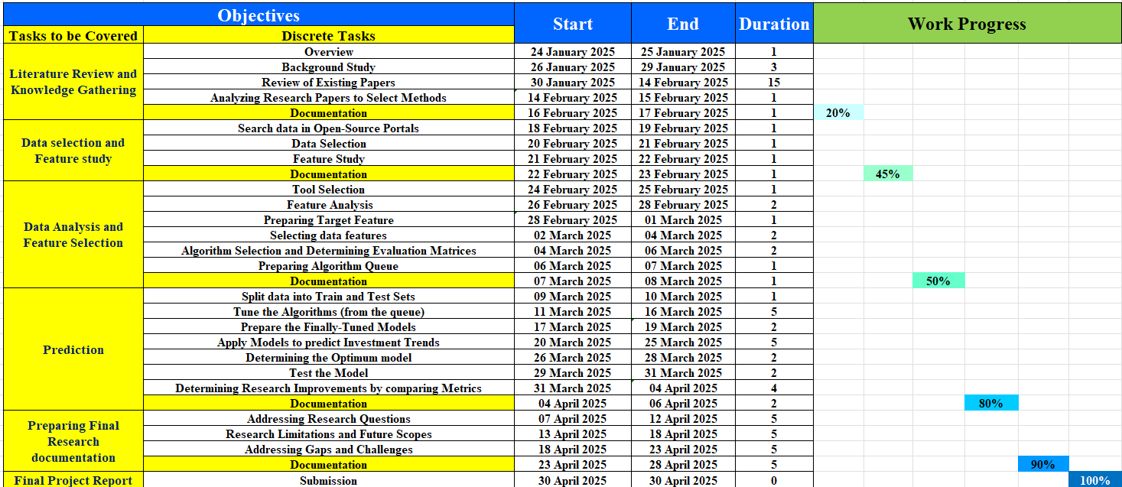

### Explanation

1. During the initial phase of the research, the introductory study on data analytics and investment trend prediction will highly prioritize the preparation of the aim, research questions, problem statement, and objectives.
2. In order to gather insights on the practical application of machine learning in data analytics and investment trend prediction, a review of previous research papers will be conducted.
3. As the research progresses, the subsequent phase will be dedicated to developing a robust research methodology. This will entail making critical decisions regarding the selection of the dataset, tools, algorithms, and evaluation methods that best suit the objectives of the research.
4. Following the establishment of the research methodology, the coding process will commence. This step involves implementing the chosen research methodology using the selected tools, with a specific focus on utilizing the targeted data for analysis and model development.
5. Once the coding stage is completed, the focus will shift towards presenting the results derived from the artefact. These results will be based on the outcomes obtained from analyzing the investment trend prediction through the developed code.
6. To ensure the effectiveness of the research findings, a thorough comparison of the performances of the chosen algorithms will be carried out. This comparative analysis aims to identify the optimum model that exhibits a higher R2 score, lower error rate and overfitting when predicting investment trends accurately.

# References

Arroyo, J., Corea, F., Jimenez-Diaz, G. & Recio-Garcia, J. A., 2019. Assessment of Machine Learning Performance for Decision Support in Venture Capital Investments. IEEE Access, pp. 124233 - 124243.

Bidgoli, M. R. & Vanani, I. R., 2024. Predicting the success of startups using a machine learning approach. Journal of Innovation and Entrepreneurship, pp. 1-5.

Cui, Y., Wu, Y. & Lou, X., 2023. Application of Gradient Boosting Algorithm in Investment Trends Forecast. 7th International Conference on Trends in Electronics and Informatics (ICOEI), pp. 1-5.

Panday, A., 2025. Investment Trends in Indian Startups (2000–2023). [Online]

Available at: https://www.kaggle.com/datasets/ankushpanday1/investment-trends-in-indian-startups-20002023

Shi, M. & Zhao, Q., 2020. Stock Market Trend Prediction and Investment Strategy by Deep Neural Networks. 11th International Conference on Awareness Science and Technology (iCAST), pp. 1-6.

Yang, J., Rao, R., Hong, P. & Ding, P., 2016. Ensemble Model for Stock Price Movement Trend Prediction on Different Investing Periods. 12th International Conference on Computational Intelligence and Security (CIS), pp. 1-7.