PART 1

Agentic Cruise Planning Assistant
  - System Architecture and Technical Design
Principal Engineer (Full-Stack) take-home technical pack
SCOPE LOCKED - implementation-ready. New functionality must replace, not expand, the approved scope.
Prepared for interview presentation and technical deep-dive

1. Executive Summary
This is not a chatbot that happens to search cruises. It is a governed commerce orchestration layer in which the model interprets intent while trusted enterprise systems remain authoritative for pricing, inventory, authorization, booking and payment.
- Selected scenario: Option 5 - guest-facing Agentic Cruise Planning Assistant embedded in the booking experience.
- Implementation posture: the presentation describes the production architecture; the runnable demo proves a critical vertical slice with one hero path and one failure path.
- Core boundary: the LLM performs language interpretation and grounded explanation; deterministic services own all commerce-sensitive state.
- RCG environment alignment: React/AEM coexistence, Next.js, GraphQL, AWS, Redis, MongoDB and SOX-regulated high-transaction controls.
- Risk posture: AEM remains headful, payment remains in existing checkout, no raw PII is sent to the model, and model outage degrades to a guided deterministic search.
In scope | Explicitly out of scope
- Next.js streaming assistant and accessible structured cards  - Typed tool adapters for search, availability, pricing, policy, hold and booking handoff  - MongoDB-backed durable holds with Redis acceleration  - Grounding, prompt-injection defense, evaluation and observability  - Employee alpha to limited feature-flagged guest beta | - Autonomous payment or end-to-end conversational checkout  - Live AEM implementation or unverified Content Fragment APIs  - Voice, multilingual support or multiple product agents  - Large vector database, Kubernetes or broad analytics dashboard  - More than one complete guest journey

2. Assumptions, Scope Lock and Design Principles
Area | Assumption / decision | Why it is defensible
AEM | AEM marketing pages remain headful. Approved content is exposed through an implementation-neutral adapter. | Matches the stated environment without assuming an existing headless GraphQL setup.
Commerce APIs | Production uses authorized GraphQL/service APIs. The prototype uses Mongo-backed services as stand-ins. | Keeps the agent integrated with the platform and prevents direct database access.
Inventory | The inventory service and MongoDB are authoritative. Redis is cache/session/coordination/expiry signal only. | Correctness cannot rely on an evictable cache.
Payment | The assistant creates a short-lived hold and signed checkout context only after explicit confirmation. | Preserves PCI/SOX controls in the existing checkout.
Model | All model calls use an enterprise gateway and provider-neutral abstraction. | Supports DLP, routing, auditability, budgets and fallback.
Fallback | UI chips and a deterministic parser capture criteria before the model call. | The failure path remains usable when the model is unavailable.
- Design for ambiguity: state assumptions and make trust boundaries explicit.
- Use probabilistic components for language; use deterministic components for state and money.
- Stream progress and partial results, but never stream unverified price or inventory.
- Make failure a first-class user journey, not an exception screen.
- Prefer simple, typed, testable services over a large multi-agent graph for this implementation.

3. Requirement Traceability to the Candidate Brief
Brief requirement | Design response | Evidence
Streaming responses and partial results | SSE from Next.js BFF; status steps and verified cards emitted as each tool result completes. | P1-02, P1-03
Uncertainty states and accessibility | Explicit unavailable/stale/needs-detail states; keyboard, focus, aria-live, reduced motion. | P1-02
Booking handoff | Signed BookingContext deep link into the existing checkout; no payment authority. | P1-01, P1-03
Orchestration and retrieval | Node agent loop, model gateway, content adapter and approved policy RAG. | P1-01, P1-03
Live API tool calls and structured outputs | Typed GraphQL/service adapters and ToolResult envelopes. | P1-01, API contracts
LLM vs deterministic logic | Explicit decision boundary and current-turn provenance rule. | P1-04
Guardrails and prompt injection | Untrusted retrieval context, schema validation, server-side authz and red team. | P1-07
Grounding | Structured cards plus commerce-claim validator tied to ToolResults. | P1-04, P1-07
Evaluation, latency, cost and observability | Golden set, judge, red team, routing, caps, traces and cost telemetry. | P1-07
Safe fallback | Model-independent criteria capture and prefilled faceted search. | P1-06
PII, authorization and rollout | PII redaction, scoped auth context, offline prototype, alpha, shadow and beta. | Security and rollout sections

4. Production Deployment and System Context
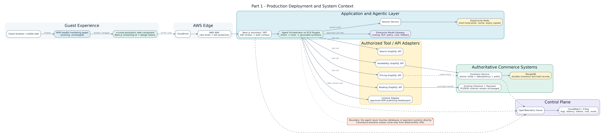
Figure P1-01. Production context in the stated AWS, GraphQL, Redis, MongoDB, React and AEM environment.
- The agent accesses commerce only through authorized adapters; it never touches databases or payment systems directly.
- AEM stays headful. The assistant is embedded as a web component and consumes approved content through a content adapter.
- Redis stores short-lived preferences, caches and expiry signals; MongoDB-backed services preserve durable correctness.
- OpenTelemetry provides a single trace across UI, orchestration, tools, model gateway and inventory service.

5. Frontend Composition and AEM Coexistence
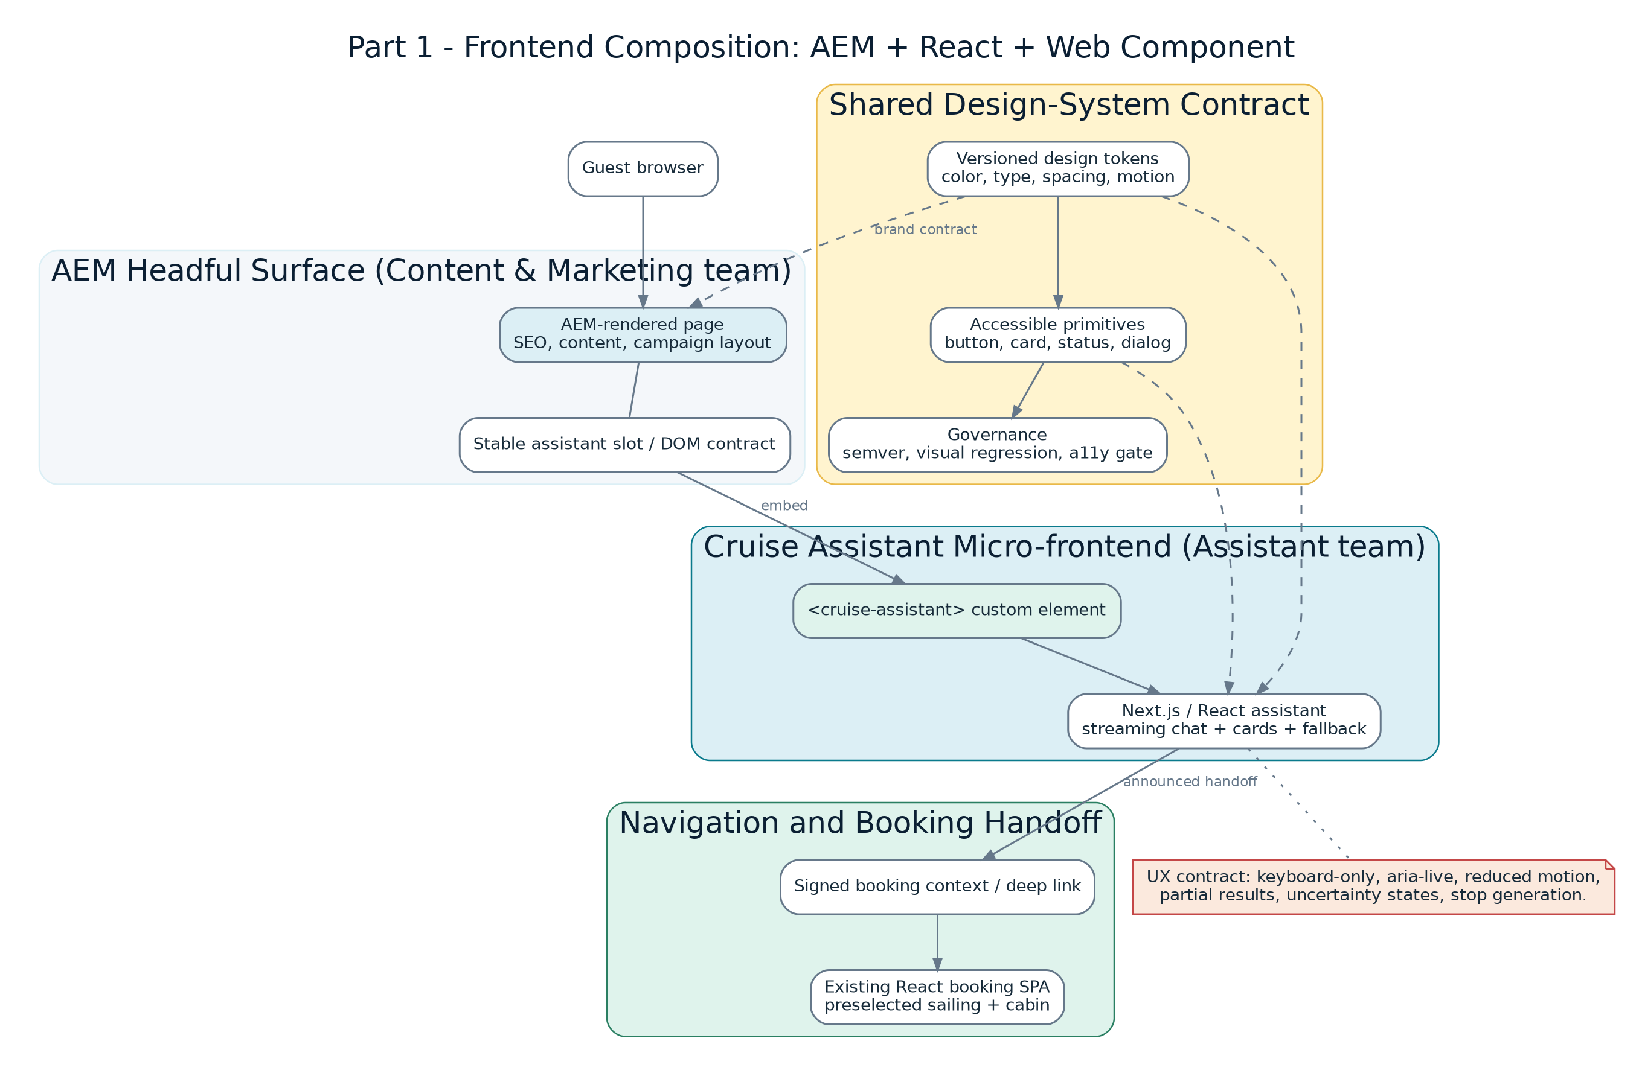
Figure P1-02. Independent ownership with a shared design-system contract.
- Content & Marketing owns AEM page composition and the stable assistant slot.
- The Assistant team owns the custom element, React runtime, streaming states and booking handoff.
- Versioned tokens and accessible primitives create visual consistency without coupling release trains.
- The assistant can be embedded on AEM pages or reused in a React surface without duplicating the feature.

6. Hero Scenario - End-to-End Request Flow
Figure P1-03. The successful family-of-four cruise search, policy question, hold and booking handoff.
- Structured criteria exist before the model call and are progressively confirmed by the guest.
- Search, availability and pricing are separate deterministic calls so partial cards can appear as they are verified.
- A hold always revalidates price and inventory. A displayed quote alone is not a reservation.
- Payment executes only in the existing checkout after the controlled handoff.

7. LLM vs Deterministic Decision Boundary
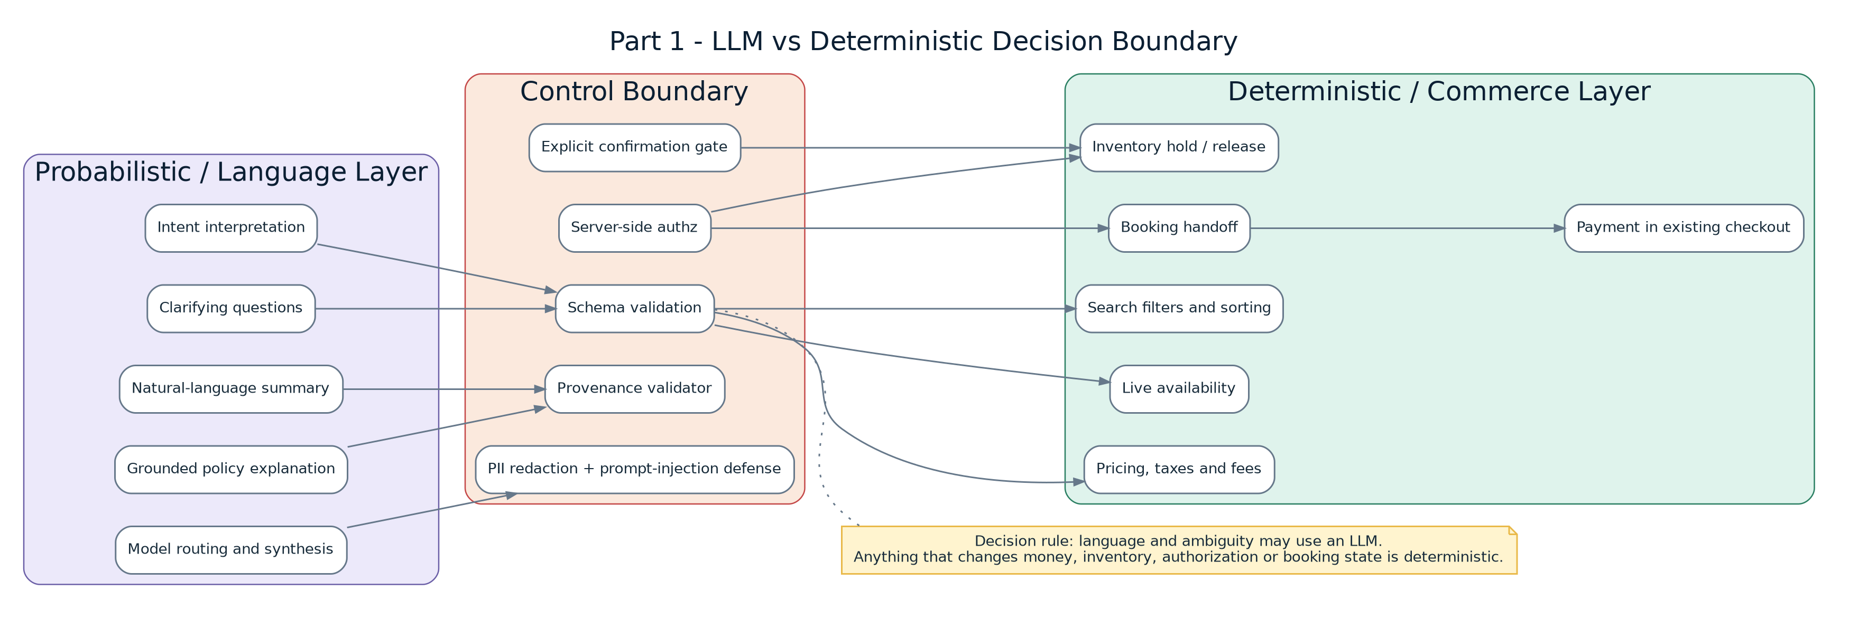
Figure P1-04. Language flexibility is separated from commerce authority.
- Use an LLM for intent, clarification, summarization and grounded explanation.
- Use deterministic logic for filters, availability, pricing, taxes, holds, authorization, booking state and payment.
- The control boundary validates schemas, authorization, explicit confirmation, PII handling and provenance.
- The rule is based on risk and state mutation, not on whether a task appears easy for a model.

8. Inventory Hold, Idempotency and Reconciliation
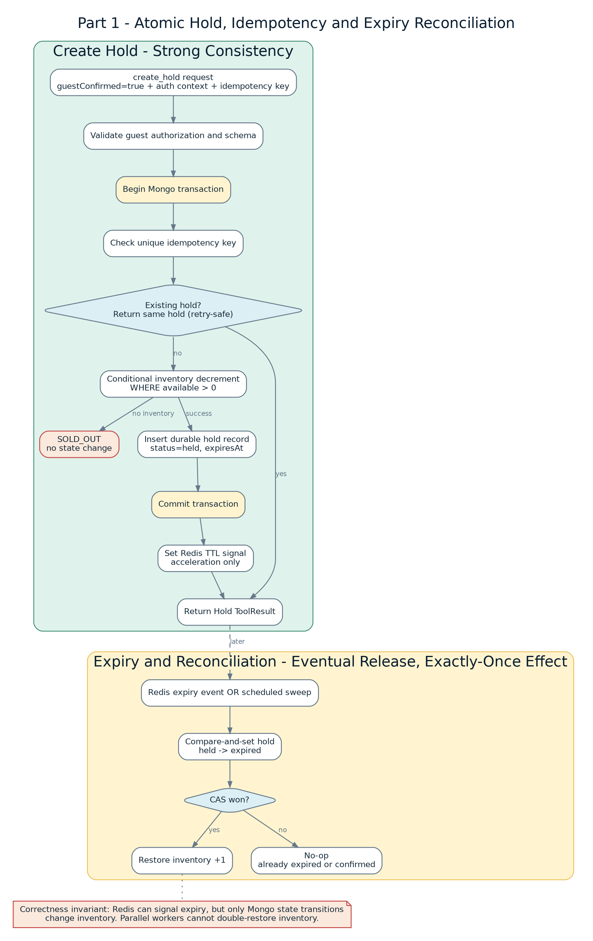
Figure P1-05. Strong-consistency hold path and exactly-once inventory restoration effect.
- A single Mongo transaction checks the idempotency key, conditionally decrements inventory and inserts the durable hold.
- Concurrent requests for the final cabin yield exactly one success; the rest receive SOLD_OUT.
- Redis accelerates expiry notification but never owns the hold.
- Compare-and-set held-to-expired ensures parallel workers cannot restore inventory twice.

9. Model-Independent Fallback
Figure P1-06. The assistant degrades to guided deterministic search while preserving progress.
- The UI and parser capture the latest confirmed criteria before the model is invoked.
- Timeouts, model errors, policy blocks or circuit-breaker events switch to a prefilled faceted form.
- The fallback uses the same authoritative search, availability and pricing APIs as the conversational path.
- No guest criteria or verified result must be reconstructed from model memory.

10. Safety, Grounding, Evaluation and Operations
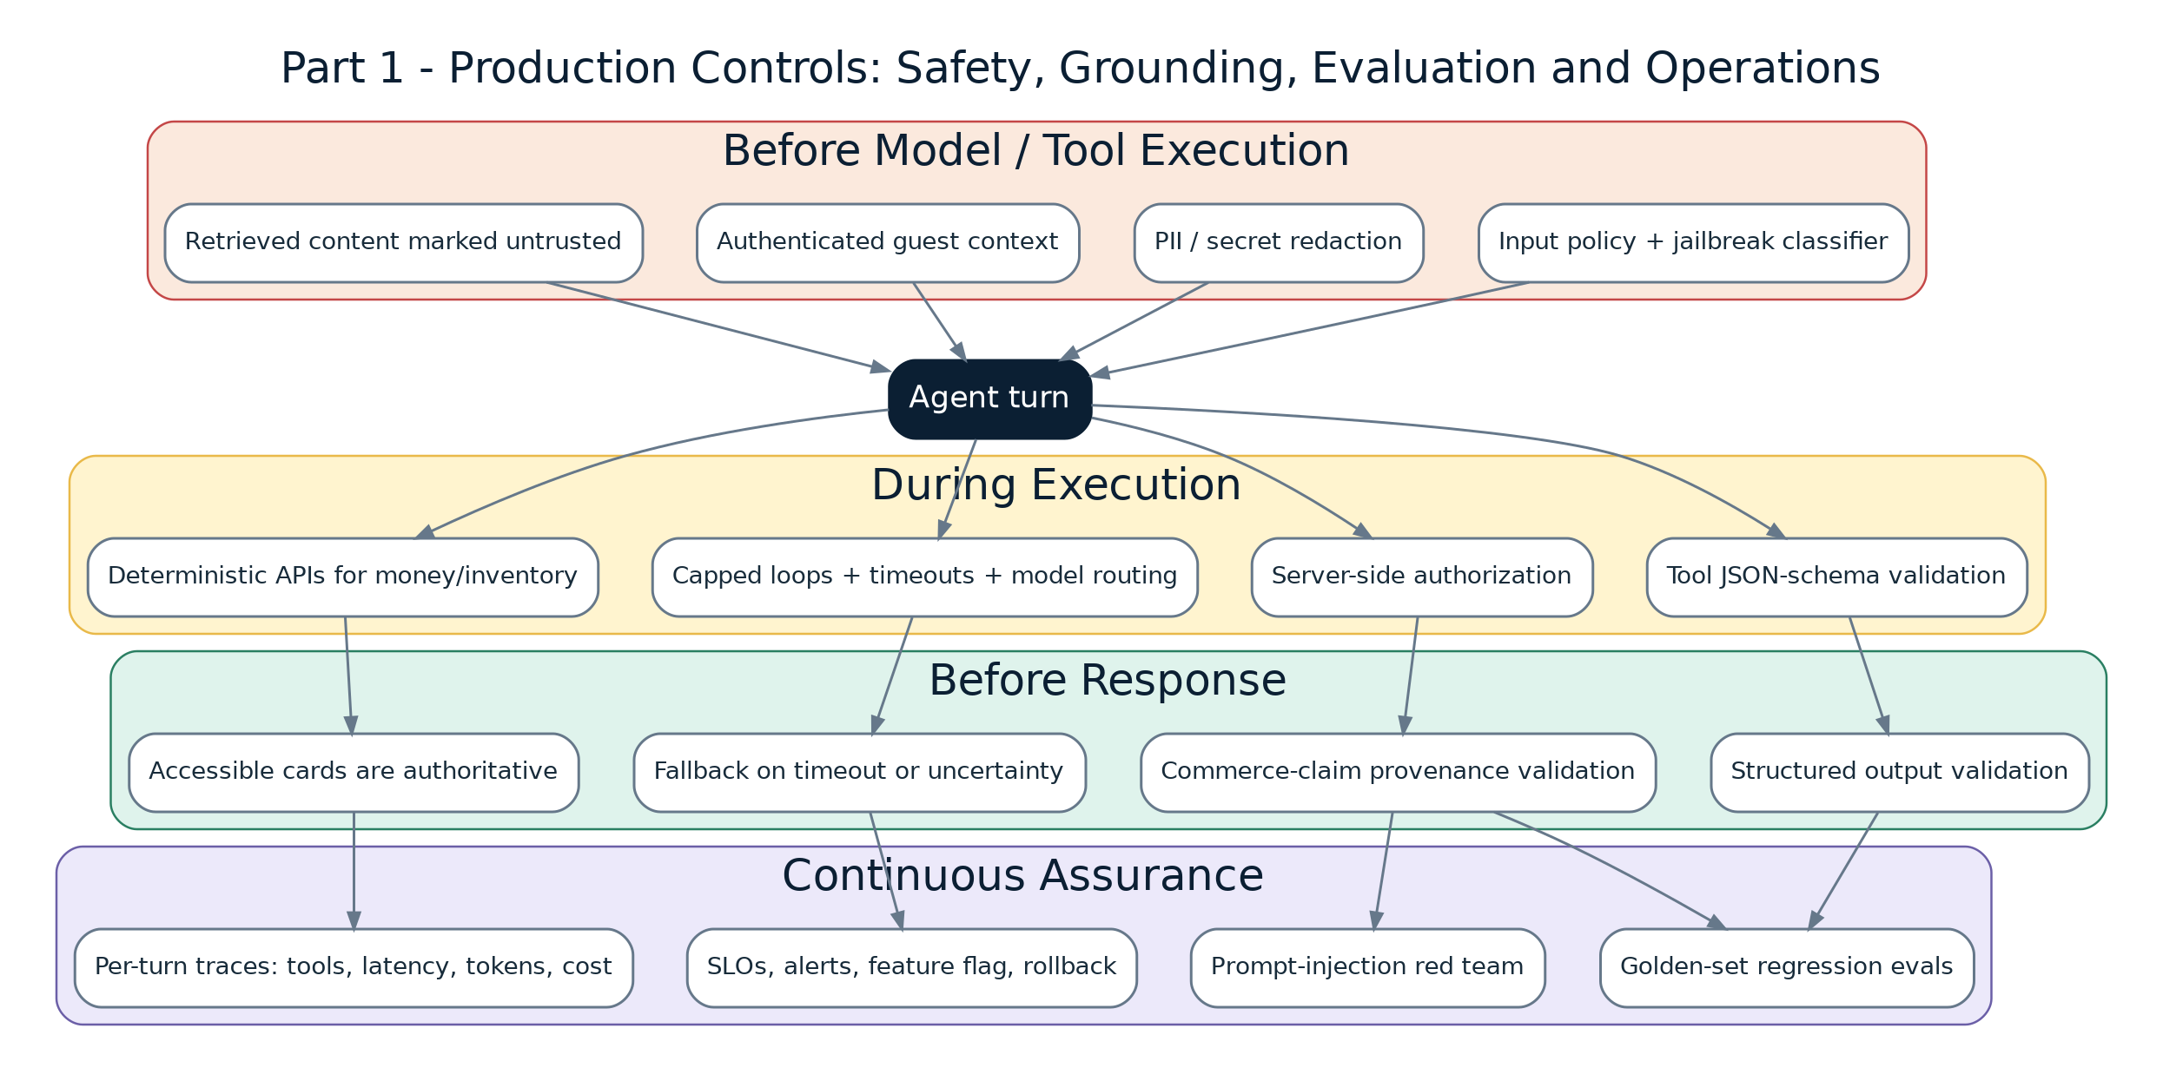
Figure P1-07. Layered production controls before, during and after each agent turn.
- Retrieved content is data, never instructions; tool calls are typed and authorization is enforced server-side.
- A post-turn validator removes any commerce-sensitive claim that is not backed by a current-turn deterministic result.
- Golden-set evaluation and red-team scenarios act as regression gates in CI.
- Feature flags, SLOs, circuit breakers, traces and rollback keep the standard booking flow available.

11. Component Responsibilities and Runtime Contracts
Component | Owns | Must not own
Next.js Assistant / BFF | Authentication context, SSE stream, UI event contract, accessibility states, booking navigation. | Inventory truth, payment, provider-specific model logic.
Agent Orchestrator | Intent workflow, tool selection, grounded synthesis, uncertainty and fallback signal. | Direct DB access, credentials, unrestricted tool execution.
Enterprise Model Gateway | Model routing, DLP, policy, version pinning, quotas, token/cost telemetry. | Commerce state or guest authorization decisions.
Tool/API adapters | Schema conversion, service calls, auth propagation, deterministic ToolResult envelopes. | Free-form model-generated arguments without validation.
Content Adapter | Approved descriptive/policy content retrieval and citations. | Live price, availability, discount or booking state.
Inventory Service | Availability, atomic holds, idempotency, expiry, reconciliation and ownership checks. | Language interpretation or payment processing.
Existing Checkout | Guest details, payment, confirmation and established PCI/SOX controls. | Model orchestration.
Redis | Short-lived preferences, cache, coordination and expiry signals. | Durable hold or final inventory authority.
Interface principle: every boundary is typed, observable and independently testable. The model receives only the minimum approved tool surface.

12. Tool, API and Streaming Contracts
search_sailings(criteria) -> ToolResult<Sailing[]>
check_availability(sailingId, cabinType) -> ToolResult<CabinAvailability>
get_pricing(sailingId, cabinType, occupancy) -> ToolResult<PriceQuote>
get_policy_content(topic, query) -> ToolResult<PolicyPassage[]>
create_hold(sailingId, cabinId, guestAuthCtx, idempotencyKey, guestConfirmed) -> ToolResult<Hold>
start_booking(holdId, guestAuthCtx) -> ToolResult<BookingContext>
Contract rule | Enforcement
Schema validation | Zod/JSON Schema validates all model-callable arguments and returned envelopes.
Explicit confirmation | create_hold requires a UI-generated guestConfirmed=true token.
Authorization | The service validates authenticated guest ownership; the LLM never receives credentials.
Freshness | Availability returns asOf. Price returns quoteId, asOf and validUntil. Hold creation revalidates both.
Provenance | Cards render ToolResult values. Commerce-sensitive prose must match a result from the current turn.
Idempotency | All state-changing requests carry a durable idempotency key.
SSE | token, status, card, handoff, fallback and error are the only public event types.
type AssistantEvent =
| { type: 'status'; step: string }
| { type: 'token'; text: string }
| { type: 'card'; cardType: 'sailing'|'cabin'|'price'; result: ToolResult<unknown> }
| { type: 'handoff'; bookingContext: BookingContext }
| { type: 'fallback'; criteria: SearchCriteria; reason: string }
| { type: 'error'; code: string; recoverable: boolean };

13. Data Model and Consistency Invariants
Entity | Key fields | Lifecycle / consistency
Sailing | id, shipName, destination, departureDate, nights, ports | Descriptive catalog; eventually refreshed.
Inventory | sailingId, cabinId/type, available, version | Authoritative; conditional decrement in transaction.
PriceQuote | quoteId, occupancy, total, breakdown, asOf, validUntil | Point-in-time; always revalidated at hold.
Hold | holdId, sailingId, cabinId, guestId, expiresAt, idempotencyKey, status | Durable state machine: held -> expired or confirmed.
BookingContext | bookingContextId, holdId, guest binding, signed deep link | Short-lived, idempotent handoff object.
SessionCriteria | session/guest key, confirmed preferences, expiry | Short-lived Redis state; no sensitive persistence.
begin transaction
if idempotency key exists:
return existing hold
conditionally decrement inventory where available > 0
insert durable hold(status='held', expiresAt=...)
commit
set Redis TTL signal
- Strong consistency is required for inventory decrement, hold creation, confirmation and ownership checks.
- Eventual consistency is acceptable for catalog indexing, approved content ingestion, telemetry aggregation and expiry notification.
- Only a successful compare-and-set held -> expired may restore inventory; confirmed holds are never reclaimed.

14. Security and Threat Model
Threat | Design control | Verification evidence
Prompt injection from policy/catalog content | Mark retrieval as untrusted, isolate it, reject embedded instructions and keep tools separately authorized. | Curated red-team set; no instruction-following or unauthorized calls.
Hallucinated commerce values | Deterministic APIs, typed cards and current-turn provenance validation. | Golden set requires zero invented price/date/availability/fee claims.
Unauthorized hold or booking | Authenticated guest context is enforced in service code and bound to hold/context. | Negative authz integration tests.
PII leakage | Field allow-lists, pre-model redaction, redacted traces and retention controls. | PII test fixtures and log inspection.
Oversell / duplicate action | Transaction, conditional update, unique idempotency key, retry-safe booking context. | Concurrency and replay tests.
Tampered booking link | Signed short-lived context bound to guest and active hold. | Signature and expiry tests.
Model outage / cost attack | Timeouts, circuit breaker, rate limits, quotas, model routing and fallback. | Chaos test and cost alarms.
Unsafe autonomy | Explicit confirmation; payment remains in existing checkout. | Tool schema rejects missing confirmation.
SOX/PCI boundary: the assistant does not perform payment, modify financial-reporting systems or bypass existing approval and audit controls.

15. Non-Functional Requirements and Initial SLOs
Category | Initial engineering target | Design response
Correctness | 0 oversells; 0 unauthorized calls; retry-safe holds and booking contexts. | Transactions, CAS, idempotency and server-side authz.
First response | First status/token <= 2.5 s p95. | Streaming, fast model tier and immediate deterministic criteria capture.
First verified card | <= 4 s p95 for hero scenario. | Parallelize availability/pricing with bounded concurrency; emit partial results.
Full hero response | <= 8 s p95. | Context limits, capped tool loop, caching and model routing.
Hold creation | <= 1.2 s p95. | Single authoritative transaction and indexed idempotency lookup.
Availability | Assistant 99.9%; deterministic fallback 99.95% initial target. | Circuit breaker and independent search path.
Accessibility | WCAG-aligned keyboard/focus/live-region behavior. | Component tests and manual screen-reader verification.
Cost | Per-session budget and alerting; capable model used only when required. | Gateway quotas, routing and trace dimensions.
- These values are pilot targets, not claims about current RCG baselines; calibrate them with measured production dependencies.
- Never trade inventory correctness, authorization or truthful sold-out behavior for lower latency.
- If live pricing is unavailable, show an explicit uncertainty state instead of a guessed value.

16. Evaluation and Test Strategy
Layer | Method | Key gates
Deterministic core | Strict TDD with Vitest and MongoMemoryReplSet. | No oversell; concurrency, idempotency, expiry, pricing, authz and provenance tests pass.
Agent behavior | Versioned golden JSONL plus judge-based faithfulness scoring. | Correct intent/tools; zero invented commerce values; approved-content faithfulness.
Security | Prompt-injection and unauthorized-tool red team. | 100% catch rate on the locked demo set; no tool execution outside guest scope.
UI | React Testing Library plus manual accessibility checks. | Keyboard, focus, aria-live, structured-card provenance.
Integration | Docker Compose with Mongo replica set and Redis. | Hero path and model-outage fallback path pass.
Operational | Feature flag, circuit breaker and rollback drill. | Standard booking remains available after assistant disablement.
- Deterministic tests are the specification for the correctness-critical core.
- Model prose is not unit-tested character-for-character; the system evaluates required behavior and safety properties.
- Every release pins model/prompt/tool versions so a failed evaluation can be traced and rolled back.

17. Deployment, Rollout and Operational Runbook
Phase | Guest exposure | Exit evidence
Offline prototype | None; synthetic data and mocked production adapters. | Vertical slice, eval baseline, threat model and fallback work.
Employee alpha | Authenticated internal users only. | Red team, load test, runbooks, dashboards and support process.
Shadow mode | No model output shown to guests. | Intent/tool decisions measured against real traffic without state mutation.
Limited guest beta | Small monitored cohort behind feature flag. | SLOs met, grounding threshold, zero unauthorized calls, rollback verified.
Scaled release | Only after evidence-based review. | Stable operations, acceptable cost, guest value and safety scorecards.
Incident | Immediate action | Preserved capability
Model gateway timeout | Trip circuit breaker; emit fallback event. | Guided search, availability and pricing.
Pricing dependency unavailable | Suppress price; show explicit uncertainty and retry/support option. | Sailing discovery and policy content.
Inventory inconsistency | Disable hold creation and run durable reconciliation. | Search and read-only results.
Retrieval injection regression | Disable affected source or RAG path. | Deterministic commerce flow.
Cost anomaly | Apply quota, lower model tier, reduce context and loop cap. | Bounded assistant or fallback.

18. Architecture Decisions and Trade-offs
Decision | Benefit | Trade-off / rejected alternative
Single orchestrator loop, not a multi-agent graph | Simple to build, observe and defend in two weeks. | Less specialized; multi-agent is a future scaling pattern.
Content adapter, not live AEM setup | Accurate boundary and reliable demo. | Does not prove a specific production AEM integration.
Mongo authority, Redis acceleration | Durable correctness and familiar RCG-aligned technologies. | Requires replica-set transaction support and reconciliation worker.
Web component micro-frontend | Embeddable in AEM or React with independent release ownership. | Requires careful bundle/version governance.
Existing checkout handoff | Preserves PCI/SOX and limits agent authority. | Not a fully conversational purchase.
Structured cards plus provenance validator | Trustworthy price and availability surface. | Adds schema and output-processing complexity.
Model-independent fallback | Real resilience and strong demo signal. | Requires a small deterministic parser and duplicate UI path.

19. Demo Script and Evidence Checklist
- Open the AEM-style host page and show the embedded assistant component.
- Enter: "7-night Caribbean cruise in March for a family of four, balcony cabin, under $X."
- Narrate the structured criteria chips and streamed status progression.
- Show verified sailing, availability and pricing cards with asOf/validUntil.
- Ask a policy question and show the approved-content citation.
- Select a sailing, explicitly confirm and create the short-lived hold.
- Show the booking context deep link and explain that payment remains in existing checkout.
- Disable the model key or trigger timeout; repeat the request and show the prefilled deterministic fallback.
- Show one prompt-injection test and the evaluation summary.
- Use a pre-recorded backup if the live environment becomes unstable.
Evidence artifact | Minimum proof
Architecture diagrams | Seven Part 1 diagrams supplied as PNG, SVG, DOT and Mermaid.
Automated tests | Inventory concurrency/idempotency, grounding, authz, fallback and e2e path.
Evaluation output | Golden-set grounding/faithfulness result and red-team result.
Observability | Single trace showing model call, tools, latency, tokens/cost and redaction.
Runbook | Feature flag disablement and fallback behavior.
Backup video | Full hero path plus model-outage failure path.

20. Technical Deep-Dive Defense Bank
Panel question | Concise defense
How do you prevent hallucinated prices? | Every commerce-sensitive claim must match a deterministic ToolResult from the current turn. Structured cards remain authoritative.
Why not put inventory holds in Redis? | Redis accelerates expiry and coordination, but durable Mongo-backed service state owns correctness. Eviction or cache loss cannot create an oversell.
What happens on retries? | A unique durable idempotency key returns the original hold or booking context without a second decrement or action.
How does fallback preserve intent when the model is down? | UI chips and a deterministic parser store the latest confirmed criteria before the model call.
How is prompt injection handled? | Retrieved text is isolated as untrusted data. It cannot grant tool authority; schemas and server-side authz remain independent.
What is strongly consistent? | Inventory decrement, hold creation, confirmation and ownership checks. Catalog/content refresh and telemetry can be eventual.
How is AEM integrated? | AEM remains headful. A content adapter consumes whichever approved publishing mechanism exists; the prototype uses a simulated export.
What do you sacrifice first under load? | Rich synthesis, extra recommendations and noncritical policy enrichment. Never inventory correctness, authorization or truthful sold-out behavior.
Why a web component? | It provides a stable ownership and embedding boundary across AEM and React while sharing design tokens and accessible primitives.
How did AI help build the solution? | Use AI to accelerate scaffolding, tests, diagrams and critique, while keeping human ownership of boundaries, security decisions and final evidence.
Final presentation posture: clearly distinguish demonstrated prototype behavior from proposed production integration and initial pilot targets.

