Flash Maps demonstrated in a BIRT report

Introduction

The report design demonstrates the visual features of Flash Maps supported in
Actuate BIRT 2.3. Features demonstrated include:

- Map drawing basics (comprehensive use of map attributes.)
- Basic markers for specific locations (circles, hexagons diamonds)
- Image markers. Use of GIF/PNG files for exotic markers.
- Animation. (Background painting, map rollout, state code rain drops)
- Connector lines between markers.
- Gradient shaded wallpaper.
- Style definition and style application.
- Movable legend
- Hyperlink drilldown to state maps. (Links work in designer tool.)

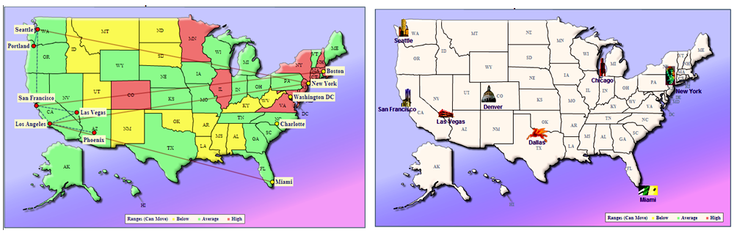

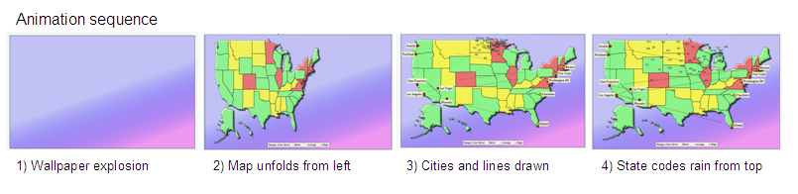
Hyperlinks show drill down maps.
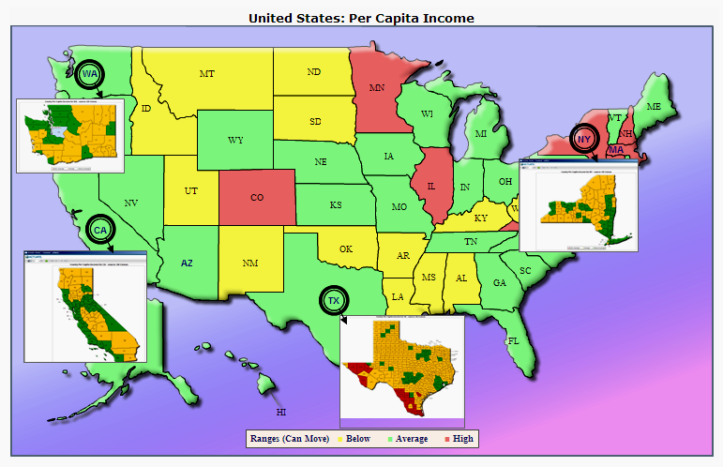
Key states have associated drilldown maps.
Clicking anywhere in the state displays the drill down map. (The hyperlinks are configured to work in the design tool for quick demonstration purposes.)

FlashMapsShowReport.rptdesign has a parameter page which enables features to be demonstrated separately. A suggested demonstration sequence is detailed later in this document.

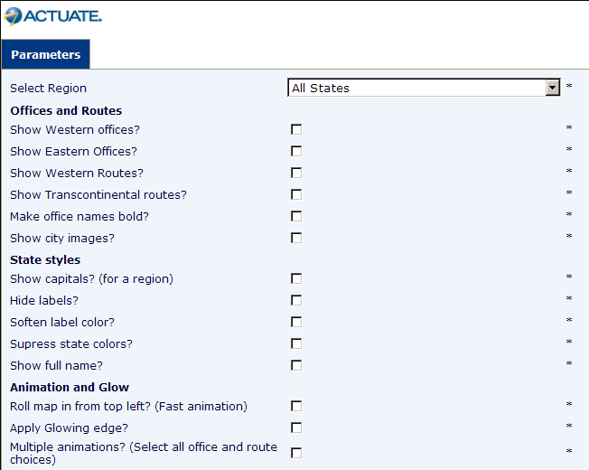

How to install the reports

The reports and their support files (data files, map attribute file and image files) are delivered as an exported BIRT project. The basic steps to install the report are:
- Open eclipse.
- Create a new empty report project (into which the files will be imported.)
- Import the project files.
- Alter the folder paths for each dataset (data files and map attribute file) to match the location of your machine’s workspace.
- Copy the image files to appropriate folder so they are accessible to the report viewer.

The project, after installation, should appear similar to the image below:

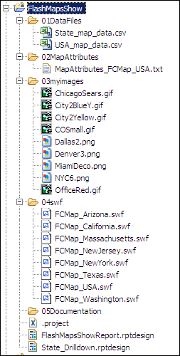

Import the project

- Copy the zip file, FlashMapsShow.zip to a temp directory. eg: C:/temp.
Unzip the zip file to C:/temp. The folder now looks as below:
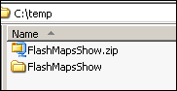
- Start Actuate BIRT 2.3.
- Click the Navigator and tab. Create a new report project.
File → New → Project. Select Report Project. Click Next.

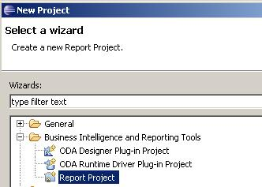

Enter the project name: FlashMapsShow. Click Finish.

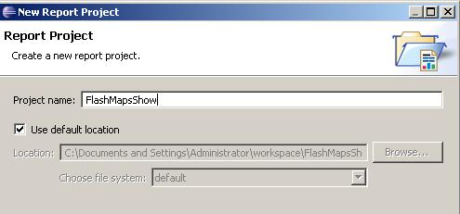

The project starts out empty, as shown below:
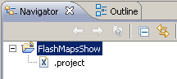
- In the Navigator list, select FlashMapsShow project. (Just created.)
- File → Import.
Select importing from the File System (see below) then click Next.

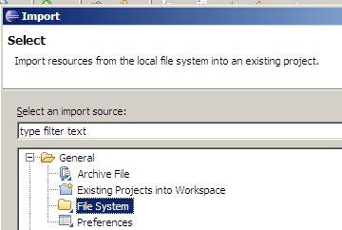
- Browse to C:/temp/FlashMapsShow. Select Import options as shown below.
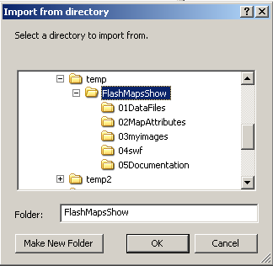
- Click OK. When the Import window appears, makes the selections shown.

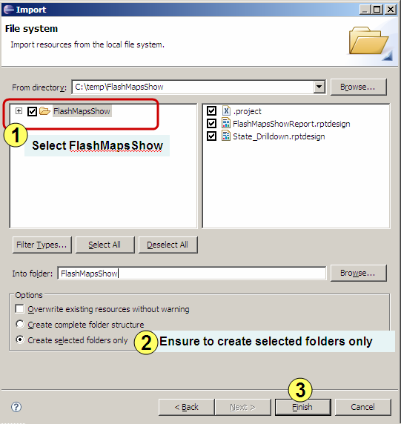

- You will get a warning message about overwriting the .project file.
Click Yes to All. (See below.)
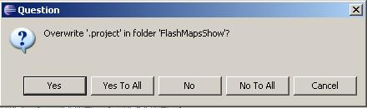

The project is now imported.
Alter the folder path for the map attributes file and data files

You will need to alter the path to the map attributes file and data files to match the location of your project folder. You will need to do this in both report designs:
- FlashMapsShowReport.rptdesign, and
- State_Drilldown.rptdesign
Open both report designs now.

The steps below show how to alter path for the map attributes file in FlashMapsShowReport.rptdesign. Repeat these steps for the data file. Also for the data file in State_Drilldown.rptdesign.

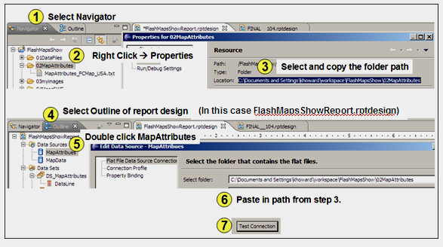

Step 1) Select Navigator tab to show the folder structure in your project.
Step 2) Right click the 02MapAttibutes folder and select Properties.
This displays the full path of the folder.
Step 3) Select and copy the full path.
Step 4) Switch to Outline more for FlashMapsShowReport.rptdesign.
Step 5) Double click the MapAttributes DataSource. This causes the properties to appear. One of the properties is the Select Folder.
Step 6) Paste the path copied in Step 3.
Step 7) To confirm the path is correct, click the Test Connection button.
Repeat these steps for the data file in FlashMapsShowReport.rptdesign. Required outcome is shown below. Save each report after making changes.

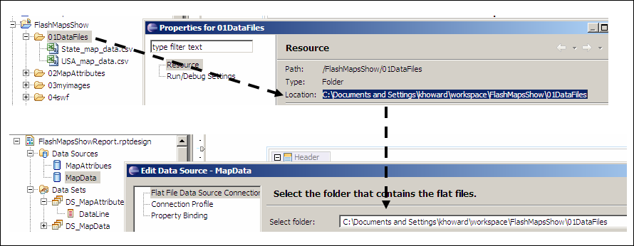
Repeat these steps for the data file in State_Drilldown.rptdesign. Required outcome is shown below.

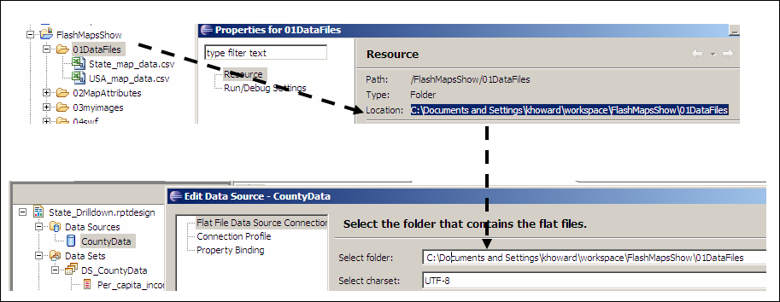

Confirm data is read successfully

Confirm data is accessible by using the Preview Results feature of the dataset.
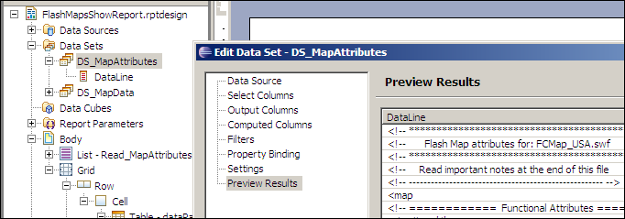
Image Files: Copy to correct location

The images are distributed in the project in the 03myimages subfolder. They can not be accessed from here, and need to be copied to the directory where the viewer application can locate them when the report is run.
In the case of the Actuate BIRT Designer Professional,
copy the image files from the 03myimages folder to the following directory:

C:\Program Files\Actuate10\BRDPro\eclipse\plugins\ ….
com.actuate.birt.report.viewer_2.3.2.v20081001\iportal\myimages
Notes on image file copying
A subdirectory called “\myimages” must be created as shown above.
The actual version may differ (eg: 2.3.2.v20081001) but the viewer folder will be the same.
The map attributes file contains the path name which includes \myimages.
For example, in the map attributes file, a shape entry which uses an image file appears as follows:

<shape id='CHIPic' type='image' url='@appBase@\myimages\ChicagoSears.gif' />
<shape id='NYCPic' type='image' url='@appBase@\myimages\NYC6.png' />

The subdirectory \myimages is not essential, but serves to demonstrate that the images can be organized into sub-directories for convenience.
The string @appbase@ is replaced by code in FlashMapsShowReport.rptdesign with the base folder of the viewer. The string @appbase@ is required in the attributes entry, so the code can locate it, then replace it with the correct folder path.

After copying the image files the target directory should look similar to the folder shown here:

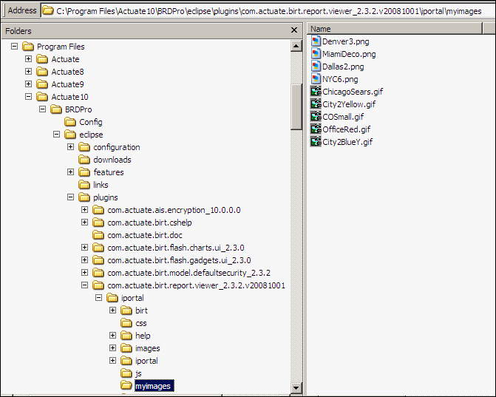

Note: The location of the image files will be different in the case when the report is deployed in an Actuate Java Components deployment (formerly and commonly referred to as a “workspace” deployment) and an iServer deployment.

Running the Report

Run FlashMapsShowReport.rptdesign. The parameter page appears as follows:

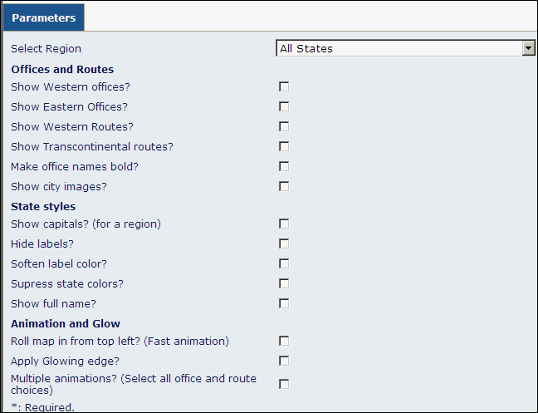

Suggested demonstration sequence

- Run with defaults. Defaults are All States and no checkboxes selected.
The US map appears. Mouse over the states to reveal the tool tip.
Note: Six state codes appear in Arial bold font and navy blue. This indicates the state has a drill down map accessible through a hyperlink.
TIP: Leave hyperlink demo till later.
Drilldown states are:
West: CA, WA, AZ,
Central: TX,
East: NY, NJ, MA.
- To show offices, return to parameter page and select the following checkboxes:
  - Show Western Offices?
  - Show Eastern Offices?

Run the report.
Note: Red and yellow markers for west and east offices respectively.
Note: City names are difficult to read, so we need to bold them.

- To bold the offices name, return to parameter page and select the following checkboxes:
  - Show Western offices?
  - Show Eastern Offices?
  - Make office names bold?

Run the report.
Note: City names easier to read.

- To show connectors, return to parameter page and select the following checkboxes:
  - Show Western Offices?
  - Show Eastern Offices?
  - Make office names bold?
  - Show western routes?
  - Show Transcontinental routes?

Run the report.
Note: This shows the connector line capabilities.
Note: Move over a connector line.
TIP: Move the mouse to the Gulf of Mexico and mouse over the route from Los Angeles to Miami over the ocean. If you try to mouse over a connector line over a state, you will battle between the state and line tool tips. Do the same over the Great Lakes on the route from Seattle to New York. (See pic. below)

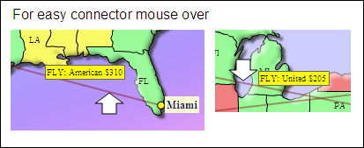

Show Animation support

- Now is good time to show the wow of animation. (You can show other features later)
To show animation sequence, return to parameter page and select the following checkboxes:
  - Show Western Offices?
  - Show Eastern Offices?
  - Make office names bold?
  - Show western routes?
  - Show Transcontinental routes?
  - Multiple animations?
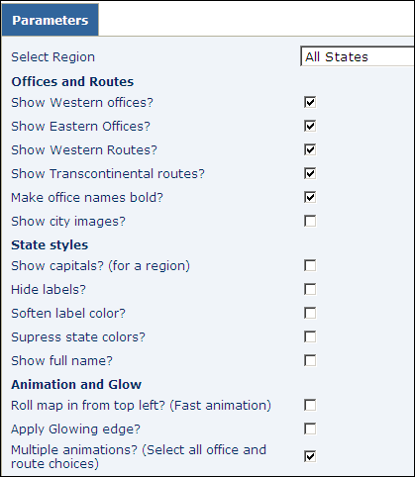

Run the report and the animation sequence plays out.

Show Hyperlink support: Map Drill Down

- To show hyperlink drill down, return to parameter page take the default options.
When the map appears indicate the different font which denotes the drill down states. (Arial, bold, blue vs. Times, plain, black)
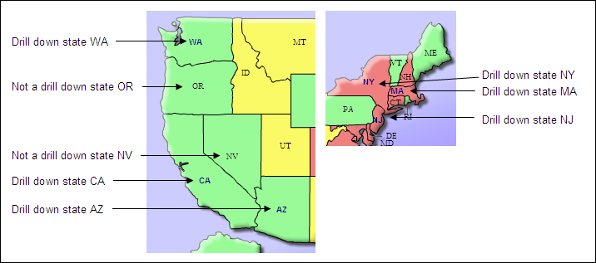

Click on any drill down state. The state map will appear in a new window.

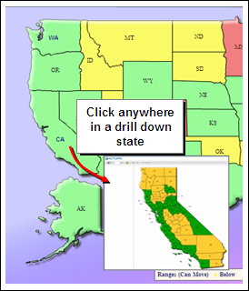

2nd tier demonstration
Custom image markers

- To show custom images for markers and high speed animation, return to parameter page and select the following checkboxes:
  - Show city images?
  - Suppress state colors?
  - Roll map in from top left? (Fast animation)

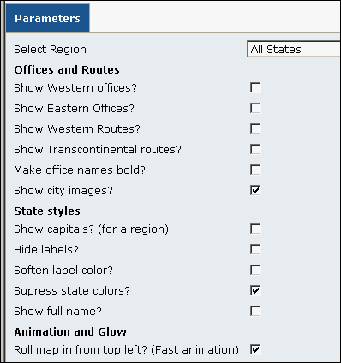

Run the report.
Note: Suppressing the state colors heightens the impact of the images.
Note: Fast animation shows how get viewers attention for critical data.
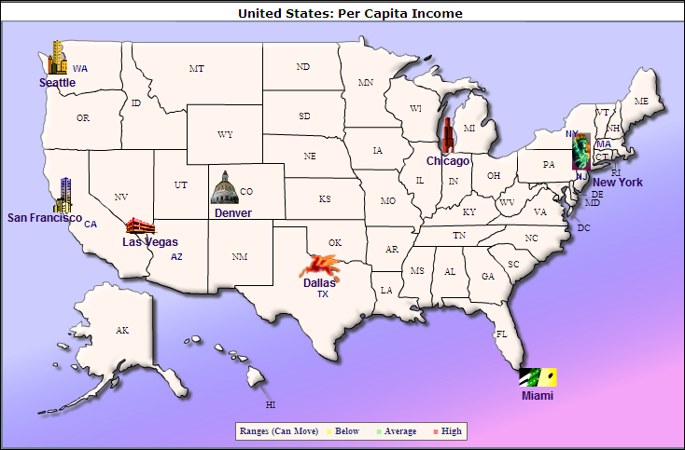

Highlight selected region

- To show region selection, return to parameter page and select the following checkboxes:
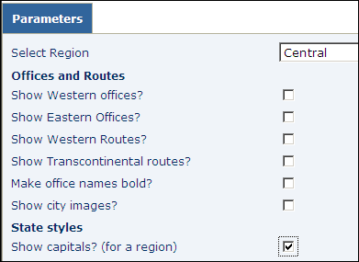

Note: Shows how a portion of a map can be selected. The feature enables the report to focus on a region based on the user’s locale.
Note: States *not* selected are displayed in a soft, uniform color to lessen their distraction.
Note: State capitals shown serves to show how specific information can be displayed for the selected region.

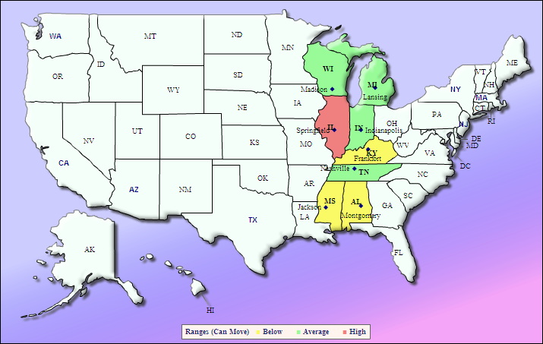
Hide all State information and glow edges

A final demonstration shows how all state labels can be hidden if the map is only required as a region indicator. For example, select Eastern states and hide all labels.
As an extra feature demonstration, select the glow option.

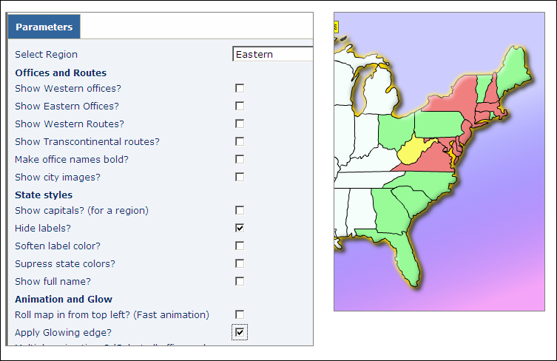

All state labels are hidden.
Notice the yellow glow around the map edge.

Structure of the report (Brief summary)

A key aspect of the report is the use of a text file to store the map attributes. This reduces greatly the amount of code required in the actual design. Altering a map’s appearance is achieved by simply editing the attributes file with a text editor, such as notepad.exe. This can be demonstrated easily by editing the map attributes file.

How to demonstrate editing the attributes file

- Double click the attributes file in the designer, as shown below:
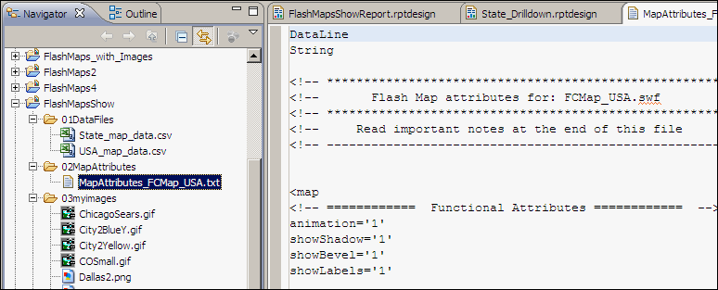

- Scroll down to the <colorRange> section, shown below:

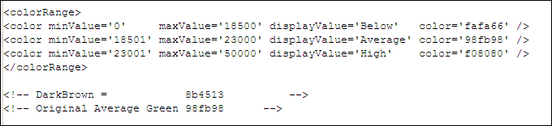

- Alter the color for Average. To make the process simple, the colors are in the file as comments.
Cut the DarkBrown value: 8b4513 and paste it over Average color. Now looks as follows:
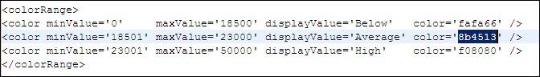

- Save the attributes file by using CTL + S
- Run the report again and take the default parameter values.
The output is not optimal but dramatically different. The point is the ease in which the map attribute was altered; a simple file edit.
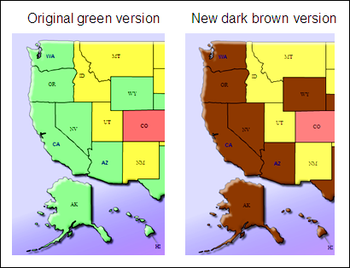
- To reverse the effect, edit the attribute file using the original color, save the file, then re-run the report.
