**EXERCISE NO** :11

**DATE** : 22-11-2020

**AIM:**

Write a Python program to find the greatest common divisor (gcd) of two integers using recursion.

**PROGRAM:**

**def gcd(a,b):**

**if(a==0):**

**return a**

**if(b==0):**

**return b**

**if(a==b):**

**return b**

**if(a>b):**

**return(gcd(a-b,b))**

**else:**

**return gcd(a,b-a)**

**a=int(input("Enter the first number:"))**

**b=int(input("Enter the second number:"))**

**GCD=gcd(a,b)**

**print("GCD is:")**

**print(GCD)**

**LINK:** <http://103.53.53.18/mod/vpl/forms/submissionview.php?id=326&userid=1685>

**OUTPUT:**

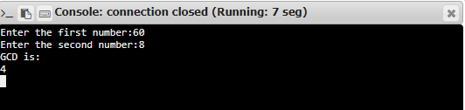

**RESULT:**

Hence, the program is executed successfully.