**EXERCISE NO** :13

**DATE** : 22-11-2020

**AIM:**

An apparel shop wants to manage the items which it sells.25 min  
Write a python program to implement the class diagram

**PROGRAM:**

**class Apparel:**

**counter=100**

**def __init__(self,price,item_type):**

**Apparel.counter+=1**

**self.__item_id=item_type[0]+str(Apparel.counter)**

**self.__price=price**

**self.__item_type=item_type**

**def calculate_price(self):**

**self.__price+=self.__price*0.05**

**def get_item_id(self):**

**return self.__item_id**

**def get_price(self):**

**return self.__price**

**def get_item_type(self):**

**return self.__item_type**

**def set_price(self,price):**

**self.__price=price**

**return self.__price**

**class Cotton(Apparel):**

**def __init__(self,price,discount):**

**super().__init__(price,'Cotton')**

**self.__discount=discount**

**def calculate_price(self):**

**super().calculate_price()**

**price=self.get_price()**

**price-=price*(self.__discount/100)**

**price+=price*0.05**

**self.set_price(price)**

**return price**

**def get_discount(self):**

**return self.__discount**

**class Silk(Apparel):**

**def __init__(self,price):**

**super().__init__(price,'Silk')**

**self.__points=None**

**def calculate_price(self):**

**super().calculate_price()**

**if(self.get_price()>10000):**

**self.__points=10**

**else:**

**self.__points=3**

**return self.set_price(self.get_price()+(self.get_price()*0.1))**

**def get_points(self):**

**return self.__points**

**silk=int(input())**

**cotton=int(input())**

**discount=int(input())**

**a=Silk(silk)**

**print(a.calculate_price())**

**b=Cotton(cotton,discount)**

**print(b.calculate_price**())

**LINK:** [**http://103.53.53.18/mod/vpl/forms/edit.php?id=328&userid=1685**](http://103.53.53.18/mod/vpl/forms/edit.php?id=328&userid=1685)

**OUTPUT:**

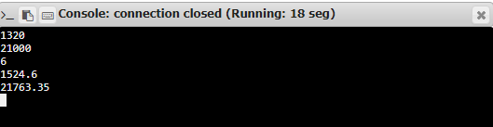

**RESULT:**

Hence, the program is executed successfully.