**EXERCISE NO** :14

**DATE** : 22-11-2020

**AIM:**

Write a Python class to find validity of a string of parentheses, '(', ')', '{', '}', '[' and ']. These brackets must be close in the correct order, for

example "()" and "()[]{}" are valid but "[)", "({[)]" and "{{{" are invalid.

**PROGRAM:**

**def areBracketsBalanced(expr):**

**stack=[]**

**open_expressions=['{','[','(']**

**for i in range(len(expr)):**

**if(expr[i] in open_expressions):**

**stack.append(expr[i])**

**else:**

**if not stack:**

**return False**

**curr=stack.pop()**

**if(curr == '{' and expr[i]!='}'):**

**return False**

**if(curr == '[' and expr[i]!=']'):**

**return False**

**if(curr == '(' and expr[i]!=')'):**

**return False**

**if stack:**

**return False**

**else:**

**return True**

**if __name__ == "__main__":**

**expr=input()**

**if(areBracketsBalanced(expr)):**

**print("valid")**

**else:**

**print("invalid")**

**LINK:**

<http://103.53.53.18/mod/vpl/forms/edit.php?id=327&userid=1685>

**OUTPUT:**

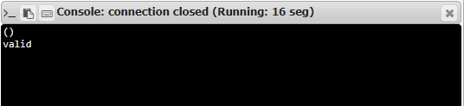

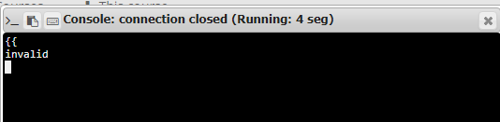

**RESULT:**

Hence, the program is executed successfully.