**EXERCISE NO** :1

**DATE** : 11-10-2020

**AIM:**

To write a Python program to print the calendar of a given month and year.

**PROGRAM:**

**import calendar as cal**

**y=int(input())**

**m=int(input())**

**if(y>999 and y<10000):**

**if(m>0 and m<13):**

**print(cal.month(y,m))**

**else:**

**print("Invalid Input")**

**else:**

**print("Invalid Input")**

**OUTPUT:**

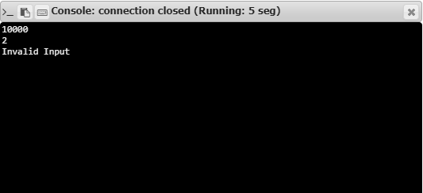

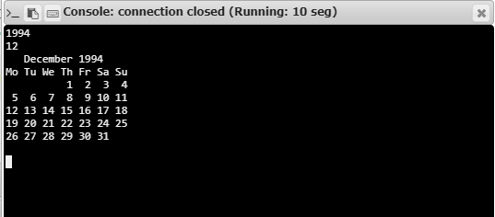

**RESULT:**

Hence, the program is executed successfully.