**EXERCISE NO** :2

**DATE** : 11-10-2020

**AIM:**

To given a list in Python and a number x, count number of occurrences of x in the given list.

**PROGRAM:**

**def countX(lst1,x1):**

**count=0**

**for i in range(0,len(lst1)):**

**if(x1==lst1[i]):**

**count=count+1**

**return count**

**lst=[]**

**n=int(input("No of elements"))**

**for i in range(0,n):**

**inp=int(input())**

**lst.append(inp)**

**print(lst)**

**x=int(input("The element to be searched"))**

**y=countX(lst,x)**

**print(y)**

**OUTPUT:**

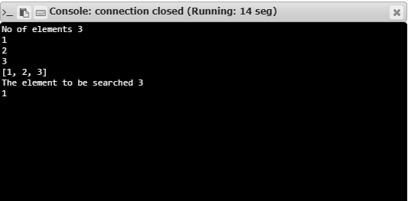

**RESULT:**

Hence, the program is executed successfully.