**EXERCISE NO** :3

**DATE** : 11-10-2020

**AIM:**

To write a Python program to remove and print every second number from a list of numbers until the list becomes empty.

**PROGRAM:**

**def removeThirdNumber(lst):**

**lst1=[]**

**position=1**

**a=0**

**for i in range(0,len(lst)):**

**a=(position+a)%len(lst)**

**e1ement=lst.pop(a)**

**lst1.append(e1ement)**

**return lst1**

**n=int(input())**

**int_list=[]**

**for i in range(0,n):**

**b=int(input())**

**int_list.append(b)**

**c=removeThirdNumber(int_list)**

**print(c)**

**OUTPUT:**

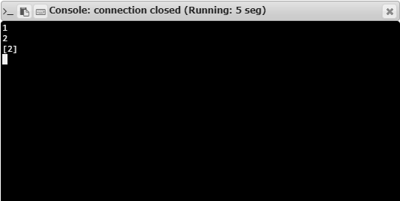

**RESULT:**

Hence, the program is executed successfully.