**EXERCISE NO** :4

**DATE** : 11-10-2020

**AIM:**

To Write a Python program (function) to print a single string from two set of strings received from user and swap the first two characters of each string.

**PROGRAM:**

**def swap(x,y):**

**if(len(x)>2 and len(y)>1):**

**a=y[:2]+x[2:]**

**b=x[:2]+y[2:]**

**print(a+' '+b)**

**else:**

**print("Invalid")**

**x=input().strip()**

**y=input().strip()**

**swap(x,y)**

**OUTPUT:**

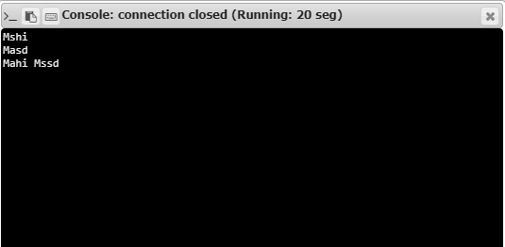

**RESULT:**

Hence, the program is executed successfully.