Name: R.Manoj 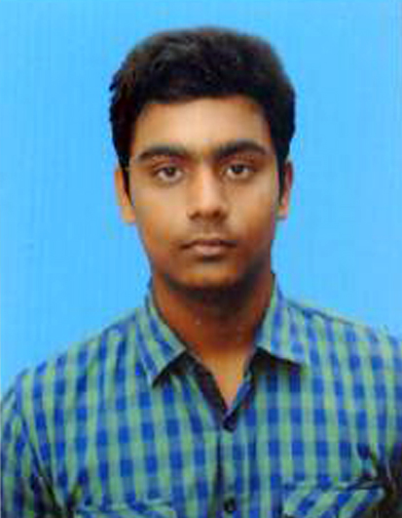

Email: dvmano18@gmail.com

Ph no: 7010031609

Address: V.Vallakundapuram

642120.

**Carrer Objective**

As a Beginner in the Industrial field, while making a  positive  contribution, I would like to build a career, making the best use of my analytical, creative and logical skills to perform the job efficiently.

**Educational Qualification :**

|  |  |  |  |  |
| --- | --- | --- | --- | --- |
| Course | Institution | Board/University | Year of passing/passed | Percentage/CGPA |
| Bachelor Of Engineering  Sem : 6 | Mahalingam College of Engineering and Technology | Autonomous | 2020 | 7.9 CGPA |
| Higher Secondary | Vivegam Higher Secondary School | State Board | 2016 | 77 % |
| Secondary School Leaving Certificate | R.G Higher Secondary School | State Board | 2014 | 92 % |

**Areas of Intrest :**

* Web Technology
* Computer Networks
* Data Structures

**Skills:**

|  |  |
| --- | --- |
| Programming | C , JAVA , PHP , NODEJS |
| Web Development | HTML, CSS , JS , AJAX , JQUERY |
| UI Frameworks | BOOTSTRAP , SEMANTIC UI |
| Web Stacks | MEAN(MongoDB,Expressjs,Angularjs,Nodejs)  LAMP(Linux,Apache,Mysql,Php) |
| Devops | Git , Docker , Jenkins |

**Projects:**

|  |  |  |  |
| --- | --- | --- | --- |
| TITLE | DESCRIPTION | TOOLS USED | DURATION |
| E-Commerce Application | An E-Commerce dynamic Web Application which dynamically loads the content . | Front-End : Express Handlebars , Html , Css.  Back-End : Nodejs , Expressjs.  Database : MongoDB. | Two month(Still Developing for updates**)** |
| A Chat Room | A chat room using python Tkinter which displays every message sent by user in that room and converts messages to speech (text-to-speech). | Front-End : Python Tkinter.  Back-End : Python. | One Week |
| Book Bin | Static Online E-Book Site using ui framework in Standalone nodejs server . | Front-End : Html , Css.  Back-End : Nodejs. | Two Weeks |
| News Application | An online news application using news api. | Framework : Ionic (Android, IOS (Developing) | One month(Still Developing for updates) |
| Polling system | **An polling system in online.** | Front-End :Html , Css.  Back-End : Php  Database : Mysql | One month(Still Developing for updates) |

**Other Projects :**

**GitHub :** https://github.com/manojravichandran

**Co-Curricular Activities:**

* Trainee in a startup (Hashh Automations) as a Web Developer.
* Participated symposium in Kumaraguru College of Engineering and Technlogy .
* Completed Courses in Udemy for MEAN stack & Udacity for PHP and Front-End Development .

**Extra-Curricular Activities:**

* An Athlet in Field Events.
* Volunteer work and community service.

**Interpersonal Skills:**

* Teamwork
* Empathy
* Adaptability
* Positivity

**Hobbies**:

* Travel
* Gardening
* Listening Music

**Personal Details:**

Date Of Birth: 04/10/1999

Gender: Male

Blood-Group: A1+ve

Father Name: N.Ravichandran

Languages Known: Tamil , English , Telugu

**Declaration**

***All the information mentioned in the resume are correct to the best of my knowledge and believe.***

**Place:**

**Date: Signature**