EDA_Analysis_Report.md
2026-07-13
NR Cell Availability — Detailed EDA Analysis Report
Project: NR Cell Availability Forecasting Data Source: Parquet file — RAN KPI data Target Variable:
NR_Cell_AvailabilityForecasting Goal: Predict NR_Cell_Availability24 hours ahead at the same
ROP (t+96 ROPs) per cell
1. Dataset Overview
1.1 Data Structure
Format: Parquet (snappy compressed)
Granularity: Per cell, per ROP (15-minute intervals)
Time Range: July 1, 2026 — July 9, 2026 (12:30)
Distinct Cells: 29,742 (maximum observed in a single ROP)
Total Columns: 70+ KPI features + identifiers
Key Identifier Columns: CELLID, SITE, DATE_ID, HOUR_ID, MIN_ID, COLLECTTIME
1.2 Column Types
Type
Columns
Identifiers
Time
CELLID, SITE, COLLECTTIME
DATE_ID, HOUR_ID, MIN_ID
NR_Cell_Availability
Target
Numeric KPIs 70+ float64 columns
2. Temporal Coverage Analysis
2.1 ROP Completeness
Using groupBy(DATE_ID, HOUR_ID, MIN_ID).countDistinct(CELLID), the following patterns were
observed for 2026-07-01:
Observation
Value
Maximum cells in any ROP
Minimum cells in any ROP
Typical cell count per ROP
Max missing cells in a ROP
29,742
~28,681
29,600 — 29,750
~1,061
Average missing cells per ROP ~150—300
2.2 Missing ROP Slots
1 / 11

EDA_Analysis_Report.md
2026-07-13
Several ROPs were found to be completely missing from the dataset (no rows at all for that time slot).
Notable gaps observed:
2026-07-01 00:00— missing
2026-07-01 02:00— missing
2026-07-01 05:00— missing
2026-07-01 07:00— missing
2026-07-01 15:00— missing
This indicates systematic gaps at certain hours, possibly due to data pipeline issues or collection windows.
2.3 Cell Count Pattern
Cell count is lowest during early morning hours (00:00 — 06:00)
Cell count peaks around 19:00 — 23:00
This suggests either traffic-based reporting or energy-saving mode suppressing KPI reporting for some
cells during off-peak hours
3. Feature Analysis
3.1 Full Feature List by Category
Traffic & Load
Feature
Description
NR_DL_Active_UEs
NR_UL_Active_UEs
Average DL active UEs
Average UL active UEs
NR_DL_Active_UEs_True True DL active UEs (variant)
NR_UL_Active_UEs_True True UL active UEs (variant)
NR_DL_MAC_Volume_MB
NR_UL_MAC_Volume_MB
NR_DL_RBSym_Util
NR_UL_RBSym_Util
DL MAC data volume in MB
UL MAC data volume in MB
DL resource block symbol utilisation
UL resource block symbol utilisation
Throughput
Feature
Description
NR_DL_MAC_Cell_Thp_Mbps
NR_UL_MAC_Cell_Thp_Mbps
DL MAC cell throughput (Mbps)
UL MAC cell throughput (Mbps)
NR_DL_MAC_Cell_Thp_total_time_Mbps DL MAC cell throughput (total time normalised)
NR_UL_MAC_Cell_Thp_total_time_Mbps UL MAC cell throughput (total time normalised)
2 / 11

EDA_Analysis_Report.md
2026-07-13
Feature
Description
NR_Avg_DL_MAC_Thp_Mbps
Average DL MAC UE throughput
Average UL MAC UE throughput
Average DL MAC throughput (EBS)
Average UL MAC throughput (EBS)
NR_Avg_UL_MAC_UE_Thp_Mbps
NR_Avg_DL_MAC_Thp_EBS_Mbps
NR_Avg_UL_MAC_Thp_EBS_Mbps
Signal Quality
Feature
Description
NR_Avg_UL_PUCCH_SINR_dB Average UL PUCCH SINR
NR_Avg_UL_PUSCH_SINR_dB Average UL PUSCH SINR
NR_UL_RSSI
UL received signal strength (interference indicator)
NR_Avg_CQI
Average Channel Quality Indicator
Average CQI for 64QAM
Average CQI for 256QAM
Average MCS (Table 1)
NR_Avg_CQI_64QAM
NR_Avg_CQI_256QAM
NR_Avg_MCS_Table1
NR_Avg_MCS_Table2
NR_RANK_Below3_Rate
Average MCS (Table 2)
Rate of rank below 3
Pathloss & Power
Feature
Description
NR_Avg_UL_Pathloss_dB
Average UL pathloss
NR_Avg_UL_Pathloss_95percentile_dB 95th percentile UL pathloss
NR_Avg_UL_Power_Headroom_dB
NR_TA
Average UL power headroom
Timing advance (proxy for cell range/distance)
Error Rates
Feature
Description
DL HARQ block error rate
NR_DL_HARQ_BLER
NR_DL_HARQ_BLER_256QAM DL HARQ BLER for 256QAM
NR_UL_HARQ_BLER
UL HARQ block error rate
NR_UL_HARQ_BLER_64_QAM UL HARQ BLER for 64QAM
3 / 11

EDA_Analysis_Report.md
2026-07-13
Feature
Description
NR_DL_RLC_BLER
DL RLC block error rate
UL RLC block error rate
UL DTX rate
NR_UL_RLC_BLER
NR_UL_DTX_Rate
NR_DL_DTX_Rate
DL DTX rate
Random Access & Paging
Feature
Description
NR_RACH_SR
Random access channel success rate
RACH attempts
NR_RACH_Att
NR_Msg2_Attempt_SR
NR_Msg2_Attempts
MSG2 attempt success rate
MSG2 attempts count
NR_SA_Paging_Discard_Rate SA paging discard rate
RRC & Signalling
Feature
Description
NR_SA_RRC_ATT
NR_SA_RRC_SSSR
NR_SA_NG_Sig_SR
NR_RRC_SSR
SA RRC setup attempts
SA RRC setup success rate
SA NG signalling success rate
RRC setup success rate
SA RRC connected users max
NR_SA_RRC_CU_Max
NR_ENDC_RRC_CU_Max ENDC RRC connected users max
NR_ENDC_RRC_CU_Avg ENDC RRC connected users average
Handover
Feature
Description
NR_SA_HO_SR
SA handover success rate
NR_SA_HO_Prep_Succ_Rate
NR_SA_HO_Exec_Succ_Rate
NR_SA_INTER_GNB_HO_SR
NR_SA_INTRA_GNB_HO_SR
SA HO preparation success rate
SA HO execution success rate
SA inter-gNB handover success rate
SA intra-gNB handover success rate
4 / 11

EDA_Analysis_Report.md
2026-07-13
Feature
Description
NR_SA_NR_to_LTE_RWR_Ratio SA NR to LTE redirect ratio
ENDC (NSA Mode)
Feature
Description
NR_ENDC_Setup_SR
NR_ENDC_Setup_Att
NR_ENDC_SARR
ENDC setup success rate
ENDC setup attempts
ENDC secondary addition rejection rate
NR_ENDC_Inter_sgNodeB_PSCell_Change_SR ENDC inter-SgNB PSCell change SR
NR_ENDC_Intra_sgNodeB_PSCell_Change_SR ENDC intra-SgNB PSCell change SR
NR_SgNB_Abnormal_RR
Secondary node abnormal release rate
Session Quality
Feature
Description
DL_Thp_Bad_Sessions
DL_Thp_Fair_Sessions
DL_Thp_Good_Sessions
DL sessions with bad throughput
DL sessions with fair throughput
DL sessions with good throughput
DL_Thp_Excellent_Sessions DL sessions with excellent throughput
UL_Thp_Bad_Sessions
UL_Thp_Fair_Sessions
UL_Thp_Good_Sessions
UL sessions with bad throughput
UL sessions with fair throughput
UL sessions with good throughput
UL_Thp_Excellent_Sessions UL sessions with excellent throughput
DL_Total_Sessions
UL_Total_Sessions
Total DL sessions
Total UL sessions
Availability & Latency
Feature
Description
NR_Cell_Availability
TARGET — cell availability %
NR_Cell_Availability_Num Numerator of availability formula — LEAKAGE, EXCLUDE
NR_Avg_DL_Latency_ms
Average DL latency in ms
Energy Saving
5 / 11

EDA_Analysis_Report.md
2026-07-13
Feature
Description
essEnabled
Energy saving enabled flag
ESS_TOTAL_PRB_AVG_UTIL_DL ESS total PRB average utilisation DL
ESS_NR_PRB_AVG_UTIL_DL
ESS NR PRB average utilisation DL
4. Correlation Analysis with NR_Cell_Availability
4.1 Correlation Across Time Granularities
Correlations were computed at three granularities: 1 ROP (15-min), 1 Hour, and Full Load.
Key Finding: Hourly aggregation significantly improves correlation signal
Granularity Top Feature
Top Correlation
1 ROP
NR_Avg_UL_Pathloss_95percentile_dB 0.185
1 Hour
Full Load
NR_Msg2_Attempt_SR
NR_Msg2_Attempt_SR
0.444
0.421
4.2 Full Correlation Rankings (1 Hour vs Full Load)
Feature
Full Load 1 Hour Direction
NR_Msg2_Attempt_SR
NR_Avg_UL_Pathloss_95percentile_dB
NR_ENDC_Setup_SR
NR_Avg_UL_Pathloss_dB
NR_Avg_UL_PUCCH_SINR_dB
NR_Avg_CQI
0.421
0.415
0.403
0.375
0.331
0.290
0.265
0.238
0.216
0.444
0.434
0.429
0.390
0.343
0.293
0.272
0.228
0.236
0.159
0.136
0.133
0.183
0.144
Positive
Positive
Positive
Positive
Positive
Positive
Positive
Positive
Positive
Positive
Positive
Positive
Positive
Positive
NR_Avg_UL_PUSCH_SINR_dB
NR_RACH_SR
NR_Avg_MCS_Table1
NR_ENDC_Inter_sgNodeB_PSCell_Change_SR 0.143
NR_RANK_Below3_Rate
NR_Avg_CQI_256QAM
0.137
0.136
NR_ENDC_Intra_sgNodeB_PSCell_Change_SR 0.135
NR_DL_HARQ_BLER 0.126
6 / 11

EDA_Analysis_Report.md
2026-07-13
Feature
Full Load 1 Hour Direction
NR_Avg_UL_Power_Headroom_dB
0.124
0.080
0.078
0.073
0.070
0.069
0.005
0.005
0.004
0.004
0.004
0.000
0.000
0.000
-0.022
-0.547
-0.691
0.128
0.092
0.089
0.073
0.067
0.082
0.005
0.005
0.005
0.005
0.005
0.001
0.000
—
Positive
NR_UL_HARQ_BLER
NR_UL_HARQ_BLER_64_QAM
NR_TA
Positive
Positive
Positive
NR_DL_HARQ_BLER_256QAM
NR_DL_RBSym_Util
Positive
Positive
NR_SA_NG_Sig_SR
Near Zero
Near Zero
Near Zero
Near Zero
Near Zero
Near Zero
Near Zero
Near Zero
Negative
Negative
LEAKAGE
NR_SA_RRC_SSSR
NR_SA_HO_Prep_Succ_Rate
NR_SA_HO_Exec_Succ_Rate
NR_SA_HO_SR
NR_DL_RLC_BLER
NR_UL_RLC_BLER
NR_SA_NR_to_LTE_RWR_Ratio
NR_SgNB_Abnormal_RR
NR_UL_RSSI
-0.044
-0.540
-0.669
NR_Cell_Availability_Num
4.3 Correlation Insights
Strong Positive Correlations — Signal Quality & Procedure Success
NR_Msg2_Attempt_SR, NR_ENDC_Setup_SR, NR_RACH_SR — procedure success rates are high when
the cell is healthy and available
NR_Avg_UL_Pathloss_dB / 95th percentile — counterintuitively positive; cells with no active UEs
report null/zero pathloss, so positive correlation reflects that active (available) cells have measurable
pathloss
NR_Avg_UL_PUCCH_SINR_dB, NR_Avg_UL_PUSCH_SINR_dB, NR_Avg_CQI — better signal quality =
cell is up and actively serving users
Strong Negative Correlations — Interference & Instability
NR_UL_RSSI (~-0.54) — high uplink RSSI indicates interference/noise, strongly associated with lower
availability; this is a key predictor
NR_Cell_Availability_Num (~-0.69) — direct component of the target KPI formula; must be excluded
as data leakage
NR_SgNB_Abnormal_RR — abnormal secondary node releases indicate cell instability
7 / 11

EDA_Analysis_Report.md
2026-07-13
Near-Zero Correlations — Safe to Drop
NR_SA_NG_Sig_SR, NR_SA_RRC_SSSR, NR_SA_HO_*, NR_DL/UL_RLC_BLER, NR_SA_NR_to_LTE_RWR_Ratio
— all below 0.005
5. Single Cell Analysis — ATG0019H_7NB01_S01
5.1 Cell-Level Correlation Observations
Correlations at cell level are noisier than population-level due to fewer data points
Some features showed Nonecorrelation — indicating constant values or all-null for this specific cell
Constant/null features per cell are candidates for exclusion and may indicate SA vs NSA mode
mismatch (e.g., ENDC features null for a pure SA cell)
5.2 Feature Behaviour Over Time (July 1—3, 2026)
Each feature was plotted against NR_Cell_Availabilityon a dual y-axis time series
Features with zero variance for this cell were automatically skipped
Visual inspection confirmed that NR_UL_RSSIspikes align with dips in NR_Cell_Availability
6. Data Quality Findings
6.1 Missing ROPs
Several complete ROP time slots are missing from the dataset (no rows for that timestamp)
Missing ROPs are not uniformly distributed — some hours have consistent gaps
Impact on modelling: Lag features (t-96) will have nulls where source ROPs are missing — needs
imputation or forward-fill strategy
6.2 Missing Cells per ROP
Cell count varies from ~28,681 to 29,742 per ROP
~300—1,000 cells are missing in any given ROP
Missing cells are not always the same cells — some are transient, some systematic
Impact on modelling: For 24h-ahead forecasting, if a cell is missing at t, we cannot generate a
prediction for t+96
6.3 Constant Features per Cell
Some features are constant for specific cells (e.g., essEnabled = 0always, or ENDC features always
null for SA cells)
These features have undefined correlation (NaN/None) and zero variance
Impact on modelling: Need per-cell feature validity check before training
6.4 Suspected Data Leakage
NR_Cell_Availability_Numshowed -1.0 correlation at 1 ROP — it is a direct component of the target
formula and must be excluded
8 / 11

EDA_Analysis_Report.md
2026-07-13
7. Suspected Redundant Feature Groups (Collinearity)
Group
Features
Recommended Action
NR_DL_MAC_Cell_Thp_Mbps,
NR_DL_MAC_Cell_Thp_total_time_Mbps,
NR_Avg_DL_MAC_Thp_Mbps, NR_DL_MAC_Volume_MB
DL
Keep
Throughput
NR_DL_MAC_Cell_Thp_Mbps
NR_UL_MAC_Cell_Thp_Mbps,
NR_UL_MAC_Cell_Thp_total_time_Mbps,
NR_Avg_UL_MAC_UE_Thp_Mbps, NR_UL_MAC_Volume_MB
UL
Keep
Throughput
NR_UL_MAC_Cell_Thp_Mbps
Keep one DL + one UL —
pending SME clarification on
"True" variant
NR_DL_Active_UEs, NR_DL_Active_UEs_True,
NR_UL_Active_UEs, NR_UL_Active_UEs_True
Active UEs
Pathloss
Keep 95th percentile —
captures edge UE behaviour
better
NR_Avg_UL_Pathloss_dB,
NR_Avg_UL_Pathloss_95percentile_dB
Keep NR_Avg_CQIas
aggregate — pending SME
confirmation
CQI
NR_Avg_CQI, NR_Avg_CQI_64QAM, NR_Avg_CQI_256QAM
NR_DL_HARQ_BLER, NR_DL_HARQ_BLER_256QAM,
NR_UL_HARQ_BLER, NR_UL_HARQ_BLER_64_QAM
Keep NR_DL_HARQ_BLER+
HARQ BLER
NR_UL_HARQ_BLER
RB
Utilisation
Keep both — different
directions
NR_DL_RBSym_Util, NR_UL_RBSym_Util
DL/UL_Thp_Bad/Fair/Good/Excellent_Sessions
NR_Cell_Availability_Num
Session
Quality
Drop if throughput KPIs
already included
Exclude — confirmed
leakage
Leakage
8. Recommended Feature Set for Modelling
Tier 1 — Must Include (|corr| > 0.2 at 1 Hour)
NR_Msg2_Attempt_SR
NR_Avg_UL_Pathloss_95percentile_dB
NR_ENDC_Setup_SR
NR_Avg_UL_Pathloss_dB
NR_Avg_UL_PUCCH_SINR_dB
NR_Avg_CQI
NR_Avg_UL_PUSCH_SINR_dB
NR_UL_RSSI
9 / 11
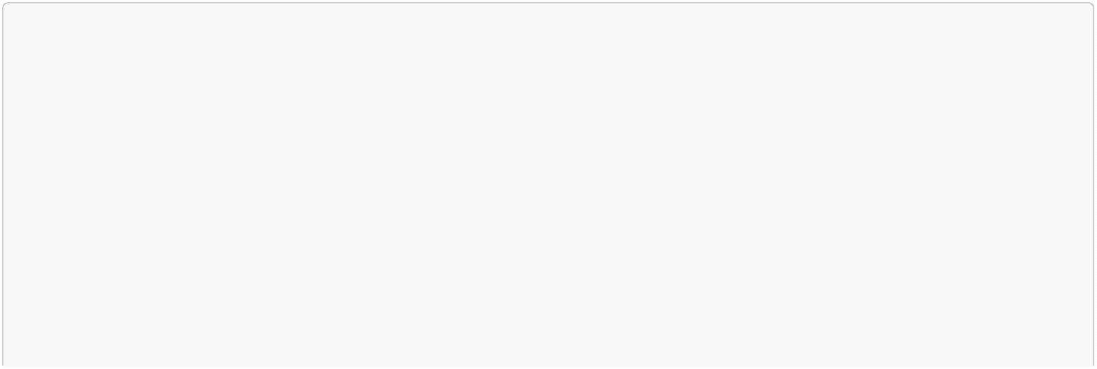

EDA_Analysis_Report.md
2026-07-13
NR_RACH_SR
NR_Avg_MCS_Table1
Tier 2 — Consider (0.05 < |corr| < 0.2 at 1 Hour)
NR_ENDC_Intra_sgNodeB_PSCell_Change_SR
NR_ENDC_Inter_sgNodeB_PSCell_Change_SR
NR_DL_HARQ_BLER
NR_RANK_Below3_Rate
NR_Avg_CQI_256QAM
NR_Avg_UL_Power_Headroom_dB
NR_UL_HARQ_BLER
NR_DL_RBSym_Util
NR_TA
Exclude — Leakage
NR_Cell_Availability_Num
Exclude — Near-Zero Correlation
NR_SA_NG_Sig_SR, NR_SA_RRC_SSSR, NR_SA_HO_SR
NR_SA_HO_Prep_Succ_Rate, NR_SA_HO_Exec_Succ_Rate
NR_DL_RLC_BLER, NR_UL_RLC_BLER
NR_SA_NR_to_LTE_RWR_Ratio, NR_SA_Paging_Discard_Rate
9. Key Decisions & Open Questions
Confirmed Decisions
Decision
Rationale
Use hourly aggregated data for
modelling
Correlation jumps significantly from 1 ROP to 1 Hour — hourly
is the sweet spot
Exclude NR_Cell_Availability_Num
Global model across all cells
Temporal train/test split
Direct leakage — component of target formula
29,742 cells makes per-cell modelling infeasible
Time-series data — random split would cause leakage
Open Questions (Pending SME)
1. Difference between NR_DL_Active_UEsand NR_DL_Active_UEs_True
10 / 11
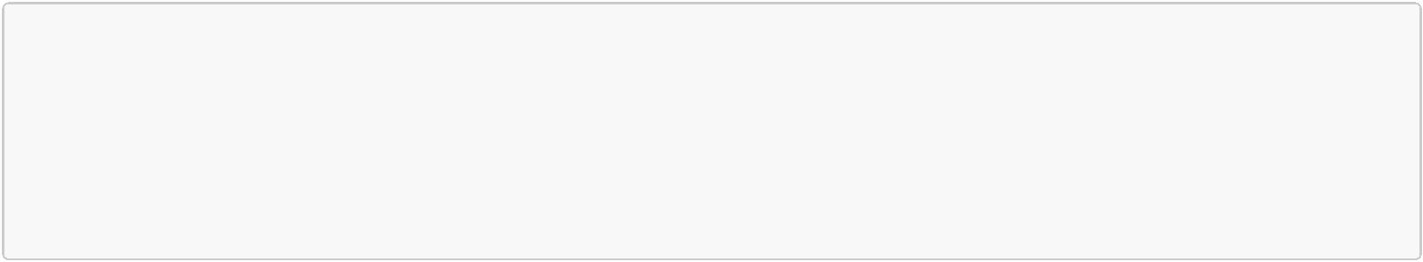
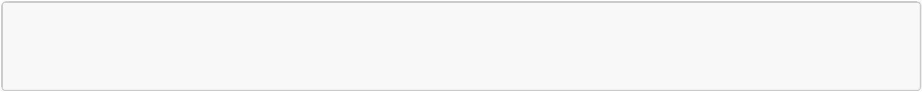
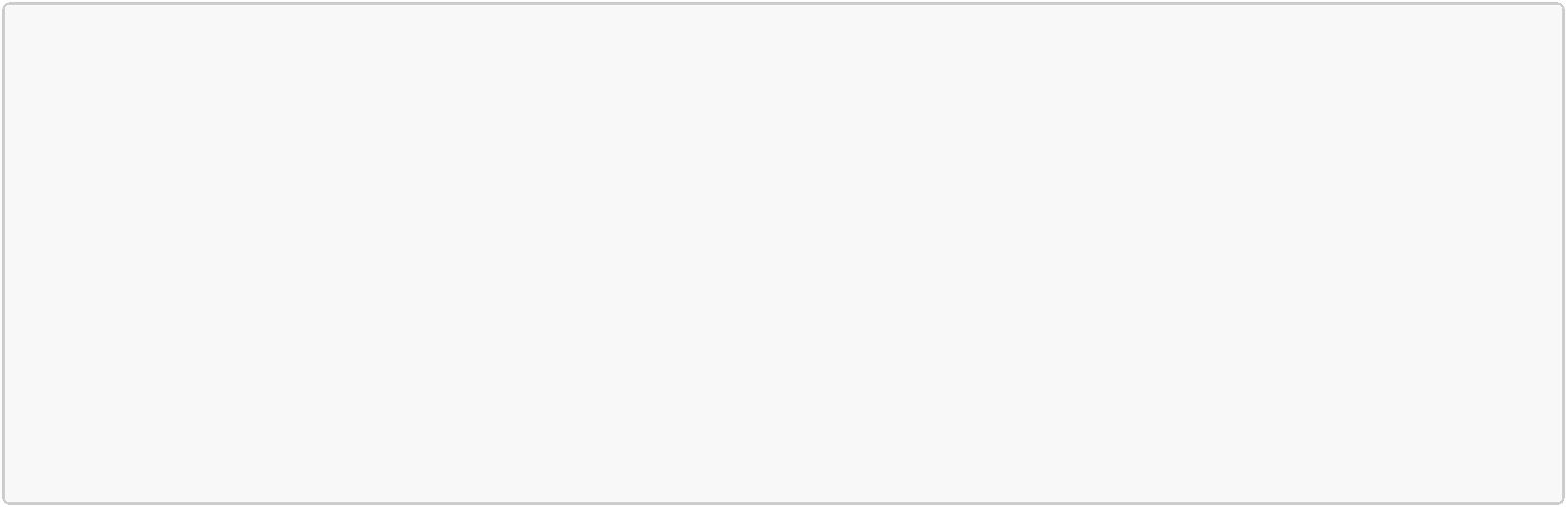

EDA_Analysis_Report.md
2026-07-13
2. Whether NR_Avg_CQIis an aggregate of NR_Avg_CQI_64QAMand NR_Avg_CQI_256QAM
3. Whether NR_Cell_Availability = 0is always unplanned or can be planned maintenance
4. SA vs NSA cell mix — are ENDC features always null for SA cells
5. Whether essEnabledshould be treated as categorical flag
6. Exact formula for NR_Cell_Availabilityto confirm leakage features
10. Next Steps
1. Collinearity Analysis — Pairwise correlation matrix + VIF + dendrogram clustering on remaining
features
2. Feature Engineering — Add lag features (t-24h, t-48h, t-168h), time features (hour_of_day,
day_of_week, is_weekend)
3. SME Review — Resolve open questions above before finalising feature set
4. Train/Test Split Design — Define holdout period and walk-forward validation strategy
5. Baseline Model — Naive 24h lag baseline (predict t+96 = value at t) to benchmark against
6. Model Experiments — XGBoost, LightGBM, compare with SHAP-based feature importance
7. SHAP Analysis — Confirm feature importance aligns with correlation findings
11 / 11

