DK-SOFNN CCPP — Visual Results
This document contains all visual results extracted from DK_SOFNN_CCPP Main-OP.ipynb.

Figures 11 & 12: Structure Adjustment Process
Fig 11: Source FNN rule number convergence (K0=10 and K0=20)
Fig 12: Target FNN (DK-SOFNN) rule number convergence
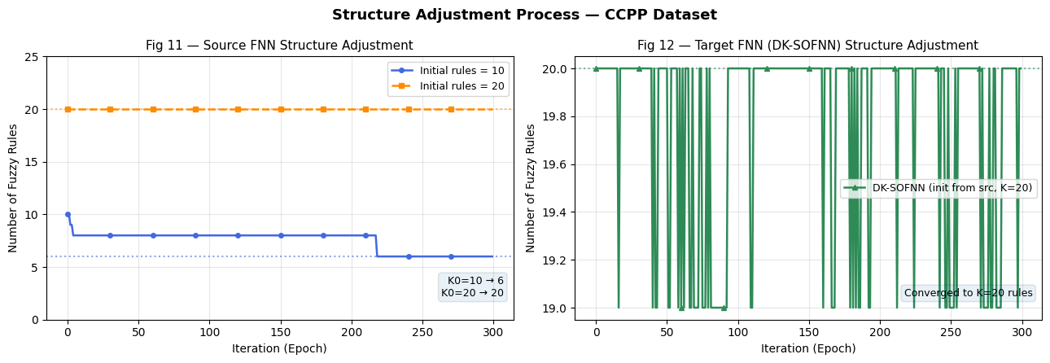

Figure 13: Training RMSE Comparison — Different Fixed Structures
Shows training convergence for K=11, 13, 15 rule networks
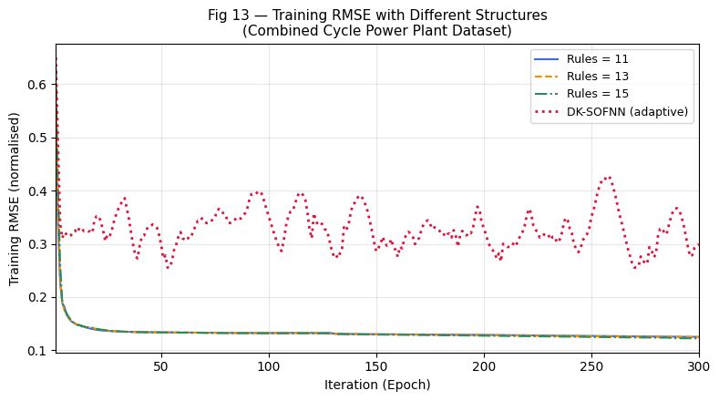

Figures 14 & 15: Testing Values and Testing Error — Different Fixed Structures
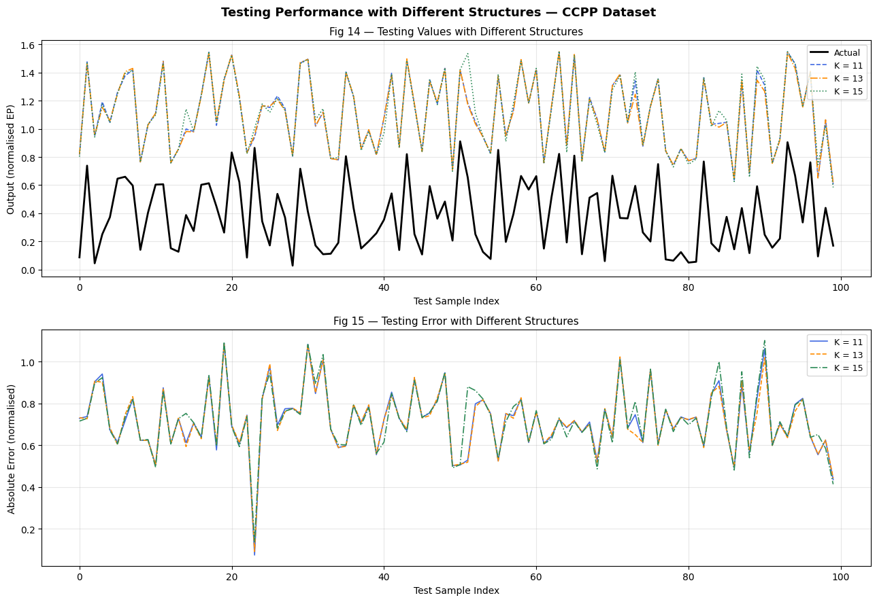

Figures 16 & 17: Testing Values and Testing Error — Method Comparison
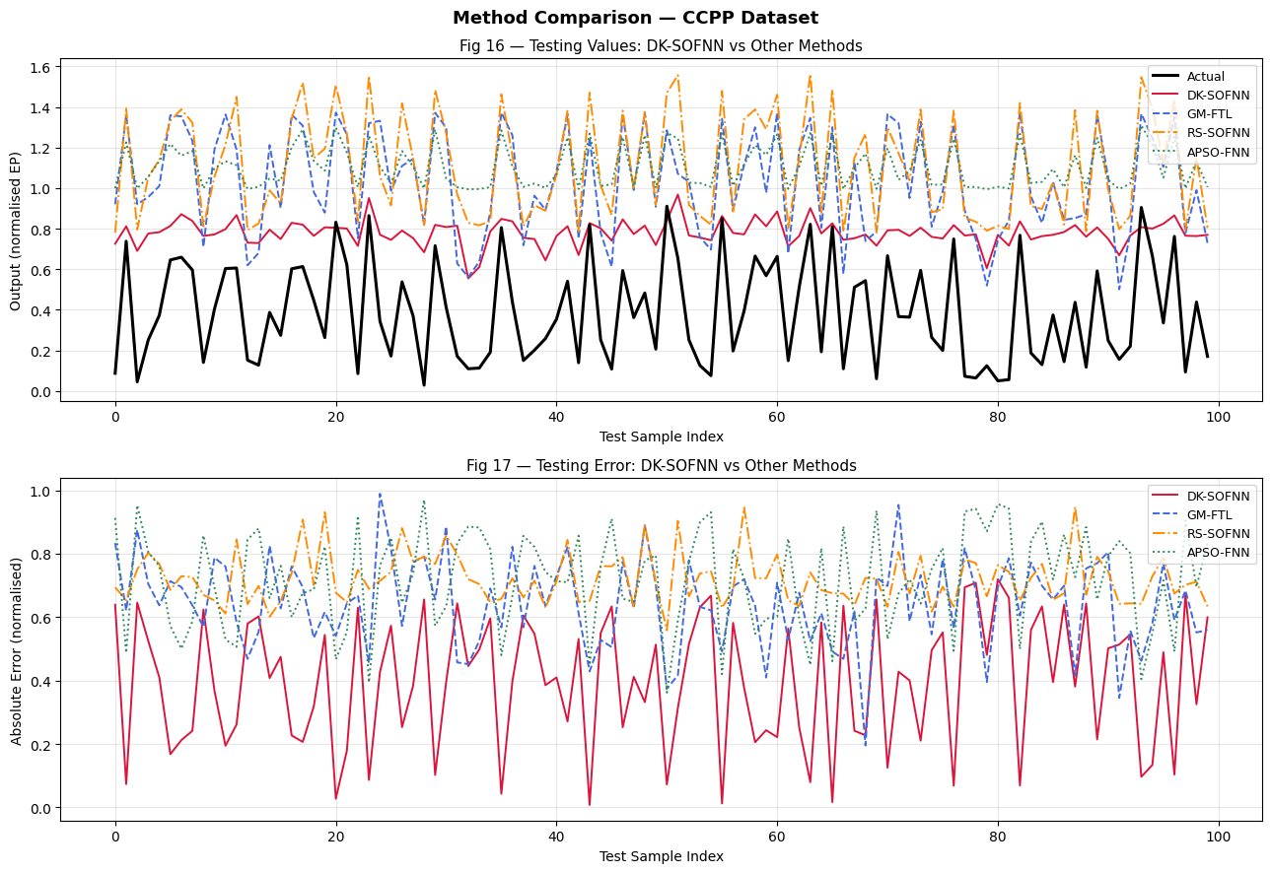

Summary Dashboard — All Results in One Figure
