Appendix (for online publication)

A1. Selection of countries
We included 90 countries in the simulation exercise. However, Saudi Arabia (SAU) and Panama (PAN) were removed from the soybean analysis, seven countries (ARE, ISL, KEN, MUS, MNE, OMN, DZA) were removed from the soybean cake analysis, and two countries (ISL, GAB) were removed from the soybean oil analysis. These countries were selected because they are either significant producers or consumers of soy products.
These countries are selected because they are either significant producers or consumers of soy products. The selected countries are: United Arab Emirates (ARE), Argentina (ARG), Australia (AUS), Austria (AUT), Belgium (BEL), Bulgaria (BGR), Bolivia (BOL), Brazil (BRA), Canada (CAN), Switzerland (CHE), Chile (CHL), China (CHN), Colombia (COL), Costa Rica (CRI), Cyprus (CYP), Czech Republic (CZE), Germany (DEU), Denmark (DNK), Algeria (DZA), Egypt (EGY), Spain (ESP), Estonia (EST), Finland (FIN), France (FRA), Gabon (GAB), United Kingdom (GBR), Greece (GRC), Hong Kong (HKG), Croatia (HRV), Hungary (HUN), Indonesia (IDN), India (IND), Ireland (IRL), Iran (IRN), Iceland (ISL), Italy (ITA), Jordan (JOR), Japan (JPN), Kenya (KEN), Cambodia (KHM), South Korea (KOR), Laos (LAO), Lebanon (LBN), Sri Lanka (LKA), Lithuania (LTU), Luxembourg (LUX), Latvia (LVA), Morocco (MAR), Madagascar (MDG), Mexico (MEX), North Macedonia (MKD), Malta (MLT), Myanmar (MMR), Montenegro (MNE), Mozambique (MOZ), Mauritius (MUS), Malaysia (MYS), Nicaragua (NIC), Netherlands (NLD), Norway (NOR), New Zealand (NZL), Oman (OMN), Panama (PAN), Peru (PER), Philippines (PHL), Poland (POL), Portugal (PRT), Paraguay (PRY), Romania (ROU), Russia (RUS), Saudi Arabia (SAU), Singapore (SGP), El Salvador (SLV), Serbia (SRB), Slovakia (SVK), Slovenia (SVN), Sweden (SWE), Thailand (THA), Trinidad and Tobago (TTO), Turkey (TUR), Taiwan (TWN), Ukraine (UKR), Uruguay (URY), United States (USA), Venezuela (VEN), Vietnam (VNM), South Africa (ZAF), Zimbabwe (ZWE), Kazakhstan (KAZ), and Ecuador (ECU).

A2. Decomposition of counterfactual trade under the “conditional” equilibrium
For the conditional counterfactual study, we decompose equation (1) for the base year 2022 as follows:
$$ΔX_{ij}^{s}=\left(1-σ_{s}\right)\left[Δt_{ij}^{s}-ΔΠ_{i}^{s}-ΔP_{j}^{s}\right] +ΔY_{i}+ΔE_{j}-ΔY . \left(A2.1\right)$$
Since under the conditional equilibrium, $ΔY_{i}=0$, $ΔE_{j}$ = 0 and $ΔY=0$. This leads to:
$$ΔX_{ij}^{s}=\left(1-σ_{s}\right)\left[Δt_{ij}^{s}-ΔΠ_{i}^{s}-ΔP_{j}^{s}\right] . \left(A2.2\right)$$
Equation (A2.2) suggests that the change in exports from the country $i$ to country $j$ is through changes in two components: (i) changes in trade cost, $Δt_{ij}^{s}$, and (ii) changes in multilateral resistances, ($ΔΠ_{i}^{s}, ΔP_{j}^{s}$).

A3. Armington elasticities
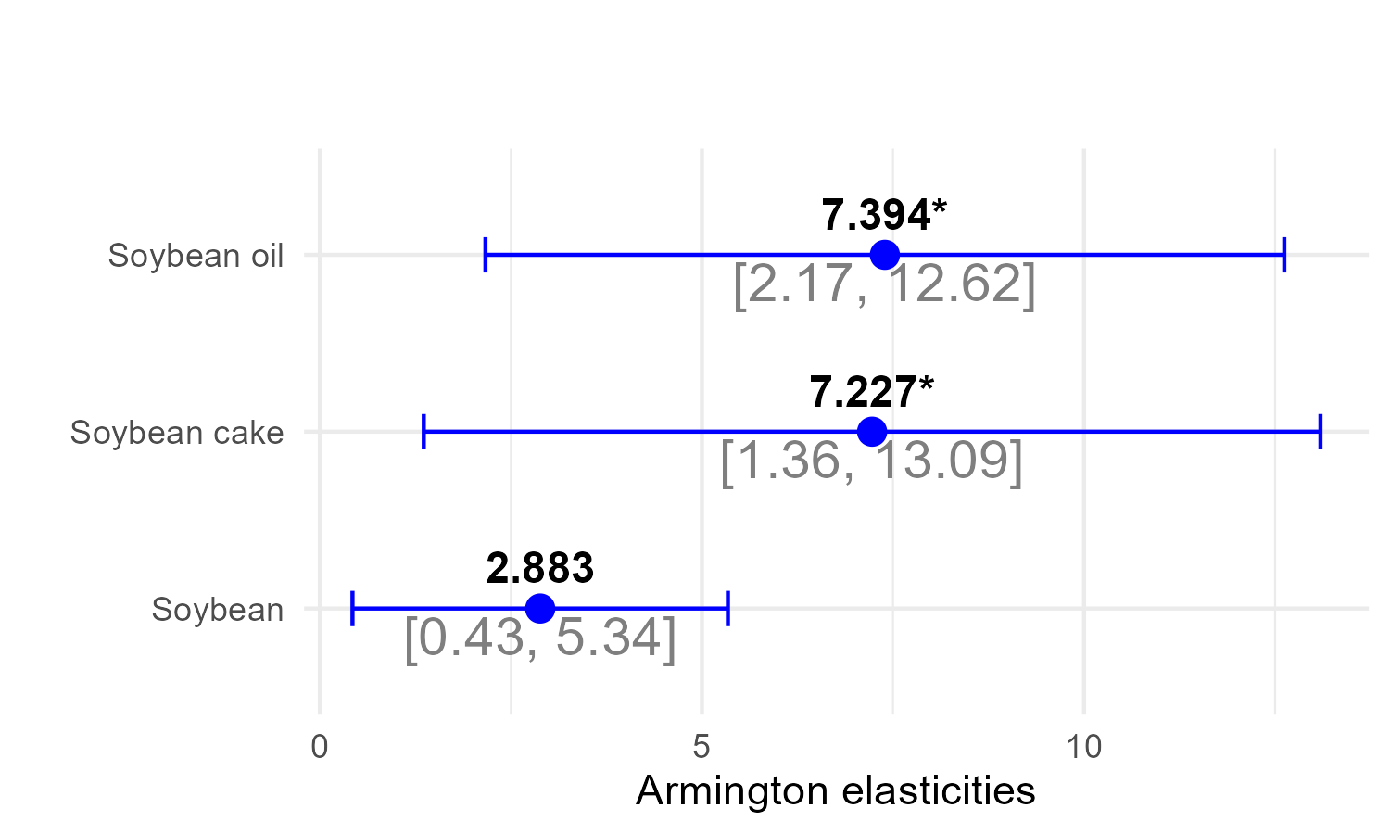
Figure A3.1: Estimates of Armington elasticities with 95% confidence intervals. Note: Armington elasticities are defined as 1 minus tariff elasticities. We estimate tariff elasticities using the pseudo-Poisson maximum likelihood (PPML) estimator. Exporter-year, importer-year, and country-pair fixed effects are included. Standard errors are clustered at the country-pair level. *** p<0.001, ** p<0.01, * p<0.05, . p<0.1

A4. EU involvement with the soy trade
Table A4.1: Import share of EU-27 countries in soy products (2021-2023)
Selected Countries | Import Share of EU-27 (%) | Export Share to EU-27 (%) | Export Share to World (%)
Brazil | 39.05 | 14.17 | 42.99
USA | 14.45 | 8.54 | 26.39
Argentina | 11.53 | 16.51 | 10.90
Ukraine | 3.67 | 50.54 | 1.13
Canada | 2.36 | 16.81 | 2.19
Paraguay | 1.14 | 6.34 | 2.80
Russia | 0.90 | 14.19 | 0.99
India | 0.80 | 18.14 | 0.69
China | 0.45 | 13.46 | 0.53
Turkey | 0.12 | 2.79 | 0.64
Bolivia | 0.02 | 0.26 | 1.34
Source: Own estimation based on CEPII-BACI database (Gaulier and Zignago 2010)

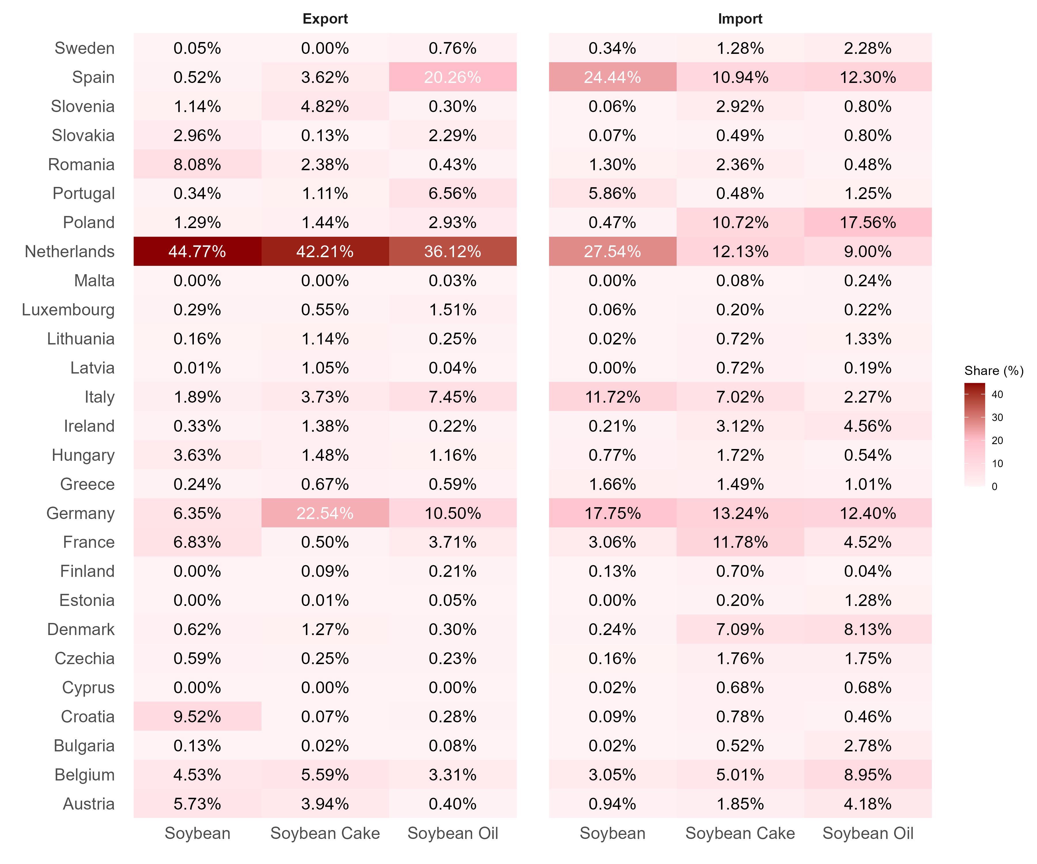
Figure A4.2: Relative sizes of the EU countries (among themselves) in import and export markets (cumulative 2019-2021)
Note: Percentages denote the EU countries’ share of total EU27 imports and exports.

A5. Additional results of the EUDR simulation
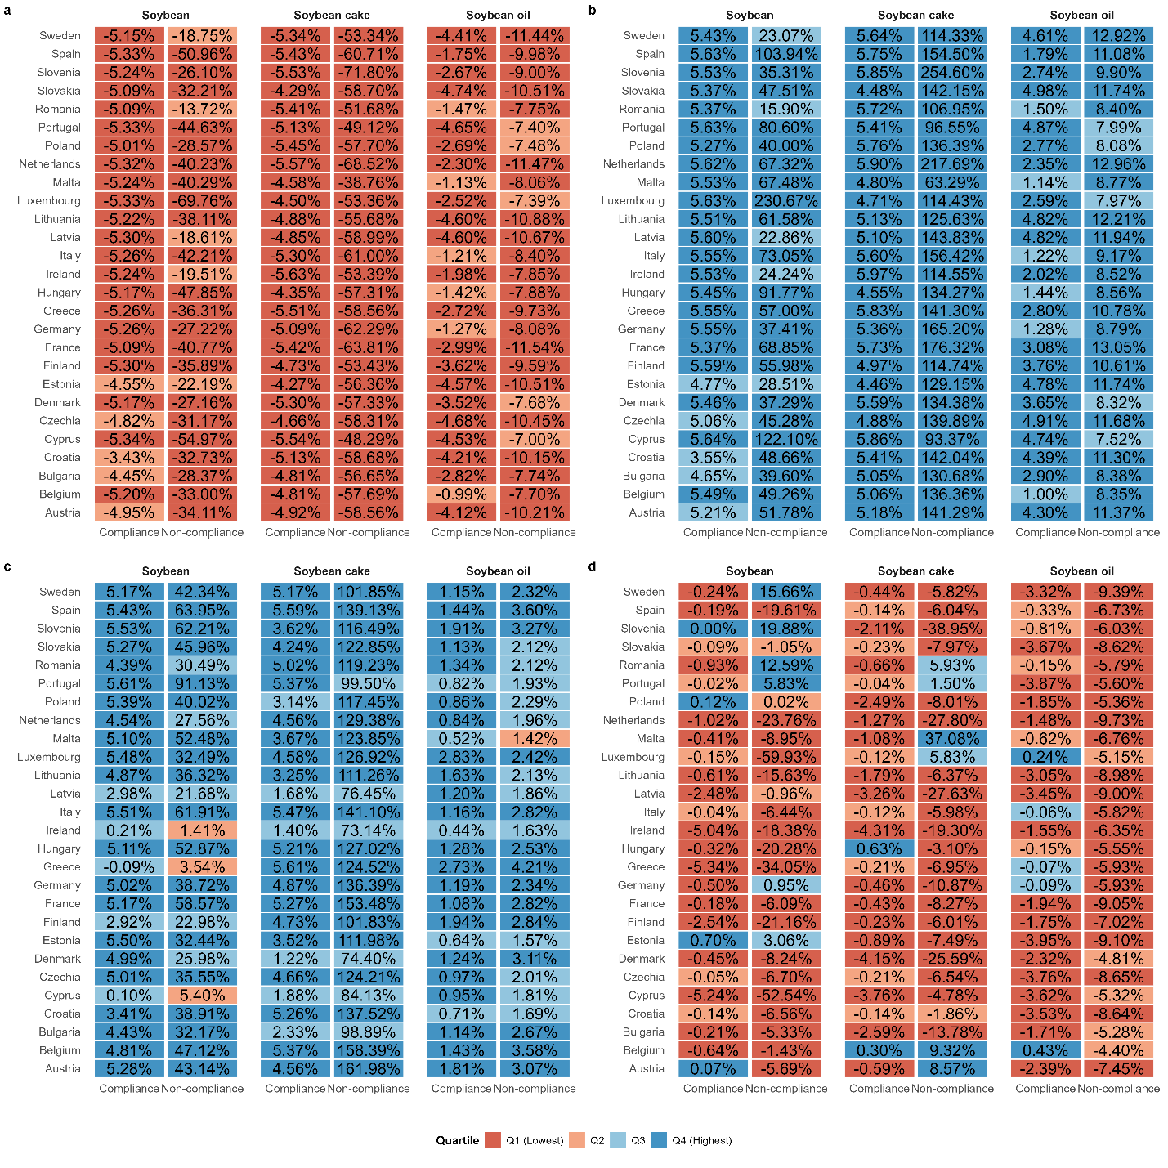
Figure A5.1: Effects of the EUDR on the EU countries, relative to a baseline without the EUDR. (a) Welfare changes (b) Price index changes (c) Producer price changes (d) Terms of trade change. Quartiles are measured at the scenario-product level.

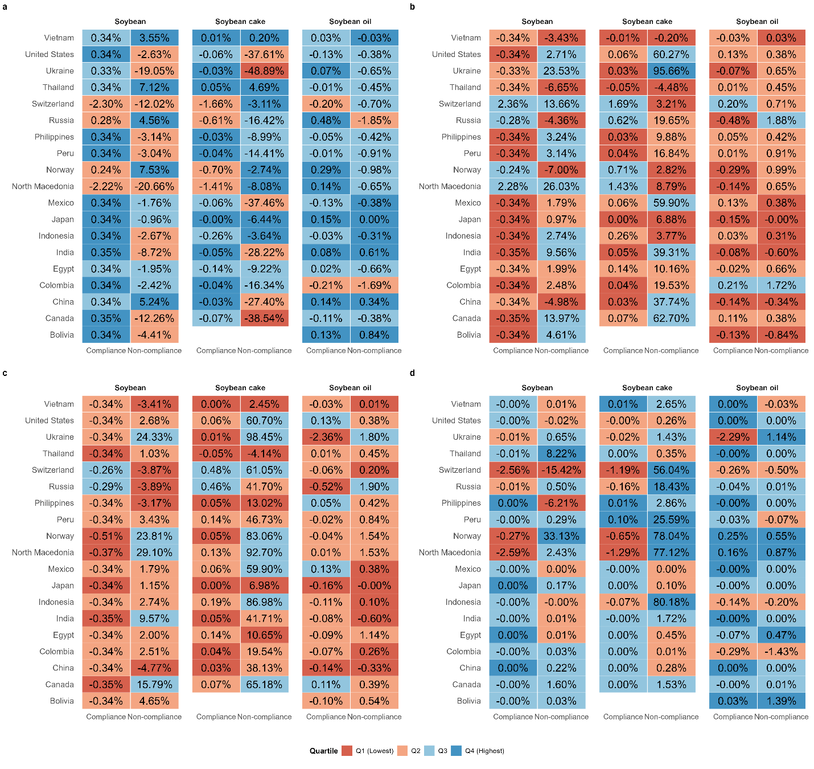
Figure A5.2: Effects of the EUDR on the selected countries, relative to a baseline without the EUDR. (a) Welfare changes (b) Price index changes (c) Producer price changes (d) Terms of trade change. Quartiles are measured at the scenario-product level.

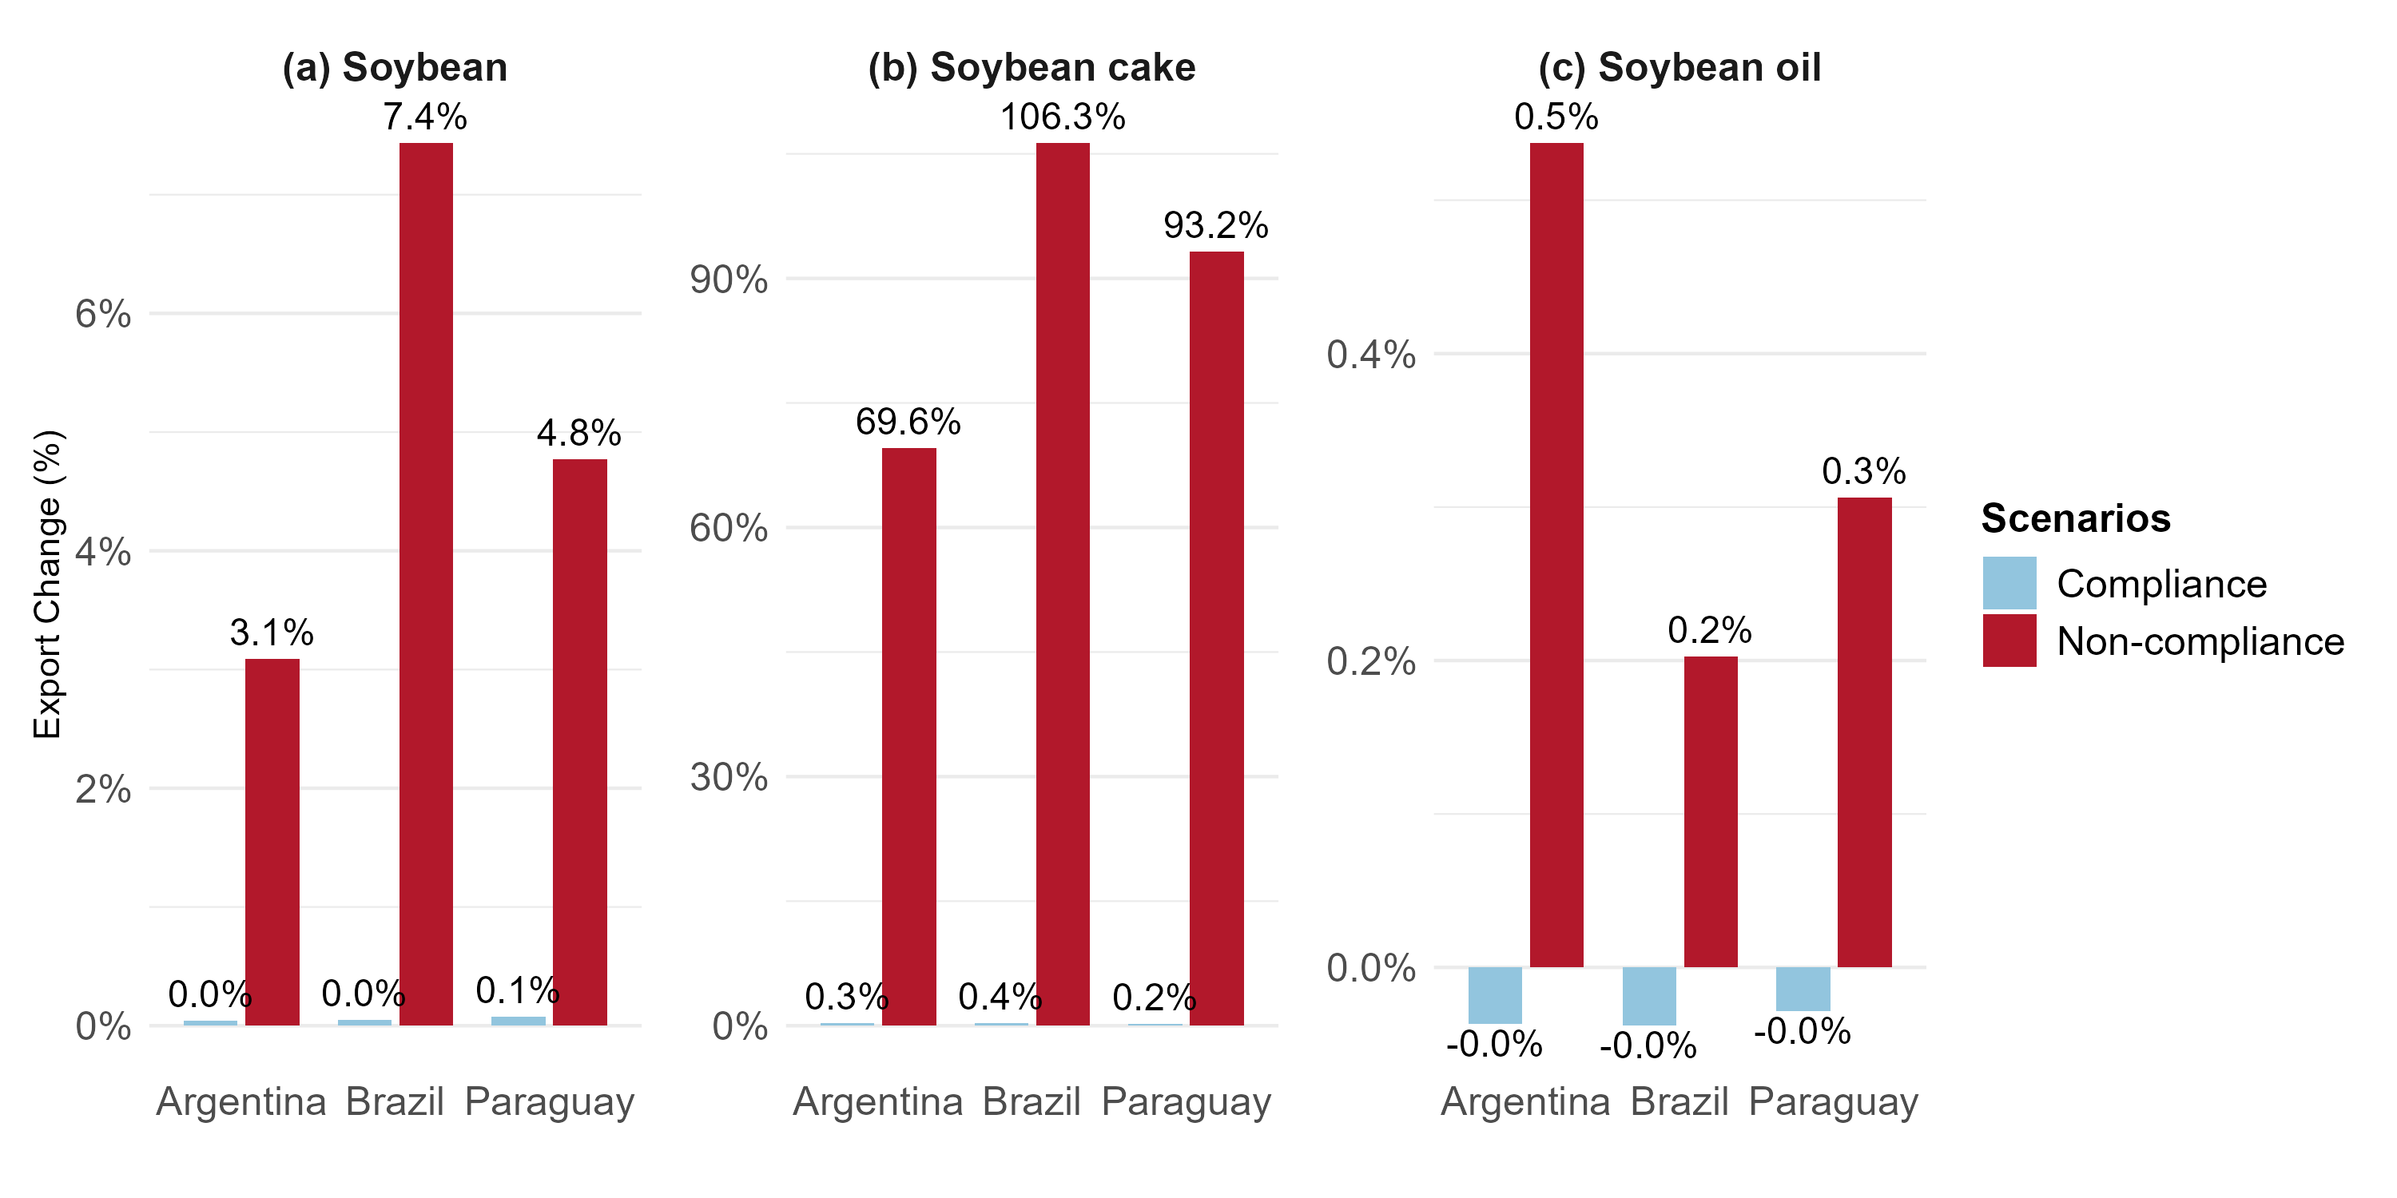
Figure A5.3: Change in exports from BAP assuming that supply remains constant, relative to a baseline without the EUDR. Quartiles are measured at the scenario-product level. The compliance and non-compliance scenarios are denoted by Com. and Non-com.

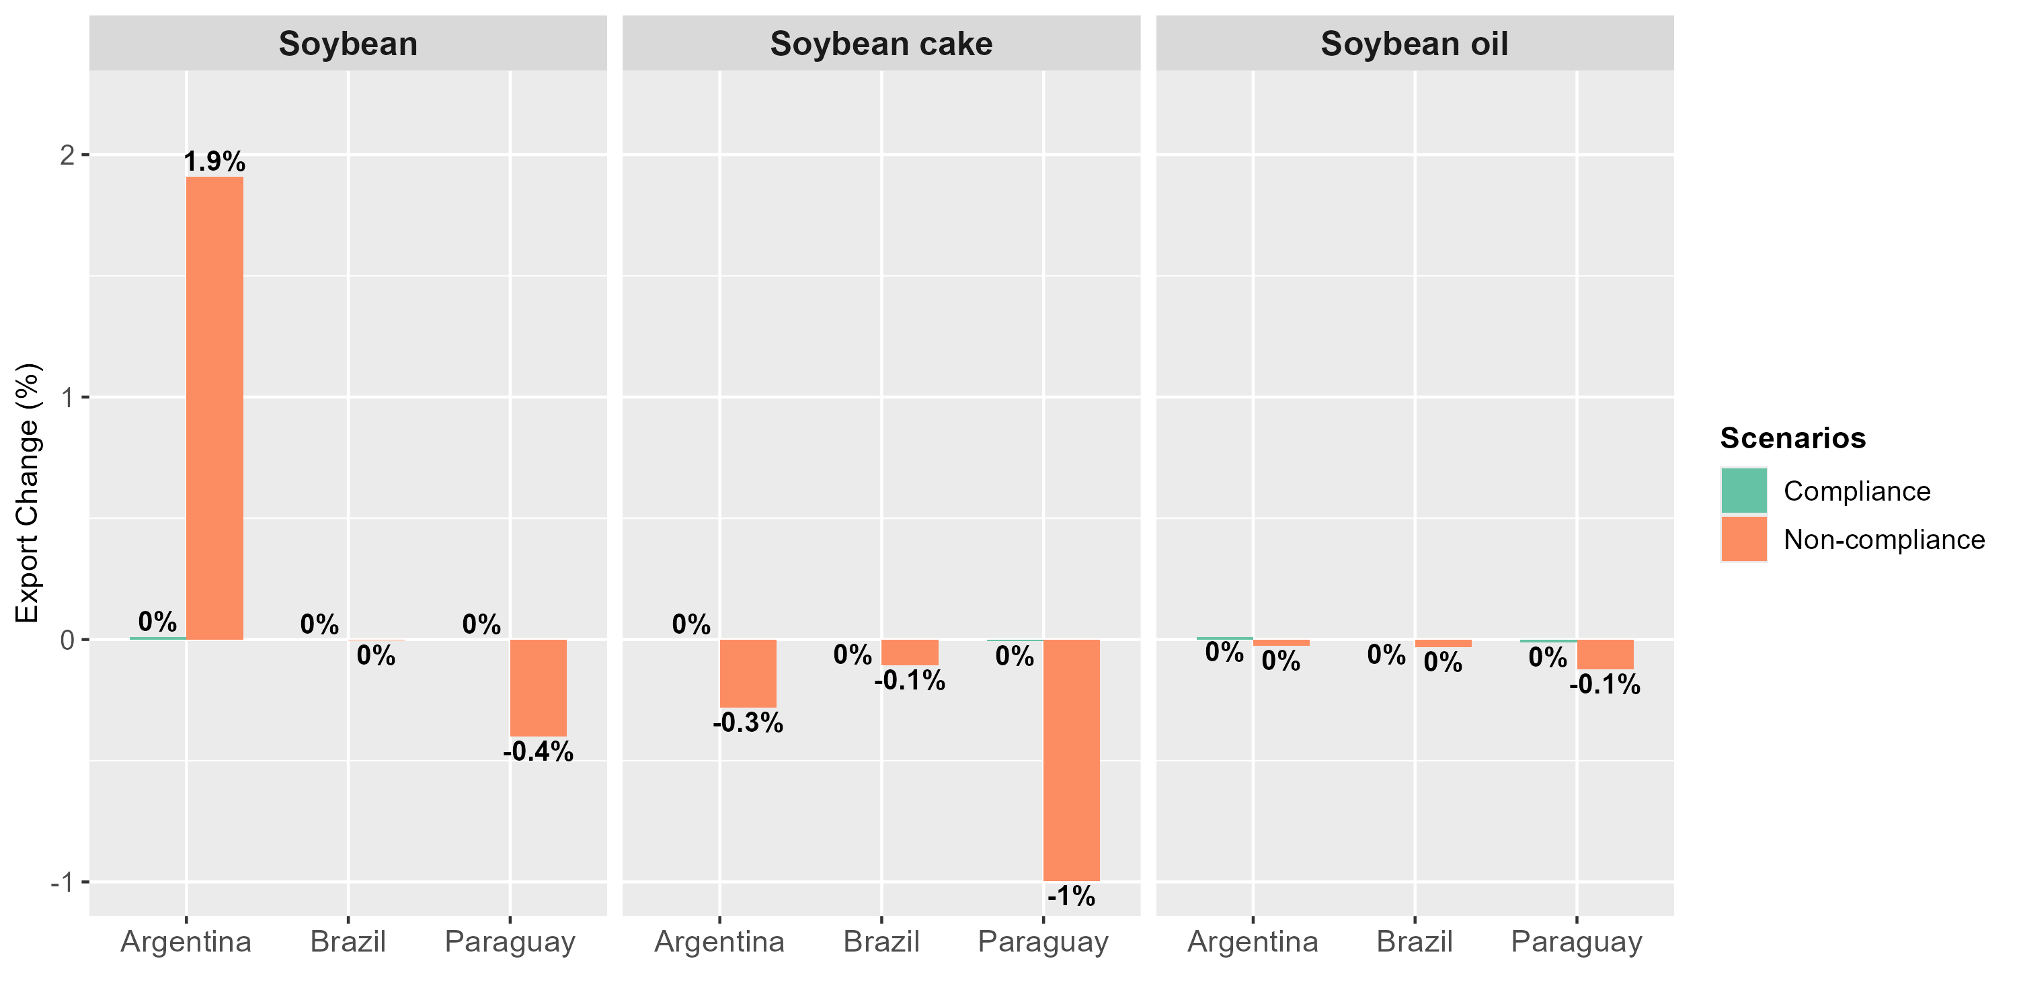
Figure A5.4: Change in exports from BAP with both supply and expenditure held constant, relative to a baseline without the EUDR. Quartiles are measured at the scenario-product level.

A6. Sensitivity check
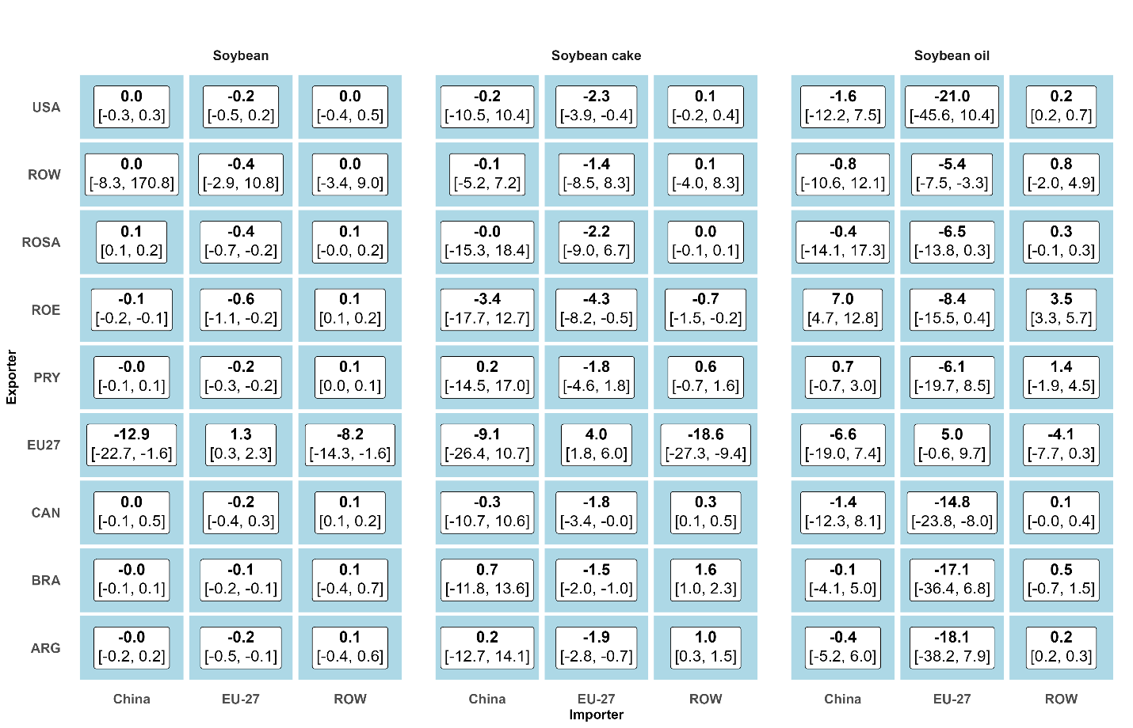
Figure A6.1: Sensitivity check under the compliance scenario. The left value in brackets denotes the minimum and the right value denotes the maximum across nine sub-scenarios, defined by three compliance cost levels (low, medium, and high) under lower, baseline, and upper-bound Armington elasticities. The bold value indicates the change in exports relative to the 2022 baseline without the EUDR, evaluated under the medium compliance cost and baseline Armington elasticities. Low, medium, and high compliance correspond to 2%, 6%, and 10% ad valorem tariff-equivalent compliance costs for EU imports, respectively.

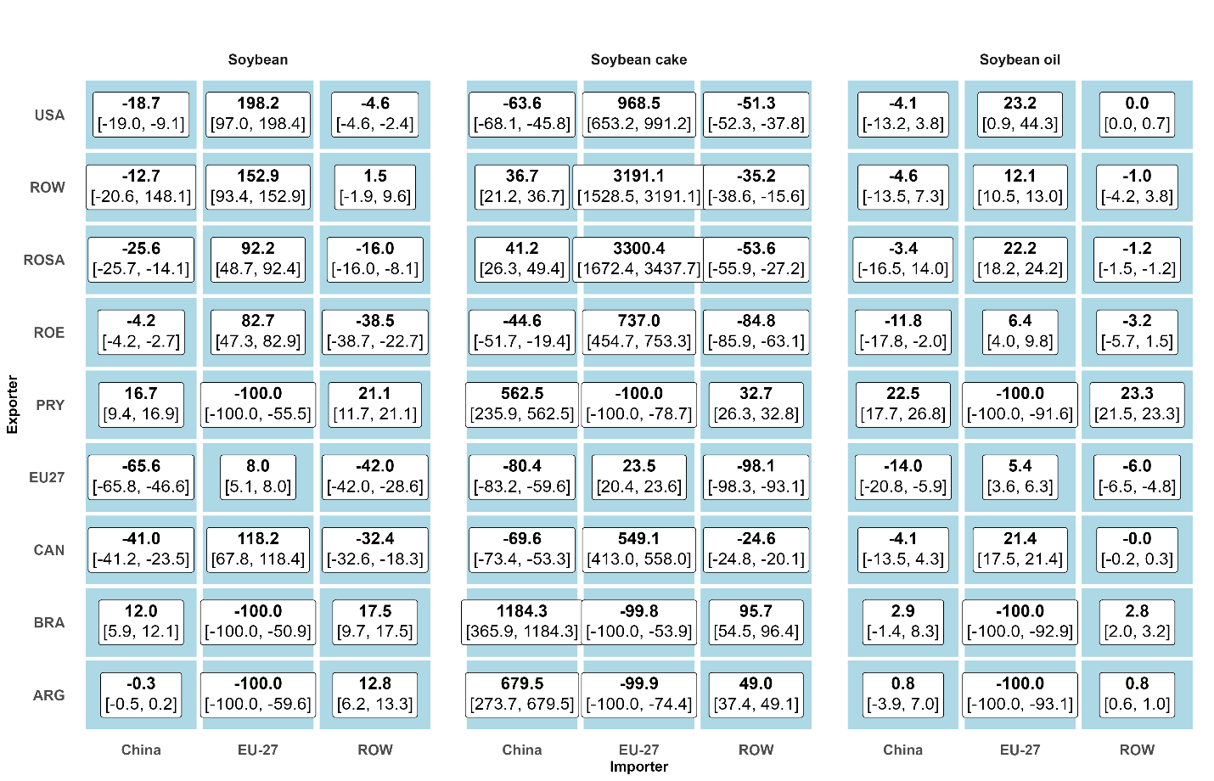
Figure A6.2: Sensitivity check under non-compliance scenario. The left value in brackets denotes the minimum and the right value denotes the maximum across nine sub-scenarios, defined by three compliance cost levels (low, medium, and high) under lower, baseline, and upper-bound Armington elasticities. The bold value indicates the change in exports relative to the 2022 baseline without the EUDR, evaluated under the medium compliance cost and baseline Armington elasticities. Low, medium, and high compliance correspond to 2%, 6%, and 10% ad valorem tariff-equivalent compliance costs for EU imports, respectively.
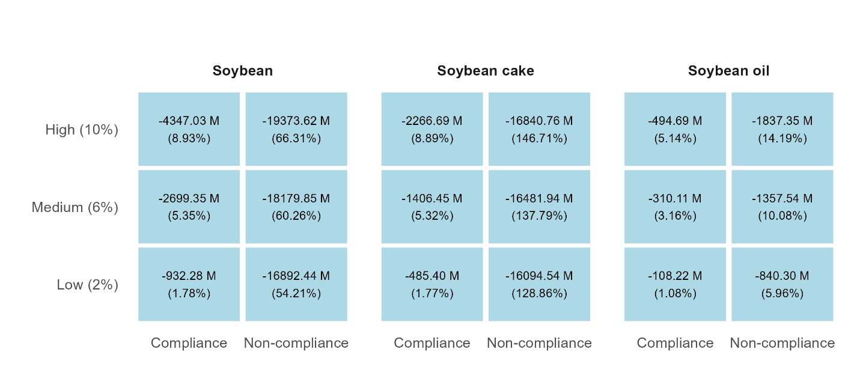
Figure A6.3: Sensitivity check for expenditure changes under different compliance costs. Changes in expenditures are measured relative to the baseline year 2022 without the EUDR. Lower, medium and higher compliance denote 2%, 6% and 10% ad valorem tariff-equivalent compliance costs for EU imports.

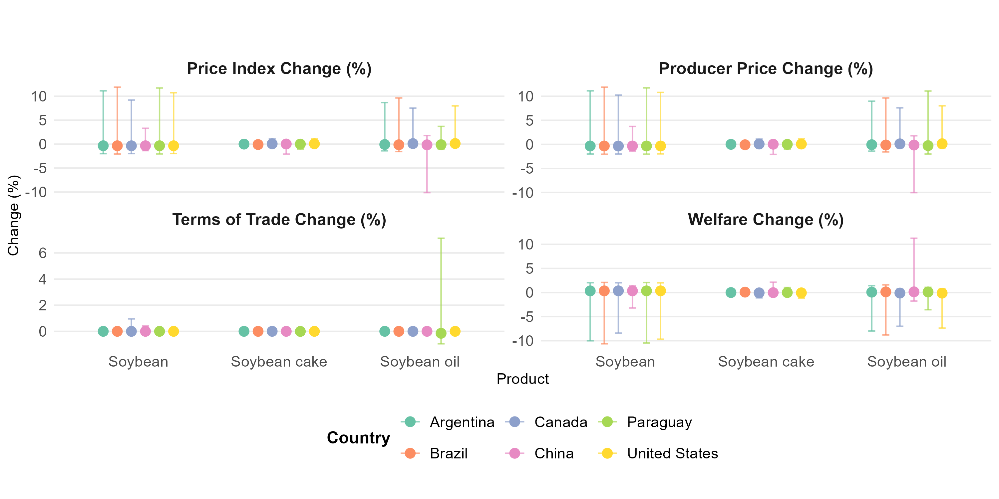
Figure A6.4: Sensitivity check for indexes under compliance scenario. Changes in indexes are measured relative to the baseline year 2022 without the EUDR. Points in the error bar represent indices change evaluated under the medium compliance cost and baseline Armington elasticities. Error bars represent the minimum and maximum across nine sub-scenarios, defined by three compliance cost levels (low, medium, and high) under lower, baseline, and upper-bound Armington elasticities.

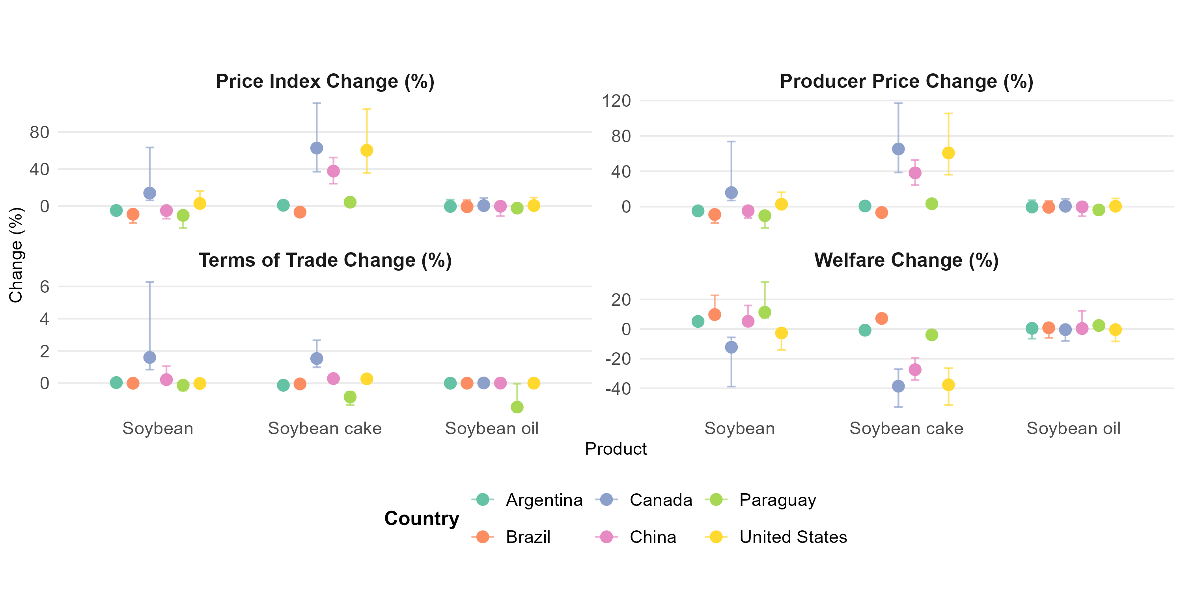
Figure A6.5: Sensitivity check for indexes under non-compliance scenario. Changes in indices are measured relative to the baseline year 2022 without the EUDR. Points in the error bar represent indices change evaluated under the medium compliance cost and baseline Armington elasticities. Error bars represent the minimum and maximum across nine sub-scenarios, defined by three compliance cost levels (low, medium, and high) under lower, baseline, and upper-bound Armington elasticities.

Brazil’s soy sector has long‑running zero‑deforestation efforts. In the Amazon, the Soy Moratorium- implemented by firms handling ~90–95% of exports- was associated with a 57% reduction in direct soy‑deforestation in treated municipalities; in the Cerrado, several traders have adopted ZDCs but implementation and coverage remain incomplete (Gollnow et al. 2022)

