Costly Regulation, Minimal Results: The EU's Deforestation Regulation Effect on Global Soy Trade
The European Union Deforestation Regulation (EUDR) seeks to reduce deforestation by restricting market access to deforestation-embodied soy products in the EU market. The main concern is that such restrictions could shift the soy trade to unregulated non-EU markets. To shed light on this issue, we employ a gravity model, treating the EUDR compliance costs as additional trade costs for exports to the EU. We find that stricter compliance costs reallocate soy exports from South America toward non-EU markets, mainly China, divert the EU imports towards North America, and increase the prices of soy faced by EU soy users. Under the counterfactual scenario in which South America does not comply with the regulation, EU consumers face even larger price increases, while South American countries experience minimal terms-of-trade losses. Our analysis suggests that trade reallocation to an unregulated market could potentially dilute the impact of the EUDR, making it less effective in directly reducing deforestation linked to soy production.
JEL-Codes: Q17, Q56, F18
Keywords: EUDR, Structural gravity model, Deforestation, Soy, Tariffs

1. Introduction
The European Union Deforestation Regulation (EUDR) prohibits the import of seven commodities—palm oil, cattle, soy, cocoa, coffee, rubber, and wood (including their derivatives) collectively known as forest risk commodities (FRCs), unless they meet three criteria: being deforestation-free, compliant with source country legislation, and covered by a due diligence statement (European Union 2023). These requirements act potentially as a non-tariff measure (NTM) to achieve environmental objectives by imposing deforestation-free production and traceability obligations on suppliers (Srivastava, Banerjee, and Banerjee 2025). The regulation supports the EU’s international commitments on climate change, including the EU Green Deal and the Paris Agreement (European Union 2023). The implementation of the EUDR is anticipated to reduce tropical deforestation by 71.92 thousand hectares per year (the equivalent of ~101 thousand football pitches, which is 0.72% of annual global deforestation), avoiding the emissions of 32 million tons of carbon per year (~0.09% of annual global emissions) (KPMG 2023).
The EUDR’s unilateral and market access reduction approach to curb deforestation has raised concerns about its effectiveness. The studies of climate policy and environmental trade policies have consistently shown that the carbon and market leakage effects, whether occurring within or across borders, undermine policy effectiveness, creating tension between environment and trade goals (e.g., Aichele and Felbermayr 2015; Shapiro 2021; Villoria et al. 2022). In the soy sector, Villoria et al. (2022) finds that within-border displacement of deforestation is a notable risk in Brazil, as exports exposed to restrictions in one sub-region shift deforestation pressures elsewhere within the country. More broadly, the global commodity market often reallocates deforestation pressure, particularly when relatively smaller destination markets implement regulatory measures (Muradian et al. 2025). Given that the EUDR is a new regulation, it is crucial to evaluate whether its market access restrictions can effectively reduce deforestation.
While the EUDR is understood as an environmental NTM (Srivastava, Banerjee, and Banerjee 2025; Zamani and Pelikan 2026), the effects are a priori, ambiguous. NTMs can either disrupt or facilitate trade, with heterogeneous effects across products, measure types, and country pairs (Li and Beghin 2012; Santeramo and Lamonaca 2019). That being said, there is evidence suggesting that environmental technical measures in food and agricultural products reduce trade (Fontagné, Mimouni, and Pasteels, 2005). Globally, environmental non-tariff measures have been expanding rapidly, increasing the coverage of 3% to 16% of world trade between 2010 and 2020, and on average, reducing trade with effects varying by sector and exporter characteristics (Santeramo, Lamonaca and Emlinger, 2025). These facts, taken together, motivate an understanding of the EUDR's potentially sizeable and heterogeneous effects across soy products and trade partners.
We analyze the impact of the proposed EU trade restrictions on the soy sector, using separate gravity models of soybeans, soybean oil, and soybean cake. We focus on the soy sector because (i) soybean expansion is an important driver of deforestation in South America, particularly Brazil (Song et al. 2021); (ii) the EU is the second-largest global importer of soybeans, accounting for 9.88% of global exports, and the largest importer of soybean meals—which constitutes 23.82% of global soy trade, with approximately 24% of global exports (Comtrade 2024); (iii) the EU’s consumption accounts for 32.80% of the deforestation associated with soybean production (Pendrill et al. 2022; European Union 2023). We estimate the Armington elasticity of each product and simulate the EUDR implementation by modeling the EUDR compliance costs as increased trade frictions, consistent with the NTM literature’s treatment of technical measures as ad valorem tariff-equivalent frictions (e.g., Fontagné et al. 2005; Santeramo and Lamonaca 2019; Santeramo et al. 2025). We develop two scenarios: one in which all countries comply with the EUDR, and another in which three major deforestation-risk countries- Brazil, Argentina, and Paraguay (BAP)- do not comply. These countries account for 59.3%, 6%, and 4.4% of deforestation linked to soybean production, respectively (Persson et al. 2024). We estimate the counterfactual trade flows under these scenarios using the procedure developed by Anderson, Larch and Yotov (2018) for the base year 2022, which holds supplies and expenditures constant while allowing domestic and bilateral trade to adjust in response to changes in trade costs and multilateral resistances stemming from the compliance costs. This approach enables us to evaluate the EUDR’s effects on trade flows and price indexes.
Three key findings emerge from our analysis. First, the EUDR is largely ineffective at reducing soy exports from the focus countries. This is because the EU accounts for only a small share of exports from BAP (~8%), while demand from China is strong. Any entry restriction into the EU faced by BAP is offset by increased Chinese imports, while the EU can substitute with soy originating in the US and Canada. As a result, deforestation-embodied trade shifts from the EU to China. Second, the EU incurs a significant increase in soy prices, as much as 51%. In contrast, China and other Asian countries benefit from lower prices. Third, major exporters see no change in their terms of trade.
Our study makes two main contributions. First, we provide direct evidence of trade reallocation in the soy sector under the EUDR. Specifically, we show that soy trade shifts from the EU market to China, pointing towards little to no change in deforestation pressure; to the extent that trade is simply relocated, on may expect minimal cross-border deforestation leakage, a fact suggested in the ex-ante modeling of policies with effects similar to the EUDR by Villoria et al. (2022). This finding reinforces concerns raised in research (e.g., Aichele and Felbermayr 2015; Copeland, Shapiro and Taylor 2022; Villoria et al. 2022) about the limited effectiveness of unilateral trade policies covering relatively smaller markets. Second, our analysis highlights the broader challenges of using trade restrictions to achieve environmental goals, contributing to the literature of environmental-trade relations (Shapiro 2021; Felbermayr, Peterson and Wanner 2024). This issue underscores two tensions in the multilateral trade system: concerns from deforestation-risk countries about the discriminatory nature of the EUDR restrictions, and policy trade-offs between environmental objectives and market access (Larch and Wanner 2017; Farrokhi and Lashkaripour 2024). The experience with the EU’s REACH suggests that, over time, stringent European technical regulations can diffuse as trading partners harmonize to retain market access (Cha and Koo 2021), but the short run is characterized by compliance burdens and trade reallocation; the very dynamics we document for soy under the EUDR.

2. The EUDR, the global soy market, and implications for deforestation
The EUDR—Regulation (EU) 2023/1115 adopted on June 2023, and postponed to come into effect on December, 2025—repeals the EU Timber Regulation (EUTR) and goes beyond timber (wood) legality standards by including the six additional agricultural commodities (including their derivatives based on Harmonized System (HS) of classification): oil palm, cattle, soy, cocoa, coffee, and rubber (European Union 2023). The EUDR prohibits the trade of products whose supply chain is linked to either deforestation or forest degradation and mandates due diligence for tracing the origin of their products and providing evidence that they are sourced from non-deforested land. The regulation applies directly to the soy processors and supply companies that must verify the lack of deforestation along the supply chain, using geospatial data, land tenure documents, and compliance records with local laws. Enforcement of the regulation is the responsibility of the EU member states, which must establish robust monitoring and evaluation mechanisms, requiring the companies to submit due diligence statements and maintain traceability throughout the supply chain. When companies are found to breach due diligence statements, the member state can charge penalties of at least 4% of the annual turnover, confiscate the soy products or revenue, impose a temporary exclusion from public procurement, and impose a temporary prohibition from placing soy products on the EU market. Further, member states will conduct checks based on the risk benchmarking of the country of origin, including document reviews and field inspections. For example, major soy-producing South American countries, such as Brazil, Argentina, Paraguay, and Bolivia, fall under the standard risk category, and the member states conduct compliance checks on at least 3% of companies sourcing soy products from these countries annually.
Four soy products based on the HS codes are subject to the EUDR: HS 1201 (soybeans whether or not broken), HS 120810 (Soybean flour and meal), HS 1507 (Soybean oil and its fractions, whether or not refined, but not chemically modified) and HS 2304 (oilcake and other solid residues, whether or not ground or in the form of pellets, resulting from the extraction of soybean oil). Soybeans account for 64.91% (USD 90.97 billion) of these products, followed by 0.36%, 10.34%, and 24.39%, respectively.
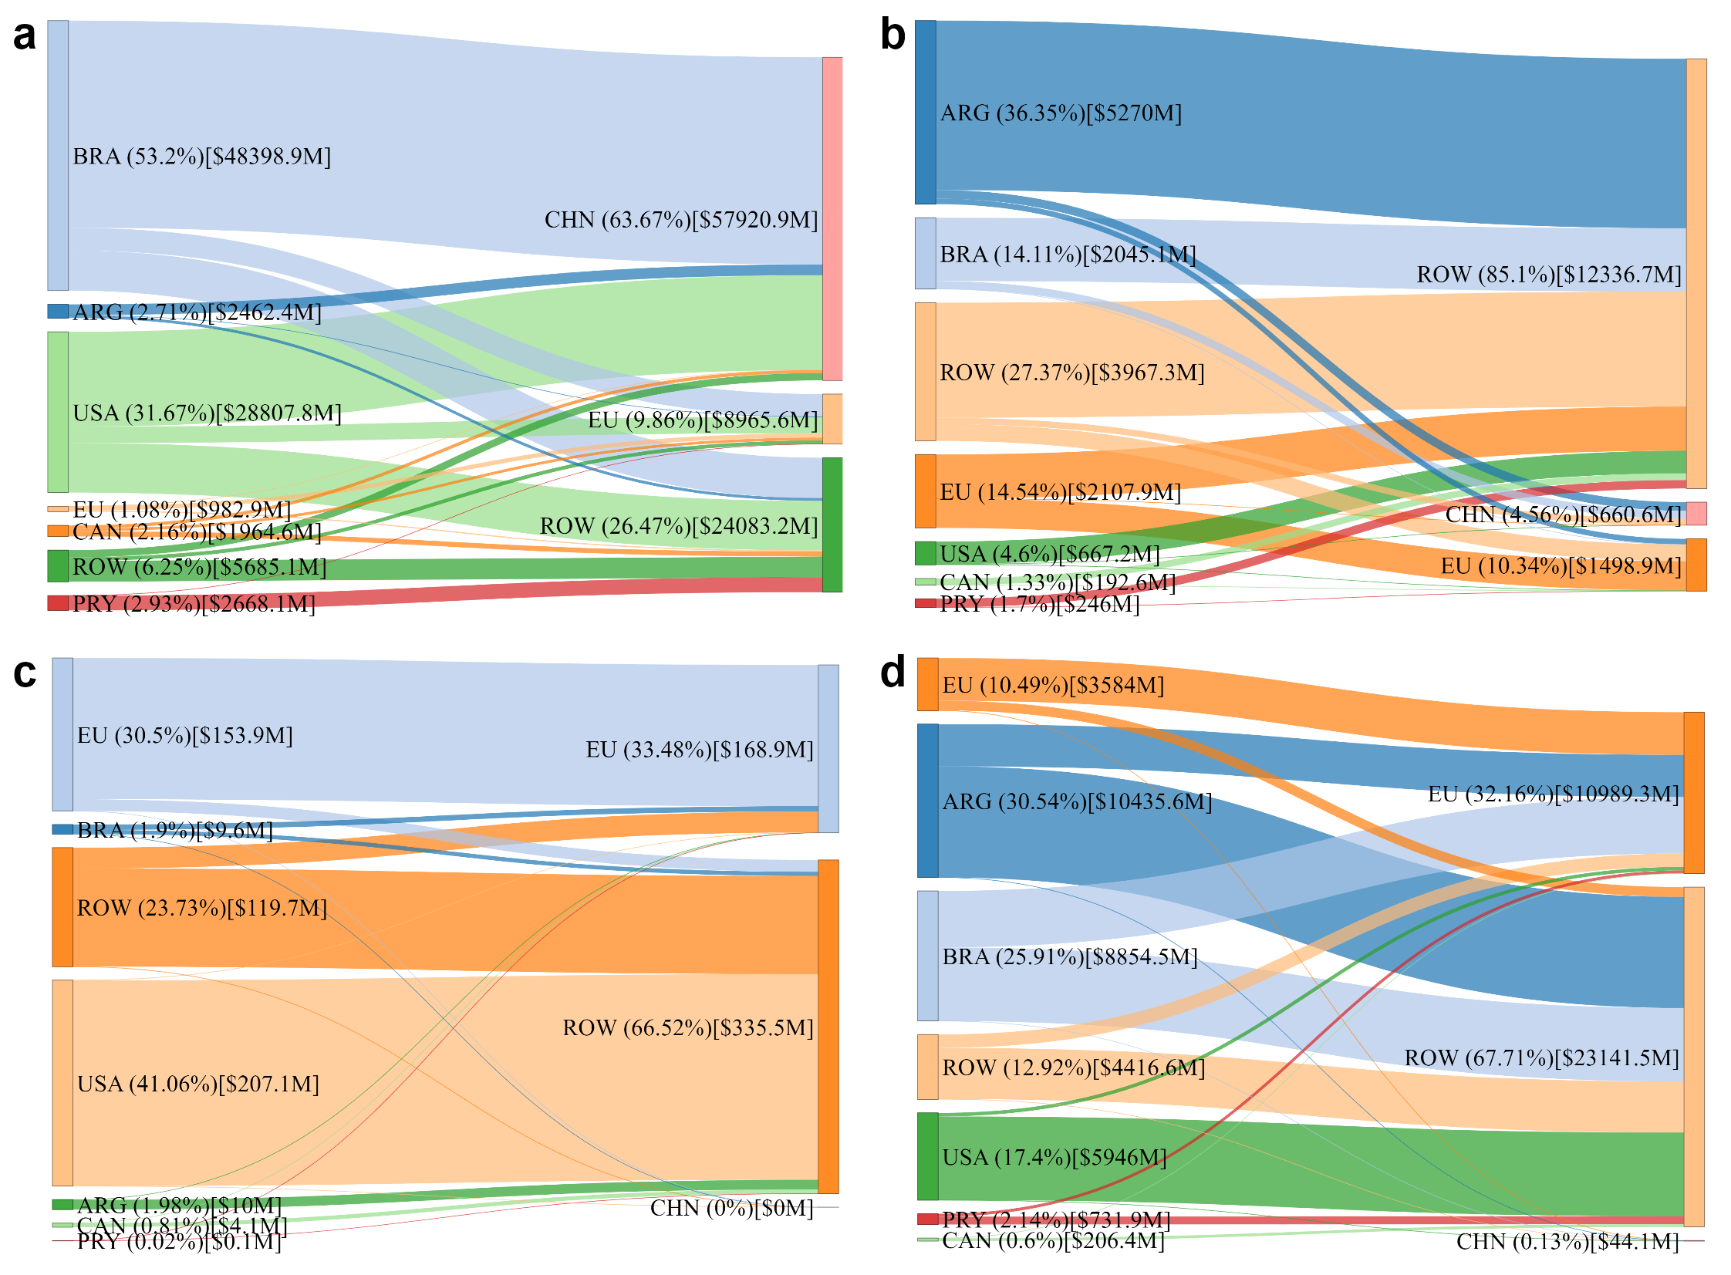
Figure 1: Global trade flows of the soy market. (a) Soybean (HS1201) trade flows, which share 64.91% of the total soy trade. (b) Soybean oil (HS1507) trade flows, which share 10.34% of total soy trade. (c) Soybean flour and meal (HS120810) trade flows, which share 0.36% of total soy trade. (d) Soybean oil cake (HS2304) trade flows, which share 24.39% of total soy trade. Trade flows are based on cumulative values from 2021 to 2023. The values in the brackets represent the average export and import values over the same period. The left side of the plot indicates exporters, while the right side indicates importers.
Source: UN Comtrade Database (Comtrade 2024)
The global soybean market is characterized by three important features: (1) The increased production of soybeans is largely attributed to expanded land area. Between 2010 and 2021, the global harvested area for soybeans increased by 20.59%, leading to an 18% rise in production. This growth was driven primarily by land expansion (85%) and, to a lesser extent, yield improvements (15%) (Cassman and Grassini 2020). In Brazil, soybean production increased ninefold between 1990 and 2020, with much of this expansion occurring at the expense of natural ecosystems such as the Amazon and Cerrado (Umburanas et al. 2022; Fehlenberg et al. 2017). (2) The global soybean market represents one of the largest and most concentrated agricultural commodity trades, dominated by three major players: the US, Brazil, and China (Gale, Valdes and Ash 2019). Brazil and the US collectively account for over 80% of global soybean exports, while China alone imports more than 60% of global soybean imports, as illustrated in figure 1. Although a relatively minor player in raw soybean and soybean oil imports, at 9.88% and 10.34%, respectively, the EU remains the leading importer in the global soybean meal and oilcake markets, representing 32.16% of the imports (see appendix table 4.1 for details on the EU’s trade share). In addition, the soybean oil market is relatively more fragmented than the soybean cake and soybeans market. This fragmentation distributes market leverage more evenly across multiple sources and destinations, unlike the concentrated markets for soybean cake and soybeans. (3) Few companies control the global soy supply chain (Heron, Prado and West 2018; Gouveris 2024). In Brazil, six multinational corporations—Archer Daniels Midland (ADM), Bunge, Cargill, Louis Dreyfus Company (LDC), Glencore, and Amaggi—together were responsible for 56.6% of soy exports and 66.3% of export-related soy deforestation risk over 2008 and 2017 (Ermgassen et al. 2020). These companies play a pivotal role in shaping supply chains and compliance with regulations.
The EUDR has faced criticism despite its aim to reduce tropical deforestation. Producer countries argue that the regulation is imposed unilaterally, ignoring their forest protection efforts (Noordwijk, Leimona and Minang 2025; Fisher et al. 2024). The regulation’s data-intensive compliance is a major challenge, especially for multinational companies that struggle to trace commodity origins. For instance, although about 95% of soy from the Amazon and Cerrado in 2020 was deforestation-free, verifying this for EU compliance remains difficult (Vasconcelos et al. 2023). Similar administrative burdens for data verification of foreign emissions are a central concern in the EU’s Carbon Border Adjustment Mechanism (CBAM) debate (see Bellora and Fontagné 2023), highlighting that data collection costs matter a lot for environmental-cum-trade regulations. Such rules may also exclude smallholder farmers, including indigenous and local communities, as collecting geospatial data and land-tenure documents is costly and complex (Bürgi and Oberlack 2023; Noordwijk et al. 2025; Fisher et al. 2024), with mapping costs estimated at $30–$40 per plot (Gilbert 2024). Finally, since the EU represents a small share of the global soybean market, its influence is limited. This could result in segregated supply chains, with compliant soy sent to the EU and non-compliant ones sold elsewhere, leading to no change in deforestation (Oliveira et al. 2024; AgUnity 2023).

3. Conceptual framework and empirical strategy
To analyze the potential effects of the EUDR on global soy trade, we employ the structural gravity model of Anderson and van Wincoop (Anderson and Van Wincoop 2003). In this framework, the bilateral trade flows ($X_{ijt}$) of soy products at time $t$, where $i$ denotes exporters and $j$ denotes importers, are a function of supply and demand shifters and the costs associated with bilateral trade, along the entire universe of trading partners. The gravity equation is given by:
$$X_{ijt}=\frac{Y_{it}E_{jt}}{Y_{t}}{\left(\frac{t_{ijt}}{Π_{it}P_{jt}}\right)}^{1-σ}, \left(1\right)$$
where ($Y_{it}$) is the total soy supply from the exporter $i$, ($E_{jt}$) is the total soy expenditure of importer $j$, and ($Y_{t}$) is total world production/consumption of soy. The parenthetical term captures trade costs, including bilateral trade cost ($t_{ijt}$) and multilateral resistance terms: outward multilateral resistance (OMR, $Π_{it}$) and inward multilateral resistance (IMR, $P_{jt}$). These resistance terms are expressed as follows:
Πit1-σ=j​tijtPjt1-σEjtYt, 2
Pjt1-σ=i​tijtΠit1-σYitYt. 3
These equations illustrate the interconnectedness of bilateral trade flows across all the countries that participate in trade. For example, when China imposed a 25% retaliatory tariff on US soybeans in 2018, the resulting increase in trade costs between the US and China directly reduced their bilateral trade. At the same time, trade between China and Brazil increased as the relative trade costs between these two countries decreased. Such relationships are captured by the trade cost term $t_{ijt}$ within the OMR and IMR, reflecting how changes in trade costs in one bilateral relationship can affect trade flows across all the country pairs that are connected through trade.
Following Silva and Tenreyro (2006), equation (1) can be expressed in multiplicative form as:
$$X_{ijt}=exp\left(α_{it}+α_{jt}+α_{ij}+\sum_{k=1}^{n}{α_{k}}d_{k,ijt}\right)ϵ_{ijt}, \left(4\right)$$
where, bilateral trade cost ($t_{ijt}^{1-σ}$) is captured by $exp\left(α_{ij}+\sum_{k=1}^{n}{α_{k}}d_{k,ijt}\right)$, incorporating both time-invariant costs (e.g., geographic distance, contiguity) through $exp\left(α_{ij}\right)$ and $k$ number of time-varying costs (e.g., tariffs, trade agreements) through $d_{k,ijt}$. Baier and Bergstrand (2007) emphasize to include country-pair fixed effects ($α_{ij}$) which captures time-invariant factors sepific to each country pair. These fixed effects also address the potential by accounting for unobserved, long-term factors such as historical trade relationships that might otherwise bias the estimates. The term $exp\left(α_{it}+α_{jt}\right)$ represents exporter-time and importer-time fixed effects, corresponding to $\frac{Y_{it}E_{jt}}{Y_{t}}{\left(\frac{1}{Π_{it}P_{jt}}\right)}^{1-σ}$. As Feenstra (2002) suggests, these fixed effects capture OMR, IMR, and market sizes that vary at the exporter-year and importer-year levels. Santos Silva and Tenreyro (2006) recommend estimating equation (4) using the pseudo-Poisson maximum likelihood (PPML) approach, which allows including zero trade flows in the dependent variable. In addition, this leads to unbiased and consistent estimation of the parameter under heteroskedasticity.

3.2 Estimation of Armington elasticities
We estimate separate gravity models for soybeans, soybean oil, and soybean cake. Our empirical model employs the PPML-gravity specification, as shown below:
$$X_{ijt}^{s}=exp\left(γ_{it}^{s}+γ_{jt}^{s}+γ_{ij}^{s}+γ_{1}^{s}log\left(1+τ_{ijt}^{s}\right)\right)ε_{ijt}^{s}, \text{(}\text{5}\text{)}$$
where $s$ indexes the soy products, with $s∈\{\text{soybean},\text{soyoil},\text{soycake}\}$. $X_{ijt}^{s}$ are the exports of soy products country $i$ to country $j$ at time $t$ and $τ_{ijt}^{s}$ is the corresponding effectively applied ad valorem tariff rate. $γ_{it}$, $γ_{jt}$ and $γ_{ij}$ are exporter-year fixed effects, importer-year fixed effects and country-pairs fixed effects, respectively. The purpose of using effectively applied tariffs is two-fold: first, to estimate Armington elasticities; and second, to incorporate an ad valorem tariff‑equivalent of the EUDR compliance cost on the EU imports, which facilitates counterfactual computations in the absence of separate non‑tariff elasticities. Following Anderson et al. (2018) and Fontagné, Guimbard and Orefice (2022), the elasticity estimation of any price shifter (i.e. tariff) in the gravity model can be used to recover Armington elasticities which are $1-γ_{1}^{s}$ in our case.

3.3 The EUDR simulation
We simulate the effects of the EUDR by computing the changes in trade costs incurred by South American exports when entering the EU and re-estimating the multilateral resistance terms in equations 2 and 3 that satisfy the new equilibrium. Under the structure of the gravity model, the multilateral resistance terms capture changes in CES price indices, which are a mesure of the costs to consumers of soy products. The multilateral resistance terms also allow computing supply prices, which capture the effects of the EUDR on suppliers. The CES price index is an indirect utility function, and as such, it is the cost of achieving a given level of utility. The supply prices along the CES price indices can be used to compute changes in the terms of trade. The process of estimating the equilibrium quantities and prices is parsimonious in so far it only requires estimating equation (5) to get the estimated fixed effects and the trade elasticity (more on this below); with the estimated elasticities in hands, new trade costs are calculated, and equation 5 is estimated again subject to the constraint that $γ_{1}$ in equation 5 equals one. This constrained optimization generates the importer- and exporter-year fixed effects that are consistent with the modified trade costs. These equilibrium fixed effects are in turn used to retrieve the new equilibrium prices and quantities.
The cost of this parsimony, is that aggregated supply and expenditures of each country are unchanged, with the change in trade patterns driven directly by compliance costs: directly for the affected exporters, and indirectly by shifts in trade patterns with third countries through multilateral resistance terms (see appendix A2 for the decomposition).
Further, we model the EUDR as a destination-specific measure that raises the marginal cost of delivering soy from origin to the EU. As the legal obligation falls on ‘operators’ (importers, traders, and processors), these firm-level expenditures can be passed on to upstream and downstream depending on marketing structure, creating an effective ad valorem (iceberg) wedge on the EU-bounded flow. In a structural gravity framework, what matters for bilateral trade is this price wedge, which we represent in the form of ‘tariff-equivalent”. Our focus is on the EUDR’s effectiveness in mitigating soybean-related deforestation by examining economic pressure faced by high-risk countries, particularly Brazil and other South American countries. If these countries experience unfavorable changes in export potential, price indexes, producer prices, and terms of trade, it suggests that compliance pressures can incentivize anti-deforestation practices. The methodology for measuring these effects is described below:
Step 1: Estimation of baseline trade costs
Using the trade elasticities derived from equation (5), we estimate the country-pair fixed effects, exporter fixed effects, and importer fixed effects. We then fit these fixed effects, taking the base year 2022, as shown in equation 6. For the ease of notation, we omit product superscripts, $s$:
$$X_{ij}=exp\left({\tilde{γ}}_{1}log\left(1+τ_{ij}\right)+{\tilde{γ}}_{i}^{\left[BLN\right]}+{\tilde{γ}}_{j}^{\left[BLN\right]}+{\tilde{γ}}_{ij}^{\left[BLN\right]}\right). \text{(}\text{6}\text{)}$$
Using the expenditure, sales, and PPML fixed effects, we recover OMR and IMR consistent with the structural gravity terms, as demonstrated by Fally (2015). The PPML ensures that the fixed effects are adjusted so that the corresponding multilateral resistances are consistent with the tariff elasticity. A unique feature of the PPML is that fitted expenditures (or sales) equal observed expenditures (sales), resulting in: j​Xij=j​Xij=YiBLN and i​Xij=i​Xij=EjBLN.
To construct baseline OMR and IMR, we normalize all the fixed effects relative to Australia, denoted as $E_{0}$. According to Yotov et al. (2016), the reference country should be the one that is presumably not significantly affected by the counterfactual shock. The idea is to make the “relative” counterfactual changes in multilateral resistances as close as possible to their “absolute” counterparts.
$${\tilde{\left[Π_{i}^{1-σ}\right]}}^{BLN}=\frac{{\tilde{E}}_{0}}{{\tilde{Y}}_{i}}exp\left(-{\tilde{γ}}_{i}^{\left[BLN\right]}\right), \text{(}\text{7}\text{)}$$
$${\tilde{\left[P_{j}^{1-σ}\right]}}^{BLN}=\frac{{\tilde{E}}_{j}}{{\tilde{E}}_{0}}exp\left(-{\tilde{γ}}_{j}^{\left[BLN\right]}\right). \text{(}\text{8}\text{)}$$
Practically, many country pairs involve zero trade flows. For such pairs, $exp\left({\tilde{γ}}_{ij}\right)$ is not available. To recover the fixed effects of all country pairs, we conduct the regression using equation (6) for those with available country pair fixed effects. We then estimate all $γ$ parameters and predict $exp\left({\tilde{γ}}_{ij}\right)$ for the missing country pair fixed effects.
$$exp\left({\tilde{γ}}_{ij}\right)=exp\left[γ_{i}+γ_{j}+γ_{2}ln\left(DIST_{ij}\right)+γ_{3}CNTG_{ij}+γ_{4}LANG_{ij}+γ_{5}CLNY_{ij}\right]⋅ε_{ij}. \text{(}\text{9}\text{)}$$
Therefore, the baseline trade cost is estimated as below:
$${\tilde{\left[t_{ij}^{1-σ}\right]}}^{BLN}=\left\{\begin{matrix}exp\left({\tilde{γ}}_{ij}\right)exp\left({\tilde{γ}}_{1}log\left(1+τ_{ij}\right)\right), & \text{if }X_{ij}>0\text{ for at least one period,} \\ \tilde{exp\left({\tilde{γ}}_{ij}\right)}exp\left({\tilde{γ}}_{1}log\left(1+τ_{ij}\right)\right), & \text{if }X_{ij}=0\text{ for all periods.}\end{matrix}\right. \text{(}\text{10}\text{)}$$
Step 2: Construction of scenarios and counterfactuals
We estimate counterfactual trade costs by adding ad valorem tariff-equivalent to unilateral EUDR compliance costs on the tariffs for the exports to the EU countries in equation (10):
$${\tilde{\left[t_{ij}^{1-σ}\right]}}^{CFL}=\left\{\begin{matrix}exp\left({\tilde{γ}}_{ij}\right)exp\left({\tilde{γ}}_{1}log\left(1+τ_{ij}^{CFL}\right)\right) \\ \tilde{exp}\left({\tilde{γ}}_{ij}\right)exp\left({\tilde{γ}}_{1}log\left(1+τ_{ij}^{CFL}\right)\right),\end{matrix}\right. \text{(}\text{11}\text{)}$$
where $τ_{ij}^{CFL}=τ_{ij}+EUDR_AVE_{i,EU}$. Under the baseline condition of the year 2022, the $EUDR_AVE_{i,EU}$ is zero, meaning there is no effect of the EUDR trade restriction. We model EUDR as an ad valorem compliance wedge on EU-bound imports, consistent with structural gravity practice of representing policy change as ad valorem trade-cost changes (Larch, Tan and Yotov 2021). We assign $EUDR_AVE_{i,EU}$ from external estimates on scenario-specific price-wedge at the EU border in the spirit of price-wedge/tariff-equivalent AVE discussed by Kravchenko et al. (2022) and Bellora and Fontagné (2023).
We simulate two scenarios for the implementation of the EUDR. In the first scenario, all countries comply with the regulation, which we will refer to as the “compliance” scenario hereafter. We assume that compliance costs impose trade frictions to enter the EU market. According to the EU impact assessment paper (European Commission 2021), the estimated compliance costs for soy range from 32.3 to 478.7 million euros. Adding these compliance costs to the EU’s imports, the rough estimate of the increase in expenditure lies between 0.29% and 4.29% (Rabobank 2023). Additionally, the European Feed Manufacturers’ Federation (FEFAC) projects that procurement costs for EUDR-compliant soy meal will rise by 5–10%, potentially leading to a similar increase in the price index of the soybean cake in the EU (European Feed Manufacturers’ Federation (FEFAC) 2024). Further, the suppliers may incur additional costs to demonstrate and transition to deforestation-free production. We model this as an increase in trade costs of a magnitude equivalent to the estimated increase in price or expenditure. We choose a conservative middle value trade cost increase of 6%, equivalent to an increase in a 6% ad valorem tariff, to simulate the compliance scenario as shown below:
$$EUD{R_AVE}_{i,EU}^{comp}=\left\{\begin{matrix}0.06, & \text{if }j∈EU\text{ and }i∉EU \\ 0, & \text{otherwise}\end{matrix},\right. (12)$$
In the second scenario, termed “non-compliance” scenario hereafter, the EU market is closed to selected deforestation-risk tropical countries- Brazil, Argentina, and Paraguay. These countries are chosen because they are the largest suppliers of soy to the EU, accounting for 39.05%, 11.53%, and 1.14% of total EU soy imports, respectively (see appendix table A4.1), and are also major contributors to deforestation. An analysis conducted by Singh and Persson (2024) using a four-year attribution window for deforestation measurement identifies Brazil as the largest contributor, with 59.3% of global soybean-related deforestation, followed by Bolivia (15.5%), Argentina (6.0%), and Paraguay (4.4%) in 2020. However, the EU’s share in the exports of Brazil, Argentina, and Paraguay is only 8.06%. If these countries expect that compliance costs outweigh their benefits from compliance, it is possible that exporters may shift to alternative markets. This economic logic is consistent with the analytical model proposed by Gilbert (2024), which illustrates that producers will invest in the EUDR compliance only when the European premium exceeds their compliance costs plus the logistic costs of selling to non-EU markets. We model the second scenario for an increase in trade costs to a prohibitive level, effectively shutting down exports to the EU market, as shown below:
$$EUD{R_AVE}_{i,EU}^{ncomp}=\left\{\begin{matrix}H_{s}, & \text{if }i∈\left\{BRA,ARG,PRY\right\},j∈EU \\ 0.06, & \text{if }i∉\left\{BRA,ARG,PRY,EU\right\},j∈EU \\ 0, & \text{otherwise}\end{matrix}\right., (13)$$
where $H_{s}$ is a product-specific prohibitive wedge. In our counterfactual gravity estimation, a 5000% AVE shuts down the export of soybeans to the EU market, while a lower AVE (~700%) shuts down the export of soybean oil and cake. This is reasonable because the trade elasticity of soybeans is lower than that of soybean oil and cake.
Step 3: Estimate conditional gravity
Using counterfactual bilateral trade costs from equation (11), we estimate counterfactual fixed effects with the constrained regression in equation (14), holding trade costs fixed and allowing fixed effects to adjust for changes in multilateral resistance due to compliance costs.
$$X_{ij}=exp\left[γ_{i}^{CFL}+γ_{j}^{CFL}+θlog{\tilde{\left[t_{ij}^{1-σ}\right]}}^{CFL}\right]ε_{ij}^{CFL},s.t.θ=1 \text{(1}\text{4}\text{)}$$
With the estimated counterfactual fixed effects and trade cost, the counterfactual trade flows are predicted as:
$${\tilde{X}}_{ij}^{CFL}={\tilde{\left[t_{ij}^{1-σ}\right]}}^{CFL}exp\left[{\tilde{γ}}_{i}^{CFL}+{\tilde{γ}}_{j}^{CFL}\right]. \text{(1}\text{5}\text{)}$$
Step 4: Estimate and report effects
We measure compliance-induced change in exports from the country $i$ to country $j$ in percent as: $\left(\frac{{\tilde{X}}_{ij}^{CFL}}{{\tilde{X}}_{ij}^{BLN}}-1\right)*100\%$. A positive value indicates an increase in exports from $i$ to $j$ while a negative value indicates a decrease in exports.
As suggested by Anderson et al. (2018), welfare change in the conditional scenario is equivalent to a change in the price index, as calculated below:
$${\hat{W}}_{i}=\left(\frac{{\tilde{Y}}_{i}^{CFL}}{{\tilde{P}}_{i}^{CFL}}\right){\left(\frac{{\tilde{Y}}_{i}^{BLN}}{{\tilde{P}}_{i}^{BLN}}\right)}^{-1}=\frac{{\tilde{P}}_{i}^{BLN}}{{\tilde{P}}_{i}^{CFL}},∀i, \text{(1}\text{5}\text{)}$$
where, the output is kept exogenous in the ‘conditional’ scenario, i.e. $\tilde{Y_{i}^{CFL}}=\tilde{Y_{i}^{BLN}}$. $\tilde{P_{i}^{BLN}}$ is estimated using equation (8), while ${\tilde{P}}_{i}^{CFL}$ is estimated analogously using the corresponding counterfactuals. However, this is only possible after obtaining the power transformation of the IMRs. We estimate the elasticity of substitution $\left(σ\right)$ from the tariff elasticity $\left({\tilde{γ}}_{1}\right)$ as $σ=1-{\tilde{γ}}_{1}$.
Further, as discussed in Anderson et al. (2018), this procedure allows the estimation of the changes in producer prices $p_{it}$ between the baseline and counterfactual scenarios. These are derived from the change in outward MRTs implied by the estimates ${\tilde{γ}}_{i}^{CFL}$ and ${\tilde{γ}}_{i}^{BLN}$. Within the structural gravity framework, these price changes and terms of trade can be calculated as:
$${\hat{p}}_{i}=\frac{{\tilde{p}}_{i}^{\left[CFL\right]}}{{\tilde{p}}_{i}^{\left[BLN\right]}}={\left[\frac{exp\left({\tilde{γ}}_{i}^{CFL}\right)}{exp\left({\tilde{γ}}_{i}^{BLN}\right)}\right]}^{\frac{1}{1-σ}} \text{(1}\text{6}\text{)}$$
$$\hat{TOT_{i}}=\frac{{\hat{p}}_{i}}{{\hat{P}}_{i}} \text{(1}\text{7}\text{)}$$

4. Data
To conduct empirical analyses, we construct a panel dataset comprising 90 countries (see appendix A1) covering the period 2007 to 2022. We chose this period because data on effective applied tariffs are available only from 2007 onward, and the bilateral and domestic sales data needed to construct intranational trade flows are available through 2022. Our data covers four key components: (i) international trade flows, (ii) intra-national trade flows, (iii) effectively applied tariffs, and (iv) standard gravity variables.
International trade flows. We compiled a dataset on bilateral trade flows for soy products using the CEPII-BACI database, which is recognized for its detailed and reliable dataset. The BACI database offers several key advantages: (i) it provides data at the product level, categorized using Harmonized System (HS) codes, and (ii) it is more reliable than raw data from Comtrade as it reconciles mirror figures to address discrepancies and improve accuracy (Gaulier and Zignago 2010). For soybeans, the data is constructed using HS code 1200100 for the period before 2012, and HS codes 120110 and 120190 for the period from 2012 onward. Similarly, the trade flows for soybean oil are based on HS codes 150710 and 150790, while those for soybean cake are based on HS code 230400.
Intra-national trade flows. Following Villoria (2025), we estimate intranational trade quantity as production minus exports plus stock variation, using the FAOSTAT Food Balance Sheets database (FAOSTAT 2024). We convert intranational trade quantities to values using prices from the World Bank’s Pink Sheet (World Bank 2025). Because the International Trade and Production Database for Estimation (ITPDE) (Larch, Shikher and Yotov 2025) includes only soybean intranational trade flows, our soybean intranational trade values correlate with ITPDE’s at 0.95.
Effectively applied tariffs. We use bilateral, effectively applied tariff rates obtained from the ITC MacMap database, which ensures accurate representation of tariff rates applied to a particular import during the study period (International Trade Centre 2024). If a preferential tariff exists, it is used as the effectively applied tariff, otherwise the most favored nation (MFN) applied tariff is used.
Standard gravity variables. In addition to trade and tariff data, we include variables capturing geographic and historical relationships between trading partners. These variables, such as distance, shared language, contiguity, and colonial ties, are sourced from CEPII’s gravity database, which is a standard reference for gravity model analyses in international trade (Conte, Cotterlaz and Mayer 2023).
Table 1 presents summary statistics for our dataset, which covers 90 countries as both exporters and importers, resulting in 129600 observations. In our sample, average tariff rates are approximately 10.6% for soybeans, 8.8% for soybean oil, and 4.2% for soybean cake. Figure 2 displays the average tariffs imposed by EU countries on major exporters from 2007 to 2022. Notably, EU tariffs on soybean and soybean cake imports from Brazil, Argentina, Paraguay, and the USA are zero, and tariffs on soybean oil are also very low. Additionally, about 2.9% of country pairs in the sample share a border, 8.2% share a common language, and 3% have colonial ties.
Table 1: Summary statistics of variables used in the study
Variable | Mean or proportion | Standard Deviation | Minimum | Maximum
Year | - | - | 2007 | 2022
Soybean (000' USD) | 16442.776 | 486355.389 | 0.000 | 35442703.415
Soyoil (000' USD) | 5576.757 | 194287.663 | 0.000 | 26468744.300
Soycake (000' USD) | 9865.004 | 311705.833 | 0.000 | 40749116.550
Tariff Soybean | 0.106 | 0.684 | 0.000 | 7.574
Tariff Soybean oil | 0.088 | 0.179 | 0.000 | 1.900
Tariff Soybean cake | 0.042 | 0.102 | 0.000 | 0.715
Distance (KM) | 7496.085 | 4761.858 | 7.000 | 19845.000
Contiguity | 2.9% | - | 0.000 | 1.000
Common Language | 8.2% | - | 0.000 | 1.000
Colonial Ties | 3.0% | - | 0.000 | 1.000
Notes: The total number of observations is 129600 (90 exporters * 90 importers * 16 years).

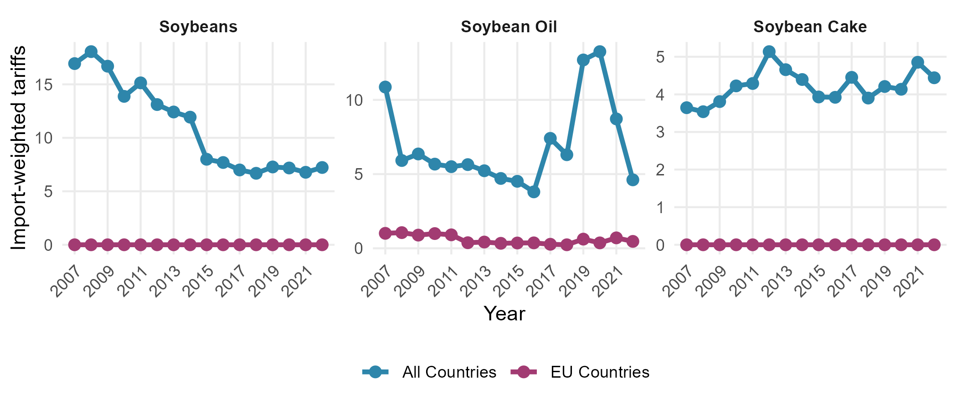
Figure 2: Import-weighted tariffs (%) faced by exporters globally and in EU countries.
Source: Own illustration based on trade data from the BACI database (Gaulier and Zignago (2010)) and tariffs data from the ITC MacMap (International Trade Centre (2024)).
Note: The spikes in import-weighted tariffs for all countries for soybean oil in 2017–2020 reflect increased tariffs by India from 4% in 2016 to 36% in 2020.

5. Results

5.1 Tariffs represent a significant trade cost in the soy market
Table 2 reports the estimated effects of tariffs on the soy product trade flows for the period 2007–2017. We exclude post-2018 trade flows from the trade elasticity estimation to avoid endogeneity arising from China’s retaliatory tariffs on the US soybean export to China. This would also represent normal market responses. Our results reveal trade elasticities of -1.883, -6.394, and -6.227 for soybean, soybean oil, and soybean cake, respectively. Our soybean tariff elasticity (-1.883) is comparable to Fontagné et al. (2022) ’s estimate of -1.254. The estimate is lower than Dhoubhadel, Ridley and Devadoss (2023)’s estimate of -5.83, but higher than the estimates reported by Ridley and Shirin (2024) (-0.879). For soybean oil, our estimate (-6.394) is slightly higher than Ridley and Shirin (2024)’s finding of -5.338. However, our soybean cake elasticity (-6.227) is somewhat lower than Fontagné et al. (2022)’s estimate of -11.92. Using these estimates, we recover the Armington elasticities, which are shown in appendix A3. The elasticity of substitution is lower for soybeans than for processed soy products. A plausible explanation could be that processed products (oil and cake) have numerous substitutes and are readily available across countries, whereas soybeans are relatively homogeneous, which limits their rapid reallocation across sources. Therefore, countries respond with more substitution in processed products despite smaller changes in trade costs relative to soybeans.
Table 2: Effects of import tariffs on soy products using PPML estimates
 | Soybean | Soybean Oil | Soybean Cake
Log(1 + Tariff) | -1.883 | -6.394* | -6.227*
 | (1.253) | (2.667) | (2.993)
Observations | 26619 | 26651 | 20748
R-squared | 0.995 | 0.991 | 0.990
Exporter-Year FE | X | X | X
Importer-Year FE | X | X | X
Pair FE | X | X | X
+ p < 0.1, * p < 0.05, ** p < 0.01, *** p < 0.001

Note: The dependent variables are the unidirectional value (1000 USD) of exports. Standard errors clustered at the country-pairs level. All estimations include exporter-year, importer-year, and pair fixed effects. The inclusion of country-pair fixed effects results in a significant reduction in the number of observations due to persistent zero trade flows between country pairs.

5.2 China, including the rest of the world, absorbs the trade restrictions imposed on BAP
The trade reallocation effects, as shown in figures 3-5, are higher for non-compliance. Under compliance, the trade relationship could possibly remain the same as it is. Under non-compliance, soybean exports to China increase substantially, with Brazil up 12% and Paraguay up 16.7%. The soybean oil exports to China from Brazil, Argentina, and Paraguay increased by 2.9%, 0.8%, and 22.5%, respectively. The largest changes appear in soybean cake exports. Brazil’s soybean cake exports to China surge by 1184.3%, Argentina’s increase by 679.5%, and Paraguay’s increase by 562.5%. Further, all three countries also experience an increase in their exports to the rest of the world.
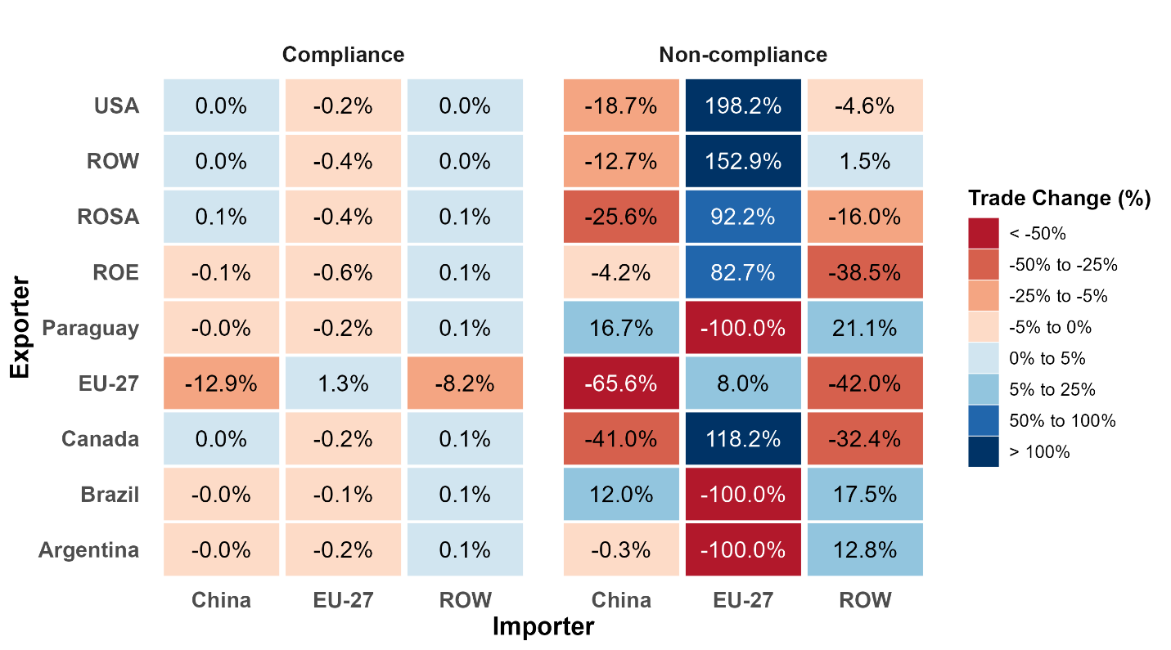

Figure 3: Trade reallocation effect of the EUDR in soybean trade under compliance and non-compliance scenarios. The figure shows the percentage change in exports from the countries and regions in the rows to China, the EU, and the rest of the world (ROW) relative to a baseline without the EUDR. Red denotes a reduction in exports; blue denotes an increase. ROSA: Rest of South America, ROE: Rest of Europe
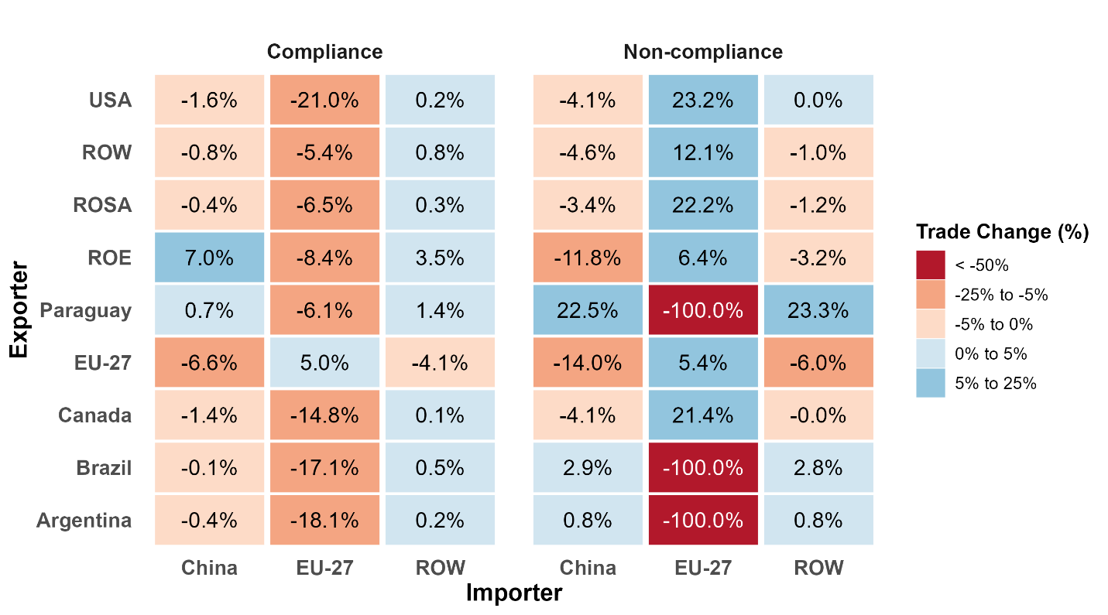
Figure 4: Trade reallocation effect of the EUDR in the soybean oil trade under compliance and non-compliance scenarios. The figure shows the percentage change in exports from the countries and regions in the rows to China, the EU, and the rest of the world (ROW) relative to a baseline without the EUDR. Red denotes a reduction in exports; blue denotes an increase. ROSA: Rest of South America, ROE: Rest of Europe.
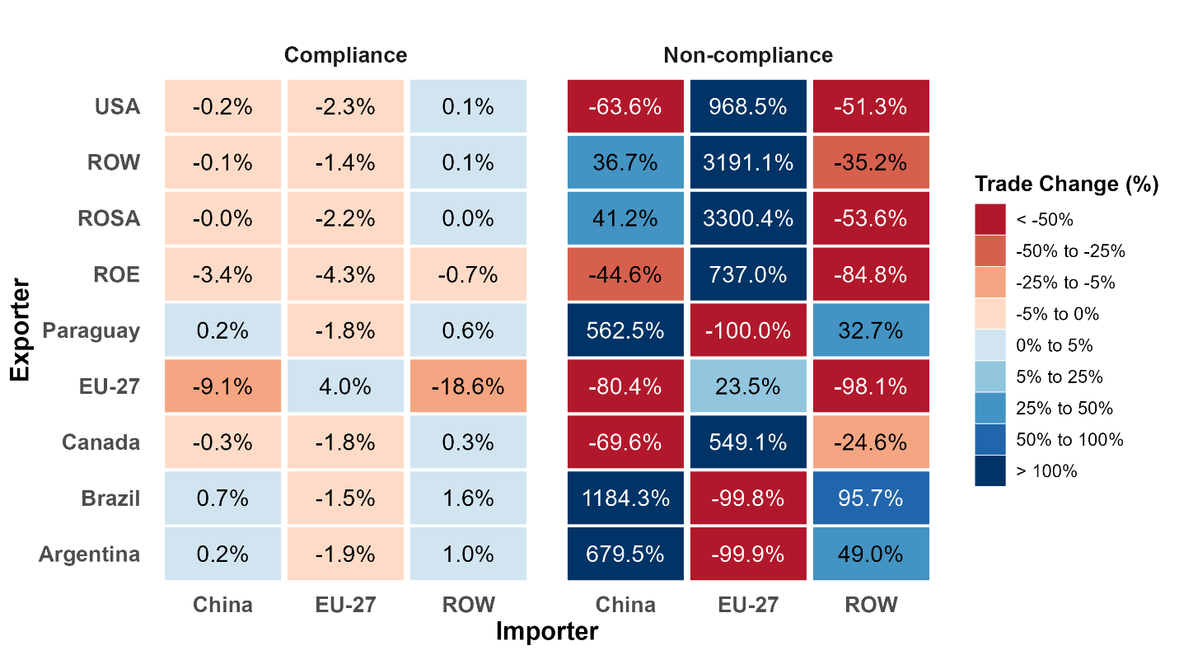
Figure 5: Trade reallocation effect of the EUDR in the soybean cake trade under compliance and non-compliance scenarios. The figure shows the percentage change in exports from the countries and regions in the rows to China, the EU, and the rest of the world (ROW) relative to a baseline without the EUDR. Red denotes a reduction in exports; blue denotes an increase. ROSA: Rest of South America, ROE: Rest of Europe.
5.3 The US and Canada export increase substantially to the EU if restrictions target BAP
In the non-compliance scenario, there is a significant shift of exports to the EU market from the US and Canada. US soybean exports to the EU rise by 198.2%, while Canadian exports increase by 118.2%. Soybean oil exports from both countries grow by about 22-23%. The most dramatic changes are seen in soybean cake exports, with US exports soaring by 968.5% and Canadian exports by 549.1%. This surge is driven by the EU’s large share of the global import market (32.16%, or USD 10,989.3 million), with Brazil and Argentina the top suppliers of soybean cake to the EU with around 65% share of the EU imports.

5.4 The EU faces rising prices and declining terms of trade
As illustrated in figure 6, the EU would bear substantial expenditure loss if BAP do not comply with the EUDR. Among the three products, the EU experiences the highest welfare losses in soybeans, followed by soybean cake and soybean oil. In the soybean trade, EU expenditure losses can reach $18,179.84 million, accompanied by average price increases of 60.26%. The EU could face expenditure losses of $ 1,357.54 million for soybean oil and $ 16,481.93 million for soybean cake. The economic burden is disproportionately concentrated among major European importers, which have larger relative shares of imports (see appendix figure A4.2). Spain, the Netherlands, Italy, and Germany face the largest expenditure losses on soybeans. Similarly, these countries, along with Poland, France, Denmark, and Belgium, experience the highest expenditure losses in soybean cake and soybean oil. Most EU countries experience expenditure losses, increases in producer prices, and increases in price indices but experience decreases in terms of trade (see appendix A5.1(d)). This indicates that the EU lacks sufficient market leverage to benefit from import restrictions, as it remains heavily dependent on imports.
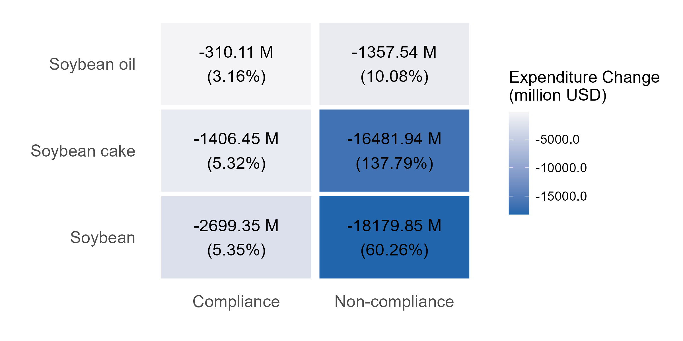
Figure 6: Expenditure loss (million USD) faced by EU27 under the EUDR simulation. The loss is measured relative to the baseline without the EUDR. The percentages in parentheses denote the average change in the price index in the EU countries.
Note: The expenditure loss is measured as $\left[\frac{\tilde{E_{i}^{CFL}}}{\tilde{P_{i}^{CFL}}}-\frac{\tilde{E_{i}^{BLN}}}{\tilde{P_{i}^{BLN}}}\right]$.

5.5 Import restrictions could boost demand for soy products from target countries
Our analysis reveals no significant change in total exports from target countries under either scenario (see figure A5.4). These results reflect the short-run nature of our simulation, which holds total output and expenditures constant and assumes zero supply elasticity. Notably, the decline in producer prices for Brazil, Argentina, and Paraguay points to increased export competitiveness driven by lower prices. We further confirm this by keeping the supply constant for each country but allowing expenditures to change. Under these conditions, we find export growth significant (see figure A5.3). Soybean exports increased by 7.4% for Brazil, 3.1% for Argentina, and 4.8% for Paraguay, directly resulting from lower producer prices in these countries. The effects emerged pronounced in soybean cake exports, with increases of 69.6% for Argentina, 106.3% for Brazil, and a surge of 93.2% for Paraguay. Moreover, soybean oil exports showed minimal growth across these countries, increasing by less than 0.5%.

5.6 BAP face a decrease in the price index of soybeans, but some declines in terms of trade
Figure 7 illustrates the effects of the EUDR on exporting countries. In the soybean and soybean oil, BAP experiences a decline in price indexes and producer prices; however, they see little to no change in terms of trade. However, for soybean cake, BAP sees an increase in price index and a decrease in terms of trade, illustrating the effects of the EUDR on major soy traders. In soybeans and soybean oil, BAP experiences a decline in price indexes and producer prices; however, it sees little to no change in terms of trade. In soybean cake, Paraguay and Argentina see an increase in price index and producer price, while Brazil sees a decrease in both prices.
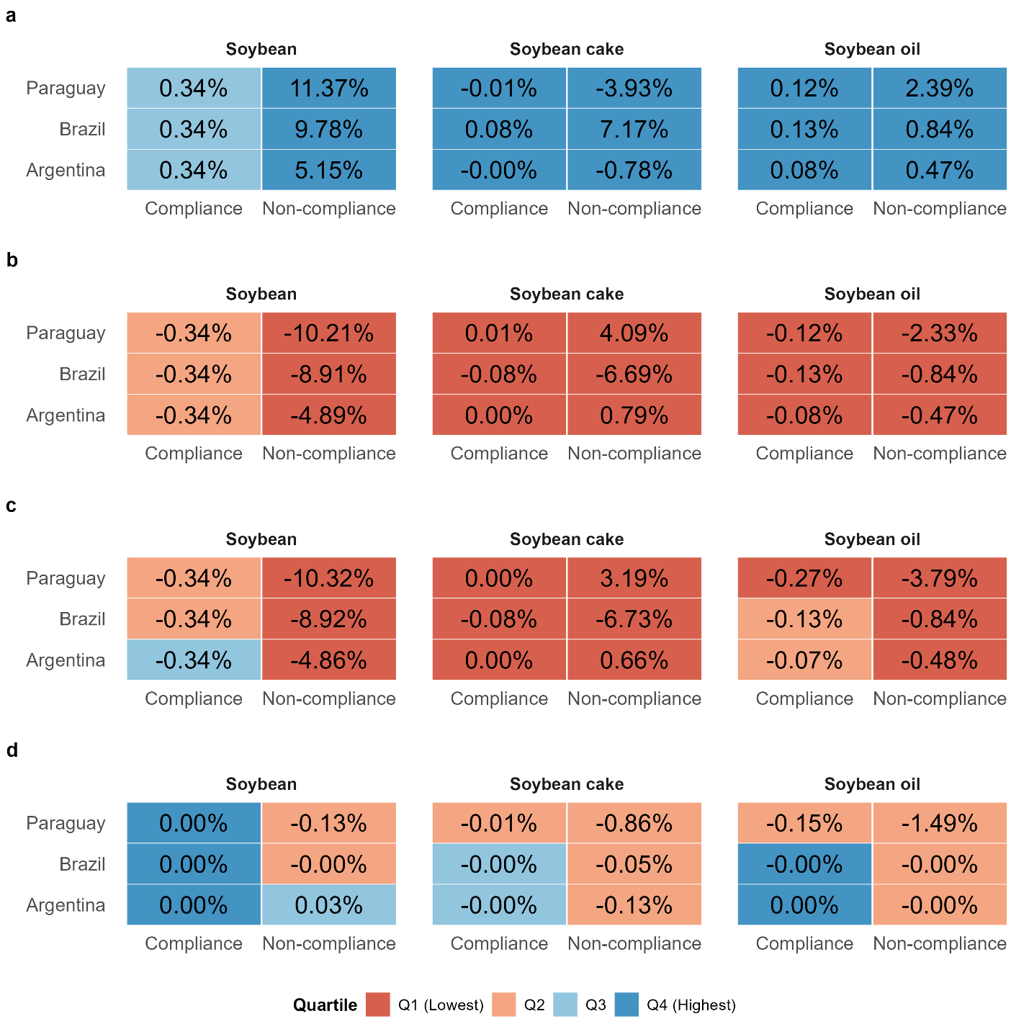
Figure 7: Changes in indices under compliance and non-compliance scenarios relative to a baseline without the EUDR. Quartile is measured at the scenario-product level for each index. (a) percentage change in welfare. (b) percentage change in price index (c) percentage change in producer price. (d) percentage change in terms of trade

6. Sensitivity checks
Our exercise is an ex‑ante assessment of the regulation based on the 2022 base year. We report findings over plausible lower and upper bounds corresponding to 2% and 10% ad valorem tariff-equivalent compliance costs under Armington elasticities at the lower and upper bounds of the 95% confidence intervals. Across these ranges, the qualitative results are stable (see appendix A6): EU substitution toward compliant suppliers and reallocation of restricted South American volumes to non‑EU destinations, mainly China. Higher compliance costs increase the EU price index and amplify welfare losses, but do not reverse the direction of reallocation.

7. Discussions
Our analysis indicates that the EUDR faces notable limitations in reducing exports that drive tropical deforestation linked to the soy sector. The direct competitors to South American soy exporters are the US and Canada, which are largely deforestation-free producers and redirect their exports to the EU under the EUDR implementation. As a result, the soy supply restricted from BAP is reallocated to China. These patterns are consistent with the literature on unilateral regulations, which emphasizes that such measures often induce substantial reallocation of trade and production across countries (Li and Beghin 2012; Branger and Quirion 2014; Böhringer, Rosendahl and Storrøsten 2017). This also aligns with empirical evidence on environmental technical measures and technical barriers to trade, which, on average, tend to reduce trade, particularly for exporters that struggle to comply, while in some cases facilitating or preserving trade for compliant origins (Fontagné et al. 2005; Santeramo and Lamonaca 2019; Santeramo et al. 2025). Recent EUDR-focused modelling studies similarly anticipate that an EU-only measure will mainly reallocate forest-risk commodity trade rather than sharply curtail global production, with displacement toward alternative markets and suppliers (Gilbert 2024; Muradian et al. 2025; de la Vega 2025; Hu et al. 2025). Our results can thus be seen as a soy-specific, model-consistent illustration of this canonical response to unilateral NTMs: supply from high-risk exporters is diverted to third markets, while the EU, under the EUDR, increasingly sources from compliant, largely deforestation-free origins.
With the EUDR in place, the trade reallocation pattern indicates two segregated supply chains: First, the EU can import verifiable deforestation-free soy from North America and, to a limited extent, from South America, where supplies are already deforestation-free. Actually, this partial compliance of South America represents the distributional consequences. Smallholders and smaller firms would lose access to the EU market. Nevertheless, this compliance supply chain represents a small fraction of the total supply chain (~15%). Consequently, with the changed composition of the destination market, the pressure on deforestation in South America does not necessarily decrease. Even with full compliance of South American soy targeted at the EU market, particularly from Brazil, it does not guarantee a reduction in deforestation, as long as the demand pressure for soy from the non-EU market remains constant. Evidence of substantial domestic leakage within Brazil, on the order of 43–50%, suggests that reductions in deforestation in some locations can be offset by increases elsewhere (Villoria et al. 2022).
Second, a conventional supply chain serving the non-EU market (notably China) without compliance requirements. The increasing reliance of South America on the Chinese market may further erode the EU’s leverage in promoting environmental compliance in the future. Understanding the long-term consequences of these trade reallocation patterns is therefore important. In our baseline EUDR simulation, producer prices in BAP fall, and constrained volumes are reallocated toward China. Over longer horizons, the net effect on production and land use in high-risk areas depends on the magnitude and persistence of the price signal, supply elasticities, and how fully China/ROW) absorb displaced flows. Because the EU accounts for a relatively small share of BAP exports, an EU‑only signal may be too weak to induce contraction; if China’s demand expansion keeps producer prices near baseline, output could be sustained, and deforestation pressures may persist or even rise, raising the prospect of a fragmented global soy market less responsive to EU regulations.
The economic implications for the EU are substantial. Certain EU members, such as the Netherlands, Poland, Spain, Germany, France, and Italy, bear disproportionate burdens, reflecting differences in import dependency, processing capacity, and the degree of integration in their supply chains. Gilbert (2024) notes that this creates a “European premium” over global prices, with compliance costs being directly passed on to EU consumers. Further, the loss is also pronounced in soybean cake, despite its lower share in global soy trade, which is due to the higher elasticity of substitution for soybean cake. This result is consistent with the studies by Branger and Quirion (2014) and Böhringer, Rosendahl and Storrøsten (2017), which show that higher trade elasticities increase trade reallocations. According to Noordwijk et al. (2025), the EUDR may cause “collateral damage” to unintended stakeholders. For example, in our analysis, restrictions on BAP increase welfare losses in the US and Canada due to an increase in the price index.
The EUDR, similar to non‑tariff measures, appears to be both a trade catalyst and a barrier. For forest‑risk countries, it functions as a trade barrier, as these countries will be under higher scrutiny and compliance costs could rise. However, the EUDR can catalyse trade within the EU; this provides an opportunity for soy producers and producers of substitute products, such as other vegetable oils and cake, from EU countries. This is evidenced by increased producer prices for soy products in EU countries (see appendix figure A5.1). Trade between compliers (most likely North American exporters) and the EU also rises. This finding is in line with Santeramo et al. (2025), which highlights that the EU TBT has the capacity to redirect imports towards compliant origins.
Our findings on the consequences of the EUDR simulation underscore the limitations of a purely demand-side regulatory. A more effective approach would combine demand-side and supply-side measures, including direct forest conservation incentives, carbon payments, and Contingent Trade Agreements (CTAs) that penalize exporters based on changes in forest cover. Muradian et al. (2025) argue that territorial approaches, such as Brazil’s Amazon Soy Moratorium and the Action Plan for the Prevention and Control of Deforestation in the Legal Amazon (PPCDAm), have been more effective in reducing deforestation by aligning with local public governance. In contrast, the EUDR’s focus on value chain interventions fails to address underlying drivers of deforestation, such as weak governance and land speculation. Harstad (2024b) also emphasizes the importance of balancing depth and breadth in environmental agreements. The EUDR, as a “deep-but-narrow” policy, imposes strict deforestation-free requirements on imports but applies only to the EU market. A “broader-but-shallow” agreement involving multiple major importers with less ambitious regulations could reduce leakage and achieve greater global impact. For instance, a CTA between the EU and the US could potentially reduce agricultural expansion in Brazil by up to 27% compared to unrestricted free trade scenarios (Harstad 2024a; Harstad 2024c).

8. Conclusion
The EUDR is the EU’s first regulatory initiative to curb tropical deforestation through a market access restriction approach on the soy sector. We used a structural gravity model, taking the base year 2022, and assessed the effects of the EUDR under two scenarios: one in which exporters comply with the regulation and another in which BAP do not export soy to the EU. We chose these three countries for the non-compliance scenario because they have faced significant forest loss directly attributable to soybean expansion, are characterized by weak environmental governance, and hold a substantial share of global soy production. Our results show that restrictions on South American exports redirect soy flows toward non-EU markets, mainly China, while EU imports are substituted by US and Canadian suppliers. The regulation appears to be a catalyst for the trade of compliant soy, most likely from North America, and the EU-intra trade, however, at the cost of consumer welfare. The EU experiences expenditure losses due to increased prices arising from compliance costs, leading to deteriorated terms of trade. The expenditure losses are even more severe when South American countries do not comply with the EUDR at all. Conversely, South American countries face declining soy price indices and producer prices with no change in terms-of-trade effects. These findings suggest that the EU lacks sufficient market leverage to incentivize pro-forest land-use decisions among major South American soy producers.
We acknowledge some limitations in our study. Our results are under “conditional” equilibrium in the sense of Anderson et al. (2018), which captures short-run and static trade reallocation and price index effects of the EUDR. This model falls short in offering a discussion on long-run environmental impacts, including endogenous output responses in major producing countries, EU domestic supply responses, and cross-commodity substitution in the vegetable oils complex (e.g., palm, sunflower, rapeseed). Importantly, the model also abstracts from substitution from soybeans toward other oilseeds, which could, for example, shift deforestation from tropical soy production areas to oil palm regions such as Indonesia. Further, if demand from the non-EU market contracts in the future, production by South American producers could also contract, leading to increased avoided deforestation. Modeling these channels requires a multi-sectoral dynamic equilibrium framework with endogenous supply responses, which is beyond the scope of this paper. Finally, we do not model heterogeneous compliance capacity (e.g., partial compliance by larger firms with the exclusion of smaller producers) or subnational leakage dynamics. A subregional trade–land–use model linking destination-specific demand to producing sub-regions would be better suited to assess how EUDR-induced demand shifts affect frontier expansion versus consolidated, low-forest areas.
While our study focuses on the soy sector, future research should also examine the trade reallocation and the possible deforestation leakage for commodities covered by the EUDR, such as palm oil, rubber, cattle, cocoa, coffee, and wood products. Examining indirect land use changes, which may result from a shift in land use pressures to commodities not covered by the EUDR, can be a significant concern. Furthermore, governance and implementation challenges, such as traceability and interactions with local governance, deserve research attention to ensure the regulation’s success.

References
AgUnity. 2023. “Unveiling EU’s green ambitions: The dual impact of EU deforestation regulations on global trade and developing economies.” Available at: https://www.linkedin.com/pulse/unveiling-eus-green-ambitions-dual-impact-eu-deforestation-regulations-91olc [Accessed March 9, 2024].
Aichele, R., and G. Felbermayr. 2015. “Kyoto and carbon leakage: An empirical analysis of the carbon content of bilateral trade.” Review of Economics and Statistics 97(1):104–115.
Anderson, J.E., M. Larch, and Y.V. Yotov. 2018. “GEPPML: General equilibrium analysis with PPML.” The World Economy 41(10):2750–2782.
Anderson, J.E., and E. Van Wincoop. 2003. “Gravity with gravitas: A solution to the border puzzle.” American Economic Review 93(1):170–192.
Baier, S.L., and J.H. Bergstrand. 2007. “Do free trade agreements actually increase members’ international trade?” Journal of International Economics 71(1):72–95.
Bellora, C., and L. Fontagné. 2023. “EU in search of a carbon border adjustment mechanism.” Energy Economics 123(106673).
Böhringer, C., K.E. Rosendahl, and H.B. Storrøsten. 2017. “Robust policies to mitigate carbon leakage.” Journal of Public Economics 149:35–46.
Branger, F., and P. Quirion. 2014. “Would border carbon adjustments prevent carbon leakage and heavy industry competitiveness losses? Insights from a meta-analysis of recent economic studies.” Ecological Economics 99:29–39.
Bürgi, E., and C. Oberlack. 2023. “Breakout Session: Impacts of the EUDR on commodity-producing countries: How to establish partnerships for deforestation-free supply chains?” University of Bern. Available at: https://boris.unibe.ch/185024/1/Summary_of_the_Gurten_Event_on_Deforestation-free_Supply_Chains___28.06.2023.pdf [Accessed March 9, 2024].
Cassman, K.G., and P. Grassini. 2020. “A global perspective on sustainable intensification research.” Nature Sustainability 3(4):262–268.
Cha, Y., and M.G. Koo. 2021. “Who embraces technical barriers to trade? The case of european REACH regulations.” World Trade Review 20(1):25–39.
Comtrade. 2024. “UN comtrade database.” Available at: https://comtradeplus.un.org/.
Conte, M., P. Cotterlaz, and T. Mayer. 2023. “The CEPII gravity database.” Available at: https://www.cepii.fr/DATA_DOWNLOAD/gravity/doc/Gravity_documentation.pdf.
Copeland, B.R., J.S. Shapiro, and M.S. Taylor. 2022. “Globalization and the environment.” In G. Gopinath, E. Helpman, and K. Rogoff, eds. Handbook of international economics. Handbook of international economics. Amsterdam: Elsevier, pp. 61–146.
de la Vega, P. 2026. “The European Union deforestation regulation: the impact on Argentina.” Ecological Economics 240:108836. doi:10.1016/j.ecolecon.2025.108836.
Dhoubhadel, S.P., W. Ridley, and S. Devadoss. 2023. “Brazilian soybean expansion, US–China trade war, and US soybean exports.” Journal of the Agricultural and Applied Economics Association 2(3):446–460.
Ermgassen, E.K.H.J. zu, B. Ayre, J. Godar, M.G.B. Lima, S. Bauch, R. Garrett, J. Green, M.J. Lathuillière, P. Löfgren, C. MacFarquhar, P. Meyfroidt, C. Suavet, C. West, and T. Gardner. 2020. “Using supply chain data to monitor zero deforestation commitments: An assessment of progress in the Brazilian soy sector.” Environmental Research Letters 15(3):035003.
European Commission. 2021. “Impact assessment: Minimising the risk of deforestation and forest degradation associated with products placed on the EU market.” No. SWD(2021) 326 final, Part 1/2, European Commission. Available at: https://environment.ec.europa.eu/system/files/2021-11/SWD_2021_326_1_EN_impact_assessment_part1_v4.pdf.
European Feed Manufacturers’ Federation (FEFAC). 2024. “FEFAC memo: EUDR implementation – economic and supply chain impact assessment.” FEFAC. Available at: https://fefac.eu/wp-content/uploads/2024/09/24_MEMO_21-rev5-1.pdf.
European Union. 2023. “Regulation (EU) 2023/1115 of the european parliament and of the council of 31 may 2023 on the making available on the union market and the export from the union of certain commodities and products associated with deforestation and forest degradation and repealing regulation (EU) no 995/2010 (text with EEA relevance).” Official Journal of the European Union 66:150–206. Available at: https://eur-lex.europa.eu/legal-content/EN/TXT/PDF/?uri=CELEX:32023R1115.
Fally, T. 2015. “Structural gravity and fixed effects.” Journal of International Economics 97(1):76–85.
FAOSTAT. 2024. “FAOSTAT- food balances.” Available at: https://www.fao.org/faostat/en/#data.
Farrokhi, F., and A. Lashkaripour. 2024. “Can trade policy mitigate climate chnage.” Available at: https://alashkar.pages.iu.edu/Farrokhi_Lashkaripour_2024.pdf.
Feenstra, R.C. 2002. “Border effects and the gravity equation: Consistent methods for estimation.” Scottish Journal of Political Economy 49(5):491–506.
Fehlenberg, V., M. Baumann, N.I. Gasparri, M. Piquer-Rodriguez, G. Gavier-Pizarro, and T. Kuemmerle. 2017. “The role of soybean production as an underlying driver of deforestation in the South American Chaco.” Global Environmental Change 45:24–34.
Felbermayr, G., S. Peterson, and J. Wanner. 2024. “Trade and the environment, trade policies and environmental policies—How do they interact?” Journal of Economic Surveys.
Fisher, M.R., K. Obidzinski, A.M. Alves, and A.D. Ekaputri. 2024. “Commodities and global climate governance: Early evidence from the EU deforestation-free regulation (EUDR).” Asia Pacific Issues - East West Center 27(165). Available at: https://www.jstor.org/stable/resrep59643.
Fontagné, L., H. Guimbard, and G. Orefice. 2022. “A new dataset on product-level trade elasticities.” Data in Brief 45:108668. Available at: https://doi.org/10.1016/j.dib.2022.108668.
Fontagné, L., M. Mimouni, and J.-M. Pasteels. 2005. “Estimating the Impact of Environmental SPS and TBT on International Trade.” Integration and Trade Journal 22(3): 7–37.
Gale, F., C. Valdes, and M. Ash. 2019. “Interdependence of China, United States, and Brazil in soybean trade.” No. OCS-19F-01, United States Department of Agriculture. Available at: https://www.ers.usda.gov/webdocs/outlooks/93390/ocs-19f-01.pdf?v=226.2 [Accessed December 27, 2024].
Gaulier, G., and S. Zignago. 2010. “BACI: International trade database at the product-level (the 1994-2007 version).” SSRN Electronic Journal.
Gilbert, C.L. 2024. “The EU deforestation regulation.” EuroChoices 23(2):64–70. Available at: https://doi.org/10.1111/1746-692X.12436.
Gollnow, F., F. Cammelli, K.M. Carlson, and R.D. Garrett. 2022. “Gaps in adoption and implementation limit the current and potential effectiveness of zero-deforestation supply chain policies for soy.” Environmental Research Letters 17(11):114003.
Gouveris, T. 2024. “Competition in the global agricultural value chain: A review of the role of ABCD giants including research on their public visibility.” Open Journal of Business and Management 12(6):4401–4412.
Harstad, B. 2024a. “Contingent trade agreements.” Available at: https://www.nber.org/system/files/working_papers/w32392/w32392.pdf.
Harstad, B. 2024b. “On international cooperation.” In L. Barrage and S. Hsiang, eds. Handbook of the economics of climate change. NBER working paper series. National Bureau of Economic Research; Elsevier. Available at: http://www.nber.org/papers/w33161.
Harstad, B. 2024c. “Trade and trees.” American Economic Review: Insights 6(2):155–175.
Heron, T., P. Prado, and C. West. 2018. “Global value chains and the governance of ’embedded’ food commodities: The case of soy.” Global Policy 9:29–37.
Hu, Y., Q. Meng, N. Chen, M. Yuan, and J. Xia. 2025. “Forecasting the Impact of the EU Deforestation Regulation (EUDR) on Asia-Pacific Forest Product Trade.” American Journal of Environmental and Resource Economics 10(4):149–160. doi:10.11648/j.ajere.20251004.14.
International Trade Centre. 2024. “Market access map.” Available at: https://www.macmap.org/.
KPMG. 2023. “A high-level introduction to the EU deforestation-free regulation (EUDR) - what it means for international supply chains.” Available at: https://kpmg.com/be/en/home/insights/2023/02/sus-the-eu-anti-deforestation-regulation.html.
Kravchenko, A., A. Strutt, C. Utoktham, and Y. Duval. 2022. “New price-based bilateral ad-valorem equivalent estimates of non-tariff measures.” Journal of Global Economic Analysis.
Larch, M., S. Shikher, and Y.V. Yotov. 2025. “The international trade and production database for estimation – release 3 (ITPD-e-R03).” No. 2025-06-A, U.S. International Trade Commission. Available at: https://www.usitc.gov/publications/332/working_papers/itpd_e_r03.pdf.
Larch, M., S. Tan, and Y. Yotov. 2021. “A simple method to quantify the ex-ante effects of “deep“ trade liberalization and “hard“ trade protection.” CESifo Working Paper Series.
Larch, M., and J. Wanner. 2017. “Carbon tariffs: An analysis of the trade, welfare, and emission effects.” Journal of International Economics 109:195–213.
Li, Y., and J.C. Beghin. 2012. “A meta-analysis of estimates of the impact of technical barriers to trade.” Journal of Policy Modeling 34(3):497–511.
Muradian, R., R. Cahyafitri, T. Ferrando, C. Grottera, L. Jardim-Wanderley, T. Krause, N.I. Kurniawan, L. Loft, T. Nurshafira, D. Prabawati-Suwito, D. Prasongko, P.A. Sanchez-Garcia, B. Schröter, and D. Vela-Almeida. 2025. “Will the EU deforestation-free products regulation (EUDR) reduce tropical forest loss? Insights from three producer countries.” Ecological Economics 227:108389.
Noordwijk, M. van, B. Leimona, and P.A. Minang. 2025. “The European deforestation-free trade regulation: Collateral damage to agroforesters?” Current Opinion in Environmental Sustainability 72:101505.
Oliveira, S.E.C. de, L. Nakagawa, G.R. Lopes, J.C. Visentin, M. Couto, D.E. Silva, and C. West. 2024. “The European Union and United Kingdom’s deforestation-free supply chains regulations: Implications for Brazil.” Ecological Economics 217:108053.
Pendrill, F., U.M. Persson, T. Kastner, and R. Wood. 2022. “Deforestation risk embodied in production and consumption of agricultural and forestry commodities 2005-2018 (version 1.1) [dataset].” Available at: https://doi.org/10.5281/ZENODO.5886600.
Persson, M., C. Singh, O. Pereira, and H. Bellfield. 2024. “DeDuCE: New data to inform action against commodity-driven deforestation.” Available at: https://trase.earth/insights/deduce-new-data-to-inform-action-against-commodity-driven-deforestation.
Rabobank. 2023. “The EU deforestation regulation is a complex and costly undertaking.” Rabobank. Available at: https://media.rabobank.com/m/49f1008d03f026ea/original/The-EU-Deforestation-Regulation-is-a-complex-and-costly-undertaking.pdf.
Ridley, W., and F. Shirin. 2024. “The effectiveness of development-oriented nonreciprocal trade preferences in promoting agricultural trade.” American Journal of Agricultural Economics. Available at: https://doi.org/10.1111/ajae.12486.
Santeramo, F.G., and E. Lamonaca. 2019. “The effects of non-tariff measures on agri-food trade: A review and meta-analysis of empirical evidence.” Journal of Agricultural Economics 70(3):595–617.
Santeramo, F.G., E. Lamonaca, and C. Emlinger. 2025. “Technical measures, environmental protection, and trade.” Review of International Economics 33(3):537–555.
Shapiro, J.S. 2021. “The environmental bias of trade policy.” The Quarterly Journal of Economics 136(2):831–886.
Silva, J.M.C.S., and S. Tenreyro. 2006. “The log of gravity.” The Review of Economics and Statistics 88(4):641–658.
Singh, C., and U.M. Persson. 2024. “DeDuCE: Deforestation and carbon emissions due to agriculture and forestry activities from 2001-2022 (v1.0.1).” Available at: https://doi.org/10.5281/zenodo.13624636.
Song, X.-P., M.C. Hansen, P. Potapov, B. Adusei, J. Pickering, M. Adami, A. Lima, V. Zalles, S.V. Stehman, C.M. Di Bella, M.C. Conde, E.J. Copati, L.B. Fernandes, A. Hernandez-Serna, S.M. Jantz, A.H. Pickens, S. Turubanova, and A. Tyukavina. 2021. “Massive soybean expansion in south america since 2000 and implications for conservation.” Nature Sustainability 4(9).
Srivastava, V., N. Banerjee, and N. Banerjee. 2025. “Combating Deforestation Through International Trade: Do Smallholders Have a Place in the European Union’s Deforestation Regulation?” Global Trade and Customs Journal 20(6): 415–423. https://doi.org/10.54648/gtcj2025072.Umburanas, R.C., J. Kawakami, E.A. Ainsworth, J.L. Favarin, L.Z. Anderle, D. Dourado-Neto, and K. Reichardt. 2022. “Changes in soybean cultivars released over the past 50 years in southern Brazil.” Scientific Reports 12(1):508.
Vasconcelos, A., F. Cerignoni, V. Silgueiro, and T. Reis. 2023. “Soy and legal compliance in Brazil: Risks and opportunities under the EU deforestation regulation.” Trase. Available at: https://resources.trase.earth/documents/Briefings/soy-and-legal-compliance-in-brazil-report.pdf [Accessed 2024].
Villoria, N.B. 2025. “Trade frictions and domestic food price stability in the presence of large-scale climate shocks.” American Journal of Agricultural Economics. Available at: https://doi.org/10.1111/ajae.12531.
Villoria, N., R. Garrett, F. Gollnow, and K. Carlson. 2022. “Leakage does not fully offset soy supply-chain efforts to reduce deforestation in Brazil.” Nature Communications 13:5476. Available at: https://doi.org/10.1038/s41467-022-33213-z.
World Bank. 2025. “"Pink sheet" data: Annual prices.” Available at: https://www.worldbank.org/en/research/commodity-markets [Accessed August 25, 2024].
Yotov, Y.V., R. Piermartini, J.-A. Monteiro, and M. Larch. 2016. An advanced guide to trade policy analysis: The structural gravity model. Geneva: World Trade Organization. Available at: https://www.wto.org/english/res_e/booksp_e/advancedwtounctad2016_e.pdf.
Zamani, O., and J. Pelikan. 2026. “Deforestation-Free Trade: The Impact of Border Regulations on Trade, Production and Land Use in the Forestry and Agricultural Sectors.” Environmental Research Letters 21: 024009. https://doi.org/10.1088/1748-9326/ae2f71.

Brazil’s soy sector has long‑running zero‑deforestation efforts. In the Amazon, the Soy Moratorium- implemented by firms handling ~90–95% of exports- was associated with a 57% reduction in direct soy‑deforestation in treated municipalities; in the Cerrado, several traders have adopted ZDCs but implementation and coverage remain incomplete (Gollnow et al. 2022)

