Game Of Three

Objective

To enable game between two players over LAN. Game is simple mathematical in nature. Game owner sends a number to Challenger and then challenger returns it back to owner. This interchange keeps on running unless one of the player achieves winning number.

Description

When a player starts, it incepts a random (whole) number and sends it to the second
player as an approach of starting the game.

The receiving player can now always choose between adding one of {1,0, 1} to get to a number that is divisible by 3. Divide it by three. The resulting whole number is then sent back to the original sender.

The same rules are applied until one player reaches the number 1 (after the division).

See example below.
In example you’ll see Manual game with broker-less mode.
Owner Screen
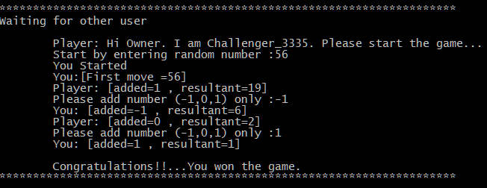

Challenger Screen
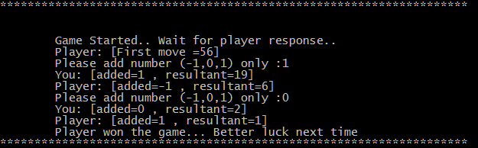

Logical Components

A. Player console:
Unit through which player can initiate or can take on challenge from other player who are waiting

Feature:
1. Player console has two boot mode that is Broker and Broker-less.
Broker mode: In this mode player can create or join game with the help of middle-ware server know as broker. Broker helps in introducing players game to other new players in user friendly manner. In broker mode player have menu through which player can submit new game or can join other per-submitted by other player.
Broker-less mode: In this mode player doesn’t have broker to publish/subscribe games. If player creates game the one has to tell the detail to other player manually such as IP and port of shown by game itself.
2. Player console can boot into two game type that is Auto and Manual
Auto: In this game mode at the start of game, owner will select while rest of the steps are going to be calculated by machine itself.
Manual: While in this mode every input will be entered by players it self, while machine will help in correcting their calculation by providing constrains.
3. LAN play

B. Broker
Broker is middle ware unit which manages player game request by storing them and introducing them to other player in order to start game.

Feature:
1. Inventory: It holds list of games which are not accepted by any challenger and remove once they are accepted by challenger or requested to remove.
2. Services: Add new game, view games, join game and remove game.
3. LAN: accepts request from any player who is on same LAN.

Manual

Prerequiste
1. Java 8 to be installed.
2. Machines are on same LAN

Broker:
1. To start broker

java -jar Broker-0.0.1-SNAPSHOT.jar <machine-address: localhost,127.0.0.1,privateIP> <port>

e.g. java -jar Broker-0.0.1-SNAPSHOT.jar localhost 3333

Player Console:

1. To start player console

broker mode

java -jar Player-0.0.1-SNAPSHOT.jar <listening-port> broker <broker-ip> <broker-port>

e.g.
java -jar Player-0.0.1-SNAPSHOT.jar 3334 broker localhost 3333

Note: for this mode broker server should be up running already.

broker-less mode
java -jar Player-0.0.1-SNAPSHOT.jar <listening-port> broker-less

e.g.
java -jar Player-0.0.1-SNAPSHOT.jar 3334 broker-less

2. First input
> enter your username
> select game type [(A)uto , (M)anual], either whole word or just first letter.

3. Start new game

broker mode
> select 1: Start new game and wait for opponent from menu.
> wait for opponent

broker-less mode

> enter Create or C after first input
> tell your game detail to opponent
> wait for opponent

4. Join existing game

broker mode
> 2: Join existing game
> enter game id from displayed list.

broker-less mode

> enter Join or J after first input
> Enter opponent game detail.
> start

5. Rules
broker mode only

6.leave
broker mode only because broker-less will exist as soon as game ends.

Note: It’s on individual player boot in which mode and which game type he wants.

Its perfectly fine one starts in broker mode while other in broker-less they can still join each other but if player with broker created then he/she should be aware about his/her private IP.

There is no issue if one is in auto mode and other is in manual mode, only issue is intellectual drawback for manual player. :D

Visual Walkthrough

broker-less manual gameplay : https://youtu.be/Iz-ZURLVqAw

broker-less auto gameplay : https://youtu.be/D4mLkiYkbP0

broker-auto manual gameplay : https://youtu.be/-UwutvoXH58

Source: youtube
playlist: https://www.youtube.com/playlist?list=PLGcglDg6P9Ij0SdHDrS_1i5UytU1Oyeyy

CodeBase: https://github.com/manojsingh3889/GameOfThree

